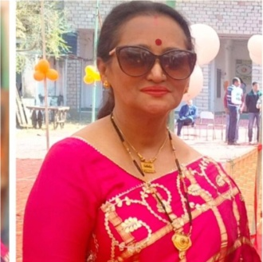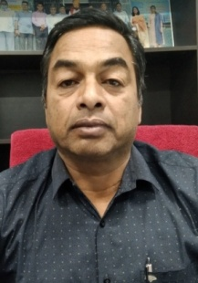
Dr. Deepali Lal Prem Singh
Ex. Professor in Zoology Associate Professor in Zoology
S.D. Govt College Beawar SPC Govt College Bhim

Abstract :-
Tables 3.1–3.5 show the species richness of Rotifers over Sites I–S V. The rotifers found at Site I included 15 different species: Brachionus angularis (304), Brachionus forficula (498), Brachionus diversicornis (607), Brachionus plicatilis (337), Brachionus calyciflorus (1890), Brachionus quadridentatus (212), Brachionus bidentata (469), Brachionus caudatus (60), Brachionus rubens (192). Among the rotifers found at Site-I, B. calyciflorus and K. tropica played a disproportionate role. The absence of Lacana papuana and Testidunella mucronata at Site I over the duration of the research is an intriguing finding. Figures 3.1–3.4 depict monthly fluctuations in the diversity of Rotifera species from families Brachionidae, Filinidae, Lecanidae, and Testudinillidae at locations S–I–S–V.
At the Site II, total of 17 rotifer species were identified, comprising of Brachionus angularis (675), B. forficula (897) , B. diversicornis (974), B. plicatilis (320), B. calyciflorus (1514,) B. quadridentatus (354), B. bidentata (792), B. caudatus (173), B. rubens (616), B. falcatus (510), K. tropica (890) K. quadrata (1065) K. cochlearis (253), Filinia longiseta (102), Filinia terminalis (154) Lacana papuana (23) and Testidunella mucronata (21). B. calyciflorus and K. quadrata were the major contributors towards Rotifer density of Site-II.
At the Site III, total of 17 Rotifer species were identified, comprising of Brachionus angularis (999), B. forficula (824) , B. diversicornis (999), B. plicatilis(356), B. calyciflorus (1079), B. quadridentatus (592), B. bidentata (1136) B. caudatus (191), B. rubens (547), B. falcatus (384), Keratella tropica (1428), Keratella quadrata (806), Keratella cochlearis (250), Filinia longiseta (203), Filinia terminalis (274), Lacana papuana (57) and Testidunella mucronata (97). Keratella tropica and B. bidentata and B. calyciflorus were the major contributors towards Rotifer diversity of site - III. It is interesting to note that some species including Lacana papuana and Testidunella mucronata were noticed only during the second year and were completely absent during the first year at Site II &III.
At the Site IV, total of 17 rotifer species were identified, comprising of Brachionus angularis (843), B. forficula (1406) , B. diversicornis (994), B.plicatilis(566), B. calyciflorus(1405), B. quadridentatus (395), B. bidentata (391) B. caudatus (162), B. rubens (984), B. falcatus (361), Keratella tropica (1782), Keratella quadrata (883), Keratella cochlearis (270), Filinia longiseta (241), Filinia terminalis (284), Lacana papuana (36) and Testidunella mucronata (99). B. calyciflorus, B. forficula and K. quadrata were the major contributors towards Rotifer density of Site - IV.
At the Site V, total of 17 rotifer species were also identified, comprising of Brachionus angularis (704), B. forficula (1019) , B. diversicornis (1118), B. plicatilis (324), B. calyciflorus (2391), B. quadridentatus (454), B. bidentata (1037) B. caudatus (139), B. rubens (926), B. falcatus (410), Keratella tropica (1782), Keratella quadrata (883), Keratella cochlearis (270), Filinia longiseta (241), Filinia terminalis (300), Lacana papuana (107) and Testidunella mucronata (268). B. calyciflorus, Keratella tropica and B. forficula and B. diversicornis were the major contributors towards Rotifer density of Site - V. It is interesting to note that some species including Lacana papuana and Testidunella mucronata were noticed only during the second year and were absent during the first year from Sites II – V. Percentage contribution of Rotifers (Org/L) in Rajsamand Lake ore (October 2019 – September 2021) are shown in Fig.3.5.

Keyword:-
Plankton , Zooplankton , Rotifera , species diversity
Introduction :-
Living organisms need fresh water as one of their most essential constituents. There has been an increase in the demand for water in the nation as a result of rapid population expansion, urbanization, and industrialization. Earth's seas hold 97% of all water on Earth; glaciers and ice sheets hold only 2%; lakes/ponds and rivers hold just 0.099%; groundwater holds the rest. A mere 0.1% of the freshwater on Earth is used by living beings. Quality control and conservation are necessary because of this. Water is a need for human survival, health, and well-being. Our consumption is expected to rise by 40% over the next two decades. Since most of these water sources have already been seized, there is little left for future generations to benefit from (Edwin, 1997). As long as there is a water supply, we have no choice but to save and save it. The management of water resources has had a significant influence in human development. Today, water is seen as a finite and restricted resource, and its usage is viewed as a major issue. As a result of population increase and urbanization, industrialization, and agricultural advancements during the last century or so, things have changed dramatically. Water shortage is currently an issue in many developing nations, but it is especially acute in those countries. In the absence of water, life as we know it would be impossible on our planet. There is a very limited supply of fresh water. Our lives would not be possible without water. Because of the fast growth in human population and the accompanying processes of industrialization and urbanization, there is a rising need for water across the world. Earth's health and well-being depend on the availability of high-quality drinking water. One of the biggest problems in poor nations is a lack of access to clean water. More than 783 million people in the globe (11 percent of the world's population) do not have access to clean water, 84 percent of whom live in rural areas, according to the Joint Monitoring Programme (JMP) for Water Supply and Sanitation (WHO and UNICEF). In order to sustain life on Earth, water is one of the most crucial renewable natural resources. Because of India's growing population and overall growth, the country's water consumption is rising rapidly. Due to the country's fast population growth and developing economy, water will become more limited in the next decade.

Materials and methods
(A ) Study area
m Udaipur. At 1.75 miles (2.82 kilometres) in diameter, the Rana Raj Singh-built structure spans a distancIndian state of Rajasthan, Rajsamand Lake (also known as Rajsamudra Lake) is a lake located 67 kilometres froe of 4 miles (6.4 kilometres) and is 60 feet (18 metres) deep. Over the Gomti River, which comes from the Sewantri, Kelwa, and Tali rivers, 196 square miles of catchment area was developed (510 km2).
The construction of the lake began in AD 1662 and was finished in AD 1676, making it Rajasthan's earliest recorded famine relief project. Rs. 1,50,78,784 is listed as the total cost of the project. About 6.4 kilometres in length, the Rajsamand Lake spans 2.8 kilometres in width, and it is 60 feet deep. Udaipur is around 66 kilometres north of the lake. Rajnagar and Kankroli are located on each side of the lake. Over the Gomati, Kelwa, and Tali rivers, it was constructed. More than half of the lake's water comes from Gomati River, which stretches over 510 square miles. If you're coming from Udaipur, you have the option of taking a personal taxi or using local transportation to go to this lake.
Located in the city of Rajsmand, the Rajsamand Lake was built in the 17th century. Maharana Raj Singh gave the order to build the lake, which was completed in 1660. Construction on this lake started on January 1, 1662, to be more precise. A foundation stone was placed on 17 April 1665 by Ranchod Rai, the oldest son of Purohit Garibdas, the royal priest at that time, who was also Ranchod Rai. In addition to Rajsamudra Lake, the locals call this body of water.
(B) Sample Collection
Samples were taken from five locations on the surface of the water. Surface water samples in five-liter plastic canes were collected every month from October 2019 to September 2021 early in the morning (6-8 am) from each location for the examination of physico-chemical parameters. The water quality examination of the lakes reveals the specific type and source of any contaminants, if any, that could be present. A lake's productivity is determined by its physical properties, such as temperature, conductivity, and turbidity. The quality of lake water is determined by the concentrations of many chemical factors, such as pH, dissolved minerals, dissolved gases, and nutrients
Result and discussion
The group of rotifers known as the Monogononta was sampled, and it yielded members of two orders (Pliomida and Flosculariacea). There were a total of 17 different Rotifer species found in this research, spread throughout 4 different families and 5 different genera. In the summer, Rotifera were most numerous at site V, whereas in the winter and spring, they were most numerous at site I. There were 13 species (2 genera) of Brachionidae, 2 species (1 genus) of Filinidae, 1 species ( 1 genus ) of Lecanidae, and 1 species ( 1 genus ) of Testudinillidae (Table 3.1). Ten species belonged to the genus Brachionus, three to the genus Keratella, two to the genus Filiinia, one to the genus Lacana, and so on. The genera Brachionus, Keratella, Filinia, Lacana, and Testudinella are home to the majority of these 17 species. The following are the known taxonomic characteristics of Rotifera:

Conclusion
The Prime Rotifers Present in the water of Rajsamand lake are brachionus plicatilis, brachionus angularis, brachionus calyciflorus, brachionus caudatus, brachionus forficula, brachionus quadridentatus, brachionus rubens , brachionus diversicornis, brachionus falcatus ,keratella cochlearis , brachionus bidentata, filinia terminalis, lacana papuana, keratella tropica, testudinella mucronata, keratella quadrata, filinia longiseta .
References
- Patil, G.P., Kedar, G.T. and Yeole, S.M., (2008) Zooplankton biodiversity study of two water bodies in Wajhim district, Maharashtra. J.Aqua.Biol.,Vol.23(1):13-17
- Chishti, N.(2002). Studies on biodiversity of freshwater zooplankton in relation to toxicity of selected heavy metals. Ph.D. Thesis, M.L. Sukhadia University, Udaipur
- Sharma, K.K. and Kour, S.et.al (2015) Diversity of zooplankton and macrobenthic Invertibrates of two perennial ponds in Jammu Region- Journal of Global Biosciences ISSN2320-1355, Vol. 4, November 2, 2015:1382-1392.
- Tonapi, G.T. 1980. Freshwater Animals of India. Oxford and IBH publishing Company, New Delhi.
5. Sharma, L.L. and Durve, V.S.(1990) : Water clarity of Rajsathan: The proceding of the second asian fisheries from tokyo japan 17-22 april 1989.

3.2.18. Species diversity of Rotifera.
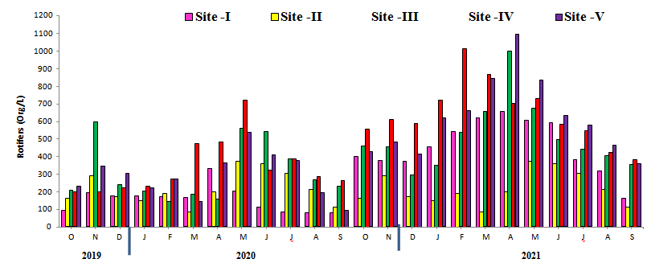
Figure 3.1: Monthly variations in Rotifera (Org/L) diversity of species belonging to Brachionidae (Brachionus angularis. B. forficula, B. diversicornis, B. plicatilis, B. calyciflorus, B. quadridentatus, B. bidentata, B. caudatus, B. rubens, B. falcatus, Keratella tropica Keratella quadrata, Keratella cochlearis, Filinia longiseta, Filinia terminalis in surface waters of Rajsamand Lake.
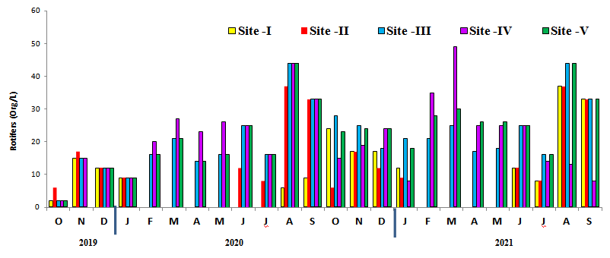
Figure 3.2: Monthly variations in Rotifera (Org/L) diversity of species belonging to Filinidae (Filinia terminalis, F.longista) in surface waters of Rajsamand Lake.
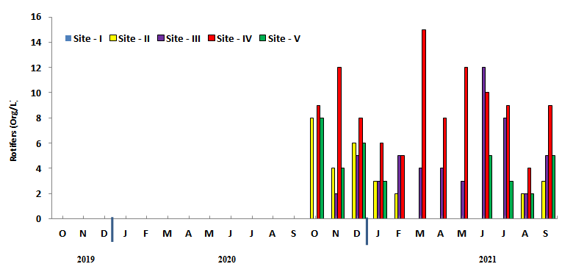
Figure 3.3: Monthly variations in Rotifera (Org/L) diversity of species belonging to Lacanidae (Lacane papuana) in surface waters of Rajsamand Lake.
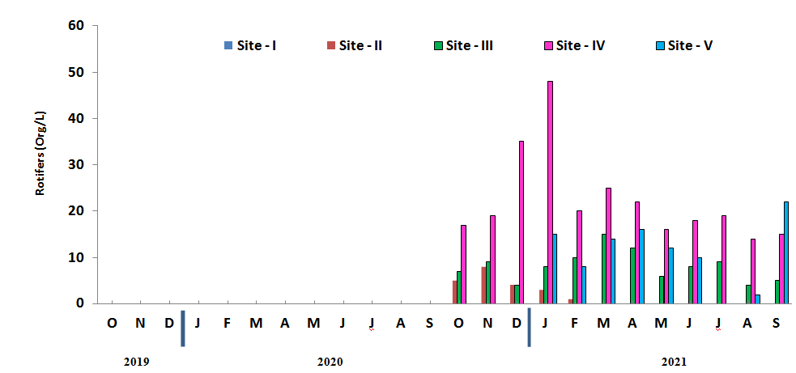
Figure 3.4: Monthly variations in Rotifera (Org/L) diversity of species belonging toTestudinillidae (Lacana papuana) in surface waters of Rajsamand Lake.
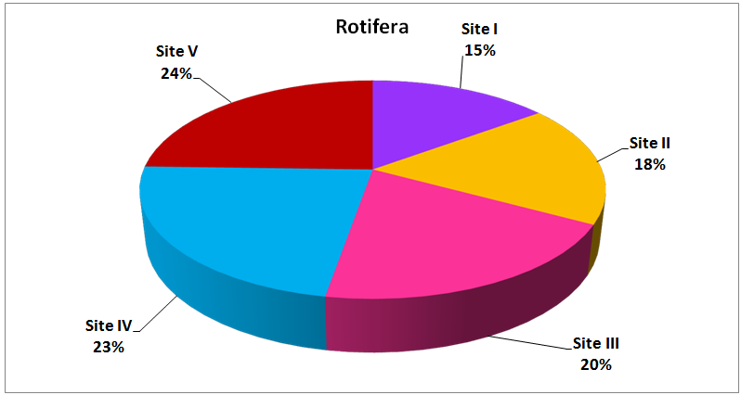
Figure 3.5: Percentage contribution of Rotifers (Org/L) in Rajsamand Lake
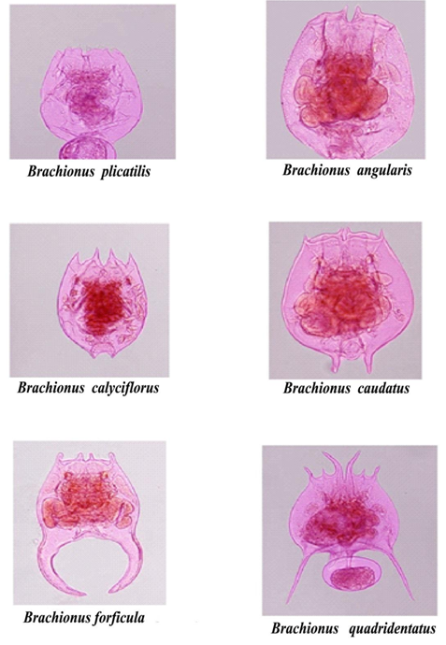
Plate 3.1: Some representatives Rotifers in the surface waters of ajsamand Lake
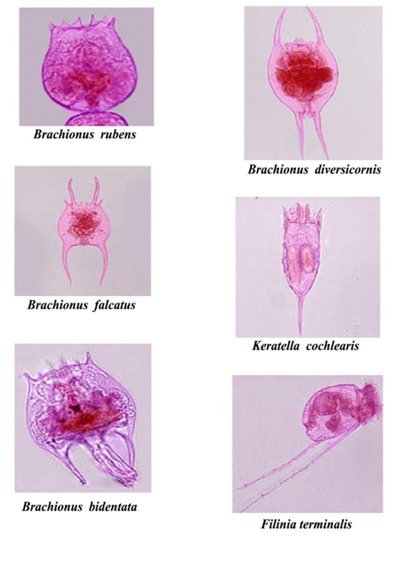
Plate 3.2: Some representatives Rotifers in the surface waters of Rajsamand Lake
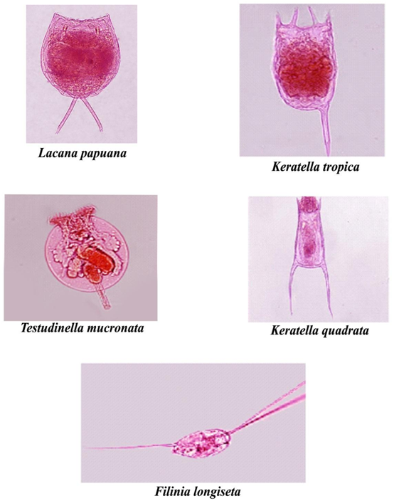
Plate 3.3: Some representatives Rotifers in the surface waters of Rajsamand Lake

