MODIFIED CIRCULAR FLUME FOR ACCURATE MEASUREMENT OF FLOW DISCHARGE

Brahmananda Reddy V V¹, Krupavathi K², Vyshnavi A¹, Sanjuktha Bera¹, Ramprakash M V¹ and Narendra K. Chowdary¹

¹Student, ²Assistant Professor
Department of Soil and Water Conservation Engineering,
Dr. N.T.R College of Agricultural Engineering, Bapatla,
Acharya N.G Ranga Agricultural University

Corresponding email address: vvbrahmanandareddy@gmail.com, akkisettyvyshu@gmail.com and krupareddy5@gmail.com.
ABSTRACT

Water is a finite and irreplaceable resource that is fundamental to human well-being. It is required to manage the water efficiently as the water becoming scarce in day to day life. For the effective and efficient management of water the first step is to measure and distribute the water accurately as per the requirements. For water measurement there are different types of devices available. The present study is conducted in one of the devices called flumes by adopting the circular flume with middle contraction without any bottom contraction to obtain critical flow conditions. In this study five types of contractions (60%, 50% with varying lengths and 40% with varying lengths) and four different discharges were conducted and derived the simple equations for measurement of water in open channels. The study concluded that the critical depth occurred at only one section in critical flow flumes. At a particular discharge, the location of the critical depth moved towards brink with the decrease in contraction. Critical depth occurred at a section little distance from the upstream end in 60% contraction cases for higher discharges, very near to the brink for 50% contraction and no critical depth for 40% contraction as the discharge decreases. All the stage discharge relationships derived were best suited for flow measurement with good R² values varies between 0.90 and 0.99.

Key words: critical depth, contraction, circular flume

- INTRODUCTION

Water is a primary source for all the sectors which is now becoming a limiting source due to increase in population and consumption in agriculture and other sectors. Recently, the competition for water between agriculture and other sector is growing enormously. To increase the efficiency of water it requires accurate measurement. It helps to allocate the equitable water quantity between competitive users both the on-farm and off-farm which gradually increase the irrigation water use efficiency.
Several devices such as volumetric measurements, velocity-area method, measuring structures (orifices, weirs and flumes) and tracer methods are used for monitoring water in open channels. Of these weirs which are measured by bottom contractions are installed at the point where the drop in elevation of channel bed occurs. The wires and other measurement devices have the disadvantage of silt trap which decreases the water accuracy measurement. Flumes are especially designed, shaped and fixed hydraulic structures those under free flow conditions force the flow to accelerate by converting side walls, bottom contraction or both. These are characterized by a known relationship between health at specific location and flow rate.
The application of concept of critical flow in weirs and flumes to measure depth and calculate the flow rate, this simplifies the monitoring of flow rate continuously. Many measuring and regulating devices have been developed by earlier researchers (Samani, 2017; Carollo et al., 2016; Ghare et al., 2014; Krupavathi et al., 2012). All of them do not satisfy the concomitant requirements of simplicity, sturdiness, reasonable accuracy, adoptability to any cross-sectional shape of channels and low head loss leaving enough scope for further research and development in the field of small measuring structures. The effective functioning of critical flow flumes depends mainly on the knowledge of hydraulic parameters such as occurrence and location of critical depth, discharge, shape or geometrical characteristics of flumes and tail water conditions under irrigated conditions.
The circular flume is a simple and low‐cost water measuring device constructed from two pieces of pipes, one installed vertically inside the other. The current research considers circular cross section for the flume in view of its adoptability and easy installation in open field channels. They also proved for their wide range of flow measurement with high degree of accuracy. An attempt has been made for providing middle contraction to obtain critical flow conditions in the semi-circular section. The contraction is achieved by placing a rectangular block in a perpendicular position at the middle of the section and not from the bottom so that obstructions to any debris and deposition of silt/any debris on upstream side is avoided. The formation of critical flow condition in the throat section is important characteristic which should be study (Krupavathi et al. 2012).
The present study is planned to design and develop a rectangular contracted flume in U channel. The flume is tested for its occurrence of critical flow conditions and flow characteristics in developed flumes.

- MATERIALS AND METHODS

As per the previous studies and works, circular critical flow flume is easy for adoption and installation and shows high degree of accuracy in measurement which was adopted along with middle rectangular contraction without any bottom contraction (Fig.1) to obtain critical flow conditions in the present study. The present study was conducted at the Dr. N. T. R. College of Agricultural Engineering (ANGRAU), Bapatla.
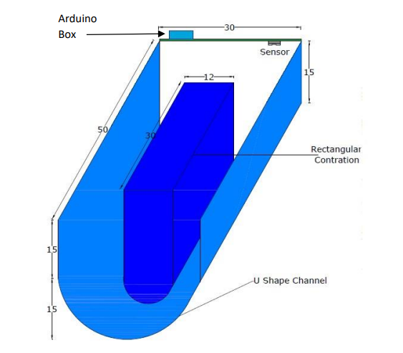

Fig. 1 View of circular critical flow flume with U-shaped circular channel and rectangular middle contraction considered in this study.

  - Experimental setup

The experimental set-up consists mainly of a large hydraulic flume with motorized bed slope alteration facility (commercial make). The total length of the hydraulic flume was 10 m, having a channel cross sectional width of 0.3 m (Fig.2) and 0.6 m depth. The flume was constructed using thick sheets of mild steel and reinforced with sturdy mild steel angles. Two gates with rack and pinion arrangement installed at either end of the flume. A trolley with point gauge arranged on the flume’s top frame runs throughout the test section. A 1 mm graduated scale fixed at the top of the frame indicates the distance between the trolley and the measuring device along with a point gauge with graduated scale, which measure the head that caused by the flow in the flume at a desired distance from the flume. The water surface in the flume was measured with a point gauge with least count of 0.1 mm.

2.2 Volumetric measurement of water in the hydraulic flume

The availability of normal flow is between 5 Ls⁻¹ to 27 Ls⁻¹. The experiments were planned to conduct at 4 different discharges of 18 Ls⁻¹, 15 Ls⁻¹, 12 Ls⁻¹ and 9 Ls⁻¹ considering the practical possibility of flow regulation with gates and outlets. This flow was measured volumetrically 3 to 4 times and the average was taken as actual discharge. The rate of flow was calculated by

Discharge (Ls⁻¹ ) = $\frac{Volume of watercollected}{Time taken}$

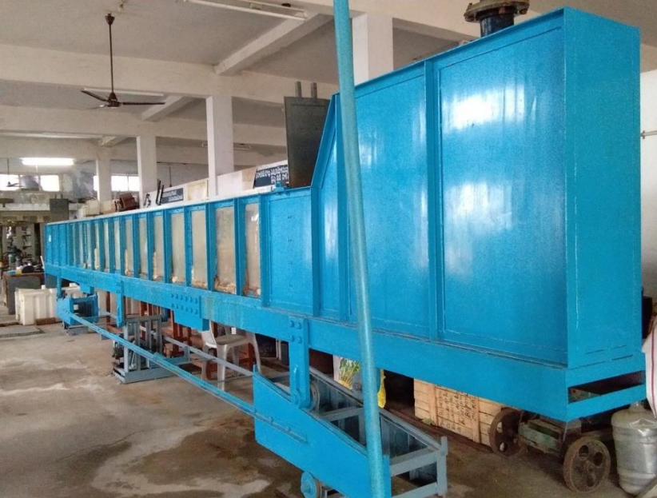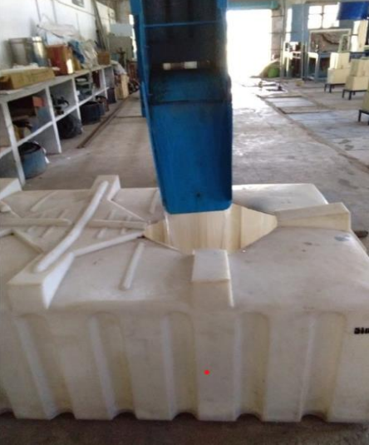

Fig 2. The side and front views of hydraulic flume with tail gate provided.

2.3 Development and installation of circular flume with middle rectangular contraction

The U channel was built by bending Flexi glass sheet into 30 cm diameter semi-circle at the bottom and straight vertical portion of 15 cm extended on both sides above the semi-circle. The contraction was achieved by placing a rectangular block in the middle of the section at a perpendicular position (Fig.3). Five flumes were prepared with three selected contractions and two lengths of section of the throat (Table 1). Proposed model contractions were chosen in such a way that no overtopping on the sides of hydraulic flume. The prefabricated rectangular contractions were installed at the middle in semi-circular bottom flume at the middle, leaving a 0.1 m from the downstream end to make the so called full-fledged circular critical flow flumes.
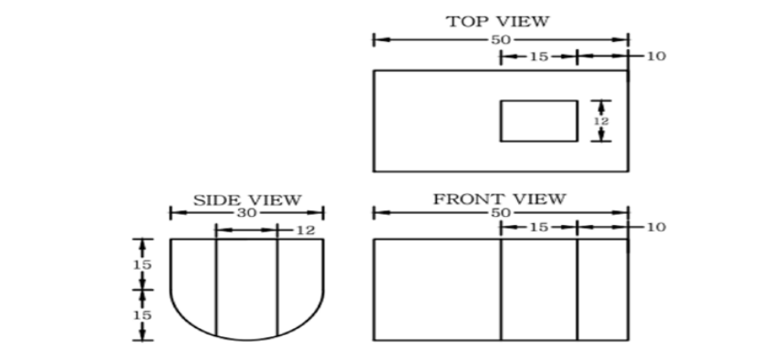

Fig.3 View of circular flumes with rectangular contraction in hydraulic flume

The five circular critical flow flumes were installed one after the other in hydraulic flume at 2m away from the tailgate of the hydraulic flume (Fig 4) and theoretical throat width (Bc) was measured as the distance between the hydraulic flume width and section of the rectangular throat. The flume width (B) was taken as 300 mm.

Table.1 Dimensions of flume selected for experimentations.

Flume Types | Rectangular contraction |  | Throat width, Bc (mm) | Contraction (%)
 | Length (mm) | Width, d (mm)
1  2  3  4  5 | 150  300  150  300  150 | 180  150  150  120  120 | 120  150  150  180  180 | 60  50  50  40  40

Fig.4 Installed circular contracted flume inside the hydraulic flume in working condition
2.4 Experimental Procedure

The hydraulic flume was kept perfectly horizontal using motorized bed slope alteration system. A circular flume-1 contraction was fixed at the center. To keep a fixed head over the crest of the sharp- 46 crested weir, a point gauge was located at upstream gauging point. The water surface profile was measured by another point gauge. The flume bottom is taken as the datum (Fig 5) and reading was noted prior to starting the experiments.

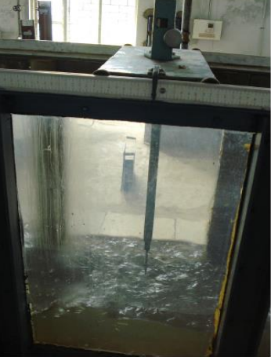

Fig.5 Point gauge used to record profiles of water surfaces

The water surfaces are measured initially with 9 Ls⁻¹ after achieving the equilibrium discharge and the it was measured at every 2 cm interval by moving the point gauge on the rails from the distance of 79 cm away from upstream side of the flume to 29 cm to have the water surface profiles throughout the flume models 50 cm length in 3 to 4 trails. This procedure was continued for remaining all discharges for all the contractions.

2.5 Critical Depth Computation

From definition of continuity equation, the rate of flow at all cross-sections of a conduit/throat must be equal at any moment. The equation relates to the velocity and area at different sections of the channel.
Q = A V = Ac * Vc …….… (3.1)
Vc =Ac/Q ………………… (3.2)
The minimum specific energy at a critical flow was considered in the calculation of the critical depth of a given discharge. From Bernoulli’s equation,

Specific Energy, E= Y+V² /2g
=Y+Q² /2gA² .……. (3.3)
Where, E = Specific Energy, Q = Flow rate, V = Velocity, A = Area of cross-section of flow, g = Acceleration due to Gravity, y = Depth of water
At critical flow conditions 𝑑𝐸/𝑑𝑦 =0
Substitute Eq. 3.2 in Eq. 3.3
E = Y+Q² /2gA² ………….(3.4)
Therefore, $\frac{dy}{dy}-\frac{2Q^{2}}{2gA^{3}}*\frac{dA}{dy}=0$
$\frac{Q^{2}}{gA^{3}}*T=1$ (⸪ 𝑑𝐴/𝑑𝑦 = 𝑇)
The above equation at critical conditions, therefore gives
𝐴_{𝑐}³ = $\frac{Q^{2}T}{g} .$……………..…… (3.5)
The subscript ‘c’ refers to the critical condition. Critical depths are calculated for four discharges using the equation (3.5). The computed critical depths are located on plotted surface profiles of water.

- RESULTS AND DISCUSSIONS

3.1 Characteristics of critical depth

The computed critical depths for all contractions and discharges are presented in the Table 2. From the results, it is clear that for a particular contraction, the critical depth increases with increase in discharge (Sharifi, 2010, Dabrowski et al., 2012, Krupavathi et al., 2012). For a particular discharge, the critical depth was found to increase with increase in contraction. These computed critical depths were used to find the formation of critical flow conditions in the throat section of all the flumes tested.

Table.2 Computed critical depths (cm) for various contractions and discharges

Flume  (% contraction) | Computed critical depths (cm)
 | Discharges (Ls⁻¹)
 | 18 | 15 | 12 | 9
60% (15 cm)  50% (30 cm)  40% (15 cm) | 25.40  18.10  14.30 | 21.11  16.45  11.10 | 20.00  13.12  6.30 | 16.12  9.00  3.50

3.2 Study of the flow characteristics of circular flumes with regard to occurrence of critical flow conditions

It was observed that the critical depth locations are moving towards the upstream end of the flume as the discharge and percent of contraction increases and moving towards the brink as the discharge and percent of contraction decreases. The water surface profiles are drawn for all the flumes for different discharges with measured depth of water. The computed critical depths for the four discharges were located on the water surface profiles graphically (Fig. 6 to Fig. 10).
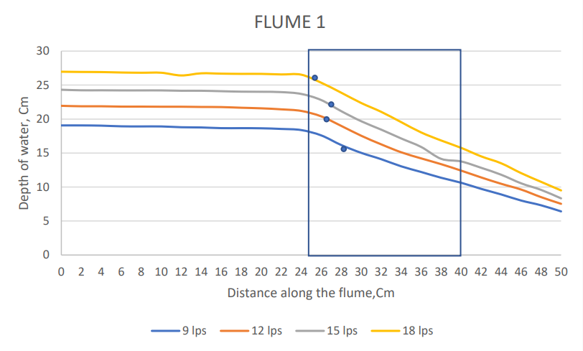
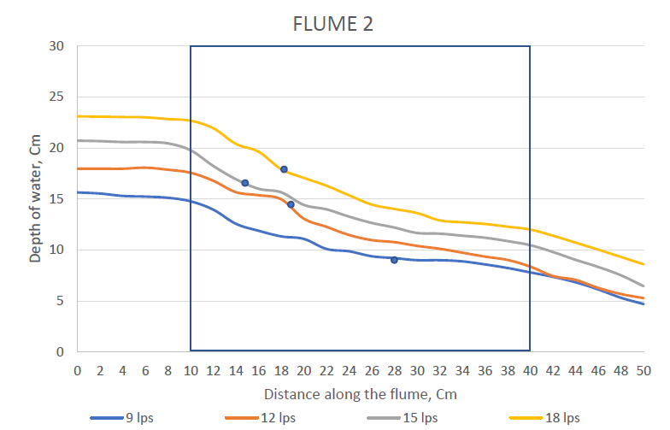
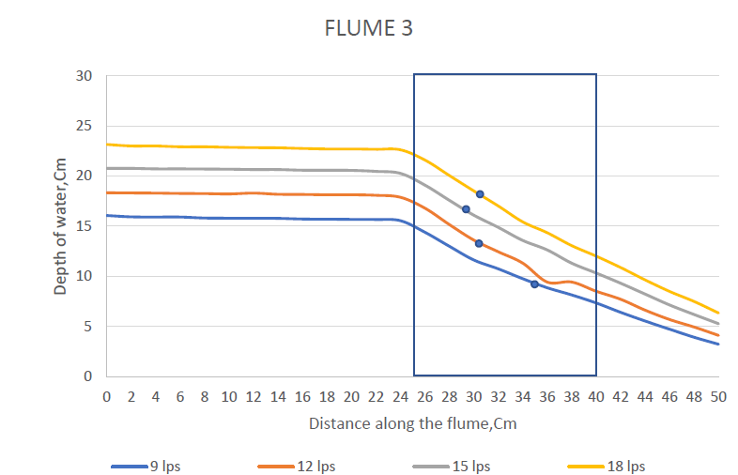
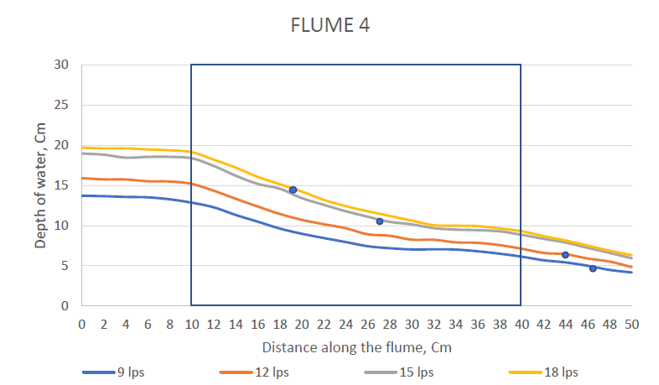
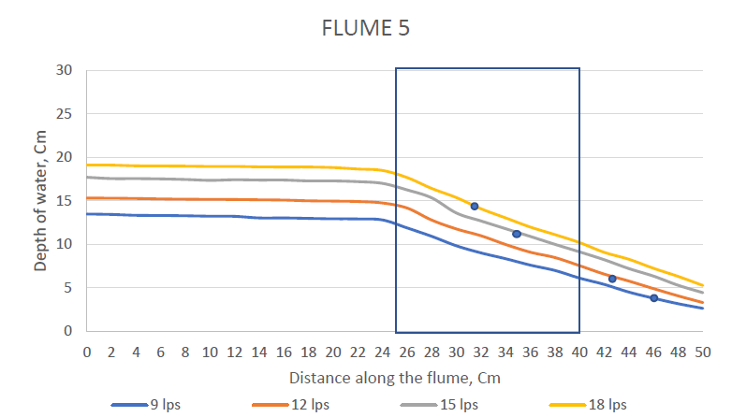

Fig.6-10 Water surface profiles and critical depth locations of flume-1 to flume-5 (L 150 mm and W 120 mm) under different discharges.

It was observed that the flume gives a constant brink-critical depth ratio in flumes with 30 cm throat length for the discharge range selected. It was clear from the observations that a fairly constant brink depth to critical depth ratio exists for each flume tested. The ratio varied between 0.67 to 0.72 for flume-1. For flume-2, the values are between 0.63 to 0.81. The ratio varied between 0.71 to 0.96 for flume-3. For flume-4, the values are between 0.65 to 1.42. For flume-5, the values are between 0.81 to 2.05.
For the flumes with 15 cm throat length the brink – critical depth ratios were near to each other. This shows that the discharge can be computed with a single measurement of brink depth at the end of the flume for the flumes under free flow conditions with 30 cm throat length.

3.3 Derivation of stage discharge relationships of the circular contracted critical flow flumes under different flow conditions

The data on critical depth, brink depth, and corresponding non-dimensional parameters were subjected to dimensional analysis for all flumes tested in the laboratory and the relationships are computed. The non-dimensional parameter ($\frac{Yb}{Bc}$) varied from 0.65 to 0.94 for discharges for the Flume-1. It was between 0.488 to 0.765; 0.57 to 0.88; 0.416 to 0.791 and 0.598 to 0.970 for Flumes 2, 3, 4 and 5 respectively. The non-dimensional parameter $\frac{Q}{g^{\frac{1}{2}}{Bc}^{\frac{5}{2}}}$varied between 0.209 to 0.418 for circular contraction Flume-1. Similarly, $\frac{Q}{g^{\frac{1}{2}}{Bc}^{\frac{5}{2}}}$ varied between0.329 to 0.659; 0.329 to 0.659; 0.576 to 1.152 and 0.576 to 1.152 for Flumes 2, 3, 4 and 5. For the all flumes, it is observed that the non-dimensional parameter ($\frac{Yb}{Bc}$) increased with increase in ($\frac{Q}{g^{\frac{1}{2}}{Bc}^{\frac{5}{2}}}$).
For all flume forms the least squares approach was used to decide the best fit relationship between the above two non-dimensional parameters.
$\frac{Q}{g^{\frac{1}{2}}{Bc}^{\frac{5}{2}}}$= c ($\frac{Yb}{Bc}$) ^{n}…………………..(4.1)
The developed relationships ($\frac{Q}{g^{\frac{1}{2}}{Bc}^{\frac{5}{2}}}$) and brink depth to throat width ratio ($\frac{Yb}{Bc}$) were found as follows
$\frac{Q}{g^{\frac{1}{2}}{Bc}^{\frac{5}{2}}}$= 1.4654($\frac{Yb}{Bc}$)^{0.5256}……. For flume-1
$\frac{Q}{g^{\frac{1}{2}}{Bc}^{\frac{5}{2}}}$= 1.0154($\frac{Yb}{Bc}$)^{1.5342} .…... For flume-2
$\frac{Q}{g^{\frac{1}{2}}{Bc}^{\frac{5}{2}}}$ = 1.1254($\frac{Yb}{Bc}$)^{0.5881} ……. For flume-3
$\frac{Q}{g^{\frac{1}{2}}{Bc}^{\frac{5}{2}}}$ = 0.7099($\frac{Yb}{Bc}$)^{0.964} ……. For flume-4
$\frac{Q}{g^{\frac{1}{2}}{Bc}^{\frac{5}{2}}}$= 0.902( $\frac{Yb}{Bc}$)^{0.6796} ……. For flume-5
The calibration coefficients of the equation for each flume are shown in Table 4.5. The R² values of equation of developed flumes varied from 0.999 to 0.95.

Table.3 Values of constants ‘c’ and ‘n’ in equation (4.1)

Flumes | c | n | R²
1 | 1.4654 | 0.5256 | 0.99
2 | 1.0154 | 1.5342 | 0.99
3 | 1.1254 | 0.5881 | 0.97
4 | 0.7099 | 0.964 | 0.98
5 | 0.9028 | 0.6796 | 0.95

3.4 Relationship between non-dimensional parameters involving discharge, throat width and upstream depth

The non-dimensional parameter ($\frac{H}{Bc}$) varied from 1.049 to 1.481 for discharges for circular contraction flume-1. It was between 1.504 to 0.978; 1.07 to 1.554; 1.141 to 1.65 and 1.116 to 1.631 for flumes 2, 3, 4 and 5. The non-dimensional parameter $\frac{Q}{g^{\frac{1}{2}}{Bc}^{\frac{5}{2}}}$ varied between 0.209 to 0.418 for circular contraction flume-1. Similarly, $\frac{Q}{g^{\frac{1}{2}}{Bc}^{\frac{5}{2}}}$varied between 0.329 to 0.659; 0.329 to 0.659; 0.576 to 1.152 and 0.576 to 1.152 for flumes 2, 3, 4 and 5. For the all flumes, it is observed that the non-dimensional parameter ($\frac{H}{Bc}$) increased with increase in ($\frac{Q}{g^{\frac{1}{2}}{Bc}^{\frac{5}{2}}}$).
The method of least squares is applied to determine the best fit relationship between the above two non-dimensional parameters in all flume types.
$\frac{Q}{g^{\frac{1}{2}}{Bc}^{\frac{5}{2}}}$= c ($\frac{Yb}{Bc}$ )^{n}……………..(4.2)
The developed relationships ($\frac{Q}{g^{\frac{1}{2}}{Bc}^{\frac{5}{2}}}$) and brink depth to throat width ratio ($\frac{H}{Bc}$) were found as follows
$\frac{Q}{g^{\frac{1}{2}}{Bc}^{\frac{5}{2}}}$= 2.2733 ($\frac{H}{Bc}$)^{0.4947}……. For flume-1
$\frac{Q}{g^{\frac{1}{2}}{Bc}^{\frac{5}{2}}}$= 0.3414 ($\frac{H}{Bc}$)^{1.6587}……. For flume-2
$\frac{Q}{g^{\frac{1}{2}}{Bc}^{\frac{5}{2}}}$= 1.8753 ($\frac{H}{Bc}$)^{0.489}…… For flume-3
$\frac{Q}{g^{\frac{1}{2}}{Bc}^{\frac{5}{2}}}$= 1.5612 ($\frac{H}{Bc}$)^{0.576}…… For flume-4
$\frac{Q}{g^{\frac{1}{2}}{Bc}^{\frac{5}{2}}}$= 1.5013 ($\frac{H}{Bc}$)^{0.5256} ….. For flume-5
The calibration coefficients of the equation for each flume are shown in Table 4.6. The R² values of equation of developed flumes varied from 0.99 to 0.90.

Table.4 Values of constants ‘c’ and ‘n’ in equations (4.2)

Flumes | c | n | R²
1 | 2.2733 | 0.4947 | 0.99
2 | 0.3414 | 1.6587 | 0.97
3 | 1.8753 | 0.489 | 0.97
4 | 1.5612 | 0.576 | 0.95
5 | 1.5013 | 0.5599 | 0.9

3.5 Relation between upstream head and discharge

The relation between measured flow rates and corresponding upstream heads under free flow conditions for each flume on a log-log scale. From the graphs, it was observed that the upstream head increases with increase in discharges. The results showed that a generalized flow equation in a flume (Samani, 2017), which can be developed for each flume as,
Q = cH^{n} …………….. (4.3)
Where, Q = discharge in Ls⁻¹;
H = upstream head in mm
c, n = calibration coefficients. Calibration coefficients ‘c’ and ‘n’ are constants for a particular type of flume.
The relationships are as follows
Q = 0.74986 (H)^{0.4977} … For flume-1
Q = 0.108124 (H)^{0.9523} …For flume-2
Q = 0.62497 (H)^{0.9429} …. For flume-3
Q = 0.154 (H)^{0.576} …… For flume-4
Q = 1.136836 (H)^{0.4719}.… For flume-5
The calibration coefficients of the same contraction have values nearer to each other. The R² values of equation of developed flumes varied from 0.99 to 0.95. This shows that the proposed general equation is useful for measuring the discharge with the measurement of upstream depth.

IV. SUMMARY AND CONCLUSION

From above, the results concluded that critical depth occurred at only one section in critical flow flumes. Critical depth occurred at a section little distance from the upstream end in 60% contraction cases for higher discharges. At a particular discharge, the location of the critical depth moved towards brink with the decrease in contraction. For 50% contraction, most values are nearer to the brink. No critical section found at low discharges with 40% contraction.
It neither occurred at any fixed location for all discharges for a single contraction nor for all contractions with a single discharge. This is because the water surface profiles do not bear the same geometric relationship to flow boundaries and hence complete dynamic similarity in the shapes of water surface profiles between any two discharges is not possible. A fairly constant brink depth to critical depth ratio exists for each flume tested. All the stage discharge relationships derived were best suited for flow measurement with good R² values.
V. REFERENCES
Krupavathi, K., Satyanarayana, T.V. and Kumar, H.V.H., 2012. Effect of submergence on flow characteristics and accuracy of measurement in semi-circular contraction critical flow flumes. International Journal of Agricultural Engineering, 5(2), 268-272.
Samani, Z., 2017. Three simple flumes for flow measurement in open channels. Journal of Irrigation and Drainage Engineering, 143(6), p.04017010.
Sharifi, S., Sterling, M. and Knight, D.W., 2011. Prediction of end-depth ratio in open channels using genetic programming. Journal of Hydroinformatics, 13(1), 36-48.
Dabrowski, W. and Polak, U., 2012. Improvements in flow rate measurements by flumes. Journal of Hydraulic Engineering, 138(8), 757-763.
Carollo, F.G., Di Stefano, C., Ferro, V. and Pampalone, V., 2016. New stage-discharge equation for the SMBF flume. Journal of Irrigation and Drainage Engineering, 142(5), p.04016005.
Ghare, A. and Badar, A., 2014. Experimental studies on the use of mobile cylinders for measurement of flow through rectangular channels. International Journal of Civil Engineering, 12(4), 504-512.

