Chapter Title: Pharmacodynamics

Akansha Singh¹, Priyadarshini Soni*¹, Neeru Singh¹, Kulsoom Hamid¹.

1. Faculty of Pharmacy, Swami Vivekanand Subharti University, Meerut, Uttar Pradesh, India.
*Corresponding Author: Priyadarshini Soni, Assistant Professor, Faculty of Pharmacy, Swami Vivekanand Subharti University, Meerut, Uttar Pradesh, India.; +91-8851040274., priyadarshinisoni274@gmail.com

- Introduction
"Pharmacodynamics, also known as drug actions on the human system, is the comprehensive study of drugs' biochemical, physiological, and molecular actions." Receptor binding, receptor sensitivity, post-receptor effects, and chemical interactions are among subjects it examines. One may achieve understanding of the complex link between drug dosage and effects by combining pharmacodynamics and pharmacokinetics, both of which focus on how the body responds to a medicine and the drug's outcome within the body. Basically, the drug's capacity to bind to its designated target defines the pharmacological response, and the amount of drug present at the receptor site determines the drug's total effect." There are numerous types of physiological changes that might have an impact on a medication's pharmacodynamics these changes include:
A disorder or disease
- The aging processes
- Interactions with other drugs
A number of factors, including genetic mutations, thyrotoxicosis, malnutrition, and myasthenia gravis, may significantly affect pharmacodynamic response, Parkinson's disease, and specific kinds of insulin-resistant diabetes.¹ These events frequently modify receptor binding, have an impact on the quantity of binding proteins, or reduce receptor sensitivity. In humans with these types of disorders, the drug's efficacy and method of action may consequently be drastically changed.
- PRINCIPLES OF DRUG ACTION
The development of new characteristics for any system, organ, or cell cannot be facilitated by drugs (apart from those based on genes). The only thing that it can do is change the rate at which activity advances, yet because of its toxicological effects, serious medical consequences can be anticipated. The following are some broad categories of actions:
2.1 Stimulation
2.2 Depression
2.3 Irritation
2.4 Replacement
2.5 Cytotoxic action
2.1 Stimulation
A targeted growth in how specific tissues perform.
Example - adrenaline stimulates the heart and pilocarpine stimulates the salivary glands.
Though, over-stimulation is common suppression of this function.
Example – high dose Picrotoxin, a central nervous system stimulant, causes seizures followed by coma and respiratory depression.
2.2 Depression
Only certain types of cells are affected by the selective reduction of activity, such as the central nervous system when using barbiturates. Quinidine and Omeprazole both lessen the production of stomach acid. While some medications repress certain cell types, others increase them. Other instances include: Acetylcholine stimulates the intestinal smooth muscle. Still, activate the cardiac SA node. Because most medicines are easily categorized as stimulants or depressants, this is not practicable with most of them.
2.3 Irritation
This non-selective method is employed particularly in non-specialized cells. Damage to the morphology, intense stimulation, inflammation, corrosion, necrosis. It may accelerate deterioration or functional loss.
2.4 Replacement
This suggests the use of common materials, a lack of metabolites, hormones, or their congeners; Examples: levodopa for Parkinson's disease, insulin for diabetes, iron in anemia.

2.5 Cytotoxic action
Cancer and parasite cells are rendered weaker by a selective cytotoxic action. It is used to treat/reduce infections and neoplasia and has extreme effects on host cells. Zidovudine, cyclophosphamide, penicillin, and chloroquine, etc.
- MECHANISM OF DRUG ACTION
To control how medications affect the body, pharmacodynamic processes are used.² Drug-receptor binding is linked to numerous complex chemical interactions, as was previously described. The drug's binding site is the area of the receptor where it attaches. The reactivity of the medication and the binding site controls how firmly the two molecules attach to one another. The drug's affinity for the binding site on the receptor is known to facilitate drug-receptor interaction.
The dissociation constant serves as a symbol for affinity, which is based on the inherent characteristics of a particular drug-receptor set (K_{d}). According to definition, the Kd is the drug concentration at which half of the accessible receptors are occupied. When a sufficient number of receptors are occupied on or inside the cell, the cumulative effect of receptor occupancy on that cell becomes obvious. Consequently, we discover that the dose-response connection and the drug-receptor binding relationship are closely connected.
Graded and quantal dose-response connections are the two main forms. Two key factors can be derived from the graded dose-response curve (Figure 1), which depicts the impact of various dosages or concentrations of a medicine on an individual: effectiveness and potency. The (L) at which a drug produces 50% of its maximum response is referred to as the drug's potency (EC50). When all of the available rectors are used, a drug's efficacy (Emax) has its greatest impact.
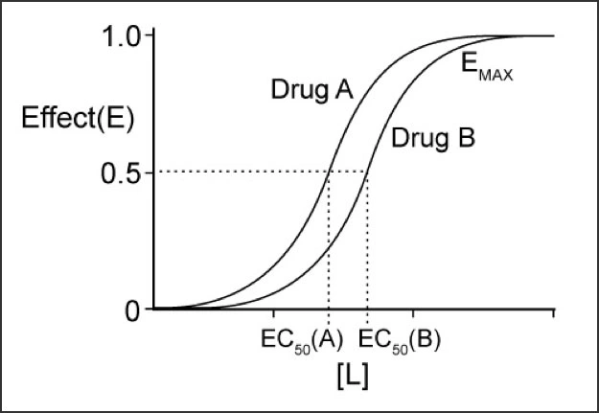
Figure 1. Graded dose-response curves for two drugs
Note that drug A is more effective than drug B. However, in this example, drug A and drug B have the same effect.

The mean impact of a drug as a function of drug dose in a population is represented by a quantitative dose-response curve (Figure 2), from which three key characteristics can be obtained: efficacy, toxicity, and lethality. The distribution of reactions is either present or absent. The median effective dose (ED50), median toxic dose (TD50), and median lethal dose (LD50), respectively, are the doses that cause these reactions in 50% of the population.

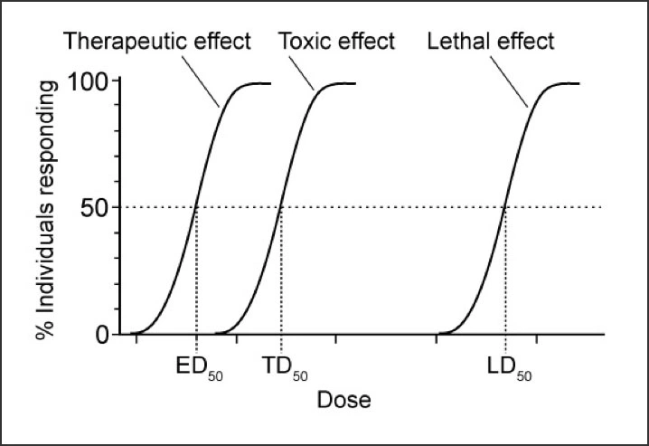
Figure 2 Quantal dose-response curve
Note that ED₅₀ is the dose at which 50% of the subjects respond to the drug, whereas EC₅₀ (see Figure 2) is the dose at which a drug elicits a half-maximal effect in an individual.

The therapeutic window is a range of pharmacological dosages that had a therapeutic benefit in a population of people without unacceptably harmful side effects. The therapeutic index (TI) can be used to calculate the therapeutic window: TI = TD₅₀/ED₅₀. A big TI demonstrates a broad therapeutic window, such as a 100-fold difference between the TD₅₀ and ED₅₀. A tiny TI demonstrates a constrained treatment window, such as a two-fold difference between TD₅₀ and ED₅₀. There are two conformational states of drug receptors that are in balance with one another: an active state and an inactive state.³
There are two conformational states of drug receptors that are in balance with one another: an active state and an inactive state.
- PROTEIN TARGETS FOR DRUG ACTION
The proteins that medications may alter in our body are discussed in this chapter. (Figure 3) These proteins can be divided into various categories as:
4.1 receptors
4.2 ion channels
4.3 enzymes
4.4 transporters (carrier molecules)
There are minor abnormalities, but major drugs that alter one or both of these protein types have a negative impact. As an illustration, the immunosuppressive drug ciclosporin binds to cytosolic proteins known as immunophilins while the anti-gout drug colchicine reacts with the structural protein tubulin.⁴
  - Receptors
Typically located in cell membranes, receptors are glycoproteins that specifically recognize and bind to ligands. These are little things, like medications, that can "bind" to the receptor protein. This binding induces a conformational change in the receptor protein, which speeds up a series of intracellular biochemical reactions (known as "signal transduction") and frequently results in the formation of "secondary messengers" that eventually cause a biological response (such as muscle contraction or hormone secretion). Human tissue receptors have been designed to bind endogenous ligands including neurotransmitters, hormones, and growth factors even if the ligands of therapeutic relevance are exogenous (i.e., medications). Drug concentration is correlated with the number of receptors used (and consequently the response), and the synthesis of drug-receptor compounds is often reversible. Reversibility indicates that similar ligands can compete for access to the receptor and enables control of biological responses. However, the term "receptor" is occasionally used in pharmacology to refer to other classes of pharmacological targets, such as voltage-sensitive ion channels, enzymes, and transporter proteins. Receptors are primarily defined as proteins whose primary purpose is to bind ligands. The ability of receptor ligands to cause a biological reaction after interacting with the receptor serves as a marker for them.
4.1.1 Agonist: Agonists interact with the protein receptor, causing it to change conformation so that a signal linked with a biological reaction can be sent. The number of receptors employed increases together with the number of free ligands, which in turn has an impact on the biological effect. Utilizing every receptor will result in the greatest physiological impact. The idea of "reserve receptors" has been supported by the observation that in many receptor systems, carry out agonists can have the greatest impact without using any of the available receptors". The apparent availability of receptors permits induction of full reactions at lower ligand concentrations than would otherwise be required.
4.1.2 Inverse agonist: When they bind to a receptor, they have the exact opposite effect of a full agonist. When no ligand is present, the relevant endogenous receptor must still be connected to the biological response in order to detect inverse agonists (i.e., constitutive activity). Different receptors may exhibit constitutive activity.
4.1.3 Antagonist: Despite joining the receptor, antagonists do not cause the conformational shift that initiates intracellular transmission. A competitive antagonist on the receptor prevents the other ligand from binding and "antagonizes" the biological response to the agonist by preventing it from binding. Raising the agonist concentration can overcome antagonist inhibition.
Antibodies known as non-competitive antagonists change the response to an agonist without engaging with the receptors. These effects will prevent the agonist from responding maximally (i.e., limiting its "efficacy") even if the agonist dose is increased).
4.1.4 Partial agonist: Even when all receptors are active, partial agonists are unable to produce effects on maximal transmission that are exactly like those of an agonist. The total response is decreased when partial agonists are paired with full agonists because they block receptor sites that the full agonist may have filled, which appears to offset the effects of the full agonist.
Partial agonists are beneficial as drugs for a variety of conditions. At the peak of their dose-response curve, they are less likely to result in receptor-mediated negative effects (such as the fact that the partial opioid receptor agonist buprenorphine does not result in as much respiratory depression as morphine when used as an analgesic). However, they do not produce the same maximum effect as the full agonist.
4.1.5 Ligand: Any substance that only binds to certain receptors or areas. A phrase that merely reflects binding affinity or capacity without reference to functional changes to competitive antagonists and stimulants acting as mediators shared the same receptor.⁵⁻⁶
  - Ion Channels
Proteins called ion-selective channels take role in and control transmembrane interactions and intracellular ionic composition. The ability to produce electrical signals is exhibited by some cells, known as excitable cells. Despite the fact that neurons can take on many different shapes, such as nerve cells, muscle cells, and touch receptors, they always rely on ion channel receptors to transform chemical or mechanical information into electrical impulses. The ion concentration in the cytoplasm of an excited cell differs from that in the external environment, as it does for all cells. Due to the convergence of these concentration changes, the plasma membrane experiences a very slight electrical potential. When the circumstances are favorable, specific plasma membrane holes allow for the quick transit of ions into and out of the cell, which produces an electrical signal.
4.2.1 Ion channel receptors: They are frequently multimeric proteins found in the cell membrane. Each of those proteins creates a pore or channel that connects the membrane's two halves. These ion routes or channels may open and close in response to chemical or mechanical inputs. When an ion channel is open, ions exit the cell in a single direction. Because each individual ion channel is ion-specific, it typically only permits one kind of ion to pass through it. The channel's physical breadth and amino acids control which ions can pass from outside to within the cell, and vice versa. A temporary occurrence is the emergence of an ion channel. Within milliseconds of opening, the majority of ion channels shut and enter a resting state, only briefly remaining open to impulses.
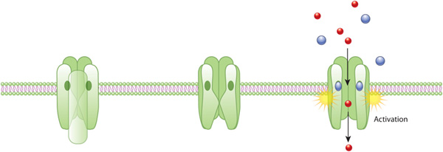

Figure 3. An example of ion channel receptor activation
The cholinergic receptor (green) creates a closed ion channel in the plasma membrane. When the plasma membrane is open, this receptor, a hydro permeable membrane protein, permits solutes to pass through. If there has been no external signal, the pore has closed (middle). A change in conformation occurs as acetylcholine molecules (blue) engage with the receptor, opening the water pore and allowing ions (red) to enter the cell.
4.2.2 Generation of electrical signal: The charge distribution in the plasma membrane is altered by ion channel opening. Keeping in mind that the ionic composition of the cytoplasm differs significantly from that of the surrounding environment.
For example: In comparison to the cell's surrounding environment, the level of sodium ions in the cytoplasm is substantially lower. However, the concentration of potassium ions inside the cell is higher than it is outside. By combining a chemical gradient and a charge gradient, these variations result in an electrochemical gradient. Ion channels open, allowing ions to go down this dual gradient on each side of the plasma membrane. An electrical signal is produced by this ion movement.⁷
  - Enzymes
Enzymes are responsible for almost all of life's functions, making them a very important target for pharmaceutical activity. Drugs have the ability to accelerate or inhibit enzyme-mediated processes. Physiological systems can, however, optimally fix enzyme activity. As a result, some only natural metabolites perform perfectly when enzymes are stimulated by medications that are truly foreign compounds, such as pyridoxine cofactor and increased decarboxylase activity. A variety of enzymes are influenced by the receptors and other messengers. For example, adrenaline stimulates liver glycogen phosphorylase through the action of b receptors and cyclic AMP. An enzyme's affinity for the substrate is increased by stimulation, which lowers the rate constant (kM) of the process.
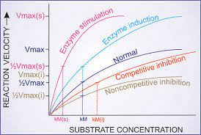
Figure 4. Effect of enzyme induction, stimulation and inhibition on kinetics of enzyme reaction
Vmax—Maximum velocity of reaction; Vmax (s) of stimulated enzyme; Vmax (i)—in presence of noncompetitive inhibitor; kM—rate constant of the reaction; kM (s)—of stimulated enzyme; kM (i)—in presence of competitive inhibitor. Enzyme induction, or the synthesis of more enzyme protein, may result in an apparent increase in enzyme activity.

    - Enzyme inhibition: Formaldehyde, phenol, and other substances that desaturate proteins and inhibit all enzymes from functioning in a non-selective manner. They can only be applied topically and have a limited therapeutic efficacy. However, the drug's typical mode of action involves the selective inhibition of a particular enzyme. A competitive or non-competitive blocking situation could occur.
    - Types of Enzyme Inhibition
4.3.2.a Normal Enzyme Reaction
- In a typical process, the substrate binds to the enzyme (via the active site), resulting in an enzyme-substrate complex.
- Specificity between an enzyme and its substrate results from the interaction between the substrate's characteristics and structure.
- In order to ensure the best possible contact with the substrate, the active site changes shape upon binding (induced fit).
- Because the substrate's chemical linkages are weakened by this conformational change, the activation energy is lower.
- Due to the interaction of the enzymes, the conversion of the substrate into the product occurs more quickly.
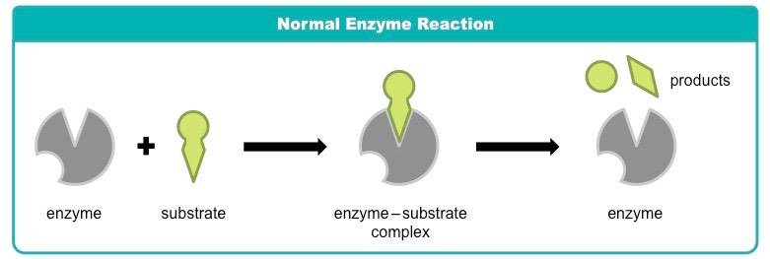
Figure 5. Normal Enzyme Reaction
4.3.2.b Competitive Inhibition
- In competitive inhibition, a molecule other than the substrate is in contact with the enzyme's active site.
- The inhibitor molecule can bind to the active site because it is physically and chemically identical to the substrate.
- By obstructing the active site, competing inhibitors hinder substrate binding.
- When the inhibitor interferes with the substrate, its effect is diminished when the substrate is present at higher concentrations.
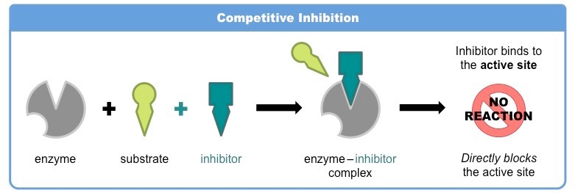
Figure 6. Competitive Inhibition

4.3.2.c Noncompetitive Inhibition
- When substances bind to places other than the active site (allosteric sites), non-competitive inhibition occurs.
- When an inhibitor enters the regulatory site, the enzyme's active site's conformation changes.
- Due to these changes, the substrate's ability to bind to the active site has been lost, and the active site no longer shares the substrate's specificity.
- Promoting the quantity of substrate cannot reduce the inhibitor's effectiveness when the substrate and inhibitor are not in direct competition.⁸

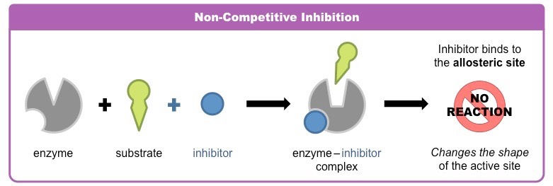
Figure 7. Noncompetitive Inhibition

- TRANSPORTERS
Some substrates are connected to particular transporters (carriers), which allow them to pass through membranes. Exchangers, gradients of concentration, and diffusion are all made easier in that way. Application of metabolic energy along a concentration gradient of a metabolite/ion pair. Numerous medications interact with the SLC (solute carrier class) right away. Transporter proteins that stop progression Metabolites and ions travel around the body.
Examples are:
- Due to its interactions with the Norepinephrine Transporter (NET), desipramine and cocaine prevent neurons from reabsorbing noradrenaline.
- Neurons are inhibited by fluoxetine and other SSRIs. 5-HT reuptake via the serotonin transporter's (SERT) interaction.
- Amphetamines specifically prevent the dopamine transporter (DAT) from reup taking dopamine into brain neurons.

- References
- Currie GM. (2018). Pharmacology, Part 1: Introduction to pharmacology and pharmacodynamics. J Nucl Med Technol 46:81–86. https://pubmed.ncbi.nlm.nih.gov/29599397/
- Baca QJ, Golan DE. Pharmacodynamics. Principles of Pharmacology: The pathophysiologic basis of drug therapy, 4th edition. David E. Golan (Ed). Philadelphia, PA. Wolters Kluwer. 2017. 17-26.
- FDA. Milestones in U.S. Food and Drug Law History. 2018 Feb 01. Accessed March 21, 2019.
- RANG AND DALE’S Pharmacology EIGHTH EDITION, H. P. Rang, et. al., (2014).
- IUPHAR, Pharmacology Education Project in our Clinical Pharmacology and Therapeutics Practice article that was published in the journal's Therapeutic Innovations themed January 2019 issue: https://doi.org/10.1002/cpt.1278 PMID: 30588614.
- Ashcroft, F.M., 2000. Ion Channels and Disease. Academic Press, London. (A useful textbook covering all aspects of ion channel physiology and its relevance to disease, with a lot of pharmacological information for good measure).
- 2008 Nature Publishing Group Moreau, C. J. et al. Coupling ion channels to receptors for biomolecule sensing. Nature Nanotechnology 3, 620-625 (2008) doi:10.1038/nnano.2008.242.
- 2016 The creator of the BioNinja, Cornell, B., The following is a link to a Harvard Referencing Generator for websites: http://harvardgenerator.com).
- Lippincott, Illustrated Reviews: Pharmacology, South Asian Edition.
- Essentials of Medical Pharmacology, K D Tripathi. Seventh Edition: 2013, ISBN: 978-93-5025-937-5.

