EVIDENCE BASED PRACTICE
Ragni Dubey*
Assistant Professor, NRI Institute of Nursing Bhopal, Madhya Pradesh

INTRODUCTION
Evidence based exercise (EBP) is the conscientious use of modern high-quality proof in making choices approximately patient care. EBP in nursing is a way of supplying nursing care that is guided with the aid of the combination of the satisfactory. It's far a trouble-solving method to scientific exercise and administrative problems that integrates. A scientific search for and vital appraisal of the maximum relevant evidence to reply a burning scientific query One's very own scientific understanding affected person preferences and values. Proof-based practice describes a much wider, more encompassing field, as compared to the unique time period evidence-based totally medicine (EBM). The concept of EBM changed into made a part of medical studies in 1991, however it wasn’t until 2005 that a greater inclusive method changed into taken. It became discovered that comparable ideas can be accompanied in extra fields of healthcare than just remedy.
The EBP technique is a technique that allows the practitioner to assess research, scientific tips, and different records resources based on excessive excellent findings and practice the effects to practice. EBP also involves integrating the nice to be had evidence with clinical knowledge and expertise, even as thinking about sufferers’ particular wishes and private choices. If used constantly, highest quality affected person outcomes are more likely to be completed. Using EBP means leaving behind previous care shipping practices and selecting effective, scientifically established strategies to satisfy individual affected person needs. Health care carriers who use EBP have to be professional at discerning the price of studies for his or her precise patient population.
Evidence-primarily based practice (EBP) is a genuinely important idea in nursing that could be a key element of outstanding affected person care. EBP in nursing is an integration of research evidence, clinical know-how, and a affected person’s options. This hassle-fixing approach to clinical exercise encourages nurses to provide individualized affected person care.EBP has developed over time to now combine the first-rate research evidence, scientific expertise, the patient's man or woman values and occasions, and the traits of the exercise in which the health professional works.3
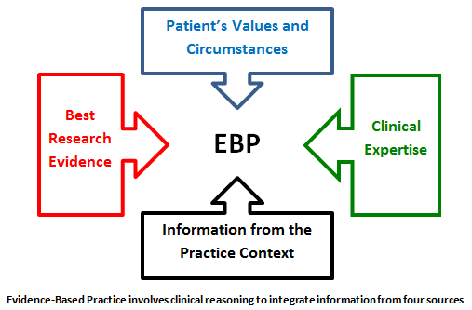
DEFINITION
• The conscientious, explicit and really apt use of contemporary exceptional evidence in making selections about the care of the man or woman patient.
• Integrating individual information with the great to be had outside medical proof from systematic research.
• to be had clinical knowledge with nursing know-how. This technique requires nurses to seriously verify relevant clinical statistics or research proof and to implement excessive great interventions for his or her nursing exercise.
• The Sicily announcement on evidence-based practice become posted in 2005, and it described EBP in a similar manner, albeit with mild changes to make it applicable in fields aside from just medical exercise. It states that selections concerning a affected person’s healthcare need to usually be taken on the premise of applicable, recent, and verified evidence.
• but, the affected person have to be supplied with the same evidence as properly before finalizing any plan of treatment. The proof and the nice feasible treatment paths ought to be simplified and defined to a affected person via concerned healthcare professionals in order that the patient can take an knowledgeable decision.
Want for evidence primarily based practice:
• For ensuring that every client get the great viable offerings.
• replace expertise
• offer scientific judgment
• development care provided and keep lives.
EBP is one useful approach to improving the impact of practice in nursing.
EBP put particular emphasis on the result of experimental comparisons.

Steps in EBP Process:

EBP allows the practitioner to assess current and past research, clinical guidelines and other
Information resources.
Steps in EBP Process are
- Formulating a well – built question
- Finding evidence
- Appraising the evidence
- Applying the evidence/ make clinical decision
- Re – evaluation.

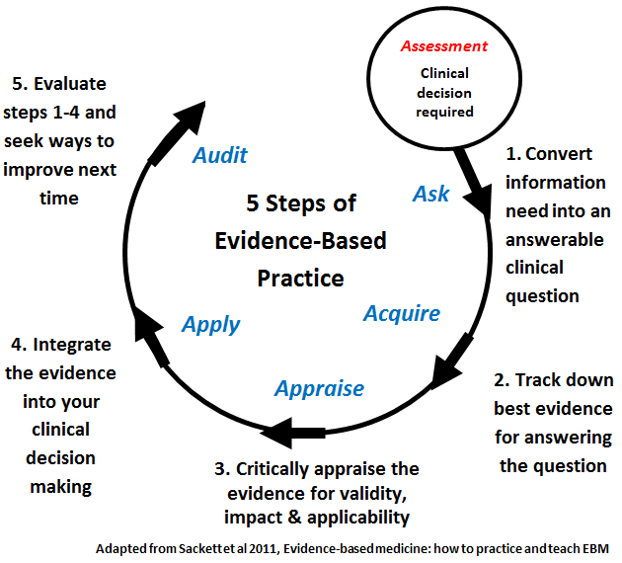
Purpose OF EBP
To do the right element, on the proper time, for the right individual, make certain first-rate care for the character consumer.
Wanted capabilities for EBP
• Observant and sensitive
• clinical competence. Expertise
• communication
• Learner
• Practitioner
• mastering abilities
• research in a position.
EBP PROCESS

Frame question
Select key words
Reevaluate access evidence

Evaluate evidence
Sources of EBP
• heritage information/professional opinion [Books]
• studies articles/ research [PubMed]
• proof pointers
• evidence summaries and abstracts
• Systematic reviews and meta analyses.

EBP IN NURSING
It have to be referred to that a protracted, long time earlier than evidence-based practice have become a field, Florence Nightingale had correctly used comparable thoughts to treat infantrymen in the course of the mid-1800s. of Path, EBP in nursing has come a long manner on account that then, but her work in later life is taken into consideration to have laid the foundations of modern nursing. These days, evidence-primarily based nursing training and practice middle around some broad steps, consisting of price status and guidance – regularly referred to as Step 0 in EBP, it entails establishing the significance, advantages, and price of following evidence-primarily based exercise inside the mind of nursing college students. Step zero is ready preparing them to embrace the Spirit of Inquiry. schooling in EBP – education nurses in EBP so they can advantage the knowledge and abilities required to correctly implement the field inpatient care.
PICOT – The five factors of creating a patient inquiry are known as PICOT in quick. The letters stand for:
• P – affected person/patients involved
• I – Intervention
• C – assessment
• O – outcome
• T – Time

PRINCIPLES OF EBP FOR PATIENT SAFETY
• First, consider the context and have interaction health care personnel who're on the factor of care in choosing and prioritizing affected person protection projects, sincerely speaking the evidence base (power and type) for the affected person protection practice subject matter(s) and the situations or putting to which it applies. Those conversation messages want to be carefully designed and focused to each stakeholder user organization.
• Second, illustrate, thru qualitative or quantitative records (e.G., close to misses, sentinel activities, negative activities, accidents from adverse events), the cause the company and people in the enterprise ought to decide to an proof-primarily based protection exercise topic. Clinicians tend to be more engaged in adopting affected person protection tasks once they recognize the evidence base of the exercise, in evaluation to directors announcing, “We must do that due to the fact it is an outside regulatory requirement.” as an example, it's miles essential to converse with busy clinicians approximately the evidence-based totally rationale for doing fall-hazard assessment, and to assist them remember that fall-chance assessment is an outside regulatory organization expectation because the power of the proof helps this patient protection exercise.
• Third, didactic training on my own is in no way sufficient to exchange practice; one-time training on a specific protection initiative isn't sufficient. Actually, enhancing expertise does no longer necessarily improve exercise. Instead, companies need to make investments in the equipment and talents needed to create a lifestyle of evidence-based totally patient protection practices in which questions are encouraged and systems are created to make it smooth to do the proper component.
• Fourth, the context of EBP upgrades in patient protection need to be addressed at every step of the implementation method; piloting the alternate in exercise is important to decide the match between the EBP patient protection records/innovation and the setting of care delivery. There may be nobody manner to enforce, and what works in one employer may additionally want modification to fit the organizational subculture of some other context.
• in the end, it is important to evaluate the tactics and results of implementation. Users and stakeholders want to recognise that the efforts to improve affected person protection have a advantageous impact on excellent of care. As an example, if a new barcoding machine is being used to manage blood products, it is imperative to know that the steps in the procedure are being followed (procedure indicators) and that the trade in practice is resulting in fewer blood product transfusion errors (final results indicators).
Advantages of EBP
- Provide better information to practitioner
- Enable consistency of care
- Better patient outcome
- Provide client focused care
- Structured process
- Increases confidence in decision – making
- Generalize information
- Contribute to science of nursing
- Provide guidelines for further research
- Help nurses to provide high quality patient care.
Disadvantages of EBP
- Not enough evidence for EBP
- Time consuming
- Reduced client choice
- Reduced professional judgment/ autonomy
- Suppress creativity
- Influence legal proceedings
- Publication bias.

Benefits OF EBP
EBP is the most effective logical method of formulating a remedy plan, as it's miles primarily based on scientific evidence and now not guesswork. If we had been to perceive the precise blessings which the field brought to healthcare, they would be as follows. Shape – EBP is a dependent, step-by-step system for finding the pleasant possible remedy and care plans for each affected person. The standardized protocols are evidence-based and established, so the very last remedy plan obviously has a higher hazard of achievement. Current and relevant – proof within the form of lab examination consequences and the brand new findings are backbones of EBP remedy and care. Opinion-based totally remedy plans are frequently advocated by senior experts, that is an outdated approach because it is able to not recollect the most current trends in clinical technological know-how.
The senior expert may additionally frequently forego the need for evidence in prefer of his/her expert opinion on the problem.
Multiplied accountability – most hospitals and clinics have now adopted a obvious, step-by way of-step, proof-primarily based method. As a end result, tracing duty to the responsible healthcare issuer is quite easy. This has created positive conditions for both the patient party and the healthcare issuer.
If a patient is not content material with the outcome of an proof-primarily based remedy plan, they could seek advice from their attorney and test for discrepancies among the steps that were purported to be taken based totally at the available evidence, and the stairs that were actually taken. At the equal time, if the clinician did comply with all standardized protocols of EBP, they are lots less likely to be sued by disgruntled patients.
Improved possibilities of high-quality results – when treatment and care plans are in entire sync with the modern day scientific records, patient alternatives, and sound actual-time proof, they're some distance much more likely to succeed. Inside the absence of evidence, it is better to attend, if this is an alternative. Uneducated guesswork can do more damage than true in maximum cases.
Customization – earlier than EBP, sufferers were no longer made privy to their personal remedy plans, which meant that that they had little to no say within the very last course of action. As we defined in the definition of proof-based practice itself, involving the patient is a crucial a part of the whole technique.
Hierarchy of evidence
• Systematic reviews and meta evaluation
• Randomized controlled trials with definitive results
• Randomized controlled trials with non definitive effects
• Cohort studies
• Case manage studies
• go- sectional research
• Case reviews.
Models of EBP in clinical setting
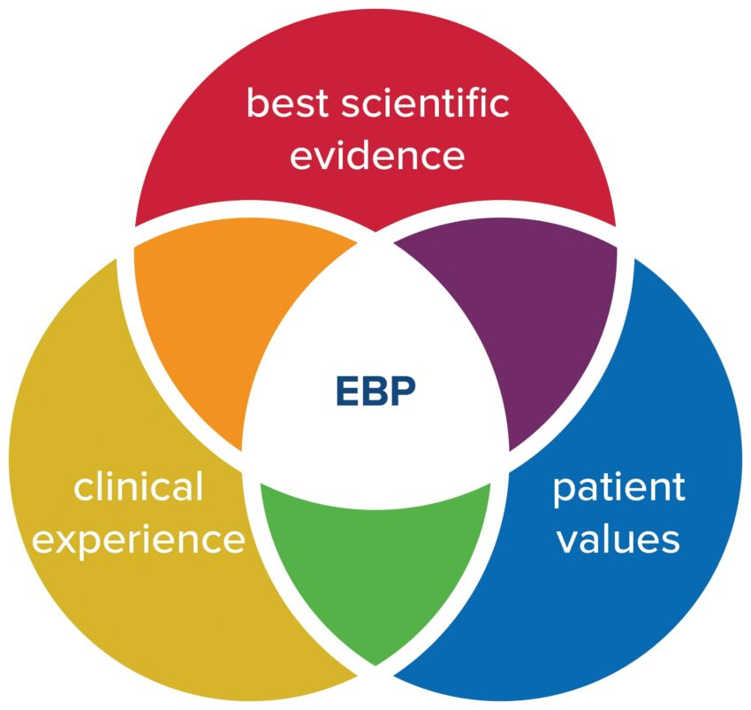
A = Clinical expertise
B= patient value
C=best evidence
John Hopkins nursing EBP model
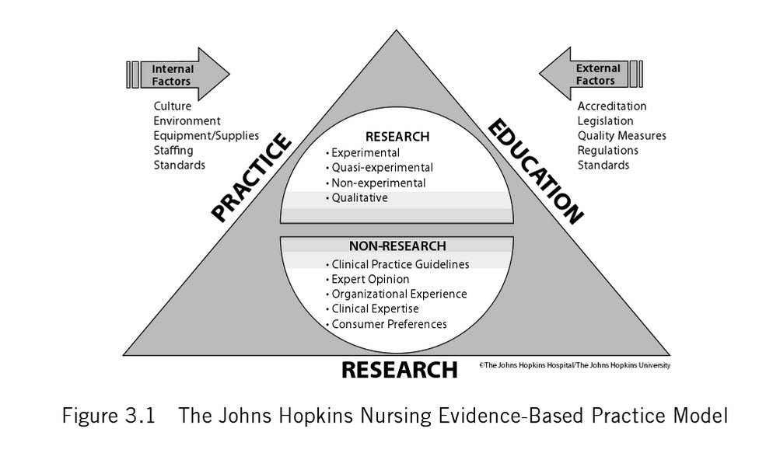
Expert opinion
- Research
- Patient experience
- Practitioner expertise
- Other evidence
Barriers in EBP
- Lack of value for research in practice
- Difficulty in bringing change
- Lack of administrative support
- Lack of knowledge mentors
- Lack of time for research
- Lack of knowledge about research
- Research reports not easily available
- Complexity of research reports
- Lack of knowledge about EBP.
Conclusion:
The purpose of accomplishing EBP is to utilize modern-day understanding and join it with affected person options and scientific expertise to standardize and improve care procedures and, in the long run, affected person results. Appeared as key selection makers within the healthcare group. They're also expected to apply the first-class available evidence in their judgments and choices. The prescriptive model of evidence-primarily based decision making and the quest-appraise- put into effect technique that accompanies it's far an energetic technique. Proof-based totally exercise has won momentum in nursing, and definitions range extensively. Studies findings, expertise from fundamental technology, clinical information, and professional opinion are all considered "proof"; however, practices based totally on research findings are much more likely to result in the preferred affected person effects across numerous settings and geographic places. Proof-primarily based practice needs adjustments in education of college students, greater exercise-applicable studies, and closer working relationships between clinicians and researchers. Proof-based exercise additionally gives possibilities for nursing care to be greater individualized, more effective, streamlined, and dynamic, and to maximise effects of clinical judgment. Whilst proof is used to define best practices rather than to guide current practices, nursing care continues tempo with the today's technological advances and takes advantage of recent understanding tendencies.
References
- Constance 1 Milton. Evidence-based practice: Ethical question for nursing. Nursing science quarterly 2007 20 (2):123-26.
- Diane s.pravikoff, susan T pierce,annelle tanner. Evidence-based practice: readiness study supported by academy nursing informatics experts panel nursing outlook 2003; 53(1): 49-50
- Katheleen s,oman,Christine duran,Regina Fink. Evidence-based policy and procedures: An Algorithm for success. The journal of nursing administrations 200;38(1):47-51.
- Makhija Neelam. Application and utilization of Research in Practice: Evidence-based practice.Nursing Nightingale Times 2007:18-20.
- Marianne Matzo evidence for Excellence, American Journal of Nursing 2008:108(8):73-74.
- Polit Denise F,Beck Cheryl Tatano. Nursing Research principal and Methods: utilizing Research : Putting Research Evidence into Nursing practice, 7th edition. Lippincott Williams and Wilkins 2008;673-99.
- http://localhost/f: /Evidence-based practice:.mht
- http://localhost/f:/ implementing Evidence-based practice-Evidence-based practice:.mht

