International Quality Standards: Prospects and Challenges
Of Indian Agro-Food Processing Industry
Dharavath Poolsingh^{1*}
¹Department of Applied Agriculture, Central University of Punjab, Bathinda, Punjab State-151401, India. poolsingh987@gmail.com
Introduction
Next to China, India is the second-largest food producer in the world, with the potential to overtake it. The largest consumption category in India is food and food items, which account for about 21% of the country's GDP.. The Indian domestic food market is expected to grow by nearly 40% of the current market size by 2025 (World of Food India, 2011; Merchant, 2008). India’s agricultural base is quite strong but wastage is very high and processing of food products is very low. While processing of food to consumable standards are at levels of up to 80% in some developed countries, the overall processing level in India has recently reached 10%. Therefore, India’s food processing sector comparatively is small and its share in exports of processed food in world trade has remained at about 1.5 percent.
The agro food processing industry is one of the largest in India, employs around 18% of the country’s industrial work force and is ranked fifth in terms of production, consumption, export and expected growth (Merchant, 2008). India also produces a variety of temperate to tropical fruits, vegetables and other food products. Processing of food products plays an important role in the conservation and effective utilization of fruits and vegetables. India’s strong agricultural base, variety of climatic zones and accelerating economic growth holds significant potential for food processing industry that provides a strong link between agriculture and consumers. In this paper I am going to examine the challenges and the prospectus of agro food processing industries in India.
Quality Control & Standards
Food processing industries cover a large spectrum of products of plant and animal origin. Quality has got to be maintained for domestic as well as export markets. In this respect, a number of organizations have come up for the formulation of standards and for monitoring their quality. These can be classified into two groups; a) compulsory legislation and b) voluntary standards.
Bureau of Indian Standards (BIS)
The activities of BIS in the field of agro-processing are two fold: a) formulation of Indian standards and b) their implementation through its voluntary and third party certification system.
1BIS has on its record over 700 Indian Standards related to food-grains and their products. These standards, in general, cover raw materials permitted and their quality parameters, hygienic conditions under which the product is manufactured and packaging and labelling requirements. The standards also prescribe, where required, freedom from toxic substances and contaminants. To ensure that processed foods are free from pathogenic or spoilage micro-organism, limits are gradually being introduced in various specifications.
Gatt and Sanitary/Phytosanitary Measures
The Sanitary and Phytosanitary Measures Agreement (SPS Agreement), which was finalised under the GATT in 1994, went into force in 1995 and is responsible for creating international standards to guarantee consumer food safety and stop the spread of pests and illnesses in animals and plants. These measures protect human/animal life from risks arising from additive contaminants, toxins or diseases – causing organisms in their food. The objectives of SPS can be accomplished in several ways as indicated below.
1. Requiring product to come from a disease free area
2. Inspection of products
3. Specific treatment of processing of products
4. Setting allowable maximum levels of pesticide residues or permitting the uses of only certain additives in food
International Quality Standards
Once a company has gone through the effort of making its processes capable, it must document its level of quality so as to better market its services or products. This documentation of quality is especially important in international trade. However, if each country had its own set of standards, companies selling in international markets would have difficulty complying with quality documentation standards in each country where they did business. To overcome this problem, the International Organization for Standardization devised a family of standards called ISO 9000 for companies doing business in the European Union. Subsequently, ISO 14000 was devised for environmental management systems and ISO 26000 for guidance on social responsibility.
The ISO 9001:2008 ISO 9001:2008 is the latest update of the ISO 9000 standards governing documentation of a quality program. The ISO 9001:2008 standards for quality management, according to the International Organisation for Standardisation, address quality management by defining what the company does to satisfy the customer's quality requirements and applicable regulatory requirements, while aiming to increase customer satisfaction and achieve continual performance improvement in pursuit of these objectives. Once certified, companies are listed in a directory so that potential customers can see which companies are certified and to what level. Compliance with ISO 9001:2008 standards says nothing about the actual quality of a product. Rather, it indicates to customers that companies can provide documentation to support whatever claims they make about quality. As of 2009, more than 1 million organizations worldwide have been certified in the ISO 9000.
The ISO 140001:2004 (Environmental Management System) The International Organisation for Standardisation claims that the ISO 140001:2004 family of standards addresses environmental management by outlining what the company does to reduce any negative environmental effects caused by its operations and to continuously improve its environmental performance.(Bailey & Communications, 2021). The documentation standards require participating companies to keep track of their raw materials use and their generation, treatment, and disposal of hazardous wastes. Although not specifying what each company is allowed to emit, the standards require companies to prepare a plan for ongoing improvement in their environmental performance.
ISO 140001:2004 covers the following areas:
- Environmental Management System: Requires a plan to improve performance in resource use and pollutant output.
- Environmental Performance Evaluation: Specifies guidelines for the certification of companies.
- Environmental Labeling: Defines terms such as recyclable, energy efficient, and safe for the ozone layer.
- Life-Cycle Assessment: Evaluates the lifetime environmental impact from the manufacture, use, and disposal of a product.
Structure and Composition of Indian Food Processing Industry
The food processing or food manufacturing industry includes companies that transform livestock and agricultural products into products used for intermediate or final consumption. Processed foods are products in which a raw commodity is transformed into a processed product regardless of whether the amount of processing is minor, such as canned fruit, or more complex, such as snack foods. By applying a variety of processes, such as grading, sorting, packaging, etc., the agricultural or horticultural produce gains value during food processing. which enhance the shelf life of food products. A country's overall economic structure is significantly influenced by its strong and vibrant food processing sector. (Bharti and Rajesh Dahiya, 2023) . The sector provides vital linkages and synergies between industry and agriculture and has been identified as a sector having immediate potential for growth of the economy. Processing also helps in generating rural employment, additionally processed fruits and vegetables are a source of earning foreign exchange. The extent of processing in India can be categorized as follows:
Primary Processing: cleaning, grading, powdering and refining of agricultural produce, e.g., grinding wheat into flour.
Secondary Processing: basic value addition, e.g., tomato-puree, ground coffee, processing of meat products.
Tertiary Processing: high value addition products like jams, sauces, biscuits and other bakery products ready for consumption.
In India, the food processing industry is significant and includes industries like agriculture, horticulture, plantations, animal husbandry, and fisheries. It also includes other sectors that produce edible goods using agricultural inputs. The Indian government's Ministry of Food Processing separates the market into the following six segments:
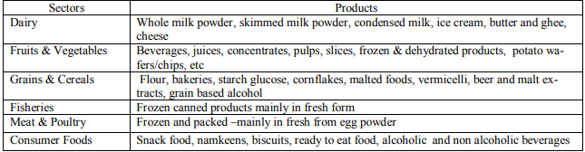
Although the Indian food processing business is enormous, its development is still in its infancy. Only 2% of the nation's entire agricultural and food production is processed. The food processing sector generated 6% of all industrial production and contributed 9% to India's GDP. By the end of 2025, the value addition of food items is anticipated to rise from the current 8% to 35%. Fruit and vegetable processing, which accounts for about 2% of total production at the moment, is anticipated to reach 25% by 2025. India’s processing industry is highly fragmented and is dominated by the unorganized sector. A number of players in this industry are small. About 42% of the output comes from the unorganized sector, 25% from the organized sector and the rest from small scale players. Though the unorganized segment varies across categories but approximately 75 percent of the market is still in this segment. The organized sector is relatively bigger in the secondary processing segment than the primary processing segment. The primary processing segment is also highly fragmented. Primary food processing is a major industry with a highly fragmented structure that includes hundreds of thousands of rice mills and hullers, flour mills and oil seeds mills, several thousands of traditional bakeries; food units and fruits, vegetable and spice processing units in the unorganized sector. The most common type of food processing units that form the organized sector are flour mills, fish processing units, fruits and vegetables processing units, meat processing units, non-alcoholic and aerated drinks units, sugar units (mills) and modernized rice mills. While India’s agricultural production base is quite strong, the food processing industry is still under developing stage. The highest share of the processed food is in the dairy sector, where
37 percent of total produce is processed, of which only 15% is processed by the organized sector. The processing level is around 2.2 percent in fruits and vegetables, 21% in meat and 6% in poultry products. Of the 2.2% processing in fruits and vegetables only 48% is in organized sector remaining in unorganized sector(Service, n.d.) .

(Source: Ministry of Food Processing Industries, Annual Report, 2014-15)

Factors Affecting Food Processing Industry in India

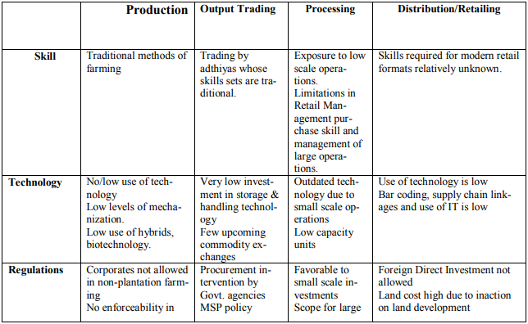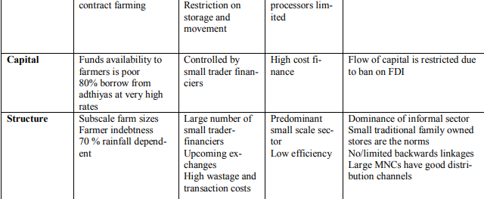
Major Constrains in the Development Path of Food Processing Sector
Like other sectors of the economy food processing sector also suffers from certain constraints. After studying various reports from different government and non government organizations following constrains has been identified that need immediate attention to smoothen the growth path of the sector.
- Inadequate infrastructural facilities: Indian food industry suffers from inadequate infrastructural facilities. Though on policy papers there have been various programmes to provide infrastructural facilities to the sector. Indian food industry has along and fragmented supply chain. The last mile connectivity is still missing from the supply chains. This is evident from the fact that transportation losses constitute the major part of the losses that is suffered by the food industry. The study conducted by MOFPI in 2010 has estimated harvest and postharvest losses of major agricultural produces at national level to be of the order of Rs. 44,143 crore per annum at 2009 wholesale prices. (MOFPI, Government of India, 2015)
- Lack of skilled and trained manpower: Though the food processing industry is major employer, but still it suffer from shortage of skilled and semi-skilled man power. This has become a critical constrain in the development path of the sector. Today the need of the sector is not only limited to supply chain, but has extended to value chain management. This requires skilled and semi skilled manpower.
- Quality of Raw Materials: This is a well known fact that India is the second largest food producer in the world. Thus giving a huge base of raw materials to the food processing industry, still the quality of the products received by the industry is not up to the world standard. (FICCI, 2010) Hence a major part of the produce could not be exported, and has to be sold at lower value in the domestic market. Not all varieties that are cultivated in India are fit for processing; there is a lack of processable varieties in India.
- Seasonal Availability of raw materials: Indian agriculture is a gamble of monsoon. There always exists an uncertainty in the crop production. Apart from this the raw materials, especially fruits and vegetables are not available throughout the year, this proves to be a major hurdle in the growth of the industry.
Other than the above mentioned constraints, there are certain other constraints which need attention from various stakeholders of the processed food industry, they are:
- Lack of consumer education on nutritional importance of processed food.
- Pricing and Taxation in Indian processed food market is not at par with that of other developed and developing nations, thus making it less competitive in the global market.
- With the entrance of MNCs into the domestic market, domestic producers face a much higher competition in the domestic market in terms of price as well as the quality and standard.
- The promotion strategy adopted by the MNCs is highly intensive that it shadows the domestic products.
With the fast changing technologies the requirements of better technology are also changing, but the actual situation is that research and development could not make pace with the demand of the sector. This is emerging as a big threat for the sector.
SWOT Analysis of Agro-Processing Industry Infrastructure in India
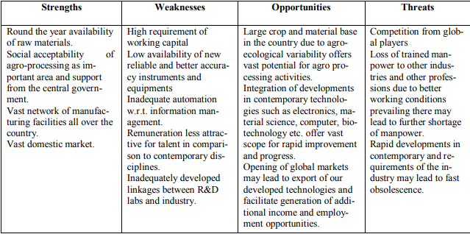International issues
• Environmental management systems
• Occupational health & safety
• Regulated industries
– medical devices
– pharmaceutical
– health care
• Sector-specific applications
– automotive (QS-9000 and TS-16949)
– aerospace (AS-9000 / AS-9100)
– telecommunications (TL-9000)
Why International Standards
- They promote trade and cooperation
- Product standards allow consumers to purchase items from different manufacturers and know those items will perform equally
- Management system standards promote common approaches to managing quality and the environment. They promote dependability and a consistent use of statistics
ISO 9000 Series | ISO 10000 Series | New ISO 9001:2000 | The Grand Vision: 2000
ISO 9000 Helps companies determine which standard of ISO 9001, 9002, and 9003 applies | ISO-10011 Quality system auditing guide | Quality management system - Put structure in what you do | 9000-Fundamentals and Vocabulary
ISO 9001 Outlines guidelines for companies that engaged in design, development, production, installation, and servicing of products or service | ISO 10013 Quality manual development guide | Management responsibility - Put someone in charge | 9001 Requirements
ISO 9002 Similar to 9001, but excludes companies engaged in design and development |  | Resource management - Provide the resources to achieve goals | 9004 Guidelines for Performance Improvements
ISO 9003 Covers companies engaged in final inspection and testing |  | Product realization - Design and make it to requirements | 10012 Measurement Control
 |  | Measurement, analysis and improvement - Know where you are and get better | 19011 QMS/EMS Auditing

Conclusion
Though there are many promising dynamics which support good growth of this industry, there are still some significant constraints which, if not addressed sooner, can impede the growth prospects of the Food Processing Industry in India. One of the biggest constraints is that this industry is capital intensive. It creates a strong entry barrier and allows limited number of players to enter the market. Players mean competition which reduces efforts to improve quality standards. Major challenges faced by the Indian food processing industry include: educating consumers that processed foods can be more nutritious; dealing with low price elasticity for processed food products; need for distribution network; development of marketing channels; streamlining of food laws; improving food quality standards and strengthening food testing network; strengthening institutional framework to develop manpower for improving R&D capabilities to address global challenges. These challenges must be addressed to achieve full potential of the Indian food processing industry.

References:
Bailey, R., & Communications, L. S. (2021). Upcoming Webinar on May 24 th : Disaster Recovery and Control Room Management with Matrox Video.
Bharti and Rajesh Dahiya. (2023). Home / International Journal of Education and Management Studies / Volume 11, 2021 / Issue 2, June / Perception of rural women towards RKVY Trainings on post-harvest interventions and value addition. 2023.
Service, E. W. (n.d.). Modern food processing has three major aims :
Mohammad Zia. “Prospects and Problems of Food Processing Sector in India: In the Light of Make in India Initiative.” Sept. 2016, www.researchgate.net/publication/299579043_Prospects_and_Problems_of_Food_Processing_SBailey, R., & Communications, L. S. (2021). Upcoming Webinar on May 24 th : Disaster Recovery and Control Room Management with Matrox Video.
Bharti and Rajesh Dahiya. (2023). Home / International Journal of Education and Management Studies / Volume 11, 2021 / Issue 2, June / Perception of rural women towards RKVY Trainings on post-harvest interventions and value addition. 2023.
Service, E. W. (n.d.). Modern food processing has three major aims :
ector_in_India_In_the_Light_of_Make_in_India_Initiative.
Kachru, R P. “Agro-Processing Industries in India—Growth, Status and Prospects.” pdfs.www.semanticscholar.org/e7ae/6958f6c7d4f4cccf46d31f82d515f777df19.pdf.
Website:
- Wanted Distributors for Food & Beverage Products in India ~ Take Distributorship
- About Us - 8th Annual INNOPACK F&B 2020 CONFEX (innopackfood.com)
- Wanted Distributors for Food & Beverage Products in India ~ Take Distributorship

