A STUDY OF CANCER, DIFFERENT STAGES AND THERAPEUTIC DEVICE – REVIEW

Mrs.K.Kiruthika  Assistant Professor  Department of Biomedical Engineering  Hindusthan College of Engineering and Technology  Coimbatore  India  krithika.bme@hicet.ac.in | Mrs.S.Shobha Christila  Assistant Professor  Department of Biomedical Engineering  Hindusthan College of Engineering and Technology  Coimbatore  India  christilashobha@gmail.com | Dr.S.Saravana Sundaram  Professor and Head  Department of Biomedical Engineering  Hindusthan college of  engineering and technology  Coimbatore  India  bmehod@hicet.ac.in | Dr.N.Nandha kumar  Proprietor, Prime, ,Biomedical Systems,  Coimabtore.  nnandaprime@gmail.com

Abstract
Biomedical devices play an important role in the process of diagnosing the diseases and helpful for better and appropriate treatment to the patients by the Medical Professionals. The 21st century is rightfully called the Biological and biomedical device century. More technological breakthroughs in the medical and industrial spheres are expected with heavily funded research programs underway in most of the countries in the world. Development in the field of biomedical engineering research to innovation more medical devices, have led to critical changes in many industrial segments and strengthened the medical engineering occupation. Although the conventional areas of engineering and other technology innovations will extend, more new openings will arise in biomedical engineering and in the fields of biology, medicine, health and medical equipment’s. The purpose of this study is aware about the cancer, different stages and therapeutic methods.
Key Words: Cancer Types, Brest Cancer, Prostate Cancer, Laser therapy.
Introduction
Cancer
Cancer is a disease that develops when cells in human or veterinary body divide at a faster rate than normal. These abnormal cells grow into a lump or tumour.Cancer is a common disease that can affect almost every part of your body. About 39.5% of all people will be diagnosed with cancer at some point in their lives.Cancer occurs when your genes stop controlling the way your cells divide. For example, instead of old cells dying, they grow and form abnormal cells.Cancer is potentially fatal. Currently, it’s the leading cause of death worldwide. However, fatality rates largely depend on the type of cancer and how far it has spread. Many types of cancer are successfully treated with prompt care.When cancer cells develop, they can disturb proper organ function. This can result in reduced oxygen supply and a build-up of waste products. If vital organ function is impaired, it can lead to death.

Cancer Types
Anal Cancer, Appendix Cancer, Bile Duct Cancer, Bladder Cancer, Bone Cancer, Breast Cancer, Cervical Cancer, Childhood Cancers, Colorectal Cancer, Esophageal Cancer, Eye Cancer, Fallopian Tube Cancer, Gallbladder Cancer, Head and Neck Cancer, Kidney Cancer, Liver Cancer, Lung Cancer, Male Breast Cancer, Metastatic Cancer, Mouth Cancer, Nasal Cavity and Para nasal Sinus Cancer, Nasopharyngeal Cancer, Oral Cancer, Ovarian Cancer, Pancreatic Cancer, Parathyroid Cancer, Penile Cancer, Pharyngeal Cancer, Pregnancy and Breast Cancer, Primary Peritoneal Cancer, Prostate Cancer, Rectal Cancer, Recurrent Cancer, Salivary Gland Cancer, Skin Cancer, Small Cell Lung Cancer, Small Intestine Cancer, Stomach (Gastric) Cancer, Testicular Cancer, Throat Cancer, Thyroid Cancer, Urethral Cancer, Uterine Cancer, Vaginal Cancer, Vulvar Cancer.

Stages of Cancer
Most cancers have four stages. The specific stage is determined by a few different factors, including the size and location of the tumour:
Stage I: Cancer is localized to a small area and hasn’t spread to lymph nodes or other tissues.
Stage II: Cancer has grown, but it hasn’t spread.
Stage III: Cancer has grown larger and has possibly spread to lymph nodes or other tissues.
Stage IV: Cancer has spread to other organs or areas of your body. This stage is also referred to as metastatic or advanced cancer.
Though stages I through IV are the most common, there is also stage zero. This earliest phase describes cancer that is still localized to the area in which it started. Cancers that are still in stage zero are usually easily treatable and are considered pre-cancerous by most healthcare providers.

Breast cancer
Breast cancer stage 0
Breast cancer stage 0, also called carcinoma in situ, is the earliest stage of breast cancer. It is non-invasive and no indication that the tumour cells have spread to other part of the breast or parts of the body. During the self-exam, there may be a lump that can be felt and you may not feel other symptoms.

There are 2 types of breast cancer stage 0.

Ductal carinoma in situ (DCIS)
Breast cancer cells develop in the breast ducts, that is called ductal carcinoma in situs(DCIS). The routine mammogram screening helps diagnose it more often now. DCIS can become invasive, so it is really important to take treatment as soon as possible.

Lobular carcinoma in situ (LCIS)
Abnormal cells develop in the lobules, that is called lobular carcinoma in situ (LCIS). These cells are not cancerous and this condition rarely becomes invasive cancer but it may be at increased risk for developing breast cancer in the future. The risk of getting an invasive cancer is 20-25percent over 15 years after the initial diagnosis.

Many breast cancers stage 0 patients do not require treatment. When we do, the treatment generally is very successful.

Surgery (modified radical mastectomy & breast reconstruction)
Open surgery is the most common treatment for breast cancer patients. Breast cancer stage 2 is the early stage cancer and open surgery can remove the tumour and have a good prognosis. However, the worst thing is a part of the breast or the entire breast also will be removed. In Modern Cancer Hospital Guangzhou, the surgeon removes the breast and carefully dissects the underarm lymph node but no muscles are removed from beneath the breast so that doctor can reconstruct the breast and keep an original shape as if it is not be removed. If you do not want to take open surgery, there are other options for the breast cancer treatment stage 3, see as followed.

Green chemotherapy
Green chemotherapy is a new type of chemotherapy which is different from the intravenous chemotherapy. Intravenous chemotherapy can cause the side effects. In accordance with human biological clock, anticancer drugs will be given when tumour cells are actively and believed to be most susceptible while normal cells inactive. In this way, minimal dose of medicine can achieve best effects with lowest side effects to the body.

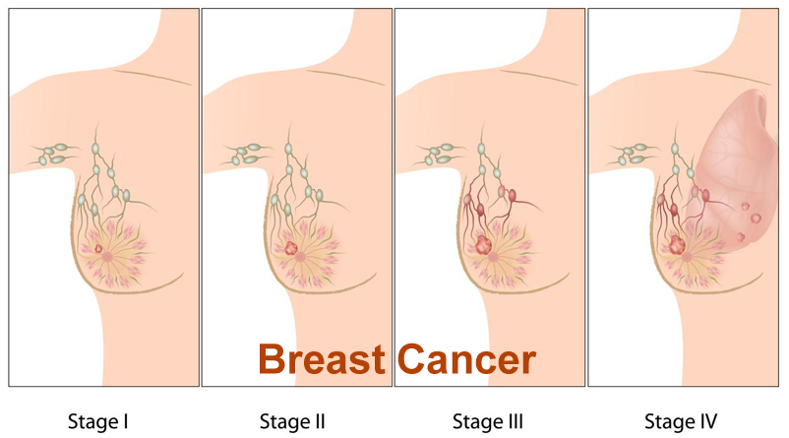
Fig 1: Stages of Breast Cancer

Prostate Cancer
Treatments Related to Various Stages of Prostate Cancer
Prostate cancer is a form of cancer that grows in the prostate, a gland in the male reproductive system. Prostate cancer is most common in the developed world with cumulative rates in the developing world and it is the sixth leading cause of cancer among men globally.

Based on the three factors such as TNM stage, PSA and Gleason score, the patients are classified into high, intermediate and low risk groups. The low risk patients are usually treated with radical prostatectomy or radiotherapy alone.

Patients who are classified in intermediate risk disease are usually treated with radiotherapy and a short duration (less than 6 months) of hormonal therapy. It depends upon surgeon’s decision to prefer for robotic radical prostatectomy or not. Although the role of surgery in these patients remain uncertain, and the patient with high risk disease are usually treated with radiotherapy and a long duration of hormonal ablation. Many high risk patients are not cured by this treatment.

Stages of Prostate Cancer Using TNM System:
Prostate cancer is staged using the TNM system. This is used all over the world. It separately assesses the tumor (T), lymph nodes (N) and secondary cancer (metastases – M).

T – For tumor — describes the size of the main area of prostate cancer.
N – For nodes — describes whether cancer has spread to any lymph nodes and to what extent.
M – For metastasis — means distant spread of prostate, for example, to the bones or liver.

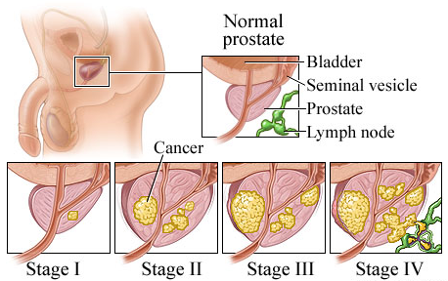

Fig 2: Stages of Prostate Cancer

There are four Stages of Prostate Cancer that we have discussed it below. Following are the different Stages along with their treatments.

Stage I
In stage I, cancer is found in the prostate only. The cancer is found by needle biopsy or in a small amount of tissue during surgery for other reasons (such as benign prostatic hyperplasia). The PSA level is lower than 10 and the Gleason score is 6 or lower. It is found in one-half or less of one lobe of the prostate. It cannot be felt during a digital rectal exam and is not visible by imaging. They usually grows very slowly and do not show any symptoms at the early stage. The cancer is very small and completely inside the prostate gland, which feels normal during a rectal examination.

Treatment:
- Surgery to remove the prostate gland (called radical prostatectomy). Since it is too small, surgery is not preferred at this stage.
- Watchful Waiting or Active Surveillance. In this therapy, the doctors closely watch the tumor to see if it causes any symptoms or it appears to be growing. Common test such as PSA is usually done in this method.
- Radiation Therapy: It uses high frequency x-ray beam to kill prostate cancer cells or to refrain them from being divided and grow rapidly.

Stage II
In stage II, cancer is more advanced than in stage I, but has not spread outside the prostate. If it is not treated then it is likely to spread outside of prostate. If the patient is so elder or having more complex diseases or after watchful waiting there are no any significant increase in growth of cancer tumor, then in such cases

Radical Prostatectomy and Radiation Therapy are the preferred options. Stage II is divided into stage IIA and stage IIB.

In stage IIA, cancer:
The PSA level is lower than 20 but higher than 10 and the Gleason score is 6-7. It is found by needle biopsy or in a small amount of tissue during surgery for other reasons.

In stage IIB, cancer:
Such cancer is found in opposite sides of the prostate. The PSA can be any level and the Gleason score can range from 2 to 10. In some cases, the tumor has not spread outside the prostate and such tumors cannot be felt during a digital rectal exam and not visible by imaging. In such cases, the PSA level is 20 or higher and the Gleason score can range from 2 to 10.

Treatment:
- Radiation therapy with ADT
- Hormone Therapy: It is used to stop the production of testosterone and all androgens either temporarily or permanently. Prostate cancer grows when it is exposed in presence of testosterone, so this therapy is used to stop its production.
- Radical prostatectomy and sometimes proceeded by hormonal therapy. In some cases the lymph nodes are removed.
- Brachytherapy and external beam radiation combine. The radiation theraphy also includes follow up of hormone therapy.

Stage III
In this stage, the cancerous cell has significant growth. Cancer tumor has spread beyond the prostate gland but not has reached to bladder, lymph nodes, rectum or any other organs. Some times for elders doctors prefer to go for watchful waiting stage. This is preferred only if patient is having many sever complications or other illness.

The PSA can be any level and the Gleason score can range from 2 to 10.

Treatment:
- External beam radiation plus hormone therapy
- Radical prostatectomy in selected cases. Many times pelvic lymph nodes are also removed. Radiation therapy may be followed after this surgery.
- In some cased only hormone therapy is preferred.

Stage IV
This is the final stage of the cancer and usually it is not curable. It has grown into the bladder or rectum, or has spread to the lymph nodes or another part of the body. It may spread to the bones, liver or lungs type of distant places. In this case, removing any part of the body will not solve the problem. It is preferred to wait and watch for the elder person.

Treatment:

- Hormone therapy
- Chemotherapy
- External beam radiation plus hormone therapy (in selected cases)
- Surgery such as TURP which helps in reducing symptoms such as bleeding
- Some reliving treatments are also done to reduce symptoms such as bone pain.

New laser technique could be used to treat cancer

A new laser technique which uses intense beams of atomic nuclei such as carbon could now be used to accurately target tumour cells in cancer patients that are resistant to other methods such as radiotherapy.
Researchers have discovered an improved method for creating carbon beams which involve the use of extremely short pulses which are then aimed at ultrathin targets. The new method is expected to deliver the dose of radiation over a much shorter period in comparison to more traditional techniques such as radiotherapy and x-rays, which release radiation to the tumour over several minutes. This has also been proven to reduce the damage to healthy cells around the tumour due to a more targeted approach. A current, promising development in radiotherapy is the ‘FLASH’ approach where radiation is delivered in short, intense bursts. This leads to reduced side effects and potentially more effective treatment. There is therefore great interest in investigating the response of human cells, healthy and cancerous, after exposure to ultrafast ion irradiation.

Currently this process has not been tested on ions larger than protons, despite heavier ions like carbon nuclei being very effective against various tumour types. The laser works by rapidly accelerating ions at an ultrathin target. The pulse then vaporises the material and creates plasma of charged particles that the laser then accelerated on the far side of the target. Aodhan McIlvenny of Queen’s University Belfast and his colleagues have found that a careful choice of the target thickness is vital to the success of the new technique. Using the GEMINI laser at the Rutherford Appleton Laboratory in the UK, the researchers directed 40-femtosecond laser pulses onto targets of amorphous carbon, which contains hydrogen on its surface as a contaminant. Using targets ranging in thickness from 2 to 100 nanometers, the team focused the laser onto a spot roughly 3 micrometers in diameter. The plasma created in this material contains two species of ions—bare carbon nuclei and protons—which the team detected downstream.

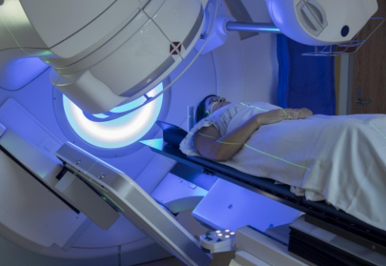
Fig 3: Laser Technique for cancer treatment

Further tests showed that a thinner target produces more energetic ions as the laser has a smaller mass of ions to accelerate but if the target is too thin there is a risk of the laser passing through with no radiation pressure. The researchers involved in the finding of the new technique which could be used on cancer patients in the future have said they hope they can refine the methods so that it can become a more efficient cancer treatment. Plasma physicist at the University of York says: ‘This is an exciting result, typically, everything we try to accelerate is contaminated with hydrocarbons. But this research demonstrates a way to remove the hydrogen from the target.

CONCLUSION

Recent advancements in cancer medical researches are resulting in less invasive, more precise, more successful cancer treatments. With ongoing efforts to design new radiation treatment modalities and techniques that continue to improve the survival and quality of life of cancer patients, radiation remains a crucial modality for the treatment of cancer. Radiation therapy-related toxicities have gained attention due to the improved clinical outcomes of cancer treatment. Through the use of dose fractionation and conformal radiation techniques, the sparing of healthy cells and tissues has improved with the emergence of mechanistic biological studies and advancements in radiation technology. To further increase the therapeutic ratio of the radiation treatment, radiation is also given in conjunction with molecular targeted therapy.

REFERENCES

- Byrne JD, Betancourt T, Brannon-Peppas L, et al. Active targeting schemes for nanoparticle systems in cancer therapeutics. Advanced Drug Delivery Rev. 2008;60(15):1615–1626. doi: 10.1016/j.addr.2008.08.005
- Kesharwani P, Jain K, Jain NK. Dendrimer as nanocarrier for drug delivery. Prog Polym Sci. 2014;39(2):268–307. doi: 10.1016/j.progpolymsci.2013.07.005.
- Bernier J, Hall EJ, Giaccia A. Radiation oncology: a century of achievements. Nature. 2004;4:737–747.
- Hanahan D, Weinberg RA. Hallmarks of cancer: the next generation. Cell. 2011;44:646–674.
- Yanovsky, R. L., Bartenstein, D. W., Rogers, G. S., Isakoff, S. J., and Chen, S. T. (2019). Photodynamic Therapy for Solid Tumors: A Review of the Literature. Photodermatol. Photoimmunol Photomed. 35 (5), 295–303. doi:10.1111/phpp.12489
- Wieder, M. E., Hone, D. C., Cook, M. J., Handsley, M. M., Gavrilovic, J., and Russell, D. A. (2006). Intracellular Photodynamic Therapy with Photosensitizer-Nanoparticle Conjugates: Cancer Therapy Using a 'Trojan Horse'. Photochem. Photobiol. Sci. 5 (8), 727–734. doi:10.1039/b602830

