The Creation & Execution of an Intelligent Grid
“SMART GRID”

¹Lidia Shanti Singavarapu, Department of Electrical Power & Energy Systems, Teesside University, Middlesbrough, United Kingdom. Email ID: shantisingavarapu@gmail.com
²Shadab Ahmad, Department of Electrical and Computer Engineering department, Samara University, Ethiopia. Email ID: shadab051@gmail.com

Introduction:
The average global temperature has risen by 0.74 degrees Celsius during the last century, causing a variety of environmental challenges such as climate change and rising sea levels.
Green energy is energy that is renewable and may be generated indefinitely by nature through sunlight, tide, rain, and wind. Humans consume 19.35% of it, with electricity consuming 24% of the above Eco-Friendly energy. In recent years, people have become increasingly reliant on fossil fuels and non-renewable energy sources. Energy demands have considerably increased investment in its utilization. According to a poll, 45% of the world's population has invested in such sustainable energy. Renewable energy, such as coal or oil, will be in short supply, according to projected data.
Furthermore, the tremendous increase followed by the Industrial Revolution is the primary reason that fossil fuels are rapidly depleting. As a result, smart grid technology for sustainable growth is continuing to emerge, and numerous academics worldwide have conducted various relevant research endeavors.
By 2025, renewable energy will power most new power plants. Among those resources, sun energy is the primary year-round source. Solar energy is employed in almost every industry, including home automation, medical, transportation, and power generation. Although this energy can be used directly in some applications, photovoltaic (PV) cells are the most common way to use it. As a result, human is no longer able to rely on renewable energy. However, as the value of fossil fuels drops, humans and businesses will need to rely more on and control green energy to meet their electrical needs.
According to a world population studies, the human population could reach 8.5 billion by 2030. It could reach 9.7 billion by 2050. Demand for energy management and green power solutions has skyrocketed. The current power grid technology cannot fulfil such large needs. These requirements are crucial for the evolution of an innovative solution such as Smart Grid (SG). Electrical power is one of the most important infrastructure components for a country's rapid economic development. The increased economic growth is putting great strain on the economy. Rapid economic growth has put severe strain on current generating, transmission, and distribution systems, which are unable to meet expanding demand.

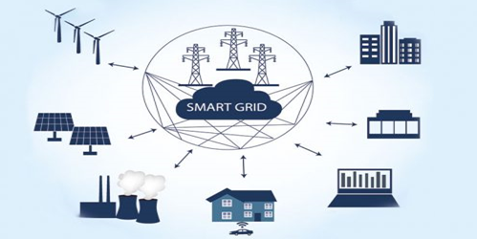
Figure 1: Smart Grid system
The establishment and inclusion of an increasing number of electric power generating units with growing capacity to satisfy rising demand has an adverse effect on the natural world; thus, effective handling of energy is critical.

Goal of the Eco Friendly Town:

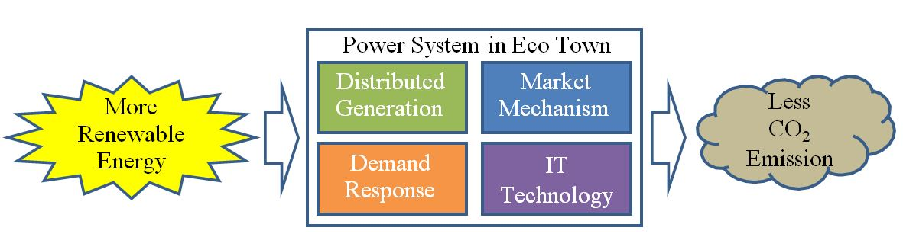

Figure 2: Power System in a Sustainable Society

Five essential power system functions will be implemented by the smart grid in an eco-town:
- Ecology
- Stability
- Adaptability
- Accessibility
- Scaling
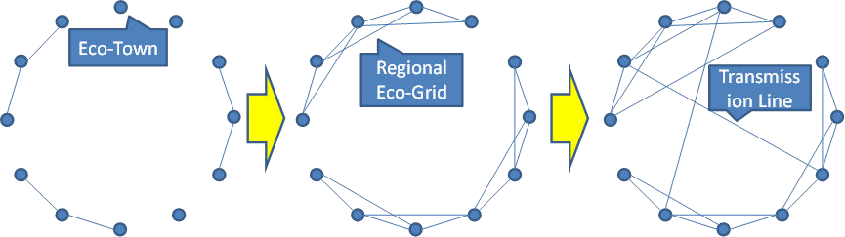
- Ecological practices include preventing climate change, utilizing fossil fuels sparingly, and conserving additional resources from nature. The term "stability" refers to the provision of reliable and high-quality energy for usage in technologically advanced industries like semiconductor device manufacture and the automotive. The sustainability and stability of the electrical system are closely dependent on "adaptability". When integrating erratic renewable energy sources like wind and solar energy, flexibility is needed to create a demand-supply equilibrium utilizing an accessible energy source like thermal and hydroelectric infrastructure. 'Accessibility' is accomplished by avoiding extremely expensive technologies such as nuclear energy reactors that are suitable worldwide super-grids, orbital solar PV, and photosynthesis that are artificial. For the growth of an eco-town, scaling is vitally crucial. Figure 3(a) illustrates an eco-town in its initial stages. The majority of eco communities are autonomous, while some are linked together by lines of transmission. Finally, as shown in Figure 3(b), regional eco-grids are created by linking nearby eco towns. Finally, a national eco grid is created by connecting numerous transmission lines between regional eco grids, as shown in Figure 3 (c). Scalability entails the ability to carry out this evolution at a cost that is affordable and inversely related to the size of the system. Each eco town must possess the four essential components from the initial stage of evolution in order to achieve this scalability. Considering the relatively big scope of the electrical power system, its pricing mechanism is crucial in specific.
Transmission Line
Eco Town

- (b) (c)
Figure 3: Scalable Evolution of Eco Towns (a) Eco Town (b) Regional Eco Grid (c) National Eco Grid

Technologies and developments for the energy grid, including possibilities for storage and costs: Smart Grid Infrastructure:
- The infrastructure which makes up a system for smart grids is intricately arranged, and its various components are intricately intertwined. Four basic layers comprise a smart grid system, and when their components are merged, they can produce grid features that increase the grid's capacity to accomplish certain objectives like integrating more sources of clean energy, enhancing dependability, and reducing energy usage.
  - The first 'hard' infrastructure, or the physical part of the grid, is the top layer. This includes energy storage facilities as well as the networks for the generation, transmission, and distribution of electricity.
  - The second layer is made up of telecommunications, which stands for the telecommunication services that keep an eye on, safeguard, and manage the grid. Wide area networks, field area networks, home area networks, and local area networks are all part of this.
  - The third layer is data management, which makes sure that data is properly mined and used to support applications for smart grids; The physical infrastructure layer is monitored, protected, and controlled by tools and software technologies that make use of and process information obtained from the grid to reinforce the grid and enable the integration of renewable energy resources.
- Reduction of Fossil Fuel Use with Integration of Alternative Energies:
Power imbalances between demand and supply might result in production failure due to power frequency difficulties or outages because of the closure of thermal power amenities.
To avoid the aforementioned problems and ensure a consistent power supply, the normal operation of an electric power system necessitates centralized energy management.
Electricity plants, electricity substations, and distribution and transmission lines must all play critical roles in balancing supply and demand. The central load dispatching office monitors the overall system and orders various load-dispatch instructions, such as parallel, parallel-off, power control, and operating switch, to accomplish this.
In recent years, there has been a rise in the integration of renewable energy, including solar power, wind power, hydropower, biomass, and geothermal, into the power system to minimize the consumption of fossil fuels.
Wind and solar electricity offer an advantage over other renewables in that their output fluctuates, as shown in Figure 4.
Panels (a) and (c) depict solar PV and wind power output time series, respectively, while panels (b) and (d) depict the related growth rate time series.
Wind and solar electricity can be difficult to incorporate into traditional power systems due to their variable manufacturing. Load fluctuations in the traditional system are generated by fluctuations in demand. Thermal and hydroelectric plants restore load balance (Figure 4a). When wind power and rooftop solar PV power are combined, load variations grow as the wind and solar PV power characteristics interact with demand oscillations. Large electric storage devices, such as batteries, would be necessary if thermal and hydroelectric stations lacked sufficient balancing capabilities (Figure 4b).
However, if demand side control is implemented, moderate-scale electric storage is sufficient to restore load balance. This means that controlling demand improves to the resource side of the system's equilibrium capability (Figure 4c).

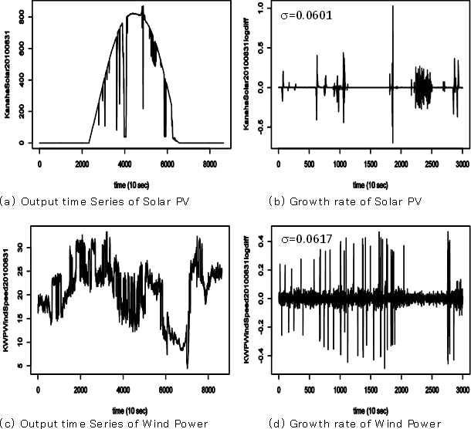

Figure 4: Renewable Energy Output Fluctuations
PV = Photovoltaic

Background Study:

A smart grid is currently attracting a lot of interest from the scientific community because it has the potential to change the direction that the traditional electric grid now takes. The primary objective of the proposed research study is to build and improve smarter power scheduling methods by establishing a small smart grid. A better forecasting technique should be used to transmit RTP rates to HEC in advance. Such publications that discuss the numerous methods of power scheduling, the infrastructure required for smart grid, and the identification of the best fitted ARIMA model are investigated for this research work. Different sorts of communication strategies are used because a huge amount of data is transmitted between customers and utilities.
Dimitris Bertsimas and John N. Tsitsiklis (1997) described linear programming, network flow problems, and discrete linear optimisation in detail. This is really handy for creating a HEC algorithm.
H. M. Khodr, J. C. Gomez, L. Barinique, and colleagues (2002) presented a mathematical model based on the use of a linear-integer programming algorithm for the optimum selection of independent electric power generation schemes in industrial power systems while taking reliability into account. They devised a mathematical programming problem that took into account investment costs, fuel expenses, operation and maintenance costs, power balance, maximum and minimum restrictions on the generated power of the units, and dependability factors such as the generation scheme's unavailability. They used a traditional branch and bound approach to tackle the problem.
Price forecasting is critical for producers and customers in the new competitive electric power markets, according to Javier Contreras, Rosario Espinola, F. J. Nogales, et al. (2002). Price projections are required for both spot markets and long-term contracts in order to establish bidding tactics or negotiation abilities that maximize benefit. They provided a full explanation of the ARIMA models as well as data collected from marketplaces in mainland Spain and California.
W. Zhang and A. Feliachi (2003) were the first to present the concept of tailoring residential load to improve the transportation company's load profile. RTP and demand side management were explored in various types of literature prior to this era, but to focus on these subjects in the current reality of the electrical market, this study provided an initial notion for design and development of the experimental setup of the small grid.
Jun Hua Zhao, Zhao Yang Dong, and Xue Li (2006) investigated existing feature pretreatment approaches and their empirical effectiveness in the price forecasting problem. They demonstrated in their work that good feature preprocessing can improve predicting accuracy dramatically. It can discover potential price-related issues for electricity. They explained how to choose appropriate feature preprocessing approaches in a price forecasting problem, which might be valuable for academics who want to incorporate successful feature preprocessing techniques in their price forecasting models.
The best fitting model should be used to forecast the hourly energy prices for the next day or week. ARIMA or Box Jenkins methods are better suited to time series in this task. Damodar's explanation of the ARIMA mechanism is quite clear.
In their book, N. Gujarati, Dawn C. Porter, et al. It was very simple to find and test the best-fitted ARIMA model using this piece of literature.
Raja Verma, Patroklos Argyroudis, and Donal O' Mahony (2009) offered an excellent introduction to matching demand and supply in residential loads utilizing RTP signals and smart meters. This study also explains five different types of tariff regimes.
K. S. Choi, Y. K. Ahn, and Y. C. Park (2009) described the concept of a home energy-saving system that uses a real-time home energy monitoring service. This is useful in designing the HAN in the described research endeavor.
An overview of forecasting challenges and techniques in power systems was presented by Michael Negnevitsky, Paras Mandal, and Anurag K. Srivastava (2009). In their work, they analyzed available forecasting methodologies, with an emphasis on data mining for wind power prediction. They talked about anticipated concerns with electricity prices.
Global electrical networks are on the verge of the largest technological shift since the introduction of electricity into the home, according to Patrick McDaniel and Stephen McLaughlin (2009). The ageing infrastructure that supplies electricity to our homes and businesses is being replaced by a network of digital technologies known as the smart grid. Smart grid, according to them, is the upgrading of the existing electrical infrastructure that improves consumers' and utilities' abilities to monitor, control, and predict energy use.
Y. S. Soon and K.D. Moon (2010) introduced HEMS (Home Energy Management System) to give easy-to-access real-time information on home energy use, intelligent planning for managing appliances, and power consumption optimization at home.
D.Y.R. Nagesh, J.V.V. Krishna, and S.S. Tulasiram (2010) classified the smart energy management system into two components: the intelligent grid (transmission and distribution system) and programmable smart appliances.
A. H. Mohsenian-Rad, V.W.S. Wong, J. Jatskevich, and colleagues (2010) investigated the use of energy consumption scheduling (ECS) devices in smart meters for autonomous demand side management within a neighborhood where multiple buildings share an energy supply.
The notion of demand-driven dispatch with application was explained by A. Brooks, E. Lu, D. Reicher, and others (2010). They also presented the concept of numerous consumer products with integrated communication features that use certain internet protocols.
R. Metke and Randy L. Ekl (2010) defined security as an essential element in an internet-driven smart grid. The authors suggested new industries to develop.
In a smart grid environment, Amir Motamedi, Hamidreza Zareipour, and William D. Rosehart (2010) examined the difficulty of anticipating future market prices. They also explored the impact of projecting power prices on actual price patterns.
Amir-Hameed Mohsenian-Rad and Alberto Leon-Garcia (2010) presented a novel energy scheduler design and price predictor to reduce peak demand on the grid. They also simulated the work to reduce the amount of energy consumed. However, in a different circumstance, the energy price prediction described in this literature may not operate well.
For the home load, Shalinee Kishore and Lawrence Snyder (2010) presented a distributed scheduling technique. They also recommended optimization methods when selecting appliances' off-peak energy price slots.
According to Albert Molderink, Vincent Bakker, Maurice G. C., et al. (2010), a smart grid can cut greenhouse gas emissions and increase system stability by optimizing energy streams. A more energy-efficient electricity supply chain can be achieved by implementing smart future energy production, consumption, and storage systems. In their work, they presented a three-step control methodology to govern the cooperation between various technologies, with a focus on domestic energy streams. With this technique, (global) goals such as peak shaving or establishing a virtual power plant can be met without jeopardizing people comfort. They demonstrated the benefits of utilizing reliable forecasts for organizing and controlling in real time of domestic appliances, a better matching of demand and supply can be achieved.
Himanshu Khurana, Mark Hadley, Ning Lu, et al. (2010) described smart grid security issues. They proposed that existing design solutions could be useful in some circumstances when deploying a security approach. However, in many circumstances, additional investigation will be required. They emphasized that various unanswered questions remain, particularly regarding how (and how much) privacy may be supported.
According to Bob Heile (2010), Electrical Vehicles (EVs) provide an attractive smart grid possibility in addition to being eco-friendly transportation. They have the ability to store energy. EVs can charge during periods of low demand and then send power to the grid during periods of high demand. With the owners' agreement, utilities can choose target automobiles with sufficient spare types.
This new capability improves resource management and is much more environmentally friendly. He proposed several fundamental ideas for developing the architecture of a smart grid that includes HAN and AMI.
A smart grid, according to Mel Olken (2010), is a digitally enabled electric grid that gathers, distributes, and acts on information about the behavior of all components in order to increase the efficiency, dependability, and sustainability of electrical services. He discussed the potential and challenges that our industry and technology will confront as we construct a smart grid.
According to David Owens (2010), utility companies might significantly change or alter the way they produce, transmit, and deliver power by adopting National Institute of regulations and Technology (NIST) regulations.
He stated that priority action plans were required to bridge the gap between the current electricity grid and a future smart grid. Building a global smart electric grid, according to Ron Schneiderman (2010), is an ambitious goal plagued with numerous complex technological and public policy concerns.
He discussed the efforts being made by industry to advance the conventional power system.
Hui Zhou, Jiangxiao Fang, and Mei Huang (2010) used the GARCH method for wind energy forecasting, which has outstanding qualities for tracking the variation of fluctuating time series. Wind power is simply obtained with power curve vs wind speed by plugging the expected wind speed into the correct equation or curve. They compared GARCH to ARIMA and established its superiority in terms of prediction accuracy. They provided results that demonstrated that GARCH has greater forecasting performance for highly fluctuating sequences.

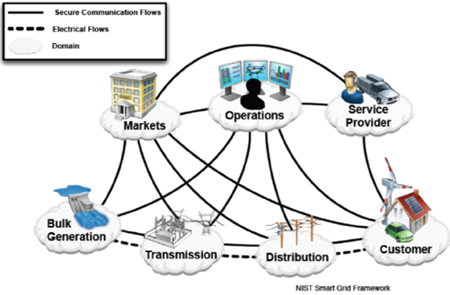

Figure 5: Building Blocks of the Smart Grid

Conclusion:
The smart grid, as the name suggests, is a more efficient electricity distribution system than the traditional grid. Regular oversight enhances the dependability and safety of the smart grid.
The Smart Energy System concept indicates a scientific paradigm shift away from single-sector thinking and towards a coherent energy systems understanding of how to benefit from the integration of all sectors and infrastructures.

References:
- Raja Verma, Patroklos Argyroudis, Donal O’ Mahony, Matching Electricity Supply and Demand using Smart Meters and Home Automation. Conference on Sustainable Alternative Energy (SAE), IEEE PES/IAS. Sep 2009; 1–7.
- Momoh JA. Smart grid design for efficient and flexible power networks operation and control. In: Power systems conference and exposition, 2009. PSCE'09. IEEE/PES; 2009.
- Greer C, Wollman DA, Prochaska DE, Boynton PA, Mazer JA, Nguyen CT, et al. NIST framework and roadmap for smart grid interoperability standards, release 3.0; 2014.
- Du X-W, Ye Q. Notice of retraction review of smart grid and its development prospect in Sichuan. In: Power and Energy Engineering Conference (APPEEC), 2010 Asia-Pacific; 2010. p. 1-4.
- E. Kabalci and Y. Kabalci, “Introduction to smart grid architecture”, Smart Grids and Their Communication Systems, pp. 3-45, 2019.
- F. B. Saghezchi, G. Mantas, J. Ribeiro, M. A. Rawi, S. Mumtaz, and J. Rodriguez, Towards a secure network architecture for smart grids in 5G era, In: Proc. of 2017 13th International Wireless Communications and Mobile Computing Conference, 2017, pp. 121-126.
- B. Chatfield and R. J. Haddad, “RSSI-based spoofing detection in smart grid IEEE 802.11 home area networks”, In: Proc. of 2017 IEEE Power & Energy Society Innovative Smart Grid Technologies Conference, pp. 1-5, 2017.
- D. B. Avancini, J. J. Rodrigues, S. G. Martins, R. A. Rabêlo, J. A. Muhtadi, and P. Solic, “Energy meters evolution in smart grids: A review”, Journal of Cleaner Production, Vol. 217, pp. 702-715, 2019.
- Z. Amjad, M. A. Shah, C. Maple, H. A. Khattak, Z. Ameer, and M. N. Asghar, “Towards energy efficient smart grids using bio-inspired scheduling techniques”, IEEE Access, Vol. 8, pp. 158947-158960, 2020.
- A. Alnasser and H. Sun, “A fuzzy logic trust model for secure routing in smart grid networks”, IEEE Access, Vol. 5, pp. 17896-17903, 2017.
- A. Xiang and J. Zheng, “A situation-aware scheme for efficient device authentication in smart grid-enabled home area networks”, Electronics, Vol. 9, p. 989, 2020.

