Agricultural Drones

Vaani Sri.S, Sai Durga.C , M. Maheswaran, K. Kokila
PG Scholars, Department of Agronomy, Faculty of Agriculture, Annamalai University, Annamalai Nagar, Chidambaram, Cuddalore dist. – 608002 , Tamil Nadu

Abstract
India’s population has reached 1.408 billion and is expected to surpass China the following years. According to the Global Food Security Index 2022, India has a prevalence of under-nutrition of 16.3%. Further, 30.9% of children in India are stunted, 33.4% are underweight, and 3.8% are obese. India’s Human Development Index is 0.65. Agriculture is essential in ensure the national food security. With over 70% of the population being engaged in agriculture related activity, agriculture serves as the backbone of India’s economy. The main challenge of the global agriculture is to provide food for the growing population. India is categorized by small-scale farmers. In addition to this, nearly 80 % of cultivable land is India is divided into less than 5 acres. The national food security can be ensured by upgrading the farm mechanization and strengthening the farm practices. So, drones being a modern technology, it can pave way to reduce the problems associated to farming practices and bring sustainability in futuristic agriculture.
Keywords: Drones, Agriculture, Technology, Spraying

Introduction:
Drone is also known as an unmanned aerial vehicle (UAV). It is an aircraft without any human pilot, crew, or passengers on board. In agriculture, drones are applied to farming in order to help in increasing the crop production and monitoring crop growth. Through the use of advanced sensors and digital imaging capabilities, farmers are able to use these drones to help them gather a high-resolution images of their fields. Information gathered from such equipment is tremendously useful in improving crop yields and farm efficiency. Agricultural drones allow the modern day farmers to stay relieved. Drone technology can lower labour requirements and reduce the use of resource requirements. Farmers are also able to use drones to retrieve aerial-view images of their fields.

Types of drones:

- Fixed wing drones: Fixed wing drones consists of a rigid wing (Non movable wing), fuselage (main body of the aircraft) and tails which use a motor and propeller as their propulsion system. They can fly at higher speeds for longer duration. They can cover wide range of areas like jungle, desert, mountain, maritime etc they hold a disadvantage of requiring runway or launcher for take-off and landing .

- Rotary wing drones: These drones will have the rotary blades or propeller- based systems and are called rotatory wing drones. Unlike the fixed wing models these drones can fly in every direction, horizontally, vertically. These can be used in surveying areas which are generally difficult to be surveyed (pipelines, bridges). They are similar to helicopters generate lift from the constant rotation of the rotor blades. But the disadvantage of low speed and short flight range.

- LTA & tethered systems drones: Rarely used in agriculture and these have management troublesome.

Major Components of Drones:

The following are major parts of drones.
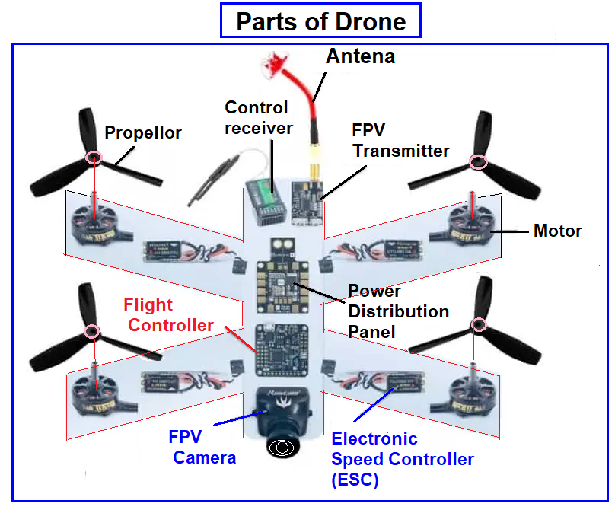
Fig.1 Components of drone
- Frame:
- Must have sufficient strength to hold the propeller momentum and additional weight for motors and cameras
- It should be sturdy and less aerodynamic resistance.

- Propellers:
  - The speed and load lifting ability of a drone depends on shape, size, and number of propellors
  - The long propellors create huge thrust to carry heavy loads at a low speed (RPM) and less sensitive to change the speed of rotation
  - Short propellors carry fewer loads. They change rotation speeds quickly and require a high speed for more thrust.
- Motor
  - Both motors brushless and brushed type can be used for drones
  - A brushed motor is less expensive and useful for small-sized drones
  - Brushless type motors are powerful and energy very efficient. But they need Electronic Speed ​​Controller (ESC) to control their speed. These brushless motors are widely used for racing freestyle drones, traffic surveys and aerial photography drones.
- ESC (Electronic Speed Controller)
  - ESC is used to connect the battery to the electric motor for the power supply
  - It converts the signal from the flight controller to the revolution per minted (RPM) of motor
  - ESC is provided to each y motor of the drone
- Flight Controller (FC)
  - It is the computer processor which manages balance and telecommunication controls using different transmitter
  - Sensors are located in this unit for the accelerometer, barometer, magnetometer, gyrometer and GPS
  - The distance measurement can be carried out by an ultrasound sensor
- Radio Transmitter sends the radio signal to ESC to pilot to control motor speed.
- Radio Receiver: Received the signal from the pilot. This device is attached to the quadcopter
- Battery: High-power capacity, Lithium Polymer (LiPo) is used for most drones. The battery can have 3S (3 cells) or 4S (4 cells).
- Drones can be controlled manually using a remote controller or programmed to fly autonomously. Autonomous drones use sensors and pre-programmed instructions to fly to a specific location, perform a task like taking photos or delivering a package, and return to their starting point.

Applications of Drones in Agriculture:
Field soil analysis:
The soil quality of crops can either make or break a farmer's productivity. Soil Analysis is a crucial step to be taken by farmers during the crop-cycle. Through Precision Agriculture, one can discern issues surrounding soil quality, nutrient management, or dead soil zones. This data supports farmers in determining the most effective farming patterns of planting, managing crops, and soil. Drones can be used to produce accurate 3-D maps that can be used for early soil analysis on soil property, moisture content, and soil erosion.

Pesticide spraying:
Chemicals to kill pests and unwanted plants such as weeds and spraying pesticides is crucial for maintaining crop health. Drones fitted with pesticide spraying equipment function more efficiently and for a fraction of the cost compared to manual spraying. Their ability to scan and modulate its distance from the ground enables them to spray the correct amount of the desired liquid evenly in real time. This results in increased efficiency with a reduction in amount of chemicals penetrating into groundwater. We are achieving Precision Agriculture by saving time and labor costs significantly and also protecting farmers from coming into contact with various toxic chemicals.

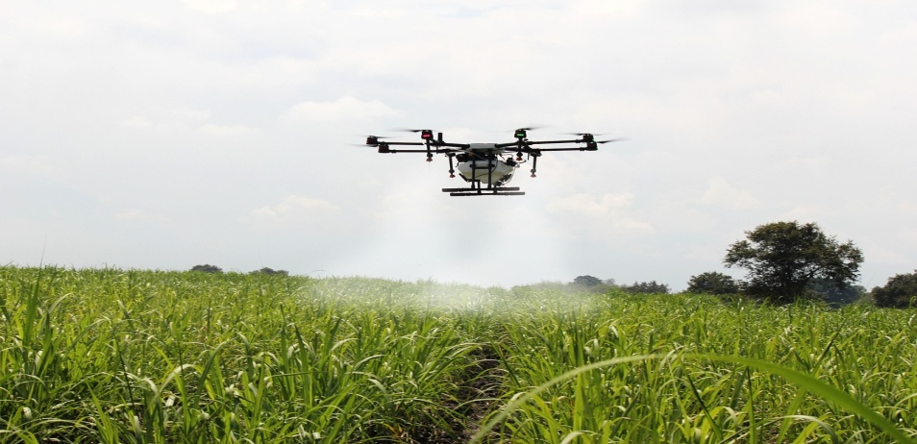
Fig.2 Drone used for spraying

Irrigation:
The drones equipped with Thermal Cameras and Remote Sensing capabilities can help to sense the irrigation issues, or areas receiving little or too much moisture. The topography of fields from RGB Imagery assists farmers to position and segregate the crops to maximize drainage, follow natural land runoff, and to avoid water-logging. With the usage of drone technology farmers will be able to adapt to different environments comfortably. Additionally, once the crop is growing, drones allow the calculation of the vegetation index, which describes the relative density and health of the crop, and show the heat signature, the amount of energy or heat the crop emits.

Monitoring Field Conditions :
Drone field monitoring is also being used to monitor the health of soil and field conditions. Drones can provide accurate field mapping including elevation information that allow growers to find any irregularities in the field. Having information on field elevation is useful in determining drainage patterns and wet/dry spots which allow for more efficient watering techniques. Some agricultural drone retailers and service providers also offer nitrogen level monitoring in soil using enhanced sensors. This allows for precise application of fertilizers, eliminating poor growing spots and improving soil health for years to come.

Health assessment :
It’s essential to assess crop health and spot bacterial or fungal infections on trees. By scanning a crop using both visible and near-infrared light, drone- carried devices can identify which plants reflect different amounts of green light and NIR light. This information can produce multispectral images that track changes in plants and indicate their health. A speedy response can save an entire orchard. In addition, as soon as a sickness is discovered, farmers can apply and monitor remedies more precisely.

Mid-field weed identification :
Using NDVI sensor data and post flight image data we can create weed maps that will help the farmers in easily differentiate the high weed intensity areas from healthy crop areas which are growing alongside them.

Cattle herd monitoring :
Drones with thermal sensors are the solid option for monitoring herds from overhead, they see whether animals are missing, injured or birthing. Thus drones give livestock farmers a new way to keep an eye on their livestock at all the times resulting greater profits.

Benefits of drones in the agriculture sector:
Drones can be used for a wide range of tasks in the agriculture sector, including crop mapping, soil analysis, irrigation, and pest management. Here are some of the key benefits of using drones in agriculture:
1.Improved efficiency: Drones can cover large areas of land quickly and efficiently, allowing farmers to gather data and monitor crops more effectively. This can help to identify issues early, leading to faster and more effective interventions.
2.Enhanced crop yields: Drones can be used to gather data on crop health, allowing farmers to identify areas that require attention. By addressing these issues, farmers can improve their crop yields and increase their profits.
3.Reduced costs: Drones can help to reduce costs by identifying areas of the farm that require attention, reducing the need for manual labour and reducing the use of pesticides and other chemicals.
4.Improved accuracy: Drones can capture high-resolution images and data, providing farmers with a detailed view of their crops. This can help to identify areas that require attention and ensure that interventions are targeted and effective.
Challenges of adopting drone technology in the agriculture sector:
There are various challenges that hold back the farmers from adopting the drone technology despite of the pros that drones possess. Here are some of the key challenges:
1.Fear of job loss: Many farmers are concerned that the adoption of drone technology will lead to job loss, as fewer workers will be needed to perform manual labour on the farm.
2.Lack of knowledge and training: Farmers may not have the knowledge or training necessary to operate drones effectively. This can make it difficult for them to adopt this technology, as they may not be confident in their ability to use it.
3.Cost: Drones can be expensive, and many farmers may not have the financial resources to invest in this technology.
4.Regulatory barriers: There may be regulatory barriers to the use of drones in agriculture, which could make it difficult for farmers to adopt this technology.

Conclusion:
The world is dealing with the emergence of new technologies to gather data in details. The UAV technology provides wide range of service opportunities. According to PwC, UAS will transform agriculture into a high-tech industry for the first time, with decisions being based on real gathering and processing of data and a likely increase in productivity and yields (Drone Powered Solutions, 2016).
Drones offer a range of benefits to farmers in the agriculture sector, including increased efficiency, improved yields, and reduced costs. However, there are also concerns about job loss and a lack of knowledge and training that may be holding farmers back from adopting this technology. As the adoption of UAV in rural areas is still gaining momentum there, efforts are being taken to address the challenges in using drones and promote the usage of them. It’s vital for the farmer to understand the potential benefits of this technology and receive necessary trainings to support the efficiency of the equipment. The adoption of drone technology in the agriculture sector has the potential to transform the way that farmers manage their crops and improve their yields.
As there are challenges to overcome, such as concerns about job loss of manual laborers , lack of knowledge and training to operate the drone, there are initiatives being taken to promote the usage of drone technology and provide the required support to the farmers who are willing to adopt. It is essential to ensure that the benefits of drone technology in agriculture are realized, while also addressing the challenges, concerns that may arise. By doing so, a more sustainable agriculture sector which profits both producer (farmer) and consumer can be created.

Referneces:

Surya rathore, Vijayalakshmi B, V V Sumanth kumar. Digital technologies in agriculture. Drones in Agriculture. Pg 171-182
https://www.financialexpress.com/opinion/food-security-and-national-security-of-india/3023836/
https://www.fao.org/documents/card/fr/c/I8494EN/
https://en.wikipedia.org/wiki/Unmanned_aerial_vehicle
https://cfdflowengineering.com/working-principle-and-components-of-drone/
file:///C:/Users/COOL/Desktop/timeline-of-drones-and-exploration-of-drone-based-applications-v2.webp
https://timesofindia.indiatimes.com/blogs/voices/drone-technology-in-agriculture-benefits-and-challenges-for-rural-india/
https://nahep.vnmkv.org.in/media/2020/05/AgriDrones.pdf
file:///C:/Users/COOL/Downloads/Drones%20in%20Agriculture%20(1).pdf

