Extraction of phenolic content from the extract of Hibiscus rosa sinensis flower.

Sandeep Kaur, Jasdeep Kaur and Bhavneek Sarwal

School of Basic & Applied Sciences

(Chemistry departement)

RIMT University Mandi Gobindgarh Punjab (147301)

ABSTRACT

Edible flowers are abundant sources of bioactive molecules as they contain, a plentiful source of antioxidant, anti-inflammatory, antibacterial, anticancer, and neuroprotective agents that have significant health advantages. The potential for phenolic molecule manufacturing using environmentally friendly extraction techniques is examined in the current study. So, choosing the right extraction technique is crucial if you want to recover the desired phenolic chemicals. The isolation of these compounds can be carried out by different methods such as traditional and non- traditional approaches. This will enable significant yields to be recovered from the sample matrix. As a result, the main focus of this review is on the various extraction techniques utilized to get phenolic chemicals from plant sources. The most efficient approach for achieving high total phenolic contents, antioxidant activity, and phenolic content was extraction with aqueous ethanol. For the isolation of phenolic compounds having antioxidant characteristics, optimized extraction techniques based on straightforward distillation extraction can be useful. In this investigation, hibiscus flower (rosa-sinensis) was utilized to produce extracts in a distillation extractor over the course of three to four hours. The flower sample was put in contact with particular solvents which is ethanol. After extraction, oily residues from the extracts were treated to flash chromatography, and the fractions resulting from this process were then characterized by gas chromatography coupled with mass spectrometry (GC-MS). The Folin-Ciocalteu technique was used to calculate the total phenolic content (TPC) from the Hibiscus ros- sinensis flower.

Keywords: Hibiscus rosa-sinensis flower, Ultra-Visible Spectrophotometer, Thin layer chromatography, Folin ciocaltea reagent, (GC-MS).

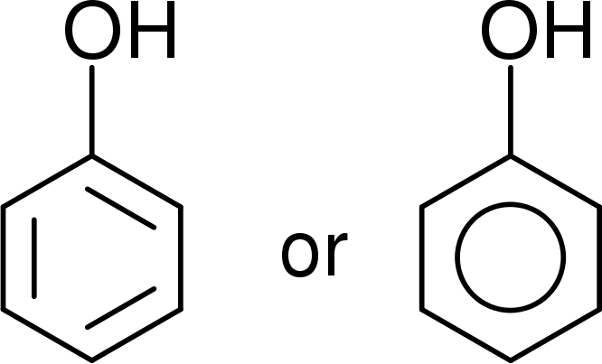
Introduction
Compounds containing one or more aromatic rings and one or more hydroxyl groups are commonly referred to as phenolic compounds. They represent the most prevalent secondary metabolites in plants, with a staggering array of over 8000 known structures. These compounds range from simple phenolic acids to more complex substances like tannins. They play a vital role in plant defense against UV radiation, pathogens, and other threats. Their ubiquity across all plant organs makes them an essential component of the human diet (Balasundram et al., 2006; Shah et al., 2018).
Figure 1: Structure of Phenolic Compound
Throughout history, people have harnessed the resources available in nature, seeking to extract valuable products from biomass. They have explored natural remedies for treating various ailments and health issues and utilized plants and trees for the production of diverse commodities, energy, tools, and manufactured goods. The world boasts a wealth of diverse and natural medicinal plants. For instance, the flowers of Hibiscus, as documented in ancient Indian medicinal literature, have exhibited beneficial effects in addressing various health conditions (Nadkarmi, A.K., 2006).
Medicinal plants are now gaining increased attention, particularly within the medical and pharmaceutical fields, owing to their potential to provide a wide range of benefits to humanity. Traditional knowledge of these plants constitutes a pivotal component of complementary and alternative medicine (CAM) and has guided the discovery of essential medications. Medicinal plants, whether used in their raw form or as basic medicinal formulations, often offer cost-effective, locally accessible, and easy-to-consume alternatives. In fact, approximately 80% of the global population relies on traditional medicine for their primary healthcare needs, with many of these therapies utilizing plant extracts or their active constituents (Buenz, E.J., and Dubey, N.K., 2004).
In recent times, there has been a surge in interest in and utilization of medicinal plant products. Contemporary scientific methods have shed light on the potential of therapeutic plants in the field of pharmacology (Triggiani, V., 2006). Phenolic compounds are prominently present in fruits, legumes, vegetables, tea, wine, coffee, and significantly contribute to the sensory attributes of plant-based foods. Furthermore, phenolic compounds are responsible for the bitterness of certain fruits, resulting from their interaction with salivary glycoproteins. They also impart color to many fruits and vegetables.
The technology for converting biomass into valuable products has evolved over millennia, dating back to around 38,000 years ago (Antal, M.J., 2003). An example from ancient times involves the use of willow tree leaves and bark to alleviate pain, a practice that eventually led to the isolation of salicylates from various tree species and plants in the 19th century. These salicylates were subsequently employed as active ingredients in the production of commercial pain relievers (Raskin, I., 1992).
The industrial utilization of rapidly growing, short-rotation crops such as miscanthus (Marín, F., 2009), wheat (Cornejo, A., 2019), and camelina straw (B. Gómez-Monedero. 2015), along with trees like eucalyptus (Gómez-Monedero, B., 2015) and poplar (X. et al., Yu. 2020), has spurred significant economic activity in the development of biobased products across various sectors, including the pulp and paper industry. Numerous studies, both in vitro and in vivo, have demonstrated the preventive potential of polyphenols in cardiovascular and neurological diseases, as well as various types of cancer (Cory et al., 2018; Forni et al., 2019; Pot et al., 2019; Vauzour et al., 2010).
1.1 Historical Roots of Hibiscus rosa-sinensis.
The likely place of origin for Hibiscus rosa-sinensis can be traced back to India. Some historical accounts attribute its introduction to Spain by the Moors (Arabs). However, there exists a debate regarding whether Hibiscus rosa sinensis is a naturally occurring herb or a result of deliberate hybridization. The term "Hibiscus" finds its etymological roots in the Greek word "hibiskos," which translates to "white" or "marshmallow."
1.2 An Overview of Hibiscus rosa-sinensis
Hibiscus rosa-sinensis is a perennial shrub belonging to the Malvaceae family. The genus Hibiscus comprises approximately 275 distinct species, originating from tropical and southern Asian regions and now distributed worldwide. Many cultivated varieties of Hibiscus are primarily grown for their ornamental appeal (Lowry, J., 1976). These plants display vibrant and captivating flowers all year round. There is a wide array of cultivars that produce flowers in diverse hues, including but not limited to red, peach, white, pink, and orange (Gilman, E.F., 1999). The physical characteristics of these flowers indicate that they are likely pollinated by hummingbirds and sunbirds, which are attracted to nectar-producing blossoms. Hibiscus rosa sinensis goes by different names across the globe, such as Hibiscus de Chine (China), Joba (Bengali), Java (Telugu), Chinesischer Roseneibisch (German), Clavel japonés (Spanish), Hibiscus (Swedish), and Gudhal (Urdu). It is also recognized as Bent EL-Kunsil (Arabic), Rosa della Cina (Italian), Aka-bana (Japanese), and Shoe flower (English).
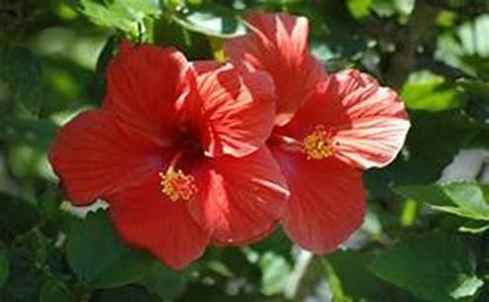
1.3 The Morphological Features of Hibiscus rosa-sinensis
Hibiscus rosa-sinensis, a perennial shrub, is characterized by its taproots. Its leaves typically measure between 3 to 12 cm in length and 2 to 5 cm in width. These leaves are relatively simple, showcasing either an ovate or lanceolate shape, with entire bases and noticeably serrated tips and margins. The flowers of this plant are known for their fullness, pentamerous structure, pedicillate attachment, and actinomorphic symmetry. The corolla, with an average diameter of 3 inches, consists of five petals (Rao, K., Geetha, K., Banji, D., 2014). There exist several variations in corolla size and color within different cultivars. The fruit of Hibiscus rosa sinensis is infrequently observed, with a capsule length of around 3 cm (Ross, I.A., 2003). Ideal growth conditions for this plant involve well-drained soils with a slight acidity. Sandy soils enriched with fully decomposed organic matter aid in enhancing soil aeration, drainage, and water retention. Adequate exposure to direct sunlight is crucial for these plants, as insufficient light can impede the blooming of flowers.
Figure 2: Structure of Hibiscus rosa-sinensis flower

1.4 Chemical Composition of Hibiscus rosa-sinensis Flowers
The chemical composition of Hibiscus rosa sinensis can vary due to factors such as plant variety, environmental conditions, and harvesting methods. Studies have reported that Hibiscus rosa sinensis contains proteins, carbohydrates, lipids, and fiber. Additionally, it contains significant amounts of calcium, iron, beta-carotene, and various vitamins. Leaves, for instance, contain phosphorus (0.52/100g), calcium (1.67g/100g), carbohydrates (69.7g/100g), fiber (15.5g/100g), and ash (11.4g/100g), along with lipids (3.5/100g). Flowers of Hibiscus rosa sinensis contain iron (1.7 mg/100 g), calcium (39 mg/100 g), phosphorus (265 mg/100 g), fat (3.9 mg/100 g), carbohydrates (86.3 mg/100 g), fiber (15.7 mg/100 g), vitamin B1 (0.29 mg/100 g), vitamin B2 (0.49 mg/100 g), vitamin B3 (5.9 mg/100 g), and vitamin C (3.9 mg/100 g) (V. Khristi, and V. Patel. 2016). Various parts of the plant also contain bioactive components such as glycosides, terpenoids, saponins, and flavonoids, which contribute to the plant's medicinal properties. Stem and leaves, for example, contain stigma sterol, taraxeryl acetate, beta-sitosterol, and three cyclopropane compounds.
In the flowers, there are abundant compounds like quercetin-3-diglucoside, cyanidin-3-sophoroside-5-glucoside, kaempferol-3-xylosylglucoside, cyanidin-3,5-diglucoside, and 3,7-diglucoside. The plant extracts also contain numerous potential antioxidants and anticancer substances, including quercetin, glycosides, riboflavin, niacin, carotene, malvalic acid, gentisic acid, margaric acid, and lauric acid. The roots are particularly rich in tannins, mucilage, flavonoids, and saponins, with potential health benefits. Saponins, in particular, are valuable for individuals with high cholesterol levels as they can bind to cholesterol, form insoluble complexes, and promote excretion via bile. Although Hibiscus rosa-sinensis exhibits a high content of total phenolics, a diverse flavonoid profile, and anti-hemolytic properties, there is still much to uncover about these aspects.
1.5 Utilization of Hibiscus rosa-sinensis Flowers
Hibiscus rosa-sinensis has a wide range of applications in the realms of culinary, cosmetics, and medicine. Hibiscus extracts are used as flavorings in a variety of food products, including jams, sauces, spices, and soups (Baranova, V., Rusina, I., 2012). They also enhance the flavor and aroma of tea blends. The essential oil derived from this plant is employed in the cosmetics industry due to its rich chemical composition. This essential oil is commonly found in cosmetics such as lotions, soaps, shampoos, conditioners, and fragrances, owing to its pleasant and soothing scent. Regular use of the oil is known to help maintain skin elasticity, flexibility, and reduce signs of aging. Hibiscus rosa-sinensis flowers are believed to possess cooling, emmenagogue (stimulating menstrual flow), and demulcent (soothing and protective) properties. They are also used to create a deep purple dye for darkening shoes and are employed for dyeing food, beverages, and hair in various parts of the world. Furthermore, Hibiscus rosa-sinensis is used in traditional remedies to address conditions such as hypertension, sore eyes, and ulcers. The leaves are known for their laxative, aperient (mild laxative), and emollient (softening) properties, while the stem bark has been historically used to aid abortion. Different plant parts are utilized to treat urinary infections, gonorrhea, stomach issues, blood vomiting, and various cattle diseases. Both alcohol and water extracts of leaf have anti-infective, anti-dandruff, and preventative properties against several skin conditions and allergies. These extracts are also known for their ability to promote hair growth and darken hair color due to their anti-graying properties.
1.6 Research Problem Statement
The yield of total phenolic compounds obtained during extraction can vary depending on the chosen method. Additionally, the choice of solvent with different polarities can influence the solubility of chemical constituents in a sample and, consequently, its extraction yield. Therefore, the selection of an appropriate solvent is a crucial step in determining the total phenolic content in a sample.

PLANT | PLAN T  PART | SOLVRENT | METHOD | COMPUND EXTRACT | CHARACTE RIZED
Hibiscus sabdariffia | calyces | Ethanol, Methanol, Water. | Micro-wave assisted extraction at 20⁰C, 50⁰C,  75⁰C, 90⁰C. | Delphindin3-o sambubioside chloride,cyandin 3- o-sambubioside chloride hydroxycitrate. | UPLC-DAD
Populus salicacae | Bark | n-hexan, dichlorometha ne,  ethyl acetate. | Soxhlet extraction and chromatograp hy at 40⁰ C temperature. | 2,3dihydrofuran, aromatic, cinnamic acid. | GC-MS
Andryala glandulosa | Flower | Dichlorometh ane,ethanol, ethanol Dichlorometh ane,ethanol. | Liquid-liquid extraction was done. | Dichloromethane an extract contain hydrocarbon. In alcoholic extract luteolin, quinnic acid. | RP-HPLC  coupled withdiode array detection and ESI/MS
2. Literature Review

References:

- Liliana, C., Rodrigues, E., Noreña, C.P. Z; Institute of Food Science and Technology, Federal University of Rio Grande do Sul, Av. Bento Gonçalves, 9500, CEP 91501-970, Porto Alegre, RS, Brazil
- Autor, E., Cornejo, A., Bimbela, F., Maisterra, M., Gandía, L.M., Martínez- Merino, V. Extraction of Phenolic Compounds from Populus Salicaceae Bark.Biomolecules 2022, 12, 539.
- Madeir, C.Q., CCCEE, Universidade da Madeira, Campus Universitário da Penteada, piso 0, 9000-390 Funchal, Portugal.

Objectives

- The purpose of current study is the extraction of phenolic compound from
Hibiscus rosa-sinensis flower.
- Selection of an appropriate extraction method to get the good yield of TPC (total phenolic content).
- Determination and quatification of phenolic compounds by TLC and UV spectra.
- GC-MS of ethanolic extract of Hibiscus rosa- sinensis flower.

4. Methods for Flower Extraction
The phenolic content and composition within different parts of a plant, such as leaves, roots, bark, flowers, or fruits, can significantly vary. For instance, fruits often have distinct distribution patterns for their flesh, skin, and seeds. When collecting samples for analysis, it is crucial to ensure they are representative of the specific plant material that will be studied, whether it involves the entire plant or a selected portion of it. Proper preservation of these samples is essential to prevent alterations in their chemical composition. Over time and under varying storage conditions, there can be a considerable decrease in the levels of phenolic compounds in the source material between sample collection and analysis. Samples can be preserved in dry, frozen, or fresh forms, although fresh samples, despite being perishable, can be stored in refrigeration.

4.1 Conventional Extraction Methods
Traditional methods for extracting phenolic compounds encompass a range of techniques such as soxhlet extraction, serial exhaustive extraction, decoction, percolation, infusion, digestion, and maceration (Alara et al., 2018a,b; Kaufmann and Christen, 2002; Sticher, 2008). Maceration, though once commonly employed, is less frequently used nowadays due to the availability of more efficient alternatives. The maceration process involves soaking finely ground material in an appropriate solvent within a closed system, agitating it intermittently or continuously at room temperature (Olejar et al., 2015; Sticher, 2008). After the extraction phase, the solid components are separated from the solvent using a suitable separation method. Typically, this separation is achieved through techniques such as filtration, decantation, or clarification (Cuji čić et al., 2016). While maceration is a straightforward method, it has drawbacks, including being time-consuming and requiring significant quantities of solvents (Alara et al., 2018a,b; Kaufmann and Christen, 2002; Sticher, 2008).

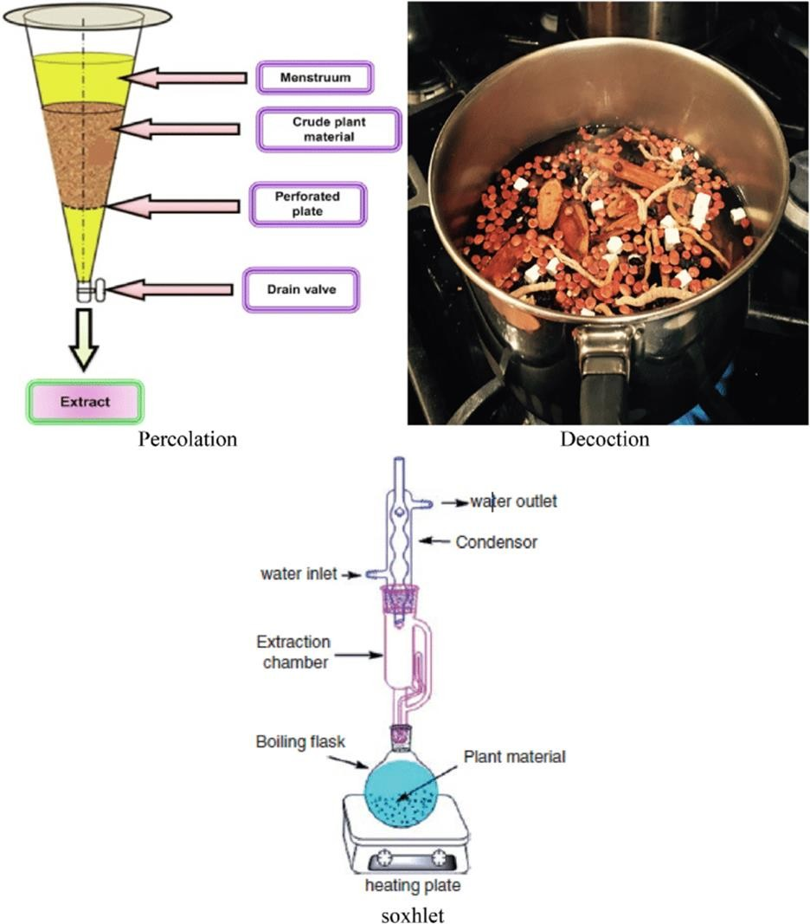

Figure 3: A various extraction method (A) Percolation (b) decoction (c) Soxhlet extraction.

Decoction procedure

The plant samples are either boiled for a shorter time or covered in boiling water and left to stand for a set amount of time when using the decoction procedure. This approach is mostly suited for water-soluble and heat-stable phytochemicals derived from unprocessed pharmaceuticals. The pulverised material is placed in a closed system with the solvent being dropped gradually from the top to the bottom. This is comparable to the maceration process (Kaufmann and Christen, 2002; Sticher, 2008). Filtration is not necessary in this case because the percolator devices have filters that only permit solvent containing the extract to pass through. The issues with the percolation approach (lengthy, huge solvent volumes) are comparable to those with the maceration method. Due to the prolonged heating, this method cannot be used to extract thermolabile chemicals (Alara and Abdurahman, 2019).

Soxhlet apparatus procedure

The pulverised materials are placed in timbles (made of cellulose) and placed in the extraction chamber according to the soxhlet extraction method (Alara et al., 2018a,b; Luque de Castro and Garca-Ayuso, 1998) beneath a reflux condenser, over the collecting flask. After that, the solvent that has already been poured to the heating bottle is heated to create a vapour that will condense under cool running water and fall back into the timbles that contain the sample (Azwanida, 2015). After several attempts to sustain the reflux, the aqueous extract is finally recovered from the heating flask. Soxhlet extraction benefits from being a continuous process since it compared to percolation and maceration procedures, uses less time and solvent (Azwanida, 2015). However, because reports have emphasised the impact of excessive heat on the soxhlet extraction process, it is important to treat it carefully the polyphenols that are thermolabile (Seidel, 2012). Convenience is another benefit of the soxhlet extraction technique (Azwanida, 2015). These processes are different, but they all require an organic solvent at a specific feed-to-liquid ratio. Methanol, water, chloroform, n-hexane, ethanol, propanol, ethyl acetate, and acetone are a few of the often-used solvents for extracting polyphenols (Zhang, 2018). The polarity of these solvents varies, and as a result, their effects on the removing plant chemicals. As a result of their ease of mixing, organic solvents are taken into account while attempting to increase extraction yield, as suggested by numerous research (Zhang, 2018).There are still questions about the best solvent for the extraction of polyphenols, despite the fact that phytochemicals are often extracted using organic solvent and its aqueous formulation. Any solvent used for extraction must be chosen based on the following criteria: solvent power, solvent polarity, boiling temperature, solvent reactivity, viscosity, stability, safety considerations, legislative compatibility for food usages, and potential for reusability.

5. Methodology

5.1 Collection and processing of material

The Hibiscus rosa sinensis flower is collected from the local area. At first, running tap water was used to completely clean the blooms. The recovered samples were then twice cleansed in sterile distilled water to get rid of any remaining impurities. The flowers were afterwards converted into powder using a mechanical grinder after being let to dry in the shade at 40°C. The powder was kept in an airtight container at room temperature.

5.2 Materials

Sample preparation may require various devices, solvents, and/or chemicals to perform drying, grinding, sieving, extraction. In solvent extraction methanol (MeOH), ethanol (EtOH), acetone, and ethyl acetate (EtOAc) can be used as a solvent for the extraction of phenolics. Accelerated simple distillation extractor, device was used. Most of the extrcation was done by using ethanol as a solvent distilled water, Gallic acid used as standard, follin cioacalteau reagent, sodium carbonate, toluene reagent, Fecl3, acetone, formaic acid and some others.
  - Extraction of flower Hibiscus rosa- sinensis

Using a simple distillation, the 50g of dried Hibiscus rosa-sinensis flower powder was progressively extracted with 30ml of ethanol. The entire extract was produced in 4-6 hours at boiling points of 80 °C. The product-solvent was filtered afterward employing a Rotavapor and lowered pressure to evaporate for dryness. The product's old version was used to screen for phytochemicals. Additionally, GC-MS analysis of the same product (Ethanolic extract).
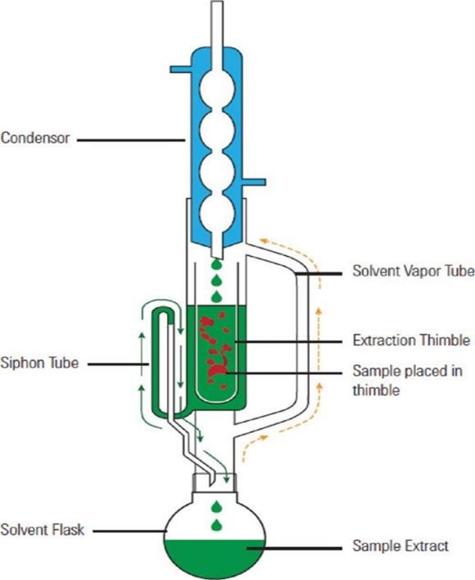
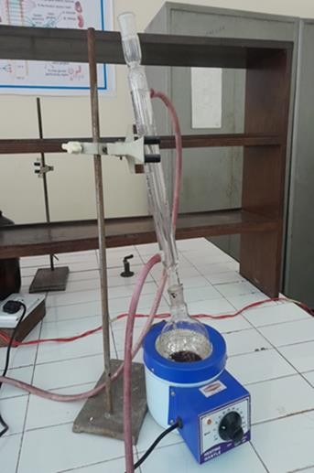

Figure 4: Simple distillation extractor Figure 5: Soxhlet extractor

  - Measuring the amount of total phenolic content

Utilising the Folin-Ciocalteu colorimetric method, which Gao et al. [40] previously developed, the total polyphenol content was determined. The Folin- Ciocalteu reagent (0.2 mL), H₂O (2 mL), and spice extracts (100 L) were combined, and the mixture was incubated at room temperature for 3-minute Total polyphenols were calculated after 1 h of incubation at room temperature following the addition of 1 mL of 20% sodium carbonate to the mixture. Using a UV-spectrophotometer, the absorbance of the resulting blue colour was determined at 765 nm. In order to quantify the toatal phenolic content, the gallic acid standard curve was used. Gallic acid equivalents (GAE), milligrammes per
100 g of dry weight (dw), were used to express the results. All determinations were performed in triplicate (n = 3).

Calculations:

Standard volume of sample(ml)dilution ×100
weight

Weight % = Ac-(As - A0)/Ac 100

Ac = (Absorption of control)( absorption of sample)

TLC (Thin layer chromatography) analysis of sample

- Preparation of Plant Extract

Kagan and Flythe (2014) for extraction of phenolic compounds from Trifolium pratense cv. Keenland.
To extract other compounds in other plants, check the phytochemical analysis literature for plant- or metabolite-specific extraction methods (many are described), or look for protocols such as those of Khurram et al.7,8 which isolate many compounds with a wide range of polarities.

Preparation of Thin-layer Plates

Clean TLC plates by developing in one or more polar, neutral solvents, in order to move adsorbed contaminants away from the zone of development. In a fume hood, prepare enough cleaning solvent (e.g. 15-100 ml of ethyl acetate-methanol.
2:1, v/v) to cover the bottom of the TLC developing chamber, as well as the lower edge of a TLC plate when set inside the chamber.
Use commercially available glass TLC developing chambers (different sizes available, with lids) or foil-covered Pyrex beakers or preserving jars.
Use scissors to cut aluminum- or plastic-backed (flexible) silica gel plates, which come in various sizes (20 cm x 20 cm and smaller), to fit the available developing chamber. (Caution: silica can cause lung damage if inhaled. Work in a fume hood, and handle TLC plates with gloves to avoid getting skin oils onto the silica.)
Insert the plates into the chamber, with the tops leaning against the chamber walls. Plates should not touch each other. Cover the chamber and let the solvent move up the plate by capillary action.
When solvent has reached the top of the plates, remove plates from chamber and arrange in a standing position within the fume hood until solvent has evaporated.
Check to see if impurities have migrated near the top of the TLC plate by looking for a yellow band under visible light, or a fluorescent band under ultraviolet (UV) light (see the “impurity front” or IF in Figure 2B). If the majority of the plate still has a yellowish tinge, repeat the cleaning process.
After removing TLC plates from the chamber, discard the solvent. Allow residual solvent to evaporate completely before using the chamber for Protocol
To remove residual moisture that can affect migration of compounds on silica16, prop the plates upright in a drying oven at 100 °C (10-15 min for a 20 cm x 20 cm plate, and 5 min for 7 cm x 10 cm plates).
If a 100 °C drying oven is not available, heat plates for a longer period of time at lower temperatures (i.e. 40 min at 60 °C). After the plates are dry, let them cool to ambient temperature before loading.

Preparation of Developing Chambers for Extract Separation

Use scissors to cut a piece of filter paper slightly below chamber height, and about half the chamber perimeter in width. This paper acts as a wick to draw solvent up the chamber wall and saturate the chamber with solvent vapors, thus improving reproducibility of separations1. In a fume hood, mix solvents (ethyl acetate- methanol 4:1, v/v, for this study). Pour solvent mixture into the chamber and cover. Wait until the entire wick is wet with solvent, indicating chamber saturation, to put plates into chamber.

Loading and Development of TLC Plates

Lightly mark the origin with pencil. If the TLC plate adsorbent is soft and easily damaged, make marks at edges. Compounds should be above the surface of the developing solvent when plates are inserted into the TLC chamber.
Dissolve extracts in enough organic solvent (in this case, methanol) to have a concentrated solution instead of a turbid suspension.
Load samples and standards as narrow bands with a microliter syringe or capillary micropipettes, leaving a 1 cm border on the sides of the plate. Allow the bands to dry (fanning the plate or loading it in a fume hood helps).
If a greater concentration of sample is needed on a plate, "overspot" by loading samples again on the dried bands.
With forceps or tongs, set plate(s) inside the saturated TLC chamber. Plates should not touch the wick because it may provide solvent to the plates at points of contact, thus altering the path of compound migration. Cover chamber and let plates develop.

Mass balance

Material balance is a application of the Conservation of Mass which is used in the industry to find out the quanitiy or composition of the residue here or in the residue it can be find out the what is the amount of ash after complete combustion. As the following table shows the different qunantity of residue after the combustion at various temperature.

Table1: Mass balance and pH observed at different temperature in ethanol as solvent.
Reactant  (organic material) | Sample | Solvent (Ethanol) | Temperature | Heating time | Product obtained | pH | Mass balance
Rosa- sinensis  flower | 10.5g | 30ml | 80⁰C | 3hour | 15ml | 6.25 | 73%
Rosa- sinensis  flower | 14g | 40ml | 65⁰C | 2hour | 35ml | 7.1 | 71%
Orange  peel | 11g | 50ml | 50⁰C | 1 hour | 45ml | 6.3 | 68%

6. GC-MS of Hibiscus rosa-sinensis
By using GC-MS Solid, gaseous, or liquid materials can all be studied using.The first step in analysis is the gas chromatograph, where a capillary column coated with a stationary (liquid or solid) phase separates the sample into its constituent components after efficiently vaporising it into the gas phase. An inert carrier gas, such as helium, hydrogen, or nitrogen, propels the chemicals. Depending on its boiling point and polarity, each compound elutes from the column at a different time as components of the mixture are separated. The retention time of a chemical is the period of elution. Complex mixtures or sample extracts containing hundreds of different chemicals can be resolved using GC.

7. Results
7.1. Total Phenolic content
The antioxidant has received a lot of attention lately characteristics of food ingredients that are sourced from plants. Secondary metabolites widely found in plants include flavonoids and phenols. They possess a variety of biological and pharmacological traits that may offer protection from chronic illnesses 26,27. According to the current research, HFE has a phenolic content of 0.095mg gallic acid equivalent (GAE) per gram of extract (Graph 1).
Absorbance 765
Absorbance 765
18
16
14
12
15.9
Total Phenolic
15.2
12.8
13.5
11.2
12.1
10
8
9.4
8.22
7.1
Extract
Gallic Acid
6
4.21
4
2
0
2.28
2.65
0.1µg/ml 1.01µg/ml 1.05µg/ml 2.01µg/ml 3.5µg/ml 6.01µg/ml
Concentrations (µg/ml)
Concentrations (µg/ml)

Weight percentage of phenolic content

We analyses the weight of phenolic content in the ethanolic extract of Hibiscus rosa sinensis by using Folin-Ciocalteu colorimetric method and the total weight is 1.8097447 µg/ml^{-1.}.

TLC (Thin layer chromatography) Analysis TLC of Standard phenolic compound
Retention factor (RF) is defined as the ratio of distance travelled by salute to distance travelled by solvent.
Distance travelled by salute(flower) = 4.5cm
Distance travelled by solvent(ethanol) =8cm
RF value of standard phenolic compound =0.56

TLC of flower sample

Distance travelled by salute(sample) =5.2cm

Distance travelled by salute(solvent) =12cm

RF value of taken sample =0.48

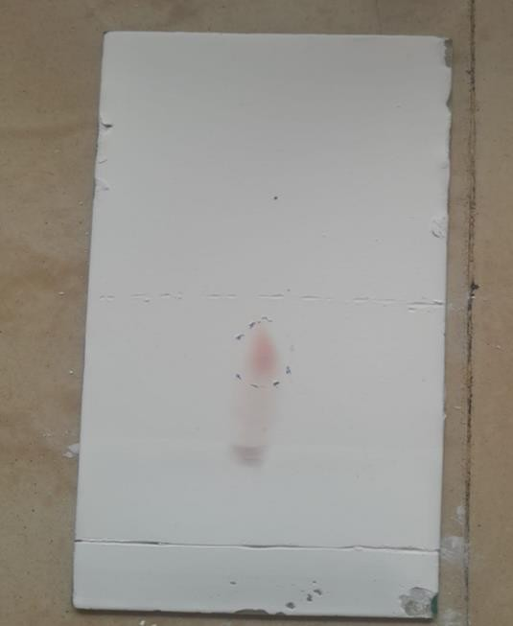
Figure 6: TLC of standard phenols Figure 7: TLC flower extract

7.3 GC-MS of Hibiscus rosa-sinensis flower extract
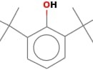
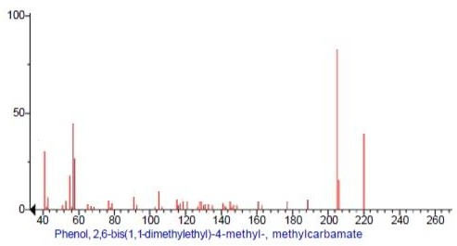
Structure of given phenol

S.NO. | RT | Name of compounds | Molecular | MW | Uses
1 | 7.94 | Phenol, 2,6- bis(1,1- dimethylethyl)- 4-methyl-, methylcarbamate | C17H27NO2 | 277 | Phenol is used as an oral aesthetic/analgesic, commonly used to temporarily treat pharyngitis.  Phenol was widely used as an antiseptic.

8. Conclusion
In conclusion, phenolic chemicals derived from plants have a variety of uses, including analgesic, antipyretic, anticancer, antiviral, and antibacterial. Consequently, they have the capacity to enhance human health. The merits and disadvantages of various phenolic compound extraction techniques from plants were discussed in this chapter. The findings of this study showed that Hibiscus rosa-sinensis flowers have high levels of phenolic content (42.38 2.66 mg gallic acid equivalent (GAE) per gramme) and displayed outstanding antioxidant properties is reported. Phenol, 2,6-bis(1,1-dimethylethyl)-4-methyl-, methylcarbamate components was detected and used as an oral aesthetic/analgesic, commonly used to temporarily treat pharyngitis. Phenol was widely used as an antiseptic by GC-MS analysis. Rutina has been discovered as the extract's main flavonoid. Oxidative stress was artificially produced using H₂O to test the preventive impact of HFE on RBC hemolysis. As a possible source of natural remedies, the result of this study would assist determine the efficacy of the extract from Hibiscus rosa-sinensis antioxidants. It can be used to reduce or stop lipid oxidation, slow down the production of harmful oxidation products, and extend the shelf life of foods and medicines.

References

- Balasundram, N., Sundram, K., & Samman, S., (2006). Phenolic compounds in plants and agri-industrial by-products: Antioxidant activity, occurrence, and potential uses. Food chemistry, 99(1), 191- 203.
- Shah, S. R., Ukaegbu, C. I., Hamid, H. A., & Alara, O. R., (2018). Evaluation of antioxidant and antibacterial activities of the stems of Flammulina velutipes and Hypsizygus tessellatus (white and brown var.) extracted with different solvents. Journal of Food Measurement and Characterization, 12, 1947-1961.
- Buenz, EJ., Schnepple DJ., Bauer, BA., Elkin,PL., Riddle, JM., Motley TJ., T(2019) Trends in Pharmacological Sciences 2004; 25: 494-498.
- Dubey, NK., Kumar R., Tripathi, P.,(2004) Global promotion of herbal medicine: India’s opportunity. Curr Sci;81: 37-41.
- Triggiani, V., Resta, F., Guastamacchia, E., Sabba C., Licchelli, B., Ghiyasaldin S., (2006). Role of antioxidants, essential fatty acids, carnitine, vitamins, phytochemicals and trace elements in the treatment of diabetes mellitus and its chronic complications. Endocrine, Metabolic and Immune Disorders Drug Targets; 6: 77-93.
- Antal, M. J., GrÃ¸ nli M., (2003). The Art. Science, and Technology of Charcoal Production. Industrial and Engineering Chemistry Research, 42(8).
- Raskin, I., (1992). Role of salicylic acid in plants. Annual review of plant biology, 43(1), 439-463.
- Marín, F., Sánchez, J. L., Arauzo, J., Fuertes, R., & Gonzalo, A.
,(2009). Semichemical pulping of Miscanthus giganteus. Effect of

pulping conditions on some pulp and paper properties. Bioresource Technology, 100(17), 3933-3940.
- Gómez-Monedero, B., Bimbela, F., Arauzo, J., Faria, J., & Ruiz, M.,
P. (2015). Pyrolysis of red eucalyptus, camelina straw, and wheat straw in an ablative reactor. Energy & Fuels, 29(3), 1766-1775.
- Cornejo, A., Alegria-Dallo, I., García-Yoldi, Í., Sarobe, Í., Sánchez, D., Otazu, E., ... & Martínez-Merino, V., (2019). Pretreatment and enzymatic hydrolysis for the efficient production of glucose and furfural from wheat straw, pine and poplar chips. Bioresource technology, 288, 121583.
11.Yu, X., Xu, D., Sun, Y., Geng, Y., Fan, J., Dai, X., ... & Li, Y., (2020).
Preparation of wood-based panel composites with poplar veneer as the surface layer modified by in-situ polymerization of active monomers. Forests, 11(8), 893.
- Cory, H., Passarelli, S., Szeto, J., Tamez, M., & Mattei, J., (2018). The role of polyphenols in human health and food systems: A mini- review. Frontiers in nutrition, 5, 87.
- Forni, C., Facchiano, F., Bartoli, M., Pieretti, S., Facchiano, A., D’Arcangelo, D., ... & Jadeja, R. N., (2019). Beneficial role of phytochemicals on oxidative stress and age-related diseases. BioMed research international, 2019.
- Potì, F., Santi, D., Spaggiari, G., Zimetti, F., & Zanotti, I., (2019). Polyphenol health effects on cardiovascular and neurodegenerative disorders: a review and meta-analysis. International journal of molecular sciences, 20(2), 351.
- Vauzour, D., Rodriguez-Mateos, A., Corona, G., Oruna-Concha, M. J., & Spencer, J. P., (2010). Polyphenols and human health: prevention of disease and mechanisms of action. Nutrients, 2(11), 1106-1131

- Lowry, J. B., (1976). Floral anthocyanins of some Malesian Hibiscus species. Phytochemistry, 15(9), 1395-1396.
- Gilman, E.F., Hibiscus rosa-sinensis (1999). Institute of Food and Agricultural Science, University of Floryda. 254.
- Rao, K., Geetha, K., Banji D., (2014). Quality control study and standardization of Hibiscus rosa-sinensis L. flowers and leaves as per WHO guidelines Journal of Pharmacognosy and Phytochemistry. 3(4).
- Ross, I.A., Hibiscus rosa-sinensis (2003). In Medicinal Plants of the World, Springer; pp 253-266.
- Khristi, V., Patel. V., Therapeutic potential of Hibiscus rosa- sinensis-A review (2016). V. Baranova, I. Rusina, D. Guseva, N.
- Baranova, V., Rusina, I., Guseva, D., Prozorovskaia, N., Ipatova,O., Kasaikina, O., (2012). The antiradical activity of plant extracts and healthful preventive combinations of these exrtacts with the phospholipid complex. Biomeditsinskaia khimiia. 58(6): 712-726.
- Alara, O. R., Abdurahman, N. H., Ukaegbu, C. I., & Azhari, N. H., (2018). Vernonia cinerea leaves as the source of phenolic compounds, antioxidants, and anti-diabetic activity using microwave-assisted extraction technique. In
- Alara, O. R., & Abdurahman, N. H., (2019). Kinetics studies on effects of extraction techniques on bioactive compounds from Vernonia cinerea leaf. Journal of food science and technology, 56, 580-588.
- De Castro, M. L., & Garcıa-Ayuso, L. E., (1998). Soxhlet extraction of solid materials: an outdated technique with a promising innovative future. Analytica chimica acta, 369(1-2), 1-10.

- Azwanida, N. N., (2015). A review on the extraction methods use in medicinal plants, principle, strength and limitation. Med Aromat Plants, 4(196), 2167-0412.
- Seidel, V., (2012). Initial and bulk extraction of natural products isolation. Natural products isolation, 27-41.
- Zhang, Q. W., Lin, L. G., & Ye, W. C., (2018). Techniques for extraction and isolation of natural products: A comprehensive review. Chinese medicine, 13, 1-26.
- Gao, X., Ohlander, M., Jeppsson, N., Björk, L., Trajkovski, V., (2000). Changes in antioxidant effects and their relationship to phytonutrients in fruits of sea buckthorn (Hippophae rhamnoides L.) during maturation. J. Agric. Food Chem. 48, 1485-1490
- Baranova, V. S., Rusina, I. F., Guseva, D. A., Prozorovskaya, N. N., Ipatova, O. M., & Kasaikina, O. T., (2012). The antiradical activity of plant extracts and healthful preventive combinations of these exrtacts with the phospholipid complex. Biomeditsinskaya khimiya, 58(6), 712-726.

