IoT in Logistics and Transportations

Gulshan Kumar Dr. Jagdish H Godihal
PG Student Professor-CIV and Deputy Dean -Academic Research
School of CS & IS School of Engineering
Presidency University Bengaluru, India
Bengaluru, India

Abstract:
The integration of the Internet of Things (IoT) in Logistics & Transportation has brought about a paradigm shift in the industry, revolutionizing how goods and people move across the globe. IoT's deployment of interconnected smart devices, sensors, and communication systems has enabled real-time data collection and analysis, enhancing visibility, efficiency, and sustainability. With IoT-powered solutions, transportation companies can track assets and shipments in real-time, optimize routes to reduce fuel consumption, and improve fleet management for cost-effective operations. Moreover, IoT facilitates predictive maintenance, enabling early detection of equipment issues and minimizing downtime. The seamless connectivity provided by IoT fosters smoother supply chain management, streamlining inventory control and minimizing delays. Embracing IoT in Logistics & Transportation not only enhances operational efficiency but also improves safety through driver behavior monitoring and risk mitigation. This abstract explores the transformative impact of IoT in the industry, showcasing its potential to optimize logistics operations, promote sustainable practices, and shape a connected and innovative future.

Introduction:

The transportation and logistics industry serves as the backbone of global trade and commerce, facilitating the movement of goods and people across vast distances. However, in this dynamic and competitive landscape, the need for enhanced efficiency, visibility, and sustainability has become increasingly crucial. The Internet of Things (IoT) has emerged as a game-changer in addressing these challenges, transforming the way transportation and logistics operations are conducted.
  - Background:
The advent of IoT has brought about a paradigm shift in various industries, and transportation and logistics are no exceptions. IoT involves the integration of smart devices, sensors, and communication systems into various assets and infrastructure, creating an interconnected network. These devices collect and exchange real-time data, providing stakeholders with valuable insights and enabling data-driven decision-making. The adoption of IoT in transportation and logistics has been fueled by advancements in sensor technology, connectivity, and data analytics. These innovations have unlocked new possibilities for optimizing fleet management, improving supply chain visibility, and enhancing overall operational efficiency.
2. The Role of Transportation & Logistics in the Global Economy
The transportation and logistics sector serves as the backbone of the global economy, facilitating the movement of goods, people, and services across vast distances. It plays a pivotal role in connecting manufacturers, suppliers, retailers, and consumers, ensuring that products and resources reach their intended destinations efficiently.

Challenges in the Transportation & Logistics Industry
While the sector is crucial for economic growth, it faces several challenges, including lack of visibility into supply chain operations, inefficiencies in fleet management, and environmental sustainability concerns. Additionally, the rapid growth of global trade and e-commerce has increased the demand for faster and more reliable transportation solutions.

The Emergence of IoT in Transportation & Logistics

The rise of IoT technologies has brought innovative solutions to the transportation and logistics industry. IoT enables the integration of smart devices, sensors, and communication systems into various assets, vehicles, and infrastructure, creating a connected ecosystem.

Applications of IoT in Transportation & Logistics

Real-Time Tracking and Visibility

One of the key advantages of IoT in transportation and logistics is its ability to provide real-time tracking and visibility. IoT-enabled devices, such as GPS trackers and smart sensors, can be installed in vehicles, containers, and shipments to monitor their location, status, and condition in real-time. This level of visibility enables logistics companies to track their assets, monitor delivery progress, and respond quickly to any unexpected delays or issues.

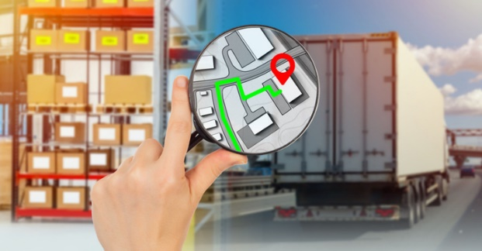

Fig1. Image of Real time Tracking

Predictive Maintenance

IoT enables predictive maintenance in the transportation and logistics industry. By equipping vehicles and machinery with sensors, companies can collect data on the health and performance of their assets. This data is then analyzed using machine learning algorithms to predict potential failures or maintenance needs before they occur. Predictive maintenance helps minimize downtime, reduce maintenance costs, and enhance overall asset reliability.
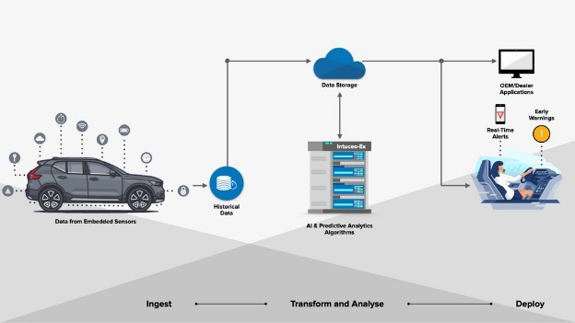

Fig.2 Predictive Maintenance of the vehicle

Fleet Optimization

Fleet optimization is a critical aspect of IoT implementation in transportation and logistics. By gathering data on vehicle performance, driver behavior, and route efficiency, logistics companies can identify areas for improvement and make data-driven decisions to optimize their fleet operations. This includes route optimization to reduce fuel consumption, implementing driver behavior monitoring to enhance safety, and scheduling maintenance based on actual usage data to maximize vehicle uptime.
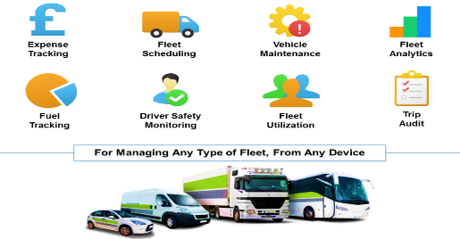

Fig.3 Fleet Optimization in Transportation

Supply Chain Management

IoT plays a pivotal role in supply chain management has revolutionized the way businesses handle logistics and inventory processes. By integrating smart sensors and devices throughout the supply chain, companies gain real-time visibility and actionable insights into their operations. IoT-enabled tracking and monitoring solutions provide valuable data on the location, condition, and movement of goods at each stage of the supply chain, from production to distribution. This data-driven approach allows for more efficient inventory management, reduced lead times, and improved demand forecasting, ultimately leading to cost savings, enhanced customer satisfaction, and increased overall supply chain efficiency. IoT's transformative impact in supply chain management paves facilitating a supply chain ecosystem that is increasingly interconnected and responsive.
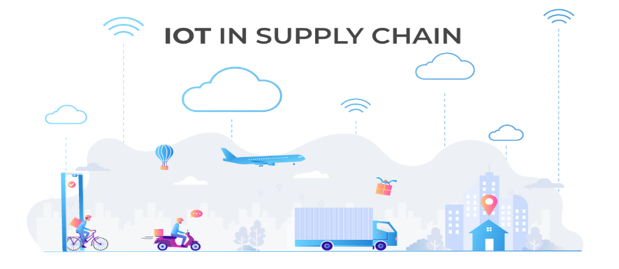

Fig.4 IOT in Supply chain Management

Benefits of IoT in Transportation & Logistics

Enhanced Operational Efficiency

The implementation of IoT in transportation and logistics leads to improved operational efficiency. Real-time tracking and data analytics enable companies to make informed decisions quickly, optimize routes, and streamline operations. This results in reduced delivery times, increased productivity, and cost savings

Improved Safety and Risk Management

IoT-powered solutions enhance safety in transportation and logistics. With real-time monitoring of driver behavior and vehicle conditions, companies can proactively address safety risks and potential hazards, leading to a safer working environment for drivers and a reduced risk of accidents.

Environmental Sustainability

Sustainability is a growing concern in the transportation industry. IoT technologies help reduce carbon emissions and promote environmental sustainability by enabling better route planning, optimizing fuel consumption, and minimizing empty trips.

Data-Driven Decision Making

IoT generates a vast amount of data that can be harnessed to make data-driven decisions. With advanced analytics and AI algorithms, logistics by leveraging this capability, businesses can acquire valuable intelligence about their operations, customer habits, and market trends, empowering them to adjust and maintain their competitiveness companies can gain valuable insights into their operations, customer behavior, and market trends, enabling them to adapt and stay competitive in a rapidly evolving market.

Challenges and Solutions in Implementing IoT in Transportation & Logistics

Data Security and Privacy

The adoption of IoT in transportation and logistics raises concerns about data security and privacy. The interconnected nature of IoT devices increases vulnerability to cyberattacks. To ensure the protection of sensitive data, companies must adopt strong security measures, including encryption and authentication protocols.

Connectivity and Reliability

IoT devices rely on reliable connectivity to transmit data in real-time. In remote or low-bandwidth areas, connectivity may be an issue. To overcome this challenge, companies can use hybrid connectivity solutions and leverage edge computing to process data closer to the source.

Interoperability and Standardization

The compatibility of different IoT devices and platforms is crucial for seamless data exchange. Standardization efforts and the use of common protocols and APIs facilitate interoperability, ensuring smooth integration of IoT solutions into existing systems.

Future Trends in IoT Transportation & Logistics

Autonomous Vehicles and Drones

Autonomous vehicles and drones are emerging as disruptive technologies in transportation and logistics. IoT plays a critical role in enabling these autonomous systems by providing real-time data for navigation, obstacle detection, and safety. Autonomous delivery vehicles and drones offer the potential for faster and more efficient last-mile delivery, reducing human intervention and operational costs.

Fig.5 Autonomous Vehicles in Transportation & Logistics

Blockchain for Supply Chain Transparency

Blockchain technology is gaining traction in the transportation industry for ensuring supply chain transparency and security. By integrating IoT devices with blockchain, companies can create an immutable record of the movement and condition of goods throughout the supply chain. This enhanced transparency improves traceability, reduces the risk of fraud, and enhances trust among stakeholders.
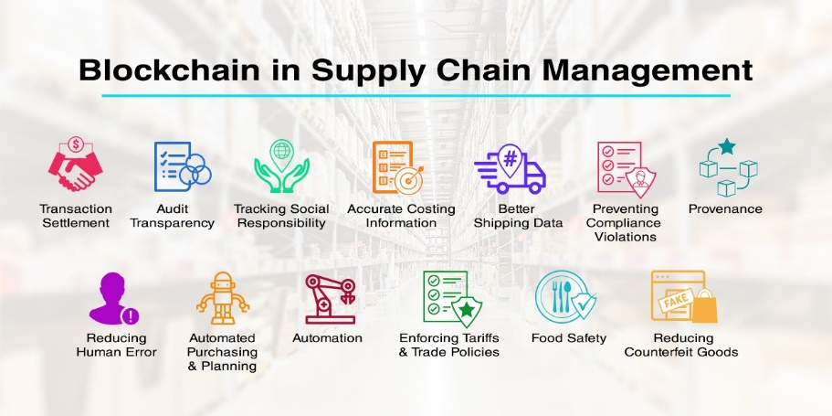

Fig.6 Blockchain for Supply Chain Transparency

Smart Warehouses

IoT-driven smart warehouses are revolutionizing logistics operations. Smart sensors and robotics are employed to optimize warehouse layouts, automate inventory management, and improve order fulfillment processes. Real-time data from IoT devices allows warehouse managers to monitor inventory levels, track stock movement, and improve overall efficiency.
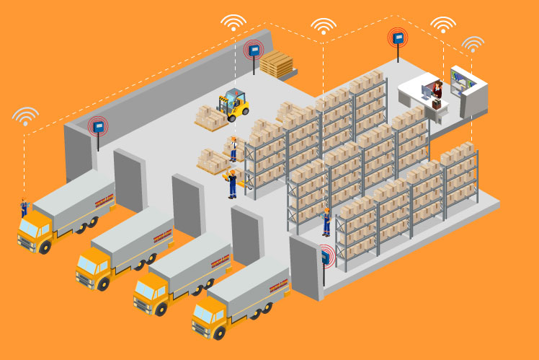

Fig.7 Smart Warehouses in Logistics

Integration with Emerging Technologies

The future of IoT in transportation and logistics lies in its integration with other emerging technologies. IoT combined with artificial intelligence, machine learning, and big data analytics will enable more sophisticated data analysis, predictive insights, and real-time decision-making. These synergies will drive further advancements in the industry.

IoT Implementation Strategies

Scalability and Flexibility

When implementing IoT solutions in transportation and logistics, scalability and flexibility are essential considerations. As the volume of data and the number of connected devices grow, the infrastructure must be capable of handling the increased workload. Additionally, solutions must be flexible to adapt to changing business requirements and technological advancements.

Collaboration and Partnerships

The successful implementation of IoT in transportation and logistics often requires collaboration and partnerships between various stakeholders. Companies may need to work with technology providers, telecommunications companies, and industry experts to leverage their expertise and create comprehensive IoT solutions.

Data Governance and Management

As IoT generates vast amounts of data, effective data governance and management are crucial. Companies must establish clear data policies, ensure data privacy compliance, and implement data analytics processes to derive valuable insights from the collected data.

Case Studies and Real-World Examples

This chapter presents case studies and real-world examples of successful IoT implementations in the transportation and logistics industry. It highlights how companies have overcome challenges and achieved significant improvements in operational efficiency, cost savings, and customer satisfaction through IoT adoption.

Case Study 1: Optimizing Last-Mile Delivery with IoT

This case study explores how a logistics company utilized IoT-enabled smart sensors and data analytics to optimize last-mile delivery. By monitoring traffic patterns, weather conditions, and customer preferences, the company achieved faster delivery times and reduced transportation costs.

Case Study 2: Enhancing Fleet Safety with IoT

In this case study, a transportation company implemented IoT-enabled devices to monitor driver behavior and vehicle conditions in real-time. The data collected helped identify high-risk drivers and proactively address safety issues, resulting in a significant reduction in accidents and insurance costs.

Conclusion
In conclusion, the integration of IoT (Internet of Things) in logistics and transportation has ushered in a new era of connectivity and efficiency, revolutionizing the way goods are transported, tracked, and managed. The transformative impact of IoT technologies extends across the entire supply chain, from production to delivery, offering numerous benefits and addressing long-standing challenges. IoT-enabled real-time tracking and visibility have provided unprecedented transparency and control over the movement of goods, enabling logistics companies to respond proactively to disruptions and optimize routes for faster and more cost-effective deliveries. This enhanced visibility has also improved customer satisfaction by providing accurate and reliable delivery information to end-users. Moreover, IoT's role in predictive maintenance has led to reduced downtime and increased asset reliability, allowing transportation companies to manage their fleets more efficiently and extend the lifespan of their vehicles. The integration of IoT with other technologies, such as AI and blockchain, further enhances operational capabilities, enabling autonomous decision-making, secure data exchange, and improved supply chain transparency. While the benefits of IoT in logistics and transportation are undeniable, challenges remain in terms of data security, interoperability, and scalability. Companies must prioritize cybersecurity measures and collaborate to establish industry-wide standards to ensure seamless integration of diverse IoT devices and solutions. As the transportation and logistics industry continues to evolve, the widespread adoption of IoT technologies will be instrumental in driving innovation, improving sustainability, and shaping the future of global trade and commerce. Embracing IoT's potential will empower businesses to make data-driven decisions, optimize resource utilization, enhance safety, and reduce environmental impact.
Overall, the successful implementation of IoT in logistics and transportation requires a forward-thinking approach, a commitment to collaboration, and a willingness to adapt to emerging technologies. By leveraging the full potential of IoT, the transportation and logistics industry can create a more connected, efficient, and sustainable ecosystem, meeting the evolving needs of a dynamic global marketplace. Sectors.

References:

- Aryal A, Liao Y, Nattuthurai P, Li B (2020) The emerging big data analytics and IoT in supply chain management: a systematic review. Surg Endosc Other Interv Tech 25(2):141–156
- Ding Y, Jin M, Li S, Feng D (2020) Smart logistics based on the internet of things technology: an overview. Int J Logist Res Appl. https://doi.org/10.1080/13675567.2020.1757053
- Tedejko.P.(2015) Application of Internet of Things in logistics-Current Challenges, Journal Economics and management.7(4),54-64
- Internet of Things (IoT) in Transportation and Logistics: Applications and Benefits https://www.telogis.com/resources/whitepapers/iot-transportation-logistics/
- IoT Applications in Logistics and Transportation. https://www.cisco.com/c/en/us/solutions/internet-of-things/iot-industry-solutions/logistics-transportation.html
- How IoT is Revolutionizing Transportation and Logistics. https://www.iotforall.com/how-iot-revolutionizing-transportation-logistics/
- https://www.IoTforall.com/logistics-and-IoT-trends-2018/

