INTRODUCTION:
Down through the ages, most managers operated on a trial and error experimental basis. The demands of industrial revolution changed this traditional practice. Management emerged as a formal discipline at the turn of 19th century and will continually evolve today and to the next generation as a means of management philosophy and principles.
Management theories are the set of general rules that guide the managers to manage an organization. Theories are an explanation to assist employees to effectively relate to the business goals and implement effective means to achieve the same.
FREDERIC WINSLOW TAYLOR’S SCIENTIFIC PRINCIPLES:
Scientific management is neither efficiency device, nor a new scheme of paying men. It is not holding a stop watch on a man and writing down things about him, it is not time and motion study nor an analysis of the movements of men. In its essence, scientific management involves a complete mental revolution on the part of the workman engaged in any particular establishment. It involves a complete mental revolution on the part of those on the management’s side. This new technique of managing involved 2 major elements:
- Discovery by experiment the best way of performing and the proper time for every operation and every component, unit of an operation in the light of the best material, tool, machine, manipulation of tool or machine.
- The division of labor in between management and workers. The great gains in productivity accruing from this technique of management came not from greater exertion on the part of workers but from elimination of wastages of workers time and machine time through delays of misapplied efforts failure in coordination of quantities and so forth.
APPROACHES:
Taylor was thoughtful and systematic in his approach and advocated the following:
- The replacement of rules of thumb with more carefully throughout guidelines to action.
- The collection of data to support decisions rather than reliance on casual judgement.
- The elimination of waste effort.
- Emphasis on fitting workers to particular task.
- Greater care in training workers to the specific requirements of their jobs.
- Greater specialization of work activities.
- The establishment of standards for performance.

CRITICISMS:
Taylor’s concept of management attracted following criticism:
- Taylor’s emphasis on extreme specialization is considered unrealistic. His advocacy of first class with developed skills raised an expectation that each worker should be an extraordinarily talented. The standards of efficacy evolved as result of time and motion studies etc. were conceived as too high, beyond the calibre and capacity of an average worker.
- Taylor ignored human elements. He thought man as a cog in the wheel. His emphasis on efficiency at all costs turned the workers into mere machine.
- In Taylorism the workers are speeded up without fundamental improvements in factory layout, production methods, tool design, training etc.
- Worker’s wage would not be increased in direct proportion to the additional productivity exhibited by the workers.
FRANK GILBRETH:
Frank Gilbreth and his wife Lillian Gilbreth made memorable contribution to improvement of working methods. He contended that it would be essential to find out the best way to perform a particular job with marked efficiency and least exertion. He developed a unique technique of speed work. Speed work, however, did not refer to hurrying with the work but economising the time sequence by eliminating unnecessary time sequence and exhausting motions and methods of doing a work.
The best method is that which implies least motions. Worker should not waste his energy and effort in moving his body unnecessarily. He advocated ‘rhythm in work’ with balanced movement of concerned members of body while at job.
SEQUENCES OF SCIENTIFIC METHOD:
- Identifying the problem and objectives.
- Defining the objectives and problems.
- Collection of data on the problem and the objectives.
- Analysis and interpretation of the data.
- Consideration of alternatives.
- Formulate tentative conclusions about tackling the problems.
- Taking up selected action on the basis of conclusions and testing the results.
- Reviewing and evaluating the results and introducing any corrective action if necessary.
- Framing ‘laws and models’ to serve as a guide to planning and execution.
PRINCIPLES OF SCIENTIFIC METHOD:
- The development of true science.
- The scientific selection of employees.
- The scientific education and development of employees.
- Intimate and friendly cooperation between employees and employer.
HENRI FAYOL’S PRINCIPLES OF MANAGEMENT:
Fayol laid down the following principles of general management:
- Division of labor: It is a law of nature. That is each man can develop special skill. The purpose of division of labor is to attain more and better returns from the same amount of effort.
- Authority and responsibility: Aithority is the power to give orders and accept obedience. It is derived from one’s personal qualities such as intelligence, knowledge, moral, attitudes, skills and leadership and calls for both statutory and personal authority, responsibility is inseparable from authority. If follows whenever authority is exercised, the man with authority carries responsibility for his decisions and actions.
- Discipline: The agreement between an enterprise and its employee calls for obedience, diligence, energy, and cooperative attitudes.
- Unity of command: Authority to give instructions to an employee must be limited to one man. If this rule is broken, authority will be weakened. An employee must know whom to give instructions, and he must not be confused by having to follow the instructions of several people who have authority.
- Unity of management: There should be only one plan and one manager directing all operations.
- Subordination to industrial interests to the common good: In any undertaking the interests of single members, or of some of the members of the team, must not take precedence over the interests of the enterprise as a whole.
- Remuneration of the team members: Fair towards for work done must be offered to all members of the organization.
- Centralization: Like division of labor, centralization is one of the natural principles of the organization. In all organization it is present to some degree. The question is- To what extend in a given enterprise will it be most advantageously adopted?
- Hierarchy: The line of command extends downwards in order of rank from the top of the organization through all levels of authority to the lowest employee. It is the channel through which all official communication travel.
- Order: Order is an organization calls ‘a place for everyone and everyone in his place.’ When the order of persons is clearly well established the function may easily identified in relation to the whole.
- Justice (equity): The employees will put all their devotion and good intentions to work for the common effort if they are treated with friendliness and justice.
- Stability of tenure: An organization needs employees who will stay with it. Such employees help the organization to achieve stability.
- Initiative: Providing opportunity to subordinates to exercise their initiative which gives them satisfaction.
- Sense of union (esprit de corps): Harmony and unity in the enterprise are source of strength. That is why modern management tries to bring the individual members of an organization to work themselves as a team.
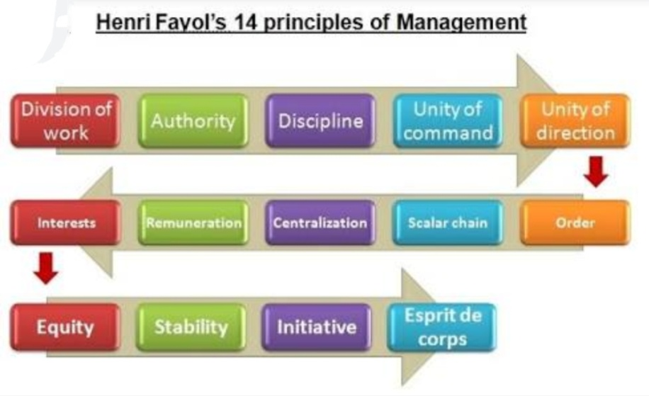

LUTHER GULICK:
Luther Gulick a classicist was influenced by Taylor and Fayol. He used Fayol’s 5 elements of administration viz. Planning, Organizing, Command, Coordination and Control as a frame work for his neutral principles. Gulick condensed the duties of administration into a famous acrnym ‘POSDCORB’. Each letter in the acronym stands for one of the seven activities of the administrator as given below:
Planning: Working out the things that need to be done and the methods for doing them to accomplish the purpose set for the enterprise.
Organising: Establishment of the formal structure of authority through which work subdivisions are arranged, designed and coordinated for the defined objective.
Staffing: The whole personnel function of bringing in and training the staff, and maintaining favourable conditions of work.
Directing: Continuous task of making decisions and embodying them in specific and general orders and instructions, and serving as the Leader of the enterprise.
COordinating: All important duties of interrelating the various parts of the work.
Reporting: Keeping the executive informed as to what is going on, which includes keeping himself and his subordinates informed through records, research and inspection.
Budgeting: All that goes with budgeting in the form of fiscal planning, accounting and control.

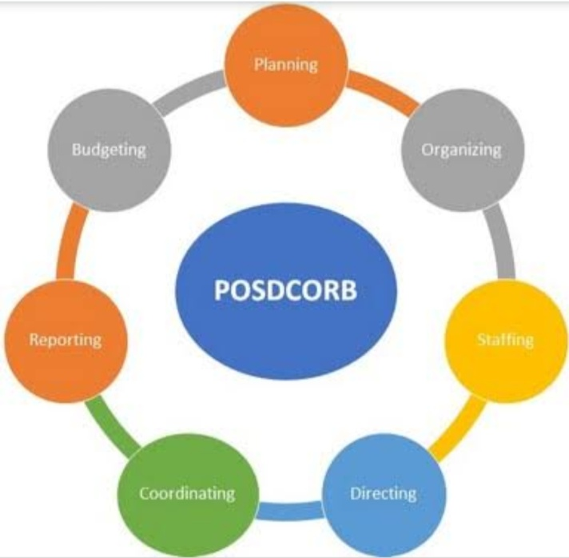

LYNDAL URWICK:
Urwick also concentrated his efforts on the discovery of Principles and identified eight Principles of administration applicable to all organisations as given below:
1. The "Principle of Objective”– that all organisations should be an expression of a purpose.
2. The “Principle of Correspondence"– that authority and responsibility must be co-equal.
3. The "Principle of Responsibility"– that the responsibility of higher authorities for the work of subordinate is absolute.
4. The "Scalar Principle"– that a pyramidical type of structure is built up in an organisation.
5. The "Principle of Span of Control".
6. The "Principle of Specialisation”– limiting one's work to single function.
7. The "Principle of Coordination".
8 The "Principle of Definition"– Clear prescription of every duty.
MAX WEBER:
Weber advocated bureaucracy as the ideal form of organisation for a complex institution. Weber described a bureaucracy as having a well defined hierarchy of authority, division of work based on specialisation, highly specific rules governing worker's duties and rights, debuted work procedures, impersonal interpersonal relationships and promotion based on technical competence. Weber also claimed that bureaucracy was superior to other forms of organisation, because it provides greater stability, precision and reliability in controlling employees. Interestingly, "Bureaucracy" which he considered highly efficient in dealing with changing circumstances, is seen as too rigid and ponderous to respond management. He felt the bureaucracy was the most efficient form for complex organisation. His areas of emphasis are:
- Hierarchy of authority
- A system of rules
- Division of labour
- Impersonality of relationship
- A system of work procedure
- Legal authority and power
MARY PARKER FOLLETT:
Follett advised managers on avoid arbitrary authority and put stress on successful leadership personality traits. She also said that investigator should analyse manager's job in the same way that Taylor analysed labourers job, so that executives could be taught effective management skills and allowed to practice new skills under supervision until they become habitual. In relation to authority, she advised that manager should never give orders to an employee, instead manager and employee should analyse the situations together, and then both should take orders from the situation. She contended that none can become a full person unless he becomes a member of a group. According to her, “Man can discover his true nature, can reach greater release of his own relative powers, gains his true freedom only through powers of the group”. Follett’s major areas of contribution are:
- Removal of conflicts. Three areas of removing conflict are viz. domination, compromise and integration. She considered integration the parties.
- Participation of workers.
- Group Dynamics. It regards group as more than a mere collection of individuals.
- Leadership.
- The law of situation.
- Management as a profession.
- Coordination.
- Authority
ELTON MAYO:
Mayo was the first to emphasis the understanding and realisation of the human factor in organisation. He concluded that of all the factors influencing employee behaviour the most powerful were those emanating from the workers participation in social groups. Mayo felt that work satisfaction depends to a large extent on the informal social pattern of the working group. He thought that the supervisor could be trained to play a different role which could help him to take personal interest in the subordinates and discharge his duties in better manner. He also noted that the worker should be made to come out openly with their needs, interact freely and without fear with company officials. The term "human relations" mostly refers to relations between workers and employer, which are not regulated by legal norms. These relations are concerned with moral and psychological factors rather than legal factors. The human relations concept is concerned with devisory concrete methods for ideological orientation of workers in the factory/enterprise.

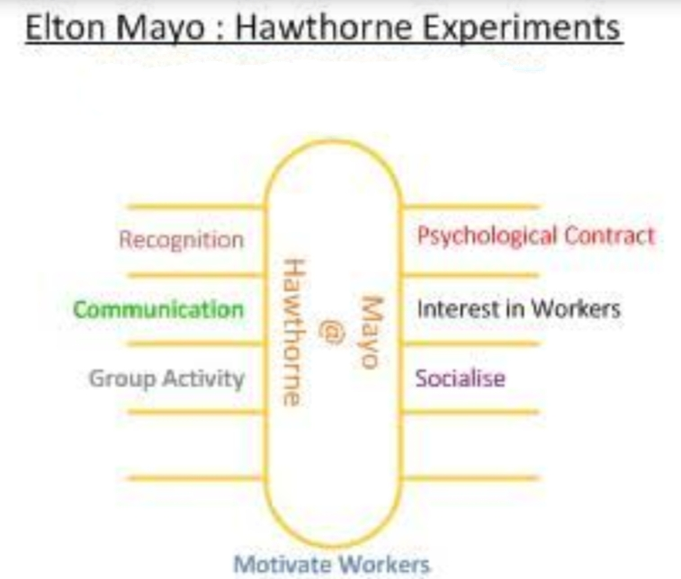

KURT LEWIN:
Kurt Lewin a social psychologist developed the Field theory of human behaviour (1951). He claimed that a worker's job behaviour is influenced by interactions between workers personality, work group structure and socio-technical climate of the work place. On the basis of his study, Lewin concluded that the process of behaviour changes occurs in three phases:
Unfreezing: When an alteration in Social and Psychological forces is perceived, an individual's equilibrium is distributed, facilitating attitudinal and behavioural change. When thus imbalanced, an individual can be motivated to other behaviour, either by increasing pressure to make the change reducing threats associated with the change.
Changing: The individual demonstrates the desired attitudes and behaviour either by mimicking behaviour of a role model who portrays those behaviours or by "discovering the desired attitudes and behaviours when placed in a situation that required trend.
Refreezing: The individual integrates the newly acquired attitudes and behaviour into daily active and organising relationships. Whether the new behaviours are learned through identification or se discovery, the individual will not display permanent behaviour change unless the desired behaviour is continually reinforced by superior, peers, and subordinates.
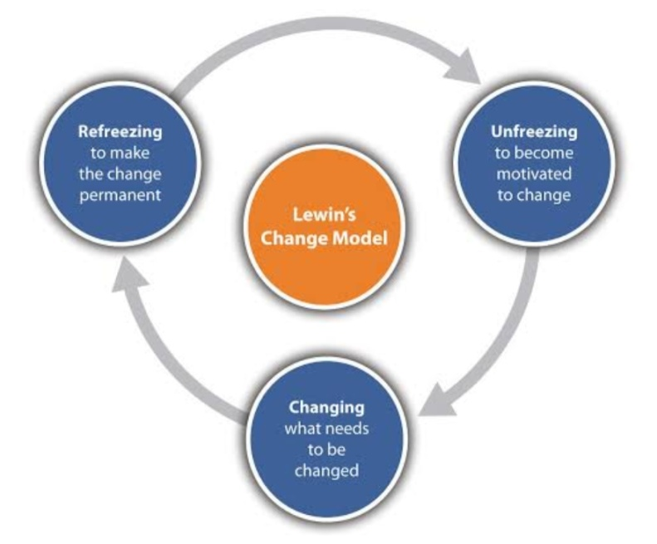
ABRAHAM MASLOW:
According to Maslow, human needs can be categorised as: Basic psychological needs, Security and safety needs, Social needs, Ego or esteem needs and self-fulfillment or self actualisation needs. These need are further divided into primary needs - Psychological and security needs and secondary needs Social, ego and self-fulfillment needs. Maslow's work most employees experience a variety, motivating them to come to work and perform at a given level of effort. He analysed the relationship between the human beings and organisations from the stand point of "human needs". Human beings join the organisation to fulfill their needs. These needs arise in many areas. Fulfillments of these needs motivate the human beings to a higher level of performance. Nonfulfillment of needs will have adverse effect on the motivations of the individuals to contribute to organisation to realise the organisational objectives. Maslow arranged individual needs in an hierarchical manner:
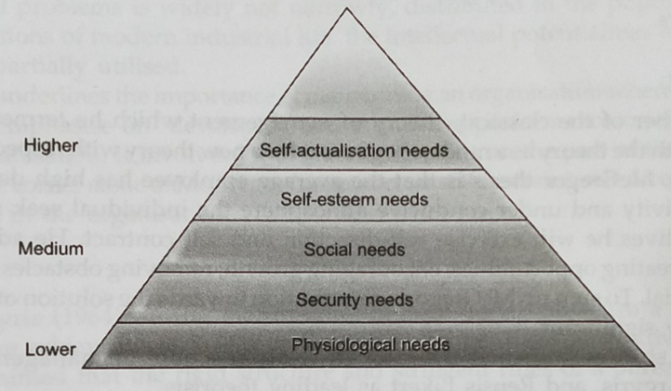
As shown in figure, physiological and security needs are lower order needs in the hierarchy. Self actualization need is higher in the hierarchy. In between comes the social and esteem needs. Maslow believed that unless the need at the lower level is satisfied, it will not moderate a person. The meaning of these needs in relation to administration is as follows:
- Physiological needs include the basic things necessary for human survival, e.g. hunger, thirst, shelter, etc. The human being has to satisfy these needs first-once these are satisfied, individual no longer strives hard to obtain these and he himself is motivated to work hard for organisation.
- Security needs include job security or safety and the work place, thus giving psychological security to human beings. Safety includes both physical and emotional safety. Human being is a safety seeking mechanism. Once safety and security is ensured, they no longer motivate the human being
- Social needs represent the relationship between and among groups of people working in the organisation. This need provides emotional security to people and also gives a sense of belongingness and association. Every human being needs friendship with others. If these needs are not met the employee becomes resistant and hostile.
- Esteem needs represent higher level needs of human beings. At this level, they strive for power, achievement and status. Esteem connotates both self-esteem and esteem from others.
- Self-actualization is a higher level need represents culmination of all other needs. The fulfilment of this need gives a higher degree of satisfaction to individual in work and life. Further, it improves the person's performance in the organisation. A self-actualised person has fulfilled all his potential. This represents person's motivation to transform perceptions of self into reality.
DOUGLAS McGREGOR:
McGregor is the father of the classical theory of management which he termed theory. According to him the traditional manager in a bureaucracy operates on a set of assumptions about human nature and human behaviour; that he called as "Theory X". Accordingly these assumptions are:
- The average human being has an inherent dislike of work and will avoid it, if he can, when possible
- Because of dislike of a work, most people must be coaxed, controlled, directed, threatened with punishment to get through, put forth adequate effort towards the achievement of organisational objectives.
- The average human being prefers to be directed, wishes to avoid responsibility, has rationally little ambition and is more interested in financial increments and wants security above all than per achievements.
Accordingly "Theory X" assumes human being as lazy, lacking in ambition, resisting change, non creative, capable of being deceived easily, etc. In such a case, management has two strategies to adopt viz. hard and soft. Hard strategy implies the use of technique like close supervision, tight center, coercion and threat. Soft strategy on the other hand, is more permissible, meets the demands and attempts to harmonise the demands of the organisations and that of employees. Theory "X" represents classical administrative theory on efficiency and economy by putting direction and control.
McGregor holds opinion that Theory "X" assumptions about organisation, management and man are obstacles to performance and productivity and inadequate to realize all the human potentialities.
McGregor himself questioned the validity of these assumptions and suggested that a different set of assumptions, broadly known as "Theory Y" to provide a more accurate assessment of human nature, one that encourages workers to develop their full potential. The assumptions about human nature under “Theory Y” are:
- The expenditure of physical and mental effort in work is as rational as play or rest. The average individual does not inherently dislike work.
- External control and the threat of punishment are not the only means of bringing about efforts towards organisational objectives. People will exercise self-control and self-direction when pursuing goals to which they are personally committed.
- Commitment to objectives is a function of the rewards associated with their achievement. The most significant of such rewards, e.g. the satisfaction of ego and self-actualisation needs, can be direct products of efforts directed towards organisational objectives.
- The average human being learns under proper conditions, not only to accept but to seek responsibility. Avoidance of responsibility, lack of ambition and emphasis on security are generally consequences of experience, they are not inherent.
- The capacity to exercise a relatively high degree of imagination, ingenuity and creativity in the solution of organisational problems is widely not narrowly, distributed in the population.
- Under the conditions of modern industrial life, the intellectual potentialities of the average human being are only partially utilised.
The Theory "Y" underlines the importance of maintaining an organisation where people feel confident and motivated. It emphasise on developing and improving performance orientation of the people working in the organisation. It involves lot of leadership skills on the part of the manager to achieve these objectives. The cornerstone of McGregor framework is self-restraint, self-direction, goal orientation and human values in the organisation.
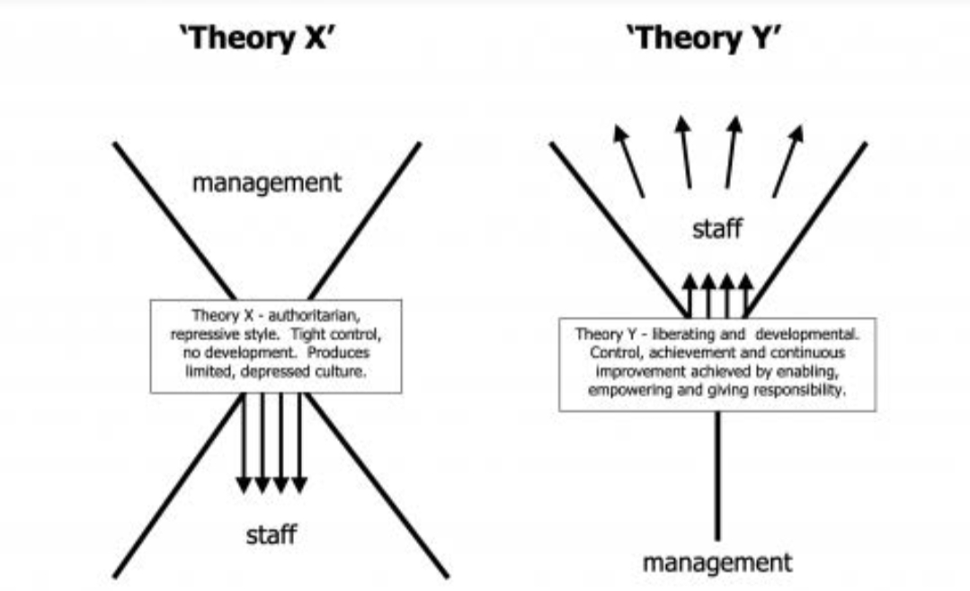

CHRIS ARGYRIS:
According to Argyris, during maturation, the individual moves to a condition of greater independence, more achievements, musts and activities, longer time perspective and increased self control. Argyris claimed that the rigid structure and stringent rules of a bureaucracy block normal maturation, encouraging employees to become passive and dependent and decreasing their job satisfaction and emotional health.
According to Chris, as the individual grows from infancy to adulthood, he has a tendency to move from passivity to activity; from dependency to independence; from lack of awareness of self to awareness of self. Argyris suggested the redesign of jobs. Organisation structures and content system and positive leadership styles for the effective motivation of employees. According to him managers must provide them with opportunities for a variety of experiences, give them responsibility and rely more on the employees, self-direction and self-content.
RENSIS LIKERT:
Rensis Likert proposed that effective organisation are those where supervisors focus attention on building effective work groups with high performance goals, so worker will support organisational goals and cooperate with superiors and peers. Likert advocated system 4" approach to organisational development in which organisational structure facilitates continuous interaction among various groups in the organisation, so work is controlled through mutual influence by employees. A "system 4" organisation is one in which superiors and subordinates trust each other in all matters, information flows freely throughout the organisation (upwards, downwards, laterally) employees participate in setting high but achievable goals, decisions are made at all levels, training is provided to upgrade personnel and the control mechanism stimulates workers to solve their own problems.
Likert conducted an extensive research at Institute of Social Sciences Michigan USA and based in the findings of research work he advocated four styles of management viz. Exploitative; Authoritative; Benevolent Authoritative; Consultative and Participative. Likert advocated participative style of leadership. He maintained that the use of supportive relationships: Group decision-making and high performance goals are must for achieving higher productivity. Likert put forward the supportive style of leadership as the new pattern of management. He concluded during the research that these are two distinct leadership orientations:
- Orientation towards employees with emphasis on interpersonal relations on the job.
- Orientation towards production with emphasis on technical aspects of the job.
He concluded that employee orientation coupled with general rather than close supervision to higher productivity, greater group cohesiveness, better morale, less anxiety and lower turnovers of employees.
HERBERT SIMON:
Herbert Simon is a decision theorist who views business and service institutions are networks of decision-makers. He analysed the human behaviour in terms of its value preference in decision-making process. Human behaviour, involves conscious or unconscious selection of particular alternative which physically possible and organisationally effective. The selection of a choice refers to preference course of action over other courses of action. In any mechanised action, the choice and the action directly related. The decision-making process involves three important phases of activities. These are:
1 Intelligence activity
2. Design activity
3. Choice activity
Intelligence activity: Involves finding, access to taking decision, for which executive has to analyse the organisational environment and identify the conditions that need decision. He likes the alternative strategies for problem solving.
Design activity: Involves development of alternatives to do a particular job. Here also the executive identifies the merits and demerits as well as problems involved in each of the alternatives, determining likely consequences of each alternative.
Choice activity: In this stage, decision-maker should choose or select one of the alternative or course of action, keeping in view the organisational goals. Here, executive evaluates consequences and selects the course of actions.
Simon advises that work decisions should be made at all levels of an organisation and that each decision be based on premises about people as information processors. He contrasts two approaches to decision-making; optimising, the approach applied by so called "economic man" and "satisfying”, the method used by so called "administrative man"
Economic man is completely rational and so uses optimising decision strategy to seek greater possible gain from each action. Whereas administrative man uses a satisfying method, in which the manager looks for the one that is good enough to satisfy a set of minimum criteria. Economic man is a ratio decision-maker and is expected to visualise all possible problem solutions and product all consequence of every action. An administrative man is willing satisfy, realising his perception of the use single rules of thumb to guide decision-making.
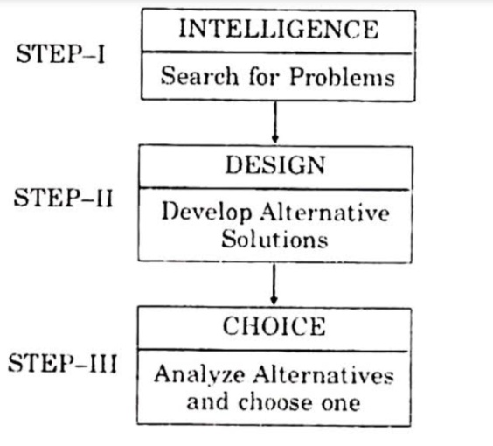

CHESTER I BARNARD:
Chester Barnard viewed organisation as a social system. A system is defined as a set of arrangements of things so related or connected to form a unity or organic whole. A system is compose of elements under one related and dependent upon one another but that wherein interaction form a unity whole. Barnard defined that there are three universals in each system:
- Willingness to cooperate
- Common purpose
- Communication
Barnard laid emphasis on organisations as cooperative systems. This conveys the very essence of group effort (He expanded the nature of formal structure and informal organisation (relationship) and then mutual inter dependency in a lucid way). It is the cooperation system that gives risk to formal organisations. He defines organisation as a system of consciously coordinated personal activities or forces. The organisation came into existence when:
- There are persons able to communicate with each other
- Who are willing to contribute action
- To accomplish a common purpose
Accordingly, the elements of organisation are communication, willingness and common purpose. The process of cooperation in an organisation requires the following to make it effective:
- The place where work is done
- The time which work is done
- The person with whom work is done
- The things upon which work is done
- The method or process by which work is done.
Barnard also laid emphasis on the acceptance of authority by others in an organisation. He defines authority as "the character of communication (Order) in a formal organisation by virtue of which it is accepted by a contributor or member of the organisation as governing the action he contributes" The acceptance of authority, in an organisation depends upon the zone of indifference, i.e. if the orders fall within these zones, they are unquestionably accepted. Barnard views helps understand the organisation in a better way.
HENRY MINTZBERG:
Mintzberg reports that the topical manager or administrator patrons ten roles; which includes those are interpersonal, they are informational and decisional role as given below:
- Interpersonal roles; are figurehead, leader and liaison. As a figure head, a manager represents his institution at ceremonial events such as conducting visiting dignitaries through the organisation and hosting other function. As a leader a manager hires and trains subordinates, schedules work hours, distributes assignments and direct group efforts to organisational goals. As a liaison a manager communicate with persons outside his or her vertical chain of command, to give or receive informations, maintain goodwill and integrate contribution from different work groups.

- Informational roles are monitor, disseminator and spokesman. As monitor a manager sees the environment for information needed a portrary other roles. As disseminator a manager transmit some recently acquired informations to superiors, peers, subordinates or clients. As a spokesman manager directs work related information to persons outside the unit or agency.

- Decisional roles are entrepreneur, disturbance or handler, resource allocator and negotiator. As Entrepreneur, a Manager develops new projects, or program to enhance agency image and welfare. As disturbance handler, a manager responds to high-pressure disturbances that threaten to disrupt the workforce and defeat goals. As Resource allocator, a manager determines what portion of agency is financial, personnel, supply and equipment resources should be allocated to each employee. In addition to allocating material resources, the manager allocates power, states, and time among subordinates, by developing work hard, making assignments and evolutionary performance. As Negotiator, a manager confers with persons inside or outside the agency to obtain concession or render agreement on pivotal issues.

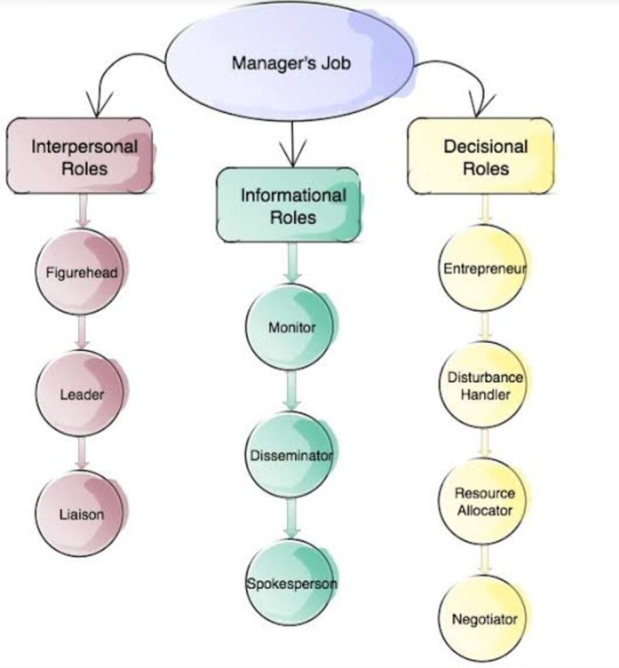

W OUCHI:
W Ouchi developed Theory Z" as a means for applying, Japanese management principles to American industry. This approach combines elements of Japanese and American management process in order to combine the strength of both. Japanese management methods derives from Executives, underlying philosophy about workers, work and product. This philosophy incorporates the following concepts:
- Lifelong employment on the same firm. Here workers are identified with organisation.
- Infrequent evaluation and promotions
- Non specialised carpet path development
- Implicit control of worker behaviour
- Collective decision-making
- Group responsibility for quality
- Holistic concern for the employees welfare
Yoshida presented following Japanese management principles for those nurses who extend to implement and Japanese management system:
- To improve service delivery. Each employee must start with a clear conception of what the most desirable service would include.
- A manager can eliminate the need for continuous inspection by building quality into the process or product in the first place.
- If employees do not understand the fundamental institutional purpose, single application of rules and procedures will not improve productivity and quality.
- The notion of replacing and unsatisfactory worker with a more satisfactory worker, requires that one perceives the total organisation as a complex that is composed of separate and replaceable parts
- Replacement of an unsatisfactory worker with a more satisfactory worker causes insecurity for remaining worker.
- Too close linking of responsibility to authority produces feeling of sectionalism and decreases loyalty to the organisation as a whole.
HENRY L. GANTT:
Taylor's ideas were further strengthened and developed by Henry Gantt and Gilbreth. Among the chief contribution of Gantt some of them are:
- Graphic chart: It helps in showing daily progress of production and thus facilitating production planning and control.
- Emphasis on the human element: It emphasises the respect for human nature and the development of talent and potential of workers. It amounts to directing their development instead of driving them.
- Industrial democracy: It amounts the organisation of industry in such a way that each individual has an equal opportunity to function at his highest capacity.
- Social responsibility: It emphasises that the business system must accept its social responsibility and devote itself primarily to service. Gantt also brought out that the responsibility of management is to teach and train workers to become more skilled, for better work habits and more dependability.
OLIVER SHELDON:
Oliver recognised that a company should play an important role as a part of socially rather that a means of earning. Better working conditions and efficient management are some of the important factors.
HENRY DENNISON:
Dennison developed the concepts of motivation, leadership, team work, etc.
ALVIN BROWN:
Alvin concentrated on the evaluation of the principles of delegation of authority.
MONEY AND REILEY:
They evolved the logical framework for the theory of organisation by presenting certain principles of organisation which occupy an important place in the modern theory of organisation and management.
RESEARCH STUDY:

Khomami M. H. and Rustomfram N. conducted a comparative study in perception of staff nurse and hospital management in a trust hospital of Gujarat, India, in May 2019.

Abstract

Background and Objective: While efficient use of resources and cost control is the responsibility of hospital managers, it is the duty of the nurses to carry out patient care and provide high-quality services. The aim of present research was to study the perception of staff nurses and nurse managers about nursing efficiency in patient care in a trust hospital.

Materials and Methods: This quantitative and explanatory research has been done on staff nurses as well as nurse managers in a 550-bedded trust hospital in rural Gujarat of India. Data collection tool was a researcher made questionnaire and the data collection method was interview schedules for staff nurse and nurse managers. The total number of staff nurse in this hospital was 450 including 50 nurse managers.

Results: Staff nurses had shown dissatisfaction regarding managers’ practice and stated some aspects of managers practice which needed to improve such as keeping competitive salary for staff nurse, providing counseling system to supporting nursing practice, better recognition and acknowledgement system, better job security, providing supportive managerial style, better unit size and Applying vacation system.

Conclusions: There was a difference between staff nurses’ perception and nurse managers’ perception regarding professional characteristics for nursing profession and factors, which affect nursing efficiency in patient care (with 95% confidence interval and P < 0.05).
CONCLUSION:
In current clinical settings, effective clinical management ensures a high-quality health care system that consistently provides safe and efficient care. It is useful for health care professionals to be able to identify the management styles and theories relevant to their nursing practice. Being adapted in recognizing these theories not only enables nurses to develop their skills to become better managers but also improves relationships with colleagues and managers who have previously been challenging to work with.

BIBLIOGRAPHY:
- Vati Jogindra. Applications of management theories. Principles and Practice of Nursing Management and Administration. 1st ed. 2013. Jaypee brothers medical publishers (P) Ltd. 23-45.
- Clement I. Introduction of management in nursing. Management of Nursing Services and Education. 2nd ed. 2015. Reed elsevier India (P) Ltd. 17-19.
- Basavanthappa BT. Concepts of administration. Nursing Administration. 2nd ed. 2009. Jaypee brothers medical publishers (P) Ltd. 105-118.
- Basavanthappa BT. Introduction to management in nursing. Nursing Administration. 1st ed. 2009. Jaypee brothers medical publishers (P) Ltd. 10-26.
- Kumara Neelam. Introduction to management in nursing. A Text Book of Management of Nursing Services and Education. 1st ed. 2014. S. Vikas and Company (Medical publishers). 9-18.
- Homa Mosaffay Khomami and Nasreen Rustomfram. Nursing efficiency in patient care: A comparative study in perception staff nurse and hospital management in a trust hospital. Journal of Family Medicine and Primary Care [Internet]. May 2019; 8(5): 1550-1557. Available from: https://doi.org/10.4103/jfmpc.jfmpc_37_19

