CONTENTS:
- Introduction:
Definition
Classification
2. History of lasers in dentistry
3. Fundamentals of Laser
Laser physics
Characteristics of laser light
4. Application of Lasers in endodontics
  - Management of post endodontic pain
  - Diagnosis of dental pulp vitality
  - Pulp capping and pulpotomy (Vital pulp therapy)
  - Cleaning and shaping of root canal system
  - Root canal irrigation disinfection.
  - Broken Files Removal
  - Fiber Posts Removal
  - Root Development Acceleration
5. Hazards
6. Conclusion
7. References

INTRODUCTION

The employment of current technologies to enhance treatment methods has been most beneficial in the field of dentistry. The use of lasers in endodontic treatments and research has grown significantly over the past few years since Maiman developed the ruby laser in 1960 and Weichman first used it in endodontics in 1971. In order to reduce the likelihood of endodontic therapy failing because of the intricacy of the root canal system, lasers have been studied. Additionally, it has been used therapeutically for the direct irradiation of the root canals or as an adjuvant to irrigants inserted into the canals, in conjunction with a photosensitizer (antimicrobial photodynamic treatment), and for the management of pain (photobiomodulation).(1) (2)
Definition of the Laser:
Lasers are devices that produce beams of coherent and very high intensity light. The word LASER is an acronym for Light Amplification by Stimulated Emission of Radiation. The laser makes use of processes that increase or amplify light signals after these signals have been amplified by other means.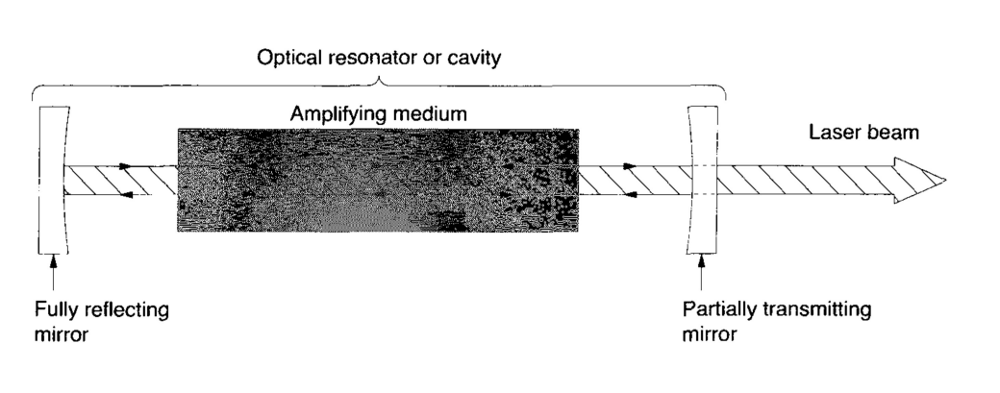Classification of Lasers:(Figure 1.3)
I. According to the wavelength: (Table 1.1)
1. UV (ultraviolet) range:140 – 400 nm
2. VS (visible spectrum) – 400 to 700 nm
3. IR (infrared) range: >700 nm.
II. According to clinical applications: (Table 1.2)
- Soft tissue applications.
- Soft and hard tissue applications. (also called all tissue lasers)
- Laser for Low level therapy.
- Laser for diagnosis.
III. According to the transportdevice
- Articulated arm (reflect type)
- Hollow waveguide
- Fiber optic cable
IV. According to sort of lasing medium:
E.g. Erbium: Yttrium Aluminium Garnet.
V. According to sort ofenergetic medium used:
1. Gas
2.Solid.
3. Semi-conductor or dye lasers.
VI. According to operation mode
1. Continuous wave lasers
2. Pulsed lasers.
VII. According to pumping scheme
1. Optically pumped
2. Electrically pumped laser.
VIII. According to degree of risk to pores, skin or eyes following inadvertent exposure, lasers can be further classified as:
Class I: (< 39mw) No threat of biologicaldamage.
Class II: (< 1 mw) The output could harm a person if they see the beam for a long period of time.
Class IIIA: (<500mw) Can cause injury when the beam is received by optical instruments and directed into the eye.
Class IIIB: (<500mw) Causes injury if viewed directly, even before blinking can occur.
Class IV: (> 500mw) Direct viewing and diffuse reflections can cause permanent damage of eye including blindness.(4)(5)
There are currently 20 distinct indications for using different dental lasers on soft tissue and hard tissue. Some lasers have been approved for use in soft tissue procedures. Coronal pulp removal, pulpotomy, and coagulation of extraction sites are all included in this. surgical procedures on the soft tissues of the mouth, such as sulcular debridement, aphthous ulcer therapy, and herpetic lesions.
Applications for hard tissue include bone cutting, shaving, contouring, and resection, as well as the preparation of cavities, roughening of the enamel, preparation of the tooth to allow access to the root canal, apicoectomy, and root canal cleaning, including expansion.
Measurements of blood flow and endodontic orifice location can both be diagnosed using lasers.. {7}

History
An intriguing illustration of how fundamental physics makes its way into clinical practice is the development of laser technology from Planck's 1900 birth of modern physics to its most recent medicinal frontiers.(1)
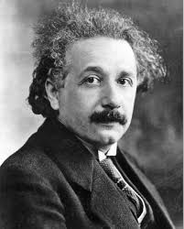
The earliest development of lasers was influenced by articles by Albert Einstein that discussed the behavior of electrons inside of atoms. Einstein created a broad theory of process in 1918. This hypothesis states that electromagnetic radiation is emitted and absorbed by atoms. This theory served as the foundation for lasers and influenced the development of current quantum electrodynamics..
Figure 1: Albert Einstein
Atoms naturally possess the ability to spontaneously produce electromagnetic waves without the need for outside assistance. Einstein postulated that it was feasible to energize an atom's electrons in order to produce light with a specific wavelength. An additional light with the same wavelength as the obtained wavelength would serve as the stimulation. Rudolf Ladenburg confirmed Einstein's forecast, but it wasn't until the early 1950s that anyone seriously considered creating a device based on that phenomena. Einstein only defined the stimulated emission; nevertheless, amplification of the previously mentioned stimulated emission is also required in order to construct a laser..
The notion of amplification of the stimulated emission was developed by Alexandrovich and two of its pupils in a Soviet patent, but it was not patented until 1959, so it had no impact on the work of the other researchers.
In 1951, Charles Hard Townes proposed the circumstances necessary to enhance the stimulated emission of such waves. He suggested James Power Gordon write his doctoral thesis on this topic under his supervision. Townes, Gordon, and Herbert Jack Zeiger collaborated to construct Columbia's first maser three years later.. (2)
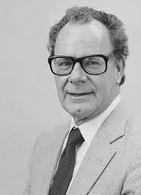
American physicist Gordon Gould (Fig. 2) was inspired by Towne's concepts for the maser and set out to build a machine that could emit light rather than microwaves. He began to outline his own plan for creating a similar gadget that he would term a laser. He made some predictive alterations as he was working on the laser's development. He emphasized that the second law of thermodynamics states that a surface heated by a beam of thermal radiation from a source cannot be heated above the source's temperature rather than limiting the power of the laser. Gould was cognizant of the idea that the laser would be a non-thermal source of light and, therefore, it would ability to withstand temperatures that are a great deal higher than their own. This has the advantage of making steel meltable with a laser that operates at room temperature. He also stated in his notes that thermonuclear fusion may be produced by a laser beam with good focalization. He confirmed that online communications on the moon were possible using the laser. In Washington, D.C.'s Smithsonian Institution, the first page of Gordon Gould's notebook is on exhibit as a verified replica.
Figure 2: Gordon Gould
Without any assistance from the government, Townes and Schawlow at Bell Labs and Columbia University, respectively, developed their work on laser technology to completion.
In order to create a laser as quickly as possible, other scientific teams were also working very hard. Up until the late 1950s, no one had created a laser, despite the fact that Townes, Schawlow, and Gould (together with other Russian scientists) had submitted patent applications and written thorough papers.
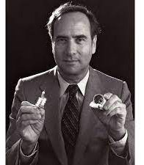
A scientist named Theodore Harold Maiman was employed by Hughes Airline during this time in Malibu, California (Fig. 3). Without assistance from the government, he also worked alone. He created a tiny gadget with a spiral flasher light encircling a cylindrical ruby gem. The ruby crystal has a diameter of roughly one centimeter. In order to achieve laser oscillation, the ends of the ruby bar were coated in a way that enabled them to function as mirrors. As a result, when the ruby crystal was subjected to light flashes that lasted for about one millionth of a second, it caused the creation of short laser light pulsations. Maiman informed the media of his first laser discovery on July 7, 1960. This laser was a very little instrument, measuring only a few centimeters. The pulse length of this early laser was barely a few millionths of a second. The electromagnetic spectrum contained an intensely red, practically invisible light that was being emitted. Delicate instruments were required to conduct tests to confirm that these light pulses were lasers and not fluorescence.
Figure 3: Theodore Harold Maiman
Many other researchers concentrated their efforts on the development of various types of lasers after Maiman's discovery attracted notice. As a result, the first gas laser was created in 1960. One of the two new types of lasers discovered in 1961 was by Gould's team at TRG Inc. Similar to Maiman's laser, Gould's also used optical pumping to work, but this time the active substance was a metal (cesiumvapor) rather than a crystal.
By 1965, a wide range of different wavelengths of laser activity had been examined. The true advancement in laser technology had begun around 1962. Since the discovery of lasers, numerous scientific researchers have begun to investigate the various applications of lasers. One of these explorations consisted of calculating the distance from different objects so that the army could use them to determine the enemy’s exact position.
Different types of gas, including nitrogen, CO2, and He-Ne, served as the medium for the first generation of lasers. The He-Ne laser being used right now has a wavelength of 633 nm. When neodymium lasers were first described in 1961, calcium-tungstate, not yttrium-aluminum-garnet (YAG), served as the laser's crystal. Other gas-based lasers were built using CO2 by Patel and Argon by Bridges.
Almost all facets of daily life employ lasers on a regular basis. Lasers enthusiastically took control of their position in medicine.Some of the developing companies quickly realized the potential of lasers, particularly in the medical disciplines, due to their capacity to burn through materials.

FUNDAMENTALS OF LASER

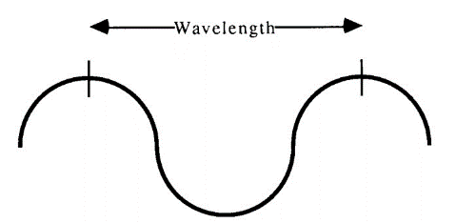
Due to the way electromagnetic radiation is produced, laser light has extremely particular characteristics. Understanding the makeup of light was the foundation for the development of lasers. Modern physics says that light waves are made of tiny energy particles called photons that move through space. They are both waves and particles, giving them a dual character. Each light wave contains both an electrical and a magnetic component, making all light a part of the electromagnetic (EM) spectrum. Their unique wavelength, which is the precise distance between each peak measured from one to the peak next to it, serves as a means of identification.
Figure: 1
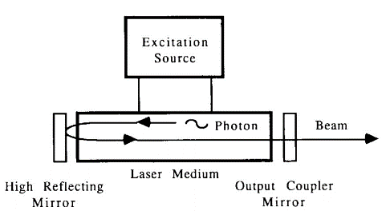
Different atoms can be used in the laser medium to produce photons of various diameters, or wavelengths. These medium can either be solid or gaseous. The atoms need to be stimulated in order to move their electrons to higher orbits after the choice of medium has been made. To begin lasing, a population must be inverted, meaning there must be more atoms in the excited state than in the ground state. Utilizing electricity, light, or radio waves will cause this excitement. The accumulation of photons can be fairly significant if the amplifying photons are imprisoned in a cavity arranged between two reflective mirrors. When a mirror is only partially transmissive, a laser beam can be produced when a beam of photons escapes (fig. 2).
Figure:2
Understanding the fundamental physics ideas is necessary to comprehend why laser light has particular qualities, and these ideas are discussed in this chapter.

LASER CONCEPTS:
Spontaneous and stimulated emission:
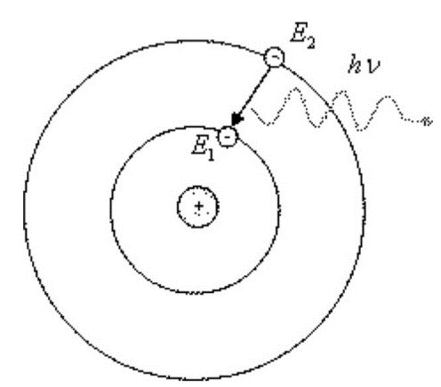
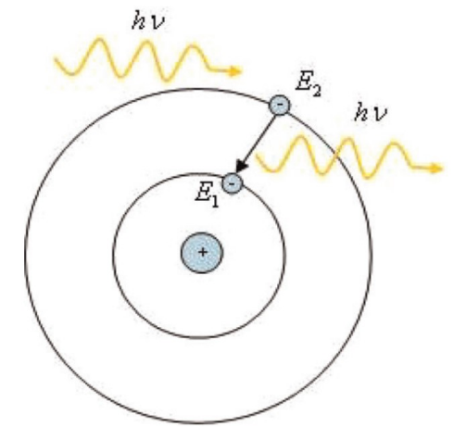
Emission that is both spontaneous and induced: Most atoms naturally live in a low energy (ground) state. When they take in thermal, optical, or electrical energy, electrons in their ground state can be stimulated to a higher energy state. When an unstable electron in a higher energy orbit attempts to return to the ground state, it releases the defined energy it has stored as a photon (particle of light). The wavelength or color of the light emitted depends on the quantity of energy released. Spontaneous emission is what this is (Fig. 3).
FIGURE: 3
The photon released during spontaneous emission travels in an arbitrary direction.
If a photon of the right energy collides with an electron that is already excited, the electrons fall to a lower orbit and emit a photon. Two photons with the same energy or wavelength are produced when the stimulating photon is not absorbed and continues on its path. This phenomenon is known as stimulated emission (Fig. 4).
FIGURE: 4
Spontaneous emission is prevalent in nature. Atoms attempt to achieve the lowest energy feasible states and are excited for such a little period of time that there is little likelihood that the proper photon will occur and cause stimulated emission.(Fig. 4)
Population inversion:
More electrons must be in the higher energy level for stimulated emission to predominate. We call this population inversion. Pumping electrical or light energy into the population of atoms (the gain medium) causes population inversion by elevating their energy. Population inversion happens when the laser is turned on, the gain medium is pumped, population inversion takes place, and then individual atoms in the population experience spontaneous emission, emitting photons in all directions. An atom with electrons at the higher level will emit a second photon that is traveling in the same direction, phase, and wavelength after a photon passes by it.
Amplification:
The gain medium is positioned between two mirrors in the penultimate step to enable the photons to continue amplifying. One of these photons is incidentally in the axis of the two mirrors when it is emitted, and it is reflected back into the gain medium to continue the amplification. Each photon that is reflected back generates stimulated emission, which leads to an increase in the number of photons and an avalanche of coherent light as a result.
CHARACTERISTICS OF LASER LIGHT:
Monochromaticity: Laser light is said to be monochromatic if it only contains one particular wavelength of light. Depending on the laser, this wavelength of laser light may be very visible (red, blue, green, or yellow, for example) or invisible (ultraviolet or infrared).

Coherence Laser: Wavelengths of laser light can be referred to as "organized." The photons in laser light "move in step" with one another as a unit. The ability of laser light to provide a large amount of energy in a narrow beam is due to its coherence

Laser light has a strong sense of direction. Laser light is produced in narrow, brilliant beams that are exceedingly tiny and focused.

OTHER PROPERTIES:

Focalization: Compared to other types of light, laser light can be focussed very effectively because of its parallelism. Focused laser beams have the ability to cover a very small area with extremely high energy levels.

The majority of health sciences lasers use Brewster's angle to emit polarized reflection laser light. The polarization angle, also known as Brewster's angle, is the incidence angle at which a transparent dielectric surface completely transmits light of a specific polarization without reflection.
APPLICATIONS OF LASERS

- The prevention and control of pain during or after endodontic treatment are frequently crucial for the patient's comfort and quality of life. Pain is a prominent concern for patients. Dental discomfort is frequently brought on by endodontic illnesses such acute apical abscess, irreversible pulpitis, and apical periodontitis. Both pre-operative and ongoing discomfort are significant contributors to endodontic treatment failure. Post-operative endodontic pain, a common consequence following endodontic therapy, was shown to have a prevalence of up to 40%, and the management of post-operative pain was considered an important goal of endodontic therapies.The genesis of pain also has something to do with the chemical, mechanical, or microbiological elements that could harm pulp or periapical tissue. For instance, bacteria, intra-canal dressings, and dental debris all have the potential to irritate and inflame the tissues around the radicle. Unexpected pain results from the nociceptor being activated by inflammatory mediators (leukotrienes, prostaglandins, bradykinin, etc.). Additionally, bacteria are understood to be the primary cause of post-operative pain. Combining root canal disinfectants with mechanical equipment has become the standard strategy in clinical practice as part of the traditional approach to overcome the microbiological issue.Unfortunately, because they can remain in closed root canals for a long time, some drug-resistant germs are challenging to get rid of. Consequently, the use of conventional chemomechanical preparation may result in a persistent risk of inflammation and postoperative discomfort. While doing so, lasers could penetrate deeper layers of dentin to reach germs without causing any harm to the tooth's structure.
- Laser therapy has been proven to increase the production of beta-endorphins, immunoglobulins, lymphokines, and anti-inflammatory prostaglandins while decreasing the production of substances that cause pain, such as substance P, histamine, dopamine, and prostaglandins.
- Diagnosis of dental pulp vitality: Vascular supply is the most precise indicator of pulp life. a potential test Assessing the vascular supply is a method of determining the health of the pulp that depends on light passing through the tooth. In order to evaluate pulpal blood flow on human teeth, Gazelius and Olgaret developed Laser Doppler flowmetry (LDF) in 1986. It is a trustworthy, non-invasive, impartial, painless, semi-quantitative approach for determining pulpal blood flow.
- Vital pulp therapy: Preserving the pulp's vitality during endodontic treatment is a key goal. Vital pulp therapies, including as pulp capping and pulpotomy, are alternatives to root canal therapy that offer less invasion and a higher cure rate for the carious exposed pulps. In order to apply the therapeutic chemicals either directly or indirectly to the pathologically exposed pulp, a procedure known as "pulp capping" is utilized. Additionally, pulpotomy involves the preservation of the Hygeian radicular pulp and the removal of the coronal infected component of the pulp.Drugs that are frequently utilized include calcium hydroxide, mineral trioxide aggregate, and formocresol. Since many years ago, calcium hydroxide has been utilized extensively for pulp capping treatment. But it should be emphasized that this method frequently yields a range of surprising results. Additionally, mineral trioxide aggregate was shown to be effective but is rather pricey. In the meantime, the long-term outcomes could be impacted by formocresol's cytotoxicity, carcinogenicity, and mutagenicity. As a result, alternative options including laser-assisted therapy are also appropriate.
The fibrous matrix and dentin bridge could form more quickly if laser irradiation is used. Additionally, the exposure of the exposed dental pulp tissues to laser irradiation may encourage the development of lectins and collagens, which would result in wound healing with respect to the pulp. In the pulp-capped teeth of rat models, it has been shown that a low-power laser can trigger a growth factor complex for dentin regeneration. High-level lasers can stimulate pulp healing by raising the temperature, but low-level lasers can control inflammation and the healing process. Low-level laser therapy has also produced positive results in the research as an adjuvant pulpotomy substitute.

Lasers in Pulp Capping:

Lasers in Pulpotomy :In a traditional pulpotomy procedure, the dentist uses a spoon excavator to remove the putrescent coronal pulp after amputating it with a round bur at a slow speed. Moist cotton pellets containing ferric sulfate, formocresol, or other coagulative agents are added to the pulp chamber after it has been flushed and dried. The use of lasers could assist in the procedures by ablating the pulp to the canal level after full hemostasis, as well as in stimulating the coagulation and healing of the pulp.Laser use may have an impact on how well the pulpotomy procedure for primary teeth works clinically.Due to the laser's low noise and reduced contact between the tooth and mechanical instruments, which was especially appealing to pediatric dentists, it was introduced to address the challenges of managing the behavior of children undergoing dental procedures as well as the varying levels of cooperation. As a result, the outcomes of pulpotomies using an Er:YAG laser in primary molars with extensive caries damage were assessed. The pulp tissue at the root canal opening was placed with the 1.3 mm laser fiber tip 1 mm away for irradiation.The Er:YAG laser group had a quicker hemostasis time and less overall treatment time than the traditional low-speed ball drilling pulpotomy, as well as greater clinical efficacy during long-term follow-ups. It was also thought that low- or high-power diode laser irradiation was a good choice for treating primary teeth. Regarding mineral trioxide aggregate and laser therapy, a randomized trial on deciduous molars pulpotomy resulted in a clinical success rate of 100% for the mineral trioxide aggregate group and low-power diode laser mineral trioxide aggregate group, while 87.5% of the high-power diode laser mineral trioxide aggregate group avoided clinical failure.In another study, formocresol and low-level laser therapy were compared for the goal of pulpotomy in primary teeth. Although the difference was small, low-level laser therapy was found to have advantages. Regarding permanent teeth, an Er,Cr:YSGG laser was used in conjunction with a mineral trioxide aggregate in a clinical and in vivo experiment to treat permanent immature molars. It was discovered that applying mineral trioxide aggregate jointly had a somewhat higher success rate than doing so alone.

- Root canal irrigation For all this time, two procedures—mechanical instrumentation and irrigation system disinfection—have been crucial to the cleaning and antisepsis of root canals, which is essential to a successful root canal procedure. However, due to the extremely complex architecture of the root canal system, canal shaping via instrumentation is mostly seen as a way to gain access to the apical anatomy at the moment. So, in this sense, irrigation is crucial for the prevention of infections.
Many years ago, root canal irrigation was supplemented with laser-activated irrigation (LAI). The LAI mechanism uses fiber tips to create tiny cavitation bubbles in irrigation solutions, whose volumetric oscillation can lead to high-speed fluid motion and the formation of biofilms as well as other contents flowing vertically in the root canals. The substances that are stuck to the root canal walls come off as a result of these repeated, swift movements, and are eventually flushed out of the canals.
Photon-induced photoacoustic streaming (PIPS), a newly developed LAI technology, was first shown for clinical usage in 2012. It provides features of low energy (10 or 20 mJ) and short pulse length (50 s) as compared to standard LAI systems. By inserting its working tip in the crown side of root canals, this technique also has the capacity to prevent heat injury to the periapical tissue and root canal walls. Shock wave-enhanced emission photoacoustic streaming (SWEEPS), a technique developed to improve the PIPS method's debriding effectiveness. SWEEPS functions similarly to extracorporeal shock wave lithotripsy in terms of how it operates.A second pulse is sent into the liquid as the cavitation bubble starts to deflate, creating a second cavitation bubble. The initial cavitation bubble then collapses violently as the second one speeds its deflation, creating a shock wave in the process. The debris connected to the walls is also removed by shock waves that are emitted by collapsing secondary cavitation bubbles that are near to the root canal walls.
In comparison to LAI utilizing a Nd:YAP laser, studies have indicated that the effectiveness of passive ultrasonic irrigation for the eradication of bacteria exhibited more advantages in the coronal and middle thirds of the root canals, while both of them produced effects similar in the apical third. None of these adjuvant techniques could entirely remove the biofilm components in root canal systems, much like accumulated hard tissue debris removal. The enhanced apical extrusion of LAI is one of its drawbacks. One of the factors that contributes to post-operative inflammation and pain, which might postpone the repair of periapical tissue, is the apical extrusion of debris, pulp tissue, solutions, bacteria, and their metabolites. According to certain studies, irrigation activated by the Er:YAG laser or when compared to needle irrigation, the Nd:YAP laser generated more trash to extrude.

- Root canal shaping : Currently, rotary and manual devices are usually used for root canal shaping. The root canal walls should be free of the smear layer created during the treatment. Furthermore, the germs that were present there will likely have an impact on the treatment's final efficacy. It was discovered that laser irradiation could assist form root canal walls and remove the smear layer once lasers were developed. The mechanism of lasers in the context of sculpting root canals is that laser irradiation can evaporate water in dental hard tissues and ablate the surrounding tissue, opening the dentinal tubules and removing the smear layer as a result. In light of this, an in vitro investigation showed that when the space between the dentin and the tip was small, the Er:YAG laser could vaporize dental hard tissues, expose dentinal tubules, and remove the smear layer. Additionally, the Er:YAG laser might lessen the likelihood that dentine sutures will form, preventing root fractures.

Broken Files Removal : There are two methods for removing separated instruments that have become stuck in the apical region: either by directly irradiating the instrument with lasers to melt it, or by irradiating the dental tissue nearby with lasers to create a bypass that is then removed by other instruments. Both approaches have significant drawbacks, though: melting metal instruments requires high-energy lasers, which can heat up nearby tissues; melting tissues around the instruments doesn't, but when applied to root canals with curved or thin walls, it can easily result in lateral perforation. Despite these restrictions, Yu et al. performed an in vitro experiment to test pulsed Nd:YAG's potential for removing damaged files from root canals.Nd:YAGlaser, and adopted the method of creating a bypass in this in vitro study. They reported that an Nd:YAG If steps were made to regulate the temperature rise, such as coupled pressurized air and water spray, laser could be effective for broken file removal. Using lasers to remove damaged files has not been the subject of many investigations in recent years. It must be noted, nonetheless, that this approach has the potential to be clinically useful and merits further investigation.

- Fiber Posts Removal :Several steps are made to strengthen the bonding between the fiber, resin cement, and dentin in order to improve the aesthetics and survival rate of the present root canal procedure. Endodontically treated teeth now resemble natural teeth more closely thanks to the semi-transparency of glass fiber posts, which makes up for the cosmetic drawbacks of carbon fiber posts. However, removing the translucent glass fiber posts that closely resemble the dentin and cling to it after retreatment might be difficult for dentists in order to preserve as much of the dental tissue as possibleIn addition, since root canal therapy has a failure rate and patients increasingly want to maintain their own teeth, more and more patients need retreatment after their initial root canal treatment fails.

Clinically, mechanical or ultrasonic techniques are frequently used to remove glass fiber posts. However, these mechanical techniques can result in a clear loss of tooth structure, and the heat produced during the procedure might harm the dental tissue as well. While ultrasonic techniques can lessen the loss of tooth structure compared to mechanical techniques, they can also create heat and microcracks, which raise the possibility of tooth fracture. Lasers have recently been employed to remove fiber posts. Deeb et al. discovered that the Er:YAG laser could successfully remove fiber posts when utilized with an endodontic tip in SWEEPS mode and a 2 W, 15 Hz, 135 mJ, 50 s Er:YAG laser. They also discovered that compared to ultrasonic devices, lasers induced fewer temperature increases and microcracks. Furthermore, compared to the ultrasonic device, the lasers' removal speed was five times faster. According to a micro-CT analysis from a different in vitro investigation, it has been demonstrated that the Er,Cr:YSGG laser (2.5 W, 20 Hz, MZ5 endodontic tip) may successfully remove the glass fiber posts while also retaining more dental tissue . The precise consequences of this method haven't yet been confirmed because there haven't been many studies specifically focused on removing fiber posts using lasers.

- Root Development Acceleration : Trauma and decay can cause the pulp tissue to necrotize, which can hinder normal root formation and result in an open apex. The gold standard for the treatment of teeth with an open apex and pulp necrosis, MTA is most frequently utilized to induce an apical barrier. The dentinogenesis and apexogenesis of teeth in rats and dogs can be sped up by combining the GaAlAs diode (810 nm) laser with MTA, according to research.Three healthy, 4-6-month-old dogs were chosen for the study by Bahman et al. The 36 teeth used in this in vivo study were split into two groups: calcium hydroxide with GaAlAs diode laser (470 mW/cm2, 59 J/cm2) irradiation and calcium hydroxide without laser irradiation, respectively. The results of this study showed that the effects of calcium hydroxide and laser irradiation on the apexogenesis process were favorable. Lasers therefore have the potential to be used in conjunction with other methods to encourage the formation of roots. However, additional clinical research as well as several animal studies are required to confirm their efficacy in the future

LASER HAZARDS

- Eye Hazards: When the use of suitable eyewear is not adhered to, the laser beam may harm the eye through direct exposure or reflection. Due to water's comparatively low absorption at wavelengths in the visible to near infrared (400–1400 nm), these wavelengths can cause retinal burns in the vicinity of the optic disk. Additionally, the red or green cones in the retina may become damaged by the visible wavelengths, which can result in color blindness.

- Nontarget Tissue Hazards (Oral Tissues and Skin): Depending on the laser's wavelength, absorption capacity, power density, exposure time, and spot size, skin injury may be possible. With visible-wavelength lasers, photosensitive skin reactions can occur; with medium- and far-infrared lasers, excessive dryness, blistering, or burning can.

- Chemical and Infective Hazards The laser beam can produce plume damage. “Plume” is defined as the gaseous by-products and debris from laser-tissue interaction, . It may appear smokey or be totally imperceptible to the naked eye. Due to the aerosol produced by the laser-tissue interaction, the plume could be dangerous. Human immunodeficiency virus, human papilloma virus, carbon monoxide, hydrogen cyanide, formaldehyde, benzene, bacterial and fungal spores, cancer cells, and, when removing composite resin materials, methyl methacrylate monomer, are just a few of the laser-generated airborne contaminants (LGAC) that may be present. As a result, it is necessary to wear protective surgical attire and fi ne-mesh face masks that can filter out 0.1 micron-sized particles.

Conclusion

The usage of lasers in the field of endodontics has expanded dramatically over the last several years. The different applications of lasers in endodontics are discussed in this chapter, which offers quick, painless, and nontraumatic treatment. However, more research is needed before lasers can be used in the future.
References
- Eugenia Anagnostaki, Valina Mylona, Steven Parker,Edward Lynch and Martin Grootveld;Systematic Review on the Role of Lasers in Endodontic Therapy: Valuable Adjunct Treatment. Dent J (Basel). 2020 Sep; 8(3): 63. doi: 10.3390/dj8030063
- Ramu Shobhana, Arumugam Karthick, Suresh Mitthra, Balasubramaniam Anuradha; Applications of laser in the field of Endodontics: an update, European Journal of Molecular & Clinical Medicine ISSN 2515-8260 Volume 07, Issue 10, 2020.
- Lasers Fundamentals : William T Silfvast; 2nd edition, Cambridge University Press. ISBN: 0 521 83345 0.
- Lasers in Endodontics: A Review Dr. Anil K Tomer, Dr. Ayan Guin, Dr. Shivangi Jain, Dr. Geetika Sabharwal, Dr. Nivedita Saini; International Journal Dental and Medical Science Research. Volume 3, Issue 5, pp: 14 1614 25.
- Giovanni Olivi, Roeland De Moor, Enrico DiVito; Lasers in Endodontics: Scientific Background and Clinical Applications. ISBN 978-3-319-19326-7, DOI 10.1007/978-3-319-19327-4.
- Emrah Cetin, Hicran Donmez, Ozkan, Senem Gokcen, Yigit Ozer. Dental Lasers and Application Fields in Endodontics. Meandros Med Dent J 2017;18:1-7.
- Joel M White; Critical appraisal, Lasers for use in dentistry. Article in Journal of Aesthetic and Restorative Dentistry · February 2005.
- Carlos de Paula, Eduardo and Sheila Gouw-Soares, The use of Lasers for endodontic applications in dentistry, 2001.
- History of lasers; Andreas J. Gross, Thomas R.W., Herrmann. World J Urol (2007) 25:217–220 DOI 10.1007/s00345-007-0173-8.
- Laser Dentistry: Current Clinical Applications; Prof. Aldo Brugnera Junior & Prof. Samir Namour. ISBN 978-1-62734-085-4.
- Huang, Qin, Zucen Li, Ping Lyu, Xuedong Zhou, and Yi Fan. 2023. "Current Applications and Future Directions of Lasers in Endodontics: A Narrative Review" Bioengineering 10, no. 3: 296. https://doi.org/10.3390/bioengineering10030296.

