Seismic Strengthening Analysis & Design (Retrofitting) of Educational Building at Nepal
Pramod K R¹
Asst.Prof Civil Engineering
pramodraghu619@gmail.com,
Sapthagiri College of Engineering, Bangalore-57

N Lakshminarasimaiah²
Professor & Head of the Civil Engineering
laknar_05@yahoo.com
APS College of engineering,
Bangalore-82

M.B. Ananthayya³
Professor & Head of the Civil Engineering
ananthayya.mb@saividya.ac.in
SVIT College of engineering, Bangalore-64

Latha M S⁴
Professor & Head of the Civil Engineering
lathamsm@yahoo.co.in
SVCE College of engineering, Bangalore-57

Abstract
Although the timing of a seismic event can be anticipated, it is a given that the damage it causes will be severe. The danger of earthquakes is substantially higher in Nepal than in many other metropolitan centres in developing nations. Uncontrolled development, subpar design, and poor building techniques have all contributed to the seismic risk. In the event of a significant earthquake, there will be significant property damage and loss of life. In order to minimise structural damage and lower mortality in the event of a major earthquake, it is strongly advised that buildings in cities like Kathmandu be designed and built with adequate care for the seismic load. Due to this, the design and construction of the structure have been prone to seismic zone.
I Introduction
One of the most feared natural calamities is an earthquake. earthquakes are waves that vibrate the earth's surface as a result of disturbances deep within the planet. It is a natural occurrence that depends on a number of variables. When it impacts an ever-increasing concentration of material goods and people, it becomes extremely destructive. Nepal experiences earthquakes frequently. This is so because Nepal is located in the Himalayan range, where tectonic plate collisions force the Indian and Eurasian plates to subduct. As a result, there has been an enormous buildup of strain energy, which has led to rapid breakdown of rock masses along the faults, which in turn leads to earthquakes. There have already been significant earthquakes in Nepal that have left a huge human and material toll.
Keywords- Retrofiting,Strengthening,SAP
Retrofiting design – background
The result of an earth shake manisfests incredible pulverization because of unpredicted seismic movement striking broad harm to incalculable structures of changing degree i.e either full or halfway or sligth. This harm to Designs in its turn cause a hopeless loss of the existence with countless setbacks. Subsequently scared tenants might decline to enter the structures except if guaranteed of the security of the structures. from future seismic tremors. It has been seen that greater part of such tremor harmed structures might be securely reused, on the off chance that they are changed over into seismically safe designs by utilizing a couple retrofitting measures. This ends up being a superior choice taking care of the financial contemplations and quick haven issues as opposed to substitutions of structures. Additionally it has frequently been seen that retrofitting of structures is by and large more practical when contrasted with destruction and reproduction even on account of serious underlying harm. Accordingly, seismic retrofitting of building structures is one of the main viewpoint for alleviating seismic risk particularly in quake inclined nations. The need of seismic retrofitting of structures emerges under two conditions: (I) tremor harm structures and (ii) quake weak structures that poor person yet experience extreme tremors.
Retrofitting Strategies
Various method used for retrofitting of reinforced concrete buildings Are:
1.Structural level (or Global)Retrofit Methods
Two approaches are used for structure-level Retrofitting.
i. Conventional method
This methods of retrofitting are used to enhance the seismic resistance of existing structure by elimination or reducing the adverse effect of design. It includes
Adding Shear walls
Adding Infill walls
Adding steel bracings
ii. Non-conventional methods
This methods of retrofitting are used to reduce the horizontal seismic forces.it includes
Seismic base isolation
supplemental damping device
2.Member Level (or Local) Retrofit Methods
Approaches Used for member level retrofit methods are:
i. Jacketing/confinements
ii. Jacketing of columns
iii. Reinforced concrete jacketing
iv. Steel jacketing
v. FRP jacketing
vi.Beam jacketing
vii. Beam-column jacketing
Adopted retrofiting Strategy : Reinforced concrete jacketing
Reinforced concrete jacketing can be used as a strengthening or repair method. Prior to its jacketing, damaged areas of the existing members should be rectified. In order to achieve a strong column-weak beam design, jacketing columns serves two main purposes: (i) increasing the shear capacity of the columns; and (ii) enhancing the column's flexural strength through the use of longitudinal steel of the jacket that is continuous through the slab system and anchored to the foundation. It is accomplished by inserting fresh concrete into the joints between the beam and column and passing new longitudinal reinforcement through holes drilled in the slab.
Details for reinforced concrete jacketing
Properties of jackets : 1. Match with the concrete of the existing structure 2. Compressive strength greater than that of existing structure by
5 N/mm^2 (50 Kg/cm^2), or at least equal to that of the existing structure.

Minimum width of jacket:
1. 10 cm for concrete cast in place and 4 cm for shotcrete
2. If possible, four-sided jacket should be used
3. Narrow gap should be provided to prevent any possible increase in flexular capacity

Minimum area of longitudinal reinforcement:
1. Spacing should not exceed six times of width of the new elements (the jacket in the case ) up to limit of 60 cm.
2. Percentage of steel in the jacket with respect to jacket area should be limited between 0.015 and 0.04
3. At least, a 12 mm bar should be used at every corner for a four-sided jacket.
Shear stress in the interfere:
chipping the concrete cover of the original member and roughening its surface may improve the bond between the old and new concrete.

Connector:
1. Connectors should be anchored in both the concrete such that it may develop at least 80% of the yeilding stress.
2. It is better to use reinforced bars anchored with epoxy resigns of grouts .
Spacing of ties: |  |  | S= | (Fy*d²)/(sqrtFck*tj)
 |  |  | Fy= | 500
 |  |  | d= | 10
 |  |  | Fck= | 25
 |  |  | tj= | 125
 |  |  | S= | 80
Provide spacing of ties 10mm dia @ 75 mm c/c.

II DESIGN DATA
1 |  |  |  | Building Type |  |  |  |  |  |  |  | : |  |  |  | Educational Building
2 |  |  |  | Type of structure |  |  |  |  |  |  |  | : |  |  |  | Frame Structure (Rigid joined Frame structure )
3 |  |  |  | No. of Storey |  |  |  |  |  |  |  | : |  |  |  | 4
4 |  |  |  | Concrete Grade |  |  |  |  |  |  |  | : |  |  |  | M 25
5 |  |  |  | Reinforcement Used |  |  |  |  |  |  |  | : |  |  |  | Fe 415 |  |  |  |  | For Existing column
 |  |  |  |  |  |  |  |  |  |  |  |  |  |  |  | Fe 500 |  |  |  |  | Retrofit Column
6 |  |  |  | Cement Used |  |  |  |  |  |  |  | : |  |  |  | Ordinary Portland Cement
7 |  |  |  | Load Taken
 |  |  |  | Class |  |  |  |  |  |  |  |  |  |  |  |  |  |  |  |  |  |  |  |  |  |  |  |  |  | 3 |  |  | kN/sqm
 |  |  |  | Kitchen, Laundaries & Laboratories |  |  |  |  |  |  |  |  |  |  |  |  |  |  |  |  |  |  |  |  |  |  |  |  |  | 2.5 |  |  | kN/sqm
 |  |  |  | Toilets & Bathrooms |  |  |  |  |  |  |  |  |  |  |  |  |  |  |  |  |  |  |  |  |  |  |  |  |  | 2 |  |  | kN/sqm
 |  |  |  | Corridore, Passage & Lobby |  |  |  |  |  |  |  |  |  |  |  |  |  |  |  |  |  |  |  |  |  |  |  |  |  | 4 |  |  | kN/sqm
 |  |  |  | Finishing Load |  |  |  |  |  |  |  |  |  |  |  |  |  |  |  |  |  |  |  |  |  |  |  |  |  | 1.5 |  |  | kN/sqm
8 |  |  |  | Design Philosophy - Limit State Design Confirming IS : 456-2000
9 |  |  |  | Analysis Software Used = |  |  |  |  |  |  |  |  |  |  |  |  |  |  |  |  | SAP 2000 |  |  |  |  |  |  |  |  | VER 16
10 |  |  |  | Earthquake Load Consideration = |  |  |  |  |  |  |  |  |  |  |  |  |  |  |  |  | IS 1893-2002
11 |  |  |  | Retrofitting Guidelines Consideration= |  |  |  |  |  |  |  |  |  |  |  |  |  |  |  |  | IS 15988-2013
 |  |  | Load Combination
 |  |  | Combination |  |  |  |  |  |  |  |  |  |  |  |  |  |  |  |  |  |  | 1 | = |  | (DL+LL)x1.5
 |  |  | Combination |  |  |  |  |  |  |  |  |  |  |  |  |  |  |  |  |  |  | 2 | = |  | (DLx1.2 + LLx1.2+ EQ1x1.2)
 |  |  | Combination |  |  |  |  |  |  |  |  |  |  |  |  |  |  |  |  |  |  | 3 | = |  | (DLx1.2 + LLx1.2+ EQ2x1.2)
 |  |  | Combination |  |  |  |  |  |  |  |  |  |  |  |  |  |  |  |  |  |  | 4 | = |  | (DLx1.2 + LLx1.2+ EQ1x-1.2)
 |  |  | Combination |  |  |  |  |  |  |  |  |  |  |  |  |  |  |  |  |  |  | 5 | = |  | (DLx1.2 + LLx1.2+ EQ2x-1.2)
 |  |  | Combination |  |  |  |  |  |  |  |  |  |  |  |  |  |  |  |  |  |  | 6 | = |  | (.9 X DL+1.5X EQ1)
 |  |  | Combination |  |  |  |  |  |  |  |  |  |  |  |  |  |  |  |  |  |  | 7 | = |  | (.9 X DL-1.5X EQ1)
 |  |  | Combination |  |  |  |  |  |  |  |  |  |  |  |  |  |  |  |  |  |  | 8 | = |  | (.9 X DL+1.5X EQ2)
 |  |  | Combination |  |  |  |  |  |  |  |  |  |  |  |  |  |  |  |  |  |  | 9 | = |  | (.9 X DL-1.5X EQ2)
 |  |  | Combination |  |  |  |  |  |  |  |  |  |  |  |  |  |  |  |  |  |  | 10 | = |  | (1.5 XDL +1.5 X EQ1)
 |  |  | Combination |  |  |  |  |  |  |  |  |  |  |  |  |  |  |  |  |  |  | 11 | = |  | (1.5 XDL -1.5 X EQ1)
 |  |  | Combination |  |  |  |  |  |  |  |  |  |  |  |  |  |  |  |  |  |  | 12 | = |  | (1.5 XDL +1.5 X EQ2)
 |  |  | Combination |  |  |  |  |  |  |  |  |  |  |  |  |  |  |  |  |  |  | 13 | = |  | (1.5 XDL -1.5 X EQ2)
 |  |  |  |  |  |  |  |  |  |  | Load Calculation
1 |  |  |  |  |  |  | A. Slab Load
 |  |  |  |  |  |  | Slab Thickness |  |  |  | 0.1 |  |  |  |  |  |  |  | 25 |  |  |  |  | 2.5
 |  |  |  |  |  |  | Floor finish |  |  |  |  |  |  |  |  |  |  |  |  |  |  |  |  | 1
 |  |  |  |  |  |  |  |  |  |  |  |  |  |  |  |  |  |  | Total |  |  |  |  | 3.5
 |  |  |  |  |  |  | B. Beam Load
 |  |  |  |  |  |  | L |  |  |  | B |  |  |  | Density |  |  |  |  |  |  |  |  | WEIGHT/M
 |  |  |  |  |  |  | 0.45 |  |  |  | 0.25 |  |  |  | 25 |  |  |  |  |  |  |  |  | 2.81
 |  |  |  |  |  |  | 0.35 |  |  |  | 0.25 |  |  |  | 25 |  |  |  |  |  |  |  |  | 2.19
 |  |  |  |  |  |  |  |  |  |  |  |  |  |  |  |  |  |  | Total |  |  |  |  | 5.00 |  |  |  |  | kN/m
 |  |  |  |  |  |  | C. Column Load
 |  |  |  |  |  |  |  |  |  |  | L |  |  |  | B |  |  |  | Density |  |  |  |  | H |  |  |  |  | WEIGHT
 |  |  |  |  |  |  | Column C1 |  |  |  | 0.3 |  |  |  | 0.3 |  |  |  | 25 |  |  |  |  | 3 |  |  |  |  | 6.75
 |  |  |  |  |  |  | Rc 500*500 |  |  |  | 0.5 |  |  |  | 0.5 |  |  |  | 25 |  |  |  |  | 3 |  |  |  |  | 18.75
 |  |  |  |  |  |  |  |  |  |  |  |  |  |  |  |  |  |  |  |  |  |  |  | Total |  |  |  |  | 25.50 |  |  | kN/m
 |  |  |  |  |  |  | B.Wall Load
 |  |  |  |  |  |  | Description |  |  |  | L |  |  |  | B |  |  |  | Density |  |  |  |  | H |  |  |  |  | WEIGHT |  |  | % of wall |  |  |  |  | Adopt
 |  |  |  |  |  |  | 4" wall |  |  |  | 1 |  |  |  | 0.138 |  |  |  | 19 |  |  |  |  | 2.655 |  |  |  |  | 6.96 |  |  | 4.87 |  |  |  |  | 5.00
 |  |  |  |  |  |  | 9" wall |  |  |  | 1 |  |  |  | 0.23 |  |  |  | 19 |  |  |  |  | 2.655 |  |  |  |  | 11.60 |  |  | 8.12 |  |  |  |  | 10.00
 |  |  |  |  |  |  |  |  |  |  | Assuming |  |  |  | 30 |  |  |  | % of Openings
III Seismic weight of the building
As per IS 1893(part I): 2002 Seismic weight of the building = dead load + percentage of imposed load
As per IS 1893(part I): 2002 clause 7.3.1 percentage of imposed load = 25
 |  | TABLE-1 Joint Reactions
 |  | TABLE: Joint Reactions
 |  | Joint |  |  |  |  |  |  |  |  |  |  |  |  |  |  | OutputCase |  |  |  |  |  |  |  |  | CaseType |  |  |  |  |  |  |  | F3
 |  | Text |  |  |  |  |  |  |  |  |  |  |  |  |  |  | Text |  |  |  |  |  |  |  |  | Text |  |  |  |  |  |  |  | KN
 |  | 262 |  |  |  |  |  |  |  |  |  |  |  |  |  |  | COMB15 |  |  |  |  |  |  |  |  | Combination |  |  |  |  |  |  |  | 150.857
 |  | 263 |  |  |  |  |  |  |  |  |  |  |  |  |  |  | COMB15 |  |  |  |  |  |  |  |  | Combination |  |  |  |  |  |  |  | 173.731
 |  | 264 |  |  |  |  |  |  |  |  |  |  |  |  |  |  | COMB15 |  |  |  |  |  |  |  |  | Combination |  |  |  |  |  |  |  | 151.955
 |  | 265 |  |  |  |  |  |  |  |  |  |  |  |  |  |  | COMB15 |  |  |  |  |  |  |  |  | Combination |  |  |  |  |  |  |  | 152.032
 |  | 266 |  |  |  |  |  |  |  |  |  |  |  |  |  |  | COMB15 |  |  |  |  |  |  |  |  | Combination |  |  |  |  |  |  |  | 152.929
 |  | 267 |  |  |  |  |  |  |  |  |  |  |  |  |  |  | COMB15 |  |  |  |  |  |  |  |  | Combination |  |  |  |  |  |  |  | 152.459
 |  | 268 |  |  |  |  |  |  |  |  |  |  |  |  |  |  | COMB15 |  |  |  |  |  |  |  |  | Combination |  |  |  |  |  |  |  | 162.617
 |  | 269 |  |  |  |  |  |  |  |  |  |  |  |  |  |  | COMB15 |  |  |  |  |  |  |  |  | Combination |  |  |  |  |  |  |  | 132.027
 |  | 270 |  |  |  |  |  |  |  |  |  |  |  |  |  |  | COMB15 |  |  |  |  |  |  |  |  | Combination |  |  |  |  |  |  |  | 423.084
 |  | 271 |  |  |  |  |  |  |  |  |  |  |  |  |  |  | COMB15 |  |  |  |  |  |  |  |  | Combination |  |  |  |  |  |  |  | 503.824
 |  | 273 |  |  |  |  |  |  |  |  |  |  |  |  |  |  | COMB15 |  |  |  |  |  |  |  |  | Combination |  |  |  |  |  |  |  | 370.319
 |  | 274 |  |  |  |  |  |  |  |  |  |  |  |  |  |  | COMB15 |  |  |  |  |  |  |  |  | Combination |  |  |  |  |  |  |  | 370.391
 |  | 275 |  |  |  |  |  |  |  |  |  |  |  |  |  |  | COMB15 |  |  |  |  |  |  |  |  | Combination |  |  |  |  |  |  |  | 428.055
 |  | 277 |  |  |  |  |  |  |  |  |  |  |  |  |  |  | COMB15 |  |  |  |  |  |  |  |  | Combination |  |  |  |  |  |  |  | 370.214
 |  | 278 |  |  |  |  |  |  |  |  |  |  |  |  |  |  | COMB15 |  |  |  |  |  |  |  |  | Combination |  |  |  |  |  |  |  | 376.429
 |  | 279 |  |  |  |  |  |  |  |  |  |  |  |  |  |  | COMB15 |  |  |  |  |  |  |  |  | Combination |  |  |  |  |  |  |  | 346.72
 |  | 280 |  |  |  |  |  |  |  |  |  |  |  |  |  |  | COMB15 |  |  |  |  |  |  |  |  | Combination |  |  |  |  |  |  |  | 372.901
 |  | 281 |  |  |  |  |  |  |  |  |  |  |  |  |  |  | COMB15 |  |  |  |  |  |  |  |  | Combination |  |  |  |  |  |  |  | 449.389
 |  | 282 |  |  |  |  |  |  |  |  |  |  |  |  |  |  | COMB15 |  |  |  |  |  |  |  |  | Combination |  |  |  |  |  |  |  | 372.133
 |  | 283 |  |  |  |  |  |  |  |  |  |  |  |  |  |  | COMB15 |  |  |  |  |  |  |  |  | Combination |  |  |  |  |  |  |  | 371.788
 |  | 284 |  |  |  |  |  |  |  |  |  |  |  |  |  |  | COMB15 |  |  |  |  |  |  |  |  | Combination |  |  |  |  |  |  |  | 429.969
 |  | 285 |  |  |  |  |  |  |  |  |  |  |  |  |  |  | COMB15 |  |  |  |  |  |  |  |  | Combination |  |  |  |  |  |  |  | 371.399
 |  | 286 |  |  |  |  |  |  |  |  |  |  |  |  |  |  | COMB15 |  |  |  |  |  |  |  |  | Combination |  |  |  |  |  |  |  | 376.105
 |  | 287 |  |  |  |  |  |  |  |  |  |  |  |  |  |  | COMB15 |  |  |  |  |  |  |  |  | Combination |  |  |  |  |  |  |  | 347.977
 |  |  |  |  |  |  |  |  |  |  |  |  |  |  |  |  |  |  |  |  |  |  |  |  |  |  |  |  |  |  |  |  |  | 7509.304
IV EARTHQUAKE LOAD CALCULATION
Lateral load distribution
Type of soil = |  |  |  |  |  |  |  |  |  | medium
Height of building (H) = |  |  |  |  |  |  |  |  |  | 12.000 |  |  | m
base dimenstion of building at the plinth level (d) in X-direction = |  |  |  |  |  |  |  |  |  |  |  |  |  |  |  |  |  |  |  |  |  |  |  |  |  |  |  | 20.60 |  |  | m
base dimenstion of building at the plinth level (d) in Y-direction = |  |  |  |  |  |  |  |  |  |  |  |  |  |  |  |  |  |  |  |  |  |  |  |  |  |  |  | 6.60 |  |  | m
Time Period in X-direction = |  |  |  |  |  |  |  |  |  |  |  |  | 0.075H ^{0.75} = |  |  |  |  |  |  |  |  | 0.484 |  |  |  |  |  | clause IS 1893:2002; 7.6.1
Time Period in Y-direction = |  |  |  |  |  |  |  |  |  |  |  |  | 0.075H ^{0.75} = |  |  |  |  |  |  |  |  | 0.484 |  |  |  |  |  | clause IS 1893:2002; 7.6.1
Sa/g (X-dir) = |  |  |  |  |  |  |  |  |  | 2.500 |  |  | Check |  |  |  |  |  |  |  |  |  |  |  |  |  |  | clause IS 1893:2002; 6.4.5
Sa/g (Y-dir) = |  |  |  |  |  |  |  |  |  | 2.500 |  |  |  |  |  |  |  |  |  |  |  |  |  |  |  |  |  | clause IS 1893:2002; 6.4.5
Zone factor (Z) = |  |  |  |  |  |  |  |  |  | 0.360 |  |  | for Zone V |  |  |  |  |  |  |  |  |  |  |  |  |  |  | clause IS 1893:2002; Table 2
Importance factor (I)= |  |  |  |  |  |  |  |  |  | 1.500
Response reduction factor (R)= |  |  |  |  |  |  |  |  |  |  |  |  | 5 |  |  |  |  | for special RCC building |  |  |  |  |  |  |  |  |  | clause IS 1893:2002; Table 7
Seismic coefficient (Ah) = (Z/2)*(I/R)*(Sa/g) = |  |  |  |  |  |  |  |  |  |  |  |  |  |  |  |  |  |  |  |  |  | 0.135 |  |  |  |  |  | clause IS 1893:2002; 6.4.2
Seismic Weight (W)= |  |  |  |  |  |  |  |  |  | 7509.304
Base Shear |  |  |  |  |  | (vb)= |  |  |  | Ah*W |  |  | 1013.756
U= |  |  |  |  |  | (T_{rem}/T_{use})^{0.5}
 |  |  |  |  |  | 0.987
Hence Taking U= |  |  |  |  |  |  |  |  |  |  |  |  | 1
Final Base Shear |  |  |  |  |  |  |  |  |  | (fvb)= |  |  | vb*U= |  |  |  |  | 1013.756
 |  |  |  |  |  |  |  |  |  |  |  |  |  |  |  |  |  |  |  |  |  |  |  |  |  |  |  |  |  |  |  |  |  |  |  |  |  |  |  |  |  |  |  |  |  |  |  |  |  |  |  | 7509.306 | 1013.756
Program Generated Base Shear along X direction |  |  |  |  |  |  |  |  |  |  |  |  |  |  |  |  |  |  |  |  |  |  |  |  |  |  |  |  |  |  |  |  |  |  |  |  |  |  |  |  |  |  |  |  |  |  |  |  |  |  |  | 7509.306 | 1013.756
Base shear Vb x = Ah X W = |  |  |  |  |  |  |  |  |  |  |  |  | 1013.756 |  |  |  |  | KN
Program Generated Base Shear along Y direction
Base shear Vb y = Ah X W = |  |  |  |  |  |  |  |  |  |  |  |  | 1013.756 |  |  |  |  | KN
 |  |  |  |  | TABLE-2 FOUNDATION LOAD
 |  |  |  |  | TABLE: Joint Reactions
 |  |  |  |  | Joint |  |  | OutputCase |  |  |  |  |  | CaseType |  |  |  |  |  | F3
 |  |  |  |  | Text |  |  | Text |  |  |  |  |  | Text |  |  |  |  |  | KN
 |  |  |  |  | 262 |  |  | COMB14 |  |  |  |  |  | Combination |  |  |  |  |  | 532.936
 |  |  |  |  | 263 |  |  | COMB14 |  |  |  |  |  | Combination |  |  |  |  |  | 556.27
 |  |  |  |  | 264 |  |  | COMB14 |  |  |  |  |  | Combination |  |  |  |  |  | 529.728
 |  |  |  |  | 265 |  |  | COMB14 |  |  |  |  |  | Combination |  |  |  |  |  | 528.937
 |  |  |  |  | 266 |  |  | COMB14 |  |  |  |  |  | Combination |  |  |  |  |  | 529.466
 |  |  |  |  | 267 |  |  | COMB14 |  |  |  |  |  | Combination |  |  |  |  |  | 532.053
 |  |  |  |  | 268 |  |  | COMB14 |  |  |  |  |  | Combination |  |  |  |  |  | 720.727
 |  |  |  |  | 269 |  |  | COMB14 |  |  |  |  |  | Combination |  |  |  |  |  | 502.435
 |  |  |  |  | 270 |  |  | COMB14 |  |  |  |  |  | Combination |  |  |  |  |  | 775.607
 |  |  |  |  | 271 |  |  | COMB14 |  |  |  |  |  | Combination |  |  |  |  |  | 877.348
 |  |  |  |  | 273 |  |  | COMB14 |  |  |  |  |  | Combination |  |  |  |  |  | 693.883
 |  |  |  |  | 274 |  |  | COMB14 |  |  |  |  |  | Combination |  |  |  |  |  | 694.938
 |  |  |  |  | 275 |  |  | COMB14 |  |  |  |  |  | Combination |  |  |  |  |  | 780.461
 |  |  |  |  | 277 |  |  | COMB14 |  |  |  |  |  | Combination |  |  |  |  |  | 696.961
 |  |  |  |  | 278 |  |  | COMB14 |  |  |  |  |  | Combination |  |  |  |  |  | 850.406
 |  |  |  |  | 279 |  |  | COMB14 |  |  |  |  |  | Combination |  |  |  |  |  | 677.006
 |  |  |  |  | 280 |  |  | COMB14 |  |  |  |  |  | Combination |  |  |  |  |  | 702.167
 |  |  |  |  | 281 |  |  | COMB14 |  |  |  |  |  | Combination |  |  |  |  |  | 809.119
 |  |  |  |  | 282 |  |  | COMB14 |  |  |  |  |  | Combination |  |  |  |  |  | 667.406
 |  |  |  |  | 283 |  |  | COMB14 |  |  |  |  |  | Combination |  |  |  |  |  | 669.071
 |  |  |  |  | 284 |  |  | COMB14 |  |  |  |  |  | Combination |  |  |  |  |  | 756.248
 |  |  |  |  | 285 |  |  | COMB14 |  |  |  |  |  | Combination |  |  |  |  |  | 667.698
 |  |  |  |  | 286 |  |  | COMB14 |  |  |  |  |  | Combination |  |  |  |  |  | 695.685
 |  |  |  |  | 287 |  |  | COMB14 |  |  |  |  |  | Combination |  |  |  |  |  | 704.81
 |  |  |  |  |  |  |  |  |  |  |  |  |  | Total |  |  |  |  |  | 16151.37

column 300*300
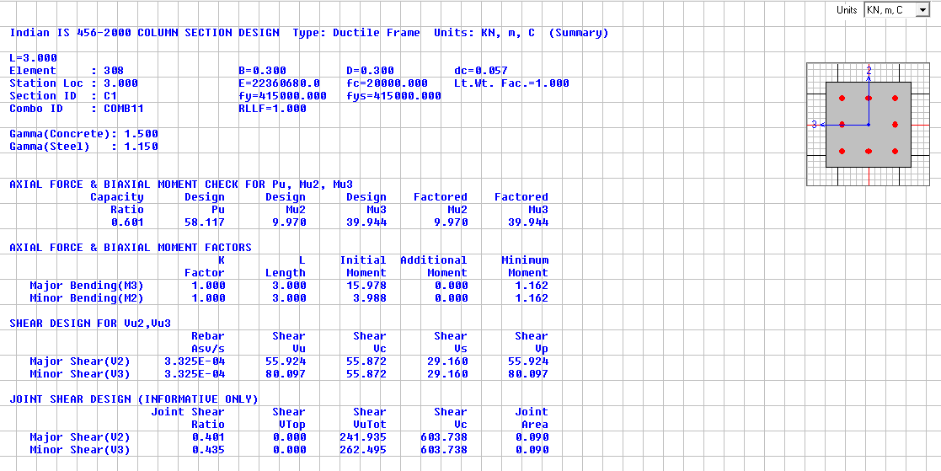
Beam design
bm 250*450
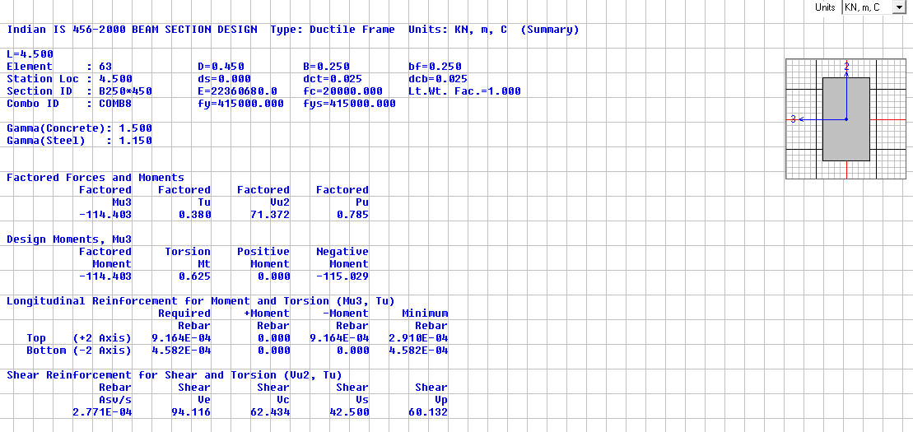

bm 250*350
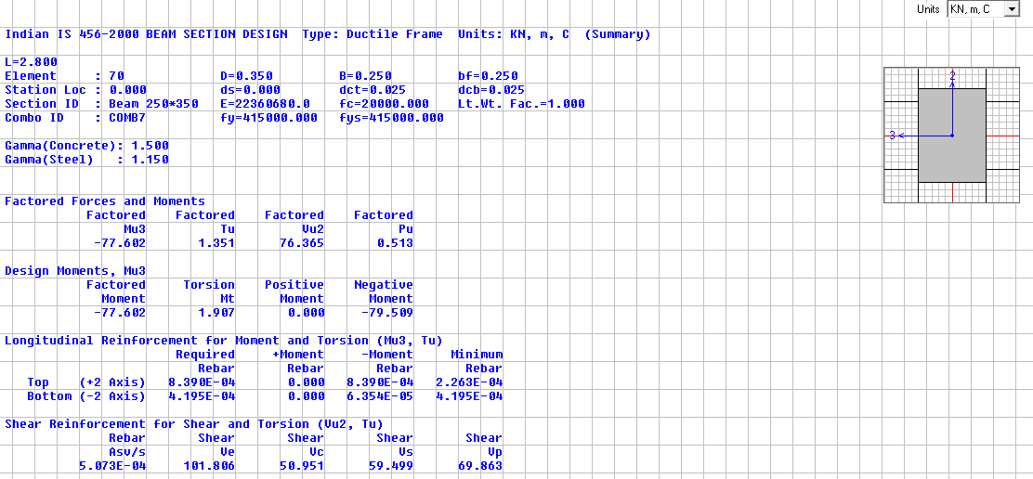
TABLE-3 Joint Reactions
TABLE: Joint Reactions
Joint | OutputCase | CaseType | F3 | Design Load | Bearing Load | Area required | Area Provided | Remarks
Text | Text | Text | KN | KN | KN/m^2 | m^2 | m^2
262 | COMB14 | Combination | 532.936 | 390.82 | 100 | 3.91 | 1.21 | micropiling Required
263 | COMB14 | Combination | 556.27 | 407.93 | 100 | 4.08 | 1.21 | micropiling Required
264 | COMB14 | Combination | 529.728 | 388.47 | 100 | 3.88 | 1.21 | micropiling Required
265 | COMB14 | Combination | 528.937 | 387.89 | 100 | 3.88 | 1.21 | micropiling Required
266 | COMB14 | Combination | 529.466 | 388.28 | 100 | 3.88 | 1.21 | micropiling Required
267 | COMB14 | Combination | 532.053 | 390.17 | 100 | 3.90 | 1.21 | micropiling Required
268 | COMB14 | Combination | 720.727 | 528.53 | 100 | 5.29 | 1.21 | micropiling Required
269 | COMB14 | Combination | 502.435 | 368.45 | 100 | 3.68 | 1.21 | micropiling Required
270 | COMB14 | Combination | 775.607 | 568.78 | 100 | 5.69 | 1.69 | micropiling Required
271 | COMB14 | Combination | 877.348 | 643.39 | 100 | 6.43 | 1.69 | micropiling Required
273 | COMB14 | Combination | 693.883 | 508.85 | 100 | 5.09 | 1.69 | micropiling Required
274 | COMB14 | Combination | 694.938 | 509.62 | 100 | 5.10 | 1.69 | micropiling Required
275 | COMB14 | Combination | 780.461 | 572.34 | 100 | 5.72 | 1.69 | micropiling Required
277 | COMB14 | Combination | 696.961 | 511.10 | 100 | 5.11 | 1.96 | micropiling Required
278 | COMB14 | Combination | 850.406 | 623.63 | 100 | 6.24 | 1.69 | micropiling Required
279 | COMB14 | Combination | 677.006 | 496.47 | 100 | 4.96 | 1.69 | micropiling Required
280 | COMB14 | Combination | 702.167 | 514.92 | 100 | 5.15 | 1.69 | micropiling Required
281 | COMB14 | Combination | 809.119 | 593.35 | 100 | 5.93 | 1.69 | micropiling Required
282 | COMB14 | Combination | 667.406 | 489.43 | 100 | 4.89 | 1.69 | micropiling Required
283 | COMB14 | Combination | 669.071 | 490.65 | 100 | 4.91 | 1.69 | micropiling Required
284 | COMB14 | Combination | 756.248 | 554.58 | 100 | 5.55 | 1.69 | micropiling Required
285 | COMB14 | Combination | 667.698 | 489.65 | 100 | 4.90 | 1.69 | micropiling Required
286 | COMB14 | Combination | 695.685 | 510.17 | 100 | 5.10 | 1.96 | micropiling Required
287 | COMB14 | Combination | 704.81 | 516.86 | 100 | 5.17 | 1.69 | micropiling Required

TABLE -3 Top Storey Deflection
TABLE: Joint Displacements
Joint | OutputCase | CaseType | U1 | Allowable deflection
Text | Text | Text | mm | mm
204 | EQX | LinStatic | 15.10 | 48
TABLE -4 Time Period
TABLE: Modal Periods And Frequencies
OutputCase | StepType | StepNum | Period
Text | Text | Unitless | Sec
MODAL | Mode | 1 | 0.466
MODAL | Mode | 2 | 0.446
MODAL | Mode | 3 | 0.405
MODAL | Mode | 4 | 0.158
MODAL | Mode | 5 | 0.156
MODAL | Mode | 6 | 0.139
MODAL | Mode | 7 | 0.085
MODAL | Mode | 8 | 0.084
MODAL | Mode | 9 | 0.076
MODAL | Mode | 10 | 0.061
MODAL | Mode | 11 | 0.057
MODAL | Mode | 12 | 0.055
TABLE -5 Drift
According to IS 1893:2002 Clause 7.11.1
TABLE: Joint Displacements |  |  |  | Inter Storey Drift | Height | Drift Limitation | Check
Joint | OutputCase | CaseType | U1 |  |  | 0.004 x H | 0.004 x H >
Text | Text | Text | mm | mm | H (m) | mm | ID
287 | EQx | LinStatic | 0.00 | 0 | 0 | 0 | PASS
35 | EQx | LinStatic | 2.56 | 2.56 | 3 | 12 | PASS
63 | EQx | LinStatic | 6.96 | 4.41 | 3 | 12 | PASS
87 | EQx | LinStatic | 11.09 | 4.12 | 3 | 12 | PASS
215 | EQx | LinStatic | 15.10 | 4.01 | 3 | 12 | PASS
TABLE -6 Joint Displacements
TABLE: Joint Displacements |  |  |  | Inter Storey Drift | Height | Drift Limitation | Check
Joint | OutputCase | CaseType | U2 |  |  | 0.004 x H | 0.004 x H >
Text | Text | Text | mm | mm | H (m) | mm | ID
287 | EQy | LinStatic | 0.00 | 0.00 | 3 | 12 | PASS
35 | EQy | LinStatic | 2.40 | 2.40 | 3 | 12 | PASS
63 | EQy | LinStatic | 6.35 | 3.95 | 3 | 12 | PASS
87 | EQy | LinStatic | 10.07 | 3.72 | 3 | 12 | PASS
215 | EQy | LinStatic | 13.86 | 3.79 | 3 | 12 | PASS

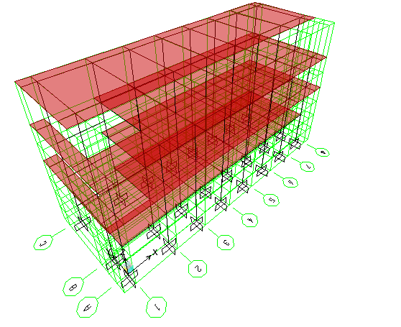
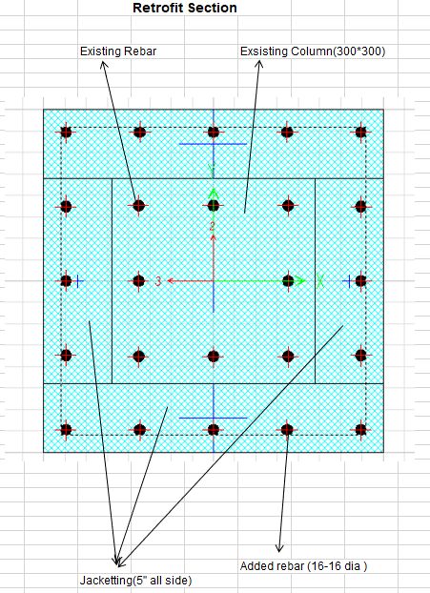
3d model in SAP
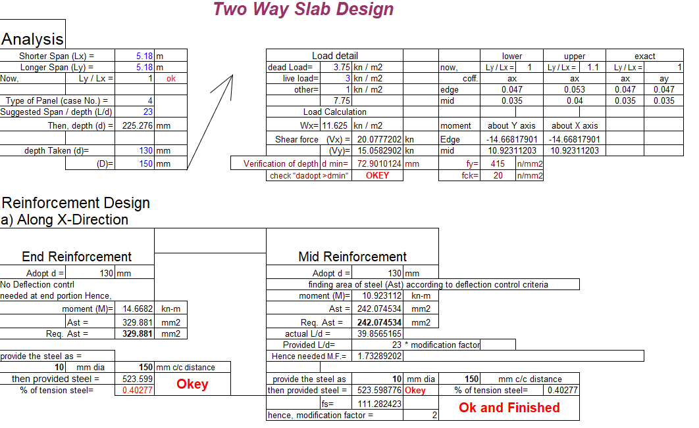
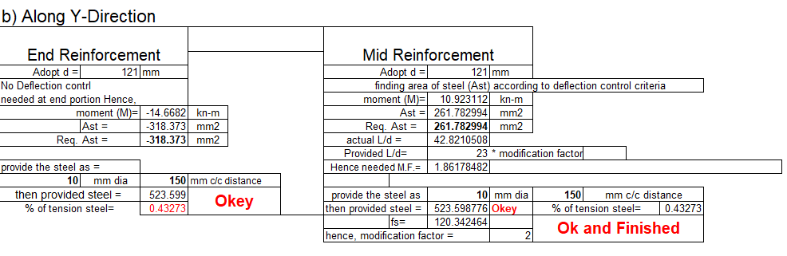
V Conclusion
The design and detailing of the mentioned building has been conducted using SAP consideration of the earthquake load in strengthening f the building and durability of the structure.
Reference
- Raza, S.; Khan, M.K.I.; Menegon, S.J.; Tsang, H.-H.; Wilson, J.L. Strengthening and Repair of Reinforced Concrete Columns by Jacketing: State-of-the-Art Review. Sustain. 2019, Vol. 11, Page 3208 2019, 11, 3208, doi:10.3390/SU11113208.
- M. Emara, M. Rizk, H. Mohamed, M. Zaghlal, Enhancement of circular RC columns using steel mesh as internal or external confinement under the influence of axial compression loading, Frat. Ed. Integrita ` Strutt. 15 (2021) 86–104.
- A. Doǧangün, Performance of reinforced concrete buildings during the May 1, 2003 bingol ¨ earthquake in Turkey, Eng. Struct. 26 (2004) 841–856.
- S.S.E. Lam, B. Wu, Y.L. Wong, Z.Y. Wang, Z.Q. Liu, C.S. Li, Drift capacity of rectangular reinforced concrete columns with low lateral confinement and high-axial load, J. Struct. Eng. 129 (2003) 733–742.
- Z.W. Shan, D.T.W. Looi, R.K.L. Su, A novel seismic strengthening method of rc columns confined by direct fastening steel plates, Eng. Struct. 218 (2020),110838.
- K.G. Vandoros, S.E. Dritsos, Concrete jacket construction detail effectiveness when strengthening RC columns, Constr. Build. Mater. 22 (2008) 264–276.
- S.-Y. Chang, T.-W. Chen, N.-C. Tran, W.-I. Liao, Seismic retroftting of RC columns with RC jackets and wing walls with different structural details, Earthq. Eng. Eng. Vib. 2014 132 13 (2014) 279–292.
- M. Deng, Y. Zhang, Cyclic loading tests of RC columns strengthened with high ductile fiber reinforced concrete jacket, Constr. Build. Mater. 153 (2017) 986–995.
- Y. Zhang, M. Deng, T. Li, Z. Dong, Strengthening of flexure-dominate RC Columns with ECC jackets: experiment and analysis, Eng. Struct. 231 (2021), 111809.
- K.M. Mahmoud, E.A. Sallam, H.M.H. Ibrahim, Behavior of partially strengthened reinforced concrete columns from two or three sides of the perimeter, Case Stud. Constr. Mater. 17 (2022), e01180

