ARTIFICIAL INTELLIGENCE (AI) IMPLEMENTATION IN PHARMACEUTICAL INDUSTRY
Jayanthy S, Anuciya R, Sofiya K, Santhosh S, Kaviyarasan D, Kanaka Parvathi Kannaiah*.

Jayanthy S,
Department of Pharmaceutical Quality Assurance
SRM College of Pharmacy,
Kattankulathur, Chennai,
Tamil Nadu, India

Anuciya R
Department of Pharmaceutical Quality Assurance
SRM College of Pharmacy,
Kattankulathur, Chennai,
Tamil Nadu, India

Sofiya K
Department of Pharmaceutical Quality Assurance
SRM College of Pharmacy,
Kattankulathur, Chennai,
Tamil Nadu, India

Santhosh S
Department of Pharmaceutical Quality Assurance
SRM College of Pharmacy,
Kattankulathur, Chennai,
Tamil Nadu, India

Kaviyarasan D.
Department of Pharmaceutical Quality Assurance
SRM College of Pharmacy,
Kattankulathur, Chennai,
Tamil Nadu, India

Kanaka Parvathi Kannaiah
Assistant Professor,
Department of Pharmaceutical Quality Assurance
SRM College of Pharmacy,
Kattankulathur, Chennai,
Tamil Nadu, India

ABSTRACT
Artificial Intelligence [AI] technology has started recently to improve the various sectors in pharmaceutical industry. It helps to minimize the problems arises in the medical and health care field. It includes various technologies such as neural networks, machine learning, etc. Artificial Intelligence has been brought to different field which helps in analysing and solving issues in short time rather than taking huge labour work and long period time. In pharmaceutical industries, Artificial Intelligence (AI) can be implemented in various departments involves production, drug discovery, clinical trials, pharmacovigilance and in marketing management. AI has both advantages and disadvantages. A 'Bio-AI' revolution is taking place in the pharmaceutical industry. This revolution has the potential to significantly reduce both the time and the cost of medication development. The capacity of AI approaches to sort and analyze massive data sets allows for the application of these techniques to improve research and development efficiency as well as efficiency at various phases of medication development. AI system has been established in different companies such as Pfizer, GSK, Sanofi, Novartis, Roche, Merck.
Keywords: Artificial Intelligence, Pharmaceutical Industries, Drug Discovery, Clinical trials and Health care centres.

INTRODUCTION
Artificial intelligence is a computer-based robotics system to process information. It also produces outputs similar to the human minds like solving problems and decision makings. It is the topmost technology which will shape the future of pharmaceutical industry. AI performs effortlessly human-like tasks, identifying errors and then correcting them [1]. A Natural Language Processing (NLP) is a technology used by AI, to understand natural human communication and it translates to code to that machine. Machine Learning (ML) is the branch of AI. In Machine Learning, the goal is defined well which is fed into the system along with rules and alternative actions. The system is automatically learned and based on experience its improves itself. The aim of Machine Learning (ML) is to produce accurate results. It doesn’t based on randomization rather it based on fixed values. A better machine performance occurs by this MI through learning from predetermined set of data and producing mechanical solutions [2]. The goal of AI is to act instead of human and to execute interdependent tasks. AI produces results through intelligence data analysis and deeper understanding. Pharmaceutical industry has been developing on treatment and cures of diseases in 21st century. The design and manufacturing of drugs, clinical trials requires several years and huge costs. AI implementation in pharmaceutical industry leads to reduced costs and time in drug discovery, drug designs and clinical trials.

ARTIFICIAL INTELLIGENCE (AI)
In the year 1956, An American computer scientist, John McCarthy, A father of AI (Artificial Intelligence), defines “The science and engineering of making intelligent machines, especially intelligent computer programs. It is related to the similar task of using computers to understand human intelligence, but AI does not have to confine itself to methods that are biologically observable”. AI can perform a cognitive function, which is relates with the human minds [3].

MACHINE LEARNING (ML)
A type of artificial intelligence known as machine learning is built on algorithms that recognise patterns, learn to make predictions, and programme data based on experiences rather than on explicit programming directives. Machine learning has had a significant impact on various industries since the 1970s, as evidenced by advances in high-resolution weather forecasting and medical image analysis.

DEEP LEARNING (DL)
Machine learning techniques called deep learning can analyse a variety of data sources and generate more accurate results. A neural network is used by deep learning, that ingest data and process it to learn complex features of the data.
In machine learning, there are three types of artificial neural networks.
      - Feed-forward neural networks
      - Convolutional neural networks (CNNs)
      - Recurrent neural networks (RNNs)
- Feed-forward neural networks
In this type of neural network, the flow of information is only one way that is, it forward the input layer to output layer from the model. The data can be feed or input the model, then hone it to forecast various sets of data.
- Convolutional neural networks (CNNs)
This is the type of feed-forward neural network. CNNs are modelled based on images, determine the species of a bird or plant. First, the CNN receives an image and then it identifies unique features in the hidden layers and now the CNN can classify a different image. If, it determines that the image has distinctive characteristics that have already been mentioned.
- Recurrent neural networks (RNNs)
There are artificial neural networks, which means the model traverses previous levels by moving data both forward and backward. They are useful for forecasting a feeling because the model itself is fed by each individual input additionally, together with the input from before [4].

OBJECTIVES OF AI [5]
- The creation of automated systems that shows intelligent behaviour and also its advices human in right course of action.
- It helps to create an identical cognitive patterns in system that will help them to behave like humans in solving complex problems. These are automated process which reduces human workload [6].
- It can be implemented in various domains like computer sciences, space technology, cognitive sciences, E-commerce, statistics, Healthcare, psychology, Engineering, medical sciences, Ethics, logic, Linguistics and more.
- It also helps in developing mechanism to solving problems in computer science field like Language Analysis, Search and Optimization, Statistical learning methods.

TYPES OF AI
Artificial Intelligence system is classified as:
- Weak intelligence or Artificial Narrow Intelligence (ANI)
This system performs narrow task, like facial recognition, traffic signalling. ANI is designed and trained as narrow task performance. The outcomes of this system is based only on inputs which fed into it. In pharmaceutical industry, this kind of network can be used in production department where the particular batches show outputs as per inputs given.

- Strong intelligence or Artificial General Intelligence (AGI)
This system is based on human level, which has the human intellectual abilities. It has the abilities of finding solution when it exposed to an unfamiliar task. It can perform all things as humans. This system can applicable in analysis, quality control which recognize the errors as per human intelligence.
- Artificial Super Intelligence (ASI)
This system are trillion times smarter than human brain power, which is more active in every field from science to art. It can be including in drug development, and other discovery process of drugs [7].

FUTURE OUTLOOK AND EMERGING INTELLIGENCE

Table. 1 Benefits and risks of AI
BENEFITS | RISKS
Buiseness: Higher efficiencies, less repetitious work, improved client experience. | Cyber-attacks: Circumstances and catastrophes on a wider level that are global in scope could be costly.
Transport: Autonomous vehicle, 90% more traffic accidents. | Technical failure: A rise in infrastructural and technology errors.
Healthcare: Advanced DNA sequencing aims to end incurable illness. | Defective products and recalls: Numerous smart vehicle accidents might result in a significant recall.
Climate change: Emissions per person are falling because to smart networks and urbanisation. | Loss of reputation: An AI misstep could result in a significant financial incident for the company.
Insurance- Greater understanding of risk. New solutions. 24/7 service. | Labor changes and political manipulation: Change in the existing roles. AI used to influence thinking and opinion.

- RISK MANAGEMENT
Five areas of concern need to be addressed to reduce consequences
- Software Accessibility
- Safety
- Accountability
- Liability
- Ethics

AI IMPLEMENTATION IN PHARMACEUTICAL INDUSTRY
Artificial intelligence in pharma refers the automated system which performs task rely on human intelligence. Over more than 10 years have been spent in the drug discovery or development of drug. The various technologies which involve in AI such as NLP, Machine Learning and Deep Learning are expected to make hunt in developing new pharmaceuticals quicker, more effective and cheaper. AI can be implemented in development of new drugs and biomarkers, tackling of diseases which were difficult to treat earlier, during clinical trials drug adherence among volunteers, better analysis and utilization of clinical data and finding the correct patients for clinical trials.

AI IN DRUG DISCOVERY AND DEVELOPMENT
In early time, the process for the discovery and development of the drug molecules requires more time and it takes over a decade and more to complete all the procedures, tests and to develop the drug molecule into a therapeutically active drug substance. Without any advanced technologies it is so difficult to do. For the solution of this only artificial intelligence is introduced.
AI plays an important role in design, development, and discovery of new drugs such as multi target drugs, drug repurposing, novel drug discoveries, determining drug activities, prediction of toxicity, etc., The main goal of the pharma industry is to reduce the time taken for the development, approval of the drugs. AI can recognize the biologically active substances, determines the activity of the drug. It can also predict the target cell to which the drug has to bind and produce the therapeutic activity. QSAR [Quantity Structure-Activity Relationship] based models which predicts the physicochemical properties of the drug using AI it can be easy to analyse the drug to know their actions, side effects, toxicity, etc., By implementing the AI, drug repurposing can be done. Drug repurposing is the identifying and predicting the new therapeutic use of the drugs. Affinity of a drug to bind with its target can be measured by using AI based methods. To predict drug-target interactions, protein, and drug molecule interaction some web applications are available [8].

5.Finding biomarkers for diagnosing

1.Literature Review
3.Discovering drug candidates
thdisease
2.Identifying targets for intervention
4.Speeding up clinical trials
5 stages of drug development
fig. 1 Five stages of drug development

Target receptor binding is affected by characteristics such drug solubility, partition coefficient, degree of ionization, and intrinsic permeability while developing a new medicine. There are about 167 startup companies using AI for drug discovery on Nov 13, 2019. Cancer, radiotherapy, drug induced liver injury, cardiovascular, pregnancy, skin are the diseases considered in the artificial intelligence [9].

ARTIFICIAL INTELLIGENCE IN CLINICAL TRIALS
In the process of drug discovery, clinical trials play an important role. Clinical trials will take the longest duration of time to finish and get the results. Even in that not all drugs are qualified. Some of the drugs are rejected due to their side effects, insufficient patients/ participants in the clinical trials, drop outs during the trials, etc., These loses can be minimized by using AI technology and also detect the patients data for further process [10].
A patient can find a clinical trial by search tool which enabled by AI

They can find a match in phase II study recruitment and enrol in it

They receive information about trials in their mobiles and can raise queries

Patient can confirm by e-consent

Wearable devices can continuously monitor and reminding about the progress

To ensure safety, they informed about progress and get access to the treatment

Fig. 2 Flow chart of AI in clinical trials

AI IN PHARMACOVIGILANCE
Pharmacovigilance was created by the WHO in 1961, which generally for global drug monitoring because of the impact of thalidomide disaster. Global drug monitoring is related to adverse drug effects and other drug related problems[11]. Currently they include traditional medicines, medical devices and materiovigilance, which is post marketing surveillances of adverse events caused by medical devices[12]. The database used in pharmacovigilance are vigibase, vigiflow, vigiaccess. The uppasala, monitoring centre were establish as WHO collaborating centre in 1978 which will be used for international drug monitoring vigiflow, vigibase operates in the name of WHO. The vigiaccess is open to the public. For case report they use vigimatch, vigirank[13]. Specific case study report is a individual document used to record information with help of FDA regulations which will provide Adverse Events (AE) information, product problems[14].
They are two categories of AI in ICSR:
- Addition of structural and unstructural content, include information with help of XML, DOCs, Image for case reading.
- AI is used for decision making. In that ICSR quality is poor. AI plays main role in making an individual or random AE. AI give accurate informations and reducing the total processing time. It stores the patient data electronically for diagnosing the AE[15].

- Importance of AI in Pharmacovigilance
It is mainly used for patient safety. This observes the profile of the drug for the use of prolonged period of time. The approval of life saving drugs are only subjected to the fast track system. The drugs like anticancer, antitubercular and antiretroviral drugs, for these types the assessment, communication about the likelihood and efficiency of the medication should be performed by the pharmacovigilance. The countries raising issues for the need of system for monitoring the safety of the drug and post marketing surveillances. Whenever the new drug is launched in the market, unwanted medication response is done by drug occurrence reported voluntarily or systematically gathered and analysed[16].

AI IN PHARMACEUTICAL MARKETING
AI in pharma companies is to explore and develop marketing strategies. It can also optimize digital advertising enhance customer engagement and streamlines sales process. AI is revolutionizing the pharmaceutical marketing landscope and enhancing decision-making process within this companies[17].
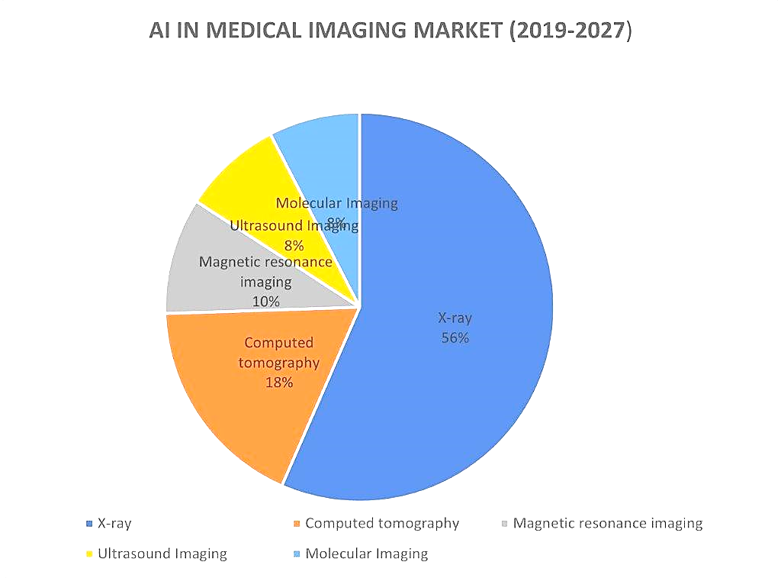
Fig. 3 AI in medical imaging market

CONCLUSION
From the research we have concluded that Artificial intelligence (AI) performs in various fields in pharmaceutical industry and health care centre. Not only in this, AI also plays a crucial role in clinical trials and drug discovery. By implementing AI in pharmaceutical industries we can attain less errors, less time consuming and higher efficacy. But the performance which AI have displayed is not that much efficient. By using AI could increase the rate of unemployment. When AI introduces new drug molecules or new dosage forms it can raise the trust issues. It can also leads to cyber attack by misusing the database.

REFERENCES

- Kaustav Dey. Artificial Intelligence in field of pharmacy, https://www.slideshare.net/KaustavDey21/artificial-intelligence-in-field-of-pharmacy.
- The Beginner’s Guide to Artificial Intelligence. 2019 sep 13; https://www.chapter247.com/blog/artificial-intelligence-beginners-guide/ (Accessed on nov 13,2019)
- John McCarthy. What is Artificial Intelligence? Computer Science department, Stanford University; http://www-formal.standford.edu/jmc/ revised nov 12,2007
- McKinsey & Company. What is AI? https://www.mckinsey.com/featured-insights/mckinsey-explainers/what-is-ai#/
- Silver D, Schrittwieser J, Simonyan K. Mastering the game of go without human knowledge. Nature 2017;550:354-359.
- Moosavi-Dezfooli S-M, Fawzi A, Fawzi O and Frossard P. Universal adversial perturbations. IEEE Conference on Computer Vision and Pattern Recognition, Hawaii, 21-26 july 2017.
- S.S Manikaran, N.L. Prasanthi, Artificial Intelligence Milestones and Role of Pharma and Healthcare Sector, Pharma times VOL. 51-NO. 01-January 2019.
- Debleena Paul, Gaurav Sanap, Snehal Shenoy, Dnyaneshwar Kalyane, Kiran kalia and Rakesh K. Tekade. Artificial Intelligence in drug discovery and development; Drug Discov Today. 2021 Jan;26(1):80-93.
- Isaac Bentwich, Pharma’s Bio-AI revolution; Drug Discovery Today, Volume 28, Number 4, May 2023.
- Naitik Jariwala, Chandra Lekha Putta, Ketki Gatade , Manasi Umarji, Syed Nazrin Ruhina Rahman, Datta Maroti Pawde, Amoolya Sree, Atul Sayaji Kamble, Abhinab Goswami, Payel Chakraborty, Tamilvanan Shunmugaperumal. Intriguing of pharmaceutical product development processes with the help of artificial intelligence and deep/machine learning or artificial neural network; Journal of Drug Delivery Science and Technology, Volume 87, Sept 2023,104751
- Meyboom RH, Egberts AC, Gribnau FW, Hekster YA. Pharmacovigilance in perspective. Drug Saf. 1999;21:429–47.
- Deye N, Vincent F, Michel P, Ehrmann S, da Silva D, Piagnerelli M, et al. Changes in cardiac arrest patients' temperature management after the 2013 TTM trial: Results from an international survey. Ann Intensive Care. 2016;6:4.
- UMC WHO [Internet] [Last modified on 2018 Oct 11]. Available from:https://www.who-umc.org/about-us/who-we-are/
- [Last accessed on 2018 Mar 27]. Available from: https://www.fda.gov/industry/fda-resources-data-standards/individual-case-safety-reports .
- White RW, Wang S, Pant A, Harpaz R, Shukla P, Sun W, et al. Early identification of adverse drug reactions from search log data. J Biomed Inform. 2016;59:42–8.
- Venulet J, Helling-Borda M. WHO's international drug monitoring – The formative years, 1968-1975: Preparatory, pilot and early operational phases. Drug Saf. 2010;33:e1–23.
- Report of CIOMS Working Group IV. Geneva: CIOMS; 1998. Council for International Organisations of Medical Sciences. Benefitrisk balance for Marketed drugs: evaluating safety signals.

