Prototyping and Design of Sensor-based Anti-Theft Security System using Microcontroller

Mrs. R.Bhuvaneswari,M.Sc.,M.Phil., M,Tech., D.K.M. College for Women(Autonomous), Vellore-1, Tamil Nadu, India, mail:msrbhuvana@gmail.com

ABSTRACT

To ensure protection of the house or different facility like bank, office constructing; a microcontroller-based anti-theft automated protection machine has been established. This system features multiple sensors that detect potential intrusion incidents and can produce three types of alarm notifications (Buzzer, bi-color LED, and SMS). An LCD provides a notification in case of a security breach based on data obtained from the interfaced sensors. (Motion Sensor, Fire Sensor, and Glass-break Sensor). The controller used to control all aspects of the system is Atmega8. The motion sensor are built using a LRD - Light Depended Resistor and a POT - Potentiometer ; Temperature Detector - LM35 is used for Fire Sensor; and a sensitive metal strip is used to construct a custom Glass-break Sensor. WIFI module with IOT is used to design an SMS generating system as one of the alarming methods. The designed system is establish to have very low power consumption when supplied with a 5V source, as the bi-color LED (0.1W) only requires 0.98µA and 23.5mA of current, and 4.88mW and 117.5mW of power during its state change; likewise, the Buzzer consumes only 0.49mW of power when it is powered ON.. The system is developed with the deliberation of incorporating for security enhancement Technique. The design of simple hardware circuit enables every user to use this wireless home security system with ultrasonic sensor, Gas sensor, Smoke sensor and Motor driven door locking system at Home. Which greatly improving the anti-theft security performance of outdoor advertising lighting.

INTRODUCTION
A security device involves the detection of intrusion, trespassing, or unauthorized entry right into a domestic or any included vicinity and getting alarmed of such unauthorized get admission to to defend property and those from being damaged or harmed. The emerging modern technology, commercial, industrial, and military properties have been extensively using some kind of security system for protection against theft, property damage, or personal harm [1], [2]. In recent years, the importance and increased demand for home security systems have been noticeably rising as well, especially in urban areas. in recent times, people are more and more maintaining them out of domestic for works and other functions, houses are becoming sufferers of burglary with the aid of illegal access by means of pressure, inclusive of breaking a pitcher-window or slashing a pitcher-door or via getting into through an unlocked door or an open window. Research have pointed out that burglaries and intrusion-associated crimes occur extraordinarily much less in locations wherein a domestic protection system is set up [3].
Not very long ago, home security systems or monitoring cannot be accomplished without human maneuver. Even today, security guards and trained-up dogs are common practice to tackle the issue, since it is evident that the crime is not going away from our society completely. Besides, people are remaining outside more than ever today, leaving their homes vulnerable if proper measures are not taken. While human security guards and trained-up dogs are reliable to a certain degree, but maintaining them is always costly and they can be fooled and corrupted. To address these issues, and to keep up with the rapidly evolving technology, the home security system needs to be automated with minimum human intervention to keep it safe, no matter if the home is occupied or empty. The concept of automated home security systems has been around since the 1970s.
But with the progress and expansion of technology, both our expectations and the idea of home security systems have been shifted [4], [5]. Home security systems involve some critical parameters like gas leakage system, fire/smoke alarming system, theft, and intruders monitoring system, etc. Many sophisticated techniques and systems are now available to serve the purpose. The latest programmable devices, controllers, sensors, video cameras, and loud buzzers are used to address the issue. Recently, very comprehensive and error-free systems are available, which are both accurate and cost-effective [6]–[8]. Many alarm monitoring services of today’s home security system now allow users to access their system via the Internet. Users can check the system status remotely, and even view real-time video feed if CCTV cameras are installed. Today’s systems even allow users to change their security passwords, lockout the security passwords, and arm or disarm the security system via the Internet [3], [9]. However, the trend of low cost and low power Microcontroller based home security system automation is not yet faded, rather still emerging. Hence, the work in this paper is focused on the very area.
Any system or device that is required to measure, store, control, calculate, or display information is an appropriate candidate for using a microcontroller in it [10]. A microcontroller is a small electronic device that can be considered as a single-chip and special-purpose computing machine dedicated to repetitively accomplishing a specific task. Similar to a general-purpose computer, a microcontroller comprises CPU core, memory units (RAM, ROM, Flash), and I/O ports [11]. Since the device is very small, and it is designed to control objects, processes, or events; hence the name microcontroller. Another term used for it is embedded controller since the microcontroller and its supporting circuitry are often constructed into, or embedded in, the devices they are programmed to control [10].
The uses and engineering application area of the microcontroller is enormous, including automatically controlled products like vehicles, engine control systems, power tools, toys, and office machinery which are commonly used i.e. photo-copier, printer, and fax machines [10]. During the 1990s, microcontrollers having EEPROM (such as flash memory) became available which made projects like the one described in this paper feasible and efficient, since these kinds of microcontrollers could be erased and reprogrammed using only electrical signals [10].A novel advertising lighting anti-thefts security system based on GPS and digital controltechnologies is designed and implementation in this paper. The system uses other digital control technologies, which can achieve outdoor lighting remote real-time online monitoring and alarmwarning functions.
OBJECTIVE
Develop a home security system prototype, simple but highly efficient that has the function of sending an SMS message to the homeowner´s mobile number in the event of an intrusion alert, to avoid property damage and to ensure protection against family members. The prototype is established based on Arduino, Pir motion detection sensor and GSM module. Home security systems are an important feature of modern home installation that must be affordable, reliable and effective.
THE SYSTEM DESIGN AND WORKING PRINCIPLE
According to market needs analysis, the main functions of the system design requirements are:human PIR infrared monitor whether someone close to advertising lighting lamps, once someoneclose, it will send a signal to the controller level, then the controller to capture abnormal signals, voicealarm module will drive a warning sound, and LCD display warning information. If the systemdetects the lamp stolen, the controller will drive GPRS module send alarm/location information andmessage to the host computer monitoring software, then inform the staff as soon as possible.
The designed system consists of a terminal site controller and remote monitoring control software.The terminal site controller including MCU controller, lightinglamps status detection, securitymonitoring, position information and alarm module. The remote monitoring control software mainly grasps the lights work status and position display, alarm information.
MATERIALS AND METHODS
The aimed automated security system generally involves a microcontroller (Atmega8) as the brain, three basic sensors (Motion sensor, Fire/Temperature sensor, Glass-breaking sensor) for detecting abnormalities at the home or application area, and it involves three output methods (LED, Buzzer, SMS) for providing the necessary alarms. In this paper, a brief explanation of Atmega8 and three basic sensors are provided below. a detailed list of components, a system flow chart, and a block diagram are also discussed.
ADVANTAGES
- WIFI module is used to design an SMS generating system as one of the alarming methods.
- That robberies and intrusion-related crimes occur extremely less in places where a home security system is installed.
- Home security systems the latest programmable devices, controllers, sensors, video cameras, and loud buzzers are used to address the issue.
Atmega8
ATmega from Atmel AVR family. It is a 8-bit microprocessors and microcontrollers. It has enormous range of features depending on the model. the following components were present in all of their products: 4256 kB Flash memory, 28 to 100 pins in SMD or DIP package, a watchdog timer, and up to 20 MHz clock speed. As well, the Atmega family offers on-chip Flash, SRAM, and internal EEPROM.
in this work is Atmega8 is used in a DIP package, which is an 8-bit Atmel microcontroller with 8kB in-system programmable Flash, designed in advanced RISC architecture. Its functional voltage is 4.5V – 5.5V, and it has 512Bytes EEPROM and 1kB Internal SRAM [13]. The below shows the pin-out diagram of an Atmega8 in the DIP package.
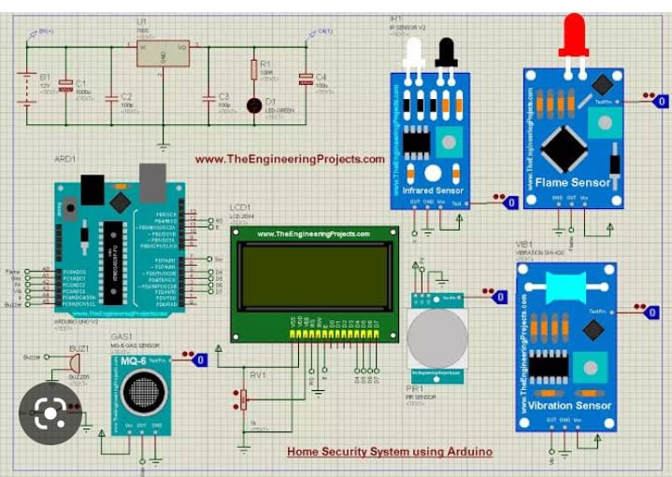
FIGURE :1
- Motion Sensor (LDR):
Light Dependent Resistors (LDRs) are a type of nonlinear resistor that can change its value based on the change in incident light intensity. LDRs are also known as Photo Resistor, Photo Conductor, Photo Conductive Cell, or just Photo Cell. These are made with semiconductors, particularly from the compounds of CdSe, CdS, InSb, or PbS. If the light is not present then, the resistance of an LRD is very high, sometimes it leads up to 1M. But when the sensor is exposed to light, its resistance decreases drastically, even down to a few Ohms. LDR is used in this work because they are economical to get and simple and easy to handle. The only weakness of LRD is that they take a few seconds to get back to their original position once the light is absent again. A motion sensor, or motion detector, is an electronic device that usages a sensor to detect nearby people or objects.
Motion sensors are an essential component of any security system. When a sensor detects motion, it will direct an alert to your security system, and with newer systems, right to your mobile phone. If you have subscribed to an alarm monitoring service, motion sensors can even be configured to send an alert to your monitoring team.
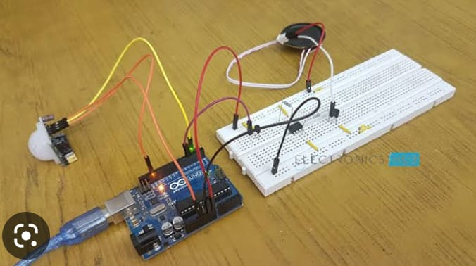
FIGURE : 2
- Fire/Temperature Sensor (LM35):
The LM35 is selected as the temperature sensor for this work, which is a precision temperature sensing IC with an output voltage linearly proportional to the temperature. A big advantage of these sensors is that they are calibrated directly in Celsius (Centigrade), and promise 0.5Â°C ensured accuracy (at 25Â°C). The operating voltage of LM35 sensors is 4V to 30V, and they cover a full 55Â°C to 150Â°C temperature range.

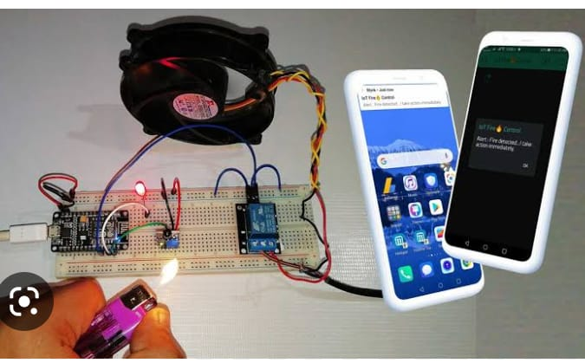
FIGURE : 3

- Glass-break Sensor:
Glass-break sensors can be built in two different ways. One way is its build is based on vibration and another one is based on acoustic sound. In the first way, the detector usually has a shock sensor attached on the glass to get sufficient transmission of the vibration and detect it.
In the second way, the crystal of a piezoelectric sensor is tuned to the resonance frequency of 40 and 12 kHz to detect the breaking sound.
This sensor also has to be mounted on the glass. In this paper, the proposed method comprises placing a tiny metal strip (current conductor) around the outer edge of a glass window or door, so that when the glass breaks, the strip breaks as well which changes the current flow in the controller to take an action.
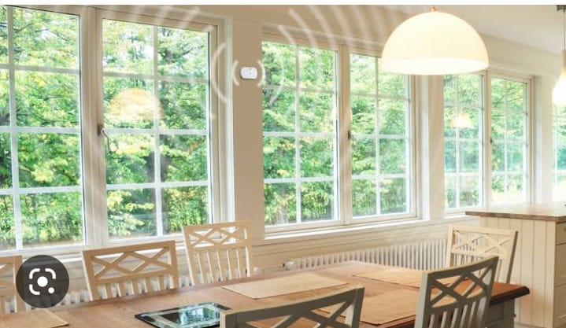
FIGURE : 4
System Flow Chart: The heart of this work is the automated security system, and to better represent its workflow step-by-step, a logic flowchart is provided in Figure 5. The core concept is to monitor the sensor (Motion, Fire, Glass-break) inputs for Real- Time Voltage (RTV) change and compare them with the predefined SET Voltage (SV); and then changing the status of the output modules (LED, Buzzer, SMS) accordingly.

Electronic circuit/hardware design: As mentioned before, the design part of the work presented in this paper can be divided into two parts:
- Design of the security system consist of two separate circuits; first one for motion sensing and glass-breaking detection, the another one for fire/temperature detection.
- Design of the Sun- tracking solar system. The circuits designs are made by Schematic Capture of Proteus 7.7 Professional and presented in the following sub-sections, here the power supply is taken to be 5V dc throughout the system. Design of the Security System represents the circuit for motion sensing [21] and glass-breaking detection, where an LED (red) is connected with the power terminal of +5V dc. A Light Depending Resistor (LDR) and a voltage dividing series resistor are connected to the rectifiers output (+5V), where the divided voltage is interpreted as a metal strip that enfolds the outer periphery of a glass window or door which is interfaced with the microcontroller (ATmega8) through ADC (4). The voltage across the Potentiometer (POT) is well thought-out as the SV, which is interfaced with the Atmega8 through ADC (3); and the voltage across R2 is considered as the RTV, which is interfaced with the Atmega8 through ADC (4). This RTV contrasts according to the change in light intensity on the LDR, or the connection of the metal strip (glass-breaking sensor). As an output device for alarm stipulating, a pair of Red and Yellow LEDs (represents a bi-color LED) with series resistor R6 and R7 is interfaced with the Atmega8 through two NPN transistors as their driver. As per the design, when RTV>SV, LED is OFF and vice versa. A buzzer is connected as an output device for alarm, through a series NPN transistor as its driver. When the metal strip is detached due to glass breaking, the RTV<SV, which disconnects R2 from the Atmega8, and an SMS is sent to a preprogrammed mobile number as an alert, A temperature sensor circuit using LM35 is also to detect fire, and the incident will be alerted through SMS as well.
CONCLUSION
A microcontroller-based Sun-tracking solar-powered anti- theft automated security system is designed with three kinds of incident detection sensors (motion, fire, glass-break) and threekinds of alarm methods (Buzzer, bi-color LED, SMS). The primary part of the security system is constructed and tested as well. The designed system is confirmed to be functional and useful in security protection, which provides the features as automatic control of the LED (color-changing in blinking manner), alarm (when LED is ON) with Buzzer sound and SMS, and displaying the information according to the different scenarios of security measures. This system functions on 5V dc power supply, requiring less than 1mA of current and 5mW of power during standby mode conditions. When the system is ON, during the bi-color LEDs blinking sequences (Yellow-Off-Red) it consumes less than 25mA of current and 120mW of power. And, the buzzer takes less than 0.5mW of power while ON, which makes it a very low-slung power system and suitable for working consistently with solar energy for a longer duration when grid connection is not available. To make the system even more proficient and sustainable a Sun-tracking solar system is also designed. Alert SMS generation system for Fire and Glass-break detection is also verified and confirmed to be reliable with the intended security system. This anti-theft system can be applied in homes or any kind of facility where security is a necessary and the control unit can be placed locally or remotely for monitoring.
FUTURE SCOPES
Engineering follows continuous process of experimenting, problem solving, and innovation for different kinds of applications. Every engineering projects have some sort of scopes to improve or extend them, and the work presented in this paper is not an exception. Besides the existing possible applications of the designed system, the future scopes, according to the revised block diagram in, may involve: (i) designing the Grid Control Unit to complete the power management system between Solar and Grid, (ii) designing a wireless Transmitter and Receiver compatible with the system to make it true remote-area applicable, and (iii) physical implementation of the whole system including the Sun-tracking system.
REFERENCES
- M. K. Hossain, P. Biswas, M. Mynuddin, and S. Morsalin, Design and implementation of an IoT-based smart home security system, International Journal of Modern Embedded System (IJMES), vol. 2, no.6, pp. 8592, 2014, doi: 10.2991/ijndc.k.190326.004.
- P. K. Dasari, D. S. Harsha, and E. Chandrasekhar, Implementation of Low Cost Home Monitoring, Controlling and Security System using IoT, International Journal of Engineering Research & Technology (IJERT), vol. 8, no. 06, pp. 11611164, Jun. 2019, [Online]. Available: https://www.ijert.org/implementation-of-low-cost-home-monitoring- controlling-and-security-system-using-iot.
- A. Elfasakhany, J. HernÃ¡ndez, J. C. GarcÃa, M. Reyes, and F. Martell, Design and Development of a House-Mobile Security System, Engineering, vol. 03, no. 12, pp. 12131224, Dec. 2011, doi: 10.4236/eng.2011.312151.
- A. Cyril Jose and R. Malekian, Smart Home Automation Security: A Literature Review, The Smart Computing Review, vol. 5, no. 4, pp. 269 285, Aug. 2015, doi: 10.6029/smartcr.2015.04.004.
- S. Chitnis, N. Deshpande, and A. Shaligram, An Investigative Study for Smart Home Security: Issues, Challenges and Countermeasures, Wireless Senso Network, vol. 8, no. April, pp. 6168, Apr. 2016, doi: 10.4236/wsn.2016.84006.
- R. M. V. and P. V. H. F. Sudhindra, S.J. Annarao, Design and Development of ARM-7 based Home Security System with GSM Technology, International Journal on Emerging Technologies, vol. 6, no. 2, pp. 5760, Oct. 2016.
- A. Bhatt, S. Bisht, and D. C. A. Andola, Anti-Theft Tracking System for Mobile-Vehicles, International Journal on Emerging Technologies, vol. 8, no. 1, pp. 554556, 2017.

