Future Applications of Internet of Things
Mr. AR. Guru Gokul*, Dr. N. Kumaratharan#, Dr. P. Leela Rani^, Dr. N. Devi^
^{* -} Assistant Professor, Department of Information Technology, Sri Venkateswara College of Engineering, Sriperumbudur
^{# -} Professor, Department of Electronics and Communication Engineering, Sri Venkateswara College of Engineering, Sriperumbudur
^{^ -} Associate Professor, Department of Information Technology, Sri Venkateswara College of Engineering, Sriperumbudur

Introduction

The Internet of Things (IoT) is indeed a transformative phenomenon that has the potential to greatly impact various aspects of our lives. IoT refers to the network of physical objects or "things" embedded with sensors, software, and other technologies that enable them to collect and exchange data over the internet. This connectivity allows these devices to interact with each other and with humans, creating a seamless and efficient system of communication and control [1].

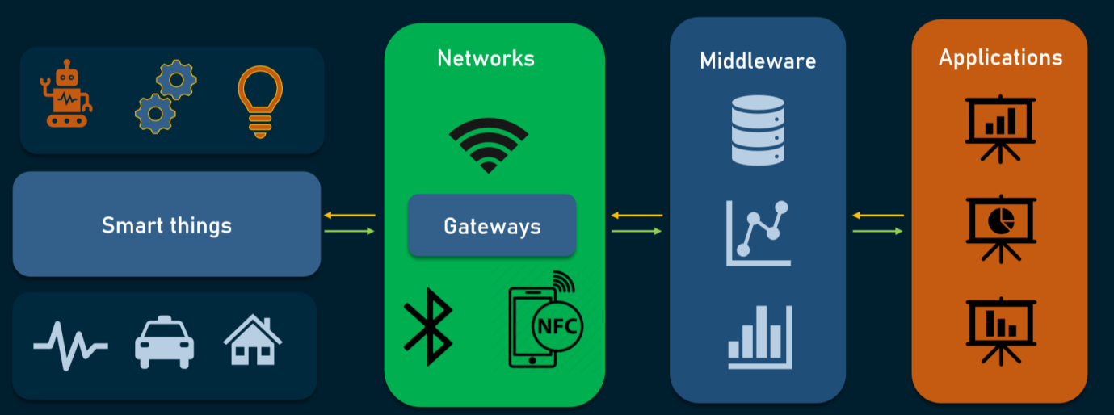
Figure 1.1: Components of IoT application

IoT is widely used in fields like environmental monitoring, energy management, healthcare, engineering and transportation etc.,. Given the limited resources of IoT devices, the calculations are performed in powerful cloud for accurate results. Still the input and output operations of the following calculations can interfere with the privacy of IoT users and are not affected by the collision of cloud servers and malicious IoT users [2-3]. The components of an IoT based applications is shown in Figure 1.1.

In addition, IoT researchers are involved in improving the lives of people with disabilities and the elderly. The IoT stands out in this regard by giving a new direction to people’s normal lives. Since these materials and tools are very advantageous in terms of construction costs and are easily available at normal prices, they are used by most people [4]. The state of the art IoT research held annually in Newark during 2022, produced some enormous results as represented in Figure 1.2. Various firms are getting involved in the development of IoT devices since they see an opportunity to improve the business and create a business culture but are not able to do it alone.

Figure 1.2: IoT Applications based on Sectors
From smart cities to smart agriculture, transportation to smart living environment, IoT is expected to penetrate almost every aspect of day to day life. Although present IoT technology has made great progress in recent years, still there are many issues left that need attention. As IoT concepts are derived from various technologies, numerous research challenges will arise. The scope of IoT is so wide that it affects almost every area of our lives, making it an important research topic in many related fields namely Information Technology and Computer related fields [5].

Prospective IoT Applications

IoT helps us save a lot of time by deploying various services and plays an important role in making better decisions by leveraging resources. The main purpose of IoT is to improve the quality of life by providing better services to users and how the concept of connecting IoT with other new technologies such as Artificial Intelligence (AI), Blockchain and Cloud Computing can make more powerful, smarter and efficient machines. The use of IoT is already having a huge impact in many areas. The following sections discuss about the applications of IoT in various fields such as Agriculture, Robotics, Healthcare and Business Sectors [6].

Application of IoT in Agriculture

The global livestock population and human beings depend on agriculture as an important source of food. Apart from generating food, the role of agriculture has now stretched out towards the acceptance of green energy based technical novelties like bio inspired diesel fuels. The organic matter required for the production of chemicals, textile materials and various medicines are also the product of agriculture [7]. Figure 1.3 represents various applications of IoT in agriculture domain.

Smart Farming:
Information and communication technology can be a tool for smart farming in agriculture. Agricultural areas are monitored with the help of IoT-enabled devices. The machine uses sensors to monitor humidity and temperature. It also enables efficient use of water by using automated irrigation models. Precision farming allows farmers to track their crops and increase productivity.

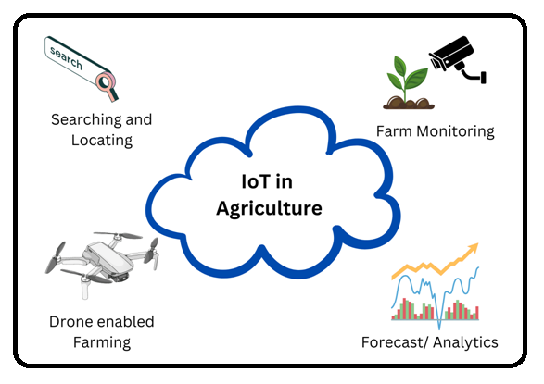
Figure 1.3: Agriculture IoT Applications
Drones in Farming:
One of the best IoT applications is agriculture and farming drones. They developed very good farming techniques. With the help of drones, the health of crops can be more easily measured. All this can be done with good IoT based equipment for the production of agricultural drones.

Green House Farming:
Farmers use greenhouses to increase the yield of their crops. Growing crops in greenhouses uses AI to monitor environmental factors that affect crop growth. In contrast, this method of manually adjusting crop growth has low efficiency. The IoT and technical advancements have led to IoT enabled Green houses equipped with climate control sensors and other related devices.

Application of IoT in Healthcare

In a secure network, medical devices will provide doctors with information about a patient’s health. This allows doctors to analyse patients remotely [8-9]. Some prospective applications in Healthcare IoT are mentioned below in Figure 1.4:

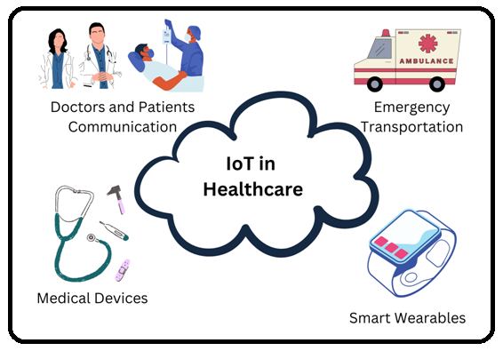
Figure 1.4: Healthcare IoT Applications
Minimizing the Treatment Error’s:
With the help of IoT devices, manual errors in identifying the patients are reduced. In this way, patients can receive timely care. Additionally, 24/7 on-board diagnostics can provide a clearer picture of a patient’s health than manual diagnostics.

Remote Assessment and Medication by Experts:
The IoT solves a huge problem in the healthcare industry: the shortage of doctor, especially specialists, in rural areas. Thanks to the IoT, it is now possible to care from patients without a doctor. All patients need is to put on the device. The computer then sends all the information about the patient’s health to the appropriate doctors for analysis. In this ways, the impact of IoT can play an adequate role for those in need.

IoT enabled Smart City

The concept of smart cities has gained significant traction in recent years, and it encompasses various IoT applications aimed at making urban environments more efficient, sustainable, and livable. One of the key components of a smart city is the integration of IoT technology into various aspects of urban life, including smart buildings and smart homes [10].
Smart Buildings and Smart Homes:
Energy Efficiency: IoT-enabled sensors and devices in smart buildings can monitor and optimize energy usage. For example, lighting and HVAC systems can adjust based on occupancy and external conditions, leading to energy savings.
Comfort and Convenience: Smart home devices can be controlled remotely through smartphones or other devices. Residents can adjust lighting, temperature, and other settings even when they are not at home.
Security: IoT-based security systems can provide real-time monitoring of homes, notifying homeowners about potential security breaches and allowing them to take immediate action.
Health and Wellness: Smart homes can incorporate health-monitoring devices, helping individuals track their health metrics and enabling timely interventions.
Resource Management: Smart appliances and systems can communicate with each other to optimize resource usage. For instance, water usage can be monitored and controlled to reduce wastage.
Data-Driven Insights: The data collected from smart devices can provide valuable insights into patterns of usage and behavior. This data can be used to further improve energy efficiency, comfort, and overall living conditions.
Smart Cities:
Urban Mobility: IoT can play a pivotal role in optimizing traffic flow, managing parking spaces, and providing real-time public transportation information to reduce congestion and improve transportation efficiency.
Waste Management: Smart waste management systems can optimize garbage collection routes and schedules based on the fill levels of waste bins, reducing unnecessary trips and associated costs.
Environmental Monitoring: IoT sensors can monitor air quality, noise levels, and other environmental factors, enabling cities to take proactive measures to address pollution and create healthier environments.
Public Safety: IoT-based surveillance and monitoring systems can enhance public safety by providing real-time information to law enforcement and emergency response teams.
Infrastructure Management: Smart sensors can help cities monitor the condition of critical infrastructure, such as bridges and roads, to ensure timely maintenance and prevent failures.
Citizen Engagement: IoT-based platforms can facilitate citizen engagement by providing channels for feedback, reporting issues, and participating in decision-making processes.

The research and development in the field of smart cities and IoT continue to evolve, driven by the growing need for more sustainable and efficient urban living. As technology advances and cities invest in infrastructure upgrades, we can expect to see even more innovative solutions that make our urban environments smarter and more connected [11].

Internet of Everything

Internet of Everything (IoE) is made up of “4 pillars” of people, data, processes and things. The IoT, on the other hand, has only “things” as represented in Figure 1.5. The IoE commerce continues to enrich people’s lives. Formerly isolated devices, including machine to machine and person to person are now connected to the Internet [12-13].

Cities of the future can be seen as scaled down versions of IoE and will benefit most from communications that use smart data to solve problems in the city. This will make it clearer how cities are leveraging IoE and “big data” to become “Smart cities”. Applications using road evaluation methods to maintain the health of highways, manage the traffic, development of education along with health services and monitor the agriculture [14].

Internet of Nano Things
Nanotechnology focuses on nanoparticles that are not recognized by previous technologies. Consider some sensors that can detect many things but fails when it comes to identifying nanoparticles. Nanosensors help to gather information from nanoparticles in the world. In medicine, nanosensors are used to detect the level of tumors. Accurate data and analysis down to the cellular level make nanosensors reliable and accurately identify the diseases [15].

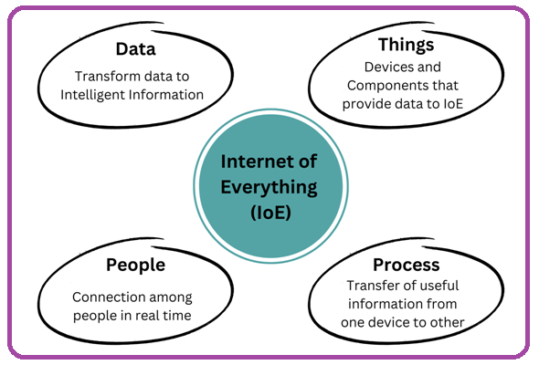
Figure 1.5: Components of IoE

Internet of Nano Things (IoNT) is nothing but the interaction of nano-devices with present networks. Thus, it has led to the change of the latest technology in electromagnetic communication of nanoscale devices. IoNT has many ways to offer this great indoor solution. Imagine that you are not at home and there is smoke in kitchen. It might be dangerous and may start a fire from electrical or other causes.

However, with the help of IoNT this can be identified early and alerts us to take the necessary steps to correct the problem. Thanks to the ability of the IoNT to detect nanoparticles, a simple nano-sensor can detect gas leaks and send notifications to take appropriate remedies. IoT application areas can be enhanced with IoNT models to a greater level [16].

Conclusion

The interconnected nature of IoT devices, coupled with their often limited processing power and security features, can indeed create vulnerabilities that hackers might exploit to gain unauthorized access to sensitive data or control over these devices. This can potentially lead to privacy breaches, data leaks, and even malicious control of devices. As nanotechnology continues to play a role in advancing IoT applications, addressing security concerns becomes even more critical. Striking a balance between innovation and security is essential to ensure that the benefits of IoT can be harnessed without compromising user safety and data integrity.

While technology has more benefits, the use of IoT costs more than most benefits due to internet connectivity, the presence of vulnerabilities and minor incidents raises security and privacy concerns. These concerns have to be addressed to the maximum possible level.

References
- Kumar, S., Tiwari, P., & Zymbler, M. (2019). Internet of Things is a revolutionary approach for future technology enhancement: a review. Journal of Big data, 6(1), 1-21.
- Zhou, J., Cao, Z., Dong, X., & Vasilakos, A. V. (2017). Security and privacy for cloud-based IoT: Challenges. IEEE Communications Magazine, 55(1), 26-33.
- https://www.altexsoft.com/blog/iot-architecture-layers-components/
- Montenegro-Marin, C. E., Gaona-García, P. A., Prieto, J. D., & Nieto Acevedo, Y. V. (2017). Analysis of security mechanisms based on clusters IoT environments.
- Hussein, A. H. (2019). Internet of things (IOT): Research challenges and future applications. International Journal of Advanced Computer Science and Applications, 10(6).
- Golpîra, H., Khan, S. A. R., & Safaeipour, S. (2021). A review of logistics internet-of-things: Current trends and scope for future research. Journal of Industrial Information Integration, 22, 100194.
- Jha, S. N., et al. "Assessment of quantitative harvest and post-harvest losses of major crops and commodities in India." Ministry of Food Processing Industries (Govt. of India), ICAR-CIPHET, Ludhiana (2015): 64-67.
- Aghdam, Z. N., Rahmani, A. M., & Hosseinzadeh, M. (2021). The role of the Internet of Things in healthcare: Future trends and challenges. Computer methods and programs in biomedicine, 199, 105903.
- Kumar, S., Tiwari, P., & Zymbler, M. (2019). Internet of Things is a revolutionary approach for future technology enhancement: a review. Journal of Big data, 6(1), 1-21.
- Zanella, A., Bui, N., Castellani, A., Vangelista, L., & Zorzi, M. (2014). Internet of things for smart cities. IEEE Internet of Things journal, 1(1), 22-32.
- Khajenasiri, I., Estebsari, A., Verhelst, M., & Gielen, G. (2017). A review on Internet of Things solutions for intelligent energy control in buildings for smart city applications. Energy Procedia, 111, 770-779.
- https://www.acte.in/future-scope-of-iot-in-modern-world-article/
- Fiaidhi, J., & Mohammed, S. (2019). Internet of everything as a platform for extreme automation. IT Professional, 21(1), 21-25.
- Shane, M., Nicola, V., Stewart-Weeks, M., & Lange, A. (2014). The Internet of Everything for Cities: Connecting People Process Data and Things To Improve the ‘Livability’of Cities and Communities. In Cisco Internet Business Solutions Group (IBSG). Cisco Systems, Inc..
- Alabdulatif, A., Thilakarathne, N. N., Lawal, Z. K., Fahim, K. E., & Zakari, R. Y. (2023). Internet of nano-things (iont): A comprehensive review from architecture to security and privacy challenges. Sensors, 23(5), 2807.
- Naser, H. A., Lateef, A. T., Bida, F. A., & Zorah, M. (2021). Systematic Review of Internet of Nano Things (IoNT) Technology: Taxonomy, Architecture, Open Challenges, Motivation and Recommendations. Iraqi Journal of Nanotechnology, (2), 7-19.

