GENE IMPRINTING
Poonam Nawalkar^{1*}, Sunil Kumar Verma²
¹ Ph.D. Research Scholar, ² Assistant Professor Plant Molecular Biology and Biotechnology.,
College of Agriculture, Indira Gandhi Krishi Vishwavidyalaya Raipur, Chhattisgarh 492012
*Corresponding Author email ID.- poonamnawalkar88@gmail.com
Introduction: -
A typical cell contains two sets of chromosomes: one that was inherited from the mother, the other from the father. Usually, autosomal alleles are expressed at similar levels from the maternally and paternally inherited chromosomes. This chapter is dedicated to an exception of this rule: the expression of genes that are regulated by genomic imprinting depends on the parental origin of the allele, leading to the non-equivalence of maternal and paternal genomes. Genomic imprinting is a paradigm of epigenetic gene regulation as genetically identical alleles can exist in two expression states within the same nucleus. The imprints marking the parental alleles are established in the parental germline, maintained during the development of the offspring, but reset before they are passed on to the next generation.
In mammals, the primary imprint is usually a differentially methylated region at the locus but there are also examples where histone modifications mark the parental alleles. Many imprinted genes play important roles for development and are associated with human disease. Interestingly, genomic imprinting evolved independently in mammals and seed plants and similar mechanisms have been recruited to regulate imprinted expression in the two kingdoms
Definition: -
“Genomic imprinting is an epigenetic phenomenon leading to a change of gene expression dependent on whether the gene was inherited from the maternal or the paternal parent (Reik and Walter, 2001)”. Or
“Genomic imprinting refers to genes that are silent when maternally inherited but expressed when paternally inherited, or vice versa”. Gene imprinting is a differential expression of autosomal genes according to their parent of origin.
Epigenetic imprints can either activate or silence the “imprinted” allele, and hence imprinting can be associated with either an expressed or silenced allele. The imprint is placed during male or female gametogenesis and determines the differential expression state of the alleles in post fertilization tissues.
- Maternally expressed genes (MEGs)
- Paternally expressed genes (PEGs)
Paternal imprinting means that an allele inherited from the father is not expressed in offspring.
Maternal imprinting means that an allele inherited from the mother is not expressed in offspring.
In mammals and flowering plants, imprinting occurs in the embryo as well as in embryo nourishing tissues, the placenta and the endosperm, respectively,
- Imprinted genes control the nutrient flow from the mother to the offspring.
- Imprinting in angiosperms occurs in endosperm early embryo but not in adult tissues.
Fig : Double Fertilization
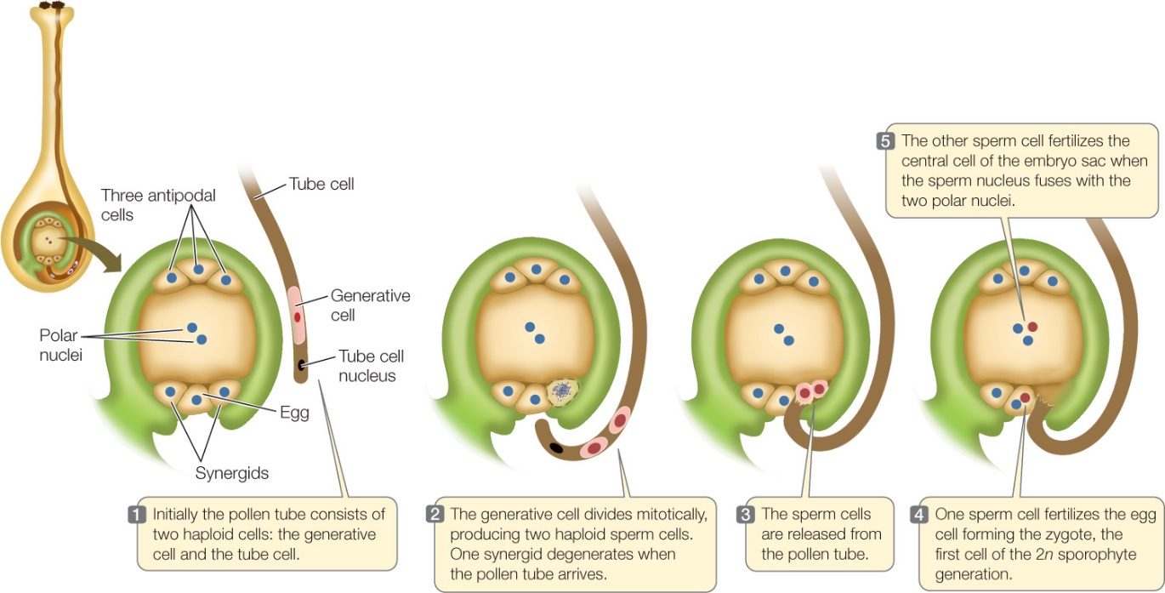
Epigenetics:
“The study of changes in gene function that are heritable and that do not entail a change in DNA sequence”
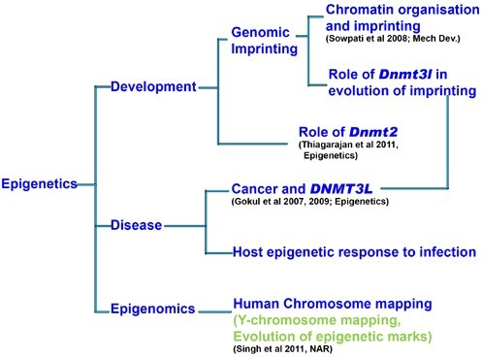

Evolution of genomic imprinting:

Parental conflict theory

If genomic imprinting was solely limited to angiosperms and mammals, this would be consistent with the parental conflict theory, whereby imprinting has evolved in organisms which have a placental habit allowing conflict between males and females over the level of maternal resource allocation to the offspring.

The theory also suggests that genes that restrict zygote growth become paternally silenced, whereas genes promoting growth would be silent from maternal alleles.
- First report by Helen Crouse in 1960.
- The first description of the imprinting phenomenon was given by McGrath and Solter in 1984.
- The word “Imprinting” was first used to describe events in insect Pseudococcus nipae.
- In plants first demonstrated in maize by Kermicle (1970)
- The study of gene specific imprinting during seed development in Arabidopsis.
- The development of embryo and endosperm is highly coordinated.
- Crosstalk between these two is essential for synchronized development.
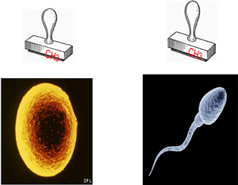
- Mutations in a specific class of genes disrupt such developmental synchrony and seeds eventually abort.

What is imprinting?
- Imprinted chromosomes are “marked”
- Imprinting differs in sperm and egg
- Imprinting turns off specific genes
- Imprinting does not change the nucleotide sequence.
- It is an inheritance process independent of the classical mendelian inheritance.
- If the allele inherited from the father is imprinted and thereby silenced then only the allele from the mother is expressed. (In the case of gene H19 or CDKN1C).
- If the allele from the mother is imprinted then only the allele from the father is expressed (e.g., in the case of gene IGF-2).
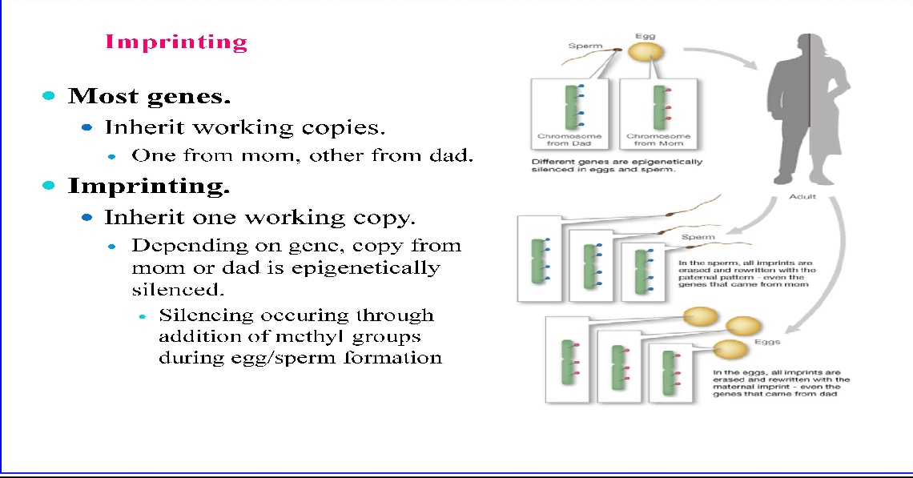
Genome imprinting is mediated via –
- DNA methylation
- Histone modification

Types of gene imprinting:
Allelic Imprinting: In which only alleles from a certain background are subject to parent- of origin–specific gene expression.
For Example: An imprinted angiosperm gene was in alleles of the maize R gene. The R gene conditions anthocyanin accumulation in the aleurone (the outer cell layer of the endosperm) of maize kernels. When an RR female (red) is mated to a rr male (colorless), all of the kernels have a fully colored aleurone. However, the reciprocal cross gives rise to kernels with mottled aleurone pigmentation, indicative of irregular anthocyanin distribution (Kermicle, 1970). This phenomenon is specific to the endosperm, and no reciprocal differences are observed in embryos or seedlings (Brink et al., 1970).
Sr.No | Genes |  | Reference
1 | R | Endosperm | Kermicle(1970);Ludwig et al., (1989)
2 | Dzr-1 | Endosperm | Chaudhari & Messing (1994)
3 | Zein | Endosperm | Lund et al., (1995a)
4 | Alpha-tubulin | Endosperm | Lund et al., (1995a)
5 | Locus- specific imprinted genes | Tissue-specific expression
6 | ZmFie1 | Endosperm | Danilevskaya et al., (2003)., Gutierrez Marcos et al (2006)
7 | ZmFie2 | Endosperm | Hermon et al (2007); Haun and Springer (2008)
8 | Nrp1 | Endosperm | Danilevskaya et al., (2003)., Gutierrez Marcos et al (2006)
9 | Meg1 | Endosperm | Gutierrez-Marcos et al., (2004)
10 | Mez1 | Endosperm | Gutierrez-Marcos et al., (2004)
11 | Mee1 | Embryo & Endosperm | Haun et al., (2007); Haun & Springer 2008
12 | VIM5 | Endosperm | Jahnke and Scholten (2009)
13 | YUC10 | Endosperm | Zhang et al (2013)
(SOURCE: Bhavani et al., 2012)

Locus imprinting:

In which all known alleles from different backgrounds are under parent- of origin control.
Example: The Arabidopsis MEDEA (MEA) gene
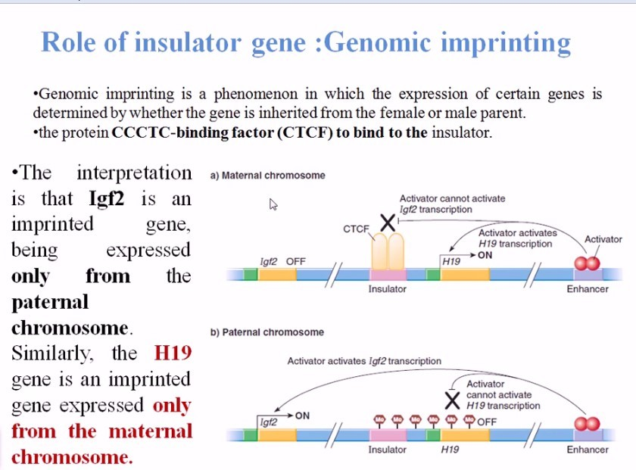
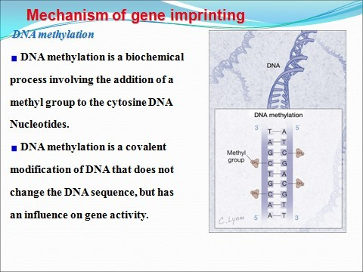
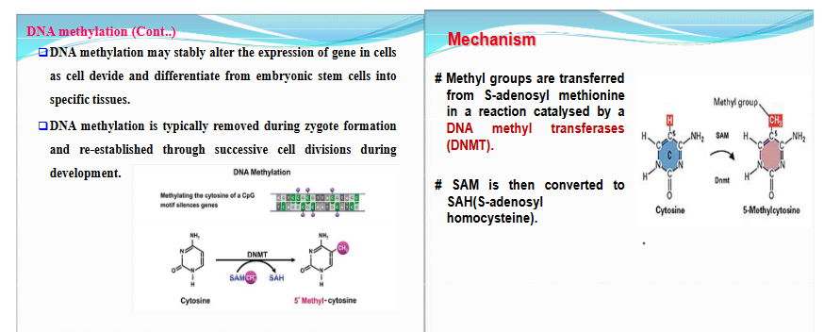

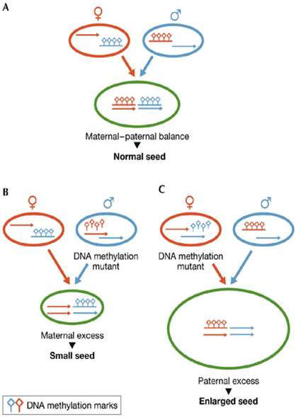

DNA methylation affect gene transcription by:

Histone modification:

A histone modification is a covalent post-translational modification (PTM) to histone proteins which includes-

Methylation

Phosphorylation

Acetylation

Ubiquitylation

Sumoylation.

In most species, histone H3 is primarily acetylated at lysines 9, 14, 18, 23, and 56, methylated at arginine 2 and lysines 4, 9, 27, 36, and 79, and phosphorylated at ser10, ser28, Thr3, and Thr11.

Histone H4 is primarily acetylated at lysines 5, 8, 12 and 16, methylated at arginine 3 and lysine 20, and phosphorylated at serine 1.

Imprinted genes in plants:
In flowering plants (angiosperms).
During fertilization of the egg cell, a second, separate fertilization event gives rise to the endosperm, an extra-embryonic structure that nourishes. Unlike the embryo, the endosperm is often formed from the fusion of two maternal cells with a male gamete. This results in a triploid genome. The 2:1 ratio of maternal to paternal genomes appears to be critical for seed development. It has been suggested that these imprinted genes are responsible for the triploid block effect in flowering plants that prevents hybridization between diploids and auto- tetraploids.

Role of genomic imprinting in seed development:

Seed development in flowering plants is initiated by double fertilization.

One haploid sperm fuse with the haploid egg to produce the diploid embryo and the second haploid sperm fuses with the diploid central to form the triploid endosperm.

The embryo has a maternal : paternal parental genomic ratio of 1:1 (1m:1p) whereas the ratio in the endosperm is 2m:1p.
Gene imprinting in Arabidopsis thaliana

4 genes in Arabidopsis are imprinted –

MEDEA (MEA), FWA and FERTILIZATION INDEPENDENT SEED 2 (FIS2) are maternally expressed and paternally silence.

PHERES1 (PHE1) is the only plant gene known to be paternally expressed and maternally silenced.

Imprinting Regulation at the Maternally Expressed MEDEA Locus in Arabidopsis thaliana

MEA encodes SET- Domain protein and controls seed development.

Loss of function mutations of MEA (mea) show a parent-of-origin maternal effect.

When inherited maternally (but not paternally), the mutant MEA allele induces endosperm and embryo over proliferation and eventually leads to seed abortion.

By default, MEA genes more likely to be transcriptional silencing due to DNA methylation (cytosine methylation) by METHYLTRANSFERASE 1 (MET1).

A maternal-specific activator(s) releases the default silencing and activates maternal expression only in the female gametophyte.

In the male gametophyte, by contrast, the paternal allele would remain silent due to an absence of a maternal-specific activator(s).

DEMETER (DME) has been identified as a transcriptional activator positively regulating MEA in the central cell.

DME encodes a DNA glycosylase that specifically removes 5-methylcytosine from DNA

Ovules carrying mutant dme do not express MEA and as a result the seeds eventually abort.

It was thus hypothesized that DME removes DNA methylation at the maternal MEA allele in the central cell and the hypomethylated maternal MEA is exclusively expressed in the early endosperm while the methylated paternal MEA is transcriptionally silenced

Imprinting Regulation at the Maternally Expressed FWA Locus in Arabidopsis thaliana

The FWA (FLOWERING WAGENINGEN) gene was the second imprinted gene to be discovered in Arabidopsis thaliana, where it behaves as a maternally expressed imprinted gene in the endosperm.

FWA is presumed to affect flowering through the speculated photoperiod promotion pathway.

FWA also plays a role in the control of flower meristem identity.

FWA by default remains silenced due to DNA methylation by METHYLTRANSFERASE 1 (MET1).

Gain in function of FWA gene occurs due to when DME removes the methyl group from the DNA making the FWA gene transcriptionally active.

This eventually leads to delayed flowering phenotype.

Imprinting Regulation at the Paternally Expressed PHERES1 Locus in Arabidopsis thaliana

PHERES1 (PHE1) is third imprinted gene studies in the Arabidopsis endosperm.

In Arabidopsis thaliana PHERES1 gene is involved in ending of seed dormancy and regulation of transcription of MADs-box genes.

Whereas MEA, FIS2, and FWA are maternally expressed, paternal PHE1 expression predominates in the endosperm, while the maternal PHE1 is silent or very weakly expressed because maternally expressed MEDEA gene represses its expression in female gametophyte.

This protein was called 'Pheres' in memory of one of the murdered sons of the mythological 'Medea', as PHERES1 is repressed by MEDEA

The PHE1 locus is regulated by histone trimethylation on H3K27 residues

Imprinting Regulation at the Maternally Expressed FIS2 Locus in Arabidopsis thaliana

The fourth imprinted gene discovered in the Arabidopsis genome is the Fertilization Independent Seed 2 (FIS2) gene which is maternally expressed in the endosperm.

At the imprinted FIS2 locus, the maternal allele of FIS2 is also activated by DME in the central cell.

Conclusion:

The study of imprinting in plants has significantly grown over the past decade. The wide availability of mutants affecting epigenetic processes in plants has allowed the plant imprinting field to apply such mutants to genetically dissect the mechanisms controlling imprinting in plants.

Genetic imprinting is found to have major role in many key developmental processes and genome dosage is one of the factors contributing to the imprinting.

To date, the scientific community is still debating on its role in evolution and significance in the process of crop improvement.

Imprinted gene regulates the transfer of nutrients to the developing progeny.

Advanced technologies like genome-wide approaches may contribute in helping the researchers to unravel the potential mechanism of genetic imprinting and its possible benefits to crop improvement.
Reference:
Arnaud, P., and Feil, R. (2006). MEDEA takes control of its own imprinting. Cell 124, 468–470. Doi: 10.1016/j.cell.2006.01.020
Bai, F., & Settles, A. M. (2015). Imprinting in plants as a mechanism to generate seed phenotypic diversity. Frontiers in plant science, 5, 780. https://doi.org/10.3389/fpls.2014.00780
Costa, L. M., Yuan, J., Rouster, J., Paul, W., Dickinson, H., and Gutierrez-Marcos, J. F. (2012). Maternal control of nutrient allocation in plant seeds by genomic imprinting. Curr. Biol. 22, 160–165. Doi: 10.1016/j.cub.2011.11.059.
Garnier, O., Laoueillé-Duprat, S., & Spillane, C. (2008). Genomic imprinting in plants. Epigenetics, 3(1), 14–20. https://doi.org/10.4161/epi.3.1.5554
Gehring M. (2013). Genomic imprinting: insights from plants. Annual review of genetics, 47, 187–208. https://doi.org/10.1146/annurev-genet-110711-155527
Köhler, C., Wolff, P., & Spillane, C. (2012). Epigenetic mechanisms underlying genomic imprinting in plants. Annual review of plant biology, 63, 331–352. https://doi.org/10.1146/annurev-arplant-042811-105514
Li, J., and Berger, F. (2012). Endosperm: food for humankind and fodder for scientific discoveries. New Phytol. 195, 290–305. Doi: 10.1111/j.1469-8137.2012. 04182.x
Lauria M, Rupe M, Guo M, Kranz E, Pirona R, Viotti A, Lund G. Extensive maternal DNA hypomethylation in the endosperm of Zea mays. Plant Cell. 2004 Feb;16(2):510-22. Doi: 10.1105/tpc.017780. Epub 2004 Jan 16. PMID: 14729913; PMCID: PMC341920.
Rodrigues, J. A., & Zilberman, D. (2015). Evolution and function of genomic imprinting in plants. Genes& development, 29(24), 2517–2531. https://doi.org/10.1101/gad.269902.115
Reik W, Walter J. Genomic imprinting: parental influence on the genome. Nat Rev Genet. 2001 Jan;2(1):21-32. Doi: 10.1038/35047554. PMID: 11253064
Soria LF, Ludwig EH, Clarke HR, Vega GL, Grundy SM, McCarthy BJ. Association between a specific apolipoprotein B mutation and familial defective apolipoprotein B-100. Proc Natl Acad Sci U S A. 1989 Jan;86(2):587-91. Doi: 10.1073/pnas.86.2.587. PMID: 2563166; PMCID: PMC286517.
Singh R, Chandel S, Dey D, Ghosh A, Roy S, Ravichandran V, Ghosh D. Epigenetic modification and therapeutic targets of diabetes mellitus. Biosci Rep. 2020 Sep 30;40(9): BSR20202160. Doi: 10.1042/BSR20202160. PMID: 32815547; PMCID: PMC7494983.

