GUIDED ENODONTICS
Details of Author
Name: Dr. Shriya Shahu
Designation: Assistant Professor
Affiliation: Ranjeet Deshmukh Dental College and Research Centre, Nagpur (Formerly known as VSPM’s Dental College and Research Centre, Nagpur)
Email: dr.shriyashahu@gmail.com
Ph. No.: +91 9527200768

CONTENT

- Introduction
- Historical Background
- Components of Guided Endodontics
- Endodontic Guided
- Types of Guided Approach
- Static Guided Approach
- Dynamic Navigation System
- Work Flow for Guided Endodontic Approach
- Application in Endodontics
- Failures and limitations
- Futuristic Trends
- Summary
- References

INTRODUCTION
The realm of contemporary endodontics has metamorphosed beyond recognition as a result of quantum leap in technological advancements.
Guided Endodontics (GE), also known as Targeted Endodontic Treatment (TET) is an emerging exemplar of evolution in this domain, representing one of the most accurate technology to perform complex surgical interventions predictably. It encompasses conservative access cavity preparation with precision, safety and reliability in accordance with the modern approaches of minimally invasive endodontics.
Minimally invasive Endodontics is based on the preservation of sound coronal, cervical, and radicular tooth structure, thereby reinforcing fracture resistance of endodontically treated teeth. Guided endodontics helps in the preservation of pericervical dentin and offers the most conservative approach for cases with higher complexity level.

The concept of Guided endodontics was introduced with the improvements in tomographic imaging and 3D printing technologies. Cone beam computed tomography (CBCT) can be used in challenging cases in which conventional radiographic techniques fail to provide adequate information on the morphology of the root canal and periradicular tissues. Guided Endodontics utilizes this three dimensional (3D) information which is integrated with the surface profile of the teeth acquired by an intraoral scanner in order to design and print a 3D guide for treatment.

The indications for use of targeted endodontic treatment approach is based upon the understanding of its characteristics and exploration of digital dentistry tools to enhance clinical applicability. These computer-designed guides are used for access cavity preparation and endodontic surgery in order to achieve predictable and safe results. 3D guides are gaining popularity in endodontic surgery for osteotomy and root- end resection, negotiation of pulp canal obliteration, calcification among the few indications.

GE has emerged as a field of research in the past 6 years, and clinical research and laboratory studies have reported high reliability and accuracy of the procedure. It may constitute a significant addition to an endodontist’s arsenal in managing complexities in contemporary practices.
HISTORICAL BACKGROUND
The main challenge to specifically target an anatomical structure safely and in a non-invasive manner remains the paramount principle of three dimensional exploration.The quest for localization of discrete anatomical structures within the human body can be traced back to the late nineteenth century.
The advent of medical imaging and exponential growth of computer-processing capabilities are vital prerequisites that enabled accurate and safe targeting of anatomy to turn into reality.

The discovery of the X-ray by Wilhelm Roentgen in 1895 unraveled the pathway for an entirely new era of diagnosis and treatment planning. In the 1970s, Sir Godfrey Hounsfield first introduced computer tomography (CT) imaging device, which he called ‘computerized axial tomography’.
Since then dramatic improvements in detectors, beam source, and movement of detectors have revolutionized three dimensional imaging. In 1988, Mozzo et al. revolutionized 3D imaging by describing importance of volumetric CT machine and its applications in dental imaging.CBCT has become an integral part of dental practices in the last decade.

The introduction of the magnetic resonance imaging (MRI) in the 1980s by Dr. Raymond Damadian marked an important milestone allowing for the imaging of soft tissue in greater detail.
In 1990, David Roberts developed the concept of frameless stereotaxy for neurosurgery that could track surgical instruments in real time and enabled constant visualization of its position on the preoperative CT or MRI. This important discovery laid the foundations for inception of dynamic navigation as we know it today.

Dr. Francois Duret was the pioneer in describing the fundamental principles of Optical impressions and CAD/CAM technology. He developed the first CAD/CAM device in 1984 which was patented and named Sopha System.
The first generation of Chairside CAD/CAM system CEREC (Siemens Corporation) was created by Werner Mörmann in 1987 to make chairside inlays. The Siemens Corporation produced the CEREC 2 software in 1994, and CEREC 3 was developed by Sirona Dental System in 1999.
Since then, developments in the field of scanning intraoral and extraoral images of dental hard and soft tissues have advanced drastically.

The development of the first 3D printing systems by Charles Chuck Hull in 1984 has enormously evolved the future of bioprinting tools from multimaterial 3D printers to a plethora of softwares and 3D printers currently used in the endodontic domain.

COMPONENTS OF GUIDED ENDODONTICS
GE approach is based upon four essential elements which comprise the tetrad of digital dentistry. (Fig. 1)
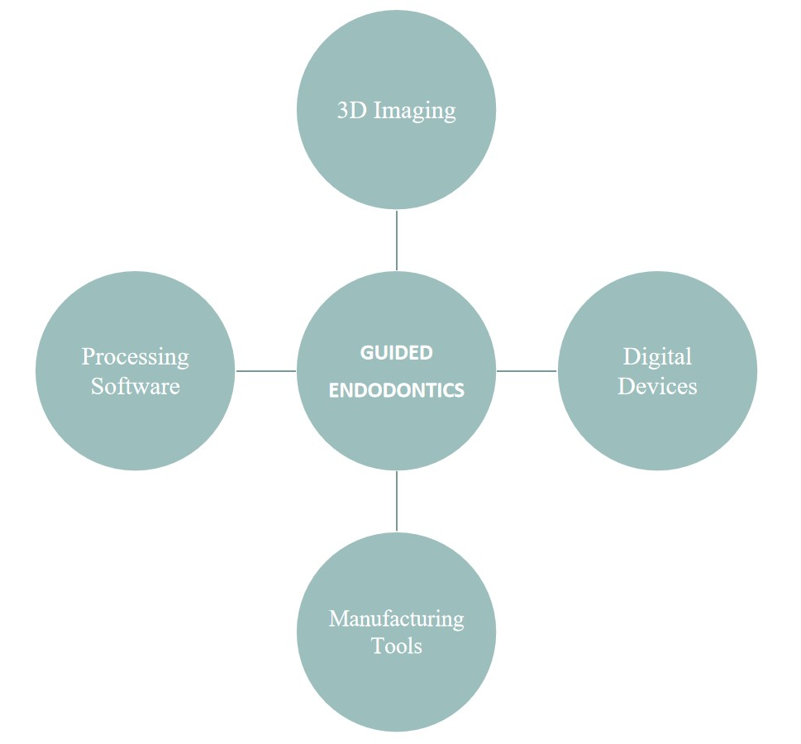
Fig. 1: Components of Guided Endodontics

- 3D IMAGING
CBCT is the quintessential imaging modality used in guided endodontic procedures. The CBCT unit comprises of a rotating gantry, an X-ray source with divergent pyramidal- or cone-shaped source of ionizing radiation and a moving detector around a fixed fulcrum within the region of interest. After exposure, multiple planar projection 2D images are acquired in an arc of at least 180°and the images are then reconstructed to visualize 3D data set. The image formation process consists of three stages:
- Acquisition stage
- Reconstruction stage
- Image display
The data obtained from the 3D scan is saved in the format of Digital Imaging and Communications in Medicine (DICOM). A smaller Field of View is recommended for CBCT utilized for endodontic purposes. Depending upon the CBCT device, images must be recorded in high definition mode for better visualization of root canals. For guided treatments, open mouth CBCT are advised to allow better evaluation of anatomy and prevention of superimposition.

- DIGITAL DEVICES
Digital devices such as digital cameras, intraoral and extraoral scanners, Digital Impression Systems and CAD/CAM systems are employed for successful acquisition of accurate virtual images.

- Digital Scanner
In contemporary dental practices, optical impressions taken with digital scanners are now replacing the conventional techniques with tray and impression materials. Various scanners are presently available based on the data capture principles. (Fig.2)
Extraoral tactile scanners are based upon attaining mechanical contact between the detection unit and the object to be scanned. On the other hand, optical Scanners utilize electromagnetic wave, specifically light in a non-contact mode to detect surface details.
The digital impression data obtained from the scanners is easily imported into processing software for designing/planning the 3D models with powerful milling machines. From the CBCT dataset (DICOM), it is possible to export and combine the 3D data as a Standard Triangle Language (STL) file using intraoral digital impression system. The STL file contains geometrical information of an object by describing it in terms of dense connected triangles based on initial resolution and mathematical algorithms. Digital impression systems are pivotal for designing the treatment plan and fabrication of a guide for better visualization and access during endodontic procedures.
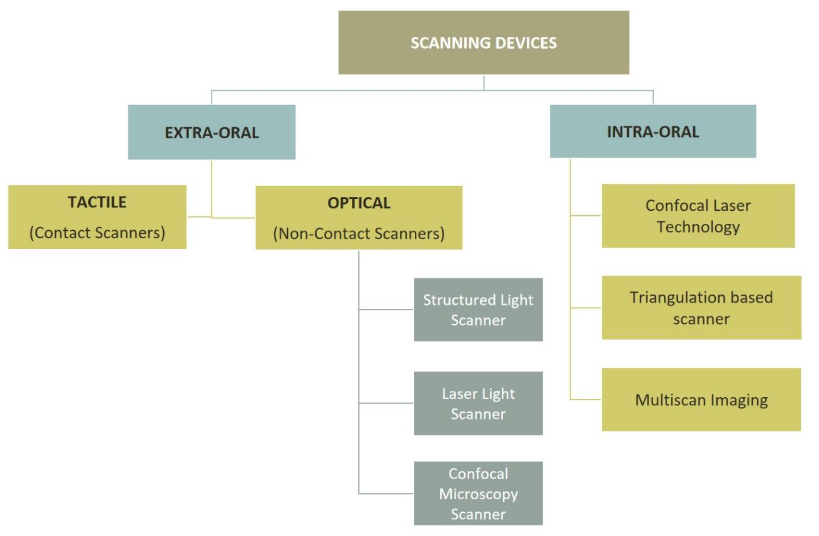
Fig. 2: Types of Scanning Devices

- CAD/CAM
The term CAD/CAM is an acronym for computer-aided design (CAD) and computer-aided manufacturing (CAM). Dental CAD/CAM systems consist of various hardware and software used for data acquisition as well as designing and manufacturing of restoration. It serves three main functions:
- Three-dimensional generation of digital data set
- Design manipulation process for generating the manufacturing data set
- Fabrication of dental restoration by a digitally controlled system

Indirect CAD/CAM workflow is based on scanning the gypsum model and cast made from conventional impression.These systems work with laboratory scanners.
Direct CAD/CAM workflow commences by scanning the prepared teeth directly with intraoral scanners.

3.PROCESSING SOFTWARE
Recent advancements in information technology have enhanced the availability of inexpensive and open-source software programs for image rendering, segmentation and redesigning. It is possible to replicate the missing anatomy, redesign the data as necessary, and visualize a digital model before the printing process with such software programs.
This permits efficient production of 3D printed guides by inter-operability between 3D imaging devices,virtual planning systems and 3D printers. The volumetric data in DICOM format from CBCT scans is acquired by 3D virtual planning software to convert the data to STL file format representing the virtual 3D surface shape. 3D imaging data from optical intra-oral/plaster model scans, existing as STL formats, are also acquired by 3D virtual planning systems.
The resultant 3D image is then edited with computer-aided design (CAD) software to create a blueprint of the 3D printed object.

- MANUFACTURING TOOLS
Additive manufacturing or 3D Printing has created an unforeseen renaissance in the treatment and diagnostic protocols in the wide domain of specialties in dentistry.It facilitates reconstruction of digital models using computer-aided software. The widely available 3D printers are based upon five basic mechanisms:
- Fused deposition modeling (FDM)
- Selective laser sintering (SLS)
- Stereolithography (SLA)/Direct Light Processing (DLP)
- Poly-jet printing
- Bioprinting
The present evidence of literature suggests a strong prospective of establishing value-based precision dentistry with the integration of additive manufacturing in the endodontic clinical management.

ENDODONTIC GUIDES
Three dimensionally printed guide or template for endodontic purpose is called Endoguide or endodontic guide. It is a template fabricated to guide drills into pre-planned positions for better localization and exploration of root canal orifices, or bone trephination and root end re-section in endodontic surgeries. Endoguides can be classified depending upon the specific use and type of support established during the procedure. Based on the literature,they may be classified as follows: (Fig. 3)

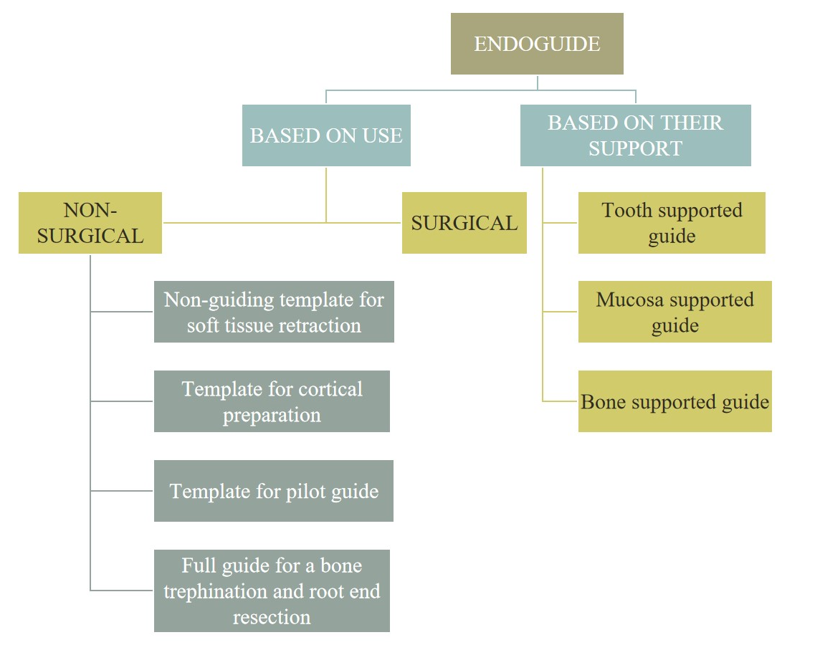 Fig. 3: Classification of Endoguides

- Nonguiding 3D printed template to help access
These templates are designed to define the surgical area. They retract soft tissues to ensure access to the surgical site

- 3D printed template for cortical preparation
This guide helps to define the exact site where the cortical bone should be penetrated for root-end resection. After placing the template, a short drill or cortical trephine is applied through it to mark the cortical bone (see Figs. 8.3 and 8.4) [20, 23]. This template helps to define osteotomy site over the root apex,

- Pilot guide
Initial drilling is performed with this drill through the template and the resulting bony cavity provides guidance to subsequent drills (applied without the template)

- Full guide for a bone trephine
3D printed surgical guide to perform both the osteotomy and the root-end removal in the same session

Following points should be considered while designing the endoguide:
- Offset of the Guide: 0.15mm is considered ideal
- Thickness of the guide: 3.5 mm is recommended
- Coverage of Guide: It is necessary to cover the adjacent teeth in the design for establishing stability of the guide
- Connector Thickness: This affects the overall stability of automatically connected parts of the manufactured guide

TYPES OF GUIDED APPROACH
3D guided approach in endodontics can be obtained in two ways:
- Static Navigation (SN)
- Dynamic Navigation (SN)

In Static guided approach, the optical impression is merged with the 3D data obtained from CBCT for designing of a virtual drill path prior to the clinical procedure.
On the other hand, Dynamic navigation is a recent technology utilizing stereoscopic monitoring camera to dynamically guide the operator's instruments to the precise location for the stipulated procedure (ex: root canal localization, root-end resection, etc.) in real-time. (Table No.1)
Both the techniques present correspondent advantages and disadvantages. (Table No. 2)
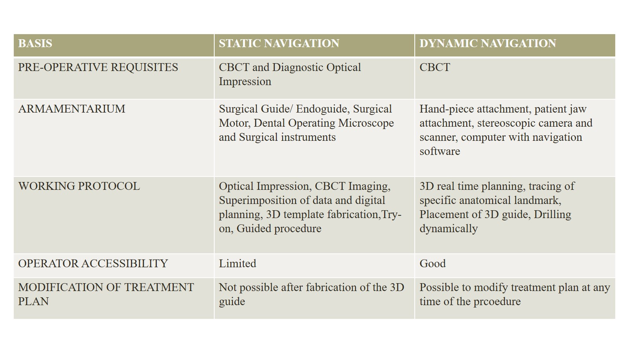
Table 1.: Characteristics of Static and Dynamic Approach in Guided Endodontics
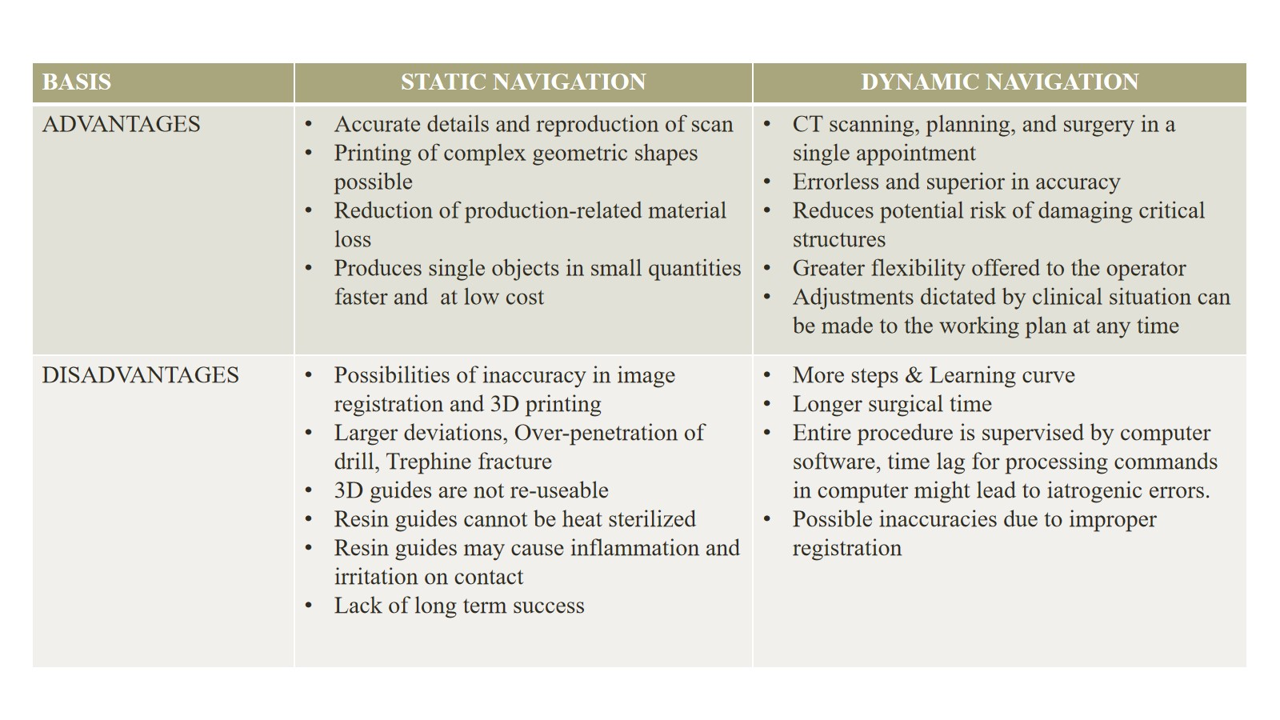
Table 1.: Comparison of Static and Dynamic Navigation Techniques

WORK FLOW FOR GUIDED ENDODONTIC APPROACH
In addition to planning the protocol of the 3D guided procedure, the endodontist is mainly responsible for verification of various aspects that may cause in interference with the final result of treatment. A virtual planning report is sent by the Planning Centers that provide information about the 3D scans, trajectory of the drill, dimensions of 3D guide. It is of utmost importance to understand the digital workflow to eliminate possible failures while performing the endodontic procedure.
(Fig. 3 and Fig. 4)

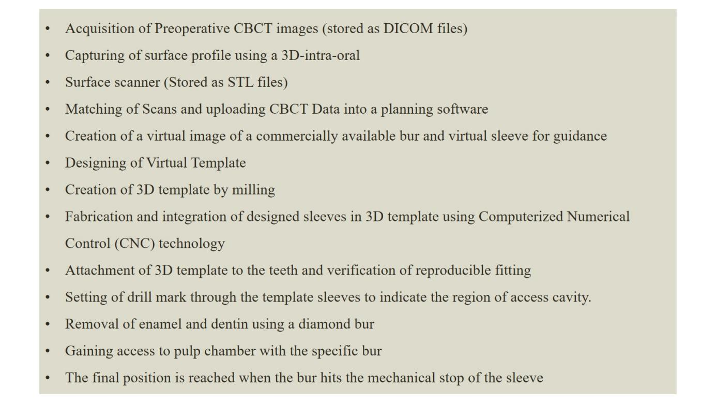
Fig.3: Workflow for Static Guided Endodontic Procedures

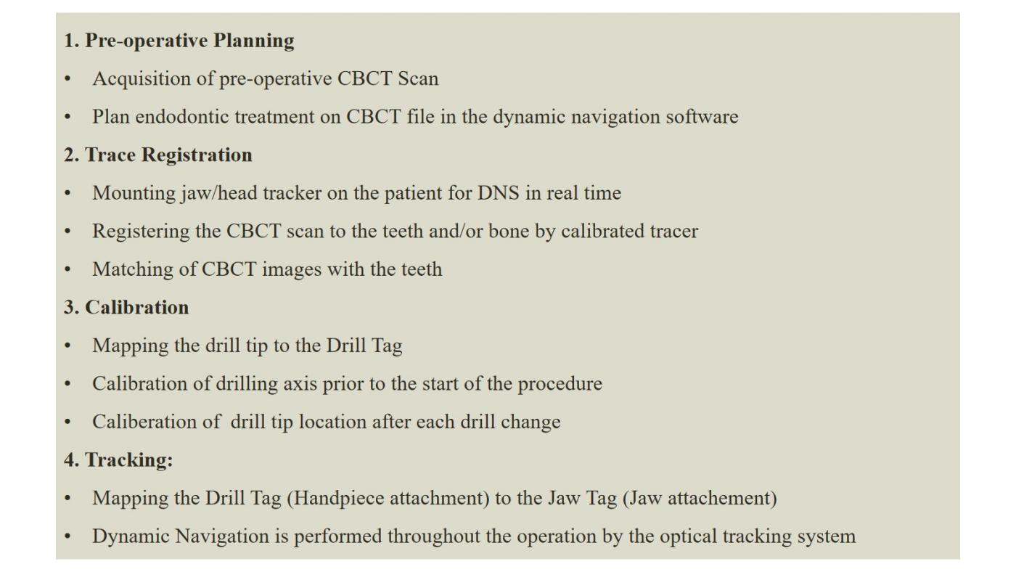
Fig.4: Workflow for Dynamic Navigation in Endodontic Procedures

INDICATIONS OF GUIDED ENDODONTICS
- Minimally Invasive Endodontic Access Cavities
Ultra-conservative access cavities are gaining popularity in routine endodontic practice with the aim of minimizing tooth weakness, preserving maximum tooth structure, and reducing instrument stress during treatment.Guided endodontics can help in preserving pericervical dentin and perform access opening according to the canal projection.

- Pulp Canal Obliterations and Calcified canals
Calcifications present in the pulp chamber and root canals predispose many clinical challenges for the operator. GE approach reduces the risk of endodontic mishaps in calcified canals Using high-speed drills in conjunction with 3D guides in static guided endodontics entails less operation time compared to traditional low-speed drills.

- Fiber post removal
In cases requiring endodontic retreatment, the practitioner’s experience influences the amount of dentin removed around the post. Inability to detect tooth colored post systems may lead to extra removal of dentin and widening of the radicular canal after the removal of the post. For these reasons, GE provides satisfactory and faster results in removal of fiber posts by providing higher precise and accuracy.

- Intraosseous anaesthesia
Dynamic Navigation Systems (DNS) allow for precise delivery of local anaesthetic agent with minimal or no root perforation in intraosseous anaesthetic techniques. The accurate entry, horizontal deviation, and 3D deviation of the tip for the DNS results in accurate drilling at 100% of the injection sites

- Endodontic surgeries
3D-printed static aids have been successfully utilized for various purposes in endodontic surgery including osteotomy, root-end resections and apicoectomy. This minimally invasive approach for endodontic microsurgery offers the advantage of being more comfortable for the patient in the postoperative process and avoids damage to anatomical structures.

FAILURES AND LIMITATIONS
One of the major difficulties with the guided endodontic systems is the high cost of the digital system, its updates, and maintenance which might not be financially feasible for the dental practitioner. Every system has its own planning software; thus, one might not be able to use any other advanced software. Adequate learning curve is associated with this approach.
Another disadvantage is that the spatial resolution of the CBCT does not always allow visualization of the canal due to the wide variability in the diameters of root canals, especially in cases of calcified canals. The small diameter is not seen in the CBCT images as the voxel size is larger.
Another issue of static guided approach is the over penetration of drill, which can be overcome by use of trephine with stop. However, trephine fracture is a possibility.
A relative disadvantage of the trephine-based technique used in endodontic surgeries is the cylindrical shape of the resulting osteotomy canal, which might interfere with cleaning and debridement. Thus this technique is not completely free of the possibility of complications.
Moreover, static guides work only for the straight portion of root canals. Presence of metallic restorations/ filling of teeth leads may to artifacts on acquired radiograph images.
Although the guided endodontic approach is quite novel, reliable data on accuracy, complication rates, and long-term success is lacking. Furthermore, the endodontic indication is not an option in any major computer-assisted guide production system at this point. Naturally, for this to change, more researches are required in this direction.

FUTURISTIC TRENDS
- 3D Printing in Autotransplantation
The clinical application of a computer-aided rapid prototyping (CARP) model for autotransplantation was first introduced in 2001 using 3D computed tomographic (CT) image acquisition followed by fabrication of a 3D printing copy model. This technique allows better simulation of the contour of the recipient bone using the actual-sized CARP models of donor teeth and recipient alveolar bones preoperatively. Utilization of 3D-printed template has been advocated for tooth autotransplantation procedures to make it faster, predictable, and more convenient.

- Bioprinting
3D printing has become a promising technology that permits the designing of anatomically correct scaffolds, which can be populated with cells. These cells include bone marrow stem cells, adipose tissue stem cells (ATSCs), cells from oral tissues, and many more

- Haptic Virtual Reality in Endodontics
Recently, the haptic VR simulators have been introduced into the dental curriculum as training devices for clinical skill acquisition in several tasks. They are used for the teaching of endodontic treatments by providing realistic simulation of a wide variety of nonsurgical and surgical treatment procedures.

SUMMARY
Guided endodontic procedures are a promising technique offering a highly predictable treatment outcomes with lower risks of iatrogenic damage. Minimally invasive treatments can be performed, with additional benefit of reduction in chairside time with the 3D GE approach.
GE utilizing static or dynamic navigation appears to be a safe and minimally invasive method for detecting calcified root canals, performing endodontic re-treatments and surgical procedures.
With continuous improvements in 3D imaging, 3D printing, and 3D virtual planning, there are potential benefits for utilization of this novel approach for the management of nonsurgical and surgical endodontic procedures.

REFERENCES:

- Decurcio DA, Bueno MR, Silva JA, Loureiro MAZ, Damião Sousa-Neto M, Estrela C. Digital Planning on Guided Endodontics Technology. Braz Dent J. 2021 Sep-Dec;32(5):23-33.
- Kulinkovych-Levchuk K, Pecci-Lloret MP, Castelo-Baz P, Pecci-Lloret MR, Oñate-Sánchez RE. Guided Endodontics: A Literature Review. Int J Environ Res Public Health. 2022 Oct 26;19(21):13900.
- Connert T, Weiger R, Krastl G. Present status and future directions - Guided endodontics. Int Endod J. 2022 Oct;55 Suppl 4(Suppl 4):995-1002.
- Ribeiro D, Reis E, Marques JA, Falacho RI, Palma PJ. Guided Endodontics: Static vs. Dynamic Computer-Aided Techniques-A Literature Review. J Pers Med. 2022 Sep 15;12(9):1516.
- Moreno-Rabié C, Torres A, Lambrechts P, Jacobs R. Clinical applications, accuracy and limitations of guided endodontics: a systematic review. Int Endod J. 2020 Feb;53(2):214-231.
- Lio F, Mampieri G, Mazzetti V, Leggeri A, Arcuri L. Guided endodontic microsurgery in apicoectomy: a review. J Biol Regul Homeost Agents. 2021 May-Jun;35(3 Suppl. 1):47-55.
- Anderson J, Wealleans J, Ray J. Endodontic applications of 3D printing. Int Endod J. 2018 Sep;51(9):1005-1018.
- Panithini DB, Sajjan GS, Kinariwala N, Medicharla UD, Varma KM, Kallepalli M. Real-time guided endodontics: A case report of maxillary central incisor with calcific metamorphosis. J Conserv Dent. 2023 Jan-Feb;26(1):113-117.
- Kinariwala N, Samaranayake L, editors. Guided endodontics. Springer International Publishing; 2021.

