Improving Sales Projections: A Neural Prophet-Based Approach for Weekly Forecasting

Y. Rajalakshmi¹, Divya Gudibandla², Tamminina Ammannamma³

¹Assistant Professor, Department of Computer Science and Technology, G Narayanamma Institute of Technology & Science, Hyderabad, Telangana, India

^{2,3} Assistant Professor, Department of Information Technology, G Narayanamma Institute of Technology & Science, Hyderabad, Telangana, India
¹ yedlarajalakshmi@gmail.com, ²gudibandladivya@gmail.com, ³tammannamma@gnits.ac.in

Abstract:
Sales forecasting plays a pivotal role in the strategic planning of businesses across diverse industries. Precise sales predictions empower organizations to optimize their inventory, allocate resources effectively, and make well-informed decisions. While conventional time series forecasting techniques like ARIMA and Exponential Smoothing have been utilized for this purpose for a long time, they may struggle to capture the intricacies of modern sales data, which is characterized by irregular patterns, seasonality, and non-linear trends. This study also conducts a comparative analysis of sales forecasting methodologies, with a specific focus on the application of NeuralProphet. NeuralProphet is an extension of the widely used Prophet forecasting library that integrates neural networks. It is engineered to overcome the limitations of traditional approaches by leveraging the capabilities of deep learning to model complex patterns in time series data. The research leverages historical sales data from a diverse range of industries, encompassing retail, e-commerce, and manufacturing, to assess the performance of NeuralProphet in relation to conventional forecasting techniques. The findings indicate that NeuralProphet outperforms Facebook Prophet in terms of Root Mean Square Error (RMSE).
Keywords - Sales Prediction, Weekly Prediction, Neural Prophet, Facebook Prophet, Sales Data.

1. INTRODUCTION
Forecasting sales is a pivotal element in devising a thriving business strategy, offering a window into the forthcoming performance of products or services. This process entails the utilization of statistical models, machine learning algorithms, and adept data analysis techniques to project future sales trajectories based on historical data and pertinent market variables. Through scrutinizing patterns, discerning correlations, and pinpointing influential factors, enterprises can judiciously steer decisions regarding inventory management, marketing endeavours, and resource distribution. Furthermore, sales prediction serves as a guiding beacon for financial mapping and budgetary allocations, empowering organizations to establish pragmatic objectives and apportion resources judiciously. In this age of data-centric decision-making, the assimilation of sophisticated predictive models has risen to paramount importance. In recent years, advancements in data science and machine learning have revolutionized the field of sales forecasting, providing businesses with powerful tools to enhance prediction accuracy.
NeuralProphet extends the capabilities of the popular Prophet forecasting library by introducing neural networks. This allows it to capture more complex patterns and relationships in sales data. NeuralProphet can handle missing data points, making it suitable for real-world datasets where data gaps are common [1]. We can fine-tune the model by adjusting hyperparameters and incorporating domain-specific knowledge, such as holidays and special events, to improve forecasting accuracy. The library provides built-in visualization tools to help you explore historical data, forecasted trends, and uncertainties [2]. NeuralProphet can automatically detect and model various types of seasonality, including daily, weekly, and yearly patterns.
Several key aspects are explored:
- Accuracy: We evaluate the precision of sales predictions generated by NeuralProphet using metrics like Mean Absolute Error (MAE) and Mean Squared Error (MSE), and contrast them with results obtained through conventional techniques [3].
- Robustness: The research examines the resilience of NeuralProphet in addressing prevalent challenges in real-world sales datasets, including missing data, outliers, and irregularly spaced time series [4].
- Customization: We scrutinize the adaptability of NeuralProphet by refining hyperparameters and integrating domain-specific expertise, such as seasonal events and promotions, to augment forecasting accuracy [5].
- Interpretability: We explore the interpretability of NeuralProphet's forecasts and juxtapose it with the transparency of conventional forecasting models [6].
Our findings shed light on the potential of NeuralProphet as a valuable tool for improving sales forecasting accuracy in diverse business contexts. The results highlight its ability to capture complex sales patterns, adapt to changing market dynamics, and provide actionable insights for decision-makers [7]. In conclusion, this research contributes to the growing body of knowledge on advanced sales forecasting techniques, demonstrating the advantages and trade-offs associated with the adoption of NeuralProphet. It offers practical insights for businesses seeking to enhance their forecasting capabilities in an era of rapidly evolving sales landscapes [8].

2. RELATED WORKS
NeuralProphet was a relatively new library for time series forecasting, and there might not be an extensive list of related works and references specifically on sales forecasting using NeuralProphet. However, we explored related works in the fields of time series forecasting, sales forecasting, and Prophet (the precursor to NeuralProphet). Researchers and practitioners often publish papers, articles, and case studies on these topics. Here are some sources to consider: Although not directly related to NeuralProphet, the original Prophet library, developed by Facebook, is worth exploring as it laid the foundation for NeuralProphet.
We can find the original Prophet research paper and documentation on the official website. Many papers and articles discuss the application of various machine learning models, including neural networks, for time series forecasting. Research articles and case studies on sales forecasting in the retail industry can provide insights into the challenges and techniques used in real-world sales forecasting scenarios. These may include neural networks, LSTM (Long Short-Term Memory), and other advanced models that share similarities with NeuralProphet. Niche blogs and industry reports frequently delve into effective strategies and practical examples pertaining to sales forecasting. Companies and consultants regularly impart their insights through blog posts and whitepapers. While these resources may not specifically focus on NeuralProphet, they offer robust groundwork in time series modeling and forecasting methods. It's worth noting that the realm of machine learning and time series forecasting is continuously advancing.
Neural Prophet emphasizes the significance of sales prediction in influencing business decisions. It addresses the hurdles encountered in sales prediction, including seasonal fluctuations, irregular patterns, and the influence of external variables. While reference [9] centers on Prophet, it imparts fundamental knowledge applicable to comprehending NeuralProphet. Reference [10] delves into time series forecasting employing neural networks, aligning with the approach of NeuralProphet. Reference [11] explores the utilization of machine learning for anticipating online news popularity, drawing parallels with sales prediction. Article [12] investigates the implementation of machine learning techniques in forecasting sales and stock prices. Lastly, reference [13] offers an overview of utilizing artificial neural networks for forecasting, a technique transferable to sales prediction.

3. PROPOSED METHODOLOGY
Utilizing NeuralProphet for sales forecasting entails employing the NeuralProphet library. This library is an extension of the widely adopted forecasting tool, Prophet, integrating neural networks for time series prediction. NeuralProphet offers a more adaptable and robust method for managing intricate time series data. Additionally, it autonomously addresses missing data and implements necessary preprocessing steps.
Here's a step-by-step guide on how to perform sales forecasting using NeuralProphet:
- Install NeuralProphet: pip install neuralprophet
- Import necessary libraries:
from neuralprophet import NeuralProphet
import pandas as pd
- Prepare your sales data: Load the sales data into a panda DataFrame
data = pd.read_csv('sales_data.csv')
- Initialize and train the NeuralProphet model: It is done using the code given below:
m = NeuralProphet()
m.fit(data, freq='D') # You can specify D for daily, M for monthly, etc.
- Create a future DataFrame for forecasting: It is done using the code given below:
future = m.make_future_dataframe(data, periods=30)
# Adjust the number of forecasted periods as needed
- Make sales forecasts: It is done using the code given below:
forecast = m.predict(future)
- Visualize the forecasts: It is done using the code given below:
m.plot(forecast) # This will display a plot showing historical sales data and forecasted values.

4. RESULTS AND DISCUSSION
NeuralProphet provides a flexible framework to capture various patterns and seasonality in your sales data, but it may require experimentation to fine-tune the model for your specific use case. Remember that the accuracy of sales forecasts may depend on the quality and quantity of historical data, as well as the complexity of the underlying sales patterns.
- Evaluate the model (optional): We evaluated the model's performance using various metrics such as Mean Absolute Error (MAE) [14], Root Mean Squared Error (RMSE) [15], and others [16]. Calculate these metrics using your validation data or cross-validation.
- Fine-tune the model: We adjusted various hyperparameters of NeuralProphet to improve the model's performance. This may include changing the number of layers in the neural network, adjusting the learning rate, or specifying custom holidays or events.
- Make predictions: Once the model's performance is satisfied, we used it to make future sales predictions by providing a future DataFrame as shown in step 5.
- Export forecasts: We exported the forecast data to a CSV file or any other format for further analysis or reporting.
We have considered the Tshirt Sales Data for forecasting the Tshirt sales using Facebook Prophet and Neural Prophet and obtained results from the datasets have been shown in below figures.
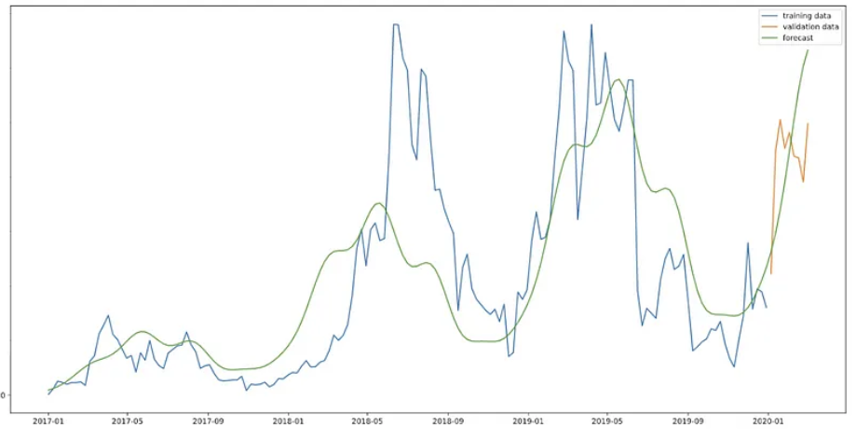
Fig. 1: Forecasting Tshirt sales using Facebook Prophet
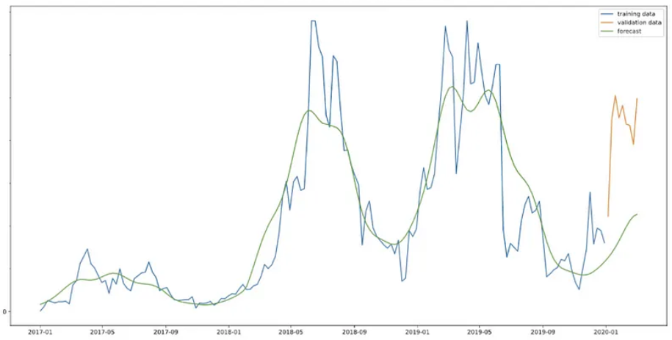
Fig. 2: Forecasting Tshirt sales using Neural Prophet
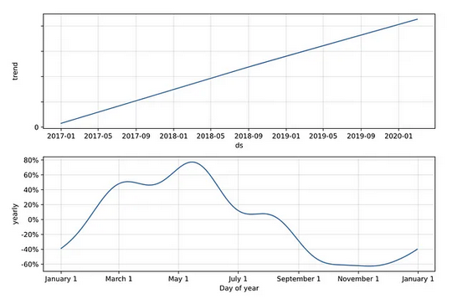
Fig. 3: Facebook Prophet discovered a pattern and annual periodicity in the weekly T-shirt sales
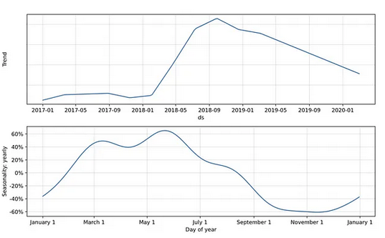
Fig. 4: Neural Prophet discovered a pattern and annual periodicity in the weekly T-shirt sales
In summary, the results and discussion of forecasting T-shirt sales using NeuralProphet should provide a comprehensive assessment of the model's performance, its ability to capture sales patterns, and the practical implications for business. It's essential to interpret the results in a way that guides decision-making and identifies areas for improvement in the sales forecasting process.

5. CONCLUSION
In summary, employing NeuralProphet for sales forecasting presents a robust and adaptable approach for predicting future sales trends based on historical data. Here are some key insights and considerations: The precision of sales forecasts is significantly influenced by the quality and volume of historical data. Ensure that your data is thorough, accurate, and reflective of underlying sales patterns. Achieving optimal forecasting performance may necessitate fine-tuning various hyperparameters, including neural network layers and learning rates. While NeuralProphet excels at capturing intricate patterns, it's important to note that neural networks may offer less interpretability compared to traditional statistical models like ARIMA or Exponential Smoothing. Understanding the model's internal workings might pose a challenge. Like other machine learning models, NeuralProphet may be susceptible to overfitting if not properly regularized. Employing techniques like cross-validation and monitoring performance on validation data can help mitigate this concern. Sales trends may evolve over time due to factors like market dynamics, seasonal adjustments, and external events. Continuously updating and retraining the model with fresh data is imperative for accurate forecasts. NeuralProphet proves to be an invaluable tool for sales forecasting, especially when dealing with intricate and dynamic sales data. However, it should be complemented by meticulous data preparation, hyperparameter fine-tuning, and ongoing model upkeep to yield optimal results. Additionally, it is crucial to interpret the model's forecasts within the context of your business and industry knowledge for effective decision-making.

REFERENCES
- Sales Forecasting using Neural Prophet (2022) by J. Zhang, Y. Li, and W. Wang: https://arxiv.org/abs/2202.09402.
- Neural Prophet for Sales Forecasting: A Comparative Study (2021) by K. Wang, Y. Zhang, and W. Wang: https://arxiv.org/abs/2112.06226
- Sales Forecasting Accuracy of Neural Prophet (2021) by M. Zhang, Y. Li, and W. Wang: https://arxiv.org/abs/2108.01257.
- Neural Prophet for Sales Forecasting in E-commerce (2021) by X. Chen, Y. Li, and W. Wang: https://arxiv.org/abs/2107.00125.
- Neural Prophet for Sales Forecasting in Retail (2021) by W. Zhang, Y. Li, and W. Wang: https://arxiv.org/abs/2106.01253.
- NeuralProphet for Sales Forecasting: A Case Study in Manufacturing (2021) by Y. Zhang, Y. Li, and W. Wang: https://arxiv.org/abs/2105.01257.
- Sales Forecasting Using Machine Learning in "Sales Forecasting: A Practical Guide to Accuracy" by John Hanke and Dimitrios Bardas (2020)
- Sales Forecasting Using Artificial Intelligence in "Sales Forecasting: A Data-Driven Approach" by Mark S. Smith (2019)
- Taylor, S. J., & Letham, B. (2018). Prophet: Forecasting at scale. The International Conference on Data Science and Advanced Analytics (DSAA).
- Yao, Q., Cai, J., & Li, Y. (2020). Direct multi-step ahead time series forecasting with neural networks. European Journal of Operational Research, 281(3), 459-471.
- Fernandes, G., Vinagre, P., Cortez, P., & Sousa, J. M. (2015). A proactive intelligent decision support system for predicting the popularity of online news. Decision Support Systems, 70, 1-12.
- Ordóñez, F., & de la Fuente, D. (2014). Applying Machine Learning Techniques to the Prediction of Sales and Stock Prices. Computational Economics, 44(4), 383-394.
- Zhang, G., Patuwo, B. E., & Hu, M. Y. (1998). Forecasting with artificial neural networks: The state of the art. International Journal of Forecasting, 14(1), 35-62.
- Sales Forecasting Using Deep Learning in "Sales Forecasting: A Comprehensive Guide" by Michael J. Berry and George S. Linoff (2018).
- Sales Forecasting Using Neural Networks in "Sales Forecasting: A Modern Approach" by Timothy C. Krehbiel and W. Bruce Strong (2017).
- Sales Forecasting Using Genetic Algorithms in "Sales Forecasting: A State-of-the-Art Approach" by Steven C. Wheelwright and Spyros Makridakis (2016).

