Ms. S.P. Desai, Ms.B.R.Mali, Ms.A.S.Patil, Dr. M.G.Saralaya, Dr.S.K.Mohite
¹Annasaheb Dange college of B.Pharmacy,Ashta (Assistant Professor)
²Annasaheb Dange college of B.Pharmacy,Ashta (Assistant Professor)
³Annasaheb Dange college of B.Pharmacy,Ashta (Assistant Professor)
⁴Annasaheb Dange college of B.Pharmacy,Ashta (Principal ADCBP)
⁵ Rajarambapu College of Pharmacy Ashta (Principal RCP)

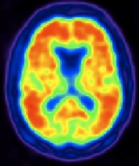
NUCLEAR MEDICINE

- Introduction
- Nuclear Medicine Definition
- Radioactive Tracer
- Principle Of Nuclear Medicine
- Single Photon Emission Tomography
- Positron Emission Tomography
- Radiopharmaceuticals Used In Nuclear Medicines
- Advantages Of Nuclear Medicine
- Disadvantages Of Nuclear Medicine
- Application Of Nuclear Medicine

TABLE OF CONTENT

INTRODUCTION
Nuclear medicine, often known as nucleology, is a medical speciality that uses radioactive chemicals to diagnose and treat disease. Nuclear medicine involves the use of radioactive substances within the body to accomplish two main objectives: the diagnosis of organ or tissue functionality and the targeted elimination of damaged or diseased organs or tissue for therapeutic purposes.
One distinctive feature of nuclear medicine (NM) is its intricate and crucial dependence on the use of radiopharmaceuticals (RPh) in every process. A radioisotope (radioisotopes [RI]) is what makes up RPh. It is produced in a particle accelerator such as a medical cyclotron (MC) or research reactor (RR). For the purposes of targeted therapy or detection-based imaging, this radioisotope emits radiation. It also has a carrier molecule that provides bio-specificity, which allows it to target the organ, lesion, or malfunction that is being examined or treated.
Over the years, nuclear medicine (NM) has experienced significant changes, including both gradual evolutionary developments and more revolutionary shifts. These transformations have been driven by the evolving landscape of radio pharmaceuticals (RPhs) on a global scale, as well as the introduction of cutting-edge technology in imaging systems that allow for data quantification, like single photon emission computed tomography (SPECT)/CT and PET/magnetic resonance..
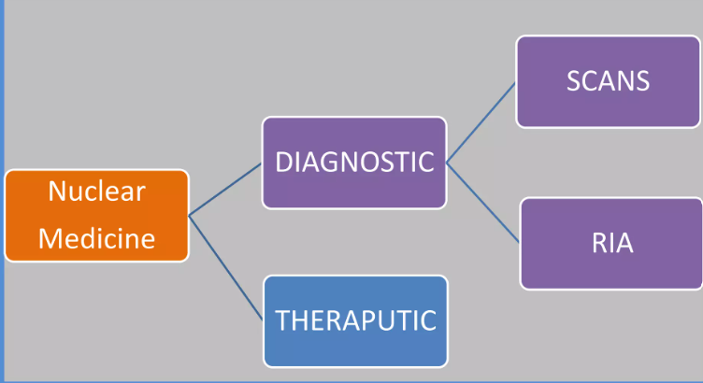
FIG 1. NUCLEAR MEDICINE USE
DEFINITION-
Using radioactive tracers, sometimes referred to as radiopharmaceuticals, nuclear medicine assesses body functions and diagnoses and treatments diseases. Using sophisticated cameras, doctors can track the passage of these radioactive tracers. In nuclear medicine, positron emission tomography (PET) and single photon emission computed tomography (SPECT) are the two main imaging modalities.
RADIOACTIVE TRACERS
Tightly bound carrier molecules to radioactive atoms make up radioactive tracers. These carrier molecules differ substantially based on the scan's intended use. Certain tracer molecules work with a particular protein or sugar in the body; other tracers even use the patient's own cells. For instance, when physicians require precise information regarding the cause of intestinal hemorrhage, they might radiolabel, or tamper with, a sample of the patient's red blood cells. After that, they reintroduce the blood, tracking the patient's blood flow with a SPECT scan.
In the majority of diagnostic nuclear medicine investigations, the patient receives an intravenous injection of the radioactive tracer. Alternatively, a radioactive tracer can be injected directly into an organ, orally swallowed, or inhaled. The disease process under investigation will dictate the tracer injection technique.
Since licensed tracer products have to adhere to the FDA's stringent safety and functional requirements for approved clinical use, they are known as radiopharmaceuticals. The nuclear medicine physician will select the tracer that offers the most accurate and detailed information regarding each patient's unique condition. Whether a patient undergoes a PET or SPECT scan depends on the tracer that is being utilized.
PRINCIPLE OF NUCLEAR MEDICINE
In diagnostic nuclear medicine, a wide variety of radionucleotides are utilized to meet the requirements for successful and efficient imaging.All radionucleotides are synthesized artificially by one of four methods.
- CYCLOTRON BOMBARDMENT: gallium-67, indium-11, thallium-201, cobalt-57, carbon-11, oxygen-15, nitrogen-13 and fluorine-18
- REACTOR IRRADIATION: chromium-51, selenium-75, iodine-125 and iodine-131.
- FISSION PRODUCTS: iodine-131, xenon-133 and strontium-90
- GENERATORS THAT PROVIDE SECONDARY DECAY PRODUCTS FROM LONGER LIVED PARENT RADIONUCLIDES: Column generators incorporating molybdenum-99 for the provision of technetium-99m.

SINGLE PHOTON EMISSION TOMOGRAPHY
Gamma rays are used in the nuclear medicine tomographic imaging procedure known as single-photon emission computed tomography, or SPECT.A radionuclide, or gamma-emitting radioisotope, must be injected into the patient's circulation in order to implement this method. As in the case of gallium (III) isotope, the radioisotope might occasionally be a simple soluble dissolved ion. On the other hand, a marker radioisotope is frequently coupled to a specific ligand to create a radioligand that has characteristics that allow it to attach to particular kinds of tissues. With the help of this connection, the radiopharmaceutical and ligand can be delivered to a specific location inside the body, where a gamma camera can measure the ligand's concentration.
Principle - A gamma camera is employed to capture multiple 2-D images, often called projections, from different angles for SPECT imaging. These diverse projections are subsequently analyzed by a computer using a tomographic reconstruction technique, resulting in a 3-D dataset. This dataset can then be manipulated to unveil narrow cross-sections of the body along any chosen axis, akin to the ones obtained through other tomographic methods like magnetic resonance imaging (MRI), X-ray computed tomography (X-ray CT), and positron emission tomography (PET).

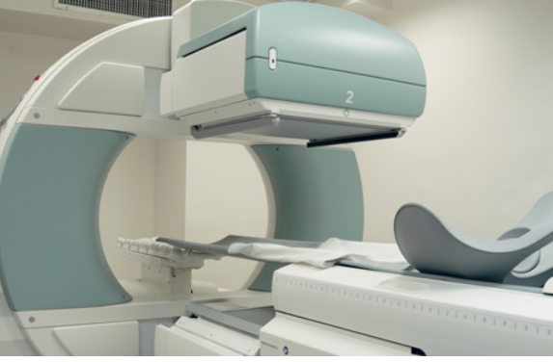
FIG NO 2.SINGLE PHOTON EMISSION TOMOGRAPHY

POSITRON EMISSION TOMOGRAPHY
Positron emission tomography (PET) is a functional imaging method that observes and quantifies alterations in metabolic processes and other physiological functions, such as blood circulation, regional chemical composition, and substance absorption, through the use of radioactive substances known as radiotracers. PET finds applications in both pre-clinical and clinical settings, serving as a valuable tool in medicine and research. Its extensive use is seen in the imaging of tumors and the detection of metastases in clinical oncology. Additionally, it aids in the clinical diagnosis of specific brain disorders that contribute to various forms of dementia. Beyond its clinical applications, PET plays a crucial role in advancing our comprehension of normal human brain function, cardiac performance, and pharmaceutical development. It is also an essential component of animal-based pre-clinical investigations, enabling repeated assessments of the same subjects over time, allowing subjects to act as their own controls, and significantly reducing the number of animals needed for a given study. This approach empowers research endeavors to reduce sample sizes while enhancing the statistical robustness of their findings.

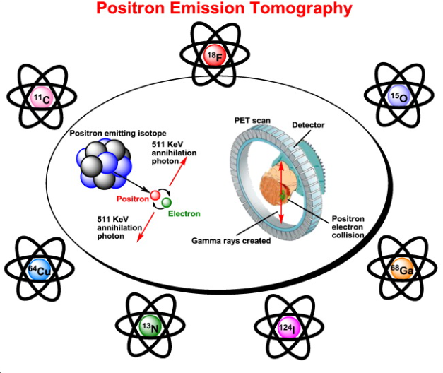

PET scanning using the tracer 18F-FDG is frequently used in clinical oncology. FDG is an analogue of glucose that is taken in by cells that need glucose and phosphorylated by hexokinase (the mitochondrial version of which is significantly elevated in malignant tumors that develop fast). The PET scan is enabled by the metabolic trapping of the radioactive glucose molecule. The imaging FDG tracer concentrations reflect tissue metabolic activity because they correspond to regional glucose uptake.

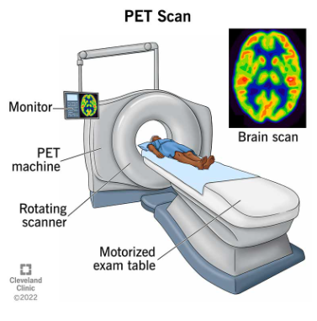

FIG NO 3.POSITRON EMISSION TOMOGRAPHY

PET imaging is most effectively conducted using a dedicated PET scanner. Alternatively, PET images can be acquired using a conventional dual-head gamma camera equipped with a coincidence detector. It's important to note that the quality of PET imaging obtained with a gamma camera is inferior, and the scanning process is more time-consuming. Nevertheless, this method offers a cost-effective in-house option, which may be suitable for facilities with limited PET scanning requirements. Another option would be to refer these patients to an external facility or rely on a mobile scanner visit.
RADIOPHARMACEUTICALS USED IN NUCLEAR MEDICINES
Carbon-11
- Chemical Symbol: ¹⁴C
- Chemical Form: Carbon-11 Choline
- Half-life: 20.334 minutes.
- Diagnostic use:
recommended for PET imaging in individuals who have high blood levels of the prostate specific antigen (PSA), suggesting a return of prostate cancer.
Carbon-14
- Chemical Symbol: ¹⁴C
- Chemical Form: Carbon-14 urea
- Half-life: 5,730 years
- Trade name(s): PYtest
- Diagnostic use: Identification of stomach urease as a tool for diagnosing Helicobacter pylori infection
Fluorine-18
- Chemical Symbol: ¹⁸F
- Chemical Form: Fluorine-18 sodium fluoride
- Half-life: 109.771 minutes
- Manufacturer: Various
- Diagnostic use: PET bone imaging agent to
delineate areas of altered osteogenesis

Fluorine-18
- Chemical Symbol: F
- Chemical Form: Fluorine-18 fludeoxyglucose
- Half-life: 109.771 minutes
- Diagnostic use:
- As a PET imaging agent to:
- Assess abnormal glucose metabolism in oncology
- Assess myocardial hibernation
- Locate areas of aberrant glucose metabolism linked to epileptic seizure foci.
Gallium-67
- Chemical Symbol: ⁶⁷Ga
- Chemical Form: Gallium-67 Gallium Citrate
- Half-life: 3.26 days
- Trade name(s): Neoscan (GE), DuPont Ga-67, Mallinckrodt Ga-67
- Diagnostic use:
- Helpful in proving the existence or degree of:
- Hodgkin's disease
- Lymphoma
- Bronchogenic carcinoma
- Aid in detecting some acute inflammatory lesions

Indium-111
- Chemical Symbol: ¹¹¹In
- Chemical Form: Indium-11 Capromab Pendetide
- Half-life: 3.20 days
- Trade name(s): ProstaScint
- Diagnostic use:
- An imaging diagnostic tool for newly diagnosed individuals whose prostate cancer, as confirmed by biopsy, has metastasized to the pelvic lymph nodes and who are at high risk of doing so.
2. A diagnostic imaging agent for patients who had a prostateectomy and their PSA was increasing.

Iodine - 131
- Chemical Symbol^{: 131} I
- Chemical Form: Iodine - 131 human serum albumin
- Half-life: 8.0197 days
- Trade name(s): Megatope
- Diagnostic use: Indicated for use in determinations of:
- Total blood and plasma volumes
- Cardiac output
- Cardiac and pulmonary blood volumes and circulation times
- Protein turnover studies
- Heart and great vessel delineation
- Localization of the placenta
- Localization of cerebral neoplasm

Advantages of Nuclear medicine
- Functional
- Sensitive, quantitative.
- Very safe.
- Low radiation.
- Screening &Follow up
- • Full body examination without subjecting the patient to higher radiation doses.
• Extremely high specificity (no body-produced radioactivity).

Disadvantages of Nuclear medicine
- Not widely available.
- Poor SNR.
- Require NM instruments & radiopharmaceuticals.
- Relatively higher cost than X-ray or US.
- Radiation exposure to the patient.
- Low spatial resolution (5-10mm)

Application of nuclear medicines-
• Scintigraphy is a method that utilizes radiopharmaceuticals to generate images of specific organs or tissues. A gamma camera, a medical device capable of detecting gamma rays emitted by the radioisotope, is employed in this process.
• Nuclear medicine treatments are employed to diagnose and treat specific medical conditions. These procedures utilize radiopharmaceuticals, which are radioactive substances. Medical conditions that can be diagnosed and treated through nuclear medicine techniques encompass
- Hyperthyroidism
Radioactive iodine (RAI) is used to treat hyperthyroidism and certain kinds of thyroid cancer. The phrase "radioactive" may sound alarming, but it is a safe, generally well-tolerated, and dependable medication that targets thyroid cells while exposing very few other cells in your body.

- Thyroid cancer
I-131 radiation is a treatment for thyroid cancer that is usually used after the thyroid has been removed. After surgery, the therapy is intended to remove any residual malignant or healthy thyroid tissue. The radioactive substance used in I-131 radiotherapy is radioactive iodine I-131.
- Lymphomas
Scanning using positron emission tomography (PET) and PET combined with CT (computer-aided tomography) scanning (PET-CT) are the most often utilized molecular imaging techniques for diagnosing and treating lymphoma. Patients with non-Hodgkin's lymphoma who do not react to chemotherapy may benefit from radioimmunotherapy (RIT).
- Radiotherapy
Radiotherapy is one of the most often utilized cancer treatments. Nuclear radiation, often known as ionizing radiation, is used in radiotherapy to injure and eliminate malignant tumor cells.
- • Radioactive drugs intended to target and eradicate malignant cells are used in nuclear medicine therapy, an approach to cancer treatment. This therapy can be beneficial for individuals dealing with conditions such as neuroendocrine tumors, prostate cancer, meningiomas, thyroid cancer, and lymphoma.
- Nuclear medicine therapy involves the utilization of a small quantity of radioactive material combined with a carrier molecule, known as a radiopharmaceutical. These therapies are applied in the treatment of cancer and various other medical conditions. Radiopharmaceuticals attach themselves to specific cells, subsequently delivering a concentrated dose of radiation to eliminate these cells.

