Synthesis And Characterization of Polystyrene / Titanium Dioxide (Ps/Tio2) Nano Composites

Mrs.R.Revathi*, P.Ajithsivam
Assistant Professor, Department of Physics,
Dr.N.G.P Arts and Science College, Coimbatore-641048, India.
revathiinuk@gmail.com
Student, Department of Physics,
Dr.N.G.P Arts and Science College, Coimbatore-641048, India.

ABSTRACT

Titanium dioxide is of very high technical importance due to its excellent electrical, optical, and chemical properties such as no toxicity, transparency in visible light, wide gap energy, high refractive index, electrochemical stability, and good insulation properties. The PS/TiO2 Nano composite was synthesized by Sol-Gel method and the gel were coated in substrate by doctor blade coating method. Polymer has been used since they have beneficial properties like Biodegradability and Biocompatibility. The characterization studies such as XRD, FTIR, SEM-EDX were carried out for the nanocomposite material. The X-ray diffraction was used for structural investigations and calculated the crystalline size through Debye Scherrer’s equation. The morphology of the film was studied by Scanning Electron Microscopy. Then, FTIR was used to determine Functional Groups which presents between wavelengths of 400 to 4000 cm -1 range.
Keywords: PS/TiO2, Sol-Gel method, Doctor blade coating method, XRD, FTIR, SEM-EDX

- INTRODUCTION

In theory, nanomaterials are substances whose smallest unit has a size between 1 and 100 nm (the standard definition of nanoscale) in at least one dimension. Utilizing developments in materials metrology and synthesis created in support of microfabrication research, nanomaterials research adopts a materials science-based approach to nanotechnology. Materials having nanoscale structure frequently have distinctive optical, electrical, thermophysical, or mechanical properties.[1][2][3].
Metals, semiconductors, and metal oxides are the main components of nano powders. The focus of this chapter is on creating Nano composites using metal oxides and polymers. Nano powders in polymers have typically been dispersed in three different methods. The first involves the direct blending or mixing of the polymer with the nano powder, either as separate phases (referred to as melt mixing) or in solution (referred to as solution mixing). The second method is known as the sol-gel process, which begins with a molecular precursor at room temperature and then uses condensation and hydrolysis to create a metal or metal oxide framework. The third involves in situ grafting macromolecular chain polymerization on the surface of Nano powder.[4]

A. TITANIUM DIOXIDE (TiO2)

Titanium dioxide is a widely applied filler to PVC, polyolefins, PS, ABS, and many other polymers to prepare composites due to their improved physical and mechanical properties induced by TiO2 while without loss of ease processing, light weight, and often ductile nature of neat polymer. Traditionally, the polymer composites were reinforced with micron sized TiO2. TiO2 can now be processed using methods that have recently been devised, enabling nanoscale TiO2 growth. Research has demonstrated that nanoscale reinforcement results in novel optical, electrical, and physiochemical processes that influence material properties and thus expand the range of applications. Due to their distinctive technological characteristics and potential uses in photocatalysis, solar cells, sensors, and memory technology, TiO2 nanoparticles are of interest. Due to its exceptional electrical, optical, and chemical characteristics, including its non-toxicity, transparency in visible light, wide gap energy, high refractive index, electrochemical stability, and superior insulating properties, titanium dioxide is of extremely high technical relevance.[5][6][7]

B. POLYSTYRENE

Polystyrene (PS), made up of the monomer styrene has been playing a significant role in our day-to-day life for the past few decades. The rigid and foamed forms of polystyrene find its application in varied areas. Since polystyrene is light, strong, durable, good at insulating heat and electricity, transparent, and can be molded into any shape that is desired, it has been used in a wide range of human needs, including those for medical supplies, household items, toys, packaging, and electronic insulation. Products constructed of polystyrene can occasionally be recycled and utilized in different ways.[8]

C. THIN FILMS

A thin film is a material layer with a thickness of several micrometers to fractions of a nanometer (monolayer). A crucial stage in numerous applications is the carefully regulated production of materials as thin films (a procedure known as deposition). A common example is the back of a sheet of glass in a household mirror, which is commonly coated in a thin layer of metal to create a reflective interface. Mirrors were once frequently made using the silvering process, but more recently, the metal layer is created using methods like sputtering. Offers a wide range of technological advancements in fields like LEDs, optical coatings, integrated passive devices, LEDs, magnetic recording media, and electronic semiconductor devices.[8]

EXPERIMENTAL METHOD

Thin Films were Synthesis by different methods. They are shown in below.
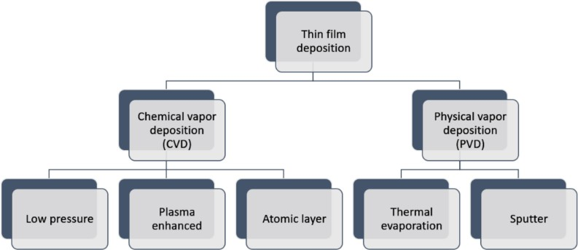

FIGURE 1: METHODS OF THIN FILM DEPOSITION

Sol gel process: The sol-gel process is a technique used in materials science to create solid
materials from tiny molecules. The technique is used to create metal oxides, particularly silicon (Si)
and titanium (Ti) oxides. During the procedure, monomers are transformed into a colloidal solution (sol),
which serves as the precursor for an integrated network (or gel) of discrete particles or network polymers.
Metal alkoxides are typical precursors. Ceramic nanoparticles are created via the sol-gel technique.[9][10]

A. SOL-GEL METHOD

For the creation of different nanostructures, particularly metal oxide nanoparticles, the sol-gel procedure is a more chemical (wet chemical) method. According to the required qualities and use of the gel, the molecular precursor (often metal alkoxide) should be dried using the suitable techniques after being dissolved in water or alcohol and transformed into gel by heating and stirring. For instance, burning alcohol is used to complete the drying process if the solution is alcoholic. The generated gels are pulverized and then calcined after the drying stage.

B. DOCTOR BLADE COATING

Doctor blade coating is a common method used to deposit thin films onto various substrates. It involves the use of a doctor blade, which is a flat, rectangular tool made of metal or plastic. The blade is used to spread a thin layer of liquid material onto a substrate, such as a glass slide or a silicon wafer. The thickness of the deposited film can be controlled by adjusting the gap between the blade and the substrate.
Doctor blade coating is a versatile and cost-effective method for depositing thin films. It can be used for a wide range of materials, including polymers, metals, and ceramics. The method is also scalable, making it suitable for both laboratory-scale research and large-scale production.
In the context of PS/TiO2 thin films, doctor blade coating can be used to deposit uniform layers of the composite onto various substrates. The thickness of the film can be controlled by adjusting the gap between the blade and the substrate, as well as the viscosity of the PS/TiO2 solution. This allows researchers to tailor the properties of the thin films for specific applications.

- PROCEDURE: [10-15]

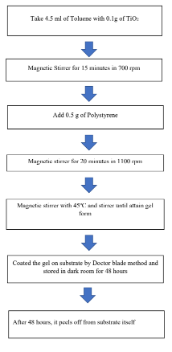

- RESULTS AND DISCUSSION
Characterization and analytical techniques are methods used to identify, isolate, or quantify chemicals or materials, or to characterize their physical properties. The importance of material characterization allows researchers to identify the structure of a material, how this structure refers to its macroscopic properties, and how it will act in certain technological applications.

X-Ray Diffraction (XRD)
    - Scanning Electron Microscopy-Electron Dispersive X-Ray Spectroscopy (SEM-EDX)
    - Fourier Transformer Infra-Red Spectroscopy (FTIR)
In this result and discussion shows analysis of the sample. The result for characterization such as XRD, SEM-EDX and FTIR.
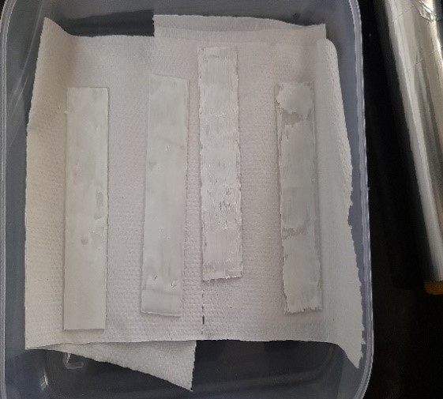
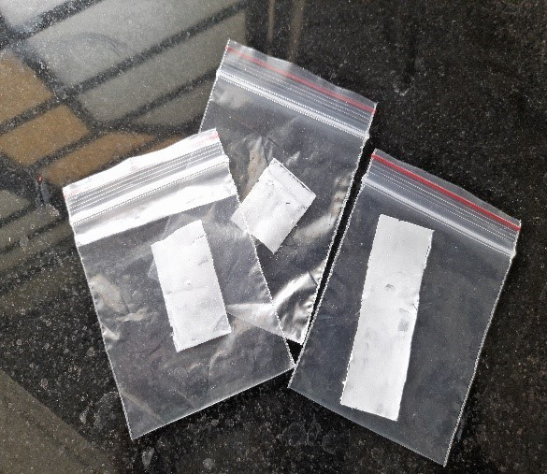
FIGURE 2. PS/TiO2 THIN FILMS

The image shows the material coated in a substrate and peeled off from a substrate.

A. STRUCTURAL ANALYSIS (XRD)
The XRD result explains the crystalline size of PS/TiO2 (Anatase) sample and Structure of TiO2 (Anatase) sample. The Crystalline Size calculated through the formula,

Crystalline size, D =K λ / β cos θ (nm)

From the above formula, the crystalline size for PS/TiO2 (Anatase) sample is calculated by average size from three different peaks and Average crystalline size of TiO2 (Anatase) sample 32.90 nm. The Crystal System of PS/TiO2 (Anatase) sample is Tetragonal. Through the structure, we can calculate d-spacing values for a sample through its Structural d-spacing formula. The d-spacing Formula for Tetragonal Structure is given below,
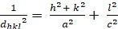

The Miller indices (h k l) and the values for the unit cell of crystal (a b c) were used to derive the d-Spacing Formula. Bragg's law relates the d-spacing to the diffraction angle and the experiment's X-rays' wavelength. According to Bragg's law, if the equation n = 2d sin, where

n is an integer, d is the d-spacing between the crystal planes, and is the diffraction angle, is true, an X-ray beam incident on a crystal at an angle will be diffracted by the crystal planes. The diffraction pattern acquired from X-ray diffraction tests can be used to compute the d- spacing. By analyzing the diffraction pattern, the position and intensity of the diffraction peaks can be used to determine the d-spacing and the crystal structure of the material.

TABLE 1: PARAMETER CALCULATION FOR X-RAY DIFFRACTION
ANGLE (2θ)  (degree) | θ  (radian) | h | k | l | FWHM  (β)  (Degree) | FWHM  (β)  (radian) | CRYSTALLINE SIZE(D)  (nm) | D- SPACING  (Tetragonal formula)  (1/d²) | D- SPACING,  (d)  (Angstrom) | STRAIN  (ɛ) | DISLOCATION DENSITY  (δ)
25.25 | 0.22029 | 1 | 0 | 1 | 0.247 | 0.0043 | 32.79 | 0.0806 | 3.521 | 0.00481 | 0.930
37.75 | 0.3293 | 0 | 0 | 4 | 0.216 | 0.0037 | 36.24 | 0.1759 | 2.384 | 0.0027 | 0.761
48.01 | 0.50604 | 2 | 0 | 0 | 0.242 | 0.0042 | 29.96 | 0.2785 | 1.894 | 0.0019 | 1.114
 |  |  |  |  |  | Mean | 32.99 nm

The Tabulation calculated the values of three peaks and through it we can find the crystalline size and structure of a sample. The Peak Values for Polystyrene and PS / TiO2 are in angle of 2θ are 25.25 °, 37.75 ° and 48.01°. The Unit cell for PS/TiO2 sample is a=3.7850 A⁰ and c=9.5196 A⁰. The Miller indices (h k l) values were used to find the d-spacing of crystal system. These Values are determined from the graph which is plotted below. [16-20]

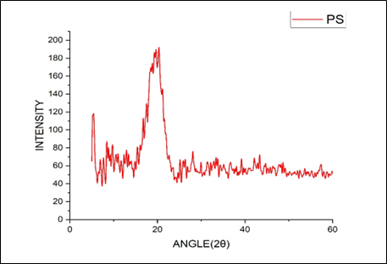

FIGURE 3. XRD GRAPH – PS SAMPLE
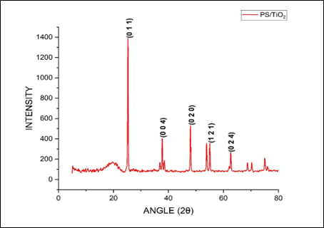

FIGURE 4. XRD GRAPH – PS / TiO2 SAMPLE

Figure 3 explains the sample of Polystyrene was amorphous and the atoms were flowing freely inside in it. But, In Figure 4 the sample was anatase.

B. MORPHOLOGY AND ELEMENT ANALYSIS (SEM-EDX)

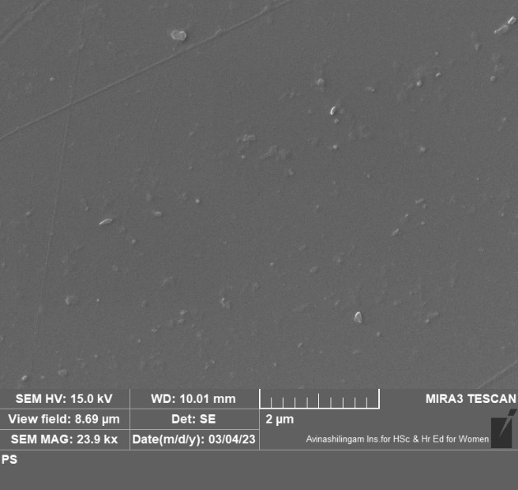
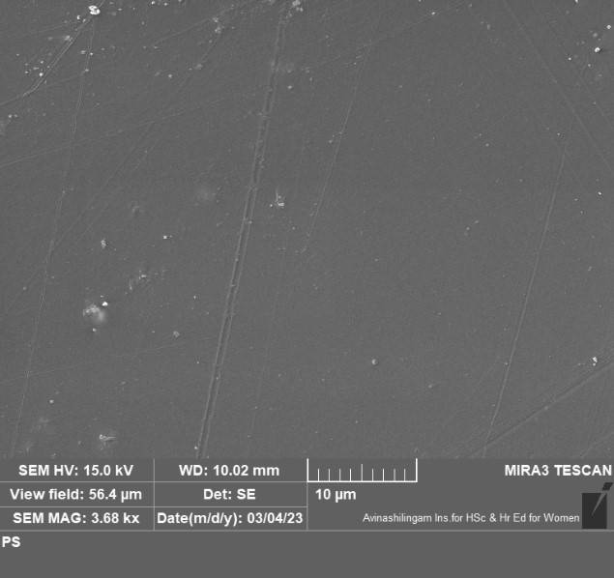
FIGURE 5. SEM ANALYSIS FOR PS

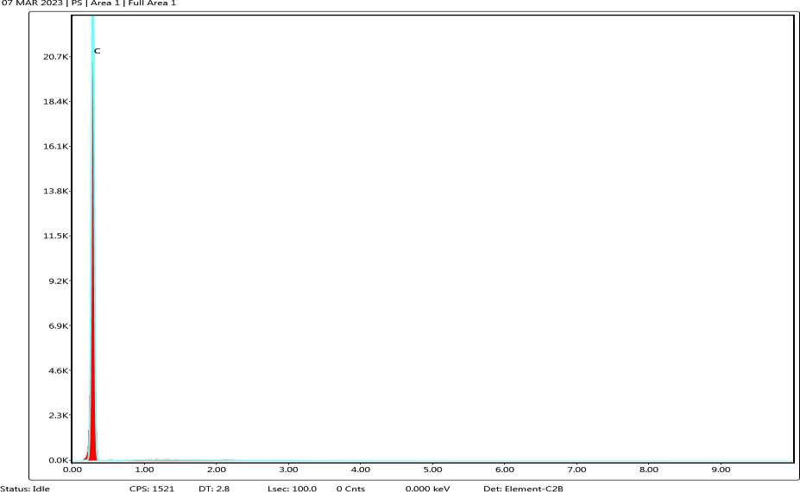

FIGURE 6. EDX ANALYSIS FOR PS

The SEM image of PS shown here and in future work, we are going analysis the cleavage by irradiating the samples for certain time intervals. The EDX shows Carbon element present [21]

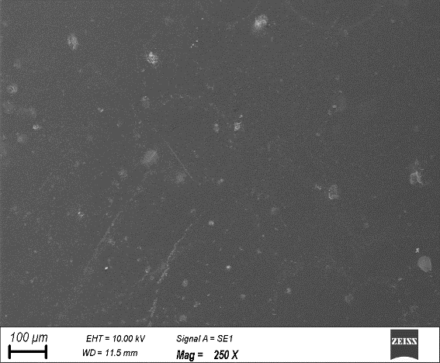
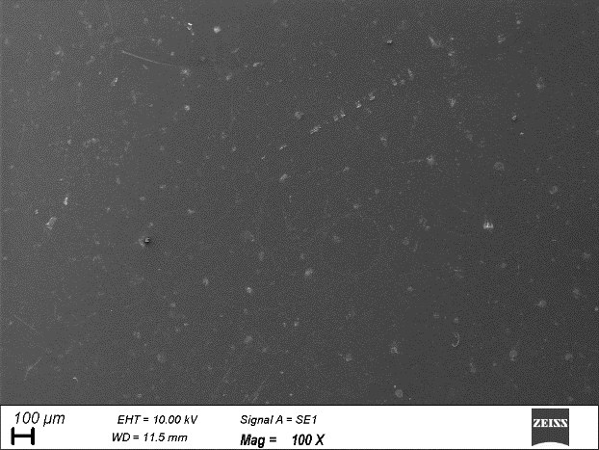
FIGURE 7. SEM ANALYSIS FOR PS/TiO2
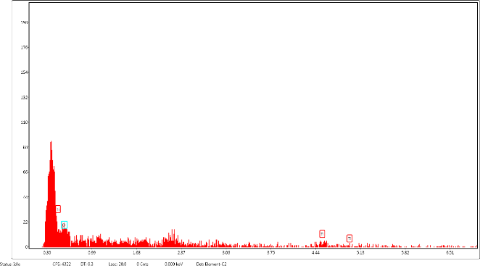
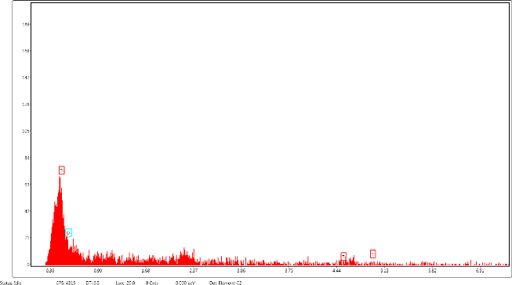
FIGURE 8. EDX ANALYSIS FOR PS/TiO2

The SEM image of PS with TiO2 shown here and in future work. We are going analysis the cleavage by irradiating the samples for certain time intervals.[21]. Through EDX result, The Ti and O were present for elemental composition in the sample. [21]

C. FUNCTIONAL GROUP ANALYSIS (FTIR)
The FTIR explains the functional groups which are present in Polystyrene polymer. The graph was plotted for such as PS .and it represents a graph between Wavenumber (cm⁻¹) and Transmittance (T%).[22]

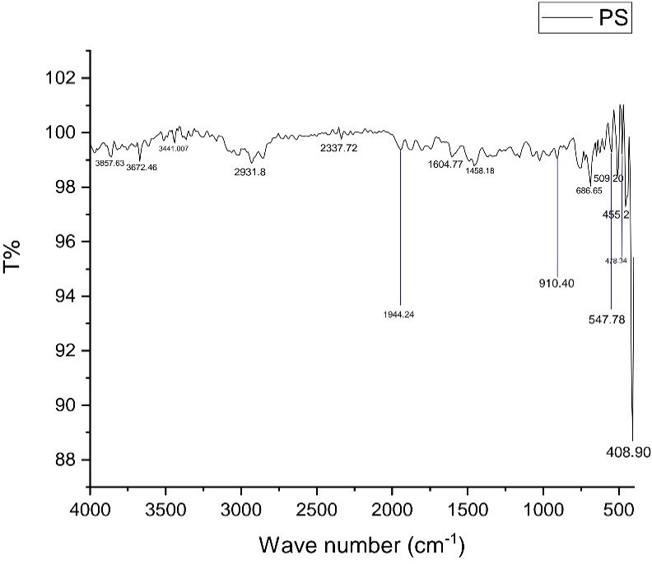

FIGURE 9. FTIR ANALYSIS FOR PS
In this Polystyrene (PS), The some of the Functional groups were present such as

TABLE 2: FUNCTIONAL GROUP ANALYSIS FOR PS

GROUP | WAVENUMBER (cm-1)
X-H HETERO ATOM GROUP | 3857.63 cm⁻¹, 3672.46 cm⁻¹,3441.007 cm⁻¹
C-H GROUP | 2931.8 cm⁻¹
C=O GROUP | 1604.77 cm⁻¹ and 1458.18 cm⁻¹
C-O-C GROUP | 910.40 cm⁻¹
ORGANOMETALLIC GROUP | 686.65 cm⁻¹, 547.48 cm⁻¹, 478.34 cm⁻¹ and  408.90 cm⁻¹

The FTIR explains the functional groups which are present in Polystyrene/Titania. The graph was plotted for PS/TiO2. and it represents a graph between Wavenumber (cm⁻¹) and Transmittance (T%).[22]

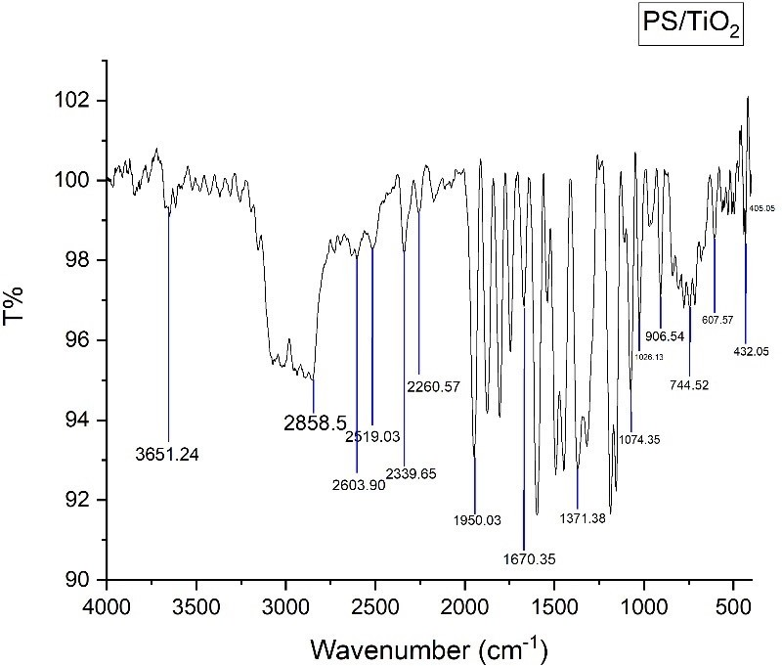
FIGURE 10. FTIR ANALYSIS FOR PS/TiO2
In this PS/TiO2, the some of the Functional groups were present such as,

TABLE 3: FUNCTIONAL GROUP ANALYSIS FOR PS/TiO2

GROUP | WAVE NUMBER (cm-1)
X-H HETERO ATOM GROUP | 3651.24 cm⁻¹
C-H GROUP | 2858.5 cm⁻¹
C=O GROUP | 1670.35 cm⁻¹
C-O-C GROUP | 1074.35, 1026.13 and 906.54 cm⁻¹
ORGANOMETALLIC GROUP | 744.52 cm⁻¹, 607.57 cm⁻¹, 432.05 cm⁻¹ and  405.05 cm⁻¹

V. CONCLUSION

In summary, the characterization and synthesis of PS/TiO2 thin films have demonstrated their potential for use in a variety of applications, including solar cells, photocatalysis, and gas sensing. The properties of these thin films can be tuned by adjusting the synthesis parameters, allowing for the creation of materials with enhanced performance. Further research in this area could lead to the development of new and innovative materials for various applications, ultimately contributing to advancements in the field of materials science.
VI. FUTURE WORK
We planned to do visible light degradation as future work for application of packaging. Along with we also
planned to calculate the mechanical properties as well the rheological analysis for the irradiated sample too.
VII. REFERENCES
[1] C. P. Poole and F. J. Owens Nanotechnology: an introduction to nanoscience and nanotechnology" Wiley, 2003.
[2] S. J. Rosenthal and M. J. Kurman "An introduction to nanotechnology" (John Wiley & Sons, 2011).
[3] M. Ratner and D. Ratner "Nanotechnology: an introduction to the future of small", Prentice Hall, 2003.
[4] G. Li, X. Li, Y. Liu, and Y. Wang, "Preparation and characterization of polystyrene/TiO2 nanocomposites
via in situ emulsion polymerization," Journal of Applied Polymer Science, vol. 124,no.3,pp.2184-2191,2012.
[5] X. Zhang, J. Wang, L. Zhang, and Z. Wang, "Preparation and characterization of polystyrene/TiO2 composite
particles by Mini emulsion polymerization," Journal of Applied PolymerScience, vol.131,no.16,pp.1-8,2014.
[6] S. S. Ray and S. K. De, "Preparation and characterization of polystyrene/TiO2 nanocomposites by in situ polymerization,
" Journal of Applied Polymer Science, vol. 94, no. 6, pp. 2377-2383, 2004.
[7] S. S. Ray and S. K. De, "Preparation and characterization of polystyrene/TiO2 nanocomposites by solution blending,
" Journal of Applied Polymer Science, vol. 96, no. 1, pp. 109-115, 2005.
[8] Y. Liu, X. Li, G. Li, and Y. Wang, "Preparation and characterization of polystyrene/TiO2 nanocomposites via in situ
suspension polymerization," Journal of Applied Polymer Science, vol. 129,no.1,pp.1-8,2013.
[9] M. A. Kiani, M. H. Fazelirad, and A. R. Khataee, "Synthesis and characterization of polystyrene/TiO2 nanocomposites
for photocatalytic degradation of methylene blue,"Journal of Hazardous Materials, vol.171, no.1-3, pp.1006-1012,2009.
[10] Y.-C. Chen, Y.-H. Hsieh, C.-C. Huang, and C.-Y. Mou, "Preparation and characterization of polystyrene/TiO2
nanocomposites by sol–gel process," Journal of Colloid and Interface Science, vol. 311, no. 1, pp. 197-204, 2007.
[11] Zhang, Y., Zhang, L., Liu, Y., Wang, S., & Wang, Y. Preparation and Characterization of Polystyrene/TiO2 Nanocomposites by Doctor Blade Coating Method. JournalofNanoscienceandNanotechnology,17(10),7175-7180. 2017
[12] Liu, Y., Zhang, Y., Wang, S., & Wang, Y. Preparation of Polystyrene/TiO2 Nanocomposites by Doctor Blade Coating Method and Their Properties. Journal of Nanomaterials,2018,1-7, 2018
[13] Liang, X., Li, J., Li, X., & Zhang, J. Preparation and Characterization of Polystyrene/TiO2 Nanocomposites via Doctor Blade Coating Method. Journal of Materials Science: Materials in Electronics,30(6),5766-5774, 2019.
[14] Wang, Y., Zhang, Y., Liu, Y., & Wang, S. Preparation and Characterization of Polystyrene/TiO2 Nanocomposites by Doctor Blade Coating Method for Antimicrobial Applications.Polymers,10(11),1265, 2018.
[15] Chen, H., Zhang, Y., Wang, S., & Wang, Y. Preparation of Polystyrene/TiO2 Nanocomposites by Doctor Blade Coating Method and Their Photocatalytic Properties. Journal of Nanomaterials, 2019, 1-7,2019.
[16] Wang, C., & Wang, Z. (2019). Polystyrene/TiO2 nanocomposites: preparation, properties and applications. Journal of Materials Science: Materials in Electronics, 30(14), 13506- 13515.
[17] Chen, W., & Zhang, L. Polystyrene/Titanium Dioxide Nanocomposites: Synthesis, Characterization, and Applications. In Polymer Nanocomposites Based on Inorganic and Organic Nanomaterials(pp.1-29). Elsevier,2017.
[18] Liu, Y., Zhang, Y., Wang, S., & Wang, Y. Preparation and characterization of polystyrene/Titanium dioxide nanocomposites by in-situ polymerization and their photocatalytic properties. Journal of Materials Science: Materials in Electronics, 30(17), 16244-16252. 2019
[19] Rana, S., & Kumar, V. Polystyrene/Titanium Dioxide Nanocomposites: Preparation, Properties, and Applications. In Nanotechnology in Industrial Wastewater Treatment(pp.123-138). Elsevier. 2019
[20] Wang, X., & Wang, J. Polystyrene/TiO2 Nanocomposites: Preparation, Properties, and Applications. In Advanced Nanomaterials for Catalysis and Energy (pp. 139-159). Springer International Publishing, 2019
[21] Maytham Qabel Hamzah, Salim Oudah Mezan, Alaa Nihad Tuama, Abdullah Hasan Jabbar & Mohd Arif Agam, Study and Characterization of Polystyrene/Titanium Dioxide Nanocomposites (PS/TiO2 NCs) for Photocatalytic Degradation Application: A review. International Journal of Engineering & Technology, 2018.
[22] Babak Jableh, Habibi Safdar, Reza Golbedagi & Mahmoud Reza Keymanesh UV- Degradation Effect on Optical and Surface Properties of Polystyrene/TiO2 nanocomposite Film. Journal of the Iranian Chemistry Society. ResearchGate, 2011.

