Application of IoT and Machine Learning Techniques for Smart Waste Management System
Dr. Vaidehi M ¹ Kritika Agrawal² Akansha Shree³ Ankita Nigam⁴
¹Associate Professor
Department of Information Science and Engineering
Dayananda Sagar College of Engineering, Bangalore, India

^{2,3,4} Final Year Students
Department of Information Science and Engineering
Dayananda Sagar College of Engineering, Bangalore, India

ABSTRACT
Smart waste management systems using the Internet of Things (IoT) and Machine Learning (ML) have emerged as a promising solution to optimize waste collection and disposal. An abstract of such a system, includes sensors placed in waste containers that measure the waste level and send data to a central server via wireless communication. The ML algorithm is used to analyze the data collected from sensors to predict and optimize the waste collection schedule.
The proposed system has several benefits, including reducing operational costs, enhancing environmental sustainability, and improving the quality of life for citizens by reducing litter, odors, and pests. Additionally, the system promotes public health and safety by providing real-time information on waste levels and potential hazards, thereby mitigating the risk of disease outbreaks and accidents.
Overall, the IoT and ML-based smart waste management system presented in this study offers a promising solution to optimize waste management processes. By leveraging IoT technology and machine learning algorithms, the system enhances operational efficiency, reduces environmental impact, ensures public health and safety, and encourages sustainable waste disposal practices, ultimately contributing to a cleaner and more sustainable environment
Key words: Waste management, IoT, Machine learning , garbage collection, sustainable
1 Introduction
With the increasing population and industrialization of nations throughout the globe, waste has become a great concern for all of us. The current waste management system is inefficient and unsustainable, resulting in high costs, environmental damage, and public health risks. There is a need for a smart waste management system that can optimize waste collection, reduce landfill waste, and improve recycling rates.
With the help of technology, initiatives that ensures reduced amount of time and energy required to provide waste management services have come into picture. Unfortunately, developing countries are not being able to implement those existing solutions due to many factors like socio-economic environment. Therefore, in this chapter we have concentrated our thought on developing a smart IoT based waste management system for developing countries like India that will ensure proper disposal, collection and transportation of waste with the minimum amount of resources being available.
1.2 Problem Statement
Waste generation is a rapidly growing problem, and traditional waste management systems are struggling to cope with the volume of waste generated. Inefficient waste collection and disposal methods can lead to environmental pollution, public health hazards, and economic losses. The garbage collecting authority in traditional waste management system doesn’t know about the level of waste in dustbins and other places like drains. The waste generated overflows thereby leading to unhygienic condition in cities. People in turn throw garbage on that place which is already overflowed.
1.3 Objectives and Scope of Chapter
The objective of an IoT and ML-based smart waste management system is to improve the efficiency and sustainability of waste management processes. This system combines the power of IoT sensors, which are capable of collecting data from various sources such as waste bins, recycling centers, and landfills, with machine learning algorithms to analyze and make sense of the collected data.
The key goals of a smart waste management system include:
- Improving operational efficiency: By tracking waste levels in real-time and optimizing waste collection routes, a smart waste management system can reduce operational costs and improve overall efficiency.
- Reducing environmental impact: By enabling more efficient waste management processes, such a system can help reduce the environmental impact of waste disposal.
- Enhancing public health and safety: By providing real-time information about waste levels and potential hazards, a smart waste management system can help ensure public health and safety.
- Encouraging sustainable behavior: By providing feedback to users about their waste disposal habits, a smart waste management system can help encourage more sustainable behavior and reduce overall waste generation.
Overall, the objective of an IoT and ML-based smart waste management system is to create a more efficient, sustainable, and safer waste management process that benefits both individuals and society as a whole.
Scope
- Tank Monitoring: Level detecting hardware systems find applications in industries that involve storage tanks, such as oil and gas, chemical manufacturing, and water treatment. These systems can monitor the levels of liquids or gases in tanks, providing insights into inventory management, leak detection, and preventive maintenance.
- Industrial Process Control: Level detecting hardware systems play a crucial role in industrial automation and process control. They can monitor the levels of raw materials, intermediates, or finished products in tanks or silos. This data enables efficient control of production processes, inventory management, and prevents overflow or shortage situations.
- Water Management: Level detecting hardware systems are utilized in water management applications, such as reservoirs, water tanks, and sewage systems. They monitor water levels in tanks, wells, or bodies of water, aiding in water resource management, flood control, and ensuring optimal water supply.
- Agriculture and Irrigation: In agriculture, level detecting systems can monitor the water levels in irrigation systems, such as drip irrigation or storage tanks. This helps optimize water usage, prevent water wastage, and ensure proper irrigation of crops based on the detected levels.
- Fuel and Liquid Storage: Level detecting hardware systems are used in storage tanks for fuel, oil, or other liquids. By monitoring the levels of these substances, the systems assist in inventory management, preventing overfilling or under filling, and ensuring smooth operations in industries such as fuel stations or chemical storage facilities.
- Vehicle Fuel Monitoring: Level detecting systems can be employed in vehicles to monitor fuel levels in tanks. This data can be utilized for fleet management, optimizing refueling schedules, and preventing fuel theft or misuse.
- Environmental Monitoring: Level detecting hardware systems can monitor water levels in rivers, lakes, or reservoirs for environmental purposes. This data is crucial for managing water resources, predicting floods, and ensuring ecological balance in aquatic ecosystems.
These use cases illustrate the versatility of level detecting hardware systems across various industries, enabling efficient monitoring, control, and optimization of processes involving liquids, gases, or waste materials.
The Application of IoT and Machine Learning
The application of "IoT and ML-based Smart Waste Management System" stems from several factors and challenges associated with traditional waste management practices. The integration of IoT and machine learning technologies addresses these challenges and offers numerous benefits. Here are some key motivations for undertaking such a chapter:
- Efficient Waste Collection and Disposal: Traditional waste management systems often suffer from inefficiencies, such as irregular collection schedules or overflowing bins. By incorporating IoT sensors to monitor waste levels in real-time, coupled with machine learning algorithms, the system can optimize waste collection routes and schedules, ensuring timely and efficient waste disposal.
- Cost Reduction and Resource Optimization: Smart waste management systems can help reduce operational costs by optimizing resource allocation. By analyzing data collected from IoT sensors and employing machine learning algorithms, waste collection routes can be optimized, leading to fuel and labor savings. Additionally, the system can accurately predict waste fill levels, enabling efficient resource allocation and reducing unnecessary collection trips.
- Environmental Sustainability: Proper waste management is crucial for environmental sustainability. IoT and machine learning technologies facilitate waste segregation and recycling by providing real-time data on bin capacities and waste types. This enables waste management authorities to implement effective recycling strategies and reduce the environmental impact of waste disposal.
- Improved Public Health and Hygiene: Inefficient waste management can lead to various health and hygiene issues. Smart waste management systems can help prevent the accumulation of waste and the associated problems, such as foul odors, pest infestations, and disease spread. By optimizing waste collection and ensuring timely disposal, these systems contribute to a cleaner and healthier environment for the public.
- Data-driven Decision Making: IoT sensors generate a vast amount of data that, when combined with machine learning techniques, can provide valuable insights. These insights can be used to make data-driven decisions, such as optimizing waste collection routes, predicting fill levels, and identifying areas with high waste generation. Such data-driven decision making enhances the overall efficiency and effectiveness of waste management operations.
- Smart City Integration: Smart waste management systems align with the concept of smart cities, where various urban systems are interconnected and utilize advanced technologies for efficient operation. By implementing IoT and machine learning in waste management, cities can enhance their overall smart city infrastructure, leading to improved livability and sustainability.
By leveraging IoT and machine learning technologies in waste management, the chapter aims to address the inefficiencies, environmental concerns, and public health issues associated with traditional waste management practices. Ultimately, the motivation behind this chapter is to create a more sustainable, cost-effective, and technologically advanced waste management system that benefits both the environment and the community.
Literature Survey
Muhammad Usman Akram et, al.,[1] in their survey provide an overview of IoT applications in solid waste management. It covers various aspects such as waste monitoring, bin filling levels, collection route optimization, and environmental monitoring. The paper discusses the challenges, benefits, and future directions of implementing IoT in waste management.
Umar Riaz et.al., [2] in their work presents an in-depth analysis of IoT-based smart waste management systems. It covers the architecture, sensing technologies, data collection and analysis methods, and waste management optimization strategies. The paper also discusses the integration of IoT with other emerging technologies like cloud computing and big data analytics.
The researchers Savita V et.al., [3] have focused on integration IoT with waste management . Their work discusses IoT-based waste bin monitoring systems, waste level sensing technologies, and communication protocols. The paper also highlights challenges, opportunities, and future trends in smart waste management using IoT.
Umair Jabbar et.al. [4], present a framework for waste management using IoT-based smart bins. It discusses the architecture, components, and communication protocols used in the smart bin system. The authors highlight the benefits of using IoT in waste management and propose a system for efficient waste collection and recycling.
Muhammad Sohail Khan et.al., [5] in their work describe the design and implementation of an IoT-based smart waste management system. It covers the hardware and software components, data acquisition and analysis techniques, and waste management optimization algorithms. The authors present a real-world implementation and discuss the system's performance and effectiveness.
Methodology
To accomplish a smart waste management system, in our work we have integrated IoT with Machine learning techniques. The methodology describes the hardware and the software requirements.
Arduino IDE (1.8.13): The Arduino IDE (Integrated Development Environment) is a software tool that provides a user-friendly platform for writing, compiling, and uploading code to Arduino boards. It simplifies the process of programming Arduino microcontrollers, making it accessible even to beginners.
Cloud platform: A cloud platform, also known as a cloud computing platform, refers to a set of services and infrastructure provided over the internet by a cloud service provider. It allows users to build, deploy, and manage applications and services without the need for on-premises hardware and infrastructure.

Hardware Requirements
- NodeMCU ESP8266: It is a popular microcontroller board that serves as the foundation for many electronics chapters. It is a powerful microcontroller, which is responsible for executing programs and controlling various components connected to it.
- Ultrasonic sensors: Ultrasonic sensors are electronic devices that use sound waves with frequencies higher than the human audible range to detect and measure distances or detect the presence of objects. They work based on the principle of sound wave reflection and are commonly used in various applications such as distance measurement, object detection, and proximity sensing.
- LCDs: Liquid Crystal Display (LCD) use 16x2 alphanumeric which means it can display Alphabets along with numbers on 2 lines each are containing 16 characters. Each character consists of 5x7 dot matrix. Contrast on display depends on the power supply voltage.
- Jumper wires and cables: Jumper wires are short, flexible wires with connectors at both ends. Jumper wires and cables play a crucial role in connecting various components, modules, and devices together to create a functional system. They are used to establish electrical connections and transmit signals between different parts of an IoT setup.
- USB connector: The USB connector in general is used to connect any two devices in order to transfer data, files etc. Here in this chapter, the USB connector is being used to connect the Arduino UNO with the computer system.

Here are some common elements of the existing waste management system in India:
- Door-to-Door Collection: Many cities in India have door-to-door waste collection services where waste pickers or municipal workers collect waste from households and commercial establishments. This system typically operates on a fixed schedule, and residents are required to segregate their waste into different categories (such as organic and inorganic) for collection.
- Community Bin System: In some areas, a community bin system is in place where waste collection bins are strategically placed in neighborhoods or residential complexes. Residents dispose of their waste in these designated bins, and municipal workers collect the waste from these bins periodically.
- Municipal Waste Collection Centers: Municipalities often establish waste collection centers where residents can directly bring their waste for disposal. These centers may have separate sections for different types of waste, such as recyclables or hazardous materials.
- Open Dumping and Landfills: Unfortunately, open dumping and landfills are still prevalent in some parts of India, especially in smaller towns and rural areas. Waste is disposed of in open spaces or designated landfill sites without proper treatment or management, leading to environmental and health hazards.
Proposed System
- Data Collection and Transmission: The IoT sensors will collect data on the fill level of the waste bins continuously. This data will be transmitted wirelessly to a central database or cloud platform for further processing and analysis.
- Data Storage and Processing: The collected data will be stored and processed in a central database or cloud platform. ML algorithms will be applied to analyze the data and identify patterns and trends in waste generation.
- Predictive Analytics: ML algorithms will be used to predict future waste generation patterns based on historical data and other relevant factors such as weather conditions, events, or holidays. This will help in optimizing waste collection schedules and routes.
- Route Optimization: Using the predicted waste generation patterns, ML algorithms can optimize waste collection routes to ensure efficient and timely collection. This will minimize fuel consumption, reduce collection costs, and improve overall efficiency.
- Alert and Notification System: The system can send alerts and notifications to waste management authorities or collection workers when a waste bin is nearing capacity or needs immediate attention. This will help prevent overflowing bins and ensure timely collection.
System Architecture
A smart waste management system that combines Internet of Things (IoT) and Machine Learning (ML) technologies typically involves the following system architecture components:
- Sensors: IoT-enabled waste bins or containers are equipped with various sensors to collect real-time data. These sensors can include ultrasonic or infrared sensors to measure the fill level of the bins, temperature sensors to monitor waste decomposition, and gas sensors to detect odors or hazardous gases.
- IoT Gateway: The sensors in the waste bins transmit the collected data to an IoT gateway. The gateway acts as a bridge between the sensors and the cloud platform. It can be a physical device installed at a centralized location or a cloud-based gateway.
- Connectivity: The IoT gateway uses wireless communication protocols such as Wi-Fi, Bluetooth, or cellular networks to establish connectivity with the sensors and transmit the data to the cloud platform. The choice of connectivity depends on factors such as the range, data transmission speed, and power consumption requirements.
- Cloud Platform: The data from the IoT gateway is sent to a cloud-based platform for storage, processing, and analysis. The platform can leverage cloud computing services such as Amazon Web Services (AWS), Microsoft Azure, or Google Cloud Platform. It provides scalability, reliability, and easy access to data from anywhere.
- Data Storage: The cloud platform stores the collected sensor data in a scalable and secure database. This data serves as a valuable resource for analysis and generating insights.
- Machine Learning Algorithms: ML algorithms are applied to the collected data to derive meaningful insights and make intelligent decisions. Various ML techniques, such as classification, regression, clustering, or anomaly detection, can be used to predict waste generation patterns, optimize waste collection routes, detect abnormal waste levels, or identify trends and patterns for efficient waste management.
- Analytics and Visualization: The analyzed data is presented to waste management operators, administrators, or city officials through intuitive dashboards and visualizations. This helps them monitor waste levels, track collection activities, identify areas that require attention, and make informed decisions.
- Actuators and Control Systems: Based on the ML analysis and system requirements, actuators can be employed to control waste collection processes. For example, ML algorithms can optimize the scheduling of waste collection routes, trigger alerts for overflowing bins, or automate waste compactors.
- Integration with External Systems: The smart waste management system can be integrated with other external systems for enhanced functionality. This may include integration with existing municipal systems, fleet management systems, or mobile applications for real-time alerts, reporting, or user engagement.
It is important to note that the specific architecture of a smart waste management system can vary based on the requirements, scale, and complexity of the implementation. The components mentioned above provide a general framework for designing an IoT and ML-based system, but the actual implementation may involve additional components or customization based on the specific use case.
Figure 1 System Model
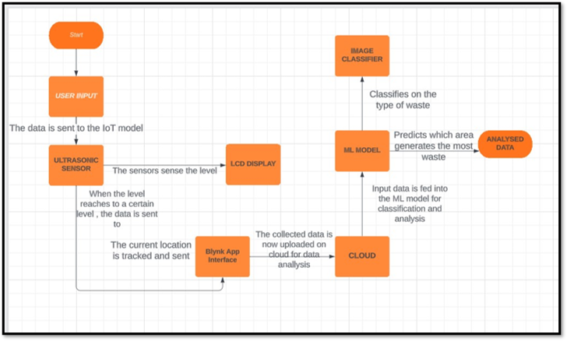
Figure 2 The operational Model
- Data Collection and Transmission: The IoT sensors will collect data on the fill level of the waste bins continuously. This data will be transmitted wirelessly to a central database or cloud platform for further processing and analysis.
- Data Storage and Processing: The collected data will be stored and processed in a central database or cloud platform. ML algorithms will be applied to analyze the data and identify patterns and trends in waste generation.
- Predictive Analytics: ML algorithms will be used to predict future waste generation patterns based on historical data and other relevant factors such as weather conditions, events, or holidays. This will help in optimizing waste collection schedules and routes.
- Route Optimization: Using the predicted waste generation patterns, ML algorithms can optimize waste collection routes to ensure efficient and timely collection. This will minimize fuel consumption, reduce collection costs, and improve overall efficiency.
- Alert and Notification System: The system can send alerts and notifications to waste management authorities or collection workers when a waste bin is nearing capacity or needs immediate attention. This will help prevent overflowing bins and ensure timely collection.​
- Data Analytics and Reporting: The system can provide data analytics and reporting features to stakeholders, such as municipalities or businesses, to gain insights into waste generation patterns, identify areas for improvement, and measure the effectiveness of waste management initiatives.​
Implementation
The implementation of a “Smart Waste Management System” using IoT and ML techniques typically involves the following steps:
- System Design and Architecture : Design the overall architecture, considering the placement of IoT sensors, data collection devices, and communication network.
- Sensor Deployment and Data Collection : Install IoT sensors in waste bins to monitor fill levels. Set up data collection devices to gather sensor data and transmit it to a cloud platform.
- Data Preprocessing and Storage : Receive and preprocess the collected data to perform data validation and store the preprocessed data in a suitable database or data storage system for further analysis.
- Machine Learning Model Development : Determine the specific waste management objectives to address, such as route optimization, waste classification, or fill level prediction.
- Real-time Data Analysis and Decision Making: Develop algorithms and software modules to process real-time data from the IoT sensors.
- System Integration and Automation : Integrate the IoT and ML-based waste management system. Automate processes, such as scheduling waste collection based on real-time fill level data and predictive analytics.

RESULTS and CONCLUSIONS
The Figure 3 depicts the implemented model, the smart management system collects data from the overflowing locations efficiently and effectively.
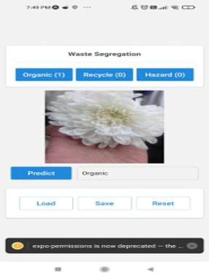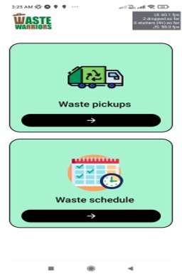
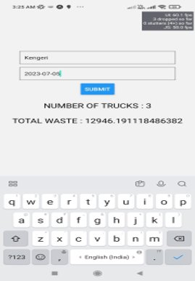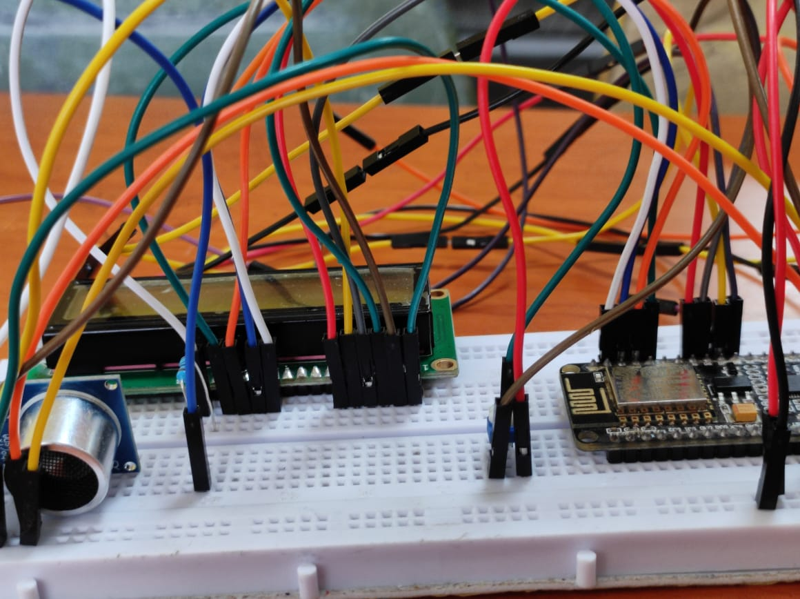
Figure 3: Implemented Model
In conclusion, a smart IoT and ML-based waste management system offers improved operational efficiency, reduced costs, and enhanced environmental sustainability. By integrating IoT sensors, ML algorithms, and data analytics, the system optimizes waste collection routes, predicts fill levels, and promotes citizen engagement. It empowers municipalities, businesses, and citizens to create cleaner, greener, and more efficient waste management practices.

REFERENCES
[1] Umar Riaz, Rashid Mehmood, "IoT-Based Smart Waste Management Systems: A Review”
Published in: Journal of Sensors, 2017.
[2] Savita V. Sawant, Satyajit R. Desai, "Smart Waste Management Using Internet of Things:
A Review” International Journal of Computer Applications, 2018.
[3] Umair Jabbar, Yaser Daanial Khan, "Smart Bin: A Framework for Waste Management
Using Internet of Things” Published in: Procedia Computer Science, 2018.
[4] Muhammad Sohail Khan, Ibrar Yaqoob, "Design and Implementation of IoT-Based
Smart Waste Management System. : IEEE Access, 2019.
[5] Carlo Mastroianni, Domenico Talia, "Wireless Sensor Networks for Smart Waste
Management: A Survey” , Sensors, 2020.
[6] Muhammad Usman Akram, Elyas Rakhshani, "Internet of Things (IoT) in Solid
Waste Management: A Survey" , Waste Management, 2021.

