**Dosage Form Design**

**Dr. Suchitra S. Mishra** (Corresponding Author)

( M. Pharm, Ph.D.)

Assistant professor and Research Associate (Pharmaceutics)

Dadasaheb Balpande College of Pharmacy, Besa, Nagpur. 440037

( M.S.) India

9146945512

suchitramishra36@yahoo.com23

**Mrs. Rohini Kharwade**( M. Pharm)

Assistant professor (Pharmaceutics)

Dadasaheb Balpande College of Pharmacy, Besa, Nagpur. 440037

( M.S.) India

9730968187

rohinismore1@gmail.com

**ABSTRACT**

The best drug in the treatment of any disease is one that immediately meets the need for the drug in the blood (or site of action) and remains constant throughout the recovery period. This can be done by administering the dosage at a certain dose and a certain frequency. Therefore, a drug can be used in different ways for different types of drugs. Information about various drugs has changed and evolved rapidly over the past few years with the advent of new technologies. Recently, new ideas and government regulations regarding bioavailability, bioequivalence and validation are affecting the development, modifications and production of drug formulations. The physical and chemical characteristics of drug have a significant impact on safeness and compitancy. Poor physical properties often lead to difficulties in establishing dose-response relationships (SARs) and a lack of compitancy in clinical trials. This could lead to further changes in capacity throughout the development process, higher medical costs, and worst of all, the abandonment of late diagnostic tests. Knowing the basic physical and chemical characteristics helps to isolate and eliminate probes so that molecular defects can be modified or corrected at the design stage. The purpose of this chapter is to present the facts and details on the production of quantitative data, the important physical properties of selected molecules and how these properties can be analyzed and incorporated into research, the visualization and development of the final dose.

**Keywords: S**tructure-activity relationship, bioavailability, bioequivalence, validation, quantitative data, new chemical entities, biopharmaceuticals.

1. **INTRODUCTION**

Medications are rarely given alone; instead, they are given as part of a formulation with specific drugs and one or more non-drugs with specific functions. The choice to use over-the-counter drugs called medicinal ingredients or supplements leads to different types of medical uses. Chemical ingredients can dissolve, remove, thicken, dilute, emulsify, stabilize, protect, colour, flavour and transform chemicals into attractive and attractive forms. The physical and chemical properties of each recipe are unique.

These different systems present challenges for pharmacists to select the drug to fill and the delivery system, as well as for pharmacists to manufacture and composition. The general study of the design, manufacture, safety and efficacy of medicinal products is called pharmacy. In the prepartion of suitable formulations, the physicochemical and biological properties of the drugs and pharmaceutical ingredients used in the manufacturing should be taken into account. Medicines and pharmaceutical products must be combined to create drugs that are stable, effective, elegant, easy to administer, and safe. The product must be produced with quality control and packaged in containers that control the durability of the product. Products should be labelled to encourage correct use and stored in conditions suitable for maximum shelf life. Methods for preparing formulations and drug delivery systems are described in the following sections. This section explains some general considerations regarding physical agents, pharmaceutical formulations, and pharmaceutical ingredients. Pharmaceutical formulation is a multi-step process in which active drugs are mixed with all other ingredients, including factors such as particle size, polymorphism, pH and solubility, to become the final drug product. A drug formulation consists of medicinal products containing the chemical properties of the drug, its formulation and treatment regimen to be used in medical practice[1, 2, 3].

1. **CHARACTERISTICS OF IDEAL DOSAGE FORMS [3, 4]**

Dosage forms are non-reusable drugs and pharmaceutical products that contain a combination of excipients and other materials. Medicines need to be in the right form so that they can reach the needs of the order, which depends on how many forms are created. The ideal formula should be:

* Easy to apply and safe
* Easy to use
* Easy to repeat and manufacture
* Patient performance
* Effective
* Physical and chemical stability
* Biocompatible ​​​
* Affordable
* Maintains treatment throughout shelf life
* Ease of transportation, use and storage
* Resistant to freezing during storage and use
* Prevents mechanical shock during transportation
* Ease of use of different drugs
* Provides medical needs
* Drug release, initiation, process effort and working time

1. **NEED FOR CONVERT DRUG TO DOSAGE FORMS [4, 5,7, 8]**

When raw materials are taken, they are rarely added with supplements, because it is difficult to take the drug correctly and the expected treatment cannot be provided. Drugs and excipients need to be mixed to turn into different types of drugs. The basic rules of prescribing are:

* Correct dose
* Protection Eg. Coated tablets, and sealed ampoules.
* To mask taste and odour (to make it delicious)
* Place the medicine in body tissue.
* It is a sustained-release drug
* Manage drug delivery
* Injecting drugs into the body cavity (breech, genitals)
* Carriers must use insoluble drugs
* Ease of transportation, use and storage
* Stability during storage and use
* Prevents mechanical shock during transportation
* Ease of use of different chemicals
* Meets medical needs
* Predictable effect duration, release, onset, power
* Economical and elegant
* Reduce discomfort and immediate relief and improve patient compliance

1. **TYPES OF DOSAGE FORM [6,8,9]**

Drugs enter into the body through various routes, depending on their absorption and therapeutic effects. Medicines can be classified in different ways according to different bases such as administration, physical properties and uses.

1. **Based on the physical state**

**a.** Solid Dosage Form: Conventional and modified release Tablets, Capsules, Powder, Lozenges, Films, Chewingum, Pallets, Suppositories etc.

**b.** Liquid Dosage Form: SolutioSuspensionsions, Elexirs, Syrup, Linctus, Parentrals, Eye and ear drops, Aromatic water, Tincture, Mouth wash, Gargles etc.

**c.** Semisolid Dosage Form: Generally used for topical applications or on mucous membranes. Cream, Ointment, Gel, Liniments, Lotions, Pastes etc.

**d.** Gaseous Dosage Form: Combination of solid fines wth liquid or gas or combination of liquid and gas. Nebulizers, Aerosol, Inhalers, Sprey etc.

1. **Based on the route of administration**
2. **Oral Dosage form**

**Tablets**

Tablets are a dosage form that is administered orally to the body. Tablets may contain single or multiple compressed drugs along with other contents such as antibiotics, fragrances and binders. Tablets come in many shapes and colours. It can be controlled, supported or released immediately.

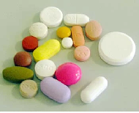

**Effavescent tablet:** This tablet dissolves by producing gas when it comes into contact with water. The oil obtained from the reaction of bicarbonate with citric or tartaric acid facilitates drug therapy. For example: Vitamin C tablets.

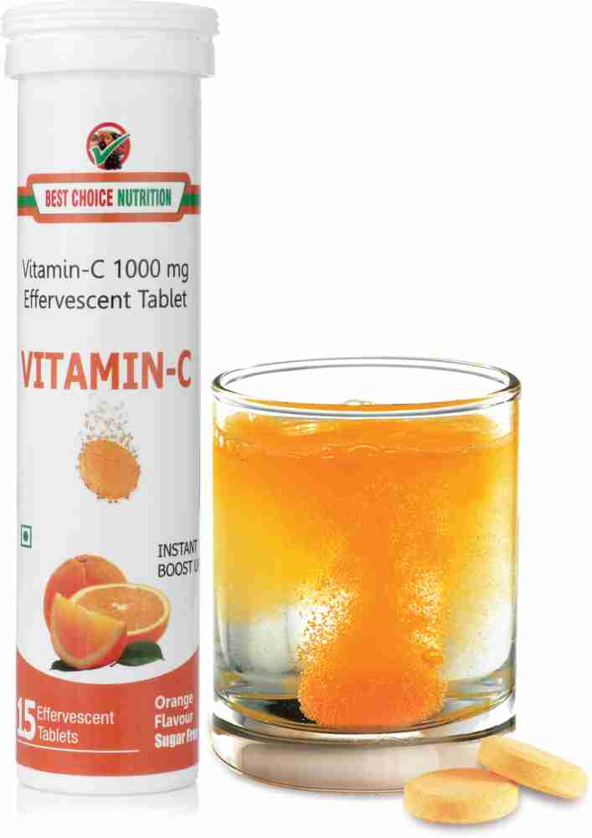

**Chewable Tablet:** It should be chewed and converted into small pieces. This will enhance the surface area exposure during detonation and allow the released drug to be absorbed faster. These tablets are usually given to patients who have difficulty in swallowing, like old age person and little one. It can be used if the dose is high. Example: Chewable multivitamins.

**Sublingual Tablet**: This tablet is formulaed to be placed below the tongue for absorption through the mucous membranes directly into the bloodstream. This method results in faster recovery than oral administration. For example trinitrate tablets.

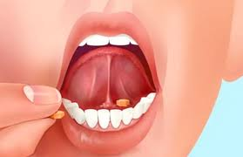

**Enteric Coated Tablets:** Tablets formulated with special coating to avoid dissolution in the stomach but does not dissolve in the intestine. It is used so that the medication can not be broken down by the juice in the stomach and absorbed into the intestines.

**Powder:** The oral powder is generally mixed in water for the patient to take it orally for therapeutic purposes. Most are available in sachets such as oral saline.

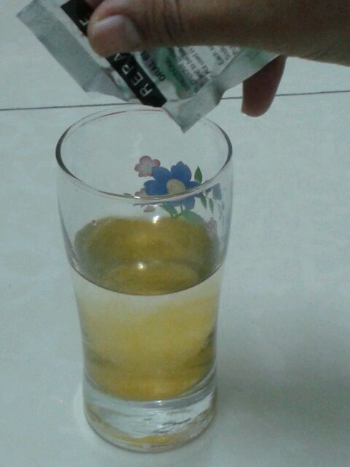

**Lozenges :** Lozenges are prescription medications that must be inhaled by mouth until they dissolve. Lozenges are often used to relieve cough and sore throat.

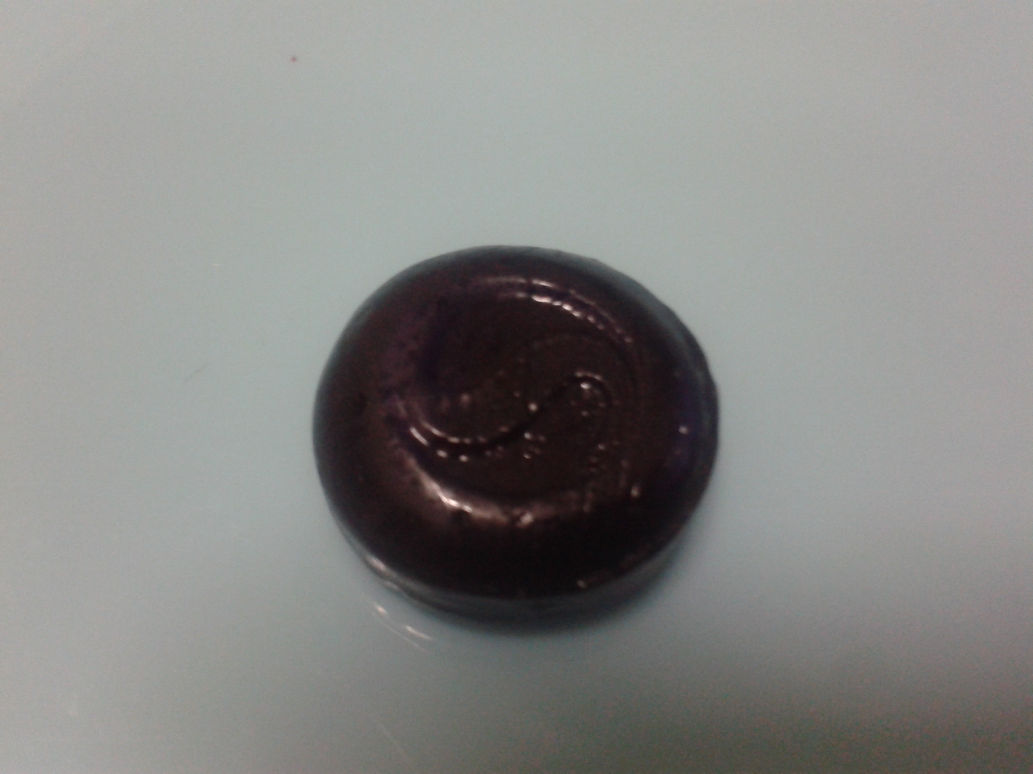

**Capsule**: A capsule is an oral formulation, usually made of gelatin, containing active ingredients and additives. Gelatin capsules are more expensive as compared to tablets, but they do have some advantages. For example, the particle size rarely changes during capsule production, and the capsule encapsulates the flavour and odour of the active ingredients and protects the photosensitive ingredients.

**Hard gelatin capsules:** for solid-filled preparations

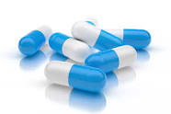

**Soft gelatin capsules:**Soft gelatin capsules for liquid-filled or semisolid-filled preparations. These are suitable for production of drugs with low water solubility as they provide good drug release and easy digestion.

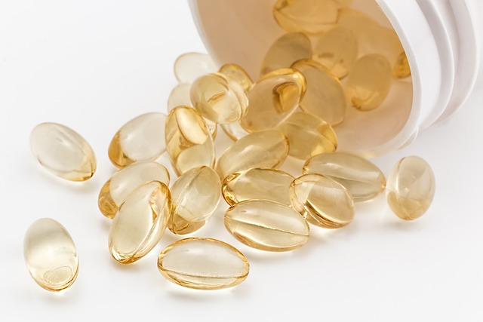

**Mixtures:** Mixtures are liquid preparations containing medicated active ingredients dissolved in a suitable solvent medium and to be taken according to the dose prescribed. For example syrup, suspension, emulsion, etc.

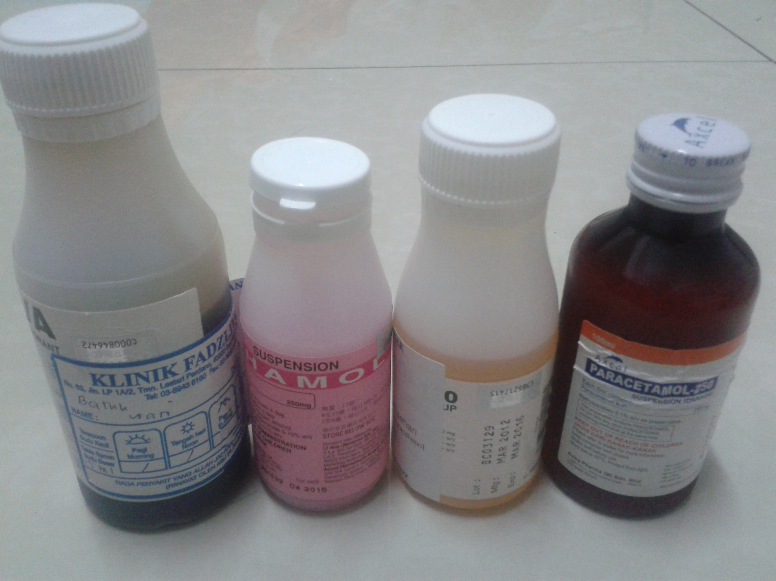

1. **Topically Applied**

Cosmetics Chemicals used for cosmetic purposes on the skin include antibiotics, antiseptics, anti-inflammatory agents, and skin softeners. The amount of drug released from ointments, creams and pastes in most of the semi-solid matrix used.

**Irrigation Solution:** Sterile, sterile solution for cleaning the body cavity, surgical site, wound, or genitourinary system. Example: saline solution.

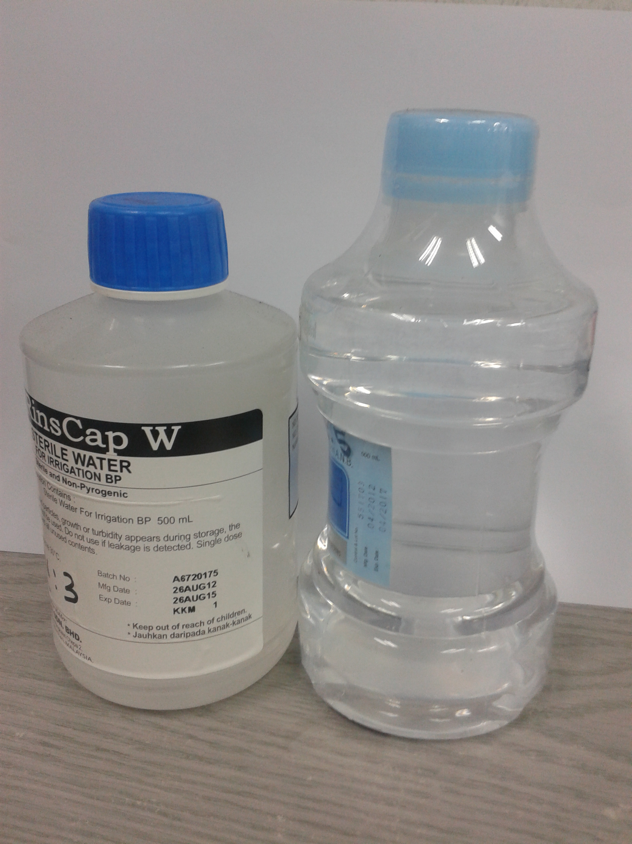

**Emulsion:** The emulsion cannot be taken orally, it can only be used externally and applied to the skin. Example: sunscreen.

**Gargles:** Mouthwash is used to rinse and treat mouth infections. Example: Chlorhexidine mouthwash.

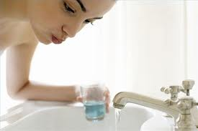

**Drops:** They are liquids containing some drugs placed in body cavities such as eyes, nose and ears to provide the desired therapeutic effect.

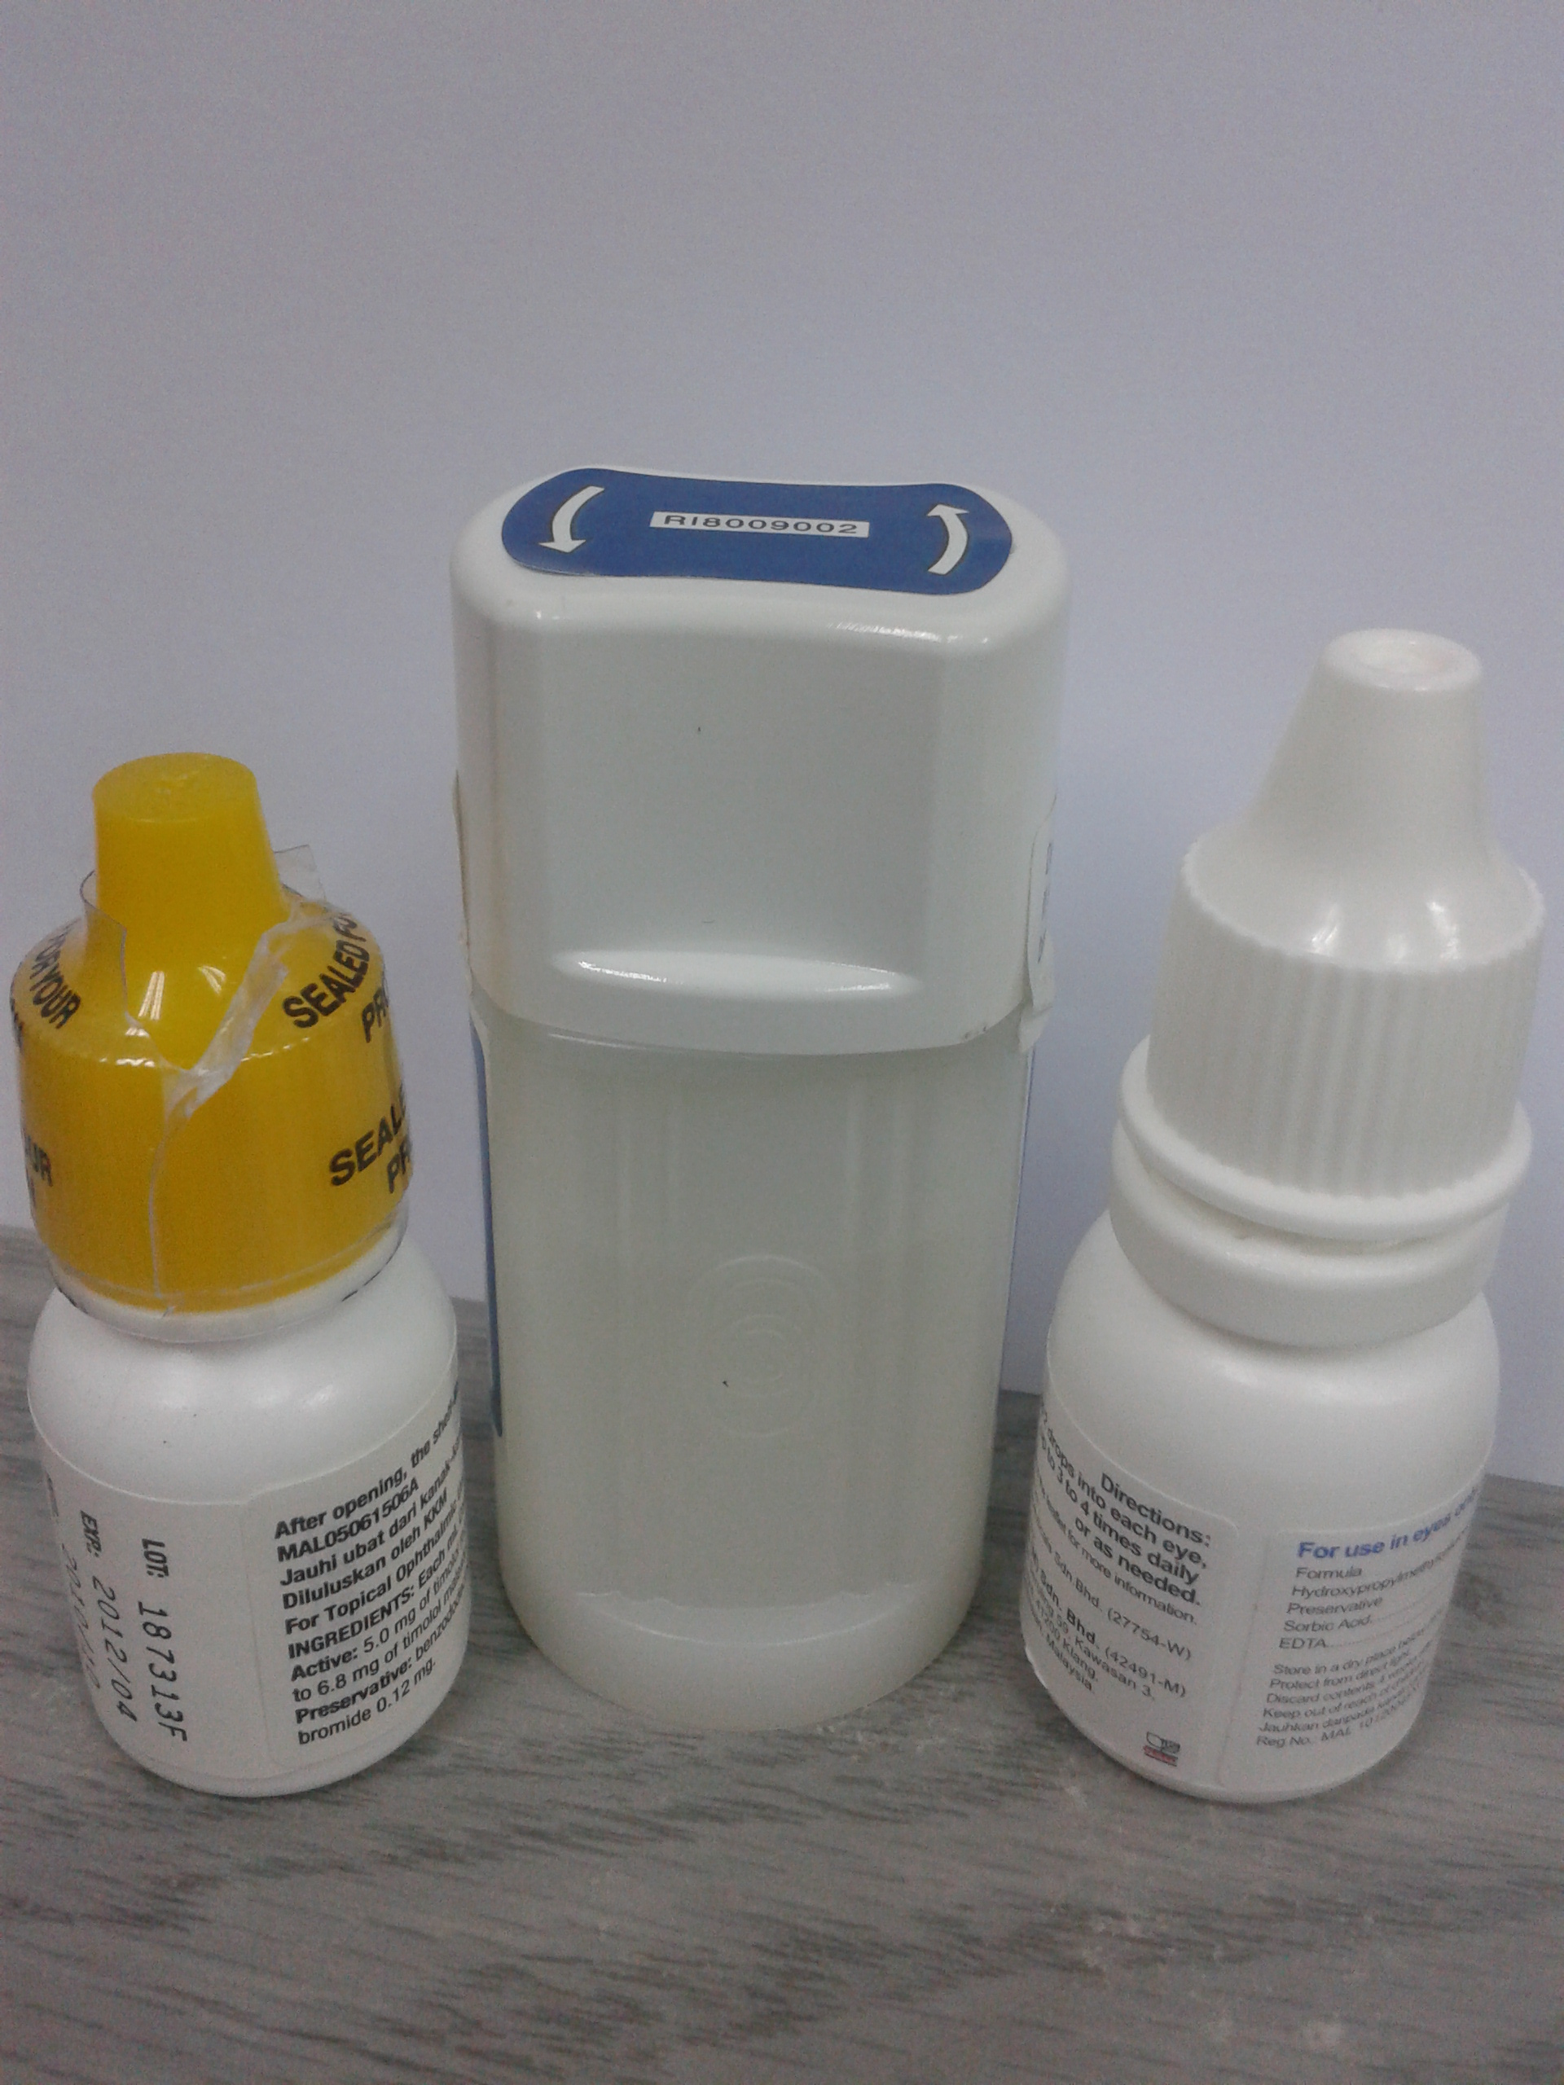

**Ointment:** An ointment is an oily preparation containing certain medicines. It can be used topically, such as the skin, eyes, or rectum, to reduce itching. Cosmetics are not easily removed from the body with water, sweat and other substances, so they stay on the skin for a long time. Therefore, ointments are also used as moisturizers and follow the protective mechanisms of the skin.

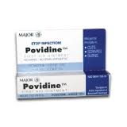

**Cream:** Cream is a semi-medical form containing one or more drugs for external use.Example: itching cream.

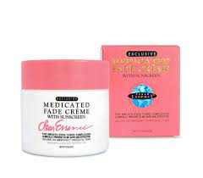

1. **Injections (sterile dosage forms)** Injections are sterile drugs containing drugs that are injected into the blood vessels, tissues, and organs of the body using needles and syringes. Injections are classified according to the method of injection into the body.

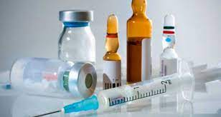

**Intramuscular:** Local or systemic injection by injection into the muscles, particularly the deltoid (shoulder), gluteus maximus (butt), and quadriceps (front of the thigh).

**Subcutaneous injection:** Inject drugs into the body by injecting them into the subcutaneous fat layer in the skin and muscles. This method is often used to administer insulin, antibiotics, opioids, and hormones.

**Intravenous:** Intravenous administration of drugs by intravenous injection (intravenous). This method is often used to administer saline infusions and parenteral nutrition.

1. **Inhalation**s

**Inhaler:** Inhaler usually consists of two types: aerosol or powder.

**Aerosol:** The term “aerosol” refers to sprays that result from a highly pressurized pressurised system/tool. This spray contains certain medications that are sprayed into the mouth.

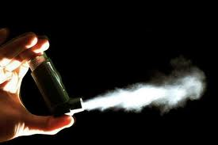

**Powder:** There are also medicated powders that are supplied in capsules. Patients will place the capsule into a special inhaler that is capable of breaking the capsules so that the medicine can be inhaled into the respiratory tract through the mouth.

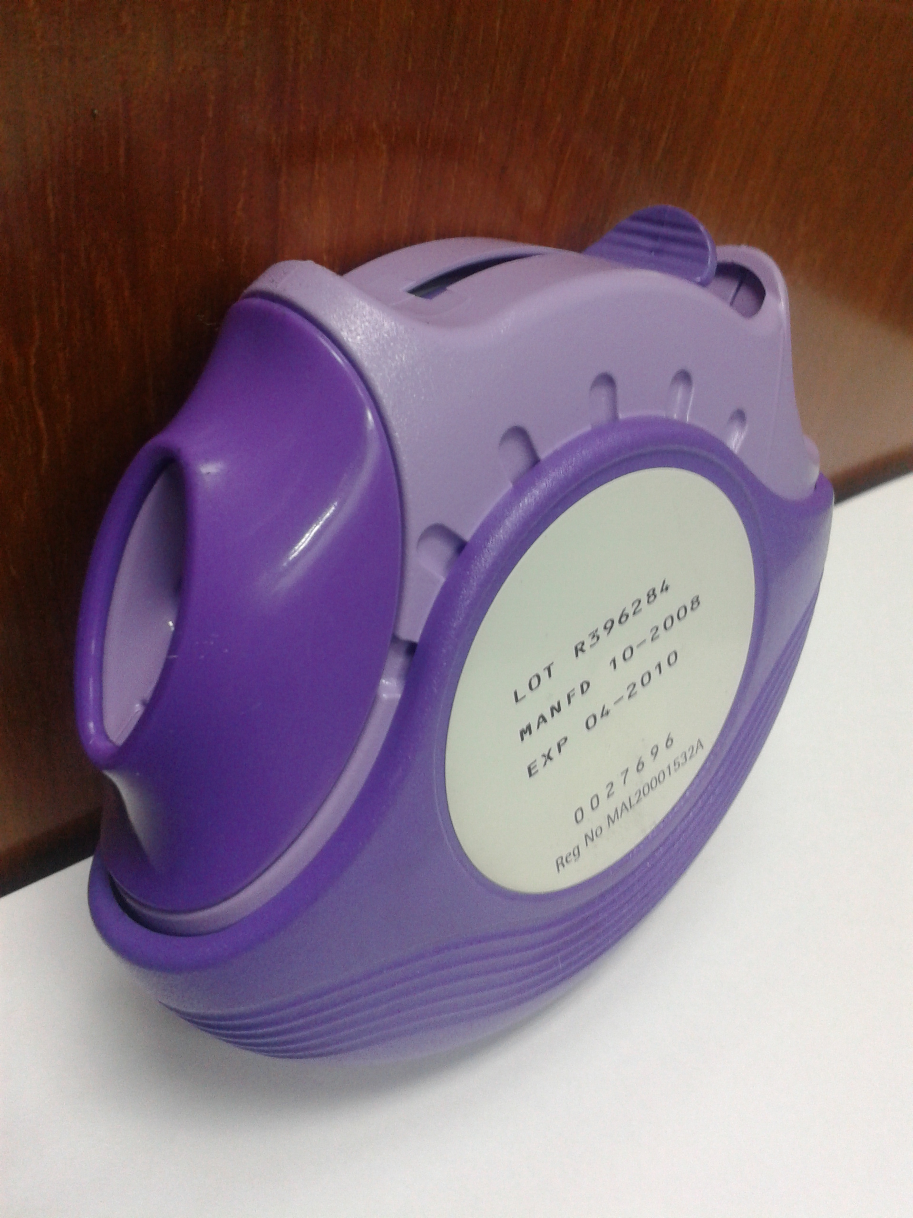

1. **Miscellaneous Implant:** An implant is a medicine delivery device planted in the body (most commonly under the skin) to enable the administration of medicine slowly and steadily over some time. This device is usually used to deliver hormones or contraceptives. For example Implanon



**Suppository: S**uppositories are the formulations introduced into the body cavity like vagina and anus. It consists a material which easily liquified at body temperature. It is used for patients who have difficulty in oral medications, such as infants and old age patients. Example: Diclofenac suppository.

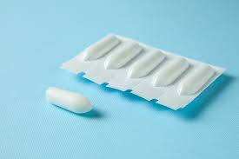

1. **GENERAL CONSIDERATIONS IN DOSAGE FORM DESIGN**

Before designing a drug into a dosage form, the required product must be determined, then various initial formulations are developed and evaluated at different levels for various parametrs. (e.g., drug release profile, bioavailability, clinical efficacy) and pilot studies and scale-up production. The formulation that best meets the product objectives is selected as the master formulation. Each batch of subsequently prepared product must meet the specifications laid down in the master recipe. There are many different forms in which the medicine can be placed for convenient and effective treatment of the disease. Most often, the manufacturer prepares the medicinal substance in several dosage forms and strengths for effective and convenient treatment of the disease. Before a drug is formulated into one or more dosage forms, among the factors considered are such therapeutic issues as [4,7,8].

1. **Drug Consideration In Dosage Form Design**
2. Properties of Drug Substances
3. Drug and Formulation Stability
4. **Therapeutic Considerations In Dosage Form Design**
5. Route of Administration
6. Nature of the illness
7. The age and anticipated condition of the patient.
8. **Biopharmaceutics Considerations**
9. **Drug Consideration In Dosage Form Design**
   1. **Properties of drug substances**

To achieve the goals of drugs and dosage forms, pre-formulation testing is the primary step. Preformulation is defined as the examination of the physicochemical properties of the drug itself and together with the excipients before formulation. The main goal of preformulation testing is to obtain information useful for the formulator in the development of stable and bioavailable dosage forms before formulation development. Pre-formulation research is designed to provide all the necessary data, especially the physical, chemical, mechanical and biopharmaceutical properties of medicinal substances, excipients and packaging materials [10].

**Organoleptic properties**

Organoleptic properties of a chemical entity start with a detailed description of the organoleptic properties of pharmaceutical substances including colour, smell, taste, appearance and these properties should be observed and describe at the preformulation stage. These characteristics shows variations with supplier to supplier and are therefore evaluated against reference standards to confirm API purity. Furthermore, once these organoleptic properties are determined, they can analyze the consistency of individual batches [12,13].

**Solid state properties**

They include crystallization, salt formation, polymorphisms, and solvates, which profoundly affect solubility, stability, permeability, and ultimately bioavailability. These are the most fundamental drug parameters that are necessary for the effective development of drug candidates for patients [14]. For example, powders are masses of solid particles enclosed in air (or another fluid), these two systems significantly affect the bulk properties of powders. Liquid content and other variable parameters are associated with powder formulations that can affect the flow, which is affected by particle physical properties such as shape, size, size inconsistency, angularity, and stiffness. Some external factors including humidity, aeration, vibration and traffic environment amplify this problem [15].

**Flow properties**

The flow properties of powders are critical to successful tabletting operations. For effective mixing and tolerable mass consistency of compressed tablets, an optimal flow of granules/powders is required. Suppose that at the preformulation stage, the drug is categorized as "poorly liquid", so the right choice of excipients can solve this problem. For powdered drugs, pre-compression and granulation methods are used for modification of flow properties. A pre-formulation test of the granule mass to measure flow properties is carried out using the angle of repose, orifice flow, Hausner ratio, bulk and shock density, interparticle porosity, Carr index and ideal fluidity. In general, a uniform shape or a large crystal exhibits a narrower deposit angle and a low Carr index resulting from changes in particle size and shape [16]. The angle of incidence can be understood as the maximum angle formed between the free-standing surface of the powder pile and the horizontal plane of the powder at the base. It can be used to evaluate the interparticle force of powder particles and bulk characterization of solids. The range of the pouring angle can vary from 0° to 90°, the pouring angle below 25° represents excellent flow properties, on the other hand, if the pouring angle is between 25° and 45°, the flow is considered poor. The formula for calculating the angle of repose is as follows [17].

Angle of repose tan θ= h/r

h is the height of the pile and r is the radius of the horizontal base.

**Particle size distribution**

The size of the particles of the dosage form affects the physicochemical properties and biopharmaceutical behaviour of medicinal substances. Drug solubility is often inversely proportional to particle size; for example, a dosage form with a smaller particle size has a large surface area, and so does the surface area to volume ratio. A stronger contact between the surface and the solvent increases the solubility. Particle size reduction methods such as grinding and milling often subject the drug product to high levels of physical stress that could lead to degradation [21]. In addition, micronization is a common technique used to reduce the size of particles and increase the surface area of drugs, thereby increasing solubility and dissolution.

**Compressibility**

Compressibility is the ability of drug powders to reduce volume under pressure and compress into tablet dosage forms with a specific tensile strength. It is calculated using Hausner's ratio and Carr's index to determine the flow behaviour of powder-based drugs for density calculation in preformulation stages [23].

**Crystallinity and polymorphism**

The polymorphism and crystalline behaviour of drugs in the solid state are important to formulators because most drugs exist in the solid state and are suitable for their intended use. In the solid state, drugs can exist as salts, co-crystals, hydrates, polymorphs, amorphous forms, solid solutions, and eutectics. Medicines in liquid form such as valproic acid and general anaesthetics in the gas phase. In a crystal, the lattice atoms are arranged in a unique pattern and are highly ordered based on this arrangement and are classified as crystalline or amorphous. Both forms exhibit different physical and chemical properties and therefore have different solubility and stability properties that affect the delivery system and drug activity [16]. Crystals and polymorphs are analyzed by advanced techniques such as X-ray diffraction, FTIR, NMR, optical crystallography, thermal microscopy, SEM/TEM, and differential scanning calorimetry [24, 25]. Polymorphism and crystal behaviour affect solubility [22].

**Hygroscopicity and Deliquescence**

Hygroscopicity can be viewed as the ability of a substance or salt to absorb moisture or water vapour. Chemicals can interact with moisture by storing them in bulk or absorbing them from the surface, capillary condensation, and chemicals. Atmospheric conditions and API area determine the amount of moisture absorbed. Changes in moisture content affect stability, compressibility and flow properties, so these properties should be carefully studied. Moisture content is measured by Karl Fischer titration, thermogravimetric analysis (TGA) and gas chromatography methods [29].

**Pseudopolymorphism**

Pseudopolymorphism refers to the incorporation of chemical molecules into a crystal lattice. The material can be found in different types of crystals called pseudopolymorphism and this process is pseudopolymorphism. These materials have secondary heterostructures with the same chemical composition (water, solvents, co-formers, etc.) in the lattice. These materials have other names such as hydrates, solvates, and co-crystals, which the FDA recognizes as polymorphs [28].

Pseudopolymorphism Pseudopolymorphism refers to the incorporation of chemical molecules into a crystal lattice. The feature can be found in different types of crystals called pseudopolymorphism and this process is pseudopolymorphism. These materials have secondary heterostructures with the same chemical composition (water, solvents, co-formers, etc.) in the lattice. These materials have other names such as hydrates, solvates, and co-crystals, which the FDA recognizes as polymorphs [28].

**Solubility Parameters**

An important issue in production is solubility. Poor drug solubility is a common cause of drug discovery and development failure. Insufficient solubility affects the ability to generate molecules because it can complicate testing and adversely affect in vivo combinations. Therefore, insufficient solubility will affect the development of therapy. In general, drug solubility is affected by many factors such as lattice energy, molecular arrangement, bond strength, weak bond, lipophilicity, ionization potential, pH, co-solvent, and additives. , dielectric constant, surfactant solubility, hydrophilicity, complexation, temperature, pressure and molecular volume. If these factors are adequately explored during preliminary research, they can be used in the final formulation and reduce the risk of drug failure [30].

**Measurement of pH in the Preformulation Step**

The negative logarithm of the hydrogen ion concentration of the solution is called pH. pH is calculated as pH = − Log [H+] depending on the pH range, pH 1-7 for acidic solutions, ± 7 for neutral solutions, and pH 7-14 for alkaline/neutral solutions. Most chemicals contain salts, weak bases or acids. Therefore, a good understanding of the molecular ionization behaviour at a given pH is important. Therefore, the effects of ionization, ionic strength, pH, and temperature are simultaneously studied to understand the form stability, solubility, bioavailability, and activity results of drug molecules during the pre-formulation phase [31].

**Dissociation Constant (pKa) Analysis**

pKa is the dissociation constant of a substance that exists in solution as a weak base or weak acid, so the substance can exist in ionized or non-ionized form at any pH. The solubility of the drug in water depends on the ionization of the drug and the ratio of the ionized form to the ionized form. The nonionic form of the drug is lipophilic and therefore able to pass through the bilayer membrane, however, the ionized form is oil-insoluble and therefore penetrates slowly. The three parameters for absorption are stable ionization, the non-ionized form of the drug available for absorption in the gastrointestinal tract region to see its effect [32].

The equations for basic and acidic compounds are mentioned below:

For acidic drugs: pH=log pKa+ratio of un-ionised to ionised drug

For basic drugs: pH=log pKa+ratio of ionised to unionised drug

**Distribution Coefficient (Log P) Analysis**

The ratio of non-ionized solution dispersed in the aqueous and organic phases is called the dispersion coefficient. This helps predict the drug's ability to cross the bilayer. Lipinski's 5 rule was used to estimate solubility and transmittance. log P can be determined from the equation log P = oil/water. The lipophilicity of the compound is indicated by the Log P value, with a log P value of 0 indicating that the drug has a solubility in n-octanol and water. A Log P value of 2 indicates the hydrophilicity of the drug and 5 indicates its lipophilicity. While the fit curve of Log P values ​​is between 1 and 3, Log P values ​​less than 1 and greater than 6 indicate weak permeability. Currently, software tools such as Molecular Modeling Pro™ 6.27 software [33] are useful for Log P determination.

**Thermal Effect (solution enthalpy)**

The effect of heat on the solubility of a solution can be measured in terms of the temperature of the solution. The heat released or absorbed when one mole of solute is dissolved in a large amount of solvent is called the heat of solution. The optimum temperature ranges are 5°C, 25°C, 37°C and 50°C. Solution temperature is considered good for endothermic processes and bad for exothermic processes. Effectively heating the drug increases the solubility of the drug when the temperature is increased, so that optimal drug solubility can be determined during preformulation using the temperature of the drug formulation. A heat of dissolution between 4 and 8 kcal/mol indicates that weak and acidic substances dissolve in water in an unionized state [14].

**Common Ion Effects (Ksp)**

Pretests to determine solubility should not avoid ion effects because ions often reduce the solubility of salts. Le Chatelier's principle states that when equilibrium is disturbed, the response changes to bring it back into equilibrium. The balance of mixed ions with a weak acid or base will shift in favour of the reactants. Most ions suppress the ionization of weak acids in the presence of weak bases or weak acids, producing more comparable product ions [34]. Therefore, the addition of mixed ions to the solution can change the reaction to the reactants to remove excess products from the solubility-reducing precipitates.

**Dissolution**

Dissolution is defined as the amount of solute per unit time of a liquid or compound under specified conditions of temperature and pressure. This process is called dissolution. The separation ratio can be determined with the aid of the Noyce-Whitney equation. The dissolution rate is the rate-limiting step at the point of absorption of the drug in solution. At the formulation stage, scientists understand how excipients, surface area, and particle size affect the dissolution behaviour of the drug and determine the rate-limiting behaviour mediated by dissolution. The drug is soluble in the body and depends on the type of drug, for example oral (pill, capsule and suspension) and intramuscular (tablet or suspension) training; The price limit determines which drug is used correctly. recommended for dosage form [35, 12].

**b.Stability analysis of Drugs and Formulations as per ICH guidelines**

According to ICH (International Conference on Harmonization) Q1A (R2) guidelines, the purpose of these guidelines is to test the drug under various stress conditions, such as longs. -period stability test, at least three stability tests at different times and sometimes intermediate tests for some properties. Tests include the effects of pH, temperature, humidity and photolysis under stress. Studies on pre-process stability are most important for controlling the chemical stability and degradation of solid and liquid materials. Physical inspection to check for clumping, liquefaction, discolouration, odour and gel formation during manufacture. After physical analysis, the degradation can be analyzed by mass spectrometry, HPLC or DSC, NMR, FTIR or other advanced analytical methods [36].

**Photostability**

Photostability criteria are fully addressed in the ICH-Q1B guidelines. The photostability of drugs and pharmaceutical products should be clearly understood for the evaluation of transport, packaging, labelling, negative drug analysis and new formulation strategies. The best simulation during drug development is usually 1.2 million lux, according to the Working Group of Experts of the European Pharmaceutical Industry Federation.

**Solid State Stability**

In terms of solid state, in addition to environmental factors such as temperature, light and humidity, packaging materials that come into contact with the drug are in the first place for drug stability. If not chosen correctly, additives can affect the different effects of the drug/drug. Lack of binding or moisture from excipients, pH and microclimate can affect the quality of the medicinal product. Therefore, excipients with low moisture content and low hygroscopicity are preferred for chemical degradation by hydrolysis[37].

**Solution State Stability Studies**

Liquid-state reactions are easier to detect than solid-state reactions. The method of checking for fluid incompatibilities is the same as for medical supplies. Research for suspension and resolution of the drug includes high nitrogen and oxygen ambient circulation, alkaline/acid pH conditions and the availability of chelation, mixtures and stabilizers conditions specified and which must be evaluated by FDA safety guidelines [38].

**Drug-excipients Compatibility**

The drug is closely related to one or more excipients in the dosage form of tablets; which will affect the stability of the drug. Therefore, understanding how drugs and excipients interact helps manufacturers select the best excipients. Binders, disintegrants, lubricants and fillers are usually found in tablets [39]. Interaction analysis of new drugs should consider adding two or more in each class. Preformulation researchers have a lot of control over the drug-to-excipient ratio used in these studies. Various techniques used to detect the composition of substances with materials include differential FT-IR spectroscopy, scanning calorimetry, fluorescence spectroscopy, differential thermal analysis, osmometry, diffuse reflection spectroscopy, high-pressure liquid chromatography, and radiolabeling [40]. Stability tests were performed at different temperatures and times, according to ICH guidelines.

**Table 1: Stability Study**

|  |  |  |
| --- | --- | --- |
| **Type of Study** | **Conditions** | **Period** |
| Long Term Testing | 25±2oC/60±5%RH | 12 Months |
| Accelerated Testing | 40±2oC/75±5%RH | 6 Months |

1. **Therapeutic Considerations In Dosage Form Design [4,7]**
2. **Route of Administration**

If the drug is intended for physical use and has to be administered orally tablets and/or capsules are usually prepared by the patient as they are easy to use and suitable for self-monitoring. In cases where the patient may forget the medicine or cannot take it orally if emergency medicine is used, injection records are also arranged.

b. **The nature of the illness**

Examples of the treatment of many other medical conditions, including abdominal pain, nausea, and vomiting, that affect formulation using tablets and skin for protection, suppositories and injections. for prophylaxis.

**c.The age and anticipated condition of the patient.**

For infants and children under 5 years of age, liquid solutions are preferred over oral administration forms. When the patient coughs, vomits or simply revolts, questions may arise about how much medicine was swallowed and how much was coughed up. In this case, a shot is required. In childhood and even in old age, a person may have difficulty swallowing large amounts of information, especially uncoated tablets, which is why some drugs are prepared as chewable tablets. Freshly sold tablets takes 10 to 15 seconds to dissolve in the mouth, this allows patients to take the tablets but be able to swallow the liquid.

1. **Biopharmaceutical considerations [4,7]**

The route of administration varies with pharmacokinetic parameters such as absorption, distribution, metabolism and elimination (ADME). Drugs enter the body through a variety of routes, including oral, topical, parenteral, inhalation, rectal, nasal, ear and eye. The preferred route of administration is based on candidate pharmacokinetic profile (ADME) and disease type (disease).

1. **METHOD FOR CHARACTERIZATION OF SOLIDS**

Conventional solid dosage forms, including tablets, granules, powder and capsules, are used to administer the majority of drugs i.e. active pharmaceutical ingredients (API). Processing of the drug with the excipients in dry form or granulating mass was necessary for the formulation of these dosage forms. This procedure entails milling, blending, and granulation which are impacted by the physicochemical characteristics of the solids. It affects the overall performance, processability, stability, and appearance of solid dosage forms. Along with this, the physicochemical status of the API and excipients used in formulations also impact on characteristics of the dosage form [41].

The pharmacological behaviour of an API can be modified by altering its structure particle size. The physicochemical characteristics of API is the most significant aspect in the preparation of a pharmaceutical dosage form. Therefore, its characterization is crucial to know the features of API and excipients to produce safe and effective dosage forms [42].

According to the United States of Pharmacopeia (USP), various characterization tests have been performed to determine the physicochemical characteristics of drugs. Additional solid-state characterization includes drug-excipient compatibility and [nano-particles](https://www.intertek.com/pharmaceutical/analysis/nanoparticles/" \o "nano-particles) confirmation and encapsulation efficiency. The structural characterisation is achieved by applying infrared spectroscopy (FTIR), UV-Visible spectroscopy, [nuclear magnetic resonance (NMR)](https://www.intertek.com/pharmaceutical/analysis/nmr/" \o "nuclear magnetic resonance (NMR)) and 1H, 13C mass spectroscopy[43].

**A.Types of solids** [44,45]

1. **Crystalline and amorphous phases**

Morphology, solubility, dissolution rate, and ultimately the properties of tablets are depends on the nature of API as well as excipients. The crystalline materials have a well-defined and regular arrangement of atoms in their molecule and therefore show sharp melting points. Subsequently, crystalline drugs have low solubility and which is the major challenge in the formulation of the dosage form. Therefore, most of the new APIs fail to show their potent pharmacological effect in the solid dosage form. Therefore, formulation of crystalline API into oral administrative solid dosage form has become a thirst area in dosage form, particularly for those drugs which show poor solubility or permeability and are eventually related to poor bioavailability. Various approaches such as salt formation, complexation, amorphism, solid dispersion, nanocarrier encapsulation, solid lipid nanoformulation, and other advanced formulation methods are used to enhance its solubility. Because amorphous entities have good solubilities, dissolution rates, and chemical reactivities with bioavailability as compared to crystalline forms. Therefore, it’s a need to study both molecular pharmaceutics as well as crystal growth and design crystalline of the new chemical moiety.

**Polymorphic forms**

The ability of a drug component exists in more than one crystalline form is called polymorphism. Therefore, it needs to ensure the optimal physical form of API because it can exist in polymorphs. Polymorphs have similar chemical formulas but have different structural and physical properties. Its rate of dissolution, melting point, flow property, compressibility, shape and size are completely different from others which affects its biopharmaceutical properties. For example, chloramphenicol palmitate is available in three polymorphic forms A, B, and C. From these, the B form shows the best bioavailability and the A form is biologically inactive.

In addition to polymorphs, the term molecular adduct nowadays is more famous in association with solvents (solvates). Molecules that form solids at room temperature are called co-crystals or with salts called ionic co-crystals. It is important to say that all these co-crystals and ionic co-crystals forms are polymorphic. The polymorphs of compounds can be characterised by optical crystallography, X-ray diffraction (XRD), and differential scanning calorimetry (DSC). From the different polymorph of the compound, only a single form exist in thermodynamically stable at a particular temperature, while the others are metastable. These metastable forms have high free energy and therefore it can show apparent solubility with a higher dissolution rate.

1. **Solvates and hydrate**

The crystalline drug can either be a polymorph or molecular adduct. The molecular adduct containing entrap solvent molecules within the crystal is called solvate. Solvates have either stoichiometric or nonstoichiometric proportions. If a water molecule is incorporated into a crystal then the solvate is called a hydrate. The different crystalline forms of solvates are called pseudo polymorphs. These solvates or molecular adducts showed different physical, pharmaceutical, and biopharmaceutical properties. Quantitative different solubility of solvates and hydrates results in differences in bioavailability. Solvate without water molecules has greater solubility than hydrates.

1. **Molecular level properties**

These properties are characterised at the molecular level of the drug. Therefore it can be quantified at an earlier stage of formulation of the dosage form. It includes properties such as molecular interactions and molecular bonds that can be characterized by spectroscopic techniques. These studies provide information regarding crystallinity, amorphism, polymorphic form, and solvates [46].

* 1. **Ultraviolet (UV) /visible spectroscopy**

UV–visible spectroscopy is a primary tool for functional characterization of drugs and excipients used in solid oral dosage. Although this technique is used for the characterisation of solutions, therefore solution should be formed to characterise the solid [47].

The performance of UV-visible spectroscopy is based on diffuse reflectance techniques and it measures the radiation fraction that penetrates the molecule and then transmits. The instrumentation of UV-spectroscopy consists of a light source, a monochromator, an integrating sphere, and a detector. The instrumentation and dilution of the sample can be optimized to minimize undesirable signals. Several diffuse reflectance theories have been proposed for the UV-spectroscopic characterization of drugs. According to the Kubelka–Munk theory diffuse reflectance can be calculated by equation (1).

$\frac{K}{S}=\frac{\left(1−R_{∞}\right)}{2R_{∞}}$ (1)

Where,

K and S = The molar absorption and the scattering coefficients, respectively,

R∞ = The reflectivity of an infinitely thick sample.

This technique has been also used to determine solid–solid interactions including the effect of excipients, method variables and the formation of new entities due to the physicochemical interaction of the drug-excipient.

* 1. **Vibrational spectroscopy**[48,49]

The purity of the drug and its interaction with excipients can be characterised by Fourier transform infrared (FTIR) and Raman spectroscopy. The electromagnetic spectra of FTIR are divided into the near-IR (4000–14,000 cm−1), mid-IR (400–4000 cm−1), and far-IR (100–400 cm−1). For drug excipient interactions are characterised by using near and mid-IR ranges. Functional groups of the active constituents such as C=O and NH are characterised by FTIR whereas C=C and SS are characterized by Raman spectroscopy. These techniques are also used to determine the degree of crystallinity.

For vibrational spectroscopy, the sample can be prepared using three different methods such as alkali halide pellet method, Mull preparation and neat powdered sample method. From these alkali kalid pellet method is mostly preferred by using KBr.

The peaks of FTIR produced all frequencies from the source as well as the signal-to-noise ratio. When a sample is irradiated, it absorbs infrared energy and diffuses reflectance which results in transitions between vibrational and rotational energy. The vibrational energy of a molecule depends upon its functional group and produce a spectral band.

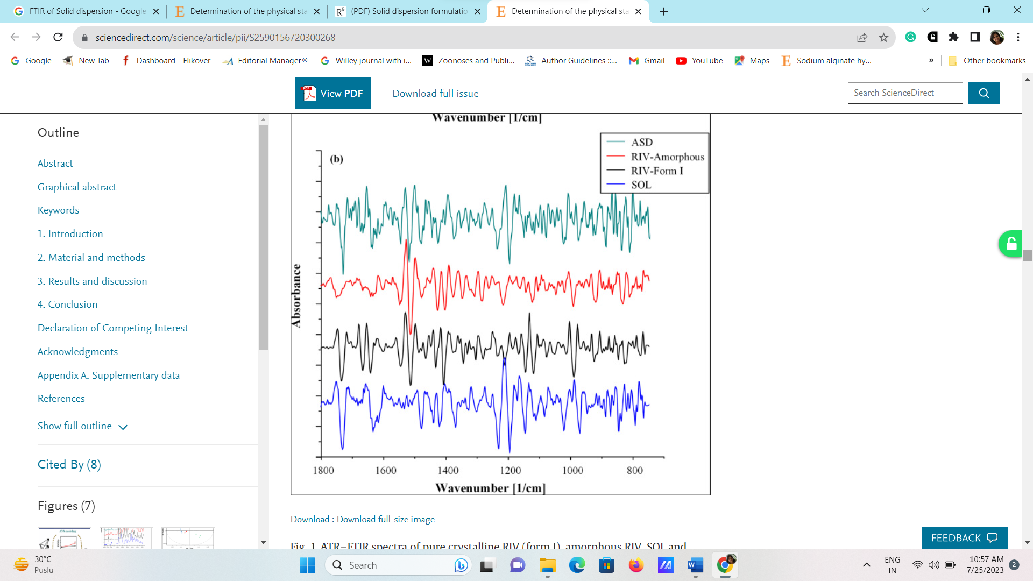

**Figure No. 1: Comparative FTIR spectra of RIV of crystalline and the amorphous, as well as its matrix (SOL) and its amorphous solid dispersion (ASDs)**

Afroditi et al. differentiated the physicochemical characteristics of Ritonavir (RTV) in crystalline, amorphous, matrix (SOL) and amorphous solid dispersion through FTIR. From the result, it was observed that peaks of crystalline RIV were significantly different from amorphous ones. In amorphous RTV peak for the amide group and ester group was broad and shifted to a lower wavelength. In addition, SOL of RTV showed two characteristic peaks for polyvinyl acetate and tertiary amide group at 1635 and 1736 cm−1 respectively. While the peak for secondary amide was missing due to the formation of a co-polymer hydrogen bond [50].

* 1. **Solid-state nuclear magnetic resonance**

The functional group near each atom in the component was obtained by nuclear magnetic resonance (NMR). It was again characterised in solution form. However, its use for the study of polymorphs or solvates is now being widely used for the qualitative and quantitative characterization of solids or in the amorphous state.

It showed various interactions such as chemical shifts, and spin–spin couplings, magnetic momentum of the nucleus with an external magnetic field and shielding by adjacent electrons. The anisotropy of solid samples is observed by chemical shift by identical nuclei due to its special arrangement concerning to applied magnetic field. The broad line effect in 13C and 1H NMR can be removed by high-power proton decoupling. Generally, it is observed that the NMR spectra of polymorphs or pseudo polymorphs are nonequivalent. This effect arises due to differing crystal structures of the various types that can bother the chemical environment of each nucleus under investigation. In considering the NMR spectra of polymorphs, certain resonance bands are observed at identical chemical shifts, while others are significantly shifted. The polymorphic variation of solid polymer can be also determined by NMR spectra [51,52].

1. **X-ray powder diffractometry** [53,54]

The physical nature of solids including hydrates and polymorphs can be characterised by X-ray powder diffraction (XRD). Each crystalline component has its unique patten of XRD spectra with different intensities. In polymorph, each crystalline solid state has a separate X-ray pattern with respect to others. This technique is also used for the identification of the nature of API in the presence of excipients.

For XRD sample should be placed between the ultraviolet and γ -rays in electromagnetic radiation. When the X-rays are incident on the crystalline component, they scatter in phase and reinforce each other. This is quantified by Bragg’s law as shown in equation 2.

nλ = 2d sin θ (2)

Where,

d is the distance between the planes in the crystal (angstrom units)

n is the order of reflection.

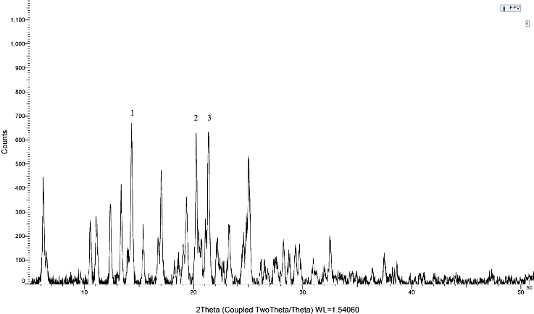 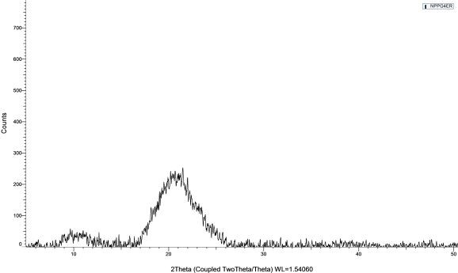

**Figure No. 2: X-ray diffractogram of crystalline EFV and its formulation**.

Kharwade et al. explored the transformations and changes in crystallinity of Efavirenz (EFV) by the X-ray diffraction pattern after being loaded into PAMAM G4 dendrimers as shown in **Fig. 2.**

The result showed that the diffractogram of pure EFV showed sharp and intense crystalline peaks at 2θ of 11.04° (peak 1),21.77(peak 2), and 23.77° (peak 3) with % crystallinity 78.5%. It confirms that the unprocessed pure EFV was crystalline. However, all of the mentioned sharp and intense peaks of pure EFV were changed to broad peaks with mild intensity after entrapment into PAMAM G4. The absence of sharp and extreme peaks of pure crystalline EFV was indicating the complete amorphization of the free EFV.

1. **Differential Scanning Calorimetry (DSC)**

The melting point, crystallization, desolvation and glass transition temperature of API can be determined by DSC. This technique has been classified into heat flux DSC and compensated power DSC. In compensated power DSC thermogram, the sample and the reference are kept at the same temperature and in heat flux DSC the temperature differential between the sample and the reference is monitored [55].

In modulated DSC, the conventional linear heating and cooling rate is overlapped by controlled modulated temperature. It helps to determine the glass transition temperature of API as well as to separate the enthalpic recovery. Pressure DSC is widely used to separate overlapping endotherms by subjecting the drug sample to different temperatures [56,57].

1. **Particle morphology**

The solid particle morphology and powder properties offer the application in the performance of solid particles in dosage form. Optical and electron microscopy methods are used to study the purest API consisting of small aggregated microcrystals. These methods are used to determine the nature of aggregated species, shape and average particle size.

If the stability of a drug is related to the degree of crystallinity, therefore it is important to identify the crystalline form of the drug and identify the most stable one. Optical microscopy can be used to determine the crystalline form of the drug (polymorphs) either enantiotropic or monotropic. The crystal habit of the solid can also be determined by scanning electron microscopy (SEM) examination. In SEM characterization the surface is scanned by a focused electron beam and the intensity of the secondary electron is monitored. It gives an excellent picture of the solid particle surface as shown in **Fig. 3.** Itshowed the SEM photograph of Tofacitinib citrate uncoated pellets which are homogenous and quite rough [58,59].

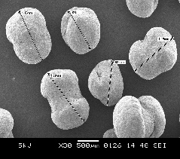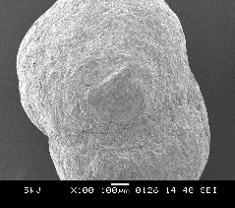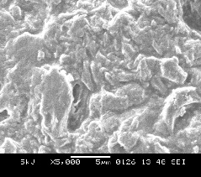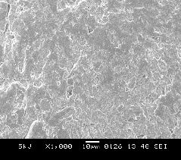

**Figure 3: SEM image of Tofacitinib citrate uncoated pellets which are homogenous and quite rough.**

1. **Bulk characterization of solid particles**[60,61]

Bulk properties include all fundamental as well as derived properties of solid including size distribution, flow property, compressibility, dispersibility, porosity, and density. These properties strongly alter the formulation characteristics. For example, surface area per unit weight and volume can alter the rate of dissolution, drug release and chemical interaction which ultimately affects the bioavailability. From all derived properties of excipients, flow property is strongly influenced by surface morphology. For example, larger particle size grades of lactose and avicel have a smaller surface area and better flow properties. The Kozeny–Carman equation can be used to determine the surface area of powder by air permeability method using equation (3).

$V=\frac{A}{n{Sw}^{2}}.\frac{ΔPt}{Kl}.\frac{ε^{3}}{{(1−ε)}^{2}}$ (3)

Where,

A = the cross-sectional area of the plug,

K = a constant,

ε = the porosity,

V = volume of air flowing through the capillary of length l in t seconds, and

η = the viscosity of air

Porosity is also an important property of a solid which is depends on interparticle and intraparticle spaces and represented in percentage. This property influences the compressibility, dissolution of tablets and capsules and size of packaging containers. It can be measured by mercury porosimetry because mercury can easily occupy the interparticle spaces. This method determined the amount of mercury that penetrates interparticle spaces of the powder sample, which indicate the porosity of the sample.

Material transfer, blending, and flow can be significantly influenced by the density of the solid particle. There are three types of densities such as true density, granule density and bulk density and depends on true volume, granule volume and bulk volume of powder respectively. Subsequently, it can depend on the size, shape, porosity, and cohesiveness of powders. Particle size also influences the flow property of powder. For smaller particles, cohesive forces in between the particle equal to the gravitational forces which restricts its flow property. Needles and flakes shape particles tend to loose packing which increases porosity. Poor flow may also arise due to high moisture content and surface roughness [62,63].

The flow property of powder can be measured by two parameters that is angle of repose and carr’s consolidation index. If the values of both parameters were lower than 15% then powder showed good flow, whereas values above 35% indicate poor flow [58].

1. **PHARMACEUTICAL INGREDIENTS AND EXCIPIENTS**

Excipients for pharmaceuticals are recognised as safe (GRAS) for human ingestion and are regarded as "inactive" components. Excipients are used to create bulk dosage forms, guarantee accuracy and precision, promote uniform blending, cover up the taste of bitterness, enhance flowability, bioavailability, patient compliance, and stability, and lessen the toxicity of API [64,65]. These are classified based on source of origin, role in the formulation, and functional group.

Application of pharmaceutical aids [66,67]:

➢ It helps to mask the unpleasant odour, taste, colour etc.

➢ It reproduces a safe, efficient, and convenient manner of drug delivery.

➢ It increases the stability and shelf life of the drugs.

➢ It protects the drug as well as dosage form from chemical and microbial degradation, it includes

antibacterial agents, preservatives and antioxidants.

➢ It helps to design the different forms of shape and size with maintaining the uniformity of the dosage

form.

➢ It improves the patient’s compliance and helps in manufacturing and designing the attractive

dosage

form.

Ideal characteristics of the pharmaceutical aids

➢ It does not change the chemical nature of the drug.

➢ It does not cause any toxic effects.

➢ It masks the unpleasant colour, odour, and taste.

➢ It does not cause any allergic reactions during administration.

➢ It improves patient compliance.

➢ It prevents microbial contamination of pharmaceutical products and improves its shelf life.

➢ It can be low-cost and easily available [68,69,70].

* + - 1. **Flavouring pharmaceuticals**

Flavouring pharmaceuticals significantly improve the taste, smell, feel and appearance. According to USP, It enhances the mixed sensation of taste, smell, touch, and sight. According to USP, a flavouring agent is a single or mixture of synthetic or natural origin chemical entities that produce an acceptable taste and smell after consumption [71,72].

Flavouring agents can be classified into two categories

1. Natural flavouring agents: Citrus fruit (lemon, orange), spice (cinnamon, peppermint, ginger, onion), fruits (apple, banana).
2. Synthetic flavouring agents: Alcohols, esters, ketones, terpenoids [73,74].

It improves flavours as well as tastes of different dosages. It also helps to improve the patient compliance or palatability of pharmaceutical dosage forms. The taste buds are sensitive to five basic tastes such as sweet, sour, salty, bitter and umami. However, its responses are altered by various factors including environmental factors, the age and sex of the consumer, and the nature of the dosage form. Generally, kids like fruit and chocolate flavours, while adults favour mint or wine flavours. Response to the flavour may be changed according to health and disease conditions. The acceptance of flavour also depends upon the category drug as shown in **Table 2.** Acceptance of flavour may be intolerable with prolonged treatment of dosage form with the same flavour. Flavours are also selected based on the taste of the drug as shown in **Table 3**.

**Table 2: Preferable flavours according to the category of drug [35]**.

|  |  |  |
| --- | --- | --- |
| **Sr. No** | **Drug** | **Preferred flavour** |
| 1 | Antibiotics | Strawberry, pineapple, banana, vanilla, raspberry, etc. |
| 2 | Antihistamines | Cherry, cinnamon, honey, lime, orange, etc. |
| 3 | Barbiturates | Orange, cinnamon, banana, vanilla, etc. |
| 4 | Decongestants and expectorants | Pineapple, coriander, gooseberry, anise, apricot, mint, lemon, strawberry, ginger, honey, etc |
| 5 | Electrolyte solution | Strawberry, orange, lime, raspberry, cherry wine, etc. |

**Table 3:** **Preferable flavours according to the taste of the drug [48]**.

|  |  |  |
| --- | --- | --- |
| **Sr. No.** | **Taste** | **Masking flavour** |
| 1 | Salt | Butterscotch, maple |
| 2 | Bitter | Wild cherry, walnut, chocolate-mint, liquorice |
| 3 | Acid | Citrus |
| 4 | Sweet | Fruit, berry, vanilla |

* + - 1. **Sweetening Pharmaceuticals**[70]

Sweetening pharmaceuticals or sweeteners are mainly used for masking the undesirable or bitter taste of any drug formulation and increasing the patient acceptance of pharmaceutical dosages form. In pediatric dosages form it is widely used because children prefer the sweet taste.

Sugar is the most widely used sweetening agent. Due to its viscosity-enhancing nature, it is also used as a preservative in syrup.

sweetening agents are divided into two categories:

A. Natural sweetening agent-Glucose, fructose, sucrose, dextrose, sorbitol.

B. Artificial colouring agent-Sucralose, aspartame, saccharin.

**a. Saccharin**

Saccharin is stared as a synthetic or non-nutritive sweetener by the Academy of Nutrition and Dietetics. Since it contains no carbohydrates, it has little or no energy-producing potential. The recommended daily consumption of saccharin for adults is between 0.2 and 0.9 mg/kg.

A form of hypersensitivity reaction known as a "sulfa" reaction is brought on by saccharin-containing o-toluene sulfonamide constituents, in children. This reaction includes wheezing, urticaria, pruritis, nausea, vomiting, diarrhoea, tachycardia, headache, diuresis, and sensory neuropathy. Therefore, it causes youngsters to become hyperactive, irritable, and sleep deprived. Therefore, the American Medical Association restricted in consumption of saccharin while pregnant.

* 1. **Aspartame**

Aspartame is a non-nutritive sweetener with no carbohydrate value, similar to saccharin, however, the FDA recommends it as safe. As a result, it is widely utilised in chewable and sugar-free formulations. It is phenylalanine and aspartic acid derivative. The content of phenylalanine should be explicitly stated on the drug product label and its use should be constantly monitored in children with autosomal recessive phenylketonuria as it considerably raises the serum levels. For kids who don't have any dietary limitations, the recommended daily consumption of aspartame might range between 5 and 10 mg/kg. Aspartame has been linked to several negative side effects, including headaches, panic attacks, mood swings, and seizures when consumed in high dosages (>30 mg/kg/day). However, not a single randomised double-blind clinical investigation was able to confirm any of the negative consequences. In paediatric formulations, natural sweeteners including stevia, date sugar, maple sugar, maple syrup molasses and agave nectar might take the place of aspartame [71].

* 1. **Sucralose**

Sucralose is 600 times sweeter than sucrose and is a non-nutritive chlorine derivative. The FDA recommends it for use in kid-friendly food, drink, and formulations. It affects the gut bacteria more and is slowly absorbed from the digestive system. Recent research suggests a connection between increased saccharin and sucralose consumption and the prevalence of irritable bowel syndrome in both children and adults.

1. **Sorbitol**

Hexahydric polyol sorbitol is a nutritive sweetener that offers sweetness while consuming less energy (2.6 vs. 4 kcal/g for sucrose). As a result, it has the "sugar-free" designation from the Academy of Nutrition and Dietetics. Children who consumed sorbitol at levels of 0.5 g/kg of body weight had abdominal pain, bloating, diarrhoea, and gastrointestinal distress. Because it undergoes pyruvic acid and lactic acid metabolism and has a laxative effect in the colon, which reduces the energy value and speeds up transit time. Due to immature and developing epithelial barriers, as well as drug-metabolizing enzymes, newborns and infants had reduced absorption. However, its absorption has improved in presence of glucose and fatty acids. Sorbitol accumulation in babies and young children has been linked to signs of diabetes. Therefore, the amount of sorbitol in the drug product should be mentioned for paediatric formulations.

1. **Preservative** [72,73]

In pharmaceutical formulations, most of the natural ingredients can promote microbial growth and promote unwanted contamination. To prevent this, antimicrobial agents or preservatives need to be added to the formulation.

Preservatives protect the product from microbial degradation but should not compromise product performance examples are methyl paraben, ethyl paraben, propylparaben, phenol, and benzoic acid.

Preservatives have the following ideal properties:

* It exerts a wide spectrum of antimicrobial activity against all possible micro-organisms at low concentration
* It maintains activity throughout product manufacture, shelf life and usage
* It should be non-toxic and compatible with other constituents of the preparation
* It should not compromise the quality or performance of the product, pack or delivery system.
* It should be safe and tolerant of the product.

There are two main types of drug preservatives.

* + 1. Antioxidants
    2. Antimicrobial agent
  1. **Antioxidants** [74]

At low concentrations, it prevents or delays the oxidation of the pharmaceutical product.

They are self-reducing substances that themselves oxidise and protect oxygen-sensitive components from oxidation while doing so. Antioxidants work in a variety of ways, including hydrogen atom transfer, single electron transfer, and metal chelate transformation. The quantity of a specific free radical that an antioxidant can absorb is known as its antioxidant capacity. Vitamin C, vitamin E, BHA (butylated hydroxy anisole), BHT (butylated hydroxytoluene), propyl gallate, and others are examples of antioxidants. They make a great defence against deterioration, which primarily takes into account oxygen and sunlight [75].

* 1. **Antimicrobial agents** [70,75]

The antimicrobial agents act by inhibiting microbial cell walls or cell membrane growth. Antimicrobial agents are of two types, antifungal preservative and antibacterial preservative.

The most common antifungal preservatives are benzoic and ascorbic acids and their salts, as well as phenols (parabens), such as methyl, ethyl, propyl, and butyl p-hydroxybenzoate. On the other hand, compounds such as quaternary ammonium salts, alcohols, phenols, and mercurials are antibacterial preservatives.

Sodium Benzoate: Sodium Benzoate is primarily used as an antimicrobial preservative in cosmetics, foods, and other pharmaceutical formulations. It is used as a bacteriostatic agent with fungistatic activity in many drug formulations

Alcohols: Chorobutanol is one of the most widely used alcohols which acts as a bacteriostatic agent and exhibits preservative properties.

Mercurial compounds: It is used as bacterial preservative in drug preparation and also used in topical antiseptics.

Benzyl alcohol: Peptide and protein products are commonly preserved with phenol and benzyl alcohol, while vaccines are preserved with phenoxyethanol.

Parabens: Preservatives commonly used in cosmetics include parabens. Propylparaben and methylparaben are widely used in medicines.

All the preservatives must undergo PET (Preservative Efficacy Testing). These tests involve a product with a defined number of colony-forming units of various microorganisms including bacteria, fungi, etc. The results are monitored for 28 days and if the compound passes these tests, then it proceeds for further tests and is used in different dosage forms.

1. **Colouring agents** [76,77]

colouring agents are mainly used to enhance the distinctive appearance of pharmaceutical dosage forms. These are cosmetics for pharmaceutical preparations because they enhance the aesthetic appearance and elegance of dosage forms. Colouring agents are needful pediatric dosage forms including tablets (either the core itself or the coating), capsule shell or coated beads, topical creams, toothpaste, ointments, and topical gel. It also helps to identify the similar-looking product of the same manufacturer or similar product of a different manufacturer [78].

The ideal properties of colouring agents are as follows

* It should be nontoxic and have no physiological activity.
* It should be free from harmful  impurities
* Its colouring power will be reliable and the assay will be practicable and easier.
* Its tinctorial ability should be high so that used only in small quantities.
* It should be stable at light and tropical  temperatures on storage
* It should not affected by oxidizing or reducing agents and pH changes.
* It should be compatible with medicaments and not interfere with them.
* It readily gets solubilised in water but in most cases, oil‐solublity and spirit‐solublity are necessary.
* Free from objectionable taste and odour.

Colouring agents are Classified as follows:

* 1. Organic dyes and their lakes
  2. Inorganic or mineral colours
  3. Natural colours or vegetable and animal colours
  4. **Organic dyes and their lakes**

Dyes are synthetic chemical compounds that exhibit their tinctorial strength by dissolving in solvents such as propylene glycol and glycerin. They are available in a wider range of shades with higher colouring power than natural pigments at a cheaper cost. The tinctorial strength of a  dye is directly proportional to its pure dye content. The dye solution should be prepared in stainless steel or glass-lined tanks with moderate mixing. This process minimises the incompatibility with the container. Examples of dyes are tartrazine and erythrosine.

Lakes

Lakes are the calcium salt of FDC water-soluble dyes extended on a substratum of alumina. They are not soluble therefore they prepare dispersion. Its particle size is very critical to its colouring capacity. Generally, the tinctorial strength of lakes is increased by smaller particle size because it increases surface area for reflating light.

The insoluble certified lakes have several advantages

* It was easily dispersible in solvent and dry.
* It reduces the effect of mottling which minimizes the tablet coating defect.
* Over-colouring is reduced due to opaque colour shade which produces a single color shade.
* Development of full colour with less quantity.
* Raw material costs are also improved.
* FDC-approved lakes are available in yellow, orange,  pink‐red, orange‐red, green‐blue and royal blue.
  1. **Inorganic colours or mineral colours**

Inorganic colours have good stability towards light and opacifying capacity. These are more useful in multinational companies in standardised formulae but the range of colours is minimal. Until the discovery of coal tar dyes,  mineral pigments were often used to colour foods and drugs but due to their toxic effects, they are readily displaced by available dyes. Titanium dioxide is used to colour and opacify hard gelatin capsules.

* 1. **Natural colours or vegetable and animal colours**

This is a chemically and physically diverse group of materials. Some of these colours are the products of chemical synthesis rather than extraction from a  natural source,  for example,  β‐carotene of commerce is of synthetic origin.  Generally, Natural colours are not stable to light and temperature as compared to dyes and lakes. Few colours are medicinally acceptable after dilution such as caramel, formerly called burnt sugar, cochineal ( a dried insect), and carmine ( aluminium lake of the colouring matter of cochineal). Other includes riboflavin and anthocyanins, paprika oleoresin, beetroot red, annatto, and curcumin. The disadvantage of these colours includes variation in colouring power and difficulty in standardisation. It has very low tinctorial power and expensive than coaltar colours [79].

1. **CONCLUSION**

Dosage form design and development involve the combination of various components and optimization processes. Excipients also play an important role in the quality of dosage form. Because any type of drug-excipient interaction or incompatibility affects the stability as well as the therapeutic efficacy of the drug. Whereas this chapter also gives affordable knowledge about various techniques used for the characterization of physicochemical properties of solid constituents. This information provides information about the future problem associated with dosage form formulation with respect to its stability, content uniformity and bioavailability. Because these properties influence the therapeutic efficacy of drugs and patient compliance.

**REFERENCES**

[1] https://www.ncbi.nlm.nih.gov/books/NBK562239/

[2] Stewart KD, Johnston JA, Matza LS, Curtis SE, Havel HA, Sweetana SA, Gelhorn HL. Preference for

pharmaceutical formulation and treatment process attributes. Patient Prefer Adherence. 2016;10:1385-99.

[3] Chapter 4 • Pharmaceutical And Formulation Considerations Pg n 90-142 Drug Dosage Form and Drug

Delivery System Design

[4] Ansel’s pharmaceutical dosage forms and drug delivery systems , tenth edition

[5] Allen LV, Popovich NG, Ansel HC. Pharmaceutical Dosage Form and Drug Delivery System. 9th ed.

New Delhi: Lippincott Williams and Wilkins; 2011.

1. R Ananthakumar. Types of dosage forms and their definitions. School of Pharmaceutical Sciences Vels

Institute of Science, Technology and Advanced Studies (VISTAS)

1. Dr. AthmarDhahirHabeeb.Presentation. Dosage Form Design Lecture 5. Industrial pharmacy and drug

delivery

1. Kamlesh.Chapter 1, Dosage Form Design 1-2 http://www.bspublications.net/downloads/05805bfacb3933_Ch-

1_Pharmaceutical%20Dosage%20form_Kamlesh.pdf.

1. [B. Prathap, K. Ananth, A. Arthi, A. Arunagiri, R. Balaji, Quality Control Test for Pharmaceutical Dosage Forms: A Review, 1 (2021) 227–233.](http://www.myhealth.gov.my/?p=2573)
2. Aulton ME. Pharmaceutics: The Design and Manufacture of Medicine. 4th ed. Edinburgh: Churchill

Livingstone; 2013.

[11] Sandip Mohan Honmane , Yuvraj Dilip Dange , Riyaz Ali M. Osmani , Dhanraj Raghunath Jadge. General

considerations of design and development of dosage forms: Preformulation review. Asian Journal of

Pharmaceutics • Jul-Sep 2017 (Suppl) • 11 (3) | S479

[12] Desu PK, Vaishnavi G, Divya K, Lakshmi U. An overview on preformulation studies. Indo American Journal

of Pharmaceutical Sciences. 2015;**2**(10):1399-1407

[13] Bandopadhyay S, Bandyopadhyay N, Deb PK, Singh C, Tekade RK. Preformulation studies of drug

substances, protein, and peptides: Role in drug discovery and pharmaceutical product development. Dosage

Form Design Considerations. 2018;**I**:401-433

[14] Ledeţi A, Vlase G, Vlase T, Bercean V, Murariu MS, Ledeţi I, et al. Solid-state preformulation studies of

amiodaronehydrochloride. Journal of Thermal Analysis and Calorimetry. 2016;**126**(1):181-187

[15] Huang LF, Tong WQ. Impact of solid-state properties on developability assessment of drug candidates.

Advanced Drug Delivery Reviews. 2004;**56**(3):321-334

[16] Baldelli A, Power RM, Miles REH, Reid JP, Vehring R. Effect of crystallization kinetics on the properties of

spray dried microparticles. Aerosol Science and Technology. 2016;**50**(7):693-704

[17] Harahap U, Marianne M, Yuandani Y, Laila L. Preformulation study of Pugun Tano (Curanga fel-terrae

[lour.] Merr) Ethanolic extract granule mass in capsule as Hepatoprotective drug. Open access Maced.

Journal of Medical Sciences. 2019;**7**(22):3729-3732

[18] Akseli I, Hilden J, Katz JM, Kelly RC, Kramer TT, Mao C, et al. Reproducibility of the measurement of

bulk/tapped density of pharmaceutical powders between pharmaceutical laboratories. Journal of

Pharmaceutical Sciences. 2019;**108**(3):1081-1084

[19] Antonio A, Júnior S, Carbinatto FM, Castro O. Preformulation studies of Gymnema sylvestre extract powder

formulation for hard gelatin capsules. Revista de Ciências Farmacêuticas Básicae Aplicada. 2011;**32**(2):175

180

[20] Moravkar KK, Korde SD, Bhairav BA, Shinde SB, Kakulade Sv, Chalikwar SS. Traditional and advanced

flow characterization techniques: A platform review for development of solid dosage form. Indian Journal of

Pharmaceutical Sciences. 2020;**82**(6):945-957

[21] Szunyogh T, Ambrus R, Szabóné RP. Importance of particle size decrease in the preformulation. Acta

Pharmaceutica Hungarica. 2011;**81**(1):29-36

[22] Quodbach J, Kleinebudde P. A new apparatus for real-time assessment of the particle size distribution of

disintegrating tablets. Journal of Pharmaceutical Sciences. 2014;**103**(11):3657-3665

[23] Nachajski MJ, Bazela A, Zarzycka M, Broszczyk A, Kołba A, Kołodziejczyk MK. Effect of API on powder

flowability, direct compression and properties of orally disintegrating tablets: A preformulation study. Indian

Journal of Pharmaceutical Sciences. 2019;**81**(3):489-495

[24] Gao Z, Rohani S, Gong J, Wang J. Recent developments in the crystallization process: Toward the

pharmaceutical industry. Engineering. 2017;**3**(3):343-353

[25] Burger A, Lettenbichler A. Polymorphism and preformulation studies of lifibrol. European Journal of

Pharmaceutics and Biopharmaceutics. 2000;**49**(1):65-72

[26] Patel C, Suthar D, Patel H, Movaliya V, Parejiya P. Preformulation study of glimepiride: An insight for

formulation and development of parenteral formulation. Journal of Pharmaceutical Research International.

2022;**34**(15b):38-49

[27] Kesharwani R, Ansari MS, Patel DK. Novel technology used in the preformulation study: A review. Journal

of Drug Delivery and Therapeutics. 2017;**7**(4):20-33

[28] Bashir Alsirawan MHD, Paradkar A. Impact of the polymorphic form of drugs/NCEs on Preformulation and

formulation development. In: Bachhav Y, editor. Innovative Dosage Forms: Design and Development at

Early Stage. Wiley. 2019:1-47

[29] Acharya PC, Shetty S, Fernandes C, Suares D, Maheshwari R, Tekade RK. Preformulation in drug research

and pharmaceutical product development. Dosage Form Design Considerations. 2018;**I**:1-55

[30] Makoni PA, Ranchhod J, WaKasongo K, Khamanga SM, Walker RB.The use of quantitative analysis and

Hansen solubility parameter predictions for the selection of excipients for lipid nanocarriers to be loaded

with water soluble and insoluble compounds. Saudi Pharmaceutical Journal. 2020;**28**(3):308-315

[31] Di L, Kerns EH. Drug-Like Properties. Amsterdam: Elsevier; 2016. DOI: 10.1016/ B978-0-12-801076-

1.00023-X

[32] Dudzinski J, Lachman L, Shami E, Tingstad J. Preformulation studies I: Molindone hydrochloride. Journal

of Pharmaceutical Sciences. 1973;**62**(4):622-624.

[33] Thumma S, Majumdar S, ElSohly MA, Gul W, Repka MA. Preformulation studies of a prodrug of Delta9-

tetrahydrocannabinol. AAPS PharmSciTech. 2008;**9**(3):982-990

[34] Chikezie Ayogu P, Ezugwu MI, Ifeanyi EF. Principle of common-ion effect and its application in chemistry:

A review. Journal of Chemistry Letters. 2020;**1**(2):77-83

[35] Kumar P, Desu PK, Vaishnavi G, Divya K, Lakshmi U, Kumar DP. An overview on preformulation studies.

Indo American Journal of Pharmacetical Sciences. 2015;**2**(10):1399-1407 .

[36] Jones TM. Preformulation studies. In: Tovey GD, editor. Pharmaceutical Formulation: The Science and

Technology of Dosage Forms. Croydon, UK: The Royal Society of Chemistry; 2018. p. 1-19.

[37] Majee SB, Biswas GR. Computational methods in preformulation study for pharmaceutical solid dosage

forms of therapeutic proteins. Physical Sciences Reviews. 2019;**2**(6):19-19.

1. Chaudhary P. Preformulation studies for ayurveda drugs: A review. International Research Journal of

Pharmacy. 2019;**10**(3):19.

[39] Egart M, Janković B, Srčič S. Application of instrumented nanoindentation in preformulation studies of

pharmaceutical active ingredients and excipients. Acta Pharmaceutica. 2016;**66**(3):303-330

[40] Verma G, Mishra MK. Pharmaceutical Preformulation studies in formulation and development of new

dosage form: A review. International Journal of Pharma Research & Review. 2016;**5**(10):12-20 .

[41] D. Horter, J.B. Dressman, Influence of physicochemical properties on dissolution of drugs in the gastrointestinal tract, Adv. Drug Deliv. Rev. **25** (1997) 3–14. https://doi.org/10.1016/S0169-409X(96)00487-5.

[42] J. Conceicao, M. Estanqueiro, M. H. Amaral, J. P. Silva, J.M. Sousa Lobo, Technological Excipients of Tablets: Study of Flow Properties and Compaction Behavior, Am. J. Med. Sci. Med. **2** (2014) 71–76. https://doi.org/10.12691/ajmsm-2-4-2.

[43] Z. Ahmad, N.N. Roziaizan, R. Rahman, A.F. Mohamad, W.I.N. Wan Ismail, Isolation and characterization of Microcrystalline Cellulose (MCC) from Rice Husk (RH), MATEC Web Conf. **47** (2016). https://doi.org/10.1051/matecconf/20164705013.

[44] J.A. Yáñez, D.R. Brocks, L.M. Forrest, N.M. Davies, Pharmacokinetic Behaviors of Orally Administered Drugs, 2011. https://doi.org/10.1002/9781118067598.ch13.

[45] H.G. Brittain, S.J. Bogdanowich, D.E. Bugay, J. DeVincentis, G. Lewen, A.W. Newman, Physical Characterization of Pharmaceutical Solids, Pharm. Res. An Off. J. Am. Assoc. Pharm. Sci. **8** (1991) 963–973. https://doi.org/10.1023/A:1015888520352.

[46] D. Bar-Shalom, K. Rose, Introduction, AAPS Adv. Pharm. Sci. Ser. **11** (2014) 5–8. https://doi.org/10.1007/978-1-4899-8011-3.

[47] I. Martins, H. Tomás, F. Lahoz, J. Rodrigues, Engineered Fluorescent Carbon Dots and G4-G6 PAMAM Dendrimer Nanohybrids for Bioimaging and Gene Delivery, Biomacromolecules. **22** (2021) 2436–2450. https://doi.org/10.1021/acs.biomac.1c00232.

[48] A.A. Mendhe, R.S. Kharwade, U.N. Mahajan, Dissolution enhancement of poorly water-soluble drug by cyclodextrins inclusion complexation, Int. J. Appl. Pharm. **8** (2016). https://doi.org/10.22159/ijap.2016v8i4.14156.

[49] J.B. Hall, M.A. Dobrovolskaia, A.K. Patri, S.E. McNeil, Characterization of Nanoparticles for Therapeutics: Physicochemical Characterization, Futur. Med. **2** (2007) 789–803. http://www.medscape.com/viewarticle/574912_2.

[50] A. Kapourani, V. Valkanioti, K.N. Kontogiannopoulos, P. Barmpalexis, Determination of the physical state of a drug in amorphous solid dispersions using artificial neural networks and ATR-FTIR spectroscopy, Int. J. Pharm. X. **2** (2020) 100064. https://doi.org/10.1016/j.ijpx.2020.100064.

[51] R. Kharwade, S. More, A. Warokar, P. Agrawal, N. Mahajan, Starburst pamam dendrimers: Synthetic approaches, surface modifications, and biomedical applications, Arab. J. Chem. **13** (2020) 6009–6039. https://doi.org/10.1016/j.arabjc.2020.05.002.

[52] R. Kharwade, N. Mahajan, S. More, A. Warokar, A. Dhobley, D. Palve, Effect of PEGylation on drug uptake , biodistribution , and tissue toxicity of efavirenz – ritonavir loaded PAMAM G4 dendrimers, Pharm. Dev. Technol. 0 (2023) 1–19. https://doi.org/10.1080/10837450.2023.2173230.

[53] Q. Wei, Q. Yang, Q. Wang, C. Sun, Y. Zhu, Y. Niu, J. Yu, X. Xu, Formulation, Characterization, and Pharmacokinetic Studies of 6-Gingerol-Loaded Nanostructured Lipid Carriers, AAPS PharmSciTech. **19** (2018) 3661–3669. https://doi.org/10.1208/s12249-018-1165-2.

[54] A. Suresh Rewar, Design, Development and Evaluation of Press Coated Tablets of an Eprosartan Mesylate, Bull. Pharm. Med. Sci. **23** (2014) 191–196.

[55] A. Akkewar, N. Mahajan, R. Kharwade, P. Gangane, Liposomes in the Targeted Gene Therapy of Cancer: A Critical Review, Curr. Drug Deliv. **20** (2022) 350–370. https://doi.org/10.2174/1567201819666220421113127.

[56] M. Maghsoodi, F. Kiafar, Co-precipitation with PVP and agar to improve Physicomechanical properties of ibuprofen, Iran. J. Basic Med. Sci. **16** (2013) 627–634. https://doi.org/10.22038/ijbms.2013.723.

[57] R. Kharwade, N. Ali, P. Gangane, K. Pawar, S. More, of Tioconazole-Loaded Transferosomal Hydrogel for the Effective Treatment of Atopic Dermatitis : In Vitro and, (2023).

[58] R. Kharwade, H. Nair, D. Masurkar, A. Pise, S. More, S. Pise, Formulation and Evaluation of Chronomodulated Pulsatile Drug Delivery System for Nocturnal Hyperacidity, Res. J. Pharm. Technol. **15** (2022) 1449–1454. https://doi.org/10.52711/0974-360X.2022.00240.

[59] S. Mallick, S.K. Pradhan, M. Chandran, M. Acharya, T. Digdarsini, R. Mohapatra, Study of particle rearrangement, compression behaviour and dissolution properties after melt dispersion of ibuprofen, Avicel and Aerosil, Results Pharma Sci. 1 (2011) 1–10. https://doi.org/10.1016/j.rinphs.2011.05.003.

[60] S.M. More. R.S . Kharwade, N. S . Vyavhare, Formulation of mucoadhesive tablet by using aegle marmelos, Int. J. Appl. Biol. Pharm. Technol. **2** (2011) 154–161.

[61] S. Ramteke, N. Haigune, S. More, S. Pise, A. Pise, R. Kharwade, Flaxseed Mucilage Hydrogel based Floating Drug Delivery System: Design and Evaluation, Res. J. Pharm. Technol. **15** (2022) 1549–1554. https://doi.org/10.52711/0974-360X.2022.00258.

[62] P. Decuzzi, R. Pasqualini, W. Arap, M. Ferrari, Intravascular delivery of particulate systems: Does geometry really matter?, Pharm. Res. **26** (2009) 235–243. https://doi.org/10.1007/s11095-008-9697-x.

[63] E. Hari Krishna, V. Rama Mohan Gupta, S. Jyothi, Spherical crystallisation - A modern technique for direct compression of pharmaceutical substances, Asian J. Pharm. Clin. Res. **5** (2012) 114–117.

[64] B. Sun, M. Zhang, J. Shen, Z. He, P. Fatehi, Y. Ni, Applications of Cellulose-based Materials in Sustained Drug Delivery Systems, (2019) 2485–2501. https://doi.org/10.2174/0929867324666170705143308.

[65] A. Pandit, J. Shikshan, P. Mandal, Study of disintegration properties of mucilage from linum study of disinteghation properties of mucilage from linum, (2018).

[66] C. Solas, I. Poizot-Martin, M.P. Drogoul, I. Ravaux, C. Dhiver, A. Lafeuillade, T. Allegre, M. Mokhtari, J. Moreau, G. Lepeu, N. Petit, A. Durand, B. Lacarelle, Therapeutic drug monitoring of lopinavir/ritonavir given alone or with a non-nucleoside reverse transcriptase inhibitor, Br. J. Clin. Pharmacol. **57** (2004) 436–440. https://doi.org/10.1046/j.1365-2125.2003.02020.x.

[67] S. Rodriguez-Mozaz, M. Ricart, M. Köck-Schulmeyer, H. Guasch, C. Bonnineau, L. Proia, M.L. de Alda, S. Sabater, D. Barceló, Pharmaceuticals and pesticides in reclaimed water: Efficiency assessment of a microfiltration-reverse osmosis (MF-RO) pilot plant, J. Hazard. Mater. **282** (2015) 165–173. https://doi.org/10.1016/j.jhazmat.2014.09.015.

[68] P. Kolhe, E. Misra, R.M. Kannan, S. Kannan, M. Lieh-Lai, Drug complexation, in vitro release and cellular entry of dendrimers and hyperbranched polymers, Int. J. Pharm. **259** (2003) 143–160. https://doi.org/10.1016/S0378-5173(03)00225-4.

[69] J. Fadke, J. Desai, H. Thakkar, Formulation Development of Spherical Crystal Agglomerates of Itraconazole for Preparation of Directly Compressible Tablets with Enhanced Bioavailability, AAPS PharmSciTech. **16** (2015) 1434–1444. https://doi.org/10.1208/s12249-015-0332-y.

[70] A.L. Harvey, R. Edrada-Ebel, R.J. Quinn, The re-emergence of natural products for drug discovery in the genomics era, Nat. Rev. Drug Discov. **14** (2015) 111–129. https://doi.org/10.1038/nrd4510.

[71] A.A. Saeed, A.M. Khidir, A. Awadallah Saeed, Aspartame Sweetener, World J. Pharm. Res. **9** (2020) 195. https://doi.org/10.20959/wjpps20202-15435.

[72] K.M.S. Fahelelbom, Y. El-shabrawy, Analysis of preservatives in pharmaceutical products, Pharm. Rev. **5** (2007) 1–54.

[73] S.M. Shaikh, R.C. Doijad, A.S. Shete, P.S. Sankpal, A Review on: Preservatives used in Pharmaceuticals and impacts on Health, PharmaTutor. **4** (2016) 25–34.

[74] R. Bahramsoltani, M.H. Farzaei, R. Rahimi, Medicinal plants and their natural components as future drugs for the treatment of burn wounds: An integrative review, Arch. Dermatol. Res. **306** (2014) 601–617. https://doi.org/10.1007/s00403-014-1474-6.

[75] R. Kharwade, P. Badole, N. Mahajan, S. More, Toxicity And Surface Modification Of Dendrimers: A Critical Review, Curr. Drug Deliv. **18** (2021) 1–15. https://doi.org/10.2174/1567201818666211021160441.

[76] B. Pramod K, M. Manoj K.Mishar, B. Anupam Singh, Y. Vivek Kumar, An updated review on colorants as the pharmaceutical excipients, Int. J. Pharm. Chem. Biol. Sci. **5** (2015) 1004–1017. https://www.researchgate.net/publication/322861568.

[77] M. Šuleková, M. Smrčová, A. Hudák, M. Heželová, M. Fedorová, Organic Colouring Agents in the Pharmaceutical Industry, Folia Vet. **61** (2017) 32–46. https://doi.org/10.1515/fv-2017-0025.

[78] K.V.I. Allam, G.P. Kumar, Colorants - the cosmetics for the pharmaceutical dosage forms, Int. J. Pharm. Pharm. Sci. **3** (2011) 13–21.

[79] N.M. Mahajan, R.S. Kharwade, P. Badole. Development of Pharmaceutical aid from agricultural and other waste. 360-degree Waste Management. 1(2023)67-87.