MRI safety
Hitesh Sharma
M.Sc. Radio-Imaging Technology
SGT University, Gurugram
Hiteshsharma2201@gmail.com

Amit Kumar Mishra
M.Sc. Radio-Imaging Technology
SGT University, Gurugram
Amiturm1997@gmail.com

Disha Sharma
M.Sc. Radio-Imaging Technology
SGT University, Gurugram
Dishasankhyan1020@gmail.com

Sanjay Yadav
M.Sc. Radio-Imaging Technology
SGT University, Gurugram
Ydvsanjay880@gmail.com

Mohit Deswal
Assistant Professor
Department of Paramedical
SGT University, Gurugram
Mohitdeswal.md.md@gmail.com

Navreet
Assistant Professor
Department of Paramedical
SGT University, Gurugram
Navreet999@gmail.com

MRI stands for “Magnetic Resonance Imaging”. Originally known as “Nuclear Magnetic Resonance” (NMR). It is used in the medical field to produce images of the internal structures of living organisms. There are potential risks in the MR environment, not only for the patient but also for the accompanying family members, attending health care professionals, and others who find themselves only occasionally or rarely in the magnetic fields of MR scanners, such as security or housekeeping personnel, firefighters, police, etc. There have been reports in the medical literature and print-media detailing Magnetic Resonance Imaging (MRI) adverse incidents involving patients, equipment and personnel that spotlighted the need for a safety review by an expert panel. To this end, the American College of Radiology originally formed the BlueRibbon Panel on MR Safety.

ACR GUIDANCE DOCUMENT ON MR SAFE PRACTICES: 2013 A. Establish, Implement, and Maintain Current MR Safety Policies and Procedures
1. All clinical and research MR sites, irrespective of magnet format or field strength, including installations for diagnostic, research, interventional, and/or surgical applications, should maintain MR safety policies.
2. These policies and procedures should also be reviewed concurrently with the introduction of any significant changes in safety parameters of the MR environment of the site (e.g., adding faster or stronger gradient capabilities or higher RF duty cycle studies) and updated as needed. In this review process, national and international standards and recommendations should be taken into consideration before establishing local guidelines, policies, and procedures
3. Each site will name an MR medical director whose responsibilities will include ensuring that MR safe practice guidelines are established and maintained as current and appropriate for the site. It is the responsibility of the site’s administration to ensure that the policies and procedures that result from these MR safe practice guidelines are implemented and adhered to at all times by all of the site’s personnel.
4. Procedures should be in place to ensure that any and all adverse events, MR safety incidents, or ‘‘near incidents’’ that occur in the MR site are to be reported to the medical director in a timely manner (e.g., within 24 hours or 1 business day of their occurrence) and used in continuous quality improvement efforts. It should be stressed that the Food and Drug Administration states that it is incumbent upon the sites to also report adverse events and incidents to them by means of their MedWatch program. The ACR supports this requirement and believes that it is in the ultimate best interest of all MR practitioners to create and maintain this consolidated database of such events to help us all learn about them and how to better avoid them in the future.

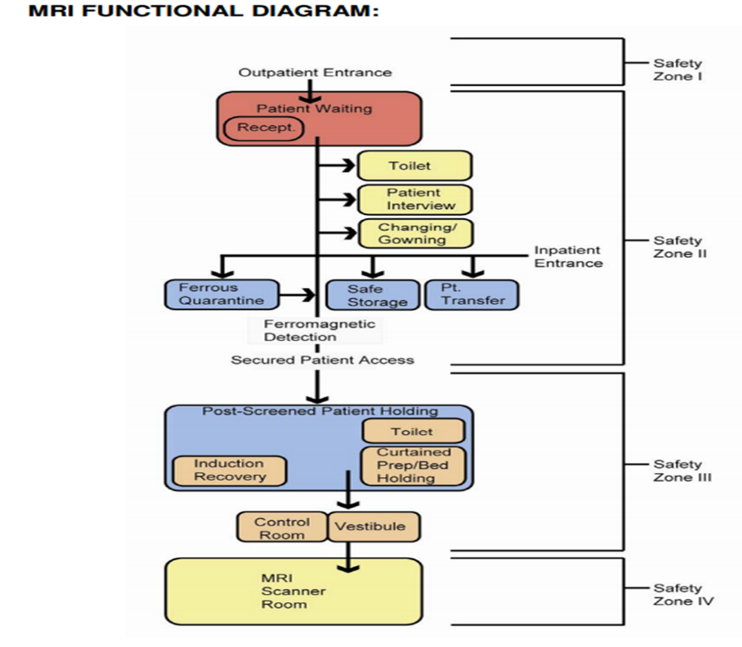

MR BIOEFFECTS
Patient undergoing MR examination is exposed to three different forms of electromagnetic fields.
- Static magnetic field
- Gradient magnetic field
- RF electromagnetic field
Static magnetic field
It can raise the skin temperature. It can cause electrical induction and cardiac effects with elevation of T-wave amplitude. It has potential effects on neurons. All these bioeffects are not proved to be hazardous at field strength < 3T whereas scanning at field strength >2T may cause Vertigo, headache and peripheral nerve stimulation.
Gradient magnetic field
Its possible effects include ventricular fibrillation, epileptogenic potentials and visual flashes. It also has thermal effects. All these effects have not been significant in present clinical MR systems.
RF magnetic field
It can result into energy deposition and tissue heating. Specific absorption rate (SAR) is measure of tissue energy deposition and its unit is Watt/kg. IEC/FDA Limits for Whole Body Heating Normal mode limit (suitable for all patients) – 0.5 degrees C or 2 W/kg First level-controlled mode (medical supervision) – 1.0 degrees C or 4 W/kg Second level-controlled mode – greater than 1 degree C or 4 W/kg (requires IRB approval)

ACOUSTIC NOISE
It is caused by vibration of gradient coils. Noise increases with heavy duty cycles and sharper pulse transition. Noise also increases with thin slice, small FOV, less TR and TE.
Ear plugs and earphones should be provided to patients and accompanying persons.

FARADAY CAGE
A Faraday cage or Faraday shield is an enclosure used to block electromagnetic fields. A Faraday shield may be formed by a continuous covering of conductive material or in the case of a Faraday cage, by a mesh of such materials.
Faraday cages come in all shapes and sizes, but all of them use a metal screen that conducts electricity, creating a shielding effect.
How faraday cage works?
Faraday cage distributes charge or radiation around the cage's exterior, it cancels out electric charges or radiation within the cage's interior. In short, a Faraday cage is a hollow conductor, in which the charge remains on the external surface of the cage.

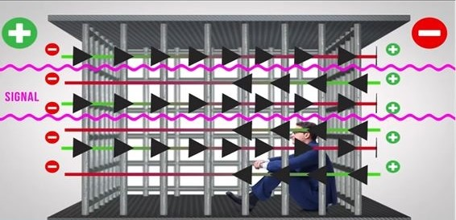

Note:
In MRI faraday cage is built for RF shielding
RF shielding is important because:
- To prevent extraneous electromagnetic field (RF) from contaminating the MR signal.
- To prevent electromagnetic radiation generated by MR machine from causing interference in nearby medical devices.

The ideal room consist of nested components:
1)An outer shell for structural support
2) A middle metallic RF-shield
3)An interior layer made of finish materials.
The floor is generally made of monolithic copper covered over with solid material.
Door must not allow any RF leakage, being shield by a set of electrical contact strips or continuous metallic pneumatic tube.
Window are laminated with blackened copper mesh between two pieces of glass.
Virtually any metal can be used including aluminium and steel but copper is generally used because it is more conductive metal.

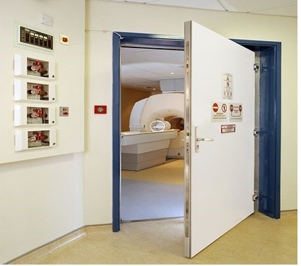
Zone 4

SITE ACCESS RESTRICTION

1) ZONES: - The MR site is conceptually divided into four zones.

ZONE 1: - This region includes all areas that are freely accessible to the general public. This area is typically outside the MR environment itself and is the area through which patients, health care personnel, and other employees of the MR site access the MR environment.

ZONE 2: - This area is the interface between the publicly accessible uncontrolled Zone I and the strictly controlled Zone III. Typically, the patients are greeted in Zone II and are not free to move throughout Zone II at will, but rather are under the supervision of MR personnel. It is in Zone II that the answers to MR screening questions, patient histories, medical insurance questions, etc. are typically obtained.

ZONE 3: - This area is the region in which free access by unscreened non-MR personnel or ferromagnetic objects or equipment can result in serious injury or death as a result of interactions between the individuals or equipment and the MR scanner’s particular environment. These interactions include, but are not limited to, those with the MR scanner’s static and time varying magnetic fields. All access to Zone III is to be strictly physically restricted, with access to regions within it (including Zone IV) controlled by, and entirely under the supervision of, MR personnel.

ZONE 4: - This area is synonymous with the MR scanner magnet room itself. Zone IV, by definition, will always be located within Zone III as it is the MR magnet and its associated magnetic field which generates the existence of Zone III. Non-MR Personnel should be accompanied by, or under the immediate supervision of and visual contact with, one specifically identified level 2 MR person for the entirety of their duration within Zone III or IV restricted regions. Level 1 and 2 MR personnel may move freely about all zones.

2) MR Personnel and non-MR personnel

a) All individuals working within at least Zone III of the MR environment should be documented as having successfully completed at least one of the MR safety live lectures or prerecorded presentations approved by the MR medical director. Attendance should be repeated at least annually, and appropriate documentation should be provided to confirm these ongoing educational efforts. These individuals shall be referred to henceforth as MR personnel.

b) There are two levels of MR personnel:

1. Level 1 MR personnel: Those who have passed minimal safety educational efforts to ensure their own safety as they work within Zone III will be referred to henceforth as level 1 MR personnel.

2. Level 2 MR personnel: Those who have been more extensively trained and educated in the broader aspects of MR safety issues, including, for example, issues related to the potential for thermal loading or burns and direct neuromuscular excitation from rapidly changing gradients, will be referred to henceforth as level 2 MR personnel. It is the responsibility of the MR medical director not only to identify the necessary training, but also to identify those individuals who qualify as level 2 MR personnel. It is understood that the medical director will have the necessary education and experience in MR safety to qualify as level 2 MR personnel.

c) All those not having successfully complied with these MR safety instruction guidelines shall be referred to henceforth as non-MR personnel. Specifically, non-MR personnel will be the terminology used to refer to any individual or group who has not within the previous 12 months undergone the designated formal training in MR safety issues defined by the MR safety director of that installation.

3) Patient and non-MR personnel screening

MR personnel should screen patient and relatives for any metallic or ferromagnetic objects before allowing entry into zone3 and zone4.
They should be asked to remove metallic personal belongings and clothing with lose metallic components and cosmetics.
Metallic objects can be screened with hand held magnet or with the help of metal detector.
Any person suspected with metallic foreign body in the orbit or near the vital organ should be investigated with plain radiograph.
Intraocular foreign body is an absolute contraindication for undergoing MR examination with metallic implants materials, the possible adverse effect includes displacement, induction of electric current in the object, excessive heating causing burns and misinterpretation because of artifacts.
Patients should be changed in site specific gowns.

4) MR Personnel Screening

All MR personnel are to undergo an MR-screening process as part of their employment interview process to ensure their safety in the MR environment. For their own protection and for the protection of the non-MR personnel under their supervision, all MR personnel must immediately report to the MR medical director any trauma, procedure, or surgery they experience or undergo where a ferromagnetic object or device may have become introduced within or on them. This will permit appropriate screening to be performed on the employee to determine the safety of permitting that employee into Zone3.

5) Device and object screening

It is divided into 3 main categories: -

MR safe: item pose no known hazards in all MR environments and are indicated by a green and white icon.
MR conditional: items do not pose any known hazards in a specific MR environment with specific condition of use. The icon consists of MR inside a yellow triangle.
MR unsafe: items such as any magnetic item are unsafe in all MR environments. Unsafe icon features a MR inside of a red circle with a bar through it.
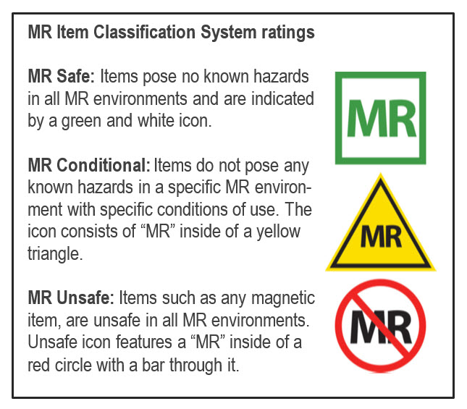

6) MR Technologist
1. MR technologists should be in compliance with the technologist qualifications listed in the MR Accreditation Program Requirements.
2. Except for emergent coverage, there will be a minimum of 2 MR technologists or one MR technologist and one other individual with the designation of MR personnel in the immediate Zone II through Zone IV MR environment. For emergent coverage, the MR technologist can scan with no other individuals in their Zone II through Zone IV environment as long as there is in-house, ready emergent coverage by designated department of radiology MR personnel (e.g., radiology house staff or radiology attending).

7) Pregnancy related issues-
Electromagnetic field used for MRI have the potential to produce developmental anomalies. It may affect the cell undergoing divisions in developing fetus. However, there is little data available at present on this issue.
a) Pregnant health care practitioner: -
Pregnant health care practitioners are permitted to work in and around the MR environment throughout all stages of their pregnancy. Acceptable activities include, but are not limited to, positioning patients, scanning, archiving, injecting contrast, and entering the MR scan room in response to an emergency. Although permitted to work in and around the MR environment, pregnant health care practitioners are requested not to remain within the MR scanner bore or Zone IV during actual data acquisition or scanning
Pregnant MR personnel can be permitted to work in and around the MR environment throughout pregnancy. However, they should be requested not to remain inside scanner room during actual data acquisition (when sequence is running).
b) Pregnant patient
Pregnant patients can be accepted to undergo MR scans at any stage of pregnancy if, in the determination of a level 2 MR personnel-designated attending radiologist, the risk–benefit ratio to the patient warrants that the study be performed. The radiologist should confer with the referring physician and document the following in the radiology report or the patient’s medical record:
1. The information requested from the MR study cannot be acquired by means of nonionizing means (e.g., ultrasonography).
2. The data is needed to potentially affect the care of the patient or fetus during the pregnancy.
3. The referring physician believes that it is not prudent to wait until the patient is no longer pregnant to obtain this data.
ACR white paper permits scanning of pregnant patient in any stage of pregnancy. It also suggests case-by-case analysis to decide whether the data obtained by MR examination will significantly affect the patient management whether postponing MRI till end of pregnancy is feasible or whether this data can be obtained by any other modality. Written and informed consent should be obtained from the patient.
c) contrast media during pregnancy
MR contrast agents should not be routinely provided to pregnant patients. This decision too, is on that must be made on a case-by-case basis by the covering level 2 MR personnel-designated attending radiologist who will assess the risk–benefit ratio for that particular patient. The decision to administer a gadolinium-based MR contrast agent to pregnant patients should be accompanied by a well-documented and thoughtful risk–benefit analysis. This analysis should be able to defend a decision to administer the contrast agent based on overwhelming potential benefit to the patient or fetus outweighing the theoretical but potentially real risks of long-term exposure of the developing fetus to free gadolinium ions.
d) contrast media in lactating mothers
Gadolinium is excreted in human milk. Breast milk should be expressed after injection & thrown away. Baby should not be breastfed for36-48 hrs.
8. Aneurysm & hemostatic clips
Many of the clips in use are ferromagnetic & they are an absolute contraindication for MR examination. Only those aneurysm clips made up of titanium & tested non ferromagnetic prior to placement along with written documentation by referring physician can undergo MR examination.
A patient with an aneurysm clip (or other implant) may have safely undergone a prior MR examination at any given static magnetic field strength. This fact in and of itself is not sufficient evidence of the implant’s MR safety and should not solely be relied upon to determine the MR safety or compatibility status of that aneurysm clip (or another implant).

9. Dental devices & materials
Lesser chances of displacement with these devices hence, they are not contraindication however, artifacts caused by them can be problematic.

Time Varying Gradient Magnetic Field Related Issues: Induced Voltages
Patient categories that require particular caution: Especially from faster MRI sequences like echo planar imaging (which may be used in sequences like diffusion weighted imaging, functional imaging, perfusion weighted imaging, MR angiographic imaging, etc.), patients with implanted or retained wires in anatomically or functionally sensitive areas (such as the myocardium or epicardium, implanted electrodes in the brain) should be considered to be at higher risk. The level 2 MR personnel-designated attending radiologist supervising the case or patient should examine the choice to limit the maximum intensity of the magnetic field of the gradient subsystems and the dB/dt (rate of magnetic field change) during imaging of such patients.

Time Varying Gradient Magnetic Field Related Issues: Auditory Considerations
1. Before undergoing any imaging in any MR scanners, hearing protection should be made available to and recommended by all patients and volunteers. According to the FDA's most recent MR Guidance Document, instructions from MR equipment manufacturers should specify that hearing protection is necessary for all patients being studied on MR imaging systems that can generate sound pressure levels higher than 99 dB(A).
2. Hearing protection must be in place before beginning any MR sequences on any patients or volunteers on whom research sequences will be conducted. Non-FDA approved MRI sequences should not be performed on patients or volunteers without adequate hearing protection.

Time Varying Radiofrequency Magnetic Field Related Issues: Thermal
1. Prior to the start of imaging, all extra or unused electrically conductive materials from the patient's environment should be taken out of the MR system. Simply "unplugging" or disconnecting unused, pointless electrically conductive material and leaving the patient inside the MR scanner during imaging is insufficient. Before each use, the scanning MR technologist must visually inspect any electrical connections, such as those on surface coil leads or monitoring devices, to confirm the quality of the thermal and electrical insulation.
2. During the MR imaging process, electrical voltages and currents may be induced within electrically conductive materials that are inside the bore of the MR imager. This could cause this material to heat up due to resistive losses. The intensity of this heat could be high enough to harm human tissue. As previously mentioned, one factor that affects the amount of induced voltage or current is the diameter of the conductive loops. The larger the diameter, the greater the potential for induced voltages or currents and, consequently, the greater the potential for thermal injury to nearby or nearby patient tissue.

Cryogen-Related Issues
For superconducting systems, in the event of a system quench, it is imperative that all personnel and patients be evacuated from the MR scan room as quickly as safely feasible and the site access be immediately restricted to all individuals until the arrival of MR equipment service personnel. This is especially so if cryogenic gases are observed to have vented partially or completely into the scan room, as evidenced in part by the sudden appearance of white ‘‘clouds’’ or ‘‘fog’’ around or above the MR scanner. It is especially important to ensure that all police and fire response personnel are restricted from entering the MR scan room with their equipment (axes, air tanks, guns, etc.) until it can be confirmed that the magnetic field has been successfully dissipated, as there may still be considerable static magnetic field present despite a quench or partial quench of the magnet.

REFERENCES
[1] Patient death illustrates the importance of adhering to safety precautions in magnetic resonance environments. Health Devices 2001;30:311–314.
[2] Chaljub G, Kramer LA, Johnson RF III, Johnson RF Jr, Singh H, Crow WN. Projectile cylinder accidents resulting from the presence of ferromagnetic nitrous oxide or oxygen tanks in the MR suite. AJR Am J Roentgenol 2001;177:27–30.
[3] Kanal E, Borgstede JP, Barkovich AJ, et al. American College of Radiology White Paper on MR Safety: 2004 update and revisions. AJR Am J Roentgenol 2004;182:1111–1114.
[4]. Kanal E, Borgstede JP, Barkovich AJ, et al. American College of Radiology White Paper on MR Safety. AJR Am J Roentgenol 2002;178:1335–1347.
[5]. Kanal E, Shellock FG. Policies, guidelines, and recommendations for MR imaging safety and patient management. SMRI Safety Committee. J Magn Reson Imaging 1992;2:247–248.
[6]. Shellock FG, Kanal E. Policies, guidelines, and recommendations for MR imaging safety and patient management. SMRI Safety Committee. J Magn Reson Imaging 1991;1:97–101.
[7]. ACR practice guideline for performing and interpreting magnetic resonance imaging (MRI). Available at: http://www.acr.org/ SecondaryMainMenuCategories/quality_safety/guidelines/dx/mri_ performing_interpreting.aspx. Accessed September 13, 2011.
[8]. Shellock FG, Kanal E. Guidelines and recommendations for MR imaging safety and patient management. III. Questionnaire for screening patients before MR procedures. The SMRI Safety Committee. J Magn Reson Imaging 1994;4:749–751.
[9]. Kanal E, Barkovich AJ, Bell C, et al. ACR guidance document for safe MR practices: 2007. AJR Am J Roentgenol 2007;188: 1447–1474.
[10]. Device Advice: Comprehensive regulatory assistance. Available at: http://www.fda.gov/MedicalDevices/DeviceRegulationandGuidance/ default.htm. Accessed September 19, 2011.
[11]. Jarvik JG, Ramsey S. Radiographic screening for orbital foreign bodies prior to MR imaging: is it worth it? AJNR Am J Neuroradiol 2000;21:245–247.
[12]. Seidenwurm DJ, McDonnell CH III, Raghavan N, Breslau J. Cost utility analysis of radiographic screening for an orbital foreign body before MR imaging. AJNR Am J Neuroradiol 2000;21: 426–433.
[13]. Kanal E, Gillen J, Evans JA, Savitz DA, Shellock FG. Survey of reproductive health among female MR workers. Radiology 1993; 187:395–399.
[14]. American Academy of Pediatrics Committee on Drugs: Guidelines for monitoring and management of pediatric patients during and after sedation for diagnostic and therapeutic procedures. Pediatrics 1992;89:1110–1115.
[15]. Guidelines for monitoring and management of pediatric patients during and after sedation for diagnostic and therapeutic procedures: addendum. Pediatrics 2002;110:836–838.
[16]. Practice guidelines for sedation and analgesia by non-anesthesiologists: An updated report by the American Society of Anesthesiologists Task Force on Sedation and Analgesia by NonAnesthesiologists. Anesthesiology 2002;96:1004–1017.
[17]. Standards and intents for sedation and anesthesia care. Comprehensive Accreditation Manual for Hospitals. Chicago, IL: Joint Commission on Accreditation of Healthcare Organizations; 2002: Report no. TX 2–2.
[18]. US Food and Drug Administration Manufacturer and User Facility Device Experience (MAUDE) Data Base (MDR Report Key 434259, 489264, 410913). Available at: http://www.accessdata.fda.gov/ scripts/cdrh/cfdocs/cfMAUDE/TextSearch.cfm. Accessed September 8, 2011.
[19]. Gandhi OP, Chen XB. Specific absorption rates and induced current densities for an anatomy-based model of the human for exposure to time-varying magnetic fields of MRI. Magn Reson Med 1999;41:816–823.
[20]. Konings MK, Bartels LW, Smits HF, Bakker CJ. Heating around intravascular guidewires by resonating RF waves. J Magn Reson Imaging 2000;12:79–85.
[21]. Food and Drug Administration Public Health Advisory: Risk of Burns during MRI Scans from Transdermal Drug Patches with Metallic Backings, March 5, 2009, Updated March 9, 2009. Available at: http://www.fda.gov/Drugs/DrugSafety/PostmarketDrugSafetyInformationforPatientsandProviders/DrugSafetyInforma tionforHeathcareProfessionals/PublicHealthAdvisories/ucm111313. htm. Accessed May 15, 2012.
[22]. IEC 60601–2-33, Ed. 2.0 Medical Electrical Equipment-Part 2: Particular requirements for the safety of magnetic resonance equipment for medical diagnosis. Geneva, Switzerland: International Electrotechnical Commission (IEC); 2002.
[23]. ACR-SIR practice guideline for adult sedation/analgesia. Available at: http://www.acr.org/SecondaryMainMenuCategories/quality_safety/guidelines/iv/adult_sedation.aspx. Accessed September 13, 2011.
[24]. Standards for basic anesthesic monitoring. (Approved by the ASA House of Delegates on October 21, 1986, and last amended on October 20, 2010 with an effective date of July 1, 2011.) Park Ridge, IL: American Society of Anesthesiologists.
[25]. Standards for postanesthesia care. (Approved by the ASA House of Delegates on October 27, 2004, and last amended on October 21, 2009.) Park Ridge, IL: American Society of Anesthesiologists.
[26]. Statement on non-operating room anesthetizing locations. (Approved by the ASA House of Delegates on October 19, 1994 and last amended on October 22, 2008.) Park Ridge, IL: American Society of Anesthesiologists.
[27]. American College of Radiology. ACR digest of council actions. Reston, VA: ACR, 1999:126 (Res 1-H 1987, 1997).
[28]. American College of Radiology. ACR Manual on Contrast Media, Version 8, 2012. Available at: http://www.acr.org/SecondaryMain MenuCategories/quality_safety/contrast_manual.aspx. Accessed September 13, 2011.
[29]. Al-Sabagh KH, Christensen BE, Thogersen AM, et al. [Safety of magnetic resonance imaging in patients with pacemaker and implantable defibrillator]. Ugeskr Laeger 2010;172:1740–1744.
[30]. Gimbel JR. Unexpected asystole during 3T magnetic resonance imaging of a pacemaker-dependent patient with a ’modern’ pacemaker. Europace 2009;11:1241–1242.
[31]. Gotte MJ, Russel IK, de Roest GJ, et al. Magnetic resonance imaging, pacemakers and implantable cardioverter-defibrillators: current situation and clinical perspective. Neth Heart J 2010;18: 31–37.
[32]. Avery JK. Loss Prevention case of the month. Not my responsibility! J Tenn Med Assoc 1988;81:523.
[33]. Ferris NJ, Kavnoudias H, Thiel C, Stuckey S. The 2005 Australian MRI safety survey. AJR Am J Roentgenol 2007;188: 1388–1394.
[34]. Irnich W, Irnich B, Bartsch C, Stertmann WA, Gufler H, Weiler G. Do we need pacemakers resistant to magnetic resonance imaging? Europace 2005;7:353–365.
[35]. Langman DA, Goldberg IB, Finn JP, Ennis DB. Pacemaker lead tip heating in abandoned and pacemaker-attached leads at 1.5 Tesla MRI. J Magn Reson Imaging 2011;33:426–431.
[36]. Hartnell GG, Spence L, Hughes LA, Cohen MC, Saouaf R, Buff B. Safety of MR imaging in patients who have retained metallic materials after cardiac surgery. AJR Am J Roentgenol 1997;168: 1157–1159.
[37]. Murphy KJ, Cohan RH, Ellis JH. MR imaging in patients with epicardial pacemaker wires. AJR Am J Roentgenol 1999;172: 727–728.
[38]. Kanal E. Safety of MR imaging in patients with retained epicardial pacer wires. AJR Am J Roentgenol 1998;170:213–214.
[39]. Faris OP, Shein M. Food and Drug Administration perspective: Magnetic resonance imaging of pacemaker and implantable cardioverter-defibrillator patients. Circulation 2006;114:1232–1233. ACR Guidance on MR Safe Practices 529
[40]. Gimbel JR. Magnetic resonance imaging of implantable cardiac rhythm devices at 3.0 tesla. Pacing Clin Electrophysiol 2008;31: 795–801.
[41]. Nazarian S, Halperin HR. How to perform magnetic resonance imaging on patients with implantable cardiac arrhythmia devices. Heart Rhythm 2009;6:138–143.
[42]. Gimbel JR. Guidelines and the growing service burden. J Interv Card Electrophysiol 2010;28:83–85.
[43]. Hauser RG, Kallinen L. Deaths associated with implantable cardioverter defibrillator failure and deactivation reported in the United States Food and Drug Administration Manufacturer and User Facility Device Experience Database. Heart Rhythm 2004;1: 399–405.
[44]. Jilek C, Tzeis S, Reents T, et al. Safety of implantable pacemakers and cardioverter defibrillators in the magnetic field of a novel remote magnetic navigation system. J Cardiovasc Electrophysiol 2010;21:1136–1141.
[45]. Gimbel JR. Unexpected pacing inhibition upon exposure to the 3T static magnetic field prior to imaging acquisition: what is the mechanism? Heart Rhythm 2011;8:944–945.
[46]. The Facility Guidelines Institute. Guidelines for the Design and Construction of Health Care Facilities, 2010 edition. Chicago: American Society for Healthcare Engineering; 2010

