**ANDROGRAPHOLIDE AND ITS ANALOGUES IN LUNG CANCER**

# **M. Alagusundaram1, Mishra Namrata *1, Bhattacharya Vijeta2, Venketeshwarlu Goli 2**

Assistant professor school of Pharmacy, ITM University Gwalior, Madhya Pradesh

[mishranamrata2710@gmail.com](mailto:mishranamrata2710@gmail.com)

**Introduction**

One type of cancer that starts in the lungs is lung cancer. Your lungs are two pliable organs located in your chest that allow you to breathe in oxygen and exhaust carbon dioxide. The largest cause of cancer-related fatalities worldwide is lung cancer. Lung cancer can affect persons who have never smoked, but smokers are at a higher risk than nonsmokers. The quantity and frequency of cigarettes you've smoked are related to your chance of developing lung cancer. Even after years of smoking, you can greatly lower your risk of developing lung cancer by quitting. Cancer is a condition in which the body's cells proliferate unchecked. When lung cancer first appears, it is also called a lung cancer

In addition to lymph nodes and other body organs including the brain, lung cancer can also start in the lungs. Figures 1 and 2 illustrate how lung cancer can spread from different organs. When cancer cells spread from one organ to another, they are referred to as metastases.

Small cell and non-small cell lung cancers—which also include adenocarcinoma and squamous cell carcinoma—are typically categorized into two primary categories. These distinct forms of lung cancer develop differently and respond to various therapies. Compared to small-cell lung cancer, non-small-cell lung cancer is more prevalent. Avoiding risk factors, such as smoking and air pollution, is the main strategy of prevention. The type of cancer, the stage (amount of spread), and the patient's general health all influence treatment and long-term results. . Most cases are not curable. Common treatments include surgery, chemotherapy, and radiotherapy. NSCLC is sometimes treated with surgery, whereas SCLC usually responds better to chemotherapy and radiotherapy.

Worldwide in 2020, lung cancer occurred in 2.2 million people and resulted in 1.8 million deaths. It is the most common cause of cancer-related death in both men and women. The most common age at diagnosis is 70 years. In most countries, the five-year survival rate is around 10 to 20%, while in Japan it is 33%, in Israel 27%, and in the Republic of Korea 25%. Outcomes typically are worse in the developing world.

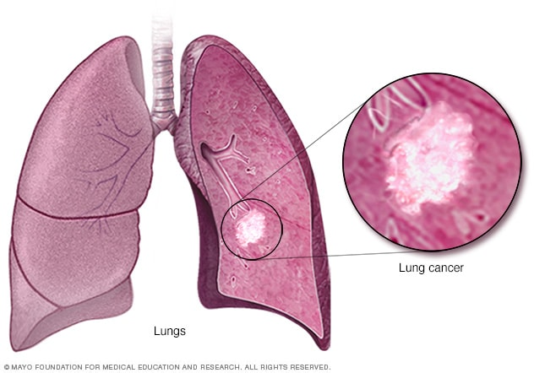

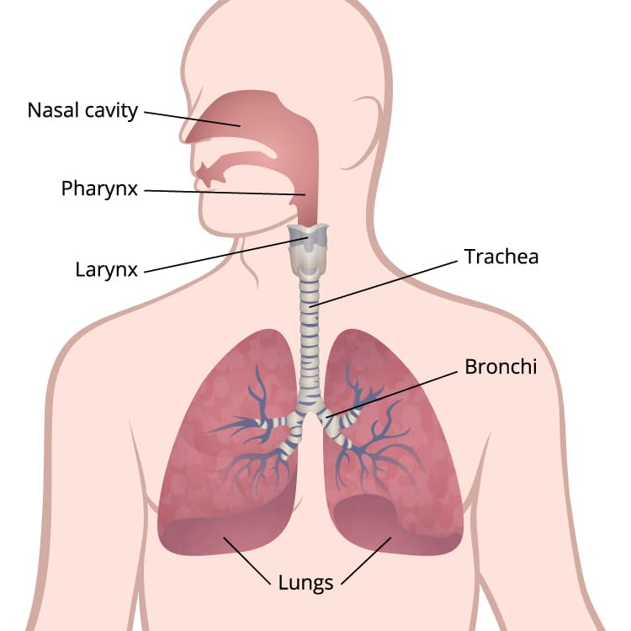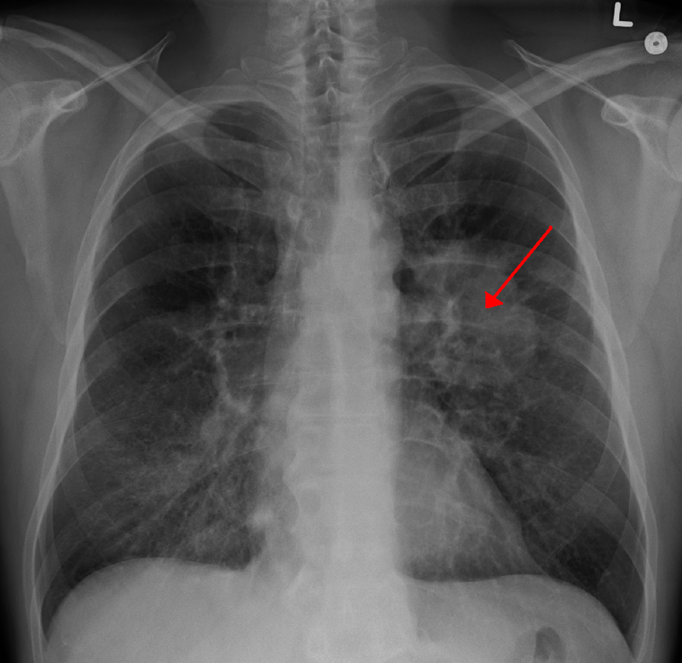

**Lung’s cancer**

**Prevalence and Death Rate highlight the severity of the diseases**

Expected Number of Cancer Deaths An estimated 609,360 people in the United States will die from cancer in 2022, corresponding to almost 1700 deaths per day. The greatest number of deaths are from lung, prostate, and colorectum cancers in men and of the lung, breast, and colorectum in women (Fig. 1). Table 4 provides the estimated number of deaths for these and other common cancers by state. More than 350 people will die each day from lung cancer, which is more than breast, prostate, and pancreatic cancers combined and 2.5 times more than CRC, the second leading cause of cancer death. Approximately 105,840 of the 130,180 lung cancer deaths (81%) in 2022 will be caused by cigarette smoking directly, with an additional 3650 due to second-hand smoke.26 The remaining balance of approximately 20,700 non-smoking-related lung cancer deaths would rank as the eighth leading cause of cancer death among sexes combined if classified separately

The methodology for calculating contemporary cancer cases and deaths was updated in 2021 to take advantage of advances in statistical modelling and improved cancer registration coverage and is described in detail elsewhere. Briefly, the first step in calculating the number of invasive cancer cases in 2022 was to estimate complete counts for every state from 2004 through 2018 using delay-adjusted, high-quality incidence data from 50 states and the District of Columbia (98% population coverage; data were unavailable for a few sporadic years for a limited number of states). A generalized linear mixed model was used that accounted for state-level variations in sociodemographic and lifestyle factors, medical settings, and cancer screening behaviours. Then, modelled state and national counts were projected forward to 2022 using a novel, data-driven join point algorithm.

In **figure 3** it estimated the number of new cases of lungs cancer or death cases new cases of ductal carcinoma in situ of the female breast and situ melanoma of the skin diagnosed in 2022 were estimated by first approximating the number of cases occurring annually from 2009 through 2018 based on age-specific NAACCR incidence rates (data from 49 states with high-quality data available for all 10 years) and US Census Bureau population estimates obtained through SEER*State. Counts were then adjusted for delays in reporting using SEER 21 delay factors for invasive disease (delay factors are unavailable for in situ cases) and projected to 2022 based on the average APC generated by the joining point regression model.

The number of cancer deaths expected to occur in 2022 was estimated by applying the same data-driven join point algorithm described previously for the case projection to report cancer deaths from 2005 through 2019 at the state and national levels, as reported to the NCHS.

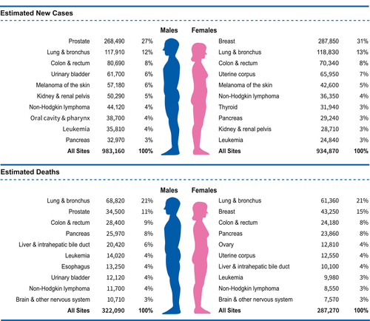

Ten Leading Cancer Types for the Estimated New Cancer Cases and Deaths by Sex, United States, 2022. Estimates are rounded to the nearest 10 and exclude basal cell, squamous cell skin cancers, and in situ carcinoma except for the urinary bladder. The ranking is based on modelled projections and may differ from the most recent observed data**.**

**Current treatment of lung cancer and their limits**

Lung cancer is treated in several ways, depending on the type of lung cancer and how far it has spread. People with non-small cell lung cancer can be treated with surgery, chemotherapy, radiation therapy, targeted therapy, or a combination of these treatments. People with small cell lung cancer are usually treated with radiation therapy and chemotherapy.

* **Surgery.** An operation where doctors cut out cancer tissue.
* **Chemotherapy.** Using special medicines to shrink or kill cancer. The drugs can be pills you take or medicines given in your veins, or sometimes both.
* **Radiation therapy.** Using high-energy rays (similar to X-rays) to kill cancer.
* **Targeted therapy.** Using drugs to block the growth and spread of cancer cells. The drugs can be pills you take or medicines given in your veins. Before this treatment is used, you will get tests to see if targeted therapy is right for your cancer type.

Doctors from different specialties often work together to treat lung cancer. *Pulmonologists* are doctors who are experts in diseases of the lungs. *Surgeons* are doctors who perform operations. *Thoracic surgeons* specialize in chest, heart, and lung surgery. *Medical oncologists* are doctors who treat cancer with medicines. *Radiation oncologists* are doctors who treat cancers with radiation.

## **Diagnosis**

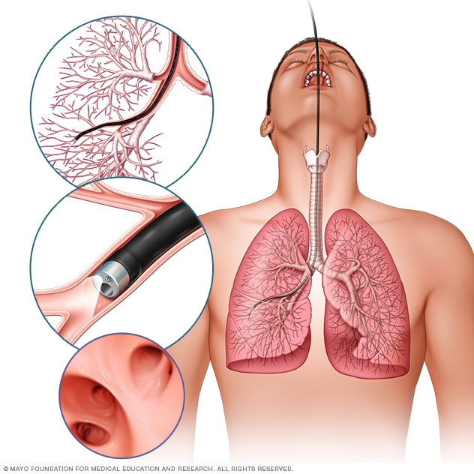

Bronchoscopy Open pop-up dialog box

**Testing healthy people for lung cancer**

People with an increased risk of lung cancer may consider annual lung cancer screening using low-dose CT scans. In the above figure 4 cancer is diagnosed through the bronchoscopy open pop-up dialog box Lung cancer screening is generally offered to older adults who have smoked heavily for many years or who have quit in the past 15 years.

Discuss your lung cancer risk with your doctor. Together you can decide whether lung cancer screening is right for you.

**Tests to diagnose lung cancer** If there's reason to think that you may have lung cancer, your doctor can order several tests to look for cancerous cells and to rule out other conditions.

Tests may include:

**Imaging tests.** An X-ray image of your lungs may reveal an abnormal mass or nodule. A CT scan can reveal small lesions in your lungs that might not be detected on an X-ray.

**Sputum cytology.** If you have a cough and are producing sputum, looking at the sputum under the microscope can sometimes reveal the presence of lung cancer cells.

**Tissue sample (biopsy).** A sample of abnormal cells may be removed in a procedure called a biopsy.

1. Your doctor can perform a biopsy in several ways, including bronchoscopy, in which your doctor examines abnormal areas of your lungs using a lighted tube that's passed down your throat and into your lungs.
2. Mediastinoscopy, in which an incision is made at the base of your neck and surgical tools are inserted behind your breastbone to take tissue samples from lymph nodes is also an option.
3. Another option is needling biopsy, in which your doctor uses X-ray or CT images to guide a needle through your chest wall and into the lung tissue to collect suspicious cells.
4. A biopsy sample may also be taken from lymph nodes or other areas where cancer has spread, such as your liver.
5. Careful analysis of your cancer cells in a lab will reveal what type of lung cancer you have. Results of sophisticated testing can tell your doctor the specific characteristics of your cells that can help determine your prognosis and guide your treatment.

**Tests to determine the extent of the cancer**

Once your lung cancer has been diagnosed, your doctor will work to determine the extent (stage) of your cancer. Your cancer's stage helps you and your doctor decide what treatment is most appropriate.Staging tests may include imaging procedures that allow your doctor to look for evidence that cancer has spread beyond your lungs. These tests include CT, MRI, positron emission tomography (PET), and bone scans. Not every test is appropriate for every person, so talk with your doctor about which procedures are right for you. The stages of lung cancer are indicated by Roman numerals that range from 0 to IV, with the lowest stages indicating cancer that is limited to the lung. By stage IV, the cancer is considered advanced and has spread to other areas of the body. You and your doctor choose a cancer treatment plan based on several factors, such as your overall health, the type and stage of your cancer, and your preferences. In some cases, you may choose not to undergo treatment. For instance, you may feel that the side effects of treatment will outweigh the potential benefits. When that's the case, your doctor may suggest comfort care to treat only the symptoms the cancer is causing, such as pain or shortness of breath.

**Lung cancer surgery Open pop-up dialog box**

During surgery, your surgeon works to remove the lung cancer and a margin of healthy tissue. Procedures to remove lung cancer include:

* **Wedge resection** to remove a small section of the lung that contains the tumor along with a margin of healthy tissue
* **Segmental resection** to remove a larger portion of the lung, but not an entire lobe
* **Lobectomy** to remove the entire lobe of one lung
* **Pneumonectomy** to remove an entire lung

If you undergo surgery, your surgeon may also remove lymph nodes from your chest to check them for signs of cancer.

Surgery may be an option if your cancer is confined to the lungs. If you have larger lung cancer, your doctor may recommend chemotherapy or radiation therapy before surgery to shrink cancer. If there's a risk that cancer cells were left behind after surgery or that your cancer may recur, your doctor may recommend chemotherapy or radiation therapy after surgery.

**Radiation therapy**

Radiation therapy uses high-powered energy beams from sources such as X-rays and protons to kill cancer cells. During radiation therapy, you lie on a table while a machine moves around you, directing radiation to precise points on your body. For people with locally advanced lung cancer, radiation may be used before surgery or after surgery. It's often combined with chemotherapy treatments. If surgery isn't an option, combined chemotherapy and radiation therapy may be your primary treatment. For advanced lung cancers and those that have spread to other areas of the body, radiation therapy may help relieve symptoms, such as pain.

**Chemotherapy**

Chemotherapy uses drugs to kill cancer cells. One or more chemotherapy drugs may be given through a vein in your arm (intravenously) or taken orally. A combination of drugs usually is given in a series of treatments over a period of weeks or months, with breaks in between so that you can recover.

Chemotherapy is often used after surgery to kill any cancer cells that may remain. It can be used alone or combined with radiation therapy. Chemotherapy may also be used before surgery to shrink cancers and make them easier to remove. In people with advanced lung cancer, chemotherapy can be used to relieve pain and other symptoms.

**Stereotactic body radiotherapy**

Stereotactic body radiotherapy, also known as radiosurgery, is an intense radiation treatment that aims many beams of radiation from many angles at cancer. Stereotactic body radiotherapy treatment is typically completed in one or a few treatments.Stereotactic body radiotherapy may be an option for people with small lung cancers who can't undergo surgery. It may also be used to treat lung cancer that spreads to other parts of the body, including the brain.

**Targeted drug therapy**

Targeted drug treatments focus on specific abnormalities present within cancer cells. By blocking these abnormalities, targeted drug treatments can cause cancer cells to die. Many targeted therapy drugs are used to treat lung cancer, though most are reserved for people with advanced or recurrent cancer. Some targeted therapies only work in people whose cancer cells have certain genetic mutations. Your cancer cells may be tested in a laboratory to see if these drugs might help you.

**Immunotherapy**

Immunotherapy uses your immune system to fight cancer. Your body's disease-fighting immune system may not attack your cancer because the cancer cells produce proteins that help them hide from the immune system cells. Immunotherapy works by interfering with that process. Immunotherapy treatments are generally reserved for people with locally advanced lung cancers and cancers that have spread to other parts of the body

**Palliative care**

People with lung cancer often experience signs and symptoms of cancer, as well as side effects of treatment. Supportive care, also known as palliative care, is a specialty area of medicine that involves working with a doctor to minimize your signs and symptoms. Your doctor may recommend that you meet with a palliative care team soon after your diagnosis to ensure that you're comfortable during and after your cancer treatment.

In one study, people with advanced non-small cell lung cancer who began receiving supportive care soon after their diagnosis lived longer than those who continued with treatments, such as chemotherapy and radiation. Those receiving supportive care reported improved mood and quality of life. They survived, on average, almost three months longer than those receiving standard care.

**Importance of natural products and highlight the importance of medicinal plants in lung cancer**

Natural products are precious gifts from nature to mankind. They include extracts of animals and plants, metabolites of insects, marine organisms, and microorganisms, as well as many chemical components found endogenously in humans and animals. In addition, traditional Chinese medicine (TCM) is based on the combination of natural products and TCM theory. Natural products have always been an important source of drug discovery. According to the latest statistics on drugs approved by the Food and Drug Administration (FDA) in the United States, many prescription medicines used for treatment originate from natural products. From 1946 to 2019, more than 50% of newly approved drugs were natural small molecules [[9](https://www.ncbi.nlm.nih.gov/pmc/articles/PMC8509218/#B9-ijms-22-10827)]. Plant preparations and Chinese medicines are multi-component, multi-channel, and multi-target products. Due to their diverse structures and activities, natural products continue to attract researchers’ attention. Although TME has been widely studied, the natural products that target and regulate the TME of lung cancer have not been systematically summarized. In this review, we describe the antitumor effect of natural products on TME in lung cancer. We summarize relevant natural products, including descriptions of their anti-tumor actions in terms of modulating the TME in lung cancer when given alone ([Table 1](https://www.ncbi.nlm.nih.gov/pmc/articles/PMC8509218/table/ijms-22-10827-t001/)), in combination with anticancer drugs ([Table 2](https://www.ncbi.nlm.nih.gov/pmc/articles/PMC8509218/table/ijms-22-10827-t002/)), and combination with materials such as nanomaterials.

Table 1

The effects of natural products on modulation of the TME.

| **No.** | **Natural Products** | **Common Source** | **Cell Lines or Animal Models or Patients** | **Function or Molecular Mechanism** | **Ref.** |
| --- | --- | --- | --- | --- | --- |
| *Targeting angiogenesis* | | | | | |
| 1 | Jolkinolide A (**1**) | *Euphorbia* *fischeriana* | A549, HUVEC; A549 cell xenograft mice | Inhibition of the Akt-STAT3-mTOR signaling pathway and reduction of VEGF protein expression; inhibition of HUVEC migration | [[10](https://www.ncbi.nlm.nih.gov/pmc/articles/PMC8509218/#B10-ijms-22-10827)] |
| 2 | Jolkinolide B (**2**) |
| 3 | Parthenolide (**3**) | *Tanacetum* *parthenium* | A549, H526 | Inhibition of A549 and H526 cell proliferation in the presence and absence of nicotine; induction of apoptosis; inhibition of angiogenesis; down-regulation of Bcl-2 expression and up-regulation of E2F1, p53, GADD45, Bax, Bim, and caspase 3,7,8,9 expression |  |

**Bronchoscopy Open pop-up dialog box**

**Testing healthy people for lung cancer**

People with an increased risk of lung cancer may consider annual lung cancer screening using low-dose CT scans. Lung cancer screening is generally offered to older adults who have smoked heavily for many years or who have quit in the past 15 years.Discuss your lung cancer risk with your doctor. Together you can decide whether lung cancer screening is right for you.

**Tests to determine the extent of the cancer**

Once your lung cancer has been diagnosed, your doctor will work to determine the extent (stage) of your cancer. Your cancer's stage helps you and your doctor decide what treatment is most appropriate. Staging tests may include imaging procedures that allow your doctor to look for evidence that cancer has spread beyond your lungs. These tests include CT, MRI, positron emission tomography (PET), and bone scans. In below figure 5, the stages of cancer are given. Not every test is appropriate for every person, so talk with your doctor about which procedures are right for you.

The stages of lung cancer are indicated by Roman numerals that range from 0 to IV, with the lowest stages indicating cancer that is limited to the lung. By stage IV, the cancer is considered advanced and has spread to other areas of the body.

**Risk factors of colon cancer**

Your risk of getting colorectal cancer increases as you get older. Other risk factors include having—

* [Inflammatory bowel disease](https://www.cdc.gov/ibd/) such as Crohn’s disease or ulcerative colitis.
* A personal or [family history](https://www.cdc.gov/genomics/famhistory/) of colorectal cancer or colorectal polyps.
* A genetic syndrome such as [familial adenomatous polyposis (FAP)external icon](https://medlineplus.gov/genetics/condition/familial-adenomatous-polyposis/) or [hereditary non-polyposis colorectal cancer (Lynch syndrome).](https://www.cdc.gov/genomics/disease/colorectal_cancer/lynch.htm)

[Lifestyle factors](https://www.cdc.gov/cancer/dcpc/prevention/other.htm) that may contribute to an increased risk of colorectal cancer include—

* Lack of regular [physical activity.](https://www.cdc.gov/physicalactivity/)
* A diet low in fruit and vegetables.
* A low-fiber and high-fat [diet,](https://www.cdc.gov/nutrition/) or a diet high in processed meats.
* [Overweight and obesity.](https://www.cdc.gov/cancer/obesity/)
* [Alcohol](https://www.cdc.gov/cancer/alcohol/) consumption.
* [Tobacco use.](https://www.cdc.gov/cancer/tobacco/)

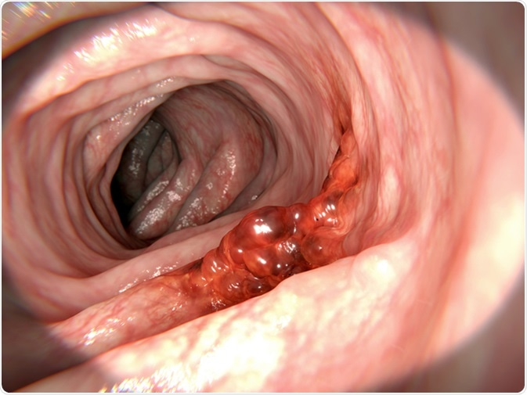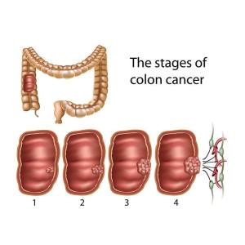

Drug targets in colon cancer

As researchers learn more about changes in cells that cause colon or rectal cancer, they have developed new types of drugs to specifically target these changes. Targeted drugs work differently from [chemotherapy](https://www.cancer.org/cancer/colon-rectal-cancer/treating/chemotherapy.html) (chemo) drugs. They sometimes work when chemo drugs don’t, and they often have different side effects. They can be used either along with chemo or by themselves if chemo is Like chemotherapy, these drugs enter the bloodstream and reach almost all areas of the body, which makes them useful against cancers that have spread to distant parts of the body.

**Current treatment strategies and side effects**

* **Use a scope to examine the inside of your colon (colonoscopy).** A colonoscopy uses a long, flexible, and slender tube attached to a video camera and monitor to view your entire colon and rectum. If any suspicious areas are found, your doctor can pass surgical tools through the tube to take tissue samples (biopsies) for analysis and remove polyps.
* **Blood tests.** No blood test can tell you if you have colon cancer. But your doctor may test your blood for clues about your overall health, such as kidney and liver function tests no longer working.

Your doctor may also test your blood for a chemical sometimes produced by colon cancers (carcinoembryonic antigen, or CEA). Tracked over time, the level of CEA in your blood may help your doctor understand your prognosis and whether your cancer is responding to treatment.

The most common side effects of these drugs are skin problems such as an acne-like rash on the face and chest during treatment, which can sometimes lead to infections. An antibiotic cream or ointment may be needed to help limit the rash and related infections. Developing this rash often means the cancer is responding to treatment. People who develop this rash often live longer, and those who develop more severe rashes also seem to respond better than those with milder rashes. Other side effects can include:

* Headache
* Tiredness
* Fever
* Diarrhoea

A rare but serious side effect of these drugs is an allergic reaction during the infusion, which could cause problems with breathing and low blood pressure. You may be given medicine before treatment to help prevent this.

**Importance of medicinal plants and phytocompounds in colon cancer**

A systematic search strategy was drafted to enhance a comprehensive review. “Colorectal cancer”, “colon cancer”, “adenomatous polyps”, “colorectal tumor”, and “colon tumor” terms were combined with either of the following Mesh terms: “Anti-tumour”, “anti-cancer”, “bioactivity”, “biological activity”, “phytochemicals”, “pharmacological activities”. These terms were strictly combined with either of the following plant term or fungus terms: “banana”, “pomegranate”, “leguminous plant”, “legumes”, “Hibiscus”, “Hibiscus sabdariffa”, “cruciferous vegetables”, “cruciferous”.

As a result of intensive research, the physiological effects of nutritional support treatments including various herbal, minerals, and vitamins are better defined. It is also believed that a better understanding of the biological structure of cancer cells gradually increases the efficacy of certain supporting products and drugs against cancer. About this issue, Yeşilada, 5-fluorouracil (5-FU) is a chemotherapeutic agent used in the treatment of colon cancer but the patients tolerate difficulties in practice due to significant side effects and in another study carried out on this subject, the blood values of the experimental animals were significantly (increase in the red cell, neutrophil and monocyte counts-1,2-fold, 9-fold and 6-fold increase respectively). He noted that the consumption of blueberries is effective in the treatment of colon cancer. As a result of the literature studies, it has been proved that Rheum ribs, Nigella sativa, Echinacea purpurea, Lignum usitatissimum, Punica granatum, Cronus mas, Vaccinium myrtillus are protective and therapeutic against colon cancer.

**Cancer and** **Rheum ribes**: In Figure 6 the addition to its many benefits, it supports the treatment of cancer types such as stomach, intestine, lung cancer, brain tumor, and lymphocyte lymphoma. Raw, olive oil, egg, and ginger with Rheum ribes are used in quite for different recipes

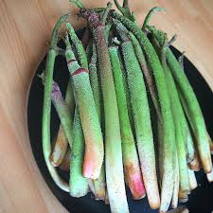

**Rheum ribes**

Rheum ribes have a direct effect on the cancerous cells and shrink quickly, even within 2 days, 50% of them are eliminated. Because of this reason Rheum ribs are used so much for the drug industry.

**Cancer and** **Nigella sativa**: Timokinone, the active ingredient of Nigella sp. (black seed), is used as an antioxidant, anti-inflammatory, and antineoplastic (anti-tumor cells prevent development) drug. Figure 7 nigella sativa is used in the diagnosis of lung cancer. Timokinone is used as raw material in drugs for adenocarcinoma of the chest, colorectal cancer, colon cancers, pancreatic adenocarcinoma, uterine sarcoma, neoplastic keratinocytes, human osteosarcoma, fibrosarcoma, and lung sarcoma. Also, timocino, an androgen hormone refractor (non-responsive) inhibits prostate cancer by targeting the receptor and transcription factor E2F-1

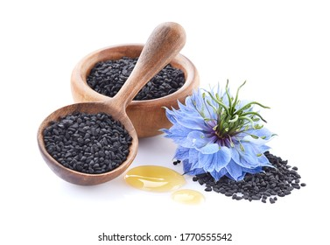

**Nigella sativa**

Laboratory studies have shown that black seeds of Nigella sp. strengthen the immune system and, consequently, increase its strength against viruses and microbes that destroy the body, as well as its resistance against cancer.

**Cancer and** **Echinacea purpurea (L.) Moench**: In figure 8 E. purpura is effective on colon and pancreatic cancer. Due to the intense antioxidant properties of E. purpura, it is consumed in high amounts in many countries as an aging retardant.



**Echinacea purpurea**

Because E. purpurea reduced free radicals it is used to support chemotherapy in many cancer treatments, especially blood cancer treatment. Consumption of tea in particular strengthens the immune system and prevents other diseases by inhibiting the immune deficiency due to chemotherapy.

**Cancer and Linum usitatissimum (L.)**: Below figure 9 is used in the treatment of cancer of the lungs Flax seed has a protective effect against cancer of the pancreas, colon, and breast. Flax seed contains alpha-linolenic acid (ALA, Omega 3), linoleic acid (LA Omega-6) and oleic acid (OA, Omega-9), lignans (SDG), mucilage, and vitamin a (Beta-carotene)

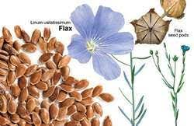

**Linum usitatissimum**

L. usitatissimum contains highly polyunsaturated fatty acids, and abundant fiber with a high percentage of small amounts of potassium, magnesium, iron, copper, zinc, and various vitamins.

**Cancer and Punica granatum (L.):** Punica granatum L. is effective in colon, breast, and prostate cancer. The root and trunk shell contains alkaloids called starch, manner, resin, triterpenic acids, tannins, pellets, Impellitteri, and methylpelletieri. In figure 10 Fruit peel and flowers, again mentioned above are alkaloids and tannins. It also contains pomegranate, Iron, potassium, calcium, phosphorus, B1, B2, and C vitamins (Ayaz and Alpsoy, 2007). Pomegranate juice contains high levels of tannin and flavonoid antioxidants. Pomegranate juice is an important anti-tumor characteristic that stimulates apoptosis and changes the cell cycle and inhibits the expression of androgen receptor

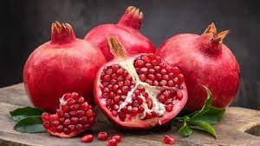

High levels of iron and vitamin C inhibit the possible effects that may occur by strengthening the immune systems of individuals (Başgöl, 2007). As a result, the effect of regular pomegranate juice intake on preventing prostate cancer and delaying the progression of the disease has been known to have beneficial results

**Cancer and Cornus mas (L.):** C. mass effective in the lung, head and neck, colon, liver, breast, prostate, esophagus, and soft tissue cancers. The melatonin hormone, secreted in the brain

and which increases our quality of life, is found in cranberry fruit. Figure 11 is used, For this reason, it is also used to prevent complications such as depression, and sleep disturbances experienced by patients during the treatment period. It also acts as an antioxidant because it is a good diuretic. It is effective in removing harmful compounds accumulated in the body. C. mas also contain phytonutrients, vitamin K, manganese, and a wide range of natural plant chemicals.

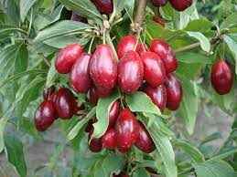

They protect the body against harmful free radicals, and anti-inflammatory (antiinflammatory) and anti-cancer properties show. It is a powerful natural antioxidant because of the vitamin C It contains. It can prevent some damage caused by free radicals and increase body resistance against infectious agents (Topuz, 2012). Urinary tract infections (UTIs) are a common cause of urinary tract infections. It is recommended to consume cranberry especially in individuals with recurrent infections and at risk of infection. Cranberry juice also protects against stomach ulcers and stomach cancer by preventing Helicobacter pylori bacteria from sticking to the lining of the stomach wall (Topuz, 2012). C. mas’ plant can be consumed as a fruit or boiled and consumed as sherbet or as water. However, if sugar is added to the syrup, it destroys its effect on cancer, but it becomes carcinogenic. For this reason, as in every plant, how the cranberry plant is consumed is very important

**Cancer and Vaccinium myrtillus (L.):** Blueberries contain pterostilbene and ellagic acid and vitamin C as well as because it is rich in cancer types especially beneficial to colon, uterus, and liver cancer. Figure 12 is treated for cancer. Consuming a handful of fresh or dried blueberries per day significantly reduces the risk of cancer in individuals HTML Access Date: 01.05.2013). Some proanthocyanidins give fruit colour with a dye substance called V. myrtillus, A, and C vitamins and useful sugars, organic acids, tannins, pectin, and merlin. V. myrtillus can be consumed as raw fruit or dried or consumed as a tea prepared

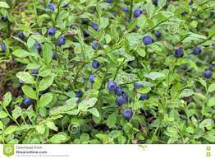

**Andrographolide and its analogy role in colon cancer**

Andrographolide has also been shown to suppress colon cancer via the in-here apoptosis pathway. It induced apoptosis in human HT-29 colon cancer cells, which seems to be linked to augmented intracellular ROS levels and disruption of the mitochondrial membrane potential via the regulation of caspase-3 activity23.

Andrographolide and analogy have been generally used against allergic reactions, haemorrhagic lesions, central nervous system dysfunction, and others disease. Andrographolide and derivatives are reported to contain high therapeutic potentials against liver disorders, common cough and cold, and inflammation and cancer in humans. These metabolites have been used as/in antipyretic, antiinflammatory, hepatoprotective, immunostimulant, and anti-neoplasm. The low aqueous solubility of andrographolide causes lower bioavailability subsequently used for oral administration in appropriate tissues localization therefore used for poor therapeutic purposes (15). Andrographolide and derivatives have an excellent property that they do not stay in the body for a long time due to short half-life and easy excretion via urine and gastrointestinal tract

1. Hepatoprotection

2. Antiplatelet aggregation

3. Anti-inflammation

4. Anticancer

5. Cytotoxicity

6. Apoptosis induction

7. Antitumor

**CONCLUSION**

Natural products have shown significant contributions to anticancer therapies. Several potent and effective anticancer agents, such as aspirin, vincristine, vinblastine, and paclitaxel, are derivatives of plant-derived bioactive molecules. *Andrographis paniculate* has been used in for medicinal purposes in traditional medicine in several countries including India. Andrographolide is among the main bioactive molecules having immunosuppressive, antipyretic, analgesic, hepatoprotective, antiviral, and anti-inflammatory properties. The cumulative effects and mechanism of action of andrographolide have been represented in Figure 2. Andrographolide and analogy induced apoptosis in various cancer cells and caused cell cycle arrest, and showed antitumor properties. Andrographolide and analogy induced cell cycle arrest and apoptosis and inhibited metastasis and anti-angiogenesis in both animal and human cancer cells. The mechanisms behind the effects of andrographolide were broadly through inhibition of v-Src, NF-κB, STAT3, and PI3K/AKT activity and downregulation of mediators of cell cycle progression, inflammation, metastasis, and angiogenesis. Andrographolide and analogy have been subjected to extensive chemical-biological investigations for anticancer drug development. Several andrographolide analogies have shown superior anticancer activities in both *in vitro* and *in vivo* models. Further clinical and biomedical studies are required to confirm the pharmacological, pharmaceutical, and toxicological properties of andrographolide. In addition,



Schematic representation of the mechanism of effects of andrographolide in cancer. Andrographolide interacts with several receptor binding sites at the cell membrane and transduces respective signaling events leading to various phenomena such as apoptosis induction, inhibition of inflammation, cell cycle arrest, and tumor growth inhibition. MT, mitochondria; NC, nucleus. combined drug discovery and combinatorial studies with andrographolide analogy may serve helpful in cancer therapeutics

**REFERENCE**

1. S. K. Mishra, N. S. Sangwan, and R. S. Sangwan: Andrographis paniculate (Kalmegh): a review. *Pharma cog Rev*, 1(2), 283 (2007)

2. S. K. Mishra and M. K. Kim: Vitamin A and Cancer Risk. In: *Vitamin A and Carotenoids*. Ed V. R. Preddy. Royal Society of Chemistry, London (2012)

DOI: 10.1039/9781849735506-00485

3. C. Wiart, K. Kumar, M. Yusof, H. Hamimah, Z. Fauzia, and M. Suleiman: Antiviral properties of pentadiene diterpenes of Andrographis paniculate Nees, inhibitors of herpes simplex virus type 1. *Phytotherapy Res*, 19(12), 1069-1070 (2005) DOI: 10.1002/ptr.176

4. S. Rajagopal, R. A. Kumar, D. S. Deevi, C. Satyanarayana and R. Rajagopalan: Andrographolide, a

therapeutic agent isolated from Andrographis paniculate. *J Exp There Oncol* 3(3), 147-58 (2003)

5. W. Deng, R. Nia, and J. Liu: Comparison of pharmacological effect of four andrographolides.

*Chinese Pharma Bull*, 17, 195-198 (1982)

6. B. Shukla, P. K. Vison, G. K. Patnaik and B. N. Dhawan: Choleretic effect of andrographolide in

rats and guinea pigs. *Planta Med*, 58(2), 146-9 (1992) DOI: 10.1055/s-2006-961416

7. A. agents from Andrographis paniculate. *J Nat Prod*, 56(7), 995-9 (1993) Puri, R. Saxena.

8. A. Valdiani, M. A. Kadir, S. G. Tan, D. Talei, M. P. Abdullah and S. Nikzad: Nain-e Havandi)

Andrographis paniculate present yesterday, absent today: a plenary review on the underutilized

herb of Iran’s pharmaceutical plants. *Mol Biol Rep*, 39(5), 5409-24 (2012) DOI: 10.1007/s11033

9. J. C. Lim, T. K. Chan, D. S. Ng, S. R. Sagineedu, J. Stanislas, and W. S. Wong: Andrographolide and its analogy: versatile bioactive molecules for combating inflammation and cancer. *Clin Exp Pharmacol Physiol*, 39(3), 300-10 (2012)

DOI: 10.1111/j.1440-1681.2011. 05633.x

10. A. Sharma, K. Lal, and S. S. Hinda: Standardization of the Indian crude drug Kalmegh by high pressure liquid chromatographic determination of andrographolide. *Phyto hem Anal*, 3(3), 129-131 (1992)

DOI: 10.1002/pca.2800030308

11. T. Matsuda, M. Kuroyanagi, S. Sugiyama, K. Umehara, A. Ueno and K. Nishi: Cell differentiation-inducing diterpenes from Andrographis paniculate Nees. *Chem Pharma Bull*, 42(6), 1216-25 (1994)

DOI: 10.1248/cpb.42.1216

12. V. K. Dua, V. P. Ojha, R. Roy, B. C. Joshi, N. Valecha, C. U. Devi, M. C. Bhatnagar, V. P. Sharma, and S. K. Subbarao: Anti-malarial activity of some xanthones isolated from the roots of Andrographis paniculate. *J Ethnopharmacology*, 95(2-3), 247-51 (2004)

DOI: 10.1016/j.jep.2004.07.008

13. U. Sirion, S. Kasemsook, K. Suksen, P. Piyachaturawat, A. Suksamrarn, and R. Saeeng: New substituted C-19- andrographolide analogy with potent cytotoxic activities. *Bioorg Med Chem Lett*, 22(1), 49-52 (2012)

DOI: 10.1016/j.bmcl.2011.11.085

14. M. L. Tan, H. K. Tan, C. E. Oona, M. Kuroyanagi and T. S. Muhammad: Identification of genes involved in the regulation of 14-deoxy-11,12- didehydroandrographolide-induced toxicity in T-47D mammary cells. *Food Chem Toxicology*, 50(2), 431-44 (2012)

DOI: 10.1016/j.fct.2011.11.001

15. A. D. Thing ale, K. S. Shaikh, P. R. Channekar, U. C. Galgatte, P. D. Chaudhari and C. Bothiraja:

Enhanced hepatoprotective activity of andrographolide complexed with a biomaterial. *Drug Deliv,*

DOI: 10.3109/10717544.2013.871602

16. S. S. Hinda and A. Sharma: Hepatoprotective activity of andrographolide from Andrographis

paniculate against carbon tetrachloride. *Ind J Med Res*, 92, 276-83 (1990)

17. C. Tang, G. Gu, B. Wang, X. Deng, X. Zhu, H. Qian, and W. Huang: Design, synthesis, and

biological evaluation of andrographolide derivatives as potent hepatoprotective agents. *Chem Biol*

*Drug Des*, 83(3), 324-33 (2014) DOI: 10.1111/cbdd.12246

18. N. P. Trivedi, U. M. Rawal, and B. P. Patel: Potency of andrographolide as an antitumor

compound in BHC-induced liver damage. *Integer Cancer There*, 8(2), 177-89 (2009)

19. P. K. Visen, B. Saraswat, V. Vuksan and B. Dhawan: Effect of andrographolide on monkey

hepatocytes against galactosamine induced cell toxicity: an in-vitro study. *J Comp Integer Med*,

4(1) (2007).

20. P. K. Visen, B. Shukla, G. K. Patnaik, and B. N. Dhawan: Andrographolide protects rat

hepatocytes against paracetamol-induced damage. *J Ethnopharmacology*, 40(2), 131-6 (1993)

DOI: 10.1016/0378-8741(93)90058-D

21 Y. J. Wang, J. T. Wang, Q. X. Fan, and J. G. Geng: Andrographolide inhibits NF-kappa Beta

activation and attenuates neointimal hyperplasia in arterial restenosis. *Cell Res*, 17(11), 933-41

22. N. Mackman: Regulation of the tissue factor gene. *Thrombus Haemon*, 78(1), 747- 54 (1997)

23. Z. X. Lin, K. Gupta, N. Mackman, A. Slungaard, N. S. Key and J. G. Geng: NF-kappa transcription factor p50 critically regulates tissue factor in deep vein thrombosis. *J Biol Chem*, 284(7), 4473-83 (2009) DOI: 10.1074/jbc.M806010200

24. L. Huang: The effects of andrographolides on experimental blood deficiency of cardiac muscle. *Chin Herb Med*, 18(7), 26-28 (1987)

25. H. W. Chen, A. H. Lin, H. C. Chu, C. C. Li, C. W. Tsai, C. Y. Chao, C. J. Wang, C. K. Lie, and K. L. Liu: Inhibition of TNF-alpha- Induced Inflammation by andrographolide via down-regulation of the PI3K/Akt signaling pathway. *J Nat Prod*, 74(11), 2408-13 (2011)

DOI: 10.1021/np200631v

26. H. R. Tsai, L. M. Yang, W. J. Tsai, and W. F. Chou: Andrographolide acts through inhibition of ERK1/2 and Akt phosphorylation to suppress chemotactic migration. *Eur J Pharmacol*, 498(1-3), 45-52 (2004)

DOI: 10.1016/j.ejphar.2004.07.077

27. L. J. Wang, X. Zhou, W. Wang, F. Tang, C. L. Qi, X. Yang, S. Wu, Y. Q. Lin, J. T. Wang, and J. G.

Geng: Andrographolide inhibits oral squamous cell carcinogenesis through NF-kappa inactivation.

28. K. C. Lee, H. H. Chang, Y. H. Chung, and T. Y. Lee: Andrographolide acts as an anti-inflammatory

agent in LPS-stimulated RAW264.7. macrophages by inhibiting STAT3-mediated suppression of

the kappa pathway. *J Ethnopharmacology*, 135(3), 678-84 (2011) DOI: 10.1016/j.jep.2011.03.068

29. V. Chandrasekaran, P. Thiyagarajan, H. B. Deepak and A. Agarwal: In vitro modulation of

LPS/calcimycin induced inflammatory and allergic mediators by pure compounds of Andrographis

paniculate (King of bitters) extract. *Int Immunopharmacology*, 11(1), 79-84 (2011).

30. Y. Chao, C. K. Lie, I. T. Tsai, C. C. Li, K. L. Liu, C. W. Tsai, and H. W. Chen: Andrographolide

inhibits ICAM-1 expression and NF-kappa activation in TNF-alpha-treated EA. hy926 cells. *J Agric*

*Food* *Chem*, 59(10), 5263-71 (2011) DOI: 10.1021/jf104003y

31. W. Chen, L. Feng, H. Nie, and X. Zheng: Andrographolide induces autophagic cell death in human

liver cancer cells through cyclophilin D-mediated mitochondrial permeability transition pore.

32. Y. C. Shen, C. F. Chen and W. F. Chiou: Andrographolide prevents oxygen radical production by

human neutrophils: possible mechanism(s) involved in its anti-inflammatory effect. *Br. Pharmacol*,

DOI: 10.1038/SJ. bj.0704493

33. W. F. Chiou, C. F. Chen and J. J. Lin: Mechanisms of suppression of inducible nitric oxide (2000)

synthase (iNOS) expression in RAW 264.7. cells by andrographolide. *Br J Pharmacol*, 129(8),

DOI: 10.1038/SJ. bj.0703191

34. L. Ying and L. J. Hofseth: An emerging role for endothelial nitric oxide synthase in chronic inflammation and cancer. *Can Res*, 67(4), 1407-10 (2007) DOI: 10.1158/0008-5472.CAN-06-2149

35. Hanahan and R. A. Weinberg: Hallmarks of cancer: the next generation. *Cell*, 144(5), 646-74 (2011) DOI: 10.1016/j.cell.2011.02.013

36. D. J. Newman and G. M. Cragg: Natural products as sources of new drugs over the 30 years from 1981 to 2010. *J Nat Prod*, 75(3), 311-35 (2012) DOI: 10.1021/np200906s

37. B. B. Zhou, H. Zhang, M. Damelin, K. G. Geles, J. C. Grindley and P. B. Dirks: Tumour-initiating cells: challenges and opportunities for anticancer drug discovery. *Nat Rev Drug Discov*, 8(10), 806-23 (2009) DOI: 10.1038/nrd2137

38. Y. A. Kim, M. Y. Kim, H. Y. Yu, S. K. Mishra, J. H. Lee, K. S. Choi, J. H. Kim, Y. K. Xiang, and Y. S. Jung: Gadd45beta is transcriptionally activated by p53 via p38alpha-mediated phosphorylation during myocardial ischemic injury. *J Mol Med (Berl)*, 91(11), 1303-13 (2013) DOI:10.1007/s00109-013-1070-9

39. S. K. Mishra, J. H. Kang, D. K. Kim, S. H. Oh and M. K. Kim: Orally administered aqueous extract of Inonotus obliquus ameliorates acute inflammation in dextran sulfate sodium (DSS)-induced colitis in mice. *J Ethnopharmacology*, 143(2), 524-32 (2012) DOI: 10.1016/j.jep.2012.07.008