Effect of Magnetic Field on Biology: Natural and Artificial
Debarati Dey*
Assistant Professor, Department of Chemistry
Vidyasagar College, 39, Sankar Ghosh Lane,
Kolkata- 700006, India
Email: debaratidey07@gmail.com

Abstract
Uses of different modern devices e.g. in medical diagnostics, energy production and storage, research laboratories, broadcast antennas, Wi-Fi, mobile network, security monitors etc have exposed the whole biological kingdom to high strength magnetic field (MF). The radical species generated within the living systems are mostly affected by the external MF. Higher concentration of radicals initiate different signalling pathways, leads to oxidative damage to proteins, nucleic acids and lipids and even sometimes to apoptosis. Though this higher radical accumulation is self controlled by different antioxidants present within the cell, so the effect of external MF is sometimes very fuzzy especially when the experiments are done within living systems. Further the strength and type of MF also plays vital role.
Key words: magnetic field effect on biology; magneto-therapy; non-invasive treatment; cancer.

I. Introduction
Epidemiological studies have consistently reported a moderate association of childhood leukemia and residential proximity of those children to high voltage power lines, generating a magnetic field (MF) of 50-60 Hz strength [1]. These prompted the International Agency for Research on Cancer (IARC) to classify extremely low frequency magnetic fields (ELFMF≤ 300Hz) as ‘possibly carcinogenic to humans’ in their report at 2002 to World Health Organisation [2]. However in 2011 IARC published a review on health risks of magnetic field effects (MFEs) concluding that the current evidence is not sufficient to confirm the exact correlation between the observed health hazards and low level MF exposure [3]. The IARC has published an extensive review in 2013 [4], similar to world health organisation in 2007 [5], on epidemiological and laboratory research concerning the effect of ELFMF on human beings. MF can penetrate the tissues without substantial decrease in intensity, unlike the electric field and so can affect specially the radical metabolism.
In contrary the whole biological kingdom is exposed to earth’s geomagnetic field (~0.05mT) that does not vary on a time scale compared to lifetime of organisms. This geomagnetic field can be perceived by a large variety of microorganisms and animals like magnetotactic bacteria, migratory birds, salamanders, frogs, sea turtles, honeybees etc and they can utilise this as a source of directional information [6-9]. One question still remain unexplained that how 0.3 – 0.4µT MF could lead to significant harmful biological effects though we are living in a much stronger geomagnetic field (~50 µT) ?
Thus MFE in biology can be subdivided into two main categories: (i) effect of natural earth’s MF on biological kingdom and (ii) effect of artificial or manmade MF on its living surroundings. Both kind of MFE can unequivocally be explained with the help of radical pair mechanism (RPM).
II. Theoretical background of RPM
Any chemical reaction is mainly controlled by coulomb energy. Magnetic energy is lower by many orders of magnitude compared to thermal energy and can be ignored in the energy balance of a chemical reaction. A very strong MF (100,000G) can induce an energy change of at most 0.03kcal mol⁻¹ even in paramagnetic molecules, which is negligible compared to commonly observed activation energies (~10 kcal mol⁻¹) [10]. The situation does not remain so simple when we consider the rate of a chemical reaction. In a thermal reaction the substrate, mostly diamagnetic, undergoes a change to paramagnetic intermediates via a transition state. During this pathway a magnetic perturbation may cause degenerate energy surface crossing that produce an observable and sometimes dramatic change in reaction rate or product yield.
A single unpaired electron containing species can be generated by means of homolytic cleavage, ending neutral radicals or by photoinduced electron transfer to generate a radical ion pairs (RIP) – a radical cation and a radical anion. The RIPs when spin correlated i.e. attached to each other (due to electrostatic force of attraction) are called geminate RIP. If the RIPs have a longer lifetime and appropriate environment, they can separate from each other and are called solvent separated ion pair.
During homolytic cleavage a σ-bond is broken where two electrons are paired according to Hund’s rule before dissociation and remain so even after the cleavage, since the process of bond breaking is much faster than any spin-interconversion mechanism of electrons. This is called anti-parallel or singlet arrangement. If they have significant lifetime they can separate or diffuse apart and the electron interaction term become small. Now the pair will fluctuate between anti-parallel (singlet state) and parallel (triplet state) arrangement because of coherent spin evolution by hyperfine interactions between the electron spin and nuclear spin. If the RIPs reencounter in the singlet state then only reforming of the bond is permitted. A spinning charged electron possesses a magnetic moment, so in the presence of an external MF, its angular momentum component along the field direction may be either parallel (+1/2ħ, α spin) or antiparallel (-1/2ħ, β spin) [10]. In a spin correlated RIP, the spins of the individual electrons can interact and the resultant of the two spins may be 1 and oriented parallel (T₊, say ↑↑, αα), perpendicular (T₀, 1/√2 (αβ + βα)) or antiparallel (T₋, say ↓↓, ββ) to the field axis, or 0 (S, say ↑↓, 1/√2 (αβ - βα)). Figure 1 shows a vector representation of a spinning electron and the possible spin states in a RIP. The three T states (T±, T₀) are degenerate in the absence of an external field. The energies of the S and T states however, differ by 2J, where J is the electron exchange integral that preserves electron indistinguishability. J depends on the separation between the two radical pair centers and falls off exponentially as the components of the RIP diffuse apart (equation 1).
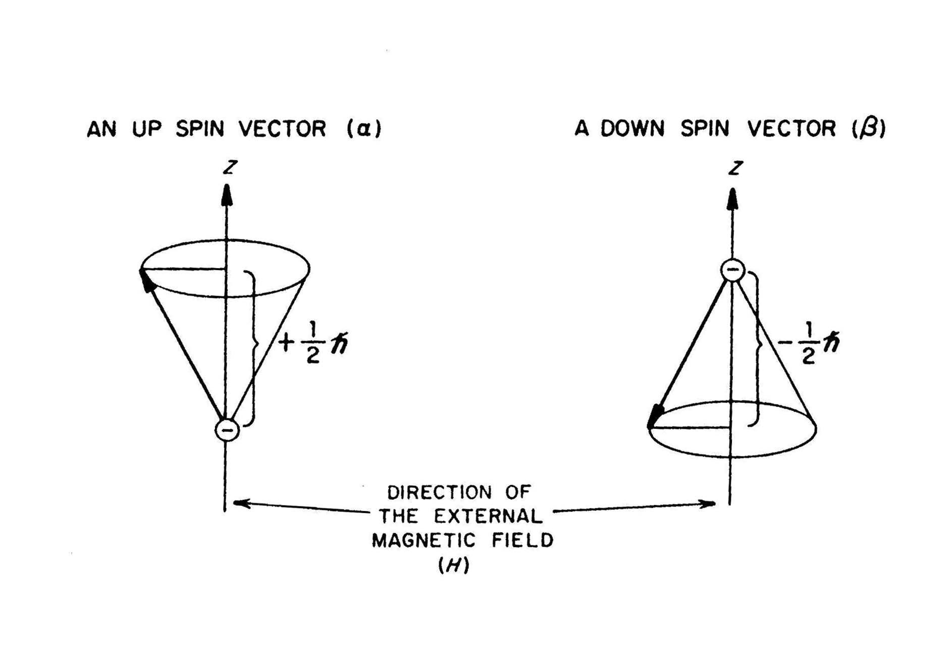
(1)

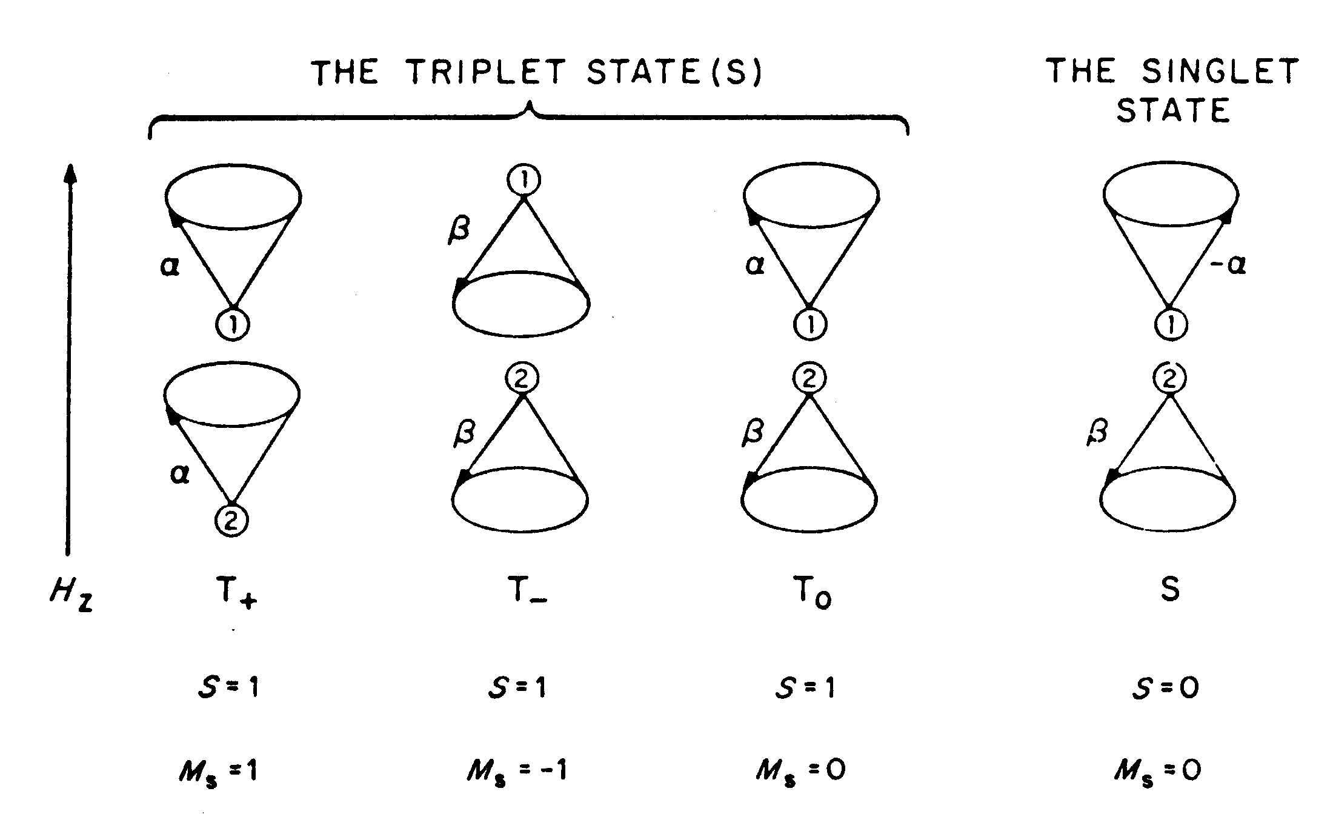

Figure 1. Vector representation of electron spin moment in presence of an external MF and the Singlet and Triplet spin states of a RIP. (Taken from Ref. [10])

where R is the inter-radical distance and a is the rate of decrease in J with R. The potential energy diagram (figure 2) showing the effect of separation on the energy difference between S and T states. Immediately after its birth, the inter-radical distance of a RIP is so small that S-T inter-conversion is difficult due to large energy gaps. After several diffusive motions the radical ions move apart so that 2J ~ 0 and S-T inter-conversion ensues. However, at an even larger separation between the radical ions, the spin correlation breaks down. To observe MF effect it is crucial to maintain the spin correlation of the RIP at a distance of 2J ~ 0 for a sufficiently long time so that S-T inter-conversion is possible. It is also important to note that a transformation from S to T₀ requires a rephasing of the two spin vectors with respect to each other whereas S to T± requires a spin flip or change in electronic spin momentum.
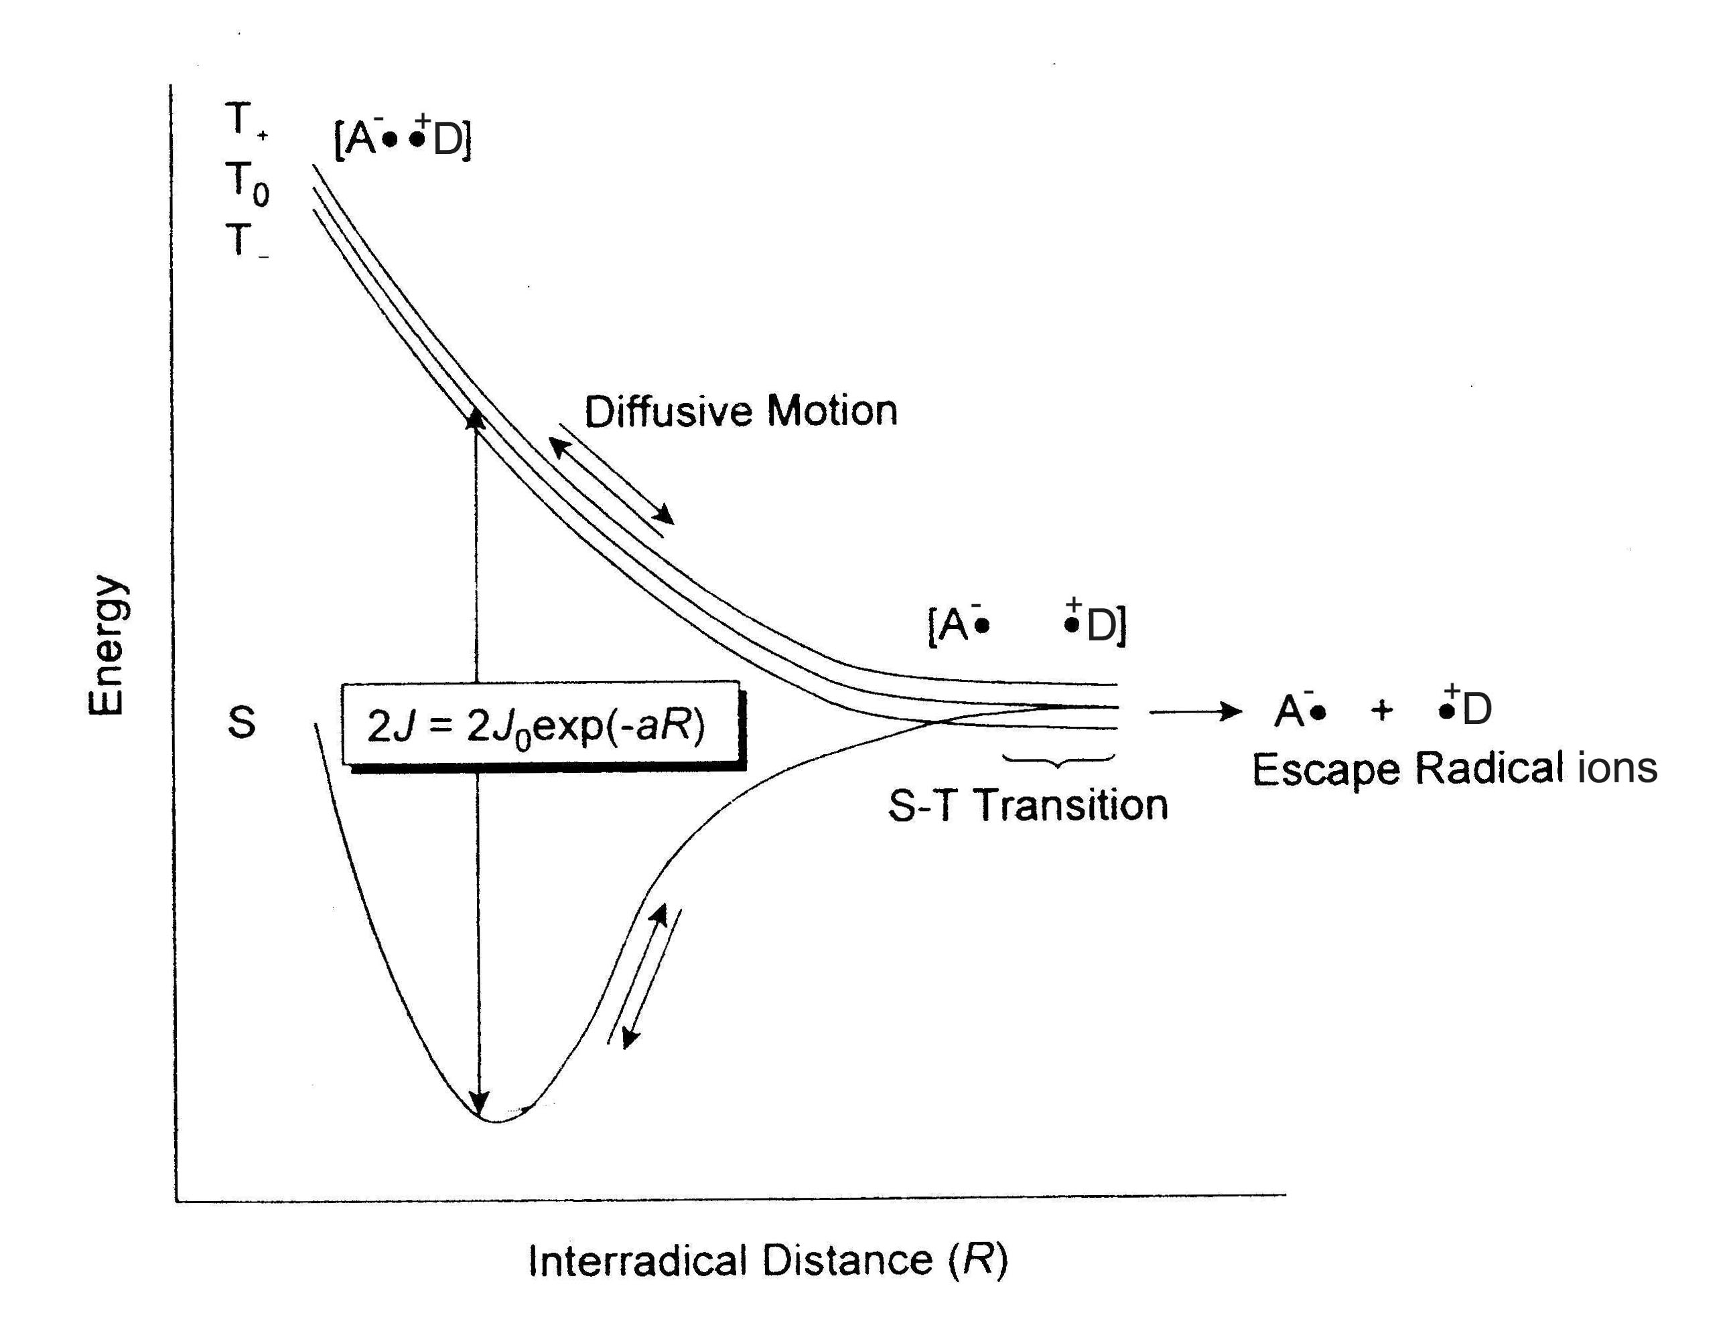

Figure 2. Energies of Singlet and Triplet RIPs and their pathways in solution. (Taken from Ref. [10])

There are various mechanisms that cause singlet-triplet intersystem crossing (ISC), e.g., hyperfine-coupling mechanism (HFC), level crossing mechanism, spin orbit coupling and ∆G mechanism, relaxation mechanism, triplet and triplet-doublet mechanism etc. Among these HFC mechanism has been discussed elaborately as this mechanism is operative at low magnetic field that is relevant to the discussion of impact of environmental magnetic fields on biological system.
A. The hyperfine coupling (HFC) mechanism
The origin of HFC is the dipole-dipole interaction, between electron and nuclear spins [10]. At an inter-radical separation where 2J ~ 0 and in the absence of an applied field, the states, S, T₊, T₋ and T₀ are degenerate. In this situation S↔T±, T₀ ISC is possible by the HFC mechanism, which can provide the torque necessary for rephasing (S↔T₀) and spin flipping (S↔T±). The latter is accompanied by a corresponding change in the nuclear spin thus preserving the total spin angular momentum (α_{e}β_{N}→ α_{N}β_{e}, where e and N refer to the electron and nucleus respectively). The efficiency of ISC at zero field is governed by the magnitude of nuclear spin -electron spin hyperfine interaction. The ISC rate constant (k_{ISC}(HFC)) governed by the HFC interaction is expressed as equation 2
k_{ISC} (HFC) = gβB_{av}/ħ (2)
where B_{av} denotes the local magnetic field, β is the Bohr magneton (9.274x 10⁻²⁴ JT⁻¹) and g is the Lande g factor, which is close to 2.00 for the free electron and most organic radicals. When an external MF is applied T₊ and T₋ sublevels separate energetically from T₀ by the electron Zeeman interaction. The extent of Zeeman splitting is ΔE = gβB, where B is the externally applied magnetic flux density. This results in suppression of S↔T± transitions and leads to an increase in population of the initial spin state. An external MF of 100 mT is sufficient for the observation of this effect. Beyond this range the Zeeman interaction exceeds the magnitude of the HFC and the effect should saturate.
B. MFE requires confinement of radical pair/ radical ion pair
The occurrence of MFE is actually a competition between intersystem crossing, feasible at a particular distance of separation and escape of radical ion pairs. If the escape is very fast and irreversible then there will be very little ISC and MFE will be small. Secondly if the primary geminate recombination is also very fast compared to diffusive separation or solvent intervention, then also MFE will be small. If an environment can be generated which allow controlled diffusive separation (~10Å) such that J~0 then ISC between S and T is allowed. Under such condition application of an external MF splits the T states and disallows S↔ T₊, T₋ ISC and the population of species in its original state increases, which is reflected greater optical density in the corresponding absorption spectra in presence of MF.
Such confined environment can be generated via introduction of a micellar, reverse micellar, vesicular or even by increasing the viscosity of the medium. In organic non-viscous solvents at ambient temperature the residence time for a primary geminate pair in a solvent cage is ~ 10⁻¹⁰ – 10⁻¹¹s. Whereas in a micellar cage the lifetime increases of the order of microsecond (10⁻⁶ s) or even more. Further in homogeneous solvent cage the RIPs cannot separate out from each other, making their geminate characteristic intact, to maintain exchange interaction J ≈ 0 and ISC between S ↔ T is not feasible. On other hand in micellar environment the radicals produced can separate from each other and again rebounce at the Stern layer, making their geminate characteristics undisturbed. Thus under such circumstances ISC between S ↔ T is possible and one can find prominent MFE in micellar medium.
III. Free radicals generated in living systems are affected by external MF
In real biological medium there are a wide variety of radicals that are generated during metabolic processes e.g. during photosynthesis radicals are generated through photoexcitation, and also free radicals can be generated in living organisms by oxidation-reduction reactions catalyzed by enzymes such as catalase, peroxidase, etc. Radicals such as reactive oxygen species (ROS), as for example superoxide (O₂⁻¹), peroxide (O₂⁻²), hydroxide (OH•) and reactive nitrogen species are used both in signalling purpose [11], response to environmental stress, programmed cell death and as protective measure against bacteria or pathogens. Free radical at high concentration may cause oxidative damage to nucleic acids, proteins as well as peroxidation of lipids.
A. MFE on enzymatic reactions
The enzymatic reactions generally follow Michaelis-Menten kinetic pathway. Thus the primary step is the formation of enzyme-substrate complex (ES). The ES complex will undergo homolytic fission or electron transfer to generate a pair of radical pair (RP) or RIP. This RP/RIP must have sufficiently long lifetime to retain spin correlation and undergo ISC. If the electron spin relaxation between the RP/RIP is very fast its geminate nature will be lost and no MFE will be observed. Further the RP/RIP must be weakly coupled. A very strong coupling will not allow separation to take place and hence the ISC and a very weak coupling or non-coupling destroys geminate characteristics. The conformational change prior to the formation of the ES complex should be reversible, otherwise all the substrate will transform to the product very fast and no MFE will be observed. The RP/RIP formed from ES complex must exist long enough for ISC to compete with other modes of reaction and in that case MFE may be observed. The review by Grissom extensively described different aspects of MFE for enzymatic reactions [12].
B. Magnetic field can be used as a non-invasive tool for anticancer treatment
Cisplatin, doxorubicin, taxol, epirubicin etc are the conventional chemotherapy drugs. The anticancer drugs used for chemotherapy can quickly spread over throughout the body and is ineffective in killing metastatic cancer cells. Moreover they are cytotoxic agents and have various side effects. E.g. doxorubicin is used to treat breast, lung, stomach, bone and thyroid cancer. But it induces toxic effects on patient’s heart that leads to limited clinical uses at high dose. Doxo induced cell death might be due to intercalation into double stranded DNA and subsequent breaking of double strand by inhibition of topoisomerase II and generation of ROS like superoxide and hydrogen peroxide. Several drug delivery systems have been developed to target the affected region and release active biomolecules at specific site to minimise the side effect. The efficacy of doxorubicin may boost up even at low dose by simultaneous use of MF. Verdom et al reported a combination of 10mT static MF (SMF) and 0.1 µM doxo decrease the viability and proliferation rate of cancer and normal cells in a synergetic manner. SMF boosts the generation and lifetime of ROS at low dose of doxo and overcome to protective effect of antioxidants like reduced glutathione (GSH). Thus the use of SMF can decrease the dose of anticancer drugs and hence the side effects.
C. Natural MF as a source of navigation
The geomagnetic field acts as a SMF. It seems that birds have two separate sensors, one for geographical location and the other for direction finding. For geographical location or formation of magnetic ‘map’ they use an iron mineral based compound called magnetite (Fe₃O₄) that is found to be present in the upper part of the beak of homing pigeons and several other bird species. The magnetite clusters depending upon direction of external magnetic field will interact with each other which in turn deform the membrane associated with magnetite and hence possibly opening and closing the ion channels. Later, Fleissner etal proposed the presence of two iron compounds: magnetite and maghemite (γ-Fe₂O₃) in the beak. In presence of an external MF the maghemite platelets become magnetised and enhance a local magnetic field in the cell by several orders of magnitude. On the other hand the basis of orientational compass is thought to be using RP mechanism generated by photo induced electron transfer. Magnetic compass orientation has been shown to be dependent on the wavelength of the ambient light. European robins and Australian silvereyes showed good orientation under blue light (λ_{max} = 443 nm) and green light (λ_{max} = 565 nm) while they are disoriented under red light (λ_{max} = 630 nm) [13]. Nocturnal migrants show no activity during darkness. This vision based magneto-reception mechanism suggests that light with energy above a certain threshold is needed for the mechanism to work. It has been suggested that this ‘magnetic sense’ may be mediated by blue light receptor protein cryptochrome (CRY), which is known to be localized in the retina of migratory birds. Spectroscopic studies on purified CRY suggest that they could be suitable as magneto receptors. CRY can bind the chromophore flavin adenine dinucleotide (FAD) internally. Absorption of blue light by non-covalently bound FAD cofactor triggers a series of electron transfer within the protein from a chain of three tryptophan (TrpH) residues to generate the RIP [FAD^{•-} TrpH^{•+}]. This RIP so formed can retain their geminate characteristics and susceptible to weak MF and leads to long lived forms of the protein that helps in signalling activity.
IV. Conclusion
It is evident that MF can affect the biological system through interaction with the radicals generated in various metabolic pathways, by changing the rate of recombination, which in turn change the concentration of radicals. In fact radicals can act as a double edged sword; most of the time, these (harmful) species trigger some signalling pathway even apoptosis or cause oxidative damage to proteins, nucleic acids or lipids. Antioxidants like GSH or other radical scavengers are generated to cope up the damaging health effects or different immune channels are getting activated. Actually biological systems contain a lot of feedback, feed-forward and repair processes that change the radical concentrations via multiple signalling pathways and often have no observable effects within the experimental runtime. Obviously this field is still remaining unexplored and much work that needs to be done to find out the conditions in which MF can be used for betterment of mankind.
REFERENCES
[1] G. Draper, T. Vincent, M. E. Kroll, J. Swanson, BMJ, 2005, 330, 1290.
[2] IARC 2002 Non-ionizing radiation, Part 1: static and extremely low frequency (ELF) electric and magnetic fields, Lyon, France: International Agency for Research on Cancer, vol. 80. p. 429.
[3] R. Boan, Y. Grosse, B. Lauby-Secretan, F. Ghissassi, V. Bouvard, L. Benbreahim-Tallaa, N. Guha, F. Islami, L. Galichet, K. Starif, Lancet Oncol., 2011, 12, 624.
[4] IARC 2013 Non-ionizing radiation, Part 2: Radiofrequency electromagnetic fields. IARC Monographs on the Evaluation of Carcinogenic Risks to Humans. vol. 102. Lyon, France.
[5] WHO 2007, Environmental Health Criteria 238. Extremely low frequency (ELF) Fields. WHO: Geneva, Switzerland.
[6] K. Lohmann, C. Lohmann, L. Erhart, D. Bagley, T. Swing, Nature, 2004, 428, 909.
[7] J. Philips, M. Freake, S. Borland, J. Comp. Physiol. (A), 2002, 188, 157.
[8] J. Philips, S. Borland, Nature, 1992, 359, 142.
[9] L. Yan, S. Zhang, P. Chen, H. Liu, H. Yin, H. Li, 2012, 167, 507.
[10] I. R. Gould, N. J. Turro, M. B. Zimmt, Adv. Phys. Org. Chem., 1984, 20, 1.
[11] H. Forman, J. Fukuto, M. Torres, Signal Transduction by Reactive oxygen and Nitrogen Species. New York: Kluwer Academic Publishers 2003.
[12] C. B. Grissom, Chem. Rev., 1995, 95, 3.
[13] W. Wiitschko, U. Munro, H. Ford, R. Wiitschko, Nature, 1993, 364, 525.

