Tellurium and Oxygen/Sulfer-Containing Macrocycles; Synthetic and Structural Chemistry
ParthaPratim Das
P. G. Dept. of Chemistry, Magadh University, Bodh-Gaya
Abstract:
Numerous articles about macrocyclic polytelluroethers have been published in scientific journals as a consequence of the major advancement of chemistry of thia and selena macrocycles earlier, which brought spotlight on the possibility of the tellurium counterparts. Nevertheless, compared with selena and thia-macrocycles, their overall number remains incredibly low. A combination of their better capacity to bind to transition metal ions and the accessibility of ¹²⁵Te NMR spectroscopy for examining their architectures in solution, they keep receiving a lot of attention. The Te-C bond's strong reactivity is shown by its simple heterolytic breakdown in the presence of some metal salts. Because organotellurium molecules are poisonous and the C-Te connection is weaker than the C-S as well as C-Se bonds, the production of tellurium macrocycles and the subsequent chemistry of these compounds will probably continue to be difficult and intriguing for scientists for decades ahead. Oxygen being hard center prefers alkali or alkaline earth metal ions, whereas Sulfer being relatively softer prefers transition metal ions during complexation. Tellurium being even softer than sulfer center mainly prefers selected transition metals. As a consequence, scientists have over the time focused on developing mixed macrocycles, e.g., Telluraoxamacrocycles or tellurathiamacrocycles, keeping in mind the accessibility to a range of metal ions with variety in their sizes and oxidation states during metal complexation. In this chapter telluramacrocycles which include O/S in their framework has been discussed from their synthetic to their metal complex formation with structural details.

Introduction:
An intriguing field that is receiving a lot of attention since last several decades is supramolecular chemistry^{1,2,3}, which entails the development and manufacturing of polytopic macrocyclic as well as macrobicyclic ligands with multiple recognizing sites. Similar to how oxa-macrocycles are for alkali or alkaline earth metal ions, the thioether macrocycles have been proven to be excellent ligands towards variety of d- as well as p-block ions. Such molecules' capacity to assume unanticipated morphologies and stabilize different oxidation states, which are their key characteristics. Systems containing the heavier chalcogens selenium as well as tellurium display extensive coordination chemistry in the area of acyclic ligands, which has been known for a very long time. When compared to polyoxa or polythia macrocycles, polyselenoether macrocycles were found to possess a comparably similar ability to function as ligands. Numerous efforts were also made to apply these principles to the analogous Te-macrocycles, as a result. Telluroether (TeR₂) being used as donors in a macrocyclic structure, provides ligands with rich coordination chemistry since Te has better σ-electron-donating capabilities than Se and/or S due to its lesser electronegativity. Because ¹²⁵Te NMR spectroscopy may be used as an effective structural investigating tool, telluromacrocyclic chemistry is far more appealing in this situation. Given its potential uses in nonlinear optics and as ionic conductors, significant effort has been put into comprehending the underlying facets of tellurite glass c hemistry⁴. Not only that, incorporation of “hard” oxygen or “soft” sulfer donors in the same macrocycle with Te, makes the situation even more interesting as its versatility towards binding metals from different groups with range of oxidation states in the same core, increases. In this chapter, telluromacrocycles having additional O/Se donor atoms have been discussed in details from their synthetic and structural perspectives.
Tellurium-Oxygen donor containing macrocycles:
According to Scheme 1, the ligand L¹ is produced through a combination of 4-aminobenzo-10-tellura-15-crown-5 and 2-pyridinecarbaldehyde in ethanol. Researchers have looked at the photophysics as well as electrochemistry for the Cu^{I} diimine compound [Cu(PPh₃)₂(L¹)](BF₄). Although having the same diameter Cd²⁺ and Na⁺, [Cu(PPh₃)₂(L¹)](BF₄) primarily bonds to softer metal cations like Zn²⁺ and Cd²⁺ because of the presence of softer Te donor. This is in contrast to the comparable all oxa-donor counterpart, that prefers to bind to Group I and Group II cations (for example, Na⁺, K⁺, and Ba²⁺). Thus, rather than size-match specificity, the hard-soft acid-base parameter controls the cation-bonding characteristics in this framework⁵.
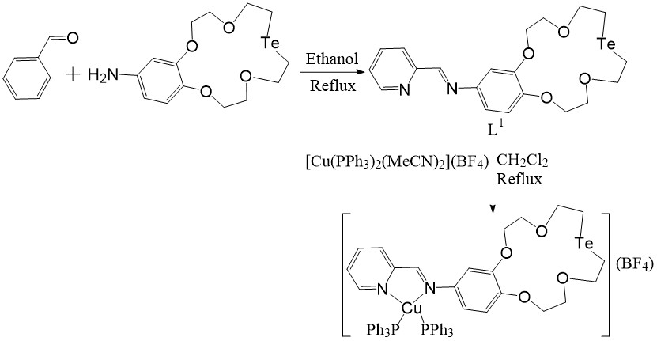
Scheme 1
By reaction between a Te-salt or a cationic ditelluroxane (as building blocks) and sodium phthalate (as bidentate converging ligand) through [3+3] as well as [2+2] addition mode, respectively, two kinds of macrocyclic multi-telluranes having hypervalent Te-O apical links in the primary chain were produced⁶ [Scheme 2]. This represented the initial instance of macrocycles that are fully characterised across the solution as well as solid states, which are made of group 13–17 members, solely containing hypervalent apical links in the primary chain. For the purpose to assemble molecules, hypervalent bonds through heteroatoms' n→σ* orbital interactions, may function as a novel supramolecular synthon. The deformed TBP morphologies for the Te donors having hypervalent Te-O apical bonding may be seen in the molecular frameworks associated with these macrocycles. The <O-Te-O and <C-Te-C angles are distorted by the lone-pair because it is stereochemically active. Compared to the macrocycle generated by the [2+2] addition mode that is composed of two ditelluroxanes as well as two phthalates the macrocycle generated by the [3+3] addition mode is made up of three Te atoms and three pthalates. All of the atoms in each of the two macrocyclic rings remain approximately coplanar. In crystal structure, the substance created by [2+2] addition takes the shape of a head-to-head kind of dimeric architecture due to the contact between the Te donors and the carbonyl O atom of the neighbouring unit. The Te^{IV} cations in [3+3] addition mode are organized in an equilateral triangle configuration without any intramolecular contact. The structures are shown in Figure 1.
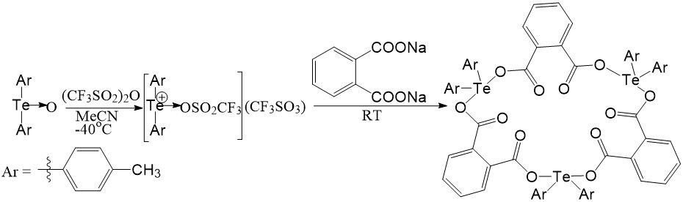
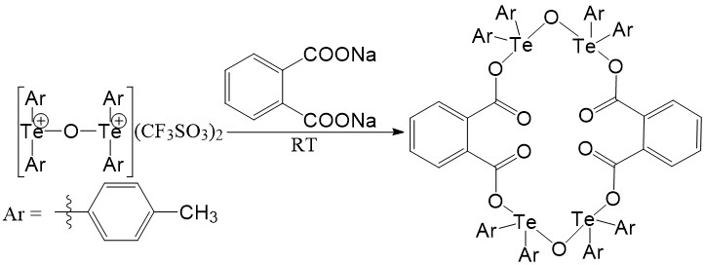
Scheme 2
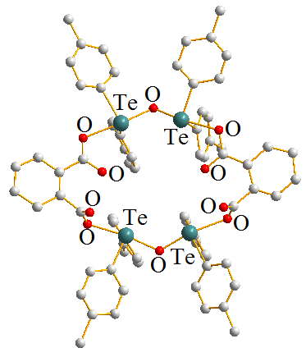 | 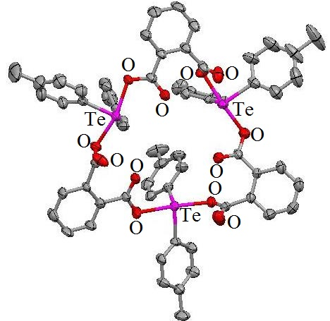
[2+2] Addition product | [3+3] Addition product
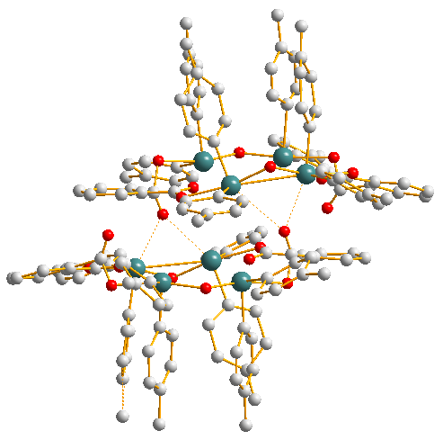
Dimeric unit of [2+2] Addition product
Figure 1
Scientists observed that the confluence of ditelluroxanecation; [Te(C₆H₄-4-Me)₂OTe(C₆H₄-4-Me)₂]²⁺ with tritelluroxanecation; [C₆H₄-4-Me)₂–Te{OTe(C₆H₄-4-Me)₂}₂]²⁺ [n = 1, as shown in Scheme 3] led to the production of a 14-member pseudo-ring by interacting the terminal Te donors with two CF₃SO₃⁻counterions within the crystal structure [Figure 2]. The cage of the macrocycle includes the remaining two CF₃SO₃⁻ ions. Te^{IV} has a pseudo-TBP shape with hypervalent apical Te-O bonds and coplanar atoms throughout, similar to previous molecules⁷. Like TBP-shaped AB₄E type systems, the position usually considered to represent the lone-pair area is occupied by a lone pair.
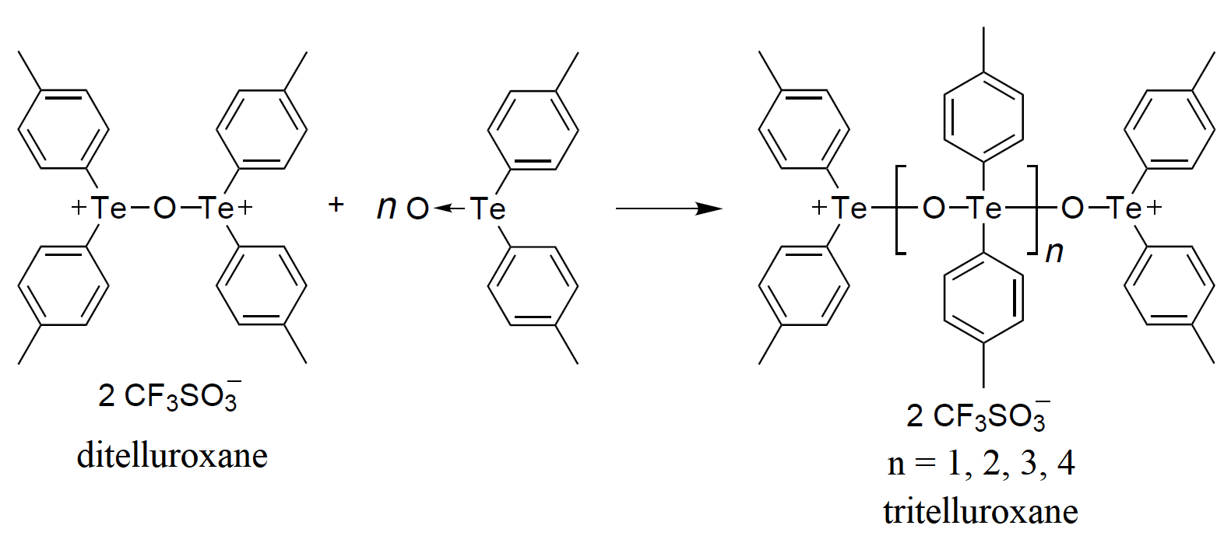
Scheme 3
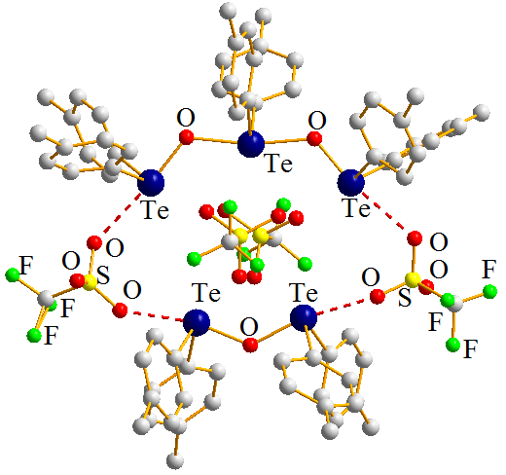
[C₆H₄-4-Me)₂–Te{OTe(C₆H₄-4-Me)₂}₂][Te(C₆H₄-4-Me)₂OTe(C₆H₄-4-Me)₂][CF₃SO₃]₄
Figure 2
New 'Telluroxane'; [Li(THF)₄][{Pr^{i}Te)₁₂O₁₆Br₄{Li(THF)Br}₄}Br]⁸, comprising of Te₁₂O₁₆ cage is a result of the incomplete oxidation in aerial oxygen of a combination of Li-hex-1-ynyl tellurolate along with (CH₃)₂CHBr in tetrahydrofuran [Scheme 4]. One Br⁻ is spherically enclosed inside the ring of the unique Te₁₂O₁₆ caged complex, that's stabilized by four [Li(THF)Br] components along with four Br⁻ in an outer layer. It is an intriguing contender for a range of chemistry purposes since it can contain guest of various atomic dimensions. The [Pr^{i}Te)₁₂O₁₆Br₄{Li(THF)Br₄}Br]⁻ anions, detached [Li(THF)₄]⁺cations, along with uncoordinated molecules of THF, build up the macrocycle's crystal structure [Figure 3]. The head-to-tail binding of four [O-Te-O-Te(μ-O)₂Te]-monomers results in the formation of the macrocycle, which contains alternating Te and O donors [Figure 3]. Although the O-Te-O component itself has stronger Te-O connections, the four [Te(μ-O)₂Te] microcycles only display weaker Te-O associations while connecting them to the -OTeO- structural unit. The cavity contains one encapsulated Br⁻ spanning four long as well as eight short Br-Te distances. The nine Br⁻, one within and eight exterior to the circle, stabilize the sphere-like Te₁₂O₁₆ architecture. The connections between the eight Te donors in the Te(μ-O)₂Te microcycle and the core Br⁻ are weaker, than what occurs with the 'outside' Br⁻ ions, which are stronger. The O-Te-O structure units and 'outer' Br⁻ have stronger Te-Br associations.
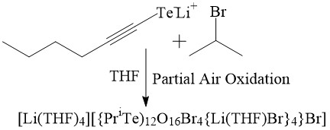
Scheme 4
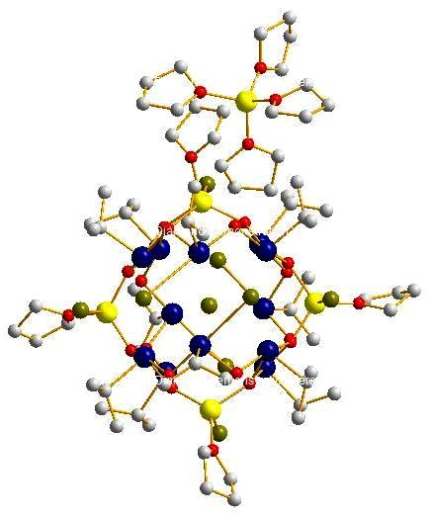 | 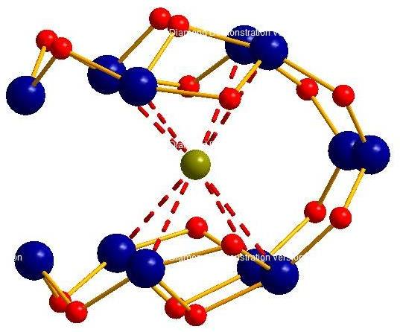  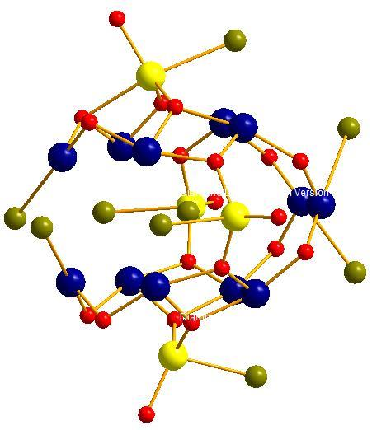
[Li(THF)₄][{Pr^{i}Te)₁₂O₁₆Br₄{Li(THF)Br}₄}Br] | Upper; [Li(THF)₄][{Pr^{i}Te)₁₂O₁₆Br₄{Li(THF)Br}₄}Br] without carbon framework.  Lower;Te₁₂O₁₆ skeleton and the central Br⁻ of the anion[{Pr^{i}Te)₁₂O₁₆Br₄{Li(THF)Br}₄}Br]
Figure 3

ClCH₂(CH₂OCH₂)₂CH₂Cl and Na₂Te combine to produce the new macrocycle L² along with minor side-product L³ [Scheme 5]⁹. To illustrate the macrocycles, the Te^{IV} analogues [(L²)Me₂I₂], [(L²)Cl₄], and [(L²)MeI] are synthesized [Scheme 5]. The L² compounds of Pd^{II} and Pt^{II} are isostructural. Investigations using spectroscopy demonstrate the cis- orientation and the absence of interaction of ethereal O donors [Figure 4]. L² functions as a bidentate Te₂-kind binding ligand towards the metal ions in both instances, producing two rings with eleven members. The structures exhibit cis- square planar architecture in which the "Hard Soft Acid Base Principle" is assumed by the soft-soft Pd/Pt-Te contacts. The higher trans- effect of Te over Se/S is demonstrated by the larger Pt-Cl bond lengths relative to its thia along with selena equivalents. There have been reports of several more L² compounds, including [RhCl₂(L²)₂]X (X = Cl, PF₆), [Cu(L²)₂](BF₄), and [Ag(L²)₂](BF₄). It is also known that L³ contains Pd as well as Pt compounds of the kind [MCl₂(L³)₂].

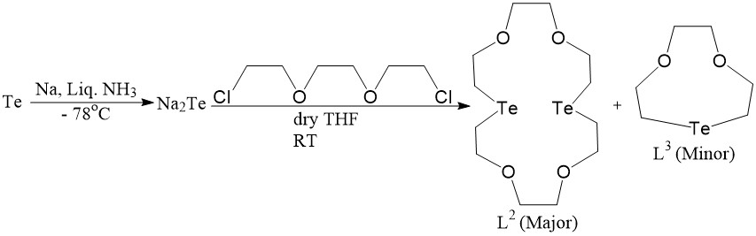
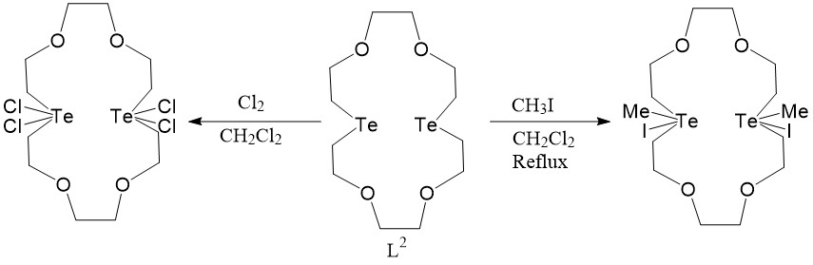
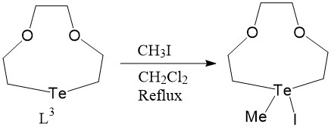
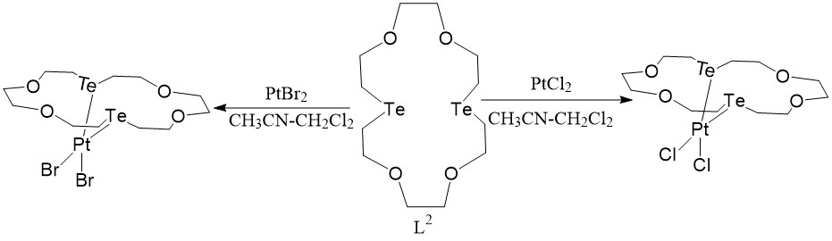
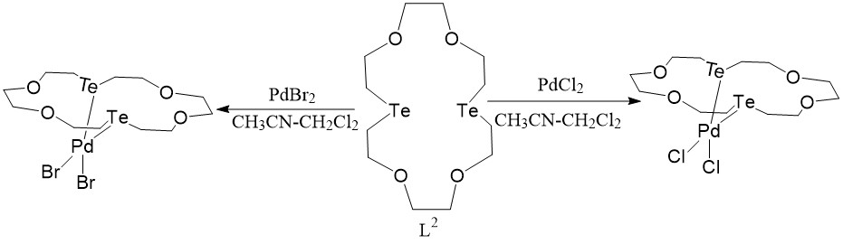
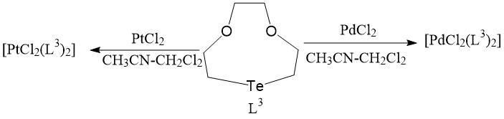
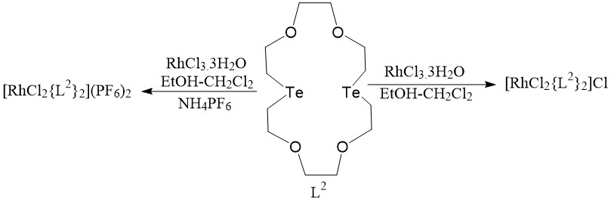
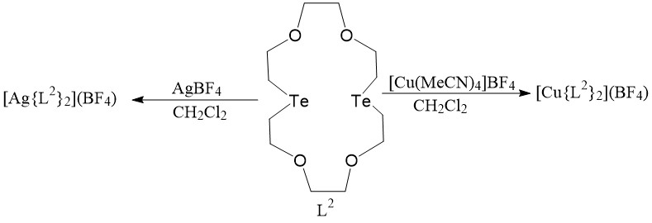
Scheme 5
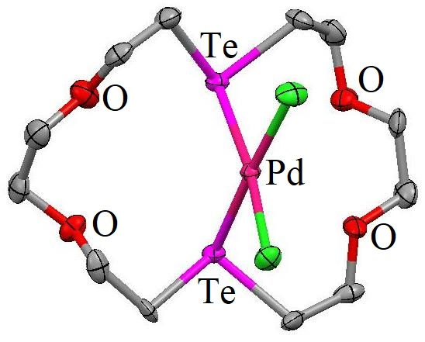  [PdCl₂(L²)] | 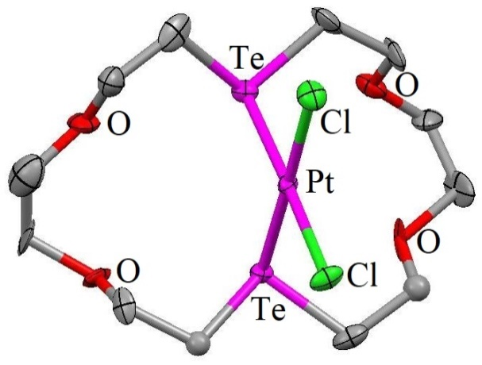  [PtCl₂(L²)]
Figure 4
In the presence of Et₃N, 1,1'-ferrocenedicarboxylic acid reacts with Ar₂TeCl₂ (Ar = 4-OMe-C₆H₄) to form the 16-member heterobimetallic tetranuclearmacrocycle [Ar₂Te(1,1'-ferrocenedicarboxylate)]₂ [Scheme 6]¹⁰. For this substance, the Te's fundamental architecture is TBP, with the O donors occupying axial places, the 4-OMe-C₆H₄ moieties occupying equatorial spots, and the stereochemically active lone pair occupying axial sites [Figure 5]. The <O-Te-O angle differs significantly from its optimum 180 degrees. The <C_{equatorial}-T-C_{equatorial} angle becoming less than 120° is another sign that the lone pair needs more room. In this macrocycle, the two ferrocene groups are almost perpendicular to one another. This macrocycle is the first instance of an organotellurium molecule possessing ligands binding ferrocene that has been structurally characterized.
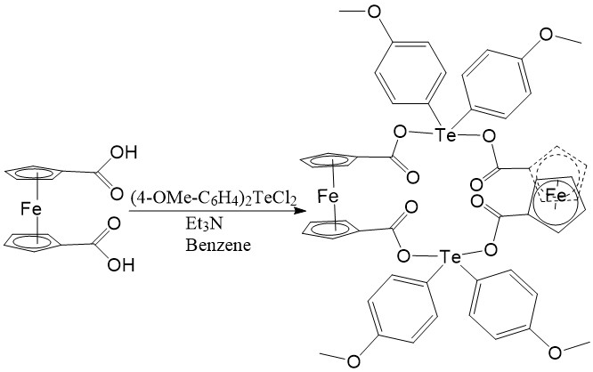
Scheme 6
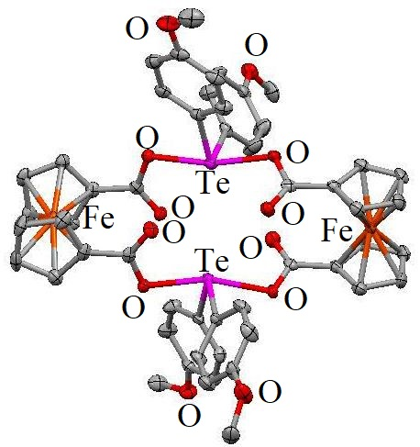
Figure 5
The interaction of bis(2-hydroxyethyl)telluride and diolditosylates produces unique Te-crown ether molecules [L⁴-L¹¹]. It is reported that L⁴'s Pt^{II} compound catalyzes hydrosilylation reaction [Scheme 7]¹¹.
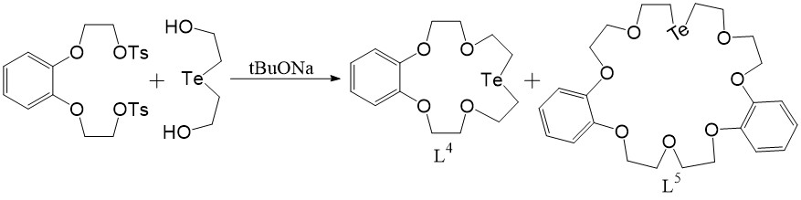
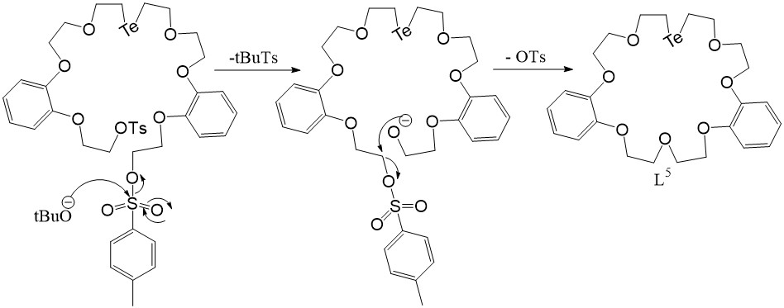
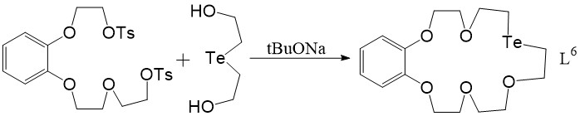
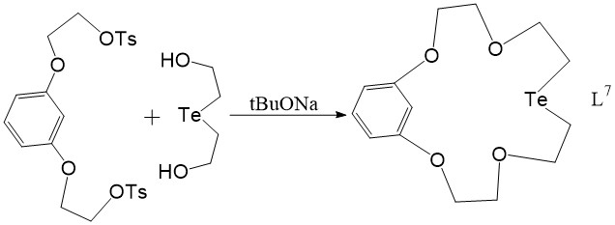
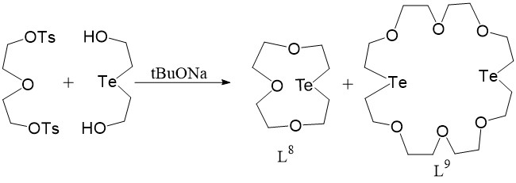
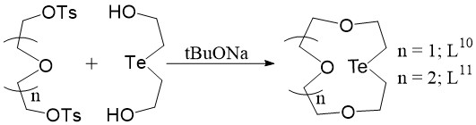
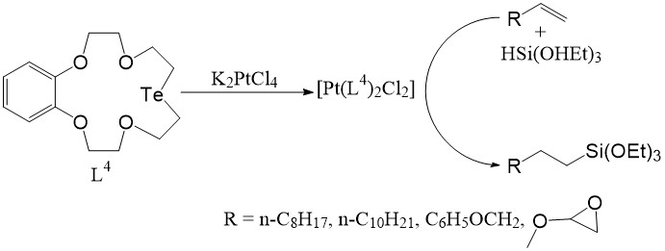
Scheme 7
R₂Te(L¹²)-type organo-Te^{IV} chelates were known^{12,13}. The crystal framework of one such chelated compounds, [(p-MeO-Ph)₂Te(L¹²)] [Figure 6, Scheme 8], in which Te^{IV} connects to just two O-donors in the L¹² ligand. The large separation between the two N-donors and the Te^{IV} ion make them non-bonding. The geometry of electron pairs around Te^{IV} assumes TBP configuration as predicted for the AX₄E type-system based on the VSEPR model. The two anisyl C atoms and the lone pair of electrons occupy equatorial positions. The salen O donors are located in axial locations. To lessen interactions between lone pair-bond pairs, axial as well as equatorial ligands are angled out of the vacant site.
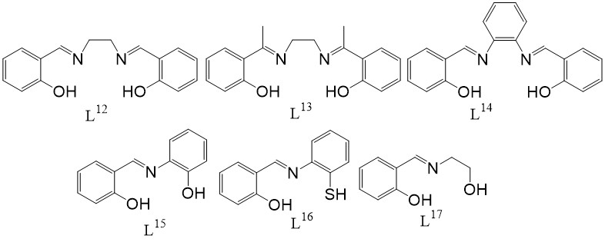
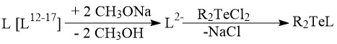
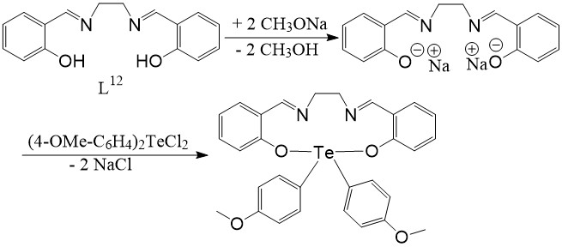
Scheme 8
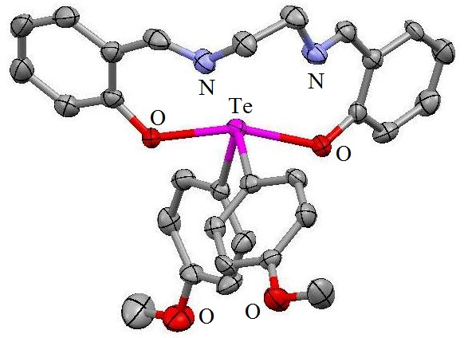
Figure 6
Tellurium-Sulfer donor containing macrocycles:
Interestingly with no signs of development of [2+2] end-products, four macrocycles having mixed S/Te-donor atoms of various ring dimensions were generated through the [1+1] cyclization combining Na₂Te and the appropriate dichlorothioalkanes [Scheme 9]^{14,15,16}. This contrasts with the similar interaction between Na₂Te and [Cl(CH₂)₂O(CH₂)₂O(CH₂)₂Cl], which produced the [2+2] cyclization result as the primary one⁹. As a by-product of the manufacture of L¹⁸, 1-thia-4-tellura-cyclohexane [L²¹], a ring-contracting resultant molecule, is found [Scheme 9]. The [1+1] cyclization product molecules that are independent molecular kinds are explicitly formed, evident from the crystal structures of L¹⁹ and L²⁰, with no discernible intermolecular interactions. The homologous trithia crown molecule, which has a roughly square layout featuring one single S donor at one of the corners while the remaining two S donors on borders, has an architecture¹⁷ that is remarkably comparable to that of L²⁰. Equivalent orientation can be seen in molecule L¹⁹, which has the Te donor on a corner while the S donors on borders. Decreasing stereochemical activity of lone pair of electrons with rising period number of central atoms throughout a periodic group matches up for the smaller <C-Te-C angles relative to the larger <C-S-C angles, showing stronger stereochemical activation of the lone pairs in the latter. However there are reports of the more stable organo-Te^{IV} methiodide counterparts for L¹⁸, L¹⁹ and L²⁰ macrocycles as well as the Te^{IV} diiodide entities [L¹⁹I₂] and [L²⁰I₂]. The architecture of [L²⁰I₂] has two trans- I⁻ donors and displays the bent pseudo-TBP shape around Te^{IV} characteristic of R₂TeX₂ [R = Alkyl group and X = Halide] substances. The C atoms along with non-bonding pair electrons on Te are located in the equatorial plane. The ring assumes an arrangement that is identical with that of the original macrocycle, with the exception that the Te atom is situated in a corner location as opposed to one S atom. Several metal complexes with these complexes has been reported and shown in Scheme 9. The structures are shown in Figure 7.
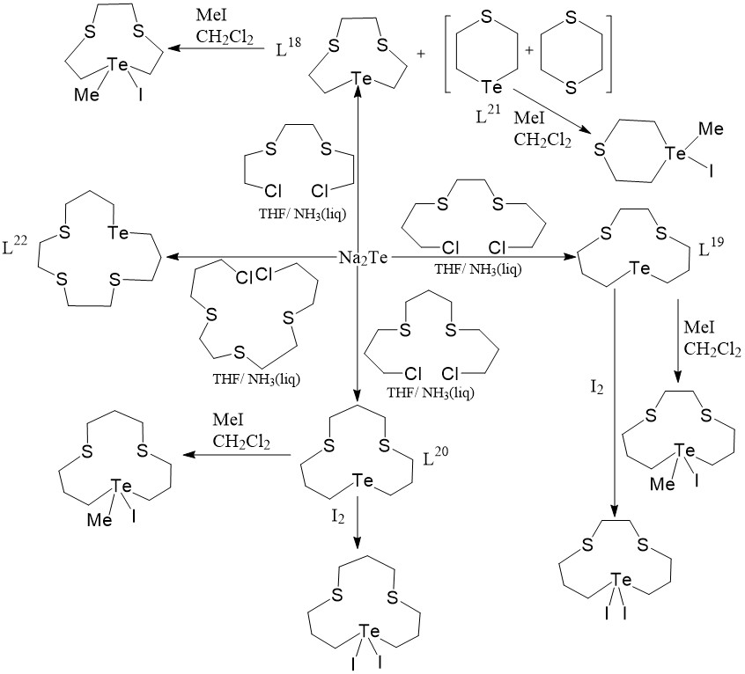
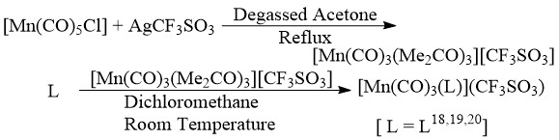
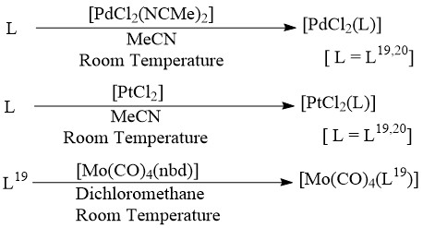
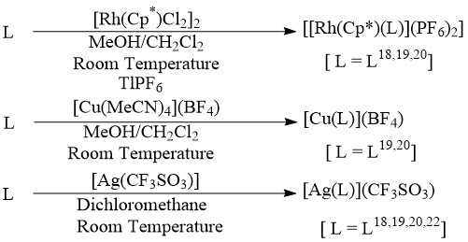
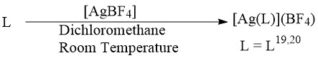
Scheme 9
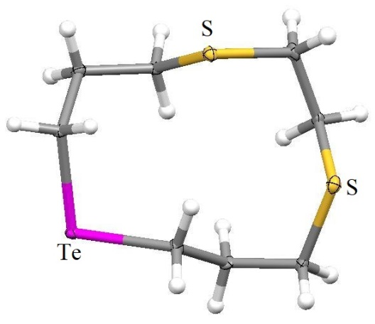 | 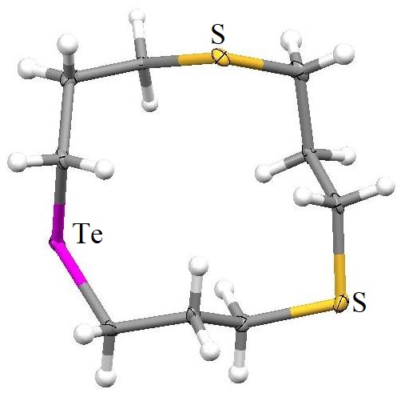 |  | 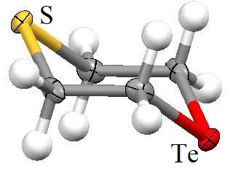
L¹⁹ | L²⁰ |  | L²¹
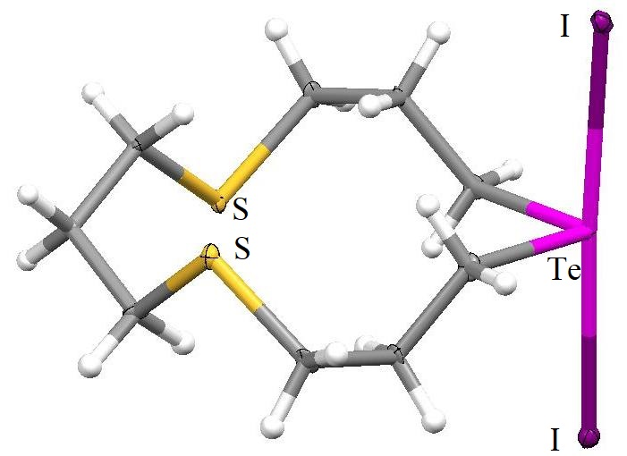 |  | 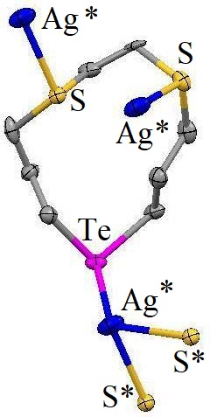
[L²⁰I₂] |  | Cation of [Ag(L¹⁹)](BF4)
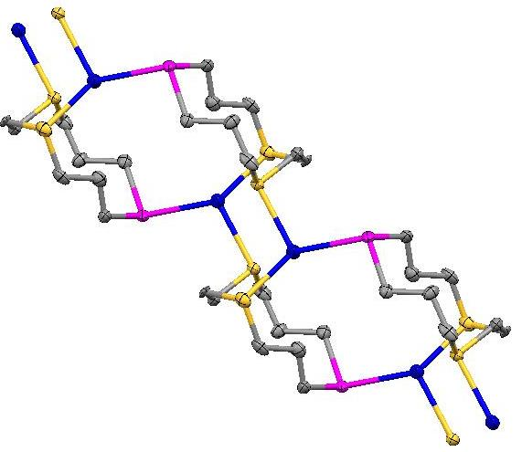
One-dimensional lattice adopted by [Ag(L¹⁹)](BF₄)
Figure 7
Using a variety of transition metal ions, the coordination chemistry associated with these macrocycles is investigated. When combined with Ag^{I}, the macrocycles generate compounds of the [Ag(L)]⁺ (L^{19,20}) as well as [Ag(L)₂]⁺ (L^{18,19,20}) types¹⁴. One-dimensional polymeric framework can be seen in the [Ag(L¹⁹)](BF₄) compound's crystal arrangement [Figure 7]. Through the adoption of two S and one Te donors across three separate macrocycles, the Ag^{I} centers assume a deformed trigonal planar coordinating arrangement. For the remaining Ag^{I} molecules, similar polymers are anticipated. Additionally described are the analogous 1:1 molecules [Cu(L)](BF₄) (L^{19,20}), the Pd^{II} and Pt^{II} compounds [MCl₂(L)] (L^{19,20}), and the deformed octahedral Rh^{III} material [Rh(Cp*)(L)](PF₆)₂ (L^{18,19,20})¹⁵. Additionally described are the Mn^{I} molecules fac-[Mn(CO)₃(L)](CF₃SO₃) (L^{18,19,20}) as well as the Mo⁰ compound cis-[Mo(CO)₄(L¹⁹)]. It was unable to synthesize equivalent Mo⁰compounds with L¹⁸ and L²⁰ ligands¹⁵.
Conclusion:
The study of chalcogen macrocycles has been thoroughly done by academicians/researchers since long. In conclusion, this chapter discusses the chemistry of certain significant macrocycles including sulfur, oxygen, and tellurium. Mixed ligands with different core dimensions and denticity and their metal complex formation were focused, along with some multi-telluranes having hypervalent Te-O apical links in the primary chain/telluroxanes, heterobinuclear systems having ferrocene in the structure etc.
References:
- C.J. Pedersen, “Cyclic polyethers and their complexes with metal salts”, J. Am. Chem. Soc., Vol. 89, pp. 7017–7036, 1967.
- (a) J.M. Lehn, “Design of organic complexing agents Strategies towards properties”, Struct. Bond. (Berl.) Vol. 16, pp. 1-69, 1973. (b) J.M. Lehn, “Supramolecular Chemistry—Scope and Perspectives Molecules, Supermolecules, and Molecular Devices (Nobel Lecture)”, Angew. Chem. Int. Ed. Engl., Vol. 27, pp. 89-112, 1988.
- D.J. Cram, “The Design of Molecular Hosts, Guests, and Their Complexes (Nobel Lecture)”, Angew. Chem. Int. Ed. Engl., Vol. 27, pp. 1009-1020, 1988.
- A. Pierre, F. Duboudin, B. Tanguy and J. Portier, “Liquid medium processing of TeO2 for ionic conductors”, Solid State Ionics, Vol. 53–56, pp. 1200-1207, 1992.
- V. W. W. Yam, Y. L. Pui, W. P. Li, K. K. W. Lo and K. K. Cheung, “Synthesis, photophysics and electrochemistry of copper (I) diimine complexes containing thia-, selena- and tellura-crowns. A spectrochemical and luminescence ion probe for soft metal ions”, J. Chem. Soc., Dalton Trans., Issue 21, pp. 3615-3622, 1998.
- K. Kobayashi, H. Izawa, K. Yamaguchi, E. Horn and N. Furukawa, “Macrocyclic multi-telluranes with hypervalent Te–O apical linkages”, Chem. Commun., Issue 16,pp. 1428-1429, 2001.
- K. Kobayashi, N. Deguchi, O. Takahashi, K. Tanaka, E. Horn, O. Kikuchi and N. Furukawa, “Nucleophilic Addition of Telluroxides to a Cationic Ditelluroxane: Oligotelluroxanes”, Angew. Chem. Int. Ed., Vol. 38, pp. 1638-1640, 1999.
- H. Citeau, K. Kirschbaum, O. Conrad and D. M. Giolando, “A novel cage organotellurate(IV) macrocyclic host encapsulating a bromide anion guest: [Li(THF)₄][{(PriTe)₁₂O₁₆Br₄{Li(THF)Br}₄}Br]·2THF”, Chem. Commun., Issue 19, pp. 2006-2007, 2001.
- M. J. Hesford, W. Levason, M. L. Matthews and G. Reid, “Synthesis and complexation of the mixed tellurium–oxygen macrocycles 1-tellura-4,7-dioxacyclononane, [9]aneO₂Te, and 1,10-ditellura-4,7,13,16-tetraoxacyclooctadecane, [18]aneO₄Te₂ and their selenium analogues”, Dalton Trans., Issue 14, pp. 2852-2858, 2003.
- V. Chandrasekhar and R. Thirumoorthi, “1,1’-Ferrocenedicarboxylate-Bridged Redox-Active Organotin and -tellurium-Containing 16-Membered Macrocycles: Synthesis, Structure, and Electrochemistry”, Organometallics, Vol. 26, pp. 5415-5422, 2007.
- (a) X. Xu, W. Li, X. Lu and X. Lui, Xuaxue Xuebao, Vol. 51, pp. 1170-1173, 1993. (b) H. Xu, W. Li, X. Lui, L. Shen, X. Mao and M. Li, Huaxue Xuebao, Vol. 52, pp. 386-390, 1994.
- T. N. Srivastava, A. K. S. Chauhan and G. K. Mehrotra, “Organotellurium (IV) chelates and tri- and tetradentate schiff bases”, Synth. React. Inorg. Met. -Org. Chem., Vol. 12, pp. 705-713, 1982.
- D. S. Grubisha, G. A. Mirafzal and L. K. Woo, “Chemistry of selenium and tellurium with tetrachelate and macrocyclic ligands”, Inorg. Chim. Acta, Vol. 361, 3079-3083, 2008.
- W. Levason, S. D. Orchard and G. Reid, “Synthesis and properties of the first series of mixed thioether/telluroether macrocycles”, Chem. Commun., Issue 5, pp. 427-428, 2001.
- M. J. Hesford, W. Levason, M. L. Matthews, S. D. Orchard and G. Reid, “Synthesis, characterisation and coordinating properties of the small ring S₂Te-donor macrocycles [9]aneS₂Te, [11]aneS₂Te and [12]aneS₂Te”, Dalton Trans., Issue 12, pp. 2434-2442, 2003.
- A. J. Barton, A. R. J. Genge, N. J. Hill, W. Levason, S. D. Orchard, B. Patel, G. Reid and A. J. Ward, “Recent Developments in Thio-, Seleno-, and Telluro-ether Ligand Chemistry”, Heteroatm. Chem., Vol. 13, pp. 550-560, 2002.
- S. C. Rawle, G. A. Admans and S. R. Cooper, “Crown Thioether Chemistry. Synthesis and Structural Investigation of 1,5,9-Trithiacyclododecane (Trithia-12-crown-3) and its Copper(II) Chloride Adduct”, J. Chem. Soc., Dalton Trans., Issue 1, pp. 93-96, 1988.

