**Perspective in Plant taxonomy through conventional to contemporary biotechnological approach**

**Sapna Tamang & Saurav Moktan\***

Department of Botany

University of Calcutta

35, B.C. Road, Kolkata, West Bengal, India

*Email: smbot@caluniv.ac.in

**ABSTRACT**

Taxonomy, the foundation of conservation effort, has evolved over centuries, aiming to identify, name, and categorize species. However, the complexity of morphology in plant species has challenged taxonomists, leading to an increased reliance on modern technologies. Contemporary plant taxonomy benefits significantly from DNA barcoding, next-generation sequencing, and AI-based plant identification tools, enhancing biosystematics and ecological surveillance. Molecular techniques, such as DNA markers, barcodes, and sequencing, play a crucial role in studying phylogenetics, reconstructing evolutionary histories, and enriching plant taxonomy. Conventional markers like RFLP, AFLP, RAPD, SSR and SNP, as well as modern markers, offer complementary insights, enabling a more comprehensive understanding of plant diversity and evolutionary relationships. The integration of data from conventional and contemporary biotechnological tools provides a powerful approach to address and enhance the challenges of plant taxonomy.

**Keywords-** Taxonomy; DNA barcoding; Phylogenetics; Molecular markers; Next-generation sequencing; Artificial Intelligence

1. **INTRODUCTION**

Taxonomy is the foundation for all conservation. For more than 250 years, the objective of taxonomy has been to identify, name, and categorize species [1]. The taxonomists' ability to make decisions may be hampered by the fact that a small number of species from various populations have been found to exhibit complicated morphology. Thus, the majority of the time spent by botanists is in manually examining and determining the characteristics of various plant species. So, the modern techniques for studying the plants have been substantially enriched by a number of technologies used in contemporary plant taxonomy. For the study of biosystematics, the DNA barcoding, next-generation sequencing, AI related plant identification are essential technological tools. Likewise, various artificial systems have been employed for plant identification, revealing that the effectiveness of automated plant identification systems is remarkably promising. This progress could potentially lead to the development of a novel generation of ecological monitoring [2]. At the same time, the molecular techniques in the study of phylogenetics of plants have a significant role in plant taxonomy. As a result, molecular methodologies could be utilized to reconstruct the evolutionary paths of organisms and enhance their taxonomic classifications [3].

By integrating molecular taxonomic approaches into vegetation surveys, the potential exists to mitigate the challenges associated with taxonomic complexities and amplify the efficacy of conservation endeavors [4]. To solve the morphological complexity problem, the genetic data are also extremely encouraging to be employed in higher plant systematics [5]. Recent advancement on the different varieties of molecular markers, DNA markers, DNA barcodes and different DNA sequencing techniques plays a pivotal role in the study of plants systematics. Every botanist, including molecular biologists and plant hunters, who still have much to offer, find molecular systematics to be extremely relevant for the study of plants [6]. Markers like RFLP, AFLP, RAPD, SSR, and SNP are considered traditional markers because they have been widely used in plant taxonomy and genetics for several decades. Modern markers offer advantages in terms of throughput, genome-wide coverage, and accuracy, making them essential tools for advancing our understanding of plant diversity, evolution, and taxonomy. Combining data from both conventional and modern markers could provide a more comprehensive framework on plant taxonomy and evolutionary relationships.

1. **DNA BARCODING AND SPECIES AUTHENTICATION**

Emile Zuckerkandl and Linus Pauling presented the idea of using molecular data for phylogenetic inference during early sixties. They proposed that DNA and protein sequences may be utilized as markers for evolutionary history [7]. A year later, Carl Woese, compared the 18S rRNA sequences from various organisms and discovered that they exhibit significant differences. This led him to propose a new classification of life, with three domain concept: Bacteria, Archeae, and Eukarya [8]. This work revolutionized our understanding of the tree of life and the evolutionary relationships between organisms. Woese's research laid the groundwork for DNA barcoding. Phylogenetic analysis and species identification frequently employ the technique of DNA barcoding. It is predicted on amplifying of brief, conserved genomic regions with sufficient variance to distinguish between species with little intraspecific variation.

Earlier, a group of plant systematists [9] from around the world first tried to reorganize the classification of flowering plants into a phylogenetic system. This reorganization was based on analyzing the molecular characteristics of *rbcL, atpB,* and 18S rDNA genes. Later, the term DNA barcoding was coined and popularized by Paul Hebert and his colleagues with their foundational study on mitochondrial gene cytochrome C oxidase subunit I (COI) [10]. The majority of modern computational barcoding techniques have made an effort to include known modelling strategies from molecular phylogenetic research. Conventional barcoding techniques are essentially tree-based evolutionary systems in which identification choices are determined using the tree-induced distances [10, 11]. Established in May 2004, the Consortium for the Barcode of Life (CBOL) now comprises over 120 organizations from 45 nations, aiming to promote the adoption of DNA barcoding for the entirety of eukaryotic life on Earth [12]. DNA barcoding technique is a useful tool for analyzing small amounts of plant data to identify the species and genus of a given plant [13]. Over 5000 angiospermic taxa have sequenced *rbcL,* the major subunit of ribulose-bisphosphate carboxylase-oxygenase, which is encoded by a plastid gene. The number of species included in published analyses has reached 2230 numbers [14]. These relatively short sequences (650 symbols in the case of mtDNA) serve as identifiers for determining the species identification through the use of mtDNA [15]. A useful tool for conducting vegetation surveys, the multi-marker DNA barcoding method using *rbcL, matK*, and *trnH-psbA* may drastically cut down the time and expense required to identify different species [16]. Reference [17] expands the use of DNA barcoding in the field of medicinal plants and helps phylogenetic research by investigating the use of the DNA barcode ITS2 to identify medicinal plants for the first time. Polymerase Chain Reaction (PCR) is used to amplify a highly variable region, such as the DNA barcode region of the nuclear, chloroplast, or mitochondrial genome. Nuclear DNA, chloroplast DNA (Figure 1) (e.g. *rbcL, trnL-F, matK, psbA, trnH, psbK*), and mitochondrial DNA (e.g. COI) are regions that are frequently utilized for DNA barcoding [18].Similarly, [19] discusses that the DNA barcoding technique with ITS2 region is a potential DNA marker for authentication of selected plants. The phylogenetic investigation put forth by [20] indicates that the barcode sequences *psbK-psbI, atpF-atpH,* and ITS2 exhibited enhanced species-level resolution.

1. **DNA Metabarcoding**

Metabarcoding depends on specific criteria for choosing genetic markers that help identify individual species within mixed data. To make metabarcoding universally effective, it would be essential to incorporate multiple markers, each designed to accurately distinguish species within different groups, such as *matK/rbcL* for plants or ITS for fungi. On the other hand, when using metabarcoding with a single combined sample, this kind of approach isn't possible. Instead, combining sequencing data from various genetic markers can enrich the taxonomic accuracy for analyzing individual organisms in barcoding [21]. In reference [22], it is shown that using the nrITS2 marker in DNA metabarcoding enhanced the accuracy of identifying pollen in aerobiological samples. This led to improved alignment with spatio-temporal patterns of airborne pollen trends, making nrITS2 the preferred molecular marker for monitoring airborne pollen. The enormous potential of ultra-barcoding is tackling difficult plant taxonomy problems and for discovering cryptic species in taxonomically difficult plant taxa [23].

1. **Microfluidic enrichment barcoding (MEBarcoding)**

DNA barcoding called Microfluidic Enrichment Barcoding (MEBarcoding) is an effective substitute for conventional PCR and Sanger sequencing for producing huge numbers of plant DNA barcodes and creating more complete barcode databases. Using a single thermal cycling method, the Fluidigm Access Array can amplify specific regions for 48 DNA samples and numerous PCR primer pairs simultaneously. This process can generate up to 23,040 PCR products [24]. Using microfluidic PCR and high-throughput sequencing (HTS), the researchers sequenced 576 samples from plant species across 96 target locations to produce a significant amount of sequence data for phylogenetic studies. The research was performed on south American lineage of the genus *Bartsia* under familyOrobanchaceae [25].



**Figure 1: Barcoding loci in ITS region of rRNA, cpDNA and mtDNA [18]**

**III. BIOINFORMATIC DATABASES**

One of the earliest and most notable attempts to launch bioinformatic databases for plant DNA barcoding was made by the Consortium for the Barcode of Life (CBOL). CBOL was formed in 2004 with the aim of promoting the use of DNA barcoding in global standard for identification and biodiversity research [12]. Online databases, like GenBank, NCBI, and BOLD stores vast amounts of genetic and taxonomic information, allowing researchers to access and analyze data for their taxonomic studies. Similarly, TIGR Plant Repeat Databases provide a resource for locating, categorizing, and analyzing repetitive sequences in 12 plant genera and four plant families, despite the fact that repetitive sequences in plants can obstruct genome annotation and sequencing efforts [26]. Current computational approaches to barcoding are more scalable and interpretable as a result of newly created alignment-free methods for DNA barcoding that can quickly and accurately identify specimens by analyzing only a small number of barcode features [27].

The composition vector (CV) method has proven to be a reliable and rapid alignment-free approach for examining extensive COI (cytochrome C oxidase) barcoding datasets. Additionally, the CV technique is proficient in analyzing large multi-gene datasets for plant DNA barcoding purposes [28]. Recent developments have introduced methods that directly tackle the challenge of barcode-based identifications. Table 1 depicts the details about the available DNA barcoding tools.

**Table 1: Bioinformatic database tools and their web address [18]**

|  |  |  |  |
| --- | --- | --- | --- |
| **Tools** | **Launch** | **Method** | **Available at** |
| Taxl | 2005 | Distance based | [Axei.meyer@uni-konstanz.de](mailto:Axei.meyer@uni-konstanz.de) |
| CBCAnalyzer | 2005 | Phylogenies based on CBC | http://cbcanalyzer.bioapps.biozentrum.uni  -wuerzburg.de/cgi-bin/index. |
| 4SALE | 2006 | RNA alignment and editing | http://4sale.bioapps.biozentrum.uniwuerzburg.  de/ |
| CodonCode Aligner | 2007 | Codon based | <http://www.codoncode.com/index.html> |
| BPSI | 2008 | Back Propagation neural networks | [zhangab2008@yahoo.com.cn](mailto:zhangab2008@yahoo.com.cn) |
| SAP | 2008 | Bayesian phylogenetics | http://ib.berkeley.edu/labs/slatkin/munch/  StatisticalAssignmentPackage.html |
| CAOS | 2008 | Character Based | <http://sarkarlab.mbl.edu/CAOS> |
| TaxonGap | 2008 | Operational Taxonomic Unit (OTU) based | http://www.kermit.ugent.be/software.php?  navigatieId=37&categorie  Id=17 |
| BioBarcode | 2009 | Sequence based | <http://www.asianbarcode.org> |
| BLOG | 2009 | Data mining approach | <http://dmb.iasi.cnr.it/blog-downloads.php> |
| B | 2010 | Sequence quality and contig overlap | http://www.nybg.org/files/scientists/dlittle  /B.html |
| OFBG | 2010 | Spp. Discrimination using oligonucleotide frequencies | <http://www.nbri.res.in/ofbg.php> |
| OTUBase | 2011 | Operational Taxonomic Unit based | http://www.bioconductor.org/packages/rel  ease/bioc/html/OTUbase.html |
| jMOTU | 2011 | Multiple Operational taxonomic Unit (MOTU) based | http://www.jmotu.com-about.com/ |
| TAxonerator | 2011 | OTU and taxonomy data based | http://www.taxonnerator.com-about.com/ |
| CLOTU | 2011 | Amplicon and taxa based | http://www.mn.uio.no/ibv/bioportal/ |
| Eco Primers | 2011 | Barcode markers and primer based | http://www.grenoble.prabi.fr/trac/ecoPrim  ers |
| PTIGS- ldit | 2011 | psbA-trnHintergenic Spacer (PTIGS) based | <http://psba-trnh-plantidit.dnsalias.org> |
| BRONX | 2011 | Sequence Identification Incorporating Taxonomic Hierchy | http://www.nybg.org/files/scientists/dlittle  /BRONX.html |
| Spider | 2012 | Analysis of species identity and evolution | http://spider.r-forge.rproject.  org/SpiderWebSite/spider.html |
| ISHAM | 2013 | Mycological classification | http://www.isham.org/ |
| LV barcoding | 2013 | Locality sensitive hashing-based | http://msl.sls.cuhk.edu.hk/vipbarcoding/ |
| Excali BAR | 2014 | Calculate intra- and interspecific distances | http://datadryad.com/resource/doi:10.5061  /dryad.r458n |
| VIP Barcoding | 2014 | Vector-based software | http://msl.sls.cuhk.edu.hk/vipbarcoding/ |
| Q-Bank | 2015 | Identification and detection reference database | http://www.q-bank.eu/ |
| Obitools package | 2015 | NGS data based | <http://metabarcoding.org/obitools> |

1. **CONVENTIONAL DNA SEQUENCING**

The di-deoxynucleotide sequencing technique also known as Sanger method of DNA sequencing or first generation sequencing was introduced by [29]. The technique was simpler and quick and it replaced other DNA sequencing techniques in the vast majority of applications (Figure 2). Subsequently, other enzymatic sequencing methods were devised including partial ribosubstitution [30] the plus and minus method of Sanger [31] and the chemical cleavage method end-radio-labeled DNA fragments [32].

Numerous nuclear, mitochondrial, and chloroplast genes have been used to examine sequence variation at the genus level. Species-level identification of plants using the Basic Local Alignment Search Tool (BLAST) [33] was most successful when utilizing individual barcodes. Among these, *matK* achieved the highest success rate (99%), followed by *trnH-psbA* (95%), and then *rbcL* (75%). Employing these three-locus, DNA barcodes led to over 98% accurate identification of 296 species belonging to woody trees, shrubs, and palms [34]. Recently, a team of researchers studying plant DNA barcodes recommended using two specific genes, *rbcL* and *matK,* together for a method called plant barcoding (CBOL). Meanwhile, the utility of tiny molecular markers has become precisely important for tasks like understanding genes, analyzing traits, creating maps, and helping with selection [35].

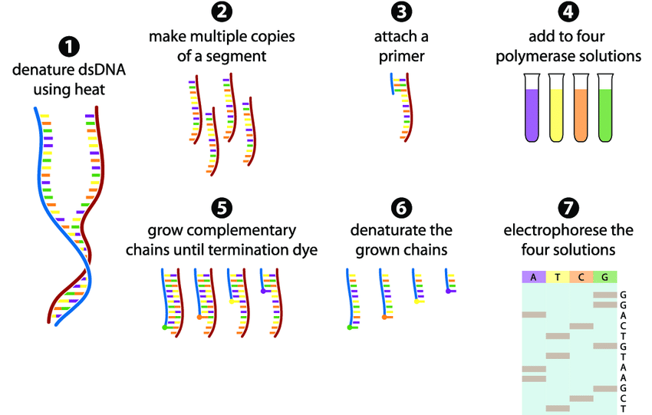

**Figure 2:  Sanger sequencing for application in phylogenetic analysis [36]**

1. **Next Generation Sequencing**

Next-generation sequencing (NGS), also known as 2nd generation sequencing, is set to reshape plant systematics, replicating the significant effects of Sanger sequencing [37]. Compared to the traditional methods of PCR and Sanger sequencing commonly used in plant systematic studies, the modern techniques of next-generation and targeted sequencing bring notable advantages in terms of time and cost. This is particularly valuable when dealing with extensive numbers of species and phylogenetic markers [38]. In order to assure the discovery of variations that are clinically relevant, it is advised to use multiple analysis tools in conjunction with next-generation sequencing, which offers time and money saving methodology for evaluating multiple targets across several modalities [39].

Next-generation sequencing technological developments have accelerated the development of herbarium genomics, giving a vital route for exploring historic biological theories in plant research [40, 41]. The function of PCR in library preparation allows commercial 2nd generation sequencing technologies to be distinguished from one another (Figure 3). Mostly, PyrosequencingTM, and Illumina® sequencing are the two NGS methods most frequently employed [42]. These NGS technologies have significantly advanced the field of plant taxonomy by providing high-throughput and cost-effective methods by providing large-scale genomic data, higher resolution, and comprehensive insights into plant diversity, evolutionary relationships, and species identification. NGS have proven to be an an indispensable tool for taxonomists, facilitating more accurate and efficient classification and understanding of the complex relationships among plant species.



**Figure 3: Steps involved in DNA fingerprinting, barcoding and NGS [42].**

1. **Oxford Nanopore Technology**

Oxford Nanopore Technology comes under third generation sequencing that works on developing a single-molecule, electrical, label-free DNA sequencing technique. This method aims to eliminate the requirement for amplification or labelling by sensing a straight electrical signal instead [43]. The use of Oxford Nanopore technology, along with complementary sequencing and analysis methods, significantly enhanced the understanding of *Atriplex hortensis*, its genetic variation, and phylogenetic positioning [44].

1. **High-throughput metagenomic shotgun sequencing**

High-throughput metagenomic shotgun sequencing is a powerful and advanced method used to analyze the collective genetic material of microbial communities present in a given environment. It provides a comprehensive and unbiased snapshot of all the DNA sequences (including both host and microbial DNA) present in a sample, without the need for prior knowledge or specific target sequences [45]. High-throughput metagenomic shotgun sequencing is very helpful for generating more complete genetic data from taxonomically significant decade old isotype herbarium specimens [46]. Concurrently, the msGBS (multispecies genotyping by sequencing) methodology, aids in plant taxonomy by quantifying multiple plant species in belowground interactions offering an advanced and scalable tool for studying complex root communities [47].

1. **Metagenomics**

Metagenomics enables the study of entire genetic material from environmental samples, providing insights into the diversity and distribution of plants in specific habitats. It harnesses the power of next-generation sequencing and bioinformatics technologies to explore the genetic diversity, abundance, composition, and metabolic pathways. Metagenomics can be a valuable tool in plant taxonomy, providing data that complements traditional morphological and molecular methods. The analysis of plant-associated microbial communities can enhance our understanding of plant diversity, evolutionary relationships, and ecological interactions, ultimately contributing to the advancement of plant taxonomy [48]. Metagenomics is known to enhance plant taxonomy by analyzing the diverse microbial communities in the rhizosphere of *Paspalum scrobiculatum* [49].

E. **Transcriptome sequencing**

Transcriptome sequencing, also known as RNA-Seq, is a powerful biotechnological tool to study and analyze the transcriptome of an organism. Complete plastid genome sequencing has facilitated analyses of hundreds of taxa at deep levels and allowed phylogeographic studies at the population level. Gene capture method promises rapid and inexpensive analyses of plastid genomes and targeted nuclear loci [50].

The transcriptome sequencing of *Dendrocalamus sinicus* study identified 8,553 simple sequence repeats (SSRs) and 81,534 single-nucleotide polymorphisms (SNPs). These molecular markers are valuable for population studies, genetic diversity assessment, and breeding programs [51]. The insights gained from transcriptome analysis can enhance the accuracy of plant classification, identify diagnostic markers for species discrimination, and shed light on the evolutionary relationships between different plant taxa.

1. **Plastome sequencing**

The process of determining and analyzing the complete DNA sequence of the plastid genome (plastome) of an organism. Plastome sequencing is a frequent application of next-generation sequencing (NGS) techniques, as demonstrated [52], which utilized 93 samples across 12 angiosperm families. Notably, 73 of these samples were derived from herbarium specimens as old as 146 years, yielding adequate paired-end reads for 84 specimens and ultimately achieving successful plastome assemblies for 74 of them. This shows that outline plastome sequencing from herbarium specimens is feasible and affordable and can be carried out with little sample destruction.

1. **Genotyping by sequencing**

A revolutionary technique called Genotyping by sequencing (GBS) combines genotyping and next-generation sequencing. It has a variety of uses, from general marker discovery to genome selection, making it a promising strategy that is likely to offer fresh insights into plant biology [53]. In 94 Amaranth accessions, GBS was used to identify 10,668 SNPs, the majority of which were species-specific, and these SNPs can be used for marker creation during further Amaranth research [54]. GBS uses genome-wide SNP markers to characterize *Lens culinaris* germplasm and identify gene pools in wild relatives

It assists in establishing connections and identifying misclassified samples, rendering it a valuable resource for plant breeders focused on crop wild relatives [55].

1. **Phylogenetics and Phylogenomics**

Unlike traditional phylogenetics, which often focuses on a few specific genes or traits, phylogenomics involves analyzing whole genomes or a significant portion of the genome of multiple species. They use genetic and genomic data to infer the branching patterns of evolutionary history, showing how different species are related to each other through common ancestry [56]. The current phylogenomic research on *Oryza* serves as an illustration of how phylogenomics has proven its strength and enormous potential in resolving challenging phylogenetic questions [57].

1. **Genome skimming**

Genome skimming is a next-generation sequencing (NGS) approach that provides a broad overview of genomic information from an organism without performing whole-genome sequencing [58]. Genome skimming of Core Goodeniaceae samples allowed researchers to analyze plastome coding regions (CDS), nuclear ribosomal repeats (NRR), and nuclear G3PDH gene, significantly contributing to plant taxonomy by providing extensive genetic data that aids in resolving deep phylogenetic nodes and make informed taxonomic decisions [59]. Genome skimming was applied to milkweed plants (*Asclepias syriaca*) and related genera to demonstrate its effectiveness in generating genome-scale data sets for phylogenomics and has proven to be highly valuable in plant systematics and evolution studies [60].

**V. CONVENTIONAL MOLECULAR MARKERS**

Genetic diversity in conventional plant breeding was identified through observational selection. Three primary types of genetic variations encountered in biological genomes are simple sequence repeat (SSRs or microsatellite polymorphisms), single nucleotide polymorphisms (SNPs), and copy number variations (CNVs) [61]. DNA polymorphisms are useful for analysis and are frequently utilized in molecular genetic investigations because they act as a genetic marker [62].

These DNA-based markers can be divided into two categories: PCR-based markers (RAPD, AFLP, SSR, SNP, etc.) and non-PCR-based markers (RFLP) (Table 2). The microsatellite DNA marker, among others, has been the one that is most frequently employed because it is straight forward to utilize by PCR, followed by a denaturing gel electrophoresis for determining allele size, and because of the high level of information offered by its numerous alleles per locus [63]. Study on *Gossypium hirsutum* (cv. CCRI36) and *G. barbadense* (cv. H7124) as the plant species for the development and application of the ISAP (Intron-based Sequence Amplification Polymorphism) marker system suggested that these are PCR-based marker that targets gene sequences, providing functional molecular markers with high polymorphism and efficient amplification of adjacent expressed sequences. It offers valuable applications in map construction, QTL analysis, and gene mapping for plant breeding and selection [35].

1. **DNA FINGERPRINTING IN PLANTS**

DNA fingerprinting in plants was developed later, building upon the principles and methods established by Alec Jeffreys and other researchers in the field of human genetics. The application of DNA fingerprinting to plants emerged as a powerful tool for studying plant genetics, biodiversity, and conservation. The use of DNA fingerprinting as a taxonomic tool in finding the variation in the species proved to be a helpful addition to morphology, particularly in plant groups with low rates of genetic recombination [64]. A rapid, dependable, and highly informative technique for DNA fingerprinting is provided by bulk analyses of RAPD and ISSR PCR markers [65]. Reference [66], evaluated the use of several DNA marker methods for fingerprinting 39 potato cultivars. RAPDs (20 primers), ISSRs (6 primers), AFLPs (2 primers), and SSRs (5 primer pairs) were the four methodologies that were looked into.

In addition to traditional phenotypic techniques, RFLP, RAPD, AFLP, microsatellites (SSRs), and SNPs, are used in plant taxonomy to identify and characterize plant species, evaluate genetic diversity and address evolutionary and taxonomic questions, complementing traditional phenotypic methods [67].

1. **Restriction Fragment Length Polymorphism**

DNA sequence variations within genes or other targeted DNA regions can be identified through the RFLP analysis, a technique that utilizes restriction endonuclease digestion (Figure 4). The construction of the *Arabidopsis thaliana* nuclear genome involves the integration of a genetic map with restriction fragment length polymorphism, providing a basis for developing a more accurate and applicable map [68]. The use of RFLP analysis to investigate genetic linkages and variation within the tomato genus *Lycopersicon*, yielding important information about how different species within the genus are classified, behave when mating, and produce varied colours of fruit [69]. Plant taxonomy employs RFLP analysis to explore the ancestry and evolutionary history of cultivated *Brassica* species [70].

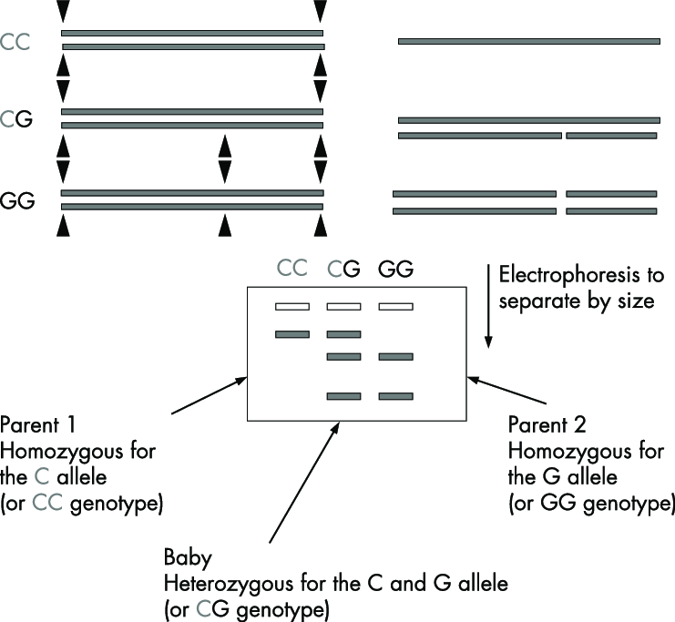

.

**Figure 4: RFLP and detection of alleles [71]**

1. **Random Amplified Polymorphic DNA**

RAPD is a PCR-based method, employing short random primers to amplify genomic DNA at various locations (Figure 5). After amplification, the resulting fragments are observed using agarose gel electrophoresis. RAPDs are capable of detecting meaningful genetic variations within entire genomes [72]. RAPD analysis can be used to create genome-specific markers that can identify between cultivars of wheat, wild *Triticum* and *Aegilops* species, and other plant species. It has also been used to find particular markers for the D and U genomes [73]. Using RAPD analysis, it was possible to determine the species and relationships between *Brassica, Sinapis,* and *Raphanus*. In general, RAPD analysis holds promise for conducting taxonomic investigations across different levels, including populations, species, and possibly genera.

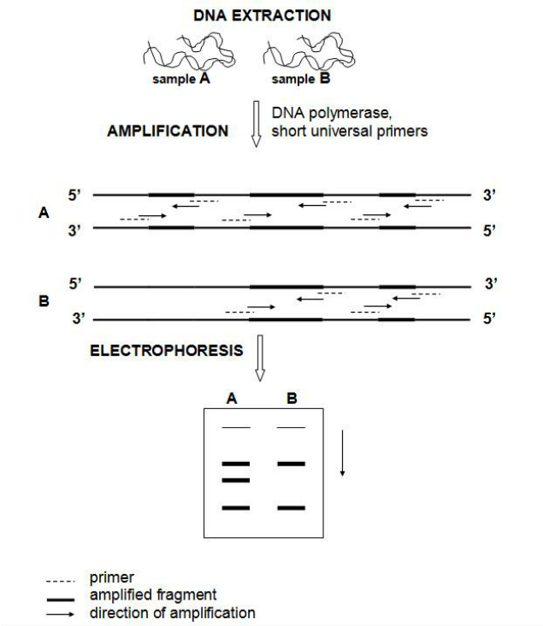

**Figure 5: Principle of RAPD-PCR technique [74]**

1. **Amplified Fragment Length Polymorphism**

The selective PCR amplification of DNA restriction fragments under exacting PCR conditions is the foundation of the AFLP technology (Figure 6). Utilizing two restriction endonucleases in tandem, the method entails digesting genomic DNA [75]. AFLP is a promising tool for evolutionary investigations because it is an effective and trustworthy method for producing biosystematic data [75]. AFLP is a new molecular marker technology which is straight forward and reliable method that might be highly beneficial in a wide range of conservation studies [76]. As part of a study [77], 87 taxa of the *Citrus, Fortunella,* and *Poncirus* families were examined using the AFLP method with two chosen primer pairs. The genetic connections between the species within these genera were unveiled through the creation of a molecular systematic tree using Nei's genetic distance. AFLP is employed to investigate taxonomic connections within the *Vicia* genus and effectively recognized closely related taxa within the *Vicia sativa* aggregate. AFLP helps clarify the taxonomy and detect potential hybridization events [78].

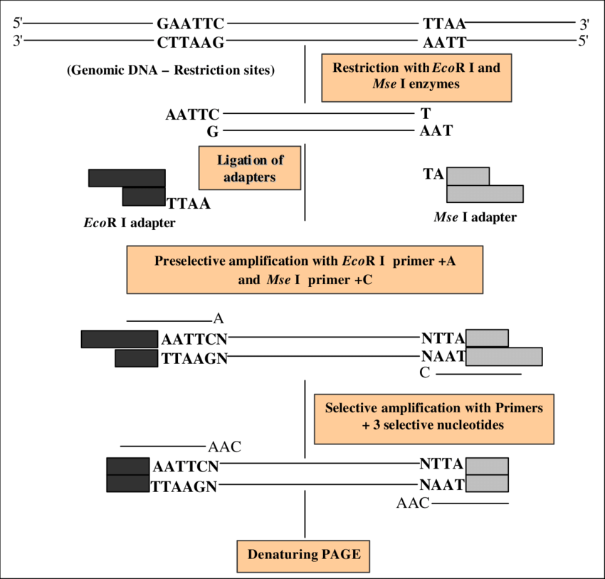

**Figure 6: Principle of the AFLP method [79]**

1. **Microsatellites**

Microsatellites, also known as Single Sequence Repeats (SSRs), are commonly employed in plant genetic research, utilizing genotyping methods of varying throughput levels. Because of its co-dominance and stability of results, SSR is comparatively a more accurate molecular marker [80]. Due to their extensive allelic variability, codominant inheritance, and ease of analysis, SSR-based markers are set to play a crucial role in various research work, including taxonomic investigations, phylogenetic reconstructions, genome mapping, and studies focused on the genetics of populations [81]. Reference [82], adopted the SSR markers to study *Rosa* hybrid, in order to enhance flower trait development, breeding, and taxonomy, genomic and floral transcriptome sequencing. These markers allowed the examination of genetic links across contemporary rose accessions and other *Rosa* species.

1. **Single Nucleotide Polymorphism**

SNPs are the most prevalent marker system in both plant and animal genomes, and they have lately become the new generation of molecular markers for a variety of uses (Figure 7). Moreover, unlike microsatellites, their strength lies in the extensive array of loci that can be examined, rather than the number of alleles [83]. The study on Litchi cultivars suggested that the SNP markers could be used to identify and characterize more precisely, clearing up confusion in cultivar nomenclature and improving knowledge of the genetic connections between different Litchi accessions [84]. SNP markers aid in evaluating the molecular categorization of Melon cultivars, while also emphasizing the limitation of relying solely on horticultural groups as botanical classifications [85].

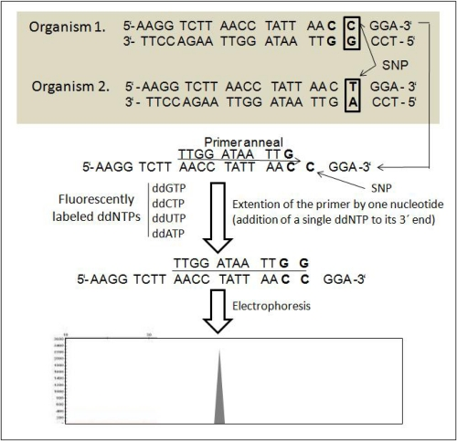

**Figure 7: A flow-chart outlining the core concept of the SNP method [67]**

**Table 2: Analyzing and differentiating the five prevalent DNA markers extensively used in plant studies [86]**

|  |  |  |  |  |  |
| --- | --- | --- | --- | --- | --- |
| **Criteria** | **RFLP** | **RAPD** | **AFLP** | **SSR** | **SNP** |
| Genomic coverage | Low copy coding region | Whole genome | Whole genome | Whole genome | Whole genome |
| Amount of DNA required | 10µg-50 | 100ng-1 | 100ng-1 | 120ng-50 | ≥50ng |
| Quality of DNA required | High | Low | High | Medium High | High |
| Type of polymorphism | Single base changes, indels | Single base changes, indels | Single base changes, indels | Changes in length of repeats | Single base changes indels |
| Level of polymorphism | Medium | High | High | High | High |
| Effective multiplex ratio | Low | Medium | High | High | Medium to high |
| Inheritance | Co-dominant | Dominant | Dominant / Codominant | Co-dominant | Co-dominant |
| Types of probes/ primers | Low copy DNA cDNA clone or | Usually 10 bp random nucleotides | Specific sequence | Specific sequence | Allele- specific PCR primers |
| Technically demanding | High | Low | Medium | Low | High |
| Radioactive detection | Usually yes | No | Usually yes | Usually no | No |
| Reproducibility | High | Low to medium | High | High | High |
| Time demanding | High | Low | Medium | High | High |
| Automation | Low | Medium | High | High | High |
| Development start up cost | High | Low | Medium | High | High |
| Proprietary rights required | No | Yes and licensed | Yes and licensed | Yes and some licensed | Yes and some  Licensed |
| Suitable utility in diversity, genetics and breeding | Genetics | Diversity | Diversity and genetics | All purposes | All purposes |

1. **Fluorescence in situ hybridization**

Complete nuclear genome sequencing is becoming common place, providing new opportunities for systematic comparative genomics research. Nevertheless, despite falling sequencing prices and technological breakthroughs, genome assembly continues to be a significant difficulty [50]. Fluorescence in situ hybridization (FISH) has showcased its utility in plant taxonomy, exemplified by its application in investigating three *Larix* species: *L. sibirica, L. gmelinii,* and *L. cajanderi*. FISH was used to analyze the karyotypes of these taxa and identify specific ribosomal RNA gene loci [87]. The utilization of FISH mapping for 35S rDNA in wild *Lilium* species contributed to comprehending their taxonomic position, evolutionary history, and variations in karyotype. [88].

1. **CRISPR-Cas9 Technology**

Clustered Regularly Interspaced Short Palindromic Repeats-Cas9 is an innovative gene-editing tool, empowers accurate manipulation of plant genomes, marking a ground breaking advancement. It has been used in plant taxonomy to study specific genes and genetic markers, helping to resolve phylogenetic relationships between closely related species. Research on *Dendrobium officinale* orchid effectively employed the CRISPR/Cas9 system to modify genes within the plant's own genome [89]. These edits can potentially serve as DNA markers for studying genetic variation and evolutionary relationships within *D. officinale* and related orchid taxa. CRISPR/Cas9 has the potential to significantly advance the study of plant taxonomy, allowing for precise genetic modifications and molecular research in various plant species, including medicinal plants [90, 91, 92]. Its versatility allows researchers to precisely edit the DNA sequences of various plant species [93].

1. **Short Interspersed Nuclear Elements**

SINEs are repetitive DNA non-coding elements that can be found in plants and are capable of retro transposition and can move within the genome, making them potentially useful markers for phylogenetic studies [94, 95]. Reference [96] unveiled the initial observation of a plant SINE family's widespread occurrence in various lineages. Their research investigated the distribution and evolution of Au SINE within plants, with particular attention to its progression in the Gramineae and Fabaceae. The 'Angio-domain' is present and conserved in SINEs across a variety of plant species, which raises the possibility that it could be used as an important identifier in plant taxonomy [97].

1. **Proteomics**

Proteomics is an essential aspect of plant biology that aids in understanding the phylogenetic relationships among plant taxa, characterizing individual lines, decoding gene functions, and studying plant development and responses to the environment [98]. In the case of Holm Oak (*Quercus ilex* subsp. *ballota*) populations, proteomic analyses help catalog and understand the protein profiles, contributing to the study of plant taxonomy and the relationships between different populations of the species [99]. Subsequently, proteomics in plant taxonomy involves comparing proteomes of various Brassicaceae species and genera to establish genetic relationships [100].

1. **ARTIFICIAL INTELLIGENCE AND PLANT TAXONOMY**

The proposed Artificial Intelligence (AI) system, which employs portrait and aerial photos for plant and weed identification, enhances accuracy and is appropriate and accurate in every class of comparison, making it a useful tool for farmers in obtaining the highest possible return on vegetable plantations [101]. Artificial neural networks (ANNs), more specifically a Multi layer perceptron (MLP), can be used to identify higher plants using morphological traits gathered through conventional methods. ANNs outperform the DELTA (DEscription Language for TAxonomy) key generator [102]. Based on an Android application created as part of the Pl@ntNet project, these apps offer Android users a useful method for plant identification and have acceptable identification accuracy [103] (Figure 8). The computer-based plant identification system consists of two primary elements: the semi-automatic graphical tool and the automatic method for identifying plants using leaf images [104]. ApLeaf, a mobile application developed for Android devices, utilizes leaf images to achieve automated plant species identification. This app demonstrates impressive identification accuracy, employing cutting-edge techniques and providing users with access to a selection of species that closely match the input leaf image [105]. The Tchebichef Moment Invariant (TMI) feature and General Regression Neural Network (GRNN) classifier, which obtained a 100% classification rate in identifying plant species based on leaf photos, can also be used to create automated plant classification tools [106]. Automatic plant identification crowd sourcing systems based on images for botanical data collection have been accepted by a large number of users [107]. The accuracy of an automated plant identification system that uses a deep convolutional neural network to identify plant species through their leaves is 97% [108]. In accordance with reference [109], a novel technique termed D-Leaf, which employs a Convolutional Neural Network (CNN), has been introduced as a valuable automated solution for species identification in plants. The effectiveness and possible capacities of image-based methods and software in plant research are showcased by the user-friendly nature of Maize-IAS. This further underscores the practicality and potential of AI technology applied within the fields of agriculture and plant science [110].

**

**Figure 8: Pl@ntNet (Android based application)**

1. **CONCLUSION AND FUTURE PERSPECTIVE**

The modern biotechnological tools bring an insight into the techniques that are empowering in plant taxonomical investigations for delineation between the taxa, and for understanding the unresolved morphological complexity with species level resolution. Specifically, next-generation sequencing and bioinformatics analysis, along with high-throughput plastome sequencing, have emerged as exceptional taxonomic resources. Recent developments in non-destructive genetic sampling and techniques for handling minute genomic DNA quantities, especially in the context of next-generation sequencing and bioinformatics analysis of ancient DNA, have opened up the possibility of utilizing a vast array of herbarium specimens for phylogenetic, population genetic, and barcoding investigations.

Enhancing the communication of taxonomic revisions and valuable plant-related insights can be achieved more effectively through online platforms that serve as collaborative hubs for plant genomics research. This encompassing research field includes studies on evolution, genetics, plant breeding, molecular biology, biochemistry, and system biology, all aimed at collecting plant sequencing data to propel molecular taxonomic investigations forward. Furthermore, the promising performance of automated plant identification systems has been demonstrated through the utilization of artificial systems for plant identification. Researchers and scientists have been able to advance science and knowledge through the application of these contemporary approaches in the study of plant taxonomy and systematic. Overall, the potential of biotechnological tools utilized in plant taxonomy to enhance our knowledge of plant diversity, evolution, and conservation is seminal. These technologies will remain as the leading competitors for taxonomic study, enabling more precise and effective species identification and categorization, ultimately supporting our efforts to protect and sustain the plant life on Earth.

1. **REFERENCES**

[1] B.P. Sheth, and V.S. Thaker, “DNA barcoding and traditional taxonomy: an integrated approach for biodiversity conservation,” Gen. vol. 60, pp. 618-628, April 2017.

[2] P. Bonnet, A. Joly, H. Goëau, J. Champ, C. Vignau, J. Molino, D. Barthélémy, and N. Boujemaa, “Plant identification: man vs. machine. Multimedia Tools and Applications,” vol. 75, pp. 1647-1665, Feb 2016.

[3] A. Wilmotte, “Molecular Evolution and Taxonomy of the Cyanobacteria,” in The Molecular Biology of Cyanobacteria. Advances in Photosynthesis, vol.1, D.A. Bryant, Eds. Dordrecht: Springer, 1994, pp. 1-25.

[4] K. Thompson, and S. Newmaster, “Molecular taxonomic tools provide more accurate estimates of species richness at less cost than traditional morphology-based taxonomic practices in a vegetation survey,” Biodiver. Cons. vol. 23, pp. 1411-1424, June 2014.

[5] S. Suranto, “Studies on Ranunculus Population: Isozymic Pattern,” Biodiv. J. Bio. Div. vol. 2, Jan 2001.

[6] C.A. Stace, “Classification by molecules: what's in it for field botanists?,” Wats. vol. 28, pp. 103, July 2010.

[7] E. Zuckerkandl and L Pauling, “Evolutionary divergence and convergence in proteins,” in InEvolving genes and proteins, Academic Press, 1965, pp. 97-166.

[8] C.R. Woese, and G.E. Fox, “Phylogenetic structure of the prokaryotic domain: the primary kingdoms,” Pro. Nat. Aca. Sci. vol. 74, pp. 5088-5090, Nov 1977.

[9] A.P.G, “An ordinal classification for the families of flowering plants,” An. Mis. Bot. Gar. pp. 531-153, Jan 1998.

[10] P.D. Hebert, A. Cywinska, S. Ball, and J. deWaard “Biological identifications through DNA barcodes,” Pro. Roy. Soc. London, vol. 270, pp. 313-321, Feb 2003.

[11] D. Steinke, M. Vences, W. Salzburger, and A. Meyer “TaxI a software tool for DNA barcoding using distance methods,” Phi. Tran. Roy. Soc. B: Bio. Sci. vol. 360, pp. 1975-1980, Oct 2005.

[12] S. Ratnasingham, and P.D. Hebert, “BOLD: The Barcode of Life Data System (http://www. barcodinglife. org),” Mole. Eco. Not. vol. 7, pp. 355-364, May 2007.

[13] E. Park, J. Kim, and H. Lee, “Plant DNA barcoding system for forensic application,” For. Sci. Int. Gen. Sup. Ser. vol.6, pp. e282-e283, Dec 2017.

[14] M. Källersjö , J.S Farris, M.W. Chase, B. Bremer, M.F Fay, C.J. Humphries, G. Petersen, O. Seberg, and K. Bremer, “Simultaneous parsimony jackknife analysis of 2538 rbcL DNA sequences reveals support for major clades of green plants, land plants, seed plants and flowering plants,” Pl. Syst. Evo. vol. 213, pp. 259-287, Sep 1998.

[15] M.Y. Stoeckle, and P.D. Hebert. “Barcode of life,” Sci. Am. vol. 299, pp. 82-89, Oct 2008.

[16] F. Mattia, R. Gentili, I. Bruni, A. Galimberti, S. Sgorbati, M. Casiraghi, and M. Labra, “A multi-marker DNA barcoding approach to save time and resources in vegetation surveys,” Bot. J. Linn. Soc. vol. 30, pp. 1207-1216, Sep 2012.

[17] W. Gu, J. Song, Y. Cao, Q. Sun, H. Yao, Q. Wu, J. Chao, J. Zhou, W. Xue, and J. Duan, “Application of the ITS2 Region for Barcoding Medicinal Plants of Selaginellaceae in Pteridophyta,” PL. One, vol. 8, p. e67818, Jun 2013.

[18] R.S. Purty, and S. Chatterjee, “DNA barcoding: an effective technique in molecular taxonomy” Austin J. Biotechnol. Bioeng. vol 3, pp. 1059, 2016.

[19] C. Husin, D. Naim, and M. Ahmad, “Authentication of a selected medicinal plants using DNA barcoding technique” In SHS Web of Conferences, vol. 45, 2018, EDP Sci. pp. 05004.

[20] P. Soledispa, E. Santos-Ordóñez, M. Miranda, R. Pacheco, Y.I. Gaiten, and R. Scull, “ Molecular barcode and morphological analysis of Smilax purhampuy Ruiz,” Ecuador. PeerJ. vol. 9, pp. e11028, Mar 2021.

[21] Q. Li, J. Wu, Y. Wang, X. Lian, F. Wu, L. Zhou, Z. Huang. and S. Zhu, “The phylogenetic analysis of *Dalbergia* (Fabaceae: Papilionaceae) based on different DNA barcodes,” Holzfors. vol. 71, pp. 939-949, Nov 2017.

[22] M. Polling, M. Sin, L.A. de Weger , A.G Speksnijder, M.J. Koenders, H. de Boer, and B. Gravendeel, “DNA metabarcoding using nrITS2 provides highly qualitative and quantitative results for airborne pollen monitoring,” Sci. Tot. Env. vol. 806, pp. 150468, Feb 2022.

[23] Y. Ji, C. Liu, J. Yang, L. Jin, L., Z. Yang, and J. Yang, “ Ultra-Barcoding Discovers a Cryptic Species in *Paris yunnanensis* (Melanthiaceae), a Medicinally Important Plant,” Front. Pl. Sci. vol. 11, pp. 411, April 2020.

[24] M. Gostel, J. Zúñiga, W. Kress, V. Funk, and C. Puente-Lelièvre, “Microfluidic Enrichment Barcoding (MEBarcoding): a new method for high throughput plant DNA barcoding,” Sci. Rep. vol. 10, pp. 8701, May 2020.

[25]S. Uribe-Convers, M.L. Settles, and D.C. Tank, “A targeted subgenomic approach for phylogenomics based on microfluidic PCR and high throughput sequencing,” bioRxiv. pp. 021246, Jun 2015.

[26] S. Ouyang, and C. Buell, “The TIGR Plant Repeat Databases: a collective resource for the identification of repetitive sequences in plants,” Nuc. Ac. Res. vol. 32, pp. D360-D363, Jan 2004.

[27] P. Kuksa, and V. Pavlovic, “Efficient alignment-free DNA barcode analytics,” BMC Bioinfor. vol. 10, pp. 1-8, Nov 2009.

[28] C. Li, Z. Yu, G. Han, and K. Chu, “Analyzing Multi-locus Plant Barcoding Datasets with a Composition Vector Method Based on Adjustable Weighted Distance,” PL. One, vol. 7, pp. e42154, July 2012.

[29] F. Sanger, S. Nicklen, and A.R. Coulson, “DNA sequencing with chain-terminating inhibitors,” Proc. Natl. Acad. Sci. vol. 74, pp. 5463-5467, Dec. 1977.

[30] W.M Barnes, “DNA sequencing by partial ribo-substitution,” J. Mol. Bio. vol. 119, pp. 83-99, Feb 1978.

[31] F. Sanger, A.R. Coulson, G.F. Hong, D.F. Hill, and G.B Petersen, “Nucleotide sequence of bacteriophage λDNA,” J. Mol. Biol. vol. 162, pp. 729-773, Dec 1982.

[32] A.M. Maxam, and W. Gilbert, “A new method for sequencing DNA,” Proc. Natl. Acad. Sci. vol. 74, pp. 560-564, Feb 1977.

[33] S.F. Altschul, W. Gish, W. Miller, E.W. Myers and D.J. Lipman,” Basic local alignment search tool,” J. Mol. Biol. vol. 215, pp. 403-410, Oct 1990.

[34] W.J Kress, D.L. Erickson, F.A. Jones, N.G. Swenson, R. Perez, O. Sanjur, and E. Bermingham, “Plant DNA barcodes and a community phylogeny of a tropical forest dynamics plot in Panama,” Proc. Natl. Acad. Sci. USA, vol. 106, pp. 18621-18626, Nov. 2009.

[35] C. Lu, S. Yu, J. Yu, S. Fan, M. Song, W. Wang, and S. Ma. “Development and appraisement of functional molecular marker: intron sequence amplified polymorphism (ISAP)]” Yi chuan = Hereditas, vol. 30, pp. 1207-1216, Sep 2008.

[36] M.G. Gauthier, “Simulation of polymer translocation through small channels,” PhD Dissertation, University of Ottawa, 2007.

[37] S. Straub, M. Parks, K. Weitemier, M. Fishbein, R. Cronn, and A. Liston, “Navigating the tip of the genomic iceberg: Next-generation sequencing for plant systematic,” Amer. J. Bot. vol. 99, pp. 349-364. Feb 2012.

[38] G. Godden, I. Jordon-Thaden, S. Chamala, A. Crowl, N. García, C. Germain-Aubrey, J. Heaney, M. Latvis, X. Qi, and M. Gitzendanner, “Making next-generation sequencing work for you: approaches and practical considerations for marker development and phylogenetics,” Pl. Eco. Div. vol. 5, pp. 427-450, Dec 2012.

[39] H. Williams, K. Walsh, A. Diamond, A. Oniscu, and Z. Deans, “ Validation of the Oncomine™ focus panel for next-generation sequencing of clinical tumour samples,” Vir. Archiv. vol. 473, pp. 489-503, Oct 2018.

[40] R.M Gutaker, and H.A Burbano, “Reinforcing plant evolutionary genomics using ancient DNA” Curr. Opi. Pl. Bio. vol. 36, pp. 38-45, April 2017.

[41] F.T. Bakker, “Herbarium genomics: plant archival DNA explored,” Paleogen. Gen. Sc. Ana. An. DNA. vol. 117, pp. 33-43, Jan 2016.

[42 N.J. Sucher, J.R. Hennell, and M.C. Carles, “DNA fingerprinting, DNA barcoding, and next generation sequencing technology in plants,” in: Plant DNA fingerprinting and barcoding: methods and protocols, Humana Press, 2012, vol. 862, pp.13-22.

[43] J. Clarke, H.C. Wu, L. Jayasinghe, A. Patel, S. Reid, and H. Bayley, “Continuous base identification for single-molecule nanopore DNA sequencing,” Nat. Nanotech. vol. 4, pp. 265-270, April 2009.

[44] S.P. Hunt, D.E. Jarvis ,D.J. Larsen, S.I. Mosyakin, B.A. Kolano, E.W. Jackson, S.L. Martin, E.N Jellen, and P.J. Maughan, “ A chromosome-scale assembly of the garden orach (*Atriplex hortensis* L.) genome using Oxford Nanopore sequencing,” Front. Pl. Sci. vol.11, pp. 624, May 2020.

[45] T.J. Sharpton, S.J Riesenfeld, S.W Kembel, J. Ladau, J.P. O'Dwyer, J.L. Green, J.A. Eisen, and K.S. Pollard, “PhylOTU: a high-throughput procedure quantifies microbial community diversity and resolves novel taxa from metagenomic data,” PLoS Comp. Bio. vol. 7, pp. e1001061, Jan 2011.

[46] S. Leavitt, R. Keuler, C. Newberry, R. Rosentreter, and L. Clair, “Shotgun sequencing decades-old lichen specimens to resolve phylogenomic placement of type material,” Pt. F. Sys. vol. 64, pp. 237-247, Oct 2019.

[47] C.A. Wagemaker, L. Mommer, E.J Visser, A. Weigelt, T.P. van Gurp, M. Postuma, A.E. Smit-Tiekstra, and H. de Kroon, “ msGBS: a new high-throughput approach to quantify the relative species abundance in root samples of multispecies plant communities,” Mole. Eco. Res. vol 21, pp.1021-1036, May 2021.

[48] A.E. Fadiji, and O.O. Babalola, “Metagenomics methods for the study of plant-associated microbial communities: a review,” J. Microbio. Met. vol.170, pp. 105860, Mar 2020.

[49] R. Prabha, D.P. Singh, S. Gupta , V.K. Gupta, H.A. El-Enshasy, and M.K. Verma, “ Rhizosphere metagenomics of *Paspalum scrobiculatum* (kodo millet) reveals rhizobiome multifunctionalities,” Microorg. vol.7, pp. 608, Nov 2019.

[50] D.E. Soltis, M.A. Gitzendanner, G. Stull, M. Chester, A. Chanderbali, S. Chamala, I. Jordon-Thaden, P.S. Soltis, P.S. Schnable, and W.B. Barbazuk, “The potential of genomics in plant systematic,” Taxon. vol. 62, pp. 886-898, Oct 2013.

[51] K. Cui, H. Wang, S. Liao , Q. Tang, L. Li, Y. Cui, and Y. He, “Transcriptome sequencing and analysis for culm elongation of the world’s largest bamboo (*Dendrocalamus sinicus*),” Pl. One, vol. 11, pp. e0157362, June 2016.

[52] F.T. Bakker, D. Lei, J. Yu, S. Mohammadin, Z. Wei, S. van de Kerke, B. Gravendeel, M. Nieuwenhuis, M. Staats, D. E. A-Planas, and R. Holmer, “Herbarium genomics: plastome sequence assembly from a range of herbarium specimens using an Iterative Organelle Genome Assembly pipeline,” Bio. J. Linn. Soc. vol. 117, pp. 33-43, Jan 2016.

[53] A.A. Golicz, P.E. Bayer, and D Edwards, “Skim-based genotyping by sequencing,” in Plant Genotyping: Methods and Protocols. 2015, pp. 257-270.

[54] X. Wu, and M. Blair, “Diversity in Grain Amaranths and Relatives Distinguished by Genotyping by Sequencing (GBS),” Front. Pl. Sc. vol. 8. 2017.

[55] M.M. Wong, N. Gujaria-Verma, L. Ramsay, H.Y. Yuan, C. Caron, M. Diapari, A. Vandenberg, and K.E. Bett, “Classification and characterization of species within the genus Lens using genotyping-by-sequencing (GBS),” PL. One, vol.10, pp. e0122025, Mar 2015.

[56] M.R. McKain, M.G. Johnson, S. Uribe-Convers, D. Eaton, and Y. Yang , “ Practical considerations for plant phylogenomics,” App. Pl. Sci. vol.6, pp. e1038, Mar 2018.

[57] X. Zou, and S. Ge, “Conflicting gene trees and phylogenomics,” J. Syst. Ev. vol. 46, pp. 795-807, Nov 2008.

[58] C.X. Zeng, P.M. Hollingsworth, J. Yang, Z.S. He, Z.R. Zhang, D.Z. Li, and J.B. Yang, “Genome skimming herbarium specimens for DNA barcoding and phylogenomics,” Pl. Met. vol.14, pp. 1-4, Dec 2018.

[59] A.G. Gardner, E.B. Sessa, P. Michener, E. Johnson, K.A. Shepherd , D.G. Howarth, and R.S. Jabaily, “Utilizing next-generation sequencing to resolve the backbone of the Core Goodeniaceae and inform future taxonomic and floral form studies,” Mole. Phylogen. Evo. 2016, vol. 94, pp. 605-617, Jan 2016.

[60] K. Weitemier, S.C. Straub, R.C. Cronn, M. Fishbein , R. Schmickl, A. McDonnell, and A. Liston,“Hyb-Seq:Combining target enrichment and genome skimming for plant phylogenomics,” App. Pl. Sci. vol. 2, pp. 1400042, Sep 2014.

[61] R. Bernardo, “Molecular markers and selection for complex traits in plants: learning from the last 20 years,” Cr. Sci. vol. 48, pp. 1649-1664, Sep 2008.

[62] S. Teama, “DNA Polymorphisms: DNA-Based Molecular Markers and Their Application in Medicine,” in Genetic Diversity and Disease Susceptibility, L. Yamin, Eds. IntechOpen, 2018. pp. 25-40.

[63] P. Kumar, V.K. Gupta, A.K. Misra, D.R. Modi, and B.K. Pandey, “Potential of molecular markers in plant biotechnology,” Pl. Om. vol. 2, pp. 141-162, July 2009.

[64] T. Kraft, H. Nybom,, and G. Werlemark, “DNA fingerprint variation in some blackberry species (*Rubus* subg. *Rubus*, Rosaceae),” Pl. Syst. Evo. vol. 199, pp. 93-108, Mar 1996.

[65] M. Fernández, A. Figueiras, and C. Benito, “The use of ISSR and RAPD markers for detecting DNA polymorphism, genotype identification and genetic diversity among barley cultivars with known origin,” Theo. App. Gen. vol. 104, pp. 845-851, April 2002.

[66] C.E. McGregor, C.A. Lambert, M.W. Greyling, J.H. Louw, and L. Warnich, “A comparative assessment of DNA fingerprinting techniques (RAPD, ISSR, AFLP and SSR) in tetraploid potato (*Solanum* *tuberosum* L.) germplasm,” Euphy. vol. 113, pp. 135-144, May 2000.

[67] I.A. Arif, M.A. Bakir, H.A. Khan, A.H. Al Farhan, A.A. Al Homaidan, A.H. Bahkali, M.A. Sadoon, and M. Shobrak, “A brief review of molecular techniques to assess plant diversity,” Int. J. Mole. Sci. vol. 11, pp. 2079-2096. May 2010.

[68] B. Hauge, S. Hanley, S Cartinhour, J. Cherry, H. Goodman,M. Koornneef, P. Stam, C. Chang, S. Kempin, L. Medrano, and E. Meyerowitz, “An integrated genetic/RFLP map of the Arabidopsis thaliana genome,” Pl. J. vol. 3, pp. 745-54, May 1993.

[69] J.C. Miller, and S.D. Tanksley, “RFLP analysis of phylogenetic relationships and genetic variation in the genus *Lycopersicon*,” Theo. App. Gen. vol. 80, pp. 437-448, Oct 1990.

[70] K.M. Song, T.C. Osborn, and P.H. Williams, “Brassica taxonomy based on nuclear restriction fragment length polymorphisms (RFLPs) 1. Genome evolution of diploid and amphidiploid species,” Theo. App. Gen. vol. 75, pp. 784-94, May 1988.

[71] D. Harding, “Impact of common genetic variation on neonatal disease and outcome,” in Archives of Disease in Childhood-Fetal and Neonatal Edition. vol. 92, pp. 2007, F408-13.

[72] K.J. Edwards, “Randomly amplified polymorphic DNAs (RAPDs),” in Molecular Tools for Screening Biodiversity: Plants and Animals, A. Karp, P.G. Isaac, D.S. Ingram, Eds. NewYork: Chapman & Hall, 1998, pp. 171-175.

[73] S. Cenkci, M. Yıldız, M. Konuk, and Y. Eren, “RAPD analyses of some wild Triticum l. and Aegilops l. species and wheat cultivars in Turkey”. Ac. Biolog. Cracov. Ser. Bot. vol. 50, pp. 35-42, Jan 2008.

[74] A. Pasqualone, “Cultivar identification and varietal traceability in processed foods: A molecular approach,” in Cultivars: Chemical Properties, Antioxidant Activities and Health Benefits, K. Carbone, Eds. Nova Science Publisher Inc., 2013, pp. 83-105.

[75] J. Kardolus, H. Eck, and R. Berg, “The potential of AFLPs in biosystematics: A first application in *Solanum* taxonomy (Solanaceae),” Pl. Syst. Evo. vol. 210, pp. 87-103, March 1998.

[76] V. Lucchini, “AFLP: a useful tool for biodiversity conservation and management.” Comp. Ren. Bio. vol. 326, pp. 43-48, Aug 2003.

[77] G. Liang, G. Xiong, Q. Guo, Q. He, and X. Li, “AFLP analysis and the taxonomy of Citrus,” in XXVII Int. Hort. Cong -IHC2006, II Inter. Sym. Pl. Gen. Res. Hort. vol. 760 pp. 137-142, Aug 2006.

[78] M. van de Wouw, N. Maxted,K. Chabane, and B.V. Ford-Lloyd, “Molecular taxonomy of *Vicia* ser. *Vicia* based on amplified fragment length polymorphisms,” Pl. Sys. Evo. vol. 229, pp. 91-105, Aug 2001.

[79] M.C. Yadav, “DNA markers in crop improvement. Molecular Genetics Laboratory,” Nat. Res. Cen. Mush. Ind. Coun. Agri. Res. Solan-173, pp. 213, 2008.

[80] K. Abdellatif, and Y. Khidr, “Genetic diversity of new maize hybrids based on SSR markers as compared with other molecular and biochemical markers,” J. Cr. Sci. Biotech. vol. 13, pp.139-145, Sep 2010.

[81] R. Singh, S. Sheoran, P. Sharma, and R. Chatrath, “Analysis of simple sequence repeats (SSRs) dynamics in fungus *Fusarium graminearum*,” Bioinfor. vol. 5, pp. 402-404, Feb 2011.

[82] W. Qi, X. Chen, P. Fang, S. Shi , J. Li , X. Liu ,X. Cao, N. Zhao, H. Hao, Y. Li, and Y. Han, “Genomic and transcriptomic sequencing of *Rosa hybrida* provides microsatellite markers for breeding, flower trait improvement and taxonomy studies,” BMC Pl. Bio. Vol. 18, pp. 1-1, Dec 2018.

[83] J.T. Foster, G.J. Allan, A.P. Chan, P.D. Rabinowicz, J. Ravel, P.J. Jackson, and P. Keim, “Single nucleotide polymorphisms for assessing genetic diversity in castor bean (*Ricinus communis*),” BMC Plant Biol. vol. 10, pp. 13–23, Dec 2010.

[84] W. Liu, Z. Xiao, X. Bao , X. Yang, J. Fang, and X. Xiang, “ Identifying litchi (*Litchi chinensis* Sonn.) cultivars and their genetic relationships using single nucleotide polymorphism (SNP) markers,” PL. One, vol. 10, pp.e0135390, Aug 2015.

[85] J. Jung, G. Park, J. Oh, J.K. Jung, E.J. Shim, S.M. Chung, G.P. Lee, and Y. Park, “Assessment of the current infraspecific classification scheme in melon (*Cucumis melo* L.) based on genome-wide single nucleotide polymorphisms,” Hort. Env. Biotech. vol. 61, pp. 537-547, June 2020.

[86] M. Kordrostami, and M. kers Rahimi, “Molecular marin plants: concepts and applications,” Genet. 3rd Millenn, vol. 13, pp.4024-4031, 2015.

[87] O.V. Goryachkina, E.D. Badaeva, E.N. Muratova, and A.V. Zelenin, “Molecular cytogenetic analysis of Siberian Larix species by fluorescence in situ hybridization,” Pl. Syst. Evo. vol. 299, pp. 471-479, Feb 2013.

[88] S. Zhou, X. Chai, Z. Yang, H. Wang,C. Yang, and T. Sun, “Maize-IAS: a maize image analysis software using deep learning for high-throughput plant phenotyping,” Pl. Met.vol. 17, p.48, April 2021.

[89] L. Kui, H. Chen, W. Zhang , S. He, Z. Xiong, Y. Zhang, L. Yan, C. Zhong, F. He, J. Chen, and P. Zeng ,“ Building a genetic manipulation tool box for orchid biology: identification of constitutive promoters and application of CRISPR/Cas9 in the orchid, *Dendrobium officinale*,” Front. Pl. Sci. vol. 7, pp 2036, Jan 2017.

[90] L. Zeng, Q. Zhang, C. Jiang, Y. Zheng, Y. Zuo, J. Qin, Z. Liao, and H. Deng, “Development of *Atropa belladonna* L. plants with high-yield hyoscyamine and without its derivatives using the CRISPR/Cas9 system,” Int. J. Mol. Sci. vol. 22, pp. 1731, Feb 2021.

[91] X. Li, X. Zuo, M. Li, X. Yang, J. Zhi, H. Sun, C. Xie, Z. Zhang, and F. Wang, “ Efficient CRISPR/Cas9-mediated genome editing in *Rehmannia glutinosa*,” Pl. Ce. Rep. vol. 40, pp.1695-1707, Sep 2021.

[92] H.F. Wan, W.J. Han, L. Zhou, S. Wang, and C. Sui, “New Advances of CRISPR/Cas9 Technique and its Application in Disease Treatment and Medicinal Plants Research,” Cur. Phar. Biotech. vol. 23, pp. 1678-1690, Nov 2022.

[93] X. Liu, S. Wu, J. Xu, C. Sui, and J. Wei, “Application of CRISPR/Cas9 in plant biology,” Ac. Phar. Sin. B. vol. 7, pp. 292-302, May 2017.

[94] A. Lenoir, B. Cournoyer, S. Warwick, G. Picard and J.M. Deragon, “Evolution of SINE S1 retroposons in Cruciferae plant species,” Mole. Bio. Evo. vol. 14, pp. 934-941, Sep 1997.

[95] J.M. Deragon, and X. Zhang. “Short interspersed elements (SINEs) in plants: origin, classification, and use as phylogenetic markers,” Syst. Bio. vol. 55, pp.949-956, Dec 2006.

[96] J.A. Fawcett, T. Kawahara, H. Watanabe, and Y. Yasui, “A SINE family widely distributed in the plant kingdom and its evolutionary history,” Pl. Mol. Bio. vol. 61, pp.505-514, June 2006.

[97] K.M. Seibt, T. Schmidt, and T. Heitkam, “The conserved 3′ Angio-domain defines a superfamily of short interspersed nuclear elements (SINEs) in higher plants,” Pl. J. vol. 101, pp.681-699, Feb 2020.

[98] C.M. Ishtiaq, Q. He, J.P. Huang, Y. Wang, P.G. Xiao, and Y.C. Yi, “Biosystematics and plant proteomics: role of proteomics in plant phylogenetic analysis,” Pak. J. Bio. Sci. vol.10, pp. 3487-3496, Oct 2007.

[99] J.V. Galván, R.G. Fernández, L. Valledor, R.M. Cerrillo, and J.V. Jorrin-Novo, “Proteotyping of Holm Oak (*Quercus ilex* subsp. *ballota*) provenances through proteomic analysis of acorn flour,” Pl. Pro: Met. Prot. pp.709-23, 2014.

[100] K. Marquès, B. Sarazin, L. Chané-Favre, M. Zivy, and H. Thiellement, “Comparative proteomics to establish genetic relationships in the Brassicaceae family,” PRO: Int. Ed. vol.1, pp. 1457-1462, Nov 2001.

[101] A. Samraj, R. Kumarasamy, N.T, K.T, and R.P, “Plant Variety and Weed Growth Identification: Trending Towards Machine Learning,” Inter. J. Rec. Tech. Eng. vol. 8, July 2019.

[102] J.Y. Clark, “Artificial neural networks for species identification by taxonomists,” Biosys. vol. 72, pp.131-147, Nov 2003.

[103] S. Mouine, I. Yahiaoui, A. Verroust-Blondet, L. Joyeux,, S. Selmi, and H. Goëau, “An android application for leaf-based plant identification,” in: Proceedings of the 3rd ACM conference on International conference on multimedia retrieval, 2013, pp. 309-310.

[104] N. Pham, T. Le, P. Grard, and V. Nguyen, “Computer aided plant identification system,” Inter. Con. Comp. Manage. Telecom. (ComManTel). pp. 134-139, Jan 2013.

[105] Z. Zhao, L. Ma, Y. Cheung, X. Wu, Y. Tang, and C. Chen, “ApLeaf: An efficient android-based plant leaf identification system,” Neurocom. vol. 151, pp 1112-1119, March 2015.

[106] Z. Zulkifli, P. Saad, and I. Mohtar, “ Plant leaf identification using moment invariants & General Regression Neural Networ,” in 11th International Conference on Hybrid Intelligent Systems (HIS), pp. 430-435, Dec 2011.

[107] T.T. Nguyen, T.L. Le, H. Vu, V.S Hoang, and T.H. Tran, “Crowdsourcing for botanical data collection towards to automatic plant identification: a review,” Comp. Elec. Agri. vol. 1, pp. 412-425, Dec 2018.

[108] D. Bisen, “Deep convolutional neural network based plant species recognition through features of leaf,” Multi. Tool App. vol. 80, pp. 6443-64456, Feb 2020.

[109] J. Tan, S. Chang, S. Abdul-kareem, H. Yap, and K. Yong, “ Deep Learning for Plant Species Classification Using Leaf Vein Morphometric” IEEE/ACM Transac. Comput. Bio. Bioinfor. vol. 17, pp. 82-90, June 2020.

[110] Y.P. Zhou, Z.X. Wang, Y.P. Du, J.W. Li, H.B. He, and G.X. Jia, “Fluorescence in situ hybridization of 35S rDNA sites and karyotype of wild *Lilium* (Liliaceae) species from China: taxonomic and phylogenetic implications,” Gen. Res. Cr. Evo. vol. 67, pp. 1601-1617, Aug 2020.