APPROACH TO A CASE OF THROMBOCYTOPENIA
Authors:

Prof Dr Manoj kumar Srivastsva.
Prof Satendra Kumar Singh .
Dr V.P. Singh .

Abstract:
Platelets are anucleate blood cells that participate in primary haemostasis, the formation of a platelet plug at site of vascular injury; platelets are produced from megakaryocytes, multinucleate hematopoietic cells located in the bone marrow. Cytokines such as thrombopoietin are necessary for normal platelet maturation and release ,once released into the circulation, the average life span of a platelet is 7 to 10 days , platelets are removed from circulation when they are activated and utilised at sites of vascular injury or as they become senescent ,At any given time ,up to one third of the platelets mass is stored in the spleen ,providing a reserve of platelets that may be released during period of physiologic stress ,the normal platelets concentration in the blood is 150000/µl to 400,000/µl as measured in most hospital laboratories. Thrombocytopenia is a common haematological finding with variable clinical expression. A low platelet count may be the initial manifestation of infection such as HIV and Hepatitis C virus or it may reflect the activity of life threatening disorder such as thrombotic microangioathies. A correct identification of the causes of Thrombocytopenia is crucial for the appropriate management of these patients. In this article review, we present a systemic evaluation of adult with thrombocytopenia, the approach is clearly different between outpatients, who are frequently asymptomatic and in whom we can sometimes indulge in sophisticated and relatively lengthy investigation and the dramatic presentation of Acute thrombocytopenia in the emergency department or in the intensive care unit i.e. ICU, which require immediate intervention and only a few diagnostic tests are available.

INTRODUCTION:
Physical examination should focus on the location and severity of bleeding risk factor and other abnormalities that can help in the diagnosis of the thrombocytopenia, such as the presence of organomegally or skeletal abnormalities, patients with Thrombocytopenia typically experience mucocutaneous bleeding. The relevance of thrombocytopenia in the individual patient is variable and depends on the clinical presentation, because platelets play a essential role in preserving vessel wall integrity ,Thrombocytopenia is associated with a defect of primary haemostasis .clinically significant bleeding does not usually occur until the platelet count is less than 10 ten thousand, however, the presence of thrombocytopenia can aggravates surgical or traumatic bleeding or prevent the administration of effective treatment for several conditions egg Ant viral therapy for chronic hepatitis C virus infection or cancer chemotherapy. Thrombocytopenia appears frequently in the background of a Multi system disorder and may be determined by multiple mechanisms.
The primary function of platelets is thought to be haemostasis; thrombosis and wound healing through a complex activation of process and formation of a core and shell at the site of injury, other physiological roles for the platelets exist including immunity and communication. PRF and PRP are now a days used in wound healing and hair growth ,PRF stands out as a superior treatment option ,PRP requires more blood to be taken than PRF ,both products require the whole blood sample to be placed into a centrifuge ,where the blood is than processed to help separate the blood into distinct layers .clinical use of PRF to help promote sink rejuvenation ,hair growth and wound healing ,PRF is a completely natural aesthetic injectable that can rejuvenate the appear.
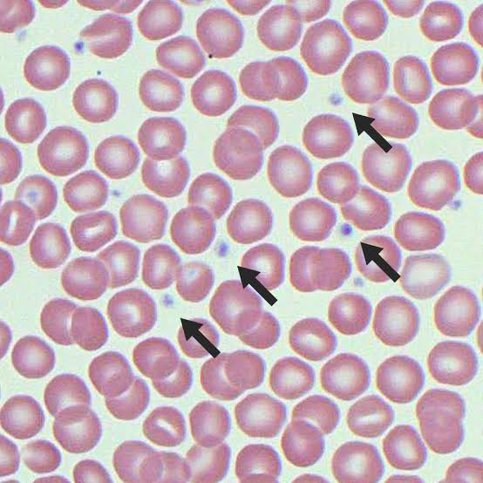
Table-1 Morphology of platelets

Aetiology and clinical features of Thrombocytopenia:
Thrombocytopenia may occur due to,
- Decreased production of platelets.
- Increased consumption of platelets.
- C- Increased sequestration of platelets.
- Any combination of this mechanism.
Regardless of the cause of thrombocytopenia, Platelet -Type bleeding is typically mucocutaneous and is characterised by petechiae, eccymoses, epistaxis, and gingival and conjunctival haemorrhages. Less commonly, severe thrombocytopenia may lead to gastrointestinal, genitourinary, or central nervous system bleeding. Spontaneous bleeding or bruising normally does not occur until the platelet count has fallen below 10.000 /µl to 20,000 /µl. The rate of decline of the platelet count may also influence the like hood of unprovoked bleeding, presumably due to compensatory processes in remaining platelets that may occur over time with persistent thrombocytopenia patients with dysfunctional platelets may bleed with higher platelets count. Patients with thrombocytopenia and platelets counts greater than 20.000/µl to 30,000/µl without bleeding usually do not require immediate treatment to increase the platelet count, a platelet count of 80.000/µl to 30,000/µl is generally adequate for Hemostasis during invasive procedures including surgery.
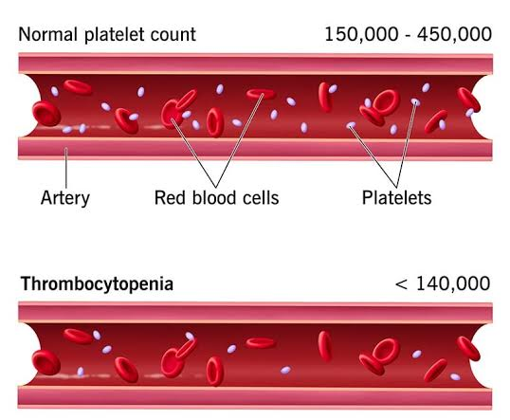 | Clinical presentation - Thrombocytopenia

Table-2

Disorder characterised by Decreased production of platelets:
Congenital disorder ,such as Fanconi anaemia or dyskeratosis congenita ,typically present early in life ,these syndrome often cause depression of other blood cell lineage ( i.e. white cells and red cells ) in addition to the platelet count ,other congenital disorders such as congenital amegakaryo cystic thrombocytopenia and ,the thrombocytopenia with absent radius (TAR syndrome are characterised by isolated thrombocytopenia. WIkott Aldrich Syndrome (WAS) is an X linked recessive disorder featuring thrombocytopenia, eczema, and Immunodeficiency. Thrombocytopenia may improve with splenectomy , but allogenic hematopoietic stem cell transplantation alone is potentially curative for this disorder . Adult patients with acquired amegakaryocytic thrombocytopenia initially may appear to have immune thrombocytopenia (ITP) but the bone marrow reveals markedly reduced or absent megakaryocytes .The disorder may progress to aplastic anaemia. Patients with acquired aplastic anaemia rarely present with isolated thrombocytopenia. Marked bone marrow hyocellularity with decreased megakaryocytes would suggest this diagnosis.
Myelodysplasia:
Mild thrombocytopenia with macrocytosis, with or without anaemia or neutropenia, in an older individual is a typical presentation of myelodysplasia (MDS). Isolated severe thrombocytopenia (less than 20,000) without any other blood abnormalities is not typical, Bone marrow aspirate and blood smear may show megakaryocytic dysplasia (including small and mononuclear erythrocytic and granulocytic precursor cells, concurrent cytogenetic abnormalities may be present, For treatment of thrombocytopenia due to MDS, note that thrombopoietin receptors agonist may be contraindicated in MDS due to a potential acceleration in transformation to acute Leukaemia.
Marrow Infiltration-
Infiltration of the marrow by malignant cells may cause thrombocytopenia, but usually only after massive replacement of the marrow space by tumour cells or immature hematologic precursor cells has occurred, Examination of the bone marrow biopsy and aspirate is required. The acute and chronic Leukaemia, myeloma, and Lymphoma are the most common tumours resulting in cytopenias due to neoplastic marrow infiltration and direct suppression of normal hematopoesis with some tumours types. Certain infections (such as tuberculosis and ehrichoisis )can result in formation of granulomas in the bone marrow that supplant the normal marrow architecture. Effective treatment of the underlying condition should be expected to restore a low platelet count to the normal range, but platelet transfusion may be required initially if bleeding is present or invasive procedures are required.

Irradiation and Chemotherapy-
Irradiation and or myelotoxic chemotherapy induce thrombocytopenia via direct toxicity to megakaryocytes or more immature hematopoietic stem and progenitor cells .The degree and duration of thrombocytopenia depends on the intensity and type of the myelotoxic regimen .Chemotherapy-induced thrombocytopenia typically resolves more slowly than does neutropenia and /or anemia, especially following repetitive cycles of treatment. Platelet transfusion may be given if required .Trials of novel platelet growth factors for thrombocytopenia due to specific chemotherapeutic regimens are on-going.

Cyclic Thrombocytopenia-
This exceedingly rare disorder is characterised by episodes of thrombocytopenia that occur cyclically ,typically 3 to 6 weeks .The thrombocytopenia is frequently severe and may be associated with significant bleeding .Treatment with oral contraceptives (female patients)androgens ,immunosuppressive agent such as (Azathioprine),or thrombopoietic growth factor has led to response in some cases .

Nutritional Deficiencies-
Folate deficiency (commonly associated with Alcoholism) and vitamin B12 deficiency may decrease megakaryocytopoiesis and thrombocytopenia, usually in conjugation with anaemia. In contrast, thrombocytopenia is typical in cases of significant iron deficiency. In very severe iron deficiency, however, thrombocytopenia may also occur .In any of these situations replacement of the deficient vitamin or mineral corrects the thrombocytopenia.

Disorder Characterised by Increased clearance of platelets
Immune Thrombocytopenia-
ITP is an acquired autoimmune disorder of increased platelet destruction and decreased platelet production, causing thrombocytopenia that may lead to bleeding. ITP is an acquired autoimmune disorder of increased platelet destruction and decreased platelet production, causing thrombocytopenia that may lead to bleeding, that may be observed at regular intervals for disease progression. Adults with platelets count of less than 20.000 to 30,000 or those with significant bleeding generally should be treated. Initials treatment generally consist of a short course of corticosteroids (prednisone 1mg/kg/day for 7 to 10 days with subsequent rapid tapering or pulse -Dexamethasone cycles of 40mg daily for 4 days). A significant increase in the platelet count should be seen within 3 to 7 days .In the event of a platelet response, prednisone may be tapered rapidly to a dose of 20mg/day, thereafter, tapering should proceed more slowly (By dose decrements of no more than 5 mg/adjustment, no more frequently than once every 2 to 3 weeks). Dexamethasone cycles may be given every other week for four cycles or monthly for up to 6 months. For patient with serious active bleeding and /or very severe thrombocytopenia (5.000-10.000 /µl) Intravenous immune globulin (IVIG,1gram /kg/day for 2 days)or Anti -D (Win Rho ,75micro gram/kg/dose, appropriate for non-splenectomised, Raj blood type positive, on anaemic patients only) can be administered in addition to corticosteroids in order to decrease clearance of antibody -coated platelets .Response are generally seen within 3 to 5 days of IVIG or anti -D administration, platelet transfusion may be administered if the presentation is complicated by serious (intra -cranial bleeding) Transfused platelets are expected to be cleared very rapidly in the presence of anti-platelet antibodies ,but they may improve haemostasis temporarily. Immune against encapsulated bacterial organism (pneumococcus, Haemophillus influenza, meningococcal) before prolonged immunosuppressive therapy in preparation for splenectomy if required at a later time point.

Second –line of treatment
Despite a high initial response rate (60% to 70%), the majority of adults with ITP experience relapse and develop chronic thrombocytopenia once initial treatment are reduced or discontinued. Treatment is appropriate for patients with platelet count <30,000or clinically significant bleeding. The selection of specific therapies should take into account patient preference, some individuals prefers sequential medical therapies prior to undergoing splenectomy ,but splenectomy may be preferable ,in case of very severe thrombocytopenia associated with bleeding because of a typically rapid postoperative increase in the platelet count in most responding patients. IVIG ant -D typically must be re administered every 2 to 3 weeks in most Instances .The thrombopoietin receptors Eltrombopag (starting dose 50 mg orally daily ,25 mg daily Individuals of Asian descent )or romiplostim (starting dose 1 micro gram /kg SC weekly )produce platelet responses (>50.000 /µl)in approximately 70% of patients with chronic ITR and they generally are well tolerated .potential complications include reticululin deposition in the bone marrow ,Thrombocytosis ,and thrombosis .The monoclonal anti -B cells antibody rituximab (anti -CD20)given at a dose of 375 mg/m2 weekly for weeks ,induce initial and long term response in about 50% and 25% respectively, of adults with severe ,chronic ITP . Splenectomy (preferably Laproscopic )yield an immediate response rate of 70% to 75% and durable response rates of 60% to 79%.All patients must receive immunisation against encapsulated bacterial organism (pneumococcus ,H Influenza, Meningococcus )several weeks prior to splenectomy if possible .

Secondary ITP
A variety of autoimmune, infectious, inflammatory. Or malignant condition may underlie a presentation of ITP. Treatment of the underlying predisposing condition may be required in some cases, in addition to management of the thrombocytopenia using accepted interventions.

Pregnancy Associated ITP.
Pregnant women with platelet count l<30,000during the second or third trimester, or with platelet count (10,000or bleeding in any trimester, should be treated .Intermittent infusion of IV IG or moderate -dose oral prednisone (commonly given in an everyday schedule) are standard. Splenectomy during the first or second trimester may be considered for women whose ITP has tailed treatment with IVIG and corticosteroids and who have platelet less than 10,000 with associated bleeding. Platelets may be administered, prophylactically prior to caesarean section in women who have platelet count <10,000 /µl or muco cutaneous bleeding near the time of delivery .A platelet count of >50.000 generally regarded as adequate prior to caesarean section or vaginal delivery.

Heparin - induced Thrombocytopenia.
Heparin Induced thrombocytopenia (HIT) is an antibody mediated disorder that result in platelet activation and clearance. Although the disorder produces thrombocytopenia, patients with HIT paradoxically are at high risk for thrombosis .If HIT is suspected, all forms of heparin should be discontinued immediately, and, if appropriate, alternative anti coagulation administered. Epidemiology—HIT occurs in approximately 3% and <1%of patients who are exposed to unfractionated heparin or low molecular-weight heparin, respectively. As many as half of these Individuals develop thrombosis. Pathophysiology ——The pathogenesis of HIT begins with binding of the heparin molecule to platelet factor 4 (PF4) ,a platelet alpha granule chemokine .The heparin -PF4 complex stimulates formation of an IgG anti body (HIT antibody ) that binds both to the heparin -PF4 complex (via its Fab portion)to platelets FC receptors (via its Fc portions).Binding of the HIT antibody to platelet activates them , resulting in release of procoagulant micro particles ,platelet clearance ,and subsequent thrombocytopenia.PF4 also binds to polysaccharides (heparin sulphate )on the endothelial surface ,recognition of these PF4 -polysaccharide complexes by HIT antibodies may lead to endothelial damage ,expression of tissue factor and a prothrombotic state.

Presentation.
The typical presentation of HIT involves a hospitalised patient who develops thrombocytopenia within 5 to 1O days of receiving heparin .A decline of 50% or more from the baseline value in a heparin treated patient may signify HIT. Platelet count generally do not fall below 20,000 ,spontaneous bleeding (including petechie) is not typical ,venous (upper or lower limb ,dural sinus )or arterial (Lower limb ,CVA ,MI ,other locations )thrombosis may accompany detection of thrombocytopenia and occur in up to 59% of untreated cases .in a minority of patients with HIT ,thrombosis is the presenting clinical sign ,The risk of HIT -related thrombosis persists for at least 30 days after the discontinuation of heparin of anti-coagulation is not administered, other presentation of HIT are possible:
- Rapid onset HIT occurs within 1 to 3 days of re -exposure to heparin in patients who have received heparin usually within the prior 30 days and have pre-existing HIT antibodies. An acute systemic reaction characterised by fever, chills, hypotension, and or cardiovascular compromise immediately after re exposure to heparin is typical.
- Delayed-onset, HIT describes new thrombocytopenia and venous or arterial thrombosis that occurs up to 14 days after completion of an uneventful course of heparin therapy .Laboratory markers of disseminated intra vascular coagulation (DIC) may be positive. Thrombocytopenia and thrombosis typically worsen if heparin is administered.

Diagnosis:
Strictly, the diagnosis of HIT requires both an appropriate clinical context and confirmatory laboratory testing (eg demonstration of HIT antibodies).Due to the limited immediate availability of HT -specific laboratory assays, however, any patient in whom the clinical probability for the disorder is intermediate or high should be managed HIT ,even if the results of diagnostic tests are pending ,immediately unavailable. Clinical probability— factors that make a diagnosis of HIT more likely are reviewed above .A variety of clinical prediction models ,such as the 4Ts ,that have been developed to assists in determination of protest probability have not undergone external validation and May overestimate diagnosis, Review of the hospital chart (including nursing notes )may be necessary to document the extent and duration of exposure to heparin ,especially if it’s use was transient (heparin flushes) or covert (heparin-impregnated catheters ).
Laboratory Diagnosis
All patients with suspected HIT ideally should undergo testing with two types of assays ,immunologic and functional .The enzyme-linked immunosorbent assay (ELISA) for PF4 -heparin associated antibody (immunologic test )has a sensitivity of >90% but a limited specificity platelet activation assays (functional test)measure activation of donor platelets in the presence of the patient serum and a high and low concentration of heparin .These assay are much more specific for HIT than the immunologic test ,but are less widely available and have a slow turn -around time (days).A positive result on both test or the immunologic assay alone indicates high and intermediate, respectively, probably for HIT .
Treatment
All form of heparin, including low molecular weight preparation, must be discontinued immediately. In patient in whom laboratory testing for HIT eventually proves negative or in whom an alternative explanation for thrombocytopenia has been found, heparin may be subsequently restarted. Doppler Ultrasound of the lower extremities should be performed to rule out sub clinical deep vein thrombosis because (1) HIT patients rarely bleed and (2) transfused platelets may worsen the already increased thrombotic risk by providing substrate for HIT antibodies, platelet transfusion are rarely indicated .Warfarin is contraindicated as initial treatment of clinically proven or suspected HIT ,due to its propensity to exacerbate hypercoagulability by reduction of plasma level of proteins C and S .Because of the high rate of serious thrombosis among HIT patients.an alternative anticoagulant such as a direct thrombin inhibitors is required in all cases of suspected (intermediate or high clinical probability)or proven HIT .The alternative anticoagulant should be contributed at least until the significant recovery of the platelet count has as occurred or for approximately 5 days ,whichever is longer ..
Long term anti coagulation:
Due to extended risk of thrombosis up to one month following a diagnosis of HIT ,patients without concurrent thrombosis require at least 30 days of anti-coagulation ,warfarin therapy is appropriate in most patients, and the DTI should be continued until therapeutic anti coagulation with warfarin had been achieved (Because of Argotroban raises the INR, a special approach is required for transitioning from this DTI to warfarin , patient with warfarin for duration of 3 to 6 month at an INR of 2.0 to 3.0)
Thrombolysis / Thromboembolectomy.
low dose or very low dose thrombolytic agent may be indicated in acute limb ischemia or life -threatening pulmonary embolism caused by HIT -associated thrombi .Surgical removal of large vessel arterial thrombi may be required if the limb is threatened and other treatment have failed .patient managed by either medical or surgical means requires concomitant use of an alternative anticoagulant, regardless of the degree of thrombocytopenia. Retreatment with Heparin-HIT antibodies probably do not persists beyond 100 days from the initial episode of HIT ,in which cases very transient use of heparin for cardiac or vascular surgery at least 100 days beyond an initial episode may be considered safe ,if immunologic (ELISA) and functional (SRA) test are both negative .if the immunologic test is positive but the functional test is negative ,either the surgery can be delayed until the functional test becomes negative or a DTI can be used .

Thrombotic Microangiopathie
The thrombotic microangiopathies (TMAs) comprise thrombotic thrombocytopenic purpura (TTP) and the related disorder, the haemolytic -uremic syndrome (HUS), and feature microangiopathic haemolytic anaemia (MAHA) due to the formation of platelet-rich thrombi in the arterial and capillary micro vascular and thrombocytopenia. Acquired or spontaneous or classical and congenital form of TTP are recognised ,and endemic (or typical ) and atypical forms of HUS may occur .In addition ,some forms of TMA have been recognised in association with surgery, pregnancy ,exposure to certain medical drugs ,and some bone marrow transplantation. Importantly, early aggressive intervention with plasma exchange is crucial in cases of classical TTP due to its extremely high mortality rate.

Epidemiology
The incidence of classical TTP is approximately 3 to 4 cases /100,000 people, there is a slight female predominance .Most cases of endemic or typical HUS occur in young children and are related to infection with enteropathogenic bacteria .TMA occurs at an increased rate during pregnancy and in peri -partum period.

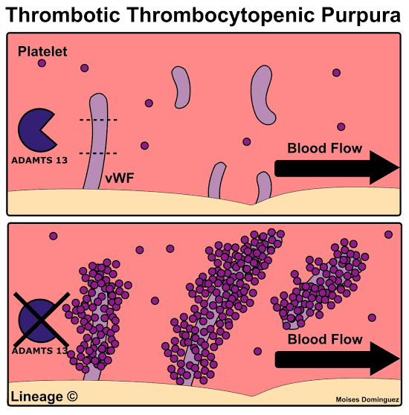  Thrombocytopenic Purpura (TTP) | 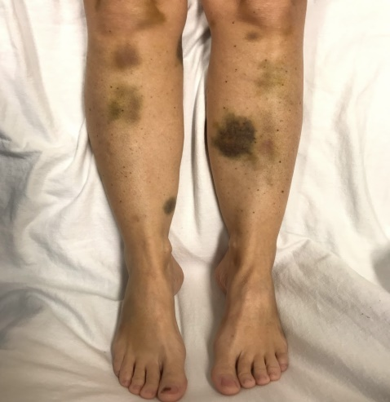  Clinical representation (TTP)

Table-3

Pathophysiology.
The TMAs are thought to arise from factors that directly or indirectly cause aggregation and /or endothelial cell damage, leading to the formation of thrombi and ischemia in involved organs .These factor include toxin ,cytokines ,drugs ,or deficiency in the function of the von Willebrand factor cleaving protease (VWFCP or ADAMTS -13). Red cells are sheared as they negotiate thrombotic obstruction and fibrin strands in the micro vasculature to haemolytic anaemia .consumption of platelets result in thrombocytopenia and bleeding. In classical TTP, an acquired deficiency of VWFCP results from production of an auto antibody against the VWFCP leading to an accumulation of ultra large VWF (ULWVF) in the plasma .The VWFCB or ADAMTS -13, is a metalloproteinase whose normal function is to cleave newly synthesised, ULVWF multimers released in the plasma into multimers of smaller size. ULVWF multimers binds to platelets more avidly than smaller VWF molecules may incite platelet aggregation. Patients with congenital TTP have decreased activity of the VWFCP due to an inherited deficiency. In many cases of endemic HUS, Shiga toxin from Escherichia coli (especially type o157:H7)is thought to promote platelet aggregation by damaging endothelial cells or by other mechanism .patient with atypical HUS may have genetic defects in proteins that regulate complement activity ,such as Factor H appears to influence the risk of the disorder ,especially if the foetus inherits different ,platelet phenotype .The Theombocytopenia is typically severe and a high prevalence of intracranial haemorrhage (ICH) during or following delivery is observed ,resulting in neonatal in 5% of cases of NAIT .Thrombocytopenia typically resolve by 2 to 3 weeks of age. IV IG with or without corticosteroids, is recommended for any neonate with platelet count <20,000 to 30,000 .Random donar or ideally irradiated maternally antigen /matched platelets are often administered in cases of ICH. Subsequent pregnancies are regarded as high risk for recurrent NAIT.

VON Willbrand Disease, Type2B
This type of Von Willebrand disease (VWD) is characterised by an abnormal von Willebrand factor (VWF) that has increased affinity for its platelet receptor, glycoproteins Ib.
Extracorporeal circulation related Thrombocytopenia
Passage of the blood for prolonged periods outside the body in an artificial circuit (such as used for cardiac bypass surgery) typically results in platelet activation and Clarence. Thrombocytopenia generally is not severe .other common causes of thrombocytopenia in the post-surgical patient (such as HIT, DIC, and sepsis -related and drug -induced thrombocytopenia) concomitantly must be considered.

DISORDER CHARACTERIZED BY INCREASED SEQUESTRATION OF PLATELET
Hypersplenism result in sequestration of blood cells (including platelets) in an enlarged or abnormal spleen .Mild to moderate thrombocytopenia is most commonly observed, but if the bulk of the platelet mass is contained within a massively enlarged spleen, thrombocytopenia can be severe. Splenomegaly with hypersplenism is almost always an acquired condition and there are many possible underlying disorder .if adequate production of platlets can be documented and significant splenomegaly with thrombocytopenia is present , splenectomy may be considered in some cases ,splenic embolisation and splenic irradiation are alternative to removal of the spleen that generally do not result in maximal platelet responses .They may be considered, however, in patients with significant hyperspleism and disorder such as CLL or Lymphoma who cannot tolerate surgery.

OTHER CAUSES OF THROMBOCYTOPENIA
Pseudothrombocytopenia:
For reason that are unclear, the calcium chelation induced by the anticoagulant ethylenediaminetetraacetic acid (EDTA) present in blood collecting tubes ,causes change on the platelet membrane of certain patients that expose cryptic antigens to which performed, otherwise non-pathogenic agglutinating antibodies may bind ,the result is art factual platelet clumping. Typically ,automated cell counters (such as those that are present in most hospital laboratories) will report a falsely low platelet count ,examination of the blood smear reveals platelet clumps .Normalization of the platelet count upon automated determination from a blood specimen collected in citrate anticoagulant and /or disappearance of platelet clump on a blo…
Drug -Induced Thrombocytopenia:
By definition drug induced thrombocytopenia develops after imitation of a given drug ,resolves when the offending medication is discontinued and May recur if the agent is re introduced, The mechanism by which many drugs may lead to a low platelet count ,however,have not been elucidated . Chemotherapeutic agents are clearly linked to decreased platelet production. Quine purpura is a type of drug induced immune thrombocytopenia (DITP),in which there is antibody -mediated destruction of platelets after exposure to a given drug .Quinine is thought to induce a conformational change in the platelet membrane allowing exposure of an otherwise cryptic antigen circulating antibodies than bind the antigen ,but only in the presence of the drug ,patients with …

Gestational Thrombocytopenia:
The blood volume increases by as much as 40%to 45% over baseline during pregnancy, causing a progressive Hemodilution, Cytopenias result, though production of blood cells is normal or increased. Approximately 10%and less than 1% of pregnant women experience platelet counts (10,000and <50,000 by the third trimester, respectively, the incidence of ITP is thought to be even lower .severe thrombocytopenia in pregnancy (<50,000) should prompt investigation to rule out a pre-existing condition, pre-eclampsia or a pregnancy-related TMA, if negative, the aetiology may be presumed to be ITP and treated accordingly.

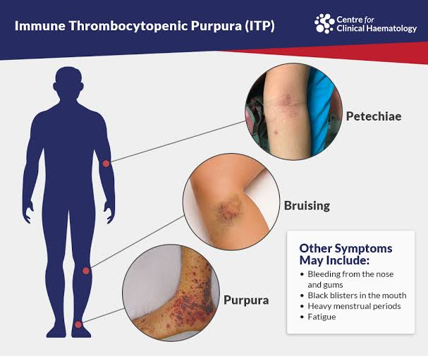

Immune Thrombocytopenic Perpura (ITP)

Table-4
Human Immunodeficiency virus related Thrombocytopenia:
Thrombocytopenia in HIV infection may result both from immune -mediated phenomena leading to increased clearance of platelets and in effective platelet production, possibly due to direct infection of megakaryocytes with HIV improvement or resolution of thrombocytopenia after imitation of anti-retro viral therapy ART in newly diagnosed patients is commonly observed ,if the thrombocytopenia proves refractory ,therapies commonly used in the treatment of ITP (IVIG ,anti -D )steroids, splenectomy, others are employed ,but the potentially immunosuppressive effects of some of these approaches need to be taken into consideration.
Infection and sepsis related Thrombocytopenia:
Thrombocytopenia in the setting of infection or sepsis is common. DIC is often implicated in critically ill patients, but other causes, such as megakaryocyte -specific effects or increased clearance due to fever or splenic enlargement, may be responsible. Transient thrombocytopenia is commonly observed in the setting of many viral infections, certain bacterial infections such as ehrilichosis. Rickettasial disease and dengue characteristically produce thrombocytopenia. A corroborative travel history and directed microbiologic testing are usually necessary to make the diagnosis. If the platelet count does not return to baseline with effective anti-microbial treatment or after resolution of the infection, an alternative ethology should be sought.

Hemophagocytosis:
Hemophagocytosis is a process in which bone marrow macrophages (Histiocytes) engulf cellular components of the marrow. The phenomenon is considered to be nonspecific if it is found only sporadically within an aspirate smear, but the observation of abundant histiocytes with itracytoplasmic white cells, red cells, or platelets in the setting of peripheral cytopenias indicate a pathogenic process. In adult ,sepsis or EBV -related infection or malignancy can drive T cells to produce cytokines that mediate Hemophagocytosis ,leading to thrombocytopenia, in these cases ,the treatment is principally immunosuppressive,but the disorder often is aggressive and unresponsive to treatment. Familial Hemophagocytic lymphocytosis is a rare, autosomal recessively inherited.

Qualitative Disorders:
Several inheritable platelet anomalies of structure or function (including the May -Heggin anomaly and the Bernard -soulier syndrome) are typically associated with mild thrombocytopenia.

DENGUE FEVER
Vector born disease causing thrombocytopenia:
Vector born disease are also responsible for thrombocytopenia, in which Dengue ,chiken Guinea and Jika virus are important ,Rashes are more common in Zika virus ,arthralgia are usually present in chikenguinea and joint pain ,high grade fever and shock are usually present in Dengue feverDengue fever is a self-limiting vector born disease, other vector Born disease that causing thrombocytopenia are Jika virus and chikenguinea . Dengue fever is characterised by high grade fever ,muscle and joint pain ,rash ,nausea and vomiting .Dengue fever is also known as the break bone fever .There is no specific treatment for dengue ,the focus is on treating pain symptoms, Acetominophen (paracetamol) is the safe drug and it’s a drug of choice for fever and pain ,Non-steroidal anti-inflammatory drug like Ibuprofen and Aspirin are avoided as they can increase the risk of bleeding.
Dengue fever is the most important emerging viral disease of human in this world affecting humanity in the terms of morbidity and mortality. Dengue fever is an acute viral disease having the potential of causing large scale outbreaks ,The risk of dengue has shown an increase in recent year due to rapid urbanisation, there is no specific treatment for dengue fever, besides the dengue vaccine has a long way to go ,as any of the form dengue viruses can cause the disease, hence the vaccine must be tetravalent ie it needs to protect against all four viruses .it’s a self-limiting acute mosquito disease characterised by high grade fever ,severe headache, muscle and joint pain ,rash ,nausea and vomiting, Dengue fever is caused by an arboviruses and spread by Aedes mosquito.
Some infection result in dengue haemorrhagic fever and it’s severe form Dengue haemorrhagic shock syndrome (DSS ) can threaten the patient’s life primarily through increased vascular permeability and shock ,Platelet deficiency is not the cause of death in people suffering from Dengue. According to International guidelines, unless a patient’s platelet count is below 10,000, and there is spontaneous, active bleeding, no platelet transfusion is required. The outbreak of dengue in the City and Hospital beds are full and families are seen running around in search of platelets for transfusion. However what most people do not realize is that the first line of treatment for dengue is not platelet transfusion. It, in fact, does more harm than good if used in a patient whose counts are over 10,000.
The primary cause of death in patients suffering from dengue is capillary leakage, which causes blood deficiency in the intravascular compartment, leading to multi-organ failure. At the first instance of plasma leakage from the intravascular compartment to the extravascular compartment, fluid replacement amounting to 20 ml per kg body weight per hour must be administered. This must be continued till the difference between the upper and lower blood pressure is over 40 mmHg, or the patient passes adequate urine. This is all that is required to treat the patient. Giving unnecessary platelet transfusion can make the patient more unwell.
“While treating dengue patients, physicians should remember the ‘Formula of 20' i.e. rise in pulse by more than 20; fall of BP by more than 20; difference between lower and upper BP of less than 20 and presence of more than 20 hemorrhagic spots on the arm after a tourniquet test suggest a high-risk situation and the person needs immediate medical attention.”
Dengue fever is a painful mosquito-borne disease. It is caused by any one of four types of dengue virus, which is transmitted by the bite of an infected female Aedes aegypti mosquito. Common symptoms of dengue include high fever, runny nose, a mild skin rash, cough, and pain behind the eyes and in the joints. However, some people may develop a red and white patchy skin rash followed by loss of appetite, nausea, vomiting, etc. Patients suffering from dengue should seek medical advice, rest and drink plenty of fluids. Paracetamol can be taken to bring down fever and reduce joint pains. However, aspirin or ibuprofen should not be taken since they can increase the risk of bleeding.
The risk of complications is in less than 1% of dengue cases and, if warning signals are known to the public, all deaths from dengue can be avoided.
DENGUE NS1-Best test is NS1
Cannot be false +ve
Is + from day 1 to 7 ideally.
If on day 1 is -ve, repeat it next day.
Always ask for ELISA based NS1 tests as card tests are misleading.
Value of IgG & IgM dengue-
In a patient with reduced platelets and looking "sick" on day 3 or 4 of illness, a very high titre of IgG with borderline rise in IgM signifies secondary dengue. These pts are more prone to complications. In primary dengue IgG becomes + at end of 7 days, while IgM is + after day 4.
Immature Platelet fraction/IPF:
A very useful test in Dengue for patient with thrombocytopenia.
If IPF in such a patient is > 10%, despite a pl count of 20, 000 he is out of danger & platelets will rise in 24 hrs. If it is 6%, repeat the same next day. Now if IPF has increased to 8% his platelets will certainly increase within 48 hrs.
If it is less than 5%, then his bone marrow will not respond for 3-4 days & may be a likely candidate for pl transfusion. Better to do an IPF even with borderline low platelet count. A low Mean Platelet volume or MPV means platelets are functionally inefficient and such patient need more attention.
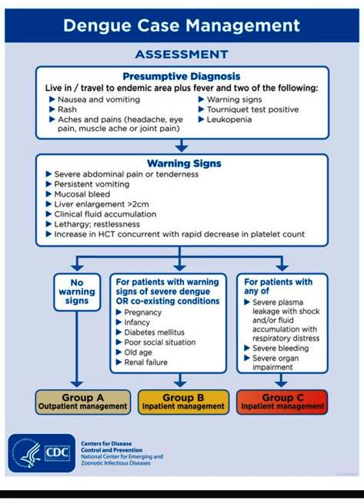
Table-5

Table-6
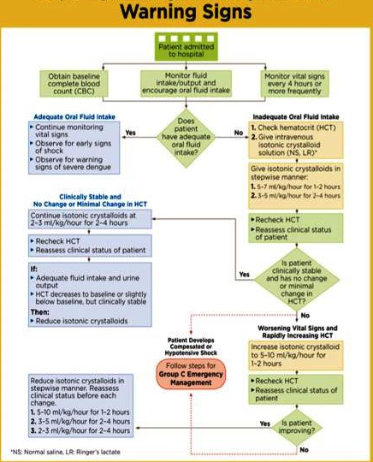
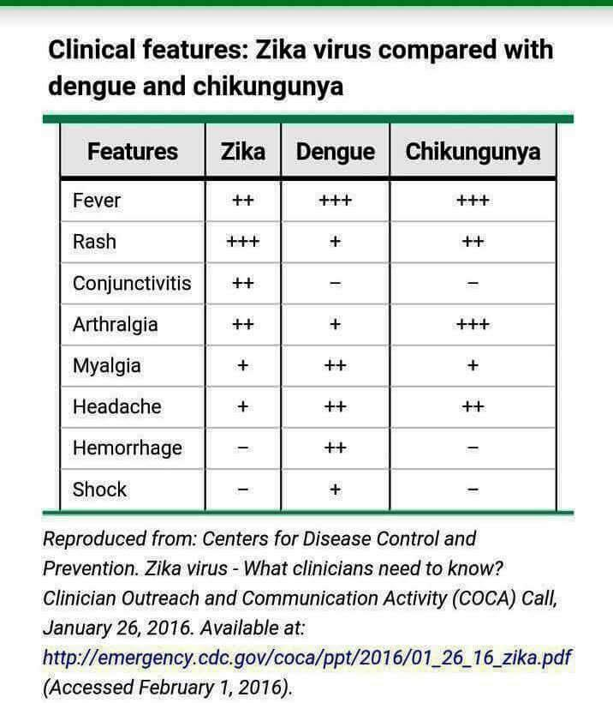
Table-7

Dengue haemorrhagic fever World Health organisation criteria:

Fever: Minor or major.
Haemorrhagic manifestation.
Thrombocytopenia <100000/mm3.
Objective evidence of increased capillary permeability (Haematocrit>20%).
Pleural effusion by chest radiography.
Hepatomegaly Hypoalbuminemia.

Criteria for Dengue shock syndrome:
It includes those for dengue haemorrhagic fever plus Hypotension or Narrow pulse.

Conclusion:
A low platelet count can result from a wide range of conditions and may be determined by multiple mechanisms. Prompt recognition of the cause of thrombocytopenia is often crucial for the correct management of patient, as in acute Promyelocytic leukaemia, heparin induced thrombocytopenia, or thrombotic thrombocytopenic purpura/ haemolytic uremic syndrome. The initial approach to determining the cause of thrombocytopenia is based on the patient's history of underlying diseases and drug treatments, on physical examination, and on careful examination of the peripheral blood smear. The two most common causes of low platelet count in the absence of other hematologic abnormalities and no evidence of the multi system disease are ITP and DITP. The most common cause of low platelet count in pregnancy is GT. In hospitalised and critically ill patients, the diagnosis of thrombocytopenia is often challenging due to the presence of several potential etiologies, including drugs and infections. Examination of the BM with aspiration and biopsy is warranted in patients with severe thrombocytopenia, or or thrombotic thrombocytopenic purpura/ haemolytic uremic syndrome. Or worsening thrombocytopenia of unexplained nature, thrombocytopenia in pregnancy deserves special consideration because of the possible consequences on the fetus.

References.
1-Abrahamoson PE ,Hall SA ,Feudjo- Tepie M ,Mitrani Gold FS long J .The incidence of idiopathic thrombocytopenia purpura among adults ,a population based study and literature review ,Eur J Haematol 2009,83(2) -83-89.
2- sample JW ,prown D ,Garvey MB ,Freedman ,J Recent progress in understanding the pathogenesis of immune thrombocytopenia,Curr opin Haematol .2010.17(6)590-595.
3- Cines DB Bussel JB Liebman HA ,Luning Park ET ,The ITP syndrome:pathogenic and clinical diversity blood :2009.113 .
4- Provan D Stasi R ,Newland AC et al ,International consensus report on the investigation and management of primary immune thrombocytopenia.Blood 2010.115 (2) 168-186 .
5- Coker A Heparin induced Thrombocytopenia:present and future .J Thromb Throombolysis .2011-31.
6- Nurnberger J ,Philip T ,Witzke O,et al eculizumab for atypical hemolytic uremic syndrome NEngl ,JMed 2009,360.
7- caramazza D ,Quintinin G Abbene I et al Reapsing or refractory Idiopathic thrombotic thrombocytopenic purpurs hemolytic uremic syndrome the role of Rituximab ,transfusion 2010.
8- Provan D, Stasi R, Newlan AC,et al.
International consensus report on the investigation and management of primary immune thrombocytopenia, Blood, 2010, Vol. 115 2(pg.168-186)
9- Neunert c, Lim W, Crowther m, Cohen A, Solberg L, Crowther MA.
The American Society of Hematology 2011 evidence- based practice guideline for immune thrombocytopenia Blood, 2011, Vol. 117 2(pg.4190-4207).
10- Neylon AJ, Saunders PW, Howard MR, Proctor SJ, Taylor PR.
Clinically significant newly presenting autoimmune thrombocytopenic purpura in adults: a prospective study of a population based cohort of 245 patients, Br J Haematol, 2003, vol.122 6(pg.966-974)
11- Pons I, Monteagudo M< Lucchetti G, et al. Correlation between immature platelet fraction

