The pragmatic and exponential advancement in use of machine learning and artificial intelligence system in various fields of industries.

Chinedu Chukwuemeka Mazi¹, Obayi Adaora Angela ²..

¹Department of Mathematics, University of Sussex; uchechi.ihedioha@unn.edu.ng

²Department of Computer Science, University of Nigeria, Nsukka, Nigeria
obinna046@gmail.com

Abstract
With the advent of the Internet of Things (IoT) with sensors and connected devices, data generation is increasingly peaking at an unprecedented pace. However, energy consumption is also on the rise based on traditional energy sources, such as fossil fuels. This is not sustainable and could have a negative impact on the environment while being quite expensive to run e.g, empowering irrigation systems using sensors. In this context, using data as an energy source for future machines could be a promising solution to mitigate the energy crisis and reduce the carbon footprint. The concept of data as a new form of energy will be discussed, examining the benefits and challenges associated with this method. This paper also proposes other potential applications for using data as an energy source, including powering self-driving cars, drones, and smart irrigation system a data-driven approach.

Keywords: Data, Energy Consumption, Future Machines, IoT, Machine Learning, Artificial Intelligence.

Introduction

Data is a new form of energy that has emerged in recent years. The volume of data generated globally is growing, and this data can be harnessed and transformed into energy. Data can be used to train machine learning models, and this process requires a considerable amount of computational power, which can be converted into energy. Moreover, data can be used to power autonomous machines by processing data from sensors and using it to make decisions. The use of machine learning and artificial intelligence is expanding quickly across a broad spectrum of industries, including manufacturing, finance, healthcare, and transportation. The high energy requirements of these machines can make their adoption and sustainability extremely difficult. However, conventional energy sources like electricity and fossil fuels are not sustainable and may harm the ecosystem. The idea of harnessing data as a source of energy for future machines has surfaced as a potential remedy to the challenge. With the aid of machine learning technology, future machines directly learn from examples and experiences stored in data. According to Bridge et al, (2014), Sarah, et al. (2017), Being data-driven refers to the approach of deciding on a course of action after analysing and interpreting data. In a data-driven approach, data is collected, analysed, and interpreted to gain insights and inform decisions. With the increasing availability of data and the development of advanced data analysis tools, organizations can now leverage data-driven approaches to optimise their operations, improve their decision-making processes and power the operation and functionality of a future machine. In a transition from device-driven to data-derive example, sensor devices make decide whether to power a water-pump machine or not which are computational expensive both in energy and time. This is an effect of Internet of Thing building a smart platform by adopting data-driven approach. This approach is widely used in various fields, as mentioned above. The data-driven approach involves collecting data from various sources, such as surveys, customer feedback, and performance metrics, and then analysing this data to identify patterns, trends, and insights. Based on these insights, organisations can make data-driven decisions that are more accurate and effective than decisions based on intuition or guesswork. Overall, being data-driven can lead to more informed decisions, better outcomes, and a more competitive advantage in today's rapidly changing business environment.
Data, also known as information in an electronic form that can be stored and used by a device, is information, particularly facts or statistics that has been gathered for analysis, consideration, and application to aid decision-making. Cambridge Dictionary (2023). Furthermore, data types, Quantitative and Qualitative which are described in their forms of input/output and can be discrete and continuous respective Qualitative vs Quantitative Data (2023). They are managed and handled through different approach, for instance, you cannot utilise Natural Language Processing techniques on discrete values or calculate statistics for qualitative data. Data are classified into quantitative and qualitative. Quantitative data are presented and measured in their types of numbers and statistics. It is a solution to questions like how much, how many, and how frequent or occurrence. They are more descriptive and are numerically. In contrast Qualitative data could be used to characterise a group of people in a room, including their feelings, appearance, attire, and reasons for being there.

Qualitative Data | Quantitative Data
Outcome from methodologies and methods, like grounded theorem, thematic, contents and narrative analysis. | Outcomes from statistical/mathematical methods, variance, standard deviation, mean, mode and median.

Figure 1.0 Description of Qualitative and Qualitative Data
Drawing outcomes

Fig 1.0 shows that quantitative and qualitative data contributed to data as an energy source to power our future machines.
Computer systems may learn directly from examples, data, and experience thanks to machine learning, a subfield of artificial intelligence. By allowing computers to carry out particular tasks intelligently, machine learning systems may carry out complex processes by learning from data rather than sticking to pre-programmed rules. The paper is focusing on data as an energy source to future machines, the predicted outcome from analysis of data is optimised to find the best solution to an existing problem. Finnsson, Hilmar, and YngviBjörnsson. (2008), Sarikaya et al, (2014), A group of researchers in their collective ideas form a phrase “Artificial Intelligence”, Dartmouth Conference in 1956 and founded the discipline of AI. The domain AI is responsible to the civilization and advancement into the future.
In the past few years, particularly since 2015, AI has grown rapidly. The primary cause of this is the ubiquitous accessibility of GPUs, which accelerates, lowers the cost, and increases the power of parallel computing. The one-two punch of almost limitless storage and an influx of data of all types (the "Big Data movement"), including images, text, transactions, mapping data, and others, all play a role. Deng and Yu (2014); Mohri, Rostamizadeh, Talwalkar, and Ameet (2012). Traditional energy sources are also known as conventional energy sources are primarily classified into primary energy source e.g fossil fuels (coal, oil, and natural gas), nuclear energy, geothermal energy, falling water, and secondary energy sources like electricity and petrol.
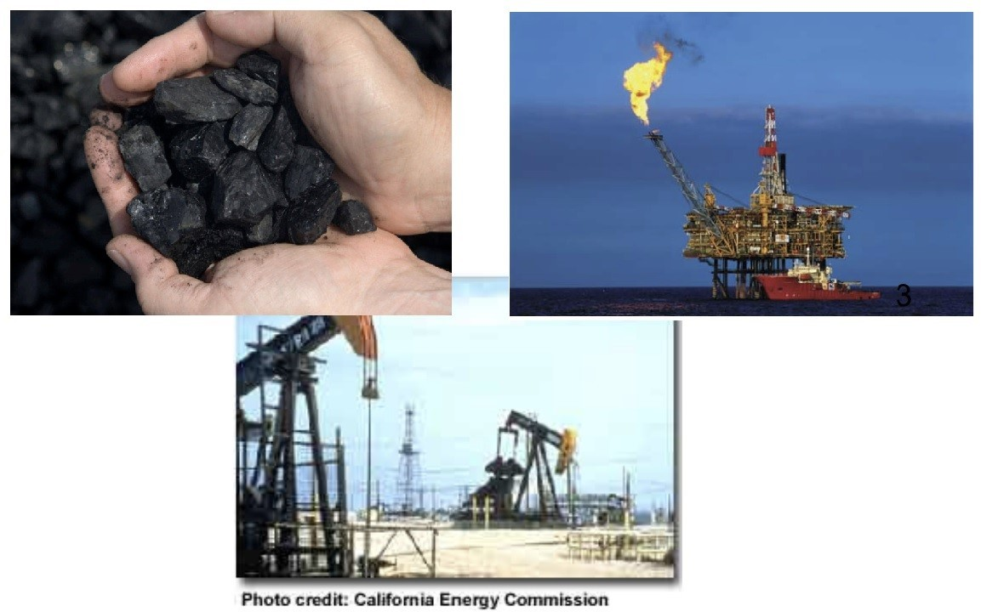

Figure 1.1 Primary energy sources ranging from coal, natural gas to liquid hydrocarbon. [Source: Ministry of new and renewable energy (2023)]
In Fig 1.1, the secondary energy sources are derivative of the primary source. Generally, conventional energy sources are management expensive, furthermore, not sustainable but have a long year of availability. These resources cannot be renewed. By the end of the twenty-first century, natural gas and petroleum reserves are expected to be exhausted. Large volumes of CO2 are produced by burning fossil fuels, adding to the global warming. Given the impurities like damaging petrol emissions from the soil, which are a major cause of pollution, the issues linked with it are tremendous. The winds carry SO2, which then precipitates as acid rain. When mercury travels on air currents, falls as particulate dust, or mixes with precipitation in other places, it bioaccumulates and biomagnifies via ecosystems and may result in skin cancer. The introduction of Internet of Things (IoT), sensors, and connected devices, data generation is increasing at an unprecedented pace. Powering sensors and devices is effectually in- efficient as a long-term approach. This demands a better approach to power our machines in the future by providing lower energy consumption means through adopting data as an energy source for future machines. The target of this paper is the potential advantage of the transition to data energy to power our future machines mainly in decision-making.

Related Work

Smart Agriculture is data driven system known as Agriculture 4.0, which related to the general approach to agriculture. At this point of conventional agriculture, the supply of power to meet the demand of over 8 billion people in the world begins with the type of soil, climate irrigation methods, energy consumption, water consumption, etc. To achieve this, several tools like Machine Learning and Artificial Intelligence models must be deployed to have data as an energy source for future machines in Agriculture ecosystems. The industry ecosystem has recently made investments in technical innovation, with a particular emphasis on low-cost, decreased energy consumption, reduced carbon footprint, and highly effective production operations with knowledge-based development gained via years of visualisation and data gathering. These efforts have paid off in the creation of an IoT system based on smart irrigation and water reuse, which has reduced yearly water usage by 44% and saved 5.5 billion m3 annually. China has 20% of the world's population and only 6% of the world's water. The Chinese government has developed and created technologies to encourage Water-Saving Irrigation (WSA) and advance towards Agriculture 4.0 in response to this data. By developing solutions based on cloud computing, the Internet of Things (IoT), and SOA technology, Kamienski et al. (2019) addressed the issue of water scarcity, a crucial component for agricultural output.

2.1 Other Area of Application

There are several potential applications for using data as an energy source. One of the most promising applications is powering self-driving cars. These vehicles require considerable energy to process data from sensors and make decisions. Using data as an energy source could enable them to operate for more extended periods without the need for frequent charging. Another potential application is powering drones, which require a lot of energy to fly and process sensor data. Using data as an energy source could enable drones to fly for longer periods and cover longer distances. All the above boil down to energy conservation through implementing a system that sources power of operation from the Data rather than the traditional means.

Understanding of Terminologies in Data as an Energy Source

- Data: data referred in this paper is collection of historical fact stored, analysed, and used for prediction of possibilities using a selected parameter generally known as dataset. The mean focus, smart irrigation system switching from sensors input to data input by applying machine learning algorithms. Dataset is a collection of document or files Snijders et al (2012).
- Energy Consumption: This much energy is often used in home or industrial production. Global energy consumption decreased by 4.5% in 2020 before increasing by 5% in 2021. In the face of a global pandemic, Fig. 1.2 determined that global energy consumption recovered with a 5% recovery in 2021 following a 4.5% fall in 2020. This recovery is three points higher than the 2%/year average from 2000 to 2019 period.
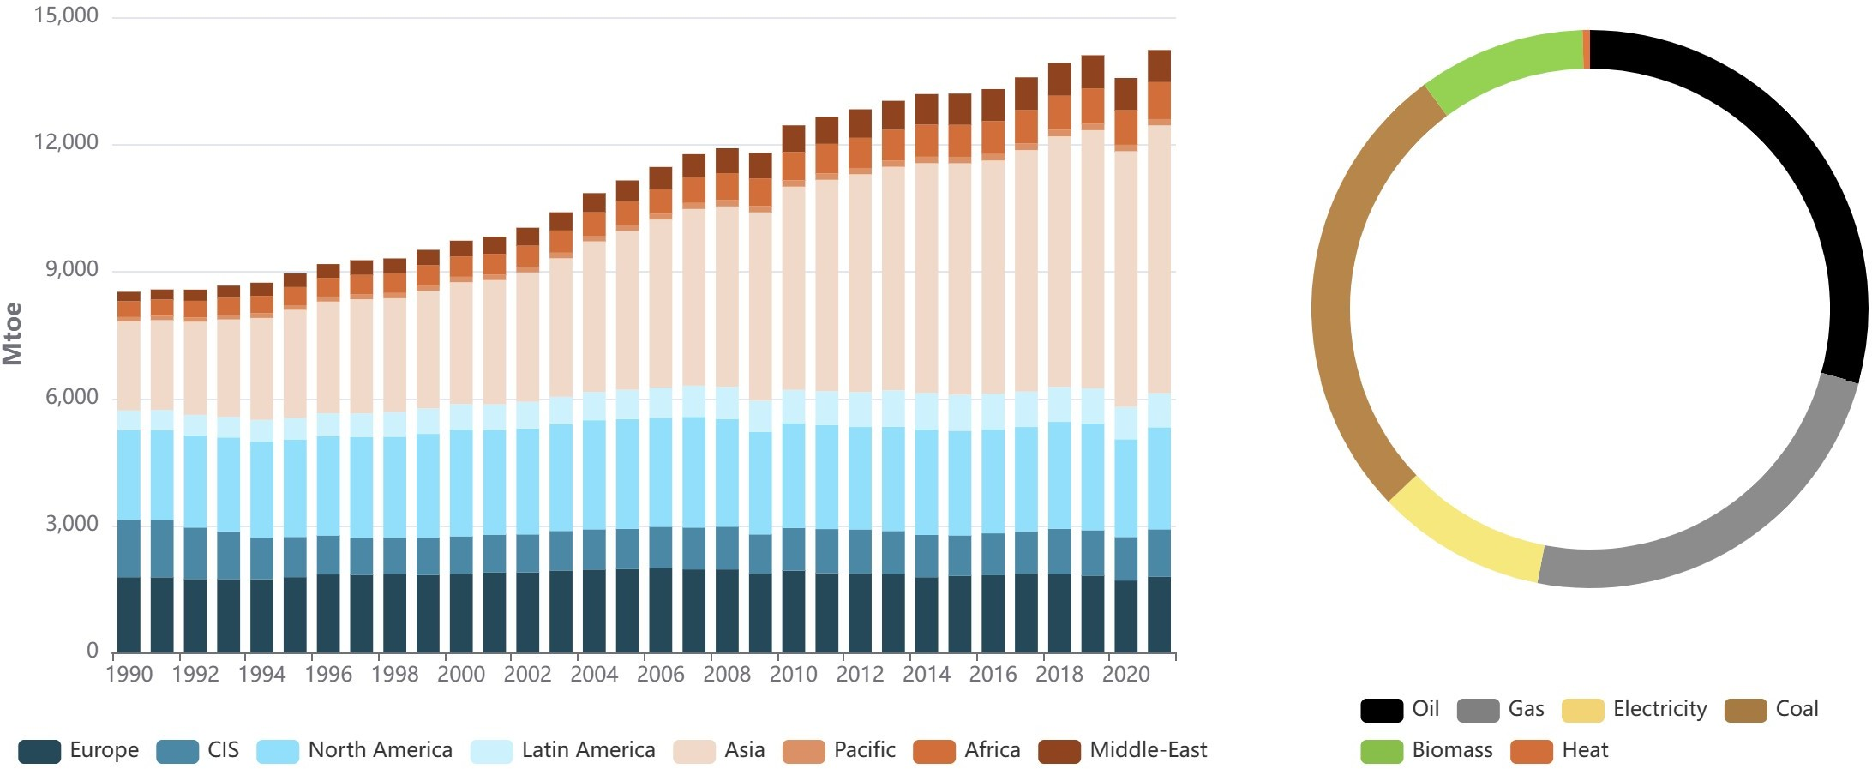

Figure 1.2 Global Energy Consumption Global Energy Consumption (2023)

Majorly chain China will account for 25% of the world's energy consumption in 2021, up 1.5 percentage points from 2019. With this spontenous increase in enrgy comsumption affect the world GDP negatively. And also increase in price of goods and services. All are negative impact of tradictional energy sources.
- Future Machines: these machines are the core target of the paper, what energy source would be efficient to an optimal functionality of the systems without stoppage, Zhong et al (2011). The data energy source is the answer to reduce energy consumption and cost. The future machines will run on data driven approach which source energy from data.
- IoT: Internet of thing are actual root ideas of the paper, where energy consumed in powering sensor replaced with energy source like data which are more efficient and affordable. Dataset are generated based on features extracted, the parameters are hyper tuned to get optimal prediction which indicate water machine ON/OFF deploying parameters like soil moisture, temperature, status, and classes. The phrase "Internet of Things" (IoT) has gained popularity over the past ten years because it conjures up images of a vast network of physically connected items that may be connected at anytime, anywhere Kosmatos, Tselikas, and Boucouvalas (2011).
- Machine Learning and Artificial Intelligence: Artificial intelligence's field of machine learning has been extensively applied in the medical sector. Information such as patient information, medical treatment records, and medication status have been digitised because of the advancement of ICT technology and the advent of the era of big data, and a significant quantity of data has been produced in the field of medicine and healthcare. Kumar, (2016). In industry of Agriculture, where crop irrigation is very paramount. The transition of energy sources from conventional methods to data as source of energy, machine learning and artificial intelligence are the forerunner of the system. Thereby determine the condition of the soil per time either wet or dry from the historic data collected from functional soil moisture.

Self-driving cars

The first self-driving car was successfully piloted from Pittsburgh to San Diego in 1995 which depended solemnly on the levels of autonomy, although it was not a standard production vehicle. The Navlab5, the fifth of ten cars that The Robotics Institute at Carnegie Mellon retrofitted, was an autonomous vehicle that could steer itself. These were predominantly powered by sensors or cameras that detect object etc which consumes a lot of energy to make decision, not in real-time. The level of autonomy where data are directly powering the decision of future machines is the context of the paper.
In this paper, data as energy source transition focuses on replacing energy sources, in powering of future machines. Adaptation of machine learning and artificial intelligence simplifies the data-driven machines for the future. This reduces energy contributing to a sustainable inhabitable ecosystem. The Conventional auto producers are on under pressure to transition from a mechanically operated car to a data-driven car. There is a clear need to become software-driven companies to compete with the fast-changing market shaped by future-generation connectivity, autonomous technologies, electrification, and shared mobility. The key to success is the simultaneous targeting of data as an energy source for next-generation vehicles.
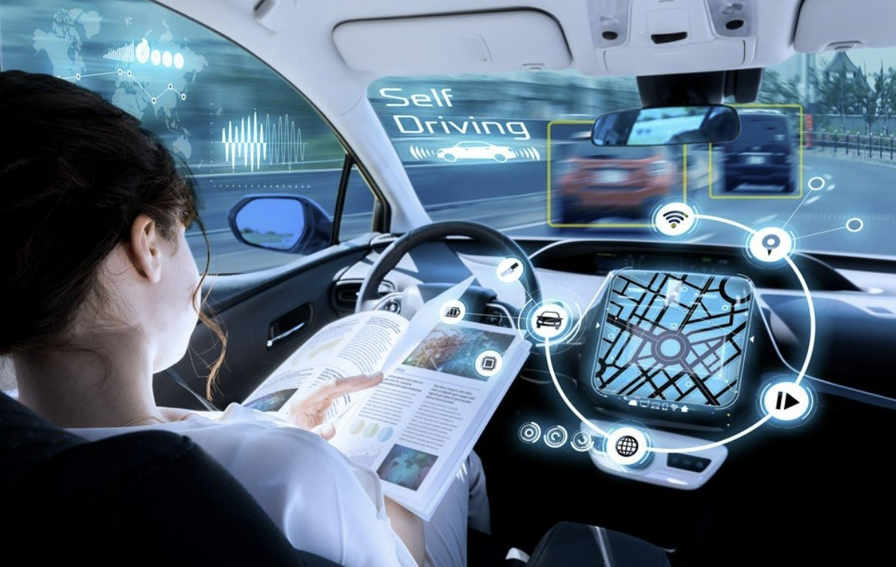

Figure 2.0 Artificial Intelligent; Self Driven Car [source: Xie et al (2022)]

In Fig 2.0 Fossil fuel power cars, known as mechanically driven, will soon reach their end. A transition to a data energy source car reduces energy consumption, and the cost of operation and making it more sustainable. Electric vehicles (EVs) will eventually take the place of fossil fuel-powered transportation, but this transition won't happen quickly. The 2030 prohibition forbids the sale of brand-new petrol or diesel vehicles, but those who currently own are still permitted to operate it on public highways. (2023) Mobility.

Smart Irrigation System using ML and AI

The research paper on the data as an energy source for future machines. The research focuses on smart irrigation system with generic idea of replacement of soil moisture devices using a data-driven approach to determine when a machine is to power on or off. After running the system for several hours, data are collected for features like, soil moisture, humidity, temperature, and soil type. The labels, which are the outcomes of the prediction are: very wet, wet, very dry, and dry.

Figure 3.0 IoT-Based Smart Irrigation System

The data as an energy source for a future machine is a clear description of the smart irrigation system where data generated by the Fig 3.0 is used for prediction. The application of machine learning and AI techniques determines machine`s state (water pump) in the feature labelled status.
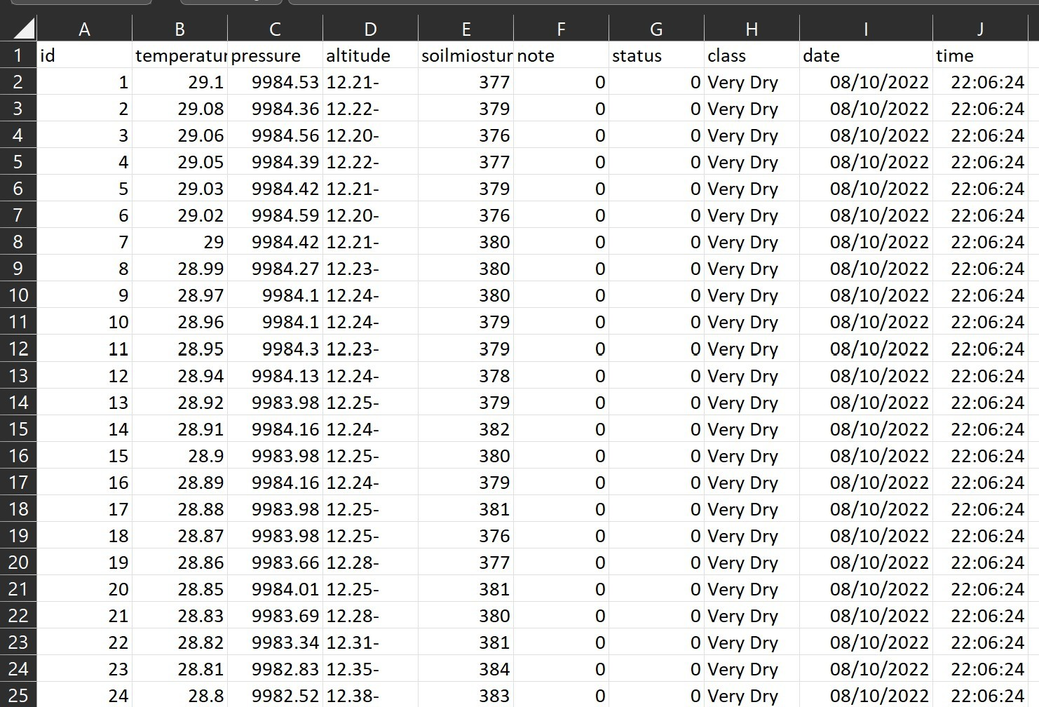

Figure 3.1 Data generated from Smart Irrigation System [Chinedu a (2023)]

The features specified in Fig 3.1 range from temperature, altitude, class, soil-moisture, date, time, and status of the pump. The total number of data samples collected is 4689 and 10 columns. The features of interest are soil moisture, pressure, temperature, class (very wet, wet, dry, very dry) and water pump status (On/Off). Two machine learning classification algorithms were selected at random, naïve bayes and random forest with a closer accuracy value after the experiment. Though accuracy is not the most suitable metrics for judgment on performance of machine learning algorithm. With this will f1 score, precision, and recall from classification report where adopted.
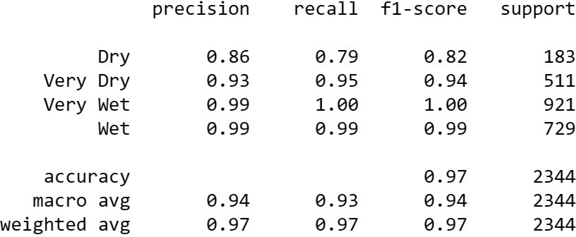

Figure 3.2 Naïve Bayes ML Algorithm Classification Report

The classification report describes the collection of selected metrics, the precision, recall and f1-score. Looking at the metrics values for performance of model considering the analysis the metric precision will be considered as a criteria of judgement due to variance or different in each performance values.
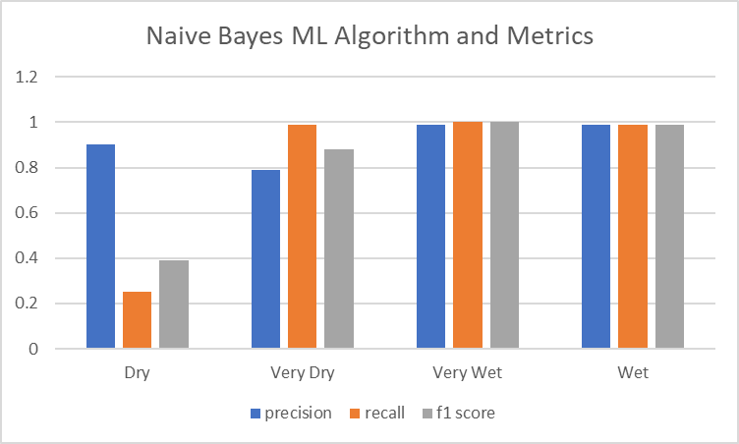

Figure 3.1 Naïve Bayes ML Algorithm Visual Analysis

The fig 3.1 is visually represented. The paper is concentrated on precision as a metric of jugdment because of a good variation among the classification. The class between the dry, very dry, very wet and wet.

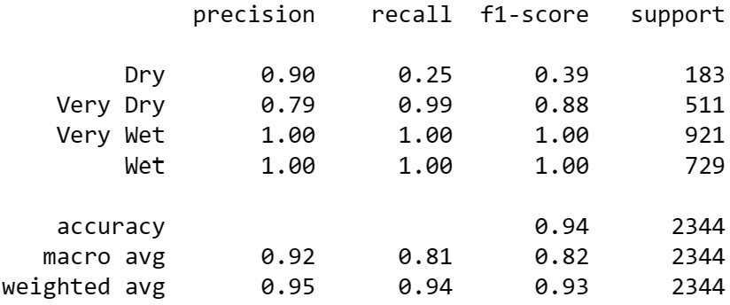

Figure 3.2 Random Forest ML Algorithm Classification Report

From classification report, this a collection of selected metrics (precision, recall and f1- score). The features selected pressure and soilmioture. The performance of ML algorithm using the precision metric
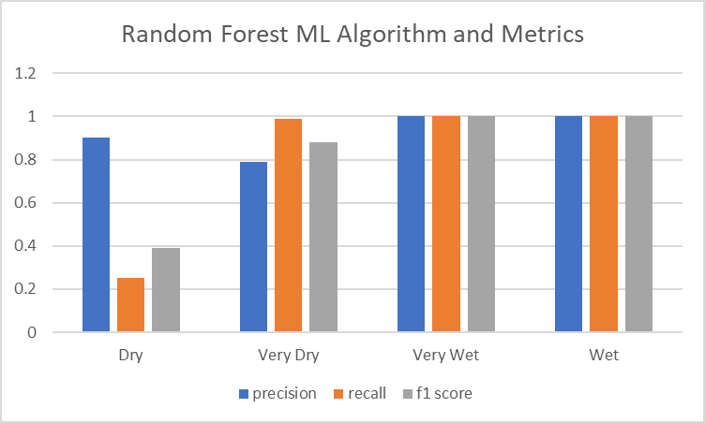

Figure 3.3 Random Forest ML Algorithm Visual Analysis

Fig 1.7 this shows precision is a good metric for jugdment over the performance machine learning model random forest.
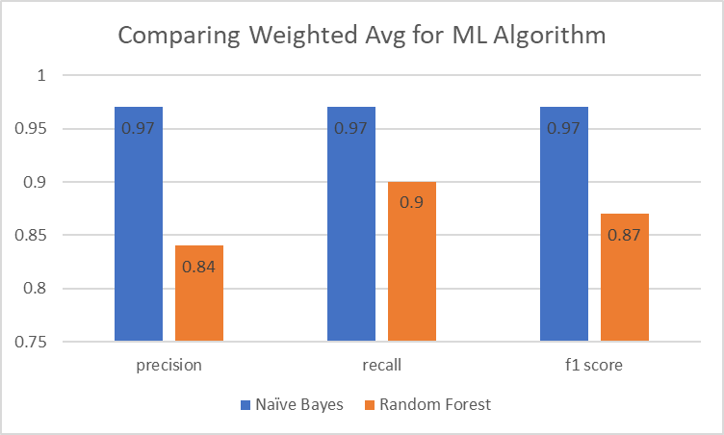

Figure 3.4. The comparative analysis between ML Models

In Fig 3.4, comparing the weighted average value, between naïve bayes and random forest ML algorithm using the metric precision for the judgment. Naïve bayes performance was rated 97 percent of good prediction score which is averagely okay and subject to optimization. To this will be used for a real time implementation of a system that predict the condition of the soil to be either dry, very dry, very wet or wet. Once the system predict dry or very dry the water pump goes ON while when predicted wet or very wet water pump goes OFF.

Benefits of the Transition

The benefits are affordability and efficiency of a system running without stoppage in operational processes of the system due to high consumption of energy sources. Using data as an energy source offers several potential benefits.
- It can significantly reduce the energy consumption of data centres.
- It can increase the processing speeds of machines by eliminating the need to transfer data between processing and memory units.
- It can improve data security by reducing the need to transfer data over networks.

Challenges posed by Technologies Adopted

There are many threats to the proper transition of energy from conventional energy to data energy sources. Several challenges that need to be addressed before data can be used as an energy source to power future machines.
a. The energy generated by data is typically very small, which makes it challenges to harness. chinedu b (2023).
b. The techniques used to harness the energy potential of data are not yet mature enough to be used in large-scale applications.
c. The cost of implementing these techniques is still very high.

Discussion and Recommendation

Transitioning from conventional energy sources to data energy source answers the question of affordability and efficiency of supplying energy consumption and looking at the destructive effect of the conventional energy sources on the human body and ecosystems. Data as an energy source is a recommendation for the future machines where processing speeds of machines by eliminating the need to transfer data between processing and memory units, data security is efficient. Furthermore, on the outcome of the analytical experiment on smart irrigation system, adopting ML algorithm to predict and make decision to determine the actual condition of the soil Fig 3.4 is a clear example of data as an energy source to future machines. Naïve bayes with precision score 0.97 will be used to implement a real time system to predict the condition of the soil by supplying parameter values like pressure, temperature, and soil moisture to determine whether the soil is dry or wet to trigger the machine OFF or ON.

5.0 Conclusion

Data is a new form of energy that has emerged in recent years. Using data as an energy source has several potential benefits, including sustainability and the ability to power machines that are not connected to the grid. Furthermore, in smart irrigation systems where functions and operation of a sensor are no longer required, now predictable parameters are used to power the machine to either irrigate or not using machine learning and AI tools. The was clearly presented in section 4. As the volume of data generated globally continues to grow, the use data as an energy source will likely become more widespread in the future. However, there are also several challenges associated with this approach, such as the high computational power required to transform data into energy. Despite these challenges, using data as an energy source has several promising applications, including power self-driving cars, drones, and other autonomous machines.

Funding: This research did not receive any specific grant from funding agencies in the public, commercial, or not-for-profit sectors.

Acknowledgments: This is to acknowledge that no financial interest or benefit has arisen from the direct applications of this research.

Conflicts of Interest: The authors declare no conflict of interest. The funders had no role in the design of the study; in the collection, analyses, or interpretation of data; in the writing of the manuscript, or in the decision to publish the results.

Abbreviations: Internet of Things (IoT), Machine Learning (ML), Artificial Intelligence (AI), Gross Domestic Product (GDP)

References
Cambridge Dictionary (2023): Data, Definition of Data: Available here: https://dictionary.cambridge.org/dictionary/english/data [accessed: 1 April 2023]
Qualitative vs Quantitative Data (2023): Definitions, Analysis, Examples available here: https://www.intellspot.com/qualitative-vs-quantitative-data/ [accessed: 29 March 2023]
Bridge, James P., Sean B. Holden, and Lawrence C. Paulson. (2014) Machine learning for first order theorem proving. Journal of automated reasoning 53.2: 141-172.
Sarah, et al., Loos (2017) Deep Network Guided Proof Search arXiv preprint arXiv:1701.06972.
Finnsson G., Hilmar G., and YngviBjörnsson H. (2008) Simulation-Based Approach to General Game Playing. AAAI. Vol. 8.
Sarikaya, Ruhi, Geoffrey E. Hinton, and AnoopDeoras. (2014) Application of deep belief networks for natural language understanding. IEEE/ACM Transactions on Audio, Speech and Language Processing (TASLP) 22.4 : 778-784.
Mohri, Mehryar; Rostamizadeh, Afshin; Talwalkar, Ameet (2012) AI-based translation to soon reach human levels: industry officials. Yonhap news agency. Retrieved 4 Mar 2017. Foundations of Machine Learning. USA, Massachusetts: MIT Press. ISBN 9780262018258.
Zhong, Sheng-hua; Liu, Yan; Liu, Yang (2011). Bilinear Deep Learning for Image Classification. Proceedings of the 19th ACM International Conference on Multimedia. MM '11. New York, NY, USA: ACM: 343–352. doi:10.1145/2072298.2072344. ISBN 9781450306164.
- Szegedy, Christian; Toshev, Alexander; Erhan, Dumitru (2013). Deep neural networks for object detection. Advances in Neural Information Processing Systems.
- Deng, L.; Yu, D. (2014). Deep Learning: Methods and Applications (PDF). Foundations and Trends in Signal Processing. 7 (3–4): 1–199. doi:10.1561/2000000039.
Ministry of new and renewable energy (2023) available here: www.mnre.gov.in/. The ministry of new and renewable energy is the nodal ministry of the Government of India for all matters relating to new and renewable energy. [April 10, 2023]

- Youness Tace, Mohamed Tabaa, Sanaa Elfilali, Cherkaoui Leghris, Hassna Bensag, Eric Renault, (2022) Smart irrigation system based on IoT and machine learning, Energy Reports, Volume 8, Supplement 9, 2022, Pages 1025-1036, ISSN 2352-4847, https://doi.org/10.1016/j.egyr.2022.07.088. (https://www.sciencedirect.com/science/article/pii/S2352484722013543)
- Kamienski C, Soininen J-P, Taumberger M, et al. (2019), Smart water management platform: Iot-based precision irrigation for agriculture. Sensors ;19(2):276.
- Nour-El Aine Y, Leghris C. (2021) Ensuring smart agriculture system communication confidentiality using a new network steganography method. In: Boumerdassi S, Ghogho M, Renault É, editors. Smart and sustainable agriculture.
Chinedu Chukwuemeka Mazi (2023) Dataset Smart Irrigation System Available here: chinedunewbirth/Smart-Irrigation-System-and-ML-: Generate Dataset from Smart Irrigation System and ML using several Algorithm to predict the condition of soil Very Dry, Dry, Very Wet and Wet (github.com)
Snijders, C.; Matzat, U.; Reips, U.-D. (2012). Big Data': Big gaps of knowledge in the field of Internet. International Journal of Internet Science. 7: 1–5.
Global Energy Consumption (2023): world consumption statistics available here https://yearbook.enerdata.net/total-energy/world-consumption-statistics.html [accessed: 4
April 2023]

Kosmatos, E.A., Tselikas, N.D. and Boucouvalas, A.C. (2011) Integrating RFIDs and Smart Objects into a Unified Internet of Things Architecture. Advances in Internet of Things: Scientific Research, 1, 5-12. http://dx.doi.org/10.4236/ait.2011.11002 [Citation Time(s):2]
Kumar G. (2016) A survey on machine learning techniques in health care industry.
International Journal of Recent Research Aspects. ;3(2):128–132. [Google Scholar]

Xie, S.; Hu, J.; Ding, Z.; Arvin, F., (2022) Cooperative Adaptive Cruise Control for Connected Autonomous Vehicles using Spring Damping Energy Model IEEE Transactions on Vehicular Technology, 2022.
Mobility (2023) Fossil Fuel Car ban Available here: The 2030 Fossil Fuel Car Ban and How it Impacts You (motability.co.uk) [accessed: 10 April 2023]

