**"Pack House: Enhancing Postharvest Quality and Market Readiness of Fresh Produce"**

**Shourathunnisa Begum1, Sharanagouda Hiregoudar2 and Udaykumar Nidoni3**

**1Ph.D Scholar, Department of Processing and Food Engineering, CAE, UASR**

**2Prof. and Head of the Department, Department of Processing and Food Engineering, ,CAE, UASR**

**3Udaykumar Nidoni, University Head, Department of Processing and Food Engineering, CAE, UASR**

**Corresponding email address: shohrat357@gmail.com**

1. **Introduction:**

Fresh fruits and vegetables are very perishable products with relatively short postharvest life. They are living tissues with high water content and are subject to continuous change after harvest ending with senescence. Senescence is the final stage in the development of the plant organ, characterized by the breakdown and death of the cells. Special efforts are required to slow down the effects of these naturally occurring processes to maintain the quality of fresh produce from the field to the consumer level (Berk, 2013). Harvesting is the first step in the postharvest system and affects subsequent operations such as packing, handling, transport, and preservation of the crop. Because of their perishability the harvesting and packing speed of fresh horticultural products is of great importance as soon as the optimum stage of maturity is reached. Maintaining high-quality produce from the field to the consumer is a major prerequisite for marketing (Oubahou *et al*., 2019).

Packing-house operations are specific for each commodity to be handled and for the target market. Operations include any of a number of steps, including trimming, cleaning, removal of excess moisture, curing, waxing, sorting and grading, ripening, degreening, packaging and pre-cooling. If excess raw material cannot be treated and packaged (Ajay, 2020).

Harvested produce is often brought to a common facility for preparation and storage pending transport to market. In its various forms, this facility is referred to as a packing-shed, a pack house or a packing house. A pack house is a physical structure where harvested produce is consolidated and prepared for transport and distribution to markets ([www.fao.com](http://www.fao.com))

1. **Users of packing-house facilities**
2. Growers
3. Processors
4. Traders, importers & exporters
5. Co-operatives and clusters
6. **Components of pack house**

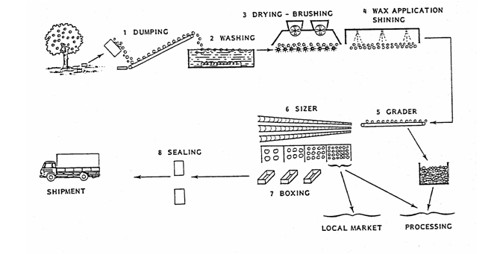

**Plate: 1. Components of pack house**

1. **Key packing-house operations**
   1. **Receiving**

On entry at the packing-house, produce must be inspected for damage, insect or rodent infestation, decay, foreign materials and visible chemical residues and assigned with a code that identifies the supplier, date harvested or delivered, and production site (origin, lot/block number and tree number). Depending on the type of produce gross harvested weight might be recorded at this time. If possible, produce should be tested for chemical residues using test kits that may be confirmed as required by accurate analyses such as gas chromatography or high performance liquid chromatography (Boonyakiat and Janchamchoi 2007).

* 1. **Maturity assessment**

Depending on the intended market or requirements of the target market, maturity must be checked. Fruits that float are culled because they are considered to be too immature. Soluble Solids Content (SSC) provides an indication of the level of sweetness of some fruit and also its maturity. A minimum SSC has been established for the following crops: pineapple – 12 per cent, papaya – 13-15 per cent, litchi – 16-17 per cent and watermelon – 10 per cent. ‘Solo’ papaya fruits are considered to have reached optimum maturity for harvest when total soluble solids (TSS) are 12 per cent. SSC and TSS are often used interchangeably (Hewett *et al.* 2009).

* 1. **Buffer storage**

The incoming fruit, in pallet bins, is next kept in a cold room, for buffer stor­age until needed. Packing lines are designed to work in a continuous mode. On the other hand, raw material is supplied to the packing house in pulses, of­ten without coordination. In such cases, buffer storage capacity between sup­ply and demand is required (Berk, 2013). Many packing houses possess buffer storage space for two or three working days. To maintain the fruit quality, this storage space must be refrigerated to approximately 10°C. Cold storage of the detached fruit at this stage is critical for the postharvest stability of the fruit. If the fruit was previously heated for degreening, subsequent cooling to about 10°C is a must. For fruit that does not require degreening, cooling from field temperature to 10°C before packing is beneficial, as it reduces moisture loss by 50% and retards decay (Yehoshua and Cameron, 1989)

* 1. **Dumping**

Pallet bins full of fruit are brought by forklift to the entrance of the packing line and placed, one by one, on the dumper platform. The dumper hydraulically lifts and tilts the bins to past-vertical position so as to empty the fruit gently on the receiving roller conveyor. Most of the trash, consisting of leaves, twigs, sand, etc., is collected by some trash-catching device below the dumper and slides down to a trash container. Remaining trash and badly split and rotten fruit is manually removed from the receiving conveyor. The dumper has usually an attach­ment for discharging the empty bins, which are returned to the grove. It is important to regulate the dumping rate so as to assure steady flow of fruit along the line. This can be achieved manually by the dumper operator or automatically. Washing the empty bins with high-pressure water sprays and steam and disinfection with chlorinated water are recommendable to avoid contamination of the next charge of fruit (Yaptenco and Esguerra, 2012)

**Plate: 2. Different dumping methods**

* 1. **Soaking (Drenching)**

The first cleaning operation is soaking in chlorinated water, both for wetting and for disinfection. Early disinfection is important, not only for cleaning the fruit but, first and foremost, for avoiding microbial buildup and bio­film on the equipment. The receiving conveyor delivers the fruit to a soak tank containing water at ambient temperature. Chlorine is added so as to maintain a free chlorine concentration of 100–200 ppm (less in lemons). In the past, higher concentrations were customary, but it has now been es­tablished that high concentrations of chlorine cause the formation of stable chlorinated organic substances suspected as carcinogens. Pure chlorine is marketed as a bottled, pressurized gas. Automatic chlorinators that regulate chlorine flow so as to maintain the desired concentration are available. In small-scale installations, sodium or calcium hypochlorite is used instead of bottled chlorine. Failure to change the soaking water properly and to main­tain an adequate concentration of free chlorine may turn the soaking step to a source of contamination rather than a cleaning operation ([www.fao.com](http://www.fao.com)).

* 1. **Presorting**

Presorting can be done before or after drenching. The advantage of soaking and sanitizing before presorting is in presenting to the workers, fruit with a cleaner surface for easier detection of defects. After washing and treat­ment with chlorine, the fruit is sufficiently clean to be manually sorted to separate the culls and fruit for juice processing from the main stream. The fruit is delivered to the presorting “table” which may be a roller or a belt conveyor. Workers manually remove the culls and fruit for juicing and throw them into separate chutes, leaving the better fruit on the conveyor (Mahajan *et al*., 2010)

* 1. **Cleaning/washing**

Cleaning removes latex, dirt, chemical residues, reduces the microbial load, insects such as mealybug and aphids, and other extraneous materials from the surface of the produce. Produce with a clean appearance is appealing to the consumer, and can be easily sold. Soil adhering to produce can produce abrasion damage during transport, and serve as a source of contamination. Harvesters should, therefore, remove as much soil as possible prior to hauling produce to the packing facility. Physical damage must be minimized during the cleaning process (CAC 2003). The method of cleaning is determined by the nature of the commodity and the demand of the consumer. Leafy vegetables such as lettuce and muskmelons have rough surfaces that favour the attachment of microorganisms (Raiden *et al.* 2003), hence the need for washing. Bulb crops that will be stored such as onion and garlic, on the other hand, need not be washed. However, the dried outer scales need to be removed as they carry dirt. Fruits that are susceptible or suffer from latex staining need to be washed immediately after harvest to remove fresh later adhering to the peel. Aside from improving appearance, this will also prevent latex burns.

**The different methods of cleaning include:**

**Washing**– microbial contamination is usually found on the surfaces of fruit and vegetables, so washing is an important step in reducing the microbial load. The different methods of washing include:

1. **Dump washing or immersion dipping**
2. **Spray washing**
3. **Brush spraying** 
   1. **Drying**

After treatment in the soak tank the fruit is elevated to a tunnel where excess water on the surface is removed by a current of air at ambient temperature. The fruit goes into a tunnel where it is dried by warm (40–45°C) air, while traveling on a roller conveyor. Alternatively, the fruit is “wiped” by soft revolving brushes or by rollers (Fito *et al*., 2004).

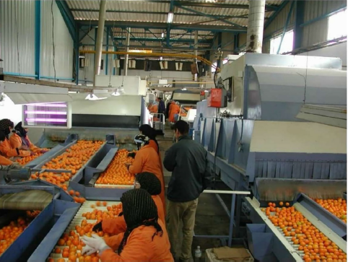

**Plate: 3. Drying**

* 1. **Waxing**

Since the natural wax coating of the fruit has been removed in the washing step, it is now necessary to apply a coating of new wax on the surface the objectives of waxing are:

■ To reduce water loss

■ To provide a barrier to gas exchange

■ To restore the shiny appearance of the fruit

■ To provide a support for preserving agents

A number of natural and synthetic waxes have been approved by regulatory agencies for use in foods. The natural waxes include beeswax, carnauba wax, candelilla wax, wood rosin, and shellac (Abdelfattah *et al*., 2020) Carnauba wax is extracted from the leaves of the plant *Copernicia cerifera*. Waxes not from vegetal or animal source comprise oxidized polyethylene, ester waxes obtained by es­terification of saturated fatty alcohols with saturated fatty acids and paraffin. Fungicides are usually added to the wax or wax emulsion (www.fda.gov.in)

.

* 1. **Grading**

Grading of the waxed fruit can be done manually or with electronic graders. At this stage, more processing quality fruit may be separated, to be sent to the factory together with the fruit discarded at the stage of presorting. Man­ual grading is labor-intensive and less accurate. For better results the stream of fruit is divided into several conveyors so as to have less fruit inspected by each worker. The quality grades are defined according to market demand.



**Plate: 4. Electronic sorter**

|  |  |  |
| --- | --- | --- |
| **Size code** | **Average weight (g)** | |
| With crown | Without crown |
| A | 2750 | 22280 |
| B | 2300 | 1910 |
| C | 1900 | 1580 |
| D | 1600 | 1330 |
| E | 1400 | 1160 |
| F | 1200 | 1000 |
| G | 1000 | 830 |
| H | 800 | 600 |

**Table: 1. Size classification of pineapples based on weight with due consideration for the presence or absence of a crown**

|  |  |
| --- | --- |
| **Size code** | **Diameter (mm)** |
| 0 | >139 |
| 1 | 109-139 |
| 2 | 100-119 |
| 3 | 93-110 |
| 4 | 88-102 |
| 5 | 84-97 |
| 6 | 81-93 |
| 7 | 77-89 |
| 8 | 73-85 |
| 9 | 70-80 |

**Table:2. Size classification of grape fruit based on fruit diameter taken at the equatorial region**

* 1. **Packaging**

Fruit can be packaged in telescopic boxes, tray boxes, wire-bound wooden crates, or net bags, depending on the subsequent mode of transport and storage. Telescopic boxes, full boxes, and wooden crates are used main­ly for long-distance overseas transport. Net bags are very popular in the local retail market. The effect of aeration in the box on fruit quality was extensively investigated. Later, the wooden crates were replaced by cardboard boxes with holes for aeration. Carton boxes have the advantage of large printable surfaces, permitting attractive graphics and ample information for easy identification and traceability (www.fao.com)

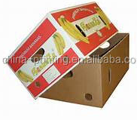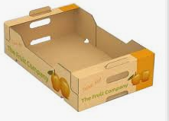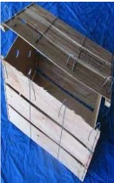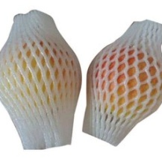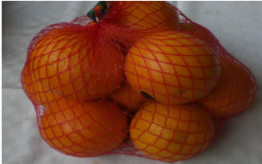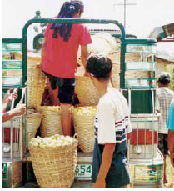

Plate: 5. Telescopic boxes, Tray boxes, Wire-bound wooden crates, Net and foam bags

Bamboo baskets

* 1. **Labeling**

Labelling is necessary to promote brand recognition and to provide distinction to a product in order to differentiate it from competing products. Labels can either take the form of a stamp with ink directly transferred to the produce surface, applied as a sticker or as a paper strap (especially for vegetables). Ink used for labeling should be resistant to moisture and must be approved for such use by the relevant government agency concerned with food safety ([https://fssai.gov.in](https://fssai.gov.in/)).

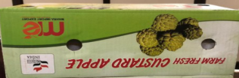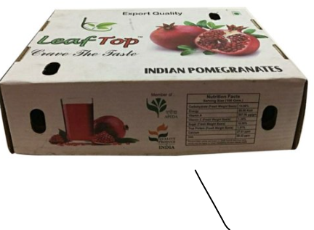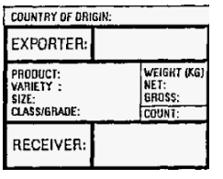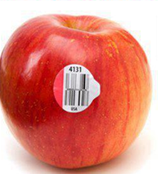

**Plate:6. Labeling types**

**Shipping labels can contain some or all of the following information:**

* + Common name of the product.
  + Net weight, count and/or volume.
  + Brand name.
  + Name and address of packer or shipper.
  + Country or region of origin.
  + Size and grade.
  + Recommended storage temperature.
  + Special handling instructions.
  + Names of approved waxes.
  1. **Trimming**

Trimming is a general term that refers to the removal of unwanted plant parts or those likely to be rejected by consumers or those parts that can contribute to deterioration. Specific trimming procedures for some commodities are described in Table 3. The dried flower remnants at the tip of the fingers of bananas are removed because these parts can decay-causing organisms that can be a potential source of inoculums besides making the bunch of bananas unsightly. Workers should wear clean gloves during removal of dried flower remnant (Bautista and Esguerra, 2007).

|  |  |  |
| --- | --- | --- |
| **Commodity** | **Procedure** | **Description** |
| Banana | Dehanding | Separation of hands from the stalk |
| Carrot | Detopping | Trimming of tops and vegetative parts |
| Garlic | Detopping | Trimming of tops and vegetative parts |
| Onion (bulbs) | Onion (bulbs) | Trimming of tops and vegetative parts |
| Radish | detopping | Trimming of tops and vegetative parts |
| Roses | Dethorning | Removal of thorns from stems |
| Sweet corn, baby corn | Desilking | Removal of silk |
| Pineapple | Detopping | Removal of crown |

**Table:3. Trimming operation in different crops**

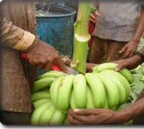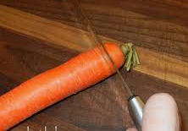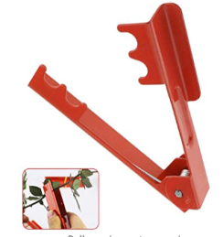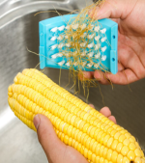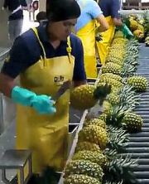

**Plate: 7. Special trimming operations**

* 1. **Palletizing**

The following illustrations show the arrangement of the most popular containers on a standard pallet (1000 x 1200 mm or 40 x 48 inches).

1. **Functions of a packing-house facility**

* The packing-house system integrates components (raw materials, utilities, technologies, equipment and personnel) that function together to prepare produce for the market.
* Each component, therefore, has a significant effect on the final quality of fresh produce.
* Control point where quality management can be applied to assure supply of produce of good quality to consumers.
* Implementation of effective strategies to eliminate or minimize microbial, chemical and physical contamination (<https://www.moa.gov>) .

1. **Benefits of using a pack house facility**

* **Increased productivity of workers**– a well designed and equipped packing-house allows workers to perform more efficiently. Volumes of commodities handled are increased and errors in sorting and grading are reduced.
* **Extended produce shelf-life**– packing-houses provide an appropriate venue where market preparations can be properly performed. Well-trained and motivated workers ensure proper post-harvest handling of commodities, hence minimizing disease development, reducing mechanical damage and decelerating the rate of ripening and deterioration.
* **Improved produce quality**– culls and rejects are more efficiently separated and removed from good-quality produce in a packing-house. This prevents cross-contamination and premature deterioration. Commodities are also better classified into different grades and sizes that can command better prices than mixed lines of produce (Boonyakiat and Janchamchai, 2017).

**References**

Abdelfattah. A., Whitehead. S. R., Macarisin, D., Liu, J., Burchard, E., Freilich, S., Dardick, C., Droby, S. and Wisniewski, M., 2020, Effect of washing waxing and low temperature storage on the postharvest microbiome of apple. *Microorganisms*, 8(6): 944-955.

Ajay, W.T., 2020. Current advances in food processing and preservation. *Indian Association Of Nuclear Chemists and Allied Scientists Bulletin*, 15(1): 1-5.

Bautista, O. K. and Esguerra, E.B. (eds.) 2007. Postharvest technology for Southeast Asian perishable crops. University of the Philippines Los Banos, Laguna and Department of Agriculture, Quezon City, Philippines. 447p.

Berk, Z., 2013. Food Process Engineering and Technology, second ed. Elsevier, London.

Boonyakiat, D. and Janchamchai, K., 2007, The royal project packing-house quality assurance. *Acta Horticulturae*, 741(7): 41-47.

Fito, P.J., Ortolá, M.D., Reyes, R., Fito, P. and Reyes, E. D., 2004, Control of citrus surface drying by image analysis of infrared thermography. *Journal of Food Engineering*, 61(5): 287–290.

Hewett, E., Rolle, R., Kanlayanarat, S. and Acedo, A. 2009, Maturity indices and harvesting. *Horticultural chain management for countries of Asia and the Pacific region: a training package,* RAP Publication*,* FAO-UN Regional Office for Asia and the Pacific.

[https://fssai.gov.in](https://fssai.gov.in/)

<https://www.fao.org/>

<https://www.moa.gov>.

Mahajan, B. V. C., Kaur, T., Gill, M. I. S., Dhaliwal, H. S., Ghuman, B. S. and Chahil, B. S. 2010, Studies on optimization of ripening techniques for banana*. Journal of Food Science and Technology*, 47(3), 315–319.

Raiden, R.M, Summer, S.S., Eifert, J.D. and Pierson, M.D. 2003,Efficacy of detergents in removing *salmonella* and *shigella* spp. from the surface of fresh produce. *J. Food Prot.,* 66: 2210-2215.

[www.fao.com](http://www.fao.com)

[www.fda.gov.in](http://www.fda.gov.in)

Yaptenco, K. and Esguerra, E., 2012, Good practice in the design, management and operation of a fresh produce packing-house. *RAP Publcations*, Bangkok.

Yehoshua, S. B. and Cameron, A. C., 1989, Exchange deternibatiob of water vapour carbon dioxide oxygen ethyelene and other gases of fruits and vegetables. *Gases in Plant abd Microbial Cells*, 30(7): 177-193.