EMERGING AND RECENT TRENDS AND FUTURE DIRECTIONS OF DENTAL RESEARCH IN DIGITAL ERA

I. INTRODUCTION
With the advancements in technology over all the fields, dentistry has also flourished. In recent years dentists are blending their science with technology to achieve optimum result. Digital dentistry is taking over the conventional in every aspect (diagnosis, treatment plan, execution of the treatment)[1]. The digitization of dentistry is becoming more and more popular, which has advanced the manufacturing and processing of computer-derived data. The Internet of medical things (IoMT), big data and analytical algorithms, internet and communication technologies (ICT) including digital social media, augmented and virtual reality (AR and VR), and artificial intelligence (AI) have all contributed tremendously to this advancement. [/2]The digitization of dentistry is becoming more and more popular, which has advanced the manufacturing and processing of computer-derived data. The Internet of medical things (IoMT), big data and analytical algorithms, internet and communication technologies (ICT) including digital social media, augmented and virtual reality (AR and VR), and artificial intelligence (AI) have all contributed tremendously to this advancement. [/2]
The interaction of these advanced digital elements has had a significant impact on the biomedical and healthcare industries, particularly in the field of dentistry. In addition to streamlining dental care, improving workflow, improving oral health at a fraction of the current conventional cost, relieving dentists and dental assistants of tedious and repetitive tasks, and igniting participation in individualized dental care, these numerous technological applications will be able to do [2].
Digital technology is a boon to dentistry, as it works effectively and efficiently, reduced working time and number of appointments, dentist - patient friendly, comfortable and easily accepted by the patient, and also gives accurate and better results when compared to other conventional techniques. It is an aid in various fields of dentistry, like diagnosis, treatment planning, execution of the treatment, and the outcome of the treatment. Basically digital dentistry works on images with scanning devices. These provide dentists with a quick 3D image of a patient’s oral or maxillofacial anatomy. It gives a complete 3D image which can be seen in 360° [1].

II. DIGITAL REVOLUTION IN DENTAL RESEARCH
Computer :
anything that is electronic that can be programmed and used to store, retrieve, and process data. The dictionary of Webster [3].
Software :
The term "dental software" refers to software applications utilized in the field of dentistry. Computer software, often simply referred to as software, comprises a collection of machine-readable instructions, typically presented in the form of a computer program, which guides a computer's processor in executing specific tasks. Software encompasses one or more computer programs as well as the associated data stored within the computer's memory. In essence, software represents a collection of programs, procedures, algorithms, and accompanying documentation designed to manage the operations of a data processing system [4].
Across most computer platforms, software can be categorized into several overarching groups, which include the following:
- System software: This category encompasses the fundamental software required for a computer to function, with the operating system being the most prominent component.
- Application software: Application software comprises all software applications that utilize the computer system to carry out productive tasks beyond the core operation of the computer itself.
- Embedded software: Embedded software takes the form of firmware and is integrated within embedded systems, which are specialized devices designed for specific, singular purposes [4].

Digital Dentistry:
Digital dentistry refers to the use of dental technologies or devices that incorporates digital or computer-controlled components to carry out dental procedures rather than using mechanical or electrical tools [5].
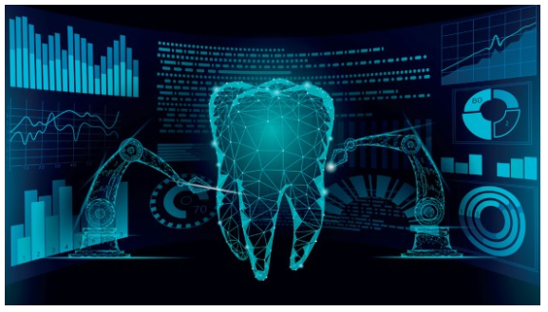
FIGURE.1. DIGITAL DENTISTRY

Dental informatics:
It is the "application of computer and information science to improve dental practice, research and program administration"[3]. Dental informatics, also known as dental information science or dental computing, is a multidisciplinary field encompassing information technology, data science, and communication systems in dentistry. It involves developing, implementing, and evaluating digital tools and technologies to improve the management, analysis, and utilization of dental data for patient care, research, and education [6].
Dental informatics has gained significant momentum in recent years due to the increasing availability of electronic health records (EHRs), the widespread use of digital imaging and other diagnostic tools, and the growing interest in telehealth and mobile health applications . These advancements have transformed the landscape of dental practice, research, and education, and hold immense potential for improving oral health outcomes and enhancing patient care[6].
Digital Transformation :
"A process that aims to improve an entity by triggering significant changes to its properties through combinations of information, computing, communication, and connectivity technologies [7]," is how Vial (2019) defines digital transformation.
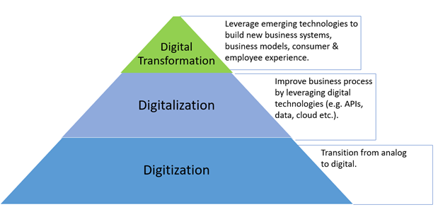
FIGURE.2. THE HIERARCHY OF DIGITISATION, DIGITALISATION, AND DIGITAL TRANSFORMATION

One area of medicine that has profited from the advancement of contemporary digital transformation is dentistry [2]. Clinical practice has been transformed by the digitization of dental data, computer-assisted imaging methods, and virtual treatment planning or simulations. The three main stages of the traditional patient workflow have all gradually—almost sequentially—embraced digitalization, giving rise to three separate processes:
i. Digital patient: The process of capturing patient data is transformed into a digital format, which includes clinical information, x-ray data, and casts. These digital records can then be stored and archived in the patient's electronic health records.
ii. Virtual patient: The mental planning of a patient's rehabilitation is now aided by digital treatment planning and on-screen simulations, facilitated through computer-aided design (CAD) tools.
iii. Real patient: Treatment procedures can be supported by computer-aided manufacturing (CAM) devices, which utilize milling or 3D printing technology [1].

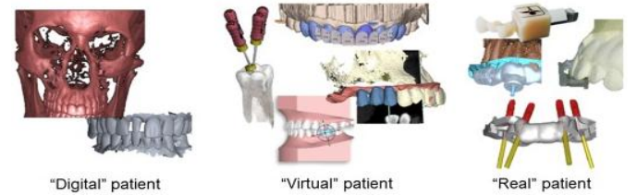
FIGURE.3. THREE MAIN STEPS OF DIGITALIZATION

The use of digitalization in dentistry is beneficial in the modern era, particularly given the various challenges associated with multiple chronic oral diseases, the complex treatment that an aging population requires, and the ongoing rise in costs over an individual's lifespan [2].
In recent decades, digital dentistry has been progressively introduced, bringing forth a range of technologies that have been developed and integrated at various stages. The primary objective has been to enhance and advance the field of dentistry through the utilization of digital tools and techniques. These advancements aim to deliver superior accuracy and precision, elevate the patient experience, boost overall efficiency and productivity, enhance communication and collaboration among dental professionals, ultimately leading to improved treatment outcomes. Additionally, digital dentistry contributes to better clinical results, streamlines laboratory workflows, offers cost-effective solutions, integrates seamlessly with other healthcare technologies, and empowers us to diagnose and treat dental conditions with greater accuracy and efficiency, all thanks to the continuous evolution of technology [8].
Advancements in bioscience research and technology have led to enhanced treatments for chronic oral conditions like periodontal disease and dental caries. The sequencing of the human genome and the thorough exploration of mutational patterns in oral and head and neck cancer have paved the way for precision diagnostics and the identification of novel therapeutic biomarkers [9].
Healthcare providers and relevant industries are investigating the use of digital computer-derived applications on smartphones, tablets, PCs, and smart watches to provide advanced management in dentistry that is both comprehensive and easy to use. This technology is made possible by superfast broadband and the internet. The fields of implant dentistry, restorative dentistry, oral and maxillofacial surgery, and other related fields have benefited from the streamlining of computer-generated care with centralized data collecting [2].
When it comes to both restorative and diagnostic dentistry, digital dentistry can be more efficient than utilizing mechanical instruments. utilized to make dental procedures easier and to suggest fresh approaches to satisfy growing patient wants [5].
Digital Dentistry Applications :
The computers are used for many purposes in the field of dentistry and can be broadly classified as:
- Administrative applications
- Clinical applications &
- Other applications
Administrative applications : They are aimed for a smooth running of the dental clinics, the hospitals & the dental institutions.
- Patient appointments and recalls
- Billing
- Accounting Correspondence
- Inventory control and supply orders
- Dental insurance claims
- Document preparation & word processing
- Referral information
- Missed appointments follow-up

Clinical Applications: The computers are very useful for the dentists in their professional practice.
- Patient record storage & retrieval
- Clinical diagnosis and treatment planning
- Patient motivation & awareness
- Computerized cephalometrics& growth prediction
- CAD-CAM
- Computer assisted densitometer image analysis system,For special purposes like computerized spirometers,blood chemistry& gas analysers, ultrasound scanners and CT scanners
- Radiovisuography (RVG) technique
- Storage of patient photographs, radiographs & study models.

Other applications:

- Controlling the circulation of books and journals and their availability in the library
- Creating a data base of survey information
- Case presentation
- Conference presentations
- Reviewing of literature
- Entertainment & family use
- Continuing dental education [5].

III. RECENT TRENDS IN DIGITAL DENTAL RESEARCH
The field of dentistry is evolving and changing to best suit patient needs. Present recent trends driven by digital advancements that have reshaped dental research methodologies as follows:
A. Advanced Imaging for Impressions and Diagnostics :
- Digital Radiography

- Computed Tomography (CT)
- Denta CT
- Magnetic Resonance Imaging (MRI)
- Cone Beam Computed Tomography (CBCT)
- Digital Occlusal Analysis
- Computer Based Thermal Imaging
- Computer Assisted Densitometric
- Image Analysis System
- Intra Oral Scanners IOS
- Intra Oral Cameras
- Optical Dental Diagnosis:
      - Caries Diagnosis : Diagnodent
      - Cancer Screening : Velscope
      - Digital Periodontal Probes : Florida Periodontal probe, Foster Miller Probe and Toronto Automatic Probe
B. Digital Reconstructive Workflows :
- CAD-CAM
- Additive Manufacturing /Rapid Prototyping /3D Printing
- Artificial Intelligence (AI) and Machine Learning (ML)
- Augmented Reality (AR) and Virtual Reality (VR)
- Teledentistry (TD)
- Electronic Dental Health Records (EOHRs)
- Analytics and Big Data
C. Digital Dental Therapeutics :
- Computer Controlled Local Anesthetic Delivery CCLAD, or WAND
- Computers Assisted Implant Surgery CAIS
- Heal Ozone
- Zoom whitening

- Smart Dental Devices :
- Smart Tooth Brushes
- Smart Water Flossers
- Oral health Trackers
- Smart Mirror Systems
- Regenerative Dentistry
- CRISPR
- Personalized Dental Medicine
- Robotics
D. Digital Dental Education :
- Dental Education and Academia
- ChatGPT

A. DIGITAL IMAGING AND DIAGNOSTICS
Digital imaging has revolutionised the field of dentistry by enabling advanced diagnostic capabilities, such as cone-beam computed tomography (CBCT) and intraoral scanners, which allow for the accurate and efficient diagnosis, treatment planning, and monitoring of various oral health conditions. CBCT has been particularly valuable in implant dentistry, orthodontics, and endodontics, as it provides three-dimensional imaging of the maxillofacial region, allowing for precise treatment planning and improved clinical outcomes [6].
A proper diagnosis will lead to a proper treatment planning. Various technologies have been used in digital dentistry for diagnostic purpose - intraoral cameras, intraoral scanners, cone beam computer tomography (CBCT), magnetic resonance imaging (MRI), CT scans, diagnodent (for caries detection) [1].

a). DIGITAL RADIOGRAPHY
Computerized images that can be stored, altered, and adjusted for under- and overexposure are made possible by digital radiography. Additionally, this approach yielded a significant dose reduction (between 1/3 and ½). Numerous advancements have been made in recent times, including wireless sensors (both CCD/CMOS and PSP), Carestream Dental's Logicon for caries diagnosis, the Intelligent Positioning System for digitally aligning the tube head to the sensor quickly and easily, tablet integration, and voice activation [3].
Two digital radiographic methods:
The direct method:
1. It connects to the computer system via a fiber optic or other wire using a charged coupled device (CCD) sensor.
2. Acquires real-time imagery that provides enhanced periodontium visualization.
The Indirect Method: (Digora System) :
1. Makes use of a phosphor luminescence plate, an intraoral film-like radiation energy sensor exposed to an x-ray tube.
2. The exposed plates are read offline by a laser scanner, which produces digital picture data [3].
b) COMPUTED TOMOGRAPHY (CT)
The inaugural commercial computed tomography (CT) scanner was created in 1972 by Sir Godfrey N. Hounsfield, an engineer working at EMI in Great Britain. Computed tomography employs a slender fan-shaped X-ray beam and multiple exposures encircling an object to unveil its internal structures. This technique aids clinicians in visualizing morphological features and identifying pathology in three dimensions.
There are four generations of CTs.
- Hounsfield's unit was part of the initial generation of CT scanners, employing a single detector element to capture X-ray beams.ϖ
- In 1975, a second generation of CT systems was introduced, featuring multiple detectors and the use of a small fan-shaped beam, in contrast to the pencil-beam scanning of the first generation.ϖ
- Third generation CT scanners, introduced in 1976, incorporated a large arc-shaped detector capable of capturing an entire projection without the need for translation.ϖ
- Fourth generation scanners replaced the arc-shaped detector with a complete circle of detectors [1].ϖ

c) Denta CT
Computed tomographic (CT) imaging of the mandible and maxilla is possible with Denta Scan, a special computer software package that offers three planes of reference: axial, panoramic, and oblique sagittal. It offers accurate treatment planning together with three-dimensional view of interior bone architecture. One may observe the density and quality of the bone in cross section. It aids in the preoperative planning of subperiosteal and endosseous dental implants. Visualization of the internal and bone structures is provided by a dental scan CT. It provides the exact position of the maxillary sinus floor and the mandibular canal. It facilitates the measurement of: in implant imaging

- Bone quantity: height and buccolingual dimension of implant site;
- Bone volume: extent of bone resorption;
- Bone quality and Precise location of vital structures [3].

d) MAGNETIC RESONANCE IMAGING (MRI)
Ionizing radiation is not used in the specialist imaging method known as an MRI scan. The magnet's strength, expressed in Tesla units, is used to assess MRI machines. The behavior of hydrogen atoms, which are made up of one proton and one electron, in a strong magnetic field is what makes an MR image in magnetic resonance imaging (MRI). MRI has mostly been used in dentistry to investigate soft-tissue abnormalities in the salivary glands, the mandible, and tumor staging [1].
e) CONE BEAM COMPUTED TOMOGRAPHY [CBCT]
In 1982, CBCT was created for angiography. uses a 2D area detector mounted on a rotating gantry and a cone-shaped ionizing radiation source. In a single scan, several consecutive pictures are generated. It turns the head 360 degrees. Most scans take less than a minute. In order to acquire an image, a reciprocating area detector and an x-ray source rotate in unison around the patient's head. To create simple images, many exposures are done at predetermined intervals [3].
Three-dimensional images are reconstructed using software. Assessment of the jaw bones, placement of implants, TMJ evaluation, lesions in the bone and soft tissue, periodontal and endodontic conditions, resorption of the alveolar ridge, and airway examination are among the conditions for which it is indicated. Additionally, it assists in the diagnosis of disorders connected to the alveolar bone as well as periodontal diseases such as gingival recession and hyperplasia [3].
When installing dental implants, CBCT serves as an implant surgical guide for periodontists and oral surgeons, improving treatment accuracy. As a result, it makes it possible to detect TMJ issues and implant devices with higher precession [10].

f) DIGITAL OCCLUSAL ANALYSIS
An accurate bite analysis and identification of any harmful occlusal forces are made possible by the T-scan II computerized occlusal analysis system. It can precisely identify forces acting on bridges, dental implants, full removable dentures, fixed and fixed-removable dentures, and fixed dentures. It gathers occlusal contact data, which is displayed in printouts and images with excellent definition. To offer a comprehensive evaluation of oral health, this data can be integrated with information from tissue exams, X-rays, and periodontal charts. One of the greatest occlusal diagnostic instruments on the market right now is Tscan II [3].
Digital occlusal analysis utilizes digital sensors for the assessment of a patient's bite and occlusion. This technology enables the detection of regions with elevated pressure or tooth wear, aiding dental practitioners in the diagnosis and management of conditions like temporomandibular joint disorder. Additionally, artificial intelligence (AI) and machine learning (ML) algorithms can be employed in the design of dental prosthetics, including implants, bridges, and dentures. These algorithms take into account factors such as the patient's bite, jaw structure, and other anatomical characteristics to craft prosthetics that offer a more natural and comfortable fit [8].
g) INTRAORAL SCANNERS [IOS]
In digital dentistry, handheld intraoral scanners are now a necessary tool. Traditional impressions are no longer necessary thanks to these scanners, which employ optical or laser technology to take extremely detailed digital imprints of the teeth and gingiva (and produce virtual models). Dental restorations including crowns, bridges, and dentures are designed and made using digital models in the fields of restorative dentistry, orthodontics, and implant dentistry. As such, the advantages of using intraoral scanning equipment include speed, precision, and patient comfort [8].
Intraoral scanners employ structured light scanning, a method that involves projecting a grid onto the tooth's surface. High-resolution cameras then capture the distortions in this grid, which are subsequently processed by a microprocessor. This data transformation results in the creation of a precisely dimensioned object, instantly visible within the acquisition software. The intraoral scanner serves as an ideal complement to all CAD-CAM procedures, offering the significant advantage of assessing impression accuracy immediately while the patient remains in the dental chair [11].
Top of Form
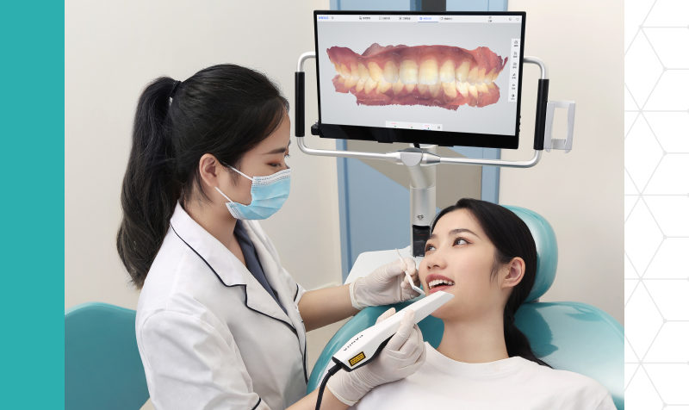
FIGURE.4. DIGITAL INTRAORAL SCANNER [IOS]
Types of IOS :
There are more than twenty iOS devices that are marketed for sale worldwide. They can be broadly classified as all-in-one scanning platforms with CAD/CAM solutions and standalone scanners. The earlier kind of scanner uses CAD software to finish the prosthetic-appliance design so the user may send the data to the dental laboratory, or it converts the intraoral scanning data into 3D models as image files [Fig. 5].
Conversely, the latter kind is the so-called "one-day treatment" gadget, which may use the 3D model data from the optical impression that the IOS generated to construct prosthetic appliances right away. Using a directly connected manufacturing device, the target prosthetic appliance is finished the same day with the necessary materials inserted. The device cuts and processes the appliance on site. A standalone scanner can function as an all-in-one scanning platform with the right system architecture [Fig. 6].
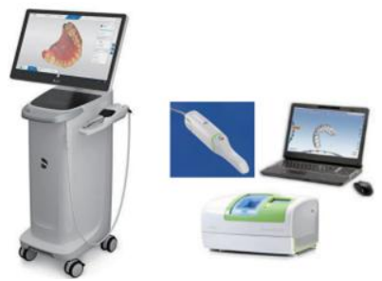
FIGURE.5. STANDALONE SCANNERS SYSTEMS OF CAD/CAM

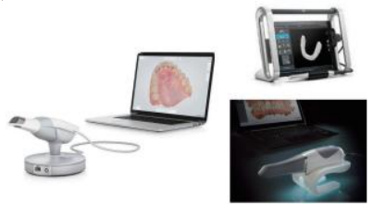
FIGURE.6. ALL - IN - ONE SCANNING PLATFORMS WITH CAD/CAM SYSTEM.

h) INTRAORAL CAMERAS
The intraoral camera is a tool employed by dentists for capturing precise and well-defined images of challenging-to-see areas within a patient's oral cavity. This camera not only enables dentists to visualize these images but also to share them with patients while assessing and educating them about their oral healthcare needs. This innovative technology empowers dentists to conduct comprehensive oral examinations, thereby enhancing their ability to evaluate their patients' oral care requirements.
Several companies, including Mouth Watch, Durr Dental, and Carestream Dental, have introduced intraoral cameras to the market. Among them, Carestream Dental stands out for its promise of revolutionary cameras that serve as effective conversation starters with patients. These cameras employ unique lens technology that mimics the human eye, ensuring effortless image capture and delivering clear, detailed visuals that patients can easily comprehend.

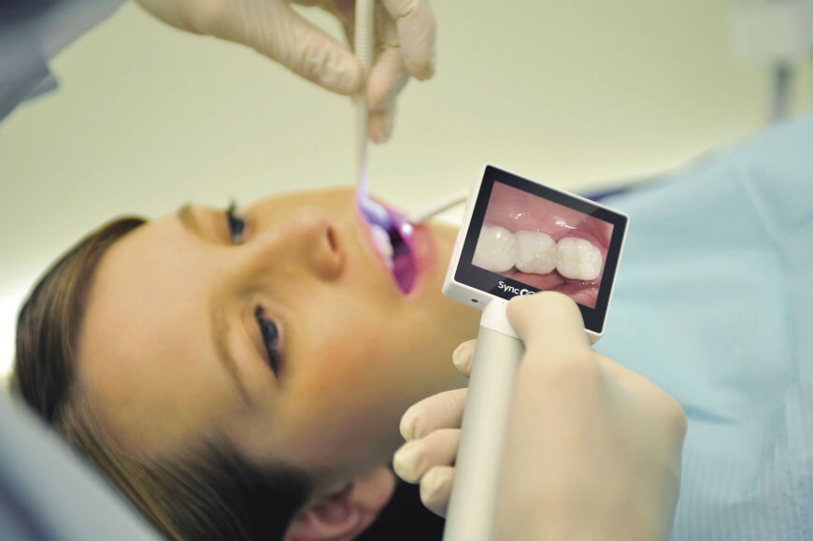
FIGURE.7. INTRA ORAL CAMERA

i) OPTICAL DENTAL DIAGNOSIS
Early detection of dental caries is crucial for starting therapy quickly and minimizing morbidity. Radiographs haven't exactly been that effective in this regard. It was revealed recently that there is a confocal microscope that can be used inside the mouth. Through the use of inexpensive laser diodes and optical cables, the device can capture depth profiles through a lesion. The depth and level of de-mineralization within the lesion can then be ascertained by analyzing the ensuing curves.
Using the newest generation of blue laser diodes as the foundation, a low-cost spectrometer system has been developed for use in the oral cavity as an alternate method. Fluorescence within the tooth is excited by 405 nm light, and this fluorescence is afterwards spectroscopically analyzed. The diagnosis can be aided by evaluating the relative emission from the appropriate wavelength regions, which can reveal the lesion's state [3].
A dentist will use VELScope, a specialized light, to examine a patient's mouth and look for any anomalies. During an oral cancer screening, this innovative technology works well for identifying early stages of cancer or other diseases.
DIAGNOdentis a brand-new, cutting-edge tool that dentists use to locate cavities that are concealed in areas that standard x-rays are unable to reach. It measures the enhanced light-induced fluorescence, which is intended to help in the early diagnosis of caries. Dental explorers and visual inspection are helpful in identifying superficial decay, but x-rays reveal deeper rot and decay in between teeth. Nevertheless, internal tooth decay is not detectable by these techniques.
Therefore, by using a light probe to scan the teeth with laser light, these digital technologies aid in the diagnosis of concealed decay. When the laser penetrates decay beneath the tooth's surface, the decay releases fluorescent light, which reflects back to the sensors and is converted into both an aural signal and a digital readout. The more the value, the more tooth rot there is. In comparison to more conventional techniques, the sophisticated technology detects cavities earlier by using sound, pulse, and laser. Thus, the dentist is able to start the procedure right away. With the use of this cutting-edge technology, we can detect tooth decay earlier on, preventing further damage and helping to protect the good tooth structure.
DIODE LASER: Monochromatic electromagnetic energy with a single wavelength is what is known as a laser. Dentists most frequently employ diode lasers for soft tissue laser applications. Soft-tissue gingivectomy, biopsy, impression toughening, frenectomy, adjunct periodontal operations, implantlogy, endodontics, and tooth whitening are only a few of the many uses for it. The target tissue can be accurately and effectively sliced, coagulated, ablated, or vaporized by the laser's infrared wavelengths. Because the devices are compact, lightweight, cordless, and inexpensive, manufacturers have made them appealing and simple to integrate into the practice.
Examples of dental laser companies include:
• Discus/Philips
• IvoclarVivadent
• Biolase
• AMD Lasers[10].
DIGITAL PERIODONTAL PROBES:
The essential and required method for determining the severity of periodontitis and the efficacy of periodontal therapy is pocket probing. The advantages of computerized periodontal probes include standard probe tip diameter, standard force, convenient digital readout, and computer data storage in addition to extremely accurate readings.
- Florida Probe: An electronic probe, as outlined by Gibbs et al. in 1988, offers highly accurate electronic measurements with a precision of up to +0.1 mm. It is widely regarded as the current gold standard for computerized probing.

Types:
- • Pocket depth probe • Disk probe: Records clinical attachment level in relation to the occlusal surface of teeth. • Stent probe: Records clinical attachment level relative to a prefabricated stent.
- The Foster-Miller probe: (an electronic probe described by Jeffcoat et al. in 1986). It has the capability to combine pocket depth measurement with the detection of the cement enamel junction, automatically determining the clinical attachment level.ϖ
- The Toronto Automatic Probe: Similar to the Florida probe, it utilizes the occlusal-incisal surface for measuring the relative clinical attachment level. Angular discrepancies are controlled by a mercury tilt sensor, limiting angulation within +/- 30 degrees [3].ϖ

B. DIGITAL RECONSTRUCTIVE WORK FLOWS
In all areas of the medical field, digitization is advancing at an unstoppable pace and providing benefits that blend modern technologies with analog workflows. Digital technology have the potential to assist physicians in accurately making decisions based on diagnosis and to help patients give more informed consent for their own care [11].
Furthermore, an innovative digital health approach can offer new possibilities for managing chronic disorders outside of typical treatment settings and helping the prevention or early diagnosis of life-threatening diseases. Orthodontics, implantology, prosthetics, and all dental laboratory operations are only a few of the specialties in the dental profession that have clearly seen modifications in all phases of protocols and materials. This enables precise planning that is driven by prosthetics and function, appropriate pre-evaluation of the suggested therapy from an aesthetic and functional standpoint, computer-assisted treatment execution, and ongoing patient follow-up [11].
The primary innovation was Computer-Aided Design/Computer-Aided Manufacturing (CAD-CAM) technology, which was first introduced with the goals of improving patient satisfaction and aesthetics, lowering costs and speeding up manufacturing [11].
a) CAD/CAM
CAD/CAM is been used widely in dentistry. It consists an handheld intraoral scanner, a desktop/screen, and a milling machine [1].
Steps in CAD/CAM are :
1) Scanner : Contact and Non-contact scanners.
Scanners in market are Lava Scan ST (3M ESPE, white light projections), Everest Scan (KaVo, white light projections), es1 (etkon, laser beam).
2) Design software: CAD software visualises the digital impression captured by extra or intra oral scanners and provides numerous design tools. Popular software packages include Dental System, DentalCAD and CEREC.
3) Processing devices : The construction data produced with the CAD software are converted into milling strips for the CAM - processing and finally loaded into the milling device.
Processing devices are distinguished by means of the number of milling axes:
- 3 - axis devices.
- 4 - axis devices.
- 5 - axis devices
4) Milling variants : Dry processing and Wet milling.
Materials for CAD/CAM Processing:
The range of materials suitable for processing with CAD/CAM devices is contingent upon the specific production system in use. While certain milling devices are tailored for crafting ZrO2 frames, others have the capability to handle a comprehensive spectrum of materials, spanning from resins to glass ceramics and high-performance ceramics.
Typically, dental CAD/CAM devices can process the following materials: Metals, resin materials, silica-based ceramics, infiltration ceramics, and oxide high-performance ceramics [1].
The utilization of computer-aided design/computer-assisted manufacturing (CAD/CAM) technology allows for the creation of dental restorations, including crowns, dentures, inlays, and onlays, through computer-driven milling processes [10].
It offers increased speed, cost-effectiveness, predictability, consistency, and a relatively high level of accuracy. Collaborative efforts between dental professionals and strategic partnerships among companies enable the merging of procedures like implant placement and immediate provisionalization, enabling dentists to achieve more within shorter timeframes [10].
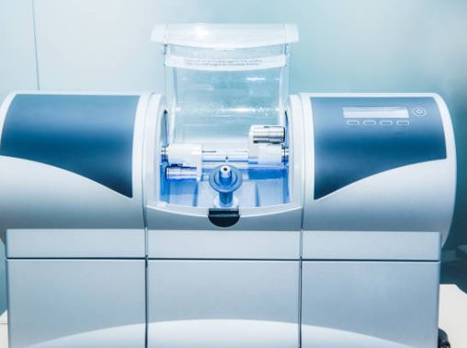
FIGURE.8. CAD/CAM MACHINE

b) 3D PRINTING / ADDITIVE MANUFACTURING

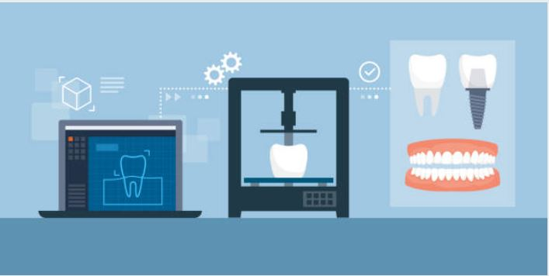
FIGURE.9. 3D PRINTING WORKFLOW

3D printing has become a digital revolution that the dental industry has quickly adopted, in both chairside and in dental laboratories. In recent years, 3D printing has proven to be a more efficient and cost-effective system to embrace an in-house workflow. Dentists, dental technicians and dental assistants can produce custom-made dental appliances, from printing orthodontic aligners and implant models to surgical guides and crowns. More accurate and highly-detailed appliances can be produced in a fraction of the time it would if using traditional, conventional methods.
The American Society of Testing and Materials defines 3D printing, also known as additive manufacturing, as "the process of joining materials to make objects from 3D model data, usually layer upon layer."Many medical fields, including dentistry (primarily prosthodontic, orthodontic, orthognathic, craniofacial, and oral and maxillofacial procedures), have successfully used 3D printed objects, which are based on 3D imaging scans, designed by 3D virtual planning software, and produced using 3D printing processes.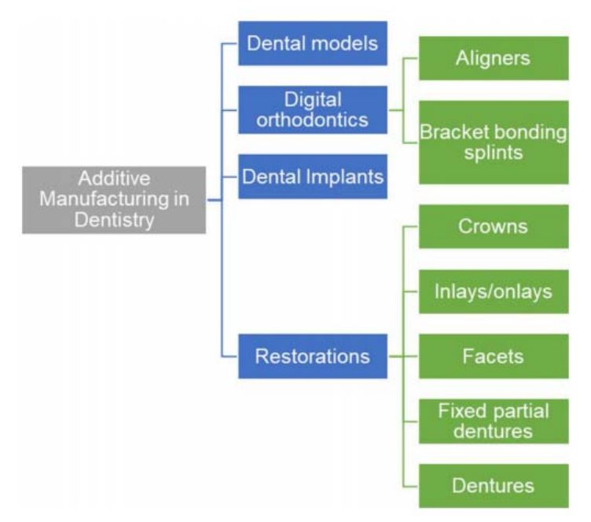
FIGURE.10. ADDITIVE MANUFACTURING DENTAL USES
So as an additive manufacturer of three-dimensional appliances, it can be used for a large range of different applications in dentistry, including but not limited to:
- Study and smile design models
- Surgical guides for implant placement and periodontal surgery
- Bite splints and night guards
- Clear aligners
- Fabrication of removable prosthetics such as dentures
- Custom trays
- Provisional restorations
- Dental Education and Training [12].
The term additive manufacturing includes many types of 3D printing technologies where the most commonly used technologies in dentistry are selective laser sintering (SLS), material jetting (MJ), stereolithography (SLA), and fused deposition modeling (FDM).
The rise of intraoral scanners has been a major catalyst for the growth of the 3D printing market in dental laboratories and clinics. New biocompatible materials specifically designed for dental applications have been developed alongside the advances in 3D printing technology.

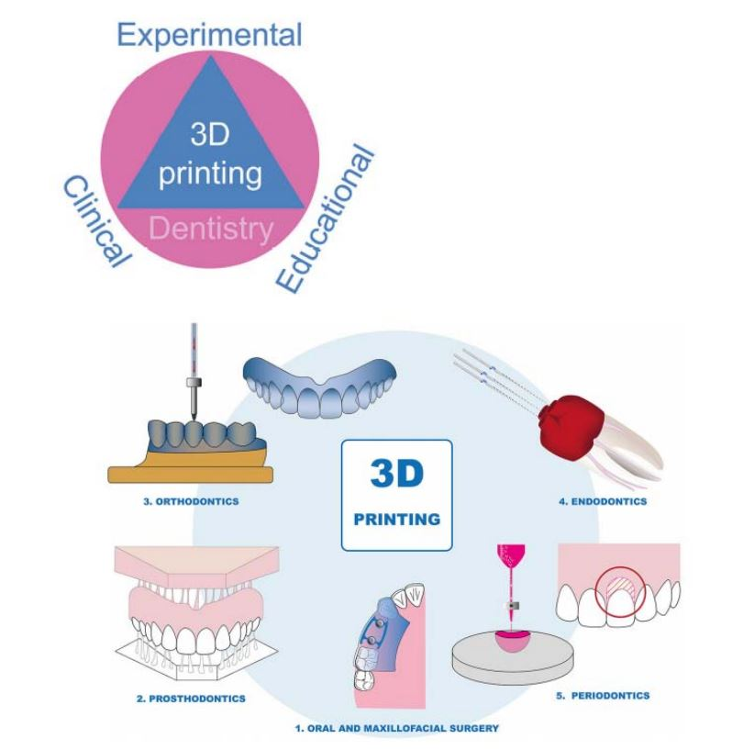
FIGURE.11. APPLICATIONS OF 3D PRINTING IN DENTISTRY
Integrated Workflows
Further integration of 3D printing into digital workflows can be accomplished with enhanced interoperability amongst other digital dentistry domains, such as intraoral scanners, computer-aided design (CAD) software, and computer-aided manufacturing (CAM) systems. A streamlined, fully digital manufacturing process can increase the overall effectiveness of dental workflows, specifically internal workflows.
Regenerative Dentistry Bone tissue that is customized for patients using a 3D printer can serve as a biomimetic scaffold. These days, stem cell proliferation may be optimized in a stable media thanks to 3D printed alginate peptide hybrid scaffolds. Powders such as calcium phosphate, calcium sulfate, and composites can be printed to serve as augmentation material [13].
Invisalign braces are another effective commercial application of 3D printing, producing 50,000 pieces daily. Each user's clear, removable, 3D-printed orthodontic braces are built specifically for them. This product serves as an excellent illustration of how 3D printing may be utilized to create sophisticated, one-of-a-kind items quickly and profitably [13].
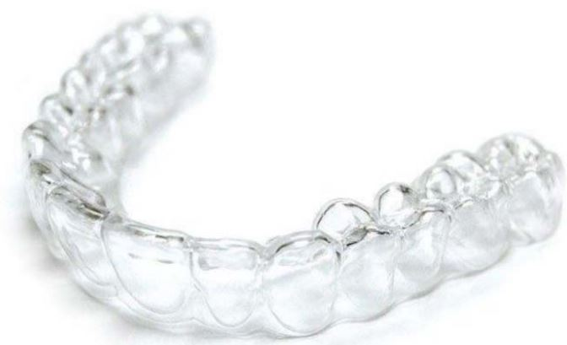
FIGURE.12. INVISALIGN BRACES
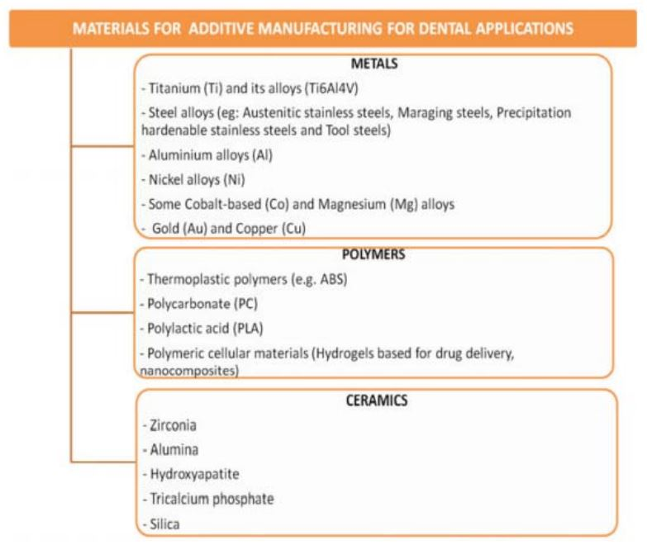
FIGURE.13. 3D PRINTING BIOMATERIALS

c) ARTIFICIAL INTELLIGENCE AND MACHINE LEARNING
An artificial intelligence (AI) system is capable of carrying out activities that a human would complete. It centers on a machine's capacity for self-intelligence and its capacity to resolve issues after acquiring a particular set of facts [2]. Artificial Intelligence (AI) is based on computers' growing capacity to think like people and execute activities that humans now perform more quickly, accurately, and efficiently with fewer resources [14].
AI eliminates the need for human intervention, thereby reducing the potential for human errors, emotional influence, and biases. This makes AI particularly well-suited for tasks that are labor-intensive and carry a heightened risk of errors. Additionally, AI mitigates issues related to human conditions such as fatigue, tiredness, and boredom that can arise from prolonged and repetitive tasks. It's crucial to highlight that AI relies on advanced machine learning techniques applied to extensive datasets, often referred to as "big data," as it employs specific algorithms to execute the necessary tasks [2].
AI, including Machine Learning (ML), has already integrated into and firmly established itself in our everyday lives, albeit in more subtle ways, exemplified by the presence of virtual assistants like "Siri" or "Alexa." In the realm of dentistry, one of the most valuable applications of AI and ML lies within the field of diagnostic imaging, particularly in dento-maxillofacial radiology. Presently, ongoing research and applications of AI in dental radiology primarily concentrate on tasks such as the automated localization of cephalometric landmarks, osteoporosis diagnosis, classification/segmentation of maxillofacial cysts and tumors, and the identification of periodontitis and periapical disease [14].
Artificial intelligence (AI) is a broad concept that involves the execution of tasks by machines and technology in a manner akin to human capabilities. As per the definition provided by "Barr and Feigenbaum," AI falls within the domain of computer science, focusing on the creation of intelligent computer systems capable of demonstrating traits typically associated with human intelligence. These attributes encompass language comprehension, learning, reasoning, problem-solving, and various other cognitive functions.
There are subcategories of AI, which is machine learning and its allied fields like deep learning, cognitive computing, natural language processing, robotics, expert systems, and fuzzy logic [15].
- Artificial Neural Networks (ANNs)
Neural Networks (ANNs) are data processing systems that draw inspiration from the cognitive processes of the human brain. ANNs are often employed to tackle challenging real-world issues. An exciting alternative, artificial neural networks (ANNs) offer many applications in medical science, including disease diagnosis, image and data analysis, and biomedical identification. These applications stem from ANNs' remarkable learning, generalization, inherent contextual information processing, and fault and noise tolerance capabilities [16].

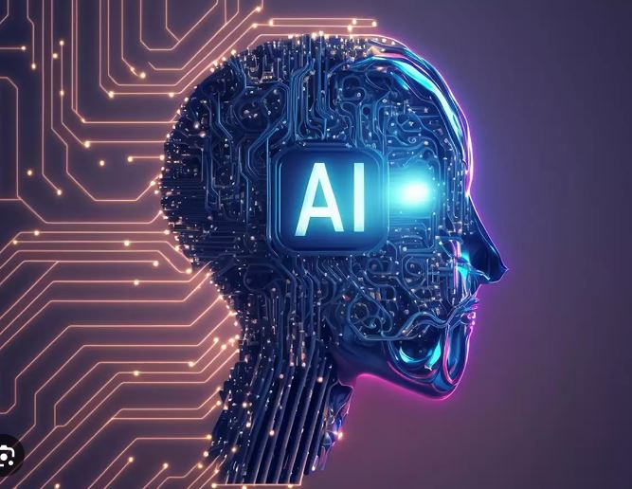
FIGURE.14.ARTIFICIAL INTELLIGENCE

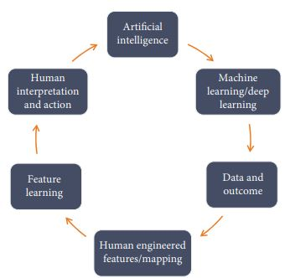
FIGURE.15. SCHEMATIC ILLUSTRATION OF ARTIFICIAL INTELLIGENCE MODEL.

- Machine learning (ML)
Machine Learning (ML) is a subset of AI that improves automated learning capabilities without requiring explicit programming. Its core objective is to facilitate autonomous learning devoid of direct human intervention. AI models utilize current data observations to make predictions about future events.
- Deep Learning (DL)
One prominent area within machine learning is "deep learning," involving the utilization of multilayered (deep) neural networks for acquiring hierarchical features from data. Deep learning (DL) encompasses the repetitive passage of data (e.g., images) and corresponding labels (e.g., "carious tooth" or "specific area indicating a caries lesion") through a neural network during the training process. This iterative procedure adjusts the model parameters (referred to as weights) to enhance the model's accuracy.
A deep learning-based convolutional neural network (CNN) algorithm demonstrated significant proficiency in detecting dental caries in periapical radiographs. Furthermore, it effectively contributed to the detection and classification of impacted supernumerary teeth in patients with fully erupted maxillary permanent incisors on panoramic radiographs [15].
- Top of Form
- ANNs as Clinical Decision Support Systems
- Clinical decision support systems are one example of how AI application technology is advancing significantly in the dental sector. A healthcare provider receives professional assistance from CDSS. Furthermore, these systems are capable of resolving issues that are too complicated to be handled by traditional means. Additionally, CDSS gives dental professionals useful information that helps them deliver better and faster oral health outcomes.

- Fuzzy Logic
Fuzzy logic has shown to be an effective technique for decision-making systems over the last ten years. The ambiguity of natural classes and notions is the source of fuzzy set theory. Because fuzzy logic can summarize from large amounts of data more effectively and with more tolerance for errors, it is a highly ideal tool for complex systems. The paper gives succinct summaries of the major advancements in dentistry brought forth by fuzzy technology [16].
Like in various other domains, AI is undergoing significant transformation as it emerges within the field of dentistry. AI exhibits the capacity to execute numerous routine tasks within dental clinics with heightened precision, reduced staffing requirements, and fewer errors compared to human counterparts. From scheduling and managing regular appointments to aiding in clinical diagnoses and treatment planning, AI demonstrates the capability to handle these responsibilities proficiently. Notably, AI applications have exhibited impressive levels of accuracy, sensitivity, specificity, and precision in the detection and classification of malocclusion in orthodontics.
In addition to helping with the detection of dental and maxillofacial abnormalities like periodontal diseases, root caries, bony lesions like BRONJ (bisphosphonate-related osteonecrosis of the jaw) linked to dental extraction, and facial defects, AI can automatically detect and classify dental restorations on panoramic radiographs [15].
AI has a wide range of applications and tremendous potential in dentistry. Using cone beam computed tomography, artificial intelligence (AI) in dental radiology enables the automated detection of particular landmarks in dental panoramic radiography, lateral cephalometric view, and other views. Other techniques, like automated caries, periodontal, and periapical disease detection as well as the detection of potential oral diseases like tumors or cysts, are also showing significant progress. Artificial Intelligence has been created in restorative dentistry to suggest and identify tooth cavities. The traditional approach to caries identification combines visual and tactile inspections with specialized studies like bitewing radiographs. However, with the use of state-of-the-art neural networks—including artificial neural networks, convoluted neural networks, and other adaptations of neural network architecture—and many types of neural networks, the evolution of AI challenges the conventional paradigm in caries detection.
For the purpose of diagnosing temporomandibular joint disorders (TMDs), signs and symptoms, as well as clinical examinations, are the main sources of information. According to a study by Shoukri et al. (2019), neural networks can be trained to identify and categorize TMDs using a variety of clinical indicators, such as range of mouth opening, detailed history of facial and muscle pain and soreness, biological markers like saliva, and other symptoms like headaches [2].
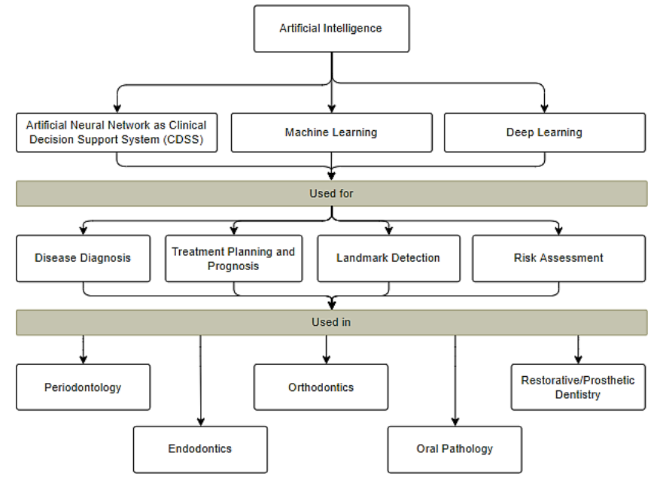
FIGURE.16. APPLICATIONS OF AI IN DIFFERENT SUBFIELDS OF DENTISTRY.

d) AUGMENTED REALITY AND VIRTUAL REALITY (AR/VR)
Recently, there have been numerous technological developments in the dental sector that have altered the scope of many dental subspecialties. New improvements have been made to further strengthen and enhance dental education and the clinical application of dentistry. Among these are virtual reality (VR) and augmented reality (AR), which have been developed and researched with the intention of advancing dentistry [17].
The technology known as augmented reality (AR) blends real-world scenes with computer-generated images, sounds, and films on a screen. Consequently, computerized virtual parts or components are required for the construction of AR.
With the use of virtual reality (VR) technology, people can enter an artificial environment made up of computer-generated sights, sounds, and movies, losing their ability to perceive the outside world.
With the use of augmented reality (AR) technology, users can overlay virtual content over the real environment. This means that virtual content is added to reality rather than completely replacing it. Because of this unique characteristic, AR is far more easily realized and comprehended than VR [18].
Some components must be present in order to create augmented reality systems. A camera, sensor, or scanning device is the primary component that will be used to record real-world objects and sceneries. A computer unit makes up the second component. It is essentially the part that processes the motions and images that are collected, assessing factors like location, tilt, and acceleration as well as adding depth to the photographs to create three-dimensional views. Thirdly, a display system that can project 3D and virtual things onto the actual screen. In order to complete the registration step and enable real-time visualization, the user must be continually tracked during the process, which calls for the employment of a tracking device [18].
Because it allows clinical information to be immediately viewed on patients, augmented reality primarily aims to improve clinical practice in the dental industry by fusing the real and digital worlds. The main application of augmented reality in dentistry is the enhancement of reality with digital data, enabling efficient patient and doctor communication via images, videos, and three-dimensional models [17].
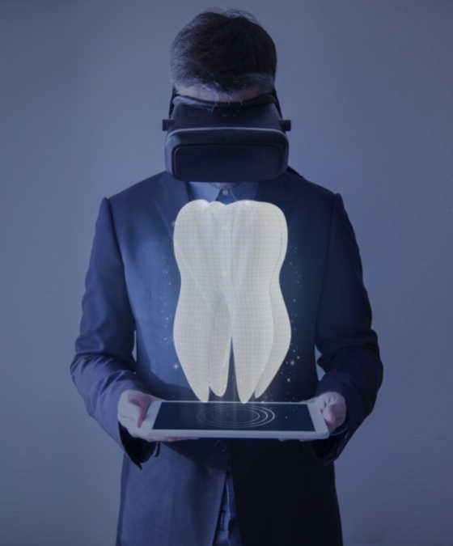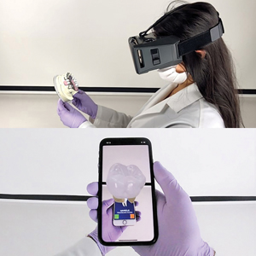
FIGURE.17. DENTAL AR/VR APPLICATION WITH HEADSET AND HAND-HELD VERSIONS

In the realm of computing and technology, the term "virtual" pertains to something that seems to exist even though it lacks physical presence in the tangible world. Within dentistry, software is employed to replicate real-time representations of dentofacial structures. On the other hand, virtual reality involves the utilization of laser scans to capture the patient's teeth, as well as other oral and extraoral structures as needed. These scans are subsequently processed by a computer to generate a 3D model, which is then integrated into a simulator.
Virtual reality relies on highly sophisticated and tailored software to create a digital three-dimensional environment where the user's senses are engaged through computer-generated feedback and sensations. Consequently, virtual reality enables users to immerse themselves in virtual worlds closely connected to the physical reality, effectively blurring the boundaries between virtual and physical experiences.
Dental surgeons and dental students utilizing this simulator have the opportunity to engage in practice sessions and evaluations prior to conducting procedures on actual patients across various dentistry specialties. These specialties include oral and maxillofacial surgery, orthodontics, implantology, restorative dentistry, dental public health, and dental education. The system is equipped with automated data recording capabilities, enabling users to conduct postoperative analyses and self-assessments [17]
This AR/VR technology considerably supports a wide range of software programs and applications that improve dentists' and specialists' abilities to provide a comprehensive patient care system.
Designs are enhanced to a patient's actual existing anatomy in prosthodontics, rehabilitation, reconstruction, and prosthetics in order to imitate a variety of functions and movements without requiring any invasive procedures. This enables early collaboration between the dentist and support personnel, such a dental technician, to plan ahead and determine the optimal course of action for a patient's prosthesis, such as when building dentures with AR/VR technology.
On the other hand, in complex trauma and implant situations, for instance, oral maxillofacial surgeons can predesign a surgical template or plan based on the existing illness manifestation and state with the use of specialized software and an engineering team. This makes it possible to use a more precise surgical method since it lowers the possibility of human error in the operating room and speeds up the surgical recovery process. As a result, there is less chance of needless surgical site contamination and surgical morbidity.
Utilizing the AR/VR technique and environment is a better way to facilitate a riskier dental routine procedure, like dental implant placement protocol and training, and reduce the potential morbidity associated with it, like nerve injury, dental implant transportation to the sinus, and incorrect implant angulation [2].
Improved simulation of the three-dimensional digital model made possible by the development of AR/VR systems has also made it easier to engage and communicate with patients. It will only expand, facilitate, and develop the modern technique in routine dental care at a rapid pace with the recent development of additional technologies like the intraoral scanner, automated computer-derived manufacturing machine, and modern cone beam computed tomography (CBCT) radiograph machine.
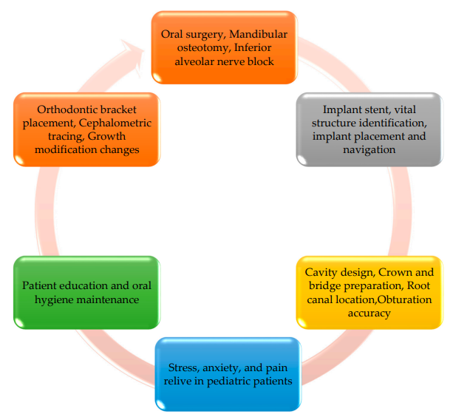
FIGURE.18. USE OF VIRTUAL /AUGMENTED REALITY IN DENTISTRY

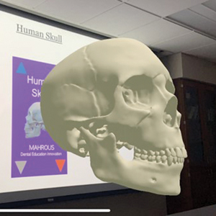
FIGURE.19. INCORPORATIONOF AR INTO DIDACTIC LECTURES FOR DENTAL EDUCATION.

Another promising avenue for AR/VR system growth is dental education. During the undergraduate dental program, theoretical knowledge is frequently taught in a regular classroom setting. However, practical skill sessions offer an opportunity to further strengthen this knowledge. This makes it possible to have an interactive learning environment that is open to objective and quantitative evaluation in addition to a responsive feedback environment.
Without endangering a live patient, the technologies will unintentionally enhance hand-eye coordination, ergonomics, and simulated prospective preclinical training. By enabling dental students to think and learn independently, the technologies will help lessen the workload of faculty members in comparison to traditional preclinical simulation training [2].
VR is controlled by a system, whereas AR allows users to adjust their presence in the actual world. These are just a few of the differences between AR and VR. Second, whereas AR can be accessed with a smartphone, VR requires a headgear device. Furthermore, AR may enhance both actual and virtual worlds, but VR can only enhance fictional reality [17].

e) TELEDENTISTRY (TD)
"Telemedicine" refers to the utilization of information-based technologies and communication systems to deliver healthcare services across geographical distances. It leverages electronic information communication technologies to facilitate the provision and support of healthcare even when participants are separated by considerable distances. Telemedicine constitutes an integral component within the broader continuum of care. Its integration can enhance the overall quality and efficiency of healthcare delivery. Telemedicine is currently employed in various settings, including academic medical centers, community hospitals, managed care organizations, rural healthcare facilities, and on an international scale to connect providers in developing nations with hospitals in developed countries. The advancement of digital communication, telecommunications, and the Internet presents an unprecedented opportunity for remote access to medical care.
In recent years, the field of dentistry has witnessed substantial technological advancements. These progressions encompass the integration of computers, telecommunication technology, digital diagnostic imaging services, as well as devices and software for analysis and ongoing patient care. With the aid of advanced information technology, dentistry has expanded its reach far beyond its previous capabilities. The advent of new information technology has not only enhanced the management of dental patients but has also made it feasible to partially or fully oversee their care from distances spanning thousands of kilometers away from healthcare facilities or qualified dentists. This entire process, involving networking, digital data sharing, remote consultations, evaluation, and analysis, falls within the domain of telemedicine focused on dentistry, commonly referred to as "Tele dentistry" [19].
Teledentistry (TD), a subdivision of telemedicine and telehealth, combines telecommunications with dentistry, enabling the transmission of clinical data and images across long distances for dental consultations and treatment planning [19]. Its objective is to simplify both prevention and treatment in key dental specialties through remote methods. This innovative approach to dental care is made achievable by leveraging computer science rather than relying on traditional face-to-face interactions between doctors and patients [20].
The internet serves as the foundation for contemporary teledentistry systems due to its real-time capabilities, high-speed performance, and capacity to transmit substantial volumes of data. All emerging teledentistry systems are reliant on the internet, including various forms of remote consultations [19]. In the present day, it represents a modern approach to dental care by integrating digital imaging, electronics, health records, and telecommunications technology via internet connectivity. This not only grants patients access to care in distant locations but also empowers remote specialists to accurately diagnose conditions, propose appropriate therapies, and, if necessary, refer challenging cases to other experts. Teledentistry can be executed through three distinct approaches:
- Synchronous, when the interaction happens in real time,
- Asynchronous, when the approach is “store and forward”, and
- Mobile health care services, when mobile technology is employed [20].
Teledentistrysubunits :
Teleconsultation
The most popular type of teledentistry is teleconsultation, in which clients or nearby medical professionals use telecommunication to consult with dental specialists. Patients from prisons and elderly care institutions, as well as those who are physically and mentally challenged, have found it useful for consultation. It has been demonstrated that teleconsultation can cut referrals to higher centers from primary health centers by more than 45%. It might have helped patients in the COVID-19 pandemic continue their treatment while under lockdown and quarantine [21].
The most popular type of TD, teleconsultation, can be conducted through video conferencing tools like Skype, Google Meet, WeChat, and Facetime, or through instant messaging apps like Telegram, WhatsApp, SMS, Instagram, and Messenger [20].
The two methods of teleconsultation available through teledentistry are the "Store-and-Forward Method" and "Real-Time Consultation." A videoconference is used in Real-Time Consultation so that patients and dentists who are in different places can see, hear, and talk to each other [Figure.20].
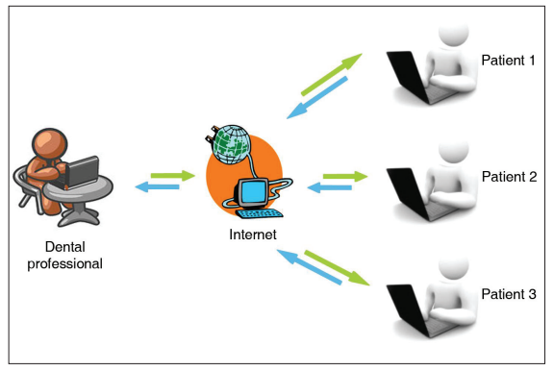
FIGURE.20. REAL-TIME CONSULTATION

Hold-and-Transfer The dental professional gathers, stores, and exchanges clinical data and static photographs, sending them for consultation and treatment planning [Figure.21]. The "consultation" takes place without the patient in attendance. Dentists can exchange patient data, lab results, test results, comments, pictures, radiographs, graphical depictions of the hard and periodontal tissues, applied therapies, and other information transportable through numerous providers. Patients may find this data exchange to be quite important, particularly if they require specialized consultation.
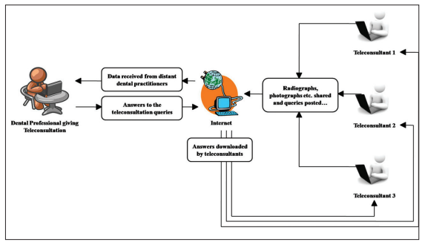
FIGURE.21. STORE-AND-FORWARDMETHOD

Store-and-forward technology yields good outcomes without incurring exorbitant costs for equipment or connectivity for the majority of dental applications. An intraoral video camera and a digital camera for photo capture; a modem and an Internet connection; and a computer with a sizable hard drive, sufficient RAM, and a quick CPU comprise a standard store-and-forward teledentistry system. In certain situations, you could additionally need a printer, a scanner, and a fax machine. One can add a PCI codec card into the system or use a commonly available standalone IP/ISDN videoconferencing solution to enable live videoconferencing. A multipoint control unit that connects three or more parties is necessary if a live group session is needed. Both audio and visual functionalities need to be supported by the codec [19].
The "Remote Monitoring Method," a third approach that has also been developed, allows patients to be observed from a distance and can be used at home or at a hospital.
The literature has also suggested a "Near-Real-Time" consultation, which is a poor resolution, low frame rate product that has a jittery television-like appearance [19].

Telediagnosis
Telediagnosis involves utilizing technology to exchange images and data for the purpose of diagnosing oral lesions. The implementation of a telediagnosis program called Estomato Net significantly reduced patient referrals to specialists from 96.9% to 35.1%. While smartphones are widely recommended for detecting dental caries, they have also proven to be a dependable tool for screening oral potentially malignant lesions. In addition to telediagnosis, there is telecytology, a system designed for the early detection of potentially malignant or malignant oral lesions. Haron et al. introduced Mobile Mouth Screening Anywhere (MeMoSA®) to facilitate early oral cancer detection, particularly benefiting patients with limited access to specialists. Skandarajah et al. evaluated a tablet-based mobile microscope (CellScope device) as an adjunct for oral cancer screening. During the COVID-19 pandemic, researchers in Brazil demonstrated the use of WhatsApp and telemedicine for making differential diagnoses of oral lesions. Given that many oral lesions are readily apparent, telediagnosis can be accomplished through dental photography, reducing the necessity for extensive clinical examinations [21].
Teletriage:
Teletriage pertains to the secure, suitable, and prompt evaluation of patient symptoms by specialists through smartphones. It has been effectively employed in the remote assessment of schoolchildren, facilitating the prioritization of those in need of dental care while minimizing unnecessary travel, irrespective of socio-economic or geographical challenges encountered in various regions. Brucoli et al. have recommended the utilization of teleradiology as a valuable resource for triaging maxillofacial trauma patients, enabling their transfer from peripheral centers to the primary trauma center.

Telemonitoring Monitoring
Telemonitoring for dental patients typically necessitates regular in-person visits to the dentist for treatment progress assessment. However, the implementation of telemonitoring can replace the need for frequent physical appointments with virtual visits aimed at consistently monitoring treatment outcomes and the progression of oral conditions. In a recent pilot study conducted during the pandemic, telemonitoring emerged as a promising tool for remotely overseeing both surgical and non-surgical dental patients, offering notable advantages in terms of cost reduction and reduced waiting times [21].
f) ELECTRONIC ORAL HEALTH RECORDS (EOHRs)
Traditionally, patient data has been kept in hard copy format globally, encompassing everything from individual care histories to publicly available research data. This type of storage system is easily destroyed and requires ever-increasing capacity. Additionally, it makes it tough to duplicate data when necessary and far more difficult to organize and aggregate the data for additional analysis. The creation of electronic health records, or EHRs, digitizes the information and turns it into a database, making information easily accessible. These kinds of systems have been promoted as long-term, affordable ways to raise the standard of healthcare.
Electronic Health Records (EOHRs) offer advantages in data storage, retrieval, and utilization. They are also essential for developing successful evidence-based interventions that are both efficient and effective. Through the reduction of paperwork, data transmission between researchers, and quick and simple data processing and analysis, it can help save time and money. Generally speaking, it is recommended that EOHRs enhance the quality, precision, and accuracy of data recording. Additionally, employing an electronic approach would enhance data sharing and project continuity [22].
In the early 1990s, the American Dental Association (ADA) initiated collaborative efforts with other stakeholders to define a specific electronic oral health record that complements the electronic health record utilized in general healthcare. The document titled "The Computer-based Oral Health Record" marked an early articulation of this description. Subsequently, the ADA established a Standards Committee for Dental Informatics (SCDI) with the following mission statement: "To advance patient care and oral health by applying information technology to the clinical and administrative aspects of dentistry; to formulate standards, specifications, technical reports, and guidelines for elements of a computerized dental clinical workstation; electronic technologies used in dental practice; and interoperability standards for various software and hardware products, ensuring seamless information exchange across all facets of healthcare" [23].
In the contemporary era of information technology, characterized by its remarkable technological capabilities, precision, and adaptability, there arises a need for specific terminology. The proposal is to represent these terms with numeric values, serving as the fundamental language for delineating oral health conditions, anatomical aspects, prescriptions, interventions, competencies, and healthcare settings. This proposal is intended for healthcare providers and institutions engaged in the education and training of healthcare professionals.
At present, the data concerning oral health status and oral health indices primarily revolve around disease-oriented parameters, focusing on specific facets of oral health conditions. Examples of these indices include the Simplified Oral Hygiene Index (OHI-S), the Community Periodontal Index (CPI), the Decayed Missing and Filled Teeth (DMFT) index, and the International Caries Detection and Assessment System (ICDAS) [24].
Functions of EOHRs :
- Patient Registration
- Practice Personnel Scheduling
- Patient Appointment Scheduling
- Practice Measurement/Observation Recording
- Patient Assessment
- Patient Treatment Planning
- Pharmacotherapy
- Encounter Recording
- Intervention Recording [23].
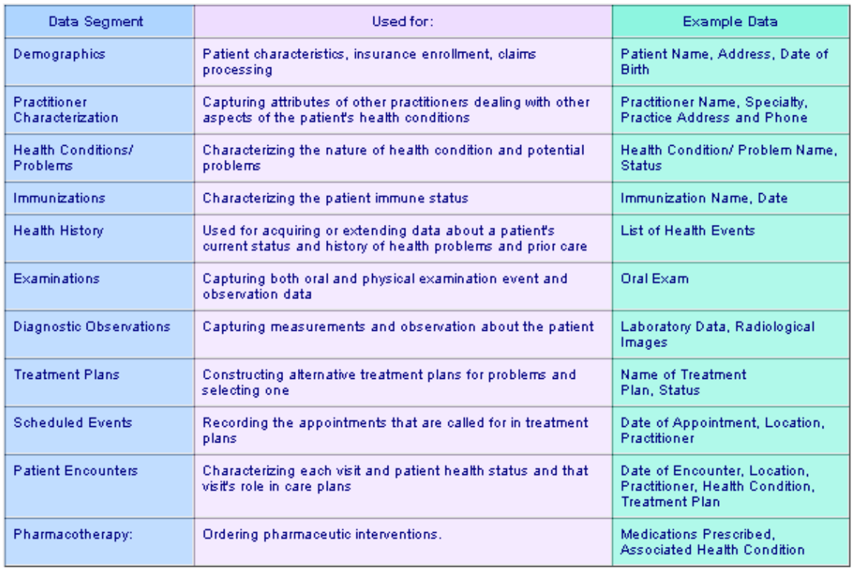
FIGURE.22. EOHR’S BASIC DATA SEGMENT AND USES

g) DATA ANALYTICS AND BIG DATA :
Data analytics and big data approaches have enabled the analysis of large and complex datasets in dental informatics, leading to the development of predictive models, identification of patterns and trends, and evaluation of treatment effectiveness. These approaches have facilitated evidence-based dentistry and personalized care [6].

C. DIGITAL DENTAL THERAPEUTICS

a) COMPUTER CONTROLLED LOCAL ANESTHETIC DELIVERY CCLAD, OR WAND :
The wand is a computerized device that can systematically and slowly administer anaesthetic. Injections are frequently painless thanks to the WAND's gradual and gentle delivery. In 1997, the first computer controlled local anesthetic delivery (CCLAD) system (wand/compuDent) was launched into the field of dentistry.
Similar systems:
- QuickSleeper
- Anaeject
- Comfort Control Syringe
The dentist can give the LA using a foot-activated joystick and precisely regulate needle placement with fingertip accuracy thanks to CCLAD. Without the typical numbness of the lips, tongue, and face, it numbs the teeth more quickly. Hour-long "fat face feeling" is also eliminated by computer controlled anesthetic distribution. It improves control and tactile perception. It provides constant computer-controlled LA supply pressure and flow rate. A better injection experience can be attributed to set flow rate and increased ergonomic control.
Since CCLAD may be controlled ergonomically and looks like a pen, it can lower pain perception by two to three times. Friedman and Hochman developed two new nerve block procedures as a result of CCLAD technology: palatal approach anterior superior alveolar (PASA) injection and anterior middle superior alveolar (AMSA) injection [3].
b) HEALOZONE
The quick, simple, and painless method of treating dental decay is using HealOzone. Ozone (O3), a typical natural gas that successfully kills bacteria and fungi, is what makes HealOzone effective. HealOzone is an excellent tool for identifying and eliminating any early indications of dental decay before it reaches a more serious level.
c) ZOOM! WHITENING
With Zoom! Whitening, patients can achieve quick and simple results with a cutting-edge whitening procedure. Zoom! in just one appointment! A person's smile can significantly improve with bleaching, which can lighten teeth up to eight shades.

d) SMART TOOTHBRUSH
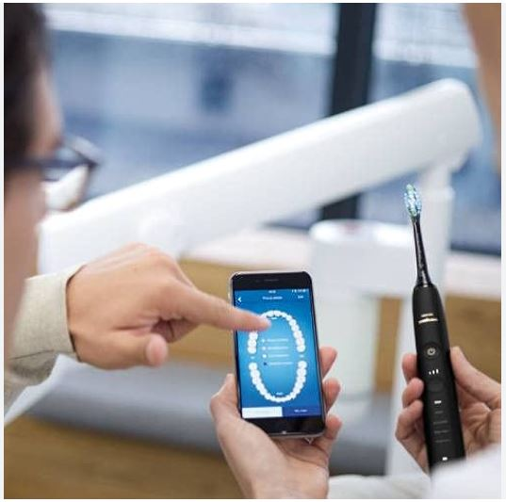
FIGURE.23. SMART TOOTH BRUSH

Recent electronic toothbrushes introduced to the market have revolutionized the way individuals engage in tooth brushing. These intelligent toothbrushes are equipped with integrated 3D sensors that gather and assess data concerning tooth brushing precision, duration, and frequency, while simultaneously providing real-time information about position and orientation across various brushing zones. Utilizing artificial intelligence (AI) and machine learning algorithms, these devices meticulously monitor any areas that may have been overlooked during brushing and offer tailored recommendations to enhance oral hygiene. The areas that were missed are typically highlighted on a dental map, along with information about the percentage of the tooth surface that has been brushed, identification of teeth requiring additional attention, and potential indications of excessive pressure being applied in specific areas, which could potentially lead to gum damage [25].
The Kolibree intelligent electric toothbrush ensures that your tooth brushing technique is on point by utilizing its accompanying app, and it engages kids with entertaining games to foster the healthy habit of regular teeth cleaning. Philips' Sonicare smart toothbrush is equipped with an array of sensors within its handle, which offer instant feedback through a companion app. This feedback includes alerts about excessive pressure application, guidance on brushing locations, and even coaching on the correct brushing method. Numerous similar devices are available from companies such as Colgate and Oral-B in the market.
e) REGENERATIVE DENTISTRY
Regenerative dentistry is centered on the restoration of both soft and hard tissues through the integration of tissue engineering methods. This field operates at the intersection of engineering and life sciences, utilizing the principles of both disciplines to create biological replacements. Its ultimate goal is to reinstate, uphold, or enhance tissue functionality.
FIGURE.24. REGENERATIVE DENTISTRY

Another field affected by digital technologies is Regenerative Dentistry, which uses stem cells, growth factors, and other biologic materials to replace lost or injured oral tissue. 3D printing and tissue engineering have the potential to completely change how dentists approach dental regenerative therapies. To be sure, 3D printing with biocompatible materials like ceramic or polymer can assist develop tailored scaffolds and implants that can be used to repair missing or damaged tissues. Digital photos and models can also aid in the design process.
Dentists can more precisely predict results and optimize treatment programs by using digital planning and simulation software to plan and simulate such regeneration operations. This may lessen the possibility of problems and enhance the results of treatment. In order to practice such intricate regenerative treatments before performing them on patients, virtual reality can also be used to construct immersive regenerative simulations [8].
f) CRISPR
Clustered regularly interspaced palindromic repeats (CRISPR) serves as a gene-editing tool that bestows a form of adaptive immunity within prokaryotic organisms. This technology is currently revolutionizing biomedical research, with its capability to rectify genetic errors, modulate gene activity in cells and organisms, and play a critical role in bacterial defense by identifying and eliminating specific Deoxyribo Nucleic Acid (DNA) segments during bacteriophage invasions [26].
The advent of CRISPR technology introduces an entirely new dimension to therapeutic and treatment strategies. Numerous oral and craniofacial diseases and conditions have been associated with specific genes in the human genome. These conditions encompass periodontal disease, dental caries, tooth agenesis, orofacial clefts, head and neck cancer, orofacial pain, temporomandibular disorders, and facial morphology (Chavez-Granados et al., 2022). Given CRISPR's precise genome-editing capabilities, it presents novel therapeutic avenues for addressing dental conditions and offers the opportunity to gain deeper insights into the genetic factors linked to these conditions [27].
One significant advantage of considering CRISPR-Cas9 is the potential for a highly personalized treatment approach. Utilizing CRISPR for treatments would encompass a comprehensive assessment of the patient's genetic profile, environmental factors, and other characteristics that may predispose them to, or elevate their risk for, specific medical conditions (Barbour et al., 2021). CRISPR also holds the promise of alleviating symptoms and, in the future, potentially serving as a curative intervention.
Two prevalent dental issues, periodontal disease and dental caries, could potentially be addressed through the implementation of the CRISPR system. CRISPR-Cas9, a genetic engineering tool, is employed to precisely target and modify specific DNA sequences, offering tailored treatment options and the potential for complete symptom elimination. Additionally, CRISPR can facilitate the exploration of genes associated with dental health, including those involved in enamel formation and inflammatory response pathways. These genes can be pinpointed and edited using CRISPR to mitigate inflammation or reduce genetic susceptibility to certain conditions. Therefore, CRISPR-Cas represents an exciting and innovative technique with the potential to revolutionize treatment strategies in dental healthcare [27].

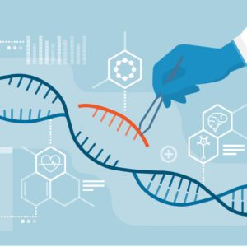
FIGURE.25. CRISPR

g) PERSONALIZED DENTAL MEDICINE
Personalized medicine is a rapidly developing field in which doctors employ diagnostic tests to pinpoint specific biological markers, frequently genetic, that help characterize which medical procedures and treatments will be most effective for each patient. In order to improve and predict how patients will respond to targeted medication, scientists are now quickly developing and employing diagnostic tools in medical diagnostics based on genomic, proteome, and metabolomics. This field, known as "personalized medicine," combines nanotechnology, biotechnology, information technology, and the human genome to deliver treatments based on individual differences compared to population trends.
We are living in changing times, especially in the era of genomics and personalized medicine. Right now, the most important question is how to apply all of the new knowledge we have acquired to the patient's advantage. In dentistry, customized medicine is still in its infancy and there aren't enough items on the market that have yet to resonate with patients' general consciences, despite the fact that personalized medicine is growing and becoming more prevalent in the medical profession [28].
The process of customizing medical care to each patient's unique needs is known as personalized medicine, sometimes known as customized or precision medicine [29]. Precision medicine is the art of customizing a treatment to a patient's biological (genomic, microbiomic, proteomic), social (economic, educational), and behavioral (lifestyle) features or traits. This not only makes it possible to predict which therapy will be most effective, efficient, and safe, but it also helps to stop the progression of early stages of disease.
Beyond this, precision medicine in other domains such as oncology is progressively extending to personalized therapeutic modifications. Notably, diagnostics—that is, tailoring the multitude of available diagnostic techniques to each individual—should and increasingly do play a role in precision medicine. P4 medicine, which refers to a more participative, preventive, and precise approach to healthcare, is strongly related to precision medicine (Fig. 26). Predicting what will happen to a patient, organ, or site is the foundation for all of these characteristics; precision medicine and medicine's increasing predictiveness are intimately related [30].
Key topics covered by personalized medicine include developments in molecular diagnosis, cost-benefit analysis of precision medicine, the effects of precision medicine on the pharmaceutical industry and the health care system, and the influence of precision medicine on contemporary ideas in the development of precession medicine based on pharmacogenomics, pharmacogenetics, and pharmacoproteomics.
Opportunity, challenges, and feature of personalized medicine that could be implemented to personalized dentistry are the following:
- Directing targeted therapy and reducing trial-and-error procedures
- Decreasing adverse drug reactions
- Increasing patient willingness to treatment
- Reducing high-risk invasive testing procedures
- Facilitating to control overall cost of health care
Recent advancements in the influential field of omics tools, encompassing genomics, epigenomics, transcriptomics, proteomics, metabolomics, and lipidomics, are paving the way for innovative approaches to detect biomarkers for the timely diagnosis of oral cancer. Identifying these biomarkers aids in assessing and distinguishing the characteristics of oral cancer in individual patients, thereby enabling the customization of therapies tailored to their specific needs. In the context of head and neck cancer, the body generates a distinct antibody response as part of its immune reaction against cancer-specific antigens. These unique antibodies can be harnessed for the early detection of cancer.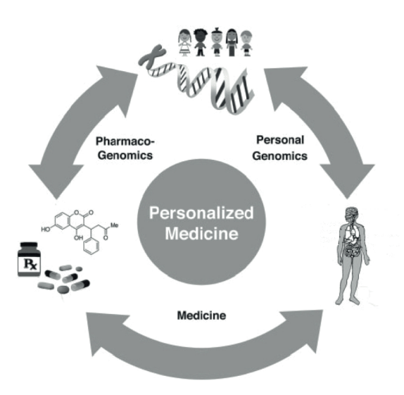
FIGURE.26. PERSONALIZED MEDICINE

Chemotherapy, radiation therapy, and surgery are all viable options for an efficient management approach once the type of cancer is identified in its early stages. Rather than using a single, standard procedure for all patients with head and neck cancer, the option or combination of alternatives can be customized for each patient based on the sensitivity of cancer cells.
Modern advanced genetic research studies are concentrating on the genetic variations causing dentofacial anomalies and the genomic basis of craniofacial growth. The way for personalized orthodontics, a novel orthodontic modality, has been paved by such genomic-associated research. Personalized orthodontics is tailored to a specific patient whose genetic information and clinical data can be used to determine their susceptibility to developing a malocclusion or cases of malocclusions; as a result, a precise treatment plan is carried out [28].
h) ROBOTICS
Seven traits define a flexible machine as a robot: mobility, individuality, intellect, versatility, semi-human, semi-mechanical, automatic, and slave-like. A "robot" is defined by the American National Standards Institute as a mechanical device that can be programmed to carry out certain activities and move under automatic control.
The swift advancement of contemporary science and technology across the globe has led to the popularity of robotics as a research field and societal issue. A wide range of industries, including aerospace, electronics, medical, and industrial, have used robotics. The use of robotics in medicine is one of these that is gaining popularity.The effective use of medical robots has also sparked interest in robotics research in dentistry, which disrupts established paradigms for oral diagnosis and treatment and opens up new possibilities for technological advancement.
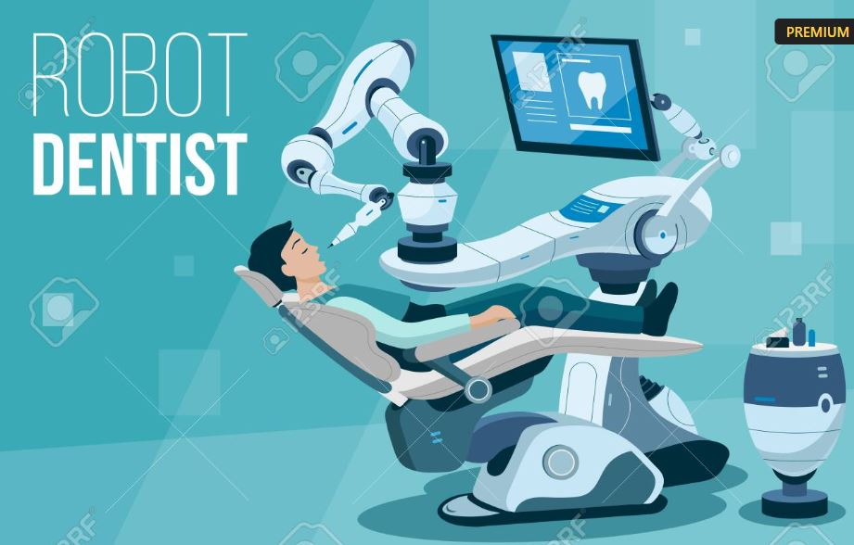
FIGURE.27. ROBOTICS IN DENTISTRY

The utilization of robots in dentistry holds great promise, encompassing various areas such as material testing, orthodontics, prosthodontics, oral surgery, and implant dentistry. Specifically, the applications of robots in prosthodontics can be categorized into three main aspects: Tooth Preparation, Tooth Arrangement, and Articulation. In the field of implantology, robotic applications can be broadly categorized into two groups: robot-assisted implantation and fully automated implantation robots.
Intelligent robots play a significant role in oral implantation, encompassing various functions, including (a) conducting preoperative digital 3D scans of the implant site and collecting imaging data for diagnostic analysis; (b) designing digital plans for implant surgery; and (c) providing real-time navigation and automatic drilling during the procedure to enhance the precision of dental implant surgery, minimize surgical trauma, and reduce operation duration.
As computer-assisted surgery continues to advance, there have been ongoing improvements in the preoperative design of maxillofacial procedures. The process of mandibular reconstruction, known for its complexity and the limitations of manual precision and human resources, has seen the emergence of robot-assisted surgery as a viable alternative. Additionally, in the field of orthognathic surgery, a robotic system has been developed to assist in the repositioning of bone segments.
In oral and maxillofacial surgery, robots are primarily used for two tasks: (a) collecting and reconstructing preoperative 3D images of the oral and maxillofacial region, analyzing lesion characteristics, and creating a targeted operation plan; and (b) precisely segmenting, reshaping, displacing, and fixing the craniofacial bone in accordance with the surgical plan.
Robots for specialized procedures in oral and maxillofacial surgery, like velopharyngeal surgery, have been effectively employed in conjunction with robotics.A K-shaped file or rotary file breaking in the root canal during root canal therapy carries a risk of creating a root perforation. The "Omni Phantom" is a robot that has been designed to assist users in efficiently training in endodontic treatments. It is equipped with a haptic virtual reality simulator. The field of dental robotics is currently moving from computer-assisted procedures to fully autonomous technologies. The use of robots in dentistry is an extension of how the human hand and eye work, a supplement to the shortcomings and restrictions of manual procedures by offering more accurate and sophisticated movements than the human hand is capable of. When robotic technology is further incorporated into dentistry, the traditional methods of practice and atmosphere in the field will change [31].
D.DIGITAL DENTAL EDUCATION
a) DIGITAL EDUCATION / ACADEMIA
Digital dentistry encompasses a broad spectrum of technologies that integrate communication, documentation, production, and distribution within the framework of computer-based algorithms for dental treatments. It also plays a significant role in driving innovation and enhancing the learning experience in dental education.
As educational methods and tools continue to evolve, understanding educational methodologies becomes essential for optimizing the effectiveness of education. Google Forms and the YouTube platform are also valuable tools in the realm of education, providing easy access and facilitating comprehension through data analysis and video content. Innovations like virtual anatomy, haptic feedback tools, and improved digital charting methods present numerous opportunities to enhance the efficiency of pre-clinical education.
In restorative dentistry and prosthodontics, digital assessment tools empower students to assess their performance in real-time, even without direct supervision. Within clinical settings, digital communication tools facilitate remote supervision and advanced local management of supervision.
In the era of big data and analytics, it's possible that students may require additional knowledge in computer programming to support evidence-based decision-making and fully harness the necessary information. Consequently, the inclusion of computer courses in the curriculum may become essential. This shift could transform digital technology into an educational objective and a coveted skill that supersedes other elements of the curriculum.
Undergraduate dental laboratory training has already seen the integration of digital simulation technologies into dental faculties and their educational programs across various countries. These simulation technologies encompass digital microscopes, virtual pathology slides, digital X-ray images, digital dental skill training devices, digital assessment systems, and robot patients.
Emerging trends in medical and dental education, instructional methods, and learning techniques encompass computer-aided instructions (computer-assisted learning), virtual patients, augmented reality, and human-patient simulation. Within contemporary dental education, digital microscopes, virtual pathology slides, digital radiography, and chairside applications for restorative and prosthetic procedures have solidified their presence. Conversely, virtual reality, haptic-enhanced VR simulations, and robot patients utilized in pre-clinical laboratory educational systems are still in their nascent stages, yet there is a growing interest in their future development. Numerous research inquiries remain to be addressed for these technological advancements to find broader acceptance in dental education. Expanding the scope of software to encompass a wider array of dental procedures could prove advantageous. There remain several unresolved research queries, both to steer these technological advancements and to foster greater acceptance of simulation within dental education.
b) CHAT-GPT
In June 2020, OpenAI Inc., a San Francisco, California, USA-based artificial intelligence research lab, first made ChatGPT available to the general public. In a nutshell, ChatGPT generates and comprehends language similar to that of a human using deep learning algorithms. It is capable of handling a wide range of natural language processing tasks, including question answering, summarization, conversation production, and language translation. It has already undergone extensive training on a sizable corpus of text data.
It seems that ChatGPT can produce extremely logical and contextually relevant responses while learning from vast volumes of data. With its ability to automate procedures, improve communication, and provide better patient care, this technology has the potential to completely transform a number of industries, including digital dentistry.
FIGURE.28. CHAT-GPT IN DENTAL EDUCATION

In fact, ChatGPT can be trained to assess a lot of data about digital dentistry, including patient records, imaging, and treatment results, thanks to its natural language processing capabilities. This can assist researchers and dentists in developing better treatment regimens and making more informed decisions. Furthermore, ChatGPT can be utilized to create patient education resources and respond to often requested queries, which may enhance patient comprehension and satisfaction. All things considered, ChatGPT's features present encouraging chances to develop and enhance digital dentistry procedures [8].
IV. CHALLENGES AND FUTURE DIRECTIONS OF DIGITAL DENTISTRY
Digital dentistry has numerous benefits, but it also has drawbacks and restrictions. These include the price of technology, the requirement for specific training, and the possibility of mistakes or malfunctions with technology. When integrating digital dentistry into their operations, dentists should be cognizant of these obstacles and constraints.
The possibility of patient privacy violations and cyber security breaches is another possible drawback to digital dentistry. Dental professionals need to make sure they have sufficient security measures in place to secure patient information because digital photographs and patient data are susceptible to cyberattacks.
Finally, apprehensions about automation and job loss may prevent certain dental practitioners from embracing digital technologies. It is crucial to understand, nevertheless, that the goal of digital dentistry is to augment dental professionals' skills and elevate patient care, not to completely replace them.
Still, the field of digital dentistry is developing all the time. Artificial intelligence, machine learning, virtual reality, and augmented reality will all be used in digital dentistry in the future. These innovations could lead to better treatment outcomes and improved patient care. Additionally, advancements in the fields of digital dentistry and nanobiotechnology, data augmentation, robotics in dentistry, cross-center training, block chain utilization, and, last but not least, minimally invasive techniques for precise and effective dental diagnosis, prevention, and improved treatment outcomes have been made.
NANO DENTISTRY
Currently, dental disorders are diagnosed, treated, and prevented by the use of nanomaterials and nanorobots in nano dentistry, or the application of nanotechnology in dentistry. In order to create, manufacture, and work with nanomaterials and devices for dental applications, digital technologies can be combined with nanotechnology. When it comes to identifying disease biomarkers and other diagnostic targets, nano-based diagnostic instruments like biosensors and imaging agents can really offer excellent sensitivity and specificity. These diagnostic equipment generate data, which may be analyzed and interpreted using digital technology. Additionally, the application of nanotechnology can lessen the need for intrusive treatments and offer precise and targeted treatment..
A novel imaging method called "nanoparticle imaging" makes use of nanoparticles to increase the resolution of digital radiography. This method can help with treatment planning and enhance the identification of dental conditions. The creation of nano-structured implants with enhanced osseointegration and lower implant failure rates has also been made possible through nanotechnology. Better aesthetics can be achieved and the implants can be tailored to fit the patient's natural dentition.
Similar to this, nanobiotechnology has made it possible to create dental restorations based on nanotechnology that are stronger, more enduring, and more aesthetically pleasing than those made of conventional restorative materials [8].
The following research avenues can aid in improving the performance, dependability, and generalizability of the deep learning model by using AI for disease diagnosis, treatment planning and prognosis, landmark identification, and risk assessment:
DATA AUGMENTATION
Various strategies can be used to address the imbalance in class sizes and enhance deep learning model performance. There are ways to reduce the disparity between classes, like data augmentation. Non-linear transformations can be used to extract the increasing quantity of information from medical photos. An effective substitute for generating comparable images using non-linear network modifications is generative adversarial networks, or GANs. In particular, GANs are being utilized more and more for medical data augmentation, such as on small-scale medical imaging datasets and on pulmonary computed tomography (CT) images to detect COVID-19 lesions. To obtain balancing generative adversarial networks (BAGANs), a potent variant of the generative model that can be used to address the class imbalance in a more advanced manner. Its main goal is to produce high-quality photos of the minority class.
CROSS CENTER TRAINING
A constraint pertaining to the utilization of deep learning in dentistry is the lack of clarity surrounding the models' generalizability. Differences in demographic factors, such dental status, and image characteristics, like variations in the data generating procedures used, may contribute to limited generalizability. Therefore, knowing the causes of generalizability constraints will aid in developing mitigation strategies for generalizability issues. The use of cross-center training to improve the generalizability of deep learning-based models should be the main focus of future research.
ROBOTICS IN DENTISTRY
Like other disciplines, dentistry is advancing toward a new era of robot-assisted, data-driven treatment. Applications for robotic dental help could be found in prosthodontics, orthodontics, and implant dentistry. More adaptable systems are required to achieve human-level performance and further enhance the dependability of AI-based models in clinical practice, which will increase the usefulness of AI in dentistry.
VIRTUAL REALITY AND AUGMENTED REALITY
Virtual reality (VR) can be used to practice dentistry safely, effectively, and to get feedback at the same time. Applications of augmented reality (AR) can produce clinical data that patients can see. There aren't many studies that evaluate the use of AR and VR, although their use is steadily growing. AR and VR provide the potential to help researchers create excellent instruments for clinical practice, from better visualization to shorter operating times, greater patient consultation, and promising therapeutic results. Physicians can utilize augmented reality (AR) to help patients see the results they can expect before having the surgery. By improving students' pre-clinical training experiences, AR and VR can be used to deliver better dentistry education [16].
BLOCKCHAIN TECHNOLOGY
It is a distributed ledger system that operates decentralized, allowing transactions to be securely recorded, stored, and verified across numerous computers, or nodes. Blockchain technology is upending established systems and procedures and has become a disruptive factor in a number of businesses. Blockchain has potential uses far beyond cryptocurrency transactions, despite being most usually identified with them. The implementation of blockchain technology has significant potential benefits for the dentistry business. Blockchain has the potential to revolutionize dentistry by offering a transparent, safe, and effective alternative for patient care and data management [33].
Future developments in technology should allow dentists and oro-dental surgeons to perform even better, which bodes well for the field of digital dentistry. This covers the development of regenerative dentistry methods utilizing 3D printing hybrid technology, as well as the application of AI and ML algorithms to enhance diagnostic and treatment planning. However, as digital dentistry develops further, ethical issues must also be taken into account [2].
V. CONCLUSION
The area of dentistry has seen a revolution because to digital dentistry, which has improved patient outcomes and procedural precision, accuracy, and efficiency. The use of digital dentistry has completely changed the way dentists treat patients, enabling increased accessibility, efficiency, and precision. The dental industry has changed as a result of developments in imaging, CAD/CAM technology, 3D printing, and regenerative dentistry.
AI, AR, and teledentistry are a few examples of current and upcoming digital dentistry applications that could expand the field's potential. Indeed, it is reasonable to say that the field of digital dentistry has a bright future ahead of it, with new advancements and technology appearing on a regular basis. Digital dentistry can have several drawbacks, too, such as expense and cybersecurity issues. Additionally, ethical issues must be taken into account, especially in light of patient privacy.
It is critical for dental practitioners to stay current on the most recent developments and ethical considerations as the usage of digital technologies in dentistry grows. Before making any changes to dental practice, it's crucial to carefully weigh the possible benefits and costs. It's also vital to keep in mind that the adoption of new technologies and techniques may require more training and investment. The choice to use digital dentistry in a dental office should ultimately be made after giving much thought to the demands of the patients as well as the available resources. Patients will gain from ongoing research, development, and innovation in digital dentistry, which will enhance dental professionals' abilities.
VI. BIBLIOGRAPHY
1. Dr. Sukriti Dhanda, Dr. Gautam Shetty, Dr. Manisha Jain. Digital dentistry. J Dent. 2021;109(4):964–7.
2. Alauddin MS, Baharuddin AS, Ghazali MIM. The modern and digital transformation of oral health care: A mini review. Healthc. 2021;9(2):1–15.
3. Thind SK, Gupta S, Kaur R, Sachdeva S, Bakshi A. Digital dentistry: The future is now. IP Int J Periodontol Implantol. 2020;3(1):4–11.
4. Tim Peter, Deepthi Cherian. Digital dentistry. Comput Graph World. 2000;23(10):50.
5. Saini A. Dental Research and Practice. Short Commun J J Dent Res Pr. 2021;3(2):2020.
6. Prabath Jayatissa, Roshan Hewapathirane. A review of dental informatics: current trends and future directions. 2004;2004(December):1–18.
7. Hermes S, Riasanow T, Clemons E, Böhm M, Krcmar H. The Digital Transformation of the Healthcare Industry : Exploring the rise of emerging platform ecosystems and their influence on the role of patients . Markus ; Krcmar , Helmut Manuscript 2020 ‐ April ‐ 01 Under review at Business Research after Major Re. 2020;
8. Ziyad S Haida. Digital Dentistry: Past, Present, and Future. 2023;(June):1–16.
9. Polverini PJ. The Importance of Research in Dental Education and Practice. J Calif Dent Assoc. 2020;48(1):17–22.
10. B. Anuradha1, R.Mensudar, A.Venkatesh, Gold Perlin Mary, P. Pravalikka.Digital Dentistry - The Future . 2017;4(1):14–22.
11. Tallarico M. Tallarico M. Computerization and digital workflow in medicine: Focus on digital dentistry. Materials. 2020;13(9):2172. 2020;
12. Oberoi G, Nitsch S, Edelmayer M, Janjic K, Müller AS, Agis H. 3D printing-Encompassing the facets of dentistry. Front Bioeng Biotechnol. 2018;6(NOV):1–13.
13. Jayaraj A, Sv S, Shetty KP, Nillan K, Rai R, Sl G. 3D printing in dentistry: A new dimension of vision. Int J Appl Dent Sci 2019; 2019;5(2):165–9.
14. Joda T, Bornstein MM, Jung RE, Ferrari M, Waltimo T, Zitzmann NU. Recent trends and future direction of dental research in the digital era. Int J Environ Res Public Health. 2020;17(6):1–8.
15. Ahmed N, Abbasi MS, Zuberi F, Qamar W, Halim MS Bin, Maqsood A, et al. Artificial Intelligence Techniques: Analysis, Application, and Outcome in Dentistry - A Systematic Review. Biomed Res Int. 2021;2021.
16. Fatima A, Shafi I, Afzal H, Díez IDLT, Lourdes DRSM, Breñosa J, et al. Advancements in Dentistry with Artificial Intelligence: Current Clinical Applications and Future Perspectives. Healthc. 2022;10(11):1–23.
17. Fahim S, Maqsood A, Das G, Ahmed N, Saquib S, Lal A, et al. Augmented Reality and Virtual Reality in Dentistry: Highlights from the Current Research. Appl Sci. 2022;12(8).
18. Al-Khaled I, Al-Khaled A, Abutayyem H. Augmented reality in dentistry: Uses and applications in the digital era. Edelweiss Appl Sci Technol. 2021;5(1):25–32.
19. Jampani ND, Nutalapati R, Dontula BSK, Boyapati R. Applications of teledentistry: A literature review and update. J Int Soc Prev Community Dent. 2011;1(2):37–44.
20. Fornaini C, Rocca JP. Relevance of Teledentistry: Brief Report and Future Perspectives. Front Dent. 2022;19:4–9.
21. Ghai S. teledentistry during COVID-19 pandemic. Diabetes Metab Syndr Clin Res Rev. Elsevier. 2020;14 (2020)(January):933–5.
22. Imaneh Asgari Development an Electronic Oral Health Record application for educational dental setting. 2018;(January):1–6.
23. Heid DW, Chasteen J, Forrey AW. The electronic oral health record. J Contemp Dent Pract. 2002;3(1):89–101.
24. Wongsapai M, Suebnukarn S, Rajchagool S, Beach D, Kawaguchi S. Health-oriented electronic oral health record: Development and evaluation. Health Informatics J. 2014;20(2):104–17.
25. Scquizzato T, Gazzato A. Adopting a smart toothbrush with artificial intelligence may improve oral care in patients admitted to the intensive care unit. Crit Care. 2019;23(1):4–5.
26. Patricia Alejandra Chavez-Granados,Ravichandran Manisekaran, Laura Susana Acosta-Torres RG-C. CRISPR/Cas gene-editing technology and its advances in dentistry. Journals and book. J ournal Pharm Bioallied Sci. volume 194. 2022;194:96–107.
27. Bales LE, Bales L. TRACE : Tennessee Research and Creative Exchange CRISPR-Cas in the Field of Dentistry : A Comprehensive Collection of the Potential Uses of CRISPR-Cas9 in Dental Health Care CRISPR-Cas9 in Dental Health Care. 2022;
28. Manchala Sesha Reddy, 1 Shishir Ram Shetty 2 and Venkataramana Vannala. 30. J ournal Pharm Bioallied Sci. 11(2):S92–6.
29. Meiliana A, Dewi NM, Wijaya A. Personalized Medicine: The Future of Health Care. Indones Biomed J. 2016;8(3):127.
30. Schwendicke F, Krois J. Precision dentistry—what it is, where it fails (yet), and how to get there. Clin Oral Investig [Internet]. 2022;26(4):3395–403. Available from: https://doi.org/10.1007/s00784-022-04420-1
31. Liu L, Watanabe M, Ichikawa T. Robotics in Dentistry: A Narrative Review. Dent J. 2023;11(3).
32. GÖNÜLOL N, KALYONCUOGLU E. Education and learning in digital dentistry. J Exp Clin Med. 2021;38:163–7.
33. Sharma V, Meena KK. Dentistry in the Digital Age : Embracing Blockchain Technology. 2023;15(5):1–3.

