Synthetic DNA delivery system
Kuldeep Vinchurkar, Praveen Sharma, Pritesh Paliwal, Nadeem Farooqui
Indore Institute of Pharmacy, Indore
Pithampur Road, opposite Indian Institute of Management, Rau, Indore, Madhya Pradesh 453331

Highlights:
- Introduction: Explain what synthetic DNA is, why it is important, and what are the main goals and challenges of synthetic DNA research and development.
- History: Provide a brief overview of the history of synthetic DNA, from the first synthesis of oligonucleotides in the 1950s to the recent achievements of creating artificial genomes and cells.
- Methods: Describe the main methods and techniques for synthesizing and manipulating synthetic DNA, such as chemical synthesis, enzymatic synthesis, gene editing, and DNA assembly.
- Applications: Discuss the various applications and potential uses of synthetic DNA in different fields, such as biotechnology, medicine, data storage, security, and bioengineering.
- Ethical and social implications: Address the ethical and social issues and concerns that arise from synthetic DNA, such as biosafety, biosecurity, intellectual property, regulation, and public perception.
- Conclusion: Summarize the main points of the chapter, highlight the current state and future prospects of synthetic DNA, and suggest some directions for further research.

- Introduction
Synthetic DNA is the artificial creation of DNA molecules that can be used for various purposes, such as research, engineering, or data storage. Synthetic DNA can be made by assembling nucleotides (the building blocks of DNA) in a specific sequence, or by modifying natural DNA to alter its properties. Synthetic DNA can offer more flexibility and functionality than natural DNA, as it can be designed to have novel features or behaviours.
Synthetic DNA is important because it can enable new discoveries and innovations in various fields of biology, medicine, engineering, and data storage. Synthetic DNA can help scientists study the genes and how they affect our traits, health, and evolution. Synthetic DNA can also help scientists create new organisms or modify existing ones for various purposes, such as producing drugs, vaccines, biofuels, or bioplastics. Synthetic DNA can also be used as a novel medium for storing information, as it can store more data in less space and for longer time than conventional methods.
Some of the main goals of synthetic DNA research and development are
- To create new biological systems with novel functions and properties,
- To understand the principles of life and its evolution, and
- To address various challenges in health, environment, energy, and data storage.
Some of the main challenges of synthetic DNA research and development are
- To reduce the cost and increase the speed and accuracy of DNA synthesis,
- To improve the design and assembly of complex DNA nanostructures,
- To ensure the safety and ethical use of synthetic DNA, and
- To overcome the limitations of natural DNA in terms of stability, diversity, and compatibility.

- History:
Synthetic DNA is the artificial creation of DNA molecules, which can be used for various purposes in medicine, molecular biology, and biotechnology. Here is a brief overview of the history of synthetic DNA:
- The first synthesis of a short DNA fragment was reported by Har Gobind Khorana and his colleagues in 1970, using chemical methods.
- The first synthesis of a peptide-coding gene was achieved by Herbert Boyer and his colleagues in 1974, using enzymatic methods.
- The first synthesis of a protein-coding gene was accomplished by Alexander Markham and his colleagues in 1976, using a combination of chemical and enzymatic methods.
- The phosphoramidite method, which is the most widely used technique for DNA synthesis today, was developed by Marvin Caruthers and his colleagues in the late 1970s and early 1980s.
- The first synthesis of an entire viral genome was reported by Craig Venter and his colleagues in 2002, using a combination of PCR and assembly methods.
- The first synthesis of an entire bacterial genome was reported by Craig Venter and his colleagues in 2008, using a combination of cloning and assembly methods.
- The first synthesis of an entire eukaryotic chromosome was reported by Jef Boeke and his colleagues in 2014, using a combination of yeast recombination and assembly methods.
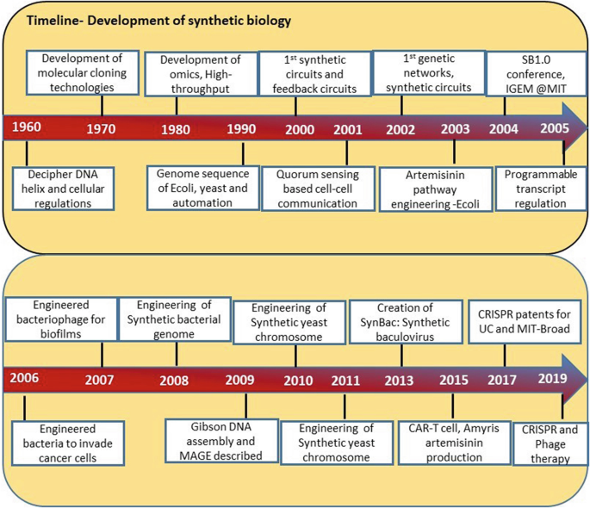
Figure 1: Timeline – Development of synthetic biology
(Source: Nxumalo, Z., Thimiri Govinda Raj, D.B. (2020). Application and Challenges of Synthetic Biology. In: Singh, V. (eds) Advances in Synthetic Biology. Springer, Singapore.)
- Oligonucleotides
Oligonucleotides are short fragments of DNA or RNA that can be synthesized chemically for various applications in molecular biology and biotechnology. Here is a brief overview of the history of oligonucleotide synthesis:
- The first published account of the directed chemical synthesis of an oligonucleotide occurred in 1955 when Michelson and Todd reported the preparation of a dithymidinyl nucleotide using chemical methods.
- The first synthesis of a longer oligonucleotide was reported by Khorana and his colleagues in 1960, using enzymatic methods.
- The phosphotriester method, which was developed by Todd's group in the 1950s, was improved by Letsinger and his colleagues in the 1960s and 1970s, allowing the synthesis of longer and more complex oligonucleotides.
- The phosphoramidite method, which is the most widely used technique for oligonucleotide synthesis today, was developed by Caruthers and his colleagues in the late 1970s and early 1980s, using solid-phase synthesis and automated systems.
- The first synthesis of an entire gene using oligonucleotides was reported by Itakura and his colleagues in 1977, using a combination of chemical and enzymatic methods.
- The first synthesis of an entire viral genome using oligonucleotides was reported by Venter and his colleagues in 2002, using a combination of PCR and assembly methods.
- The first synthesis of an entire bacterial genome using oligonucleotides was reported by Venter and his colleagues in 2008, using a combination of cloning and assembly methods.
- The first creation of a synthetic cell with a minimal genome using oligonucleotides was reported by Venter and his colleagues in 2016, using a combination of genome design, synthesis, and transplantation methods.
Oligonucleotide synthesis has enabled many advances in genetic engineering, synthetic biology, gene therapy, DNA computing, and data storage. It is expected to have more applications and impacts in the future.
Some of the recent achievements of creating artificial genomes and cells are:
- The first creation of a synthetic cell with a minimal genome was reported by Craig Venter and his colleagues in 2016, using a combination of genome design, synthesis, and transplantation methods. They designed and synthesized a genome of 473 genes, which is the smallest genome known to support life, and transplanted it into a recipient cell, creating a new bacterial species called JCVI-syn3.0.
- The first bacterium with a synthetic genome was reported by Craig Venter and his colleagues in 2010, using a similar approach as above. They synthesized the genome of Mycoplasma mycoides and transplanted it into a Mycoplasma capricolum cell, creating a new bacterial strain called JCVI-syn1.0.
- The first recoded organism with an expanded genetic code was reported by George Church and his colleagues in 2013, using a combination of genome editing and synthesis methods. They recoded the genome of Escherichia coli to remove all instances of the stop codon UAG and replace it with UAA, freeing up UAG for encoding novel amino acids. They also introduced an orthogonal tRNA-synthetase pair that can incorporate unnatural amino acids into proteins in response to UAG.
- The first synthesis of an entire eukaryotic chromosome was reported by Jef Boeke and his colleagues in 2014, using a combination of yeast recombination and assembly methods. They synthesized the chromosome III of Saccharomyces cerevisiae, which is about 272 kb long, and replaced the native chromosome with the synthetic one, creating a new yeast strain called synIII.
- The first synthesis of an entire viral genome was reported by Craig Venter and his colleagues in 2002, using a combination of PCR and assembly methods. They synthesized the genome of bacteriophage phi X174, which is about 5.4 kb long, and used it to infect E. coli cells, producing infectious viral particles.
These achievements demonstrate the feasibility and potential of creating artificial genomes and cells for various purposes, such as understanding the origin and evolution of life, engineering novel biological functions, and developing new therapeutics and biotechnologies.
Synthetic DNA has enabled many advances in genetic engineering, synthetic biology, gene therapy, DNA computing, and data storage. It is expected to have more applications and impacts in the future.
- Methods:
Synthetic DNA is the artificial creation of DNA molecules with defined sequences, which can be used for various purposes in molecular biology and biotechnology. Some of the main methods and techniques for synthesizing and manipulating synthetic DNA are:
- The phosphoramidite method, which is the most widely used technique for synthesizing short DNA fragments (oligonucleotides) up to 200 nucleotides long. This method involves the sequential coupling of nucleoside monomers with phosphoramidite groups on a solid support, followed by deprotection and cleavage from the support.
- The gene synthesis method, which is the assembly of longer DNA fragments (genes) from oligonucleotides using various strategies, such as PCR, ligation, recombination, or Gibson assembly. This method allows the synthesis of genes with desired sequences and modifications, such as codon optimization, restriction sites, or mutations.
- The genome synthesis method, which is the construction of entire genomes or chromosomes from genes or larger DNA fragments using various strategies, such as cloning, yeast recombination, or transplantation. This method allows the creation of synthetic genomes or chromosomes with desired features, such as minimal genomes, recoded genomes, or novel functions.
- The DNA manipulation method, which is the modification of synthetic or natural DNA using various techniques, such as restriction enzymes, nucleases, polymerases, ligases, recombinases, or genome editing tools. This method allows the manipulation of DNA for various purposes, such as cloning, mutagenesis, integration, or deletion.
These methods and techniques enable the synthesis and manipulation of synthetic DNA for various applications, such as understanding and engineering biological systems, developing new therapeutics and biotechnologies, and exploring the origin and evolution of life.
- Phosphoramidite method
The phosphoramidite method is the most widely used technique for synthesizing DNA oligonucleotides, which are short DNA fragments with defined sequences. Here is a brief introduction, principle, procedure, advantages and disadvantages of the phosphoramidite method:
Introduction:
The phosphoramidite method was developed by Marvin Caruthers and his colleagues in the late 1970s and early 1980s, based on the earlier work by Alexander Todd and his colleagues on the phosphotriester method. The phosphoramidite method involves the sequential coupling of nucleoside monomers with phosphoramidite groups on a solid support, followed by deprotection and cleavage from the support.
Principle:
The phosphoramidite method relies on the formation of a phosphite triester linkage between the 5'-hydroxyl group of a nucleoside monomer and the 3'-hydroxyl group of a growing oligonucleotide chain, catalysed by an acidic activator. The phosphite triester linkage is then oxidized to form a more stable phosphate triester linkage, which is the natural internucleotide linkage in DNA.
Procedure:
The phosphoramidite method consists of four main steps that are repeated for each nucleotide addition: deprotection (or detritylation), coupling, capping, and oxidation. The procedure is as follows:
- Deprotection: The 5'-dimethoxytrityl (DMT) protecting group is removed from the first nucleoside monomer that is attached to a solid support (such as controlled pore glass or polystyrene beads) using an acid solution (such as trichloroacetic acid or dichloroacetic acid). This exposes a free 5'-hydroxyl group that can react with the next nucleoside monomer.
- Coupling: A solution of the next nucleoside monomer with a phosphoramidite group at the 3'-position and various protecting groups at other positions (such as benzoyl for adenine and cytosine, isobutyryl for guanine, and dimethylformamidine for thymine) is added to the reaction vessel along with an acidic activator (such as tetrazole or pyridinium salt). The activator protonates the diisopropylamino group of the phosphoramidite, making it more electrophilic and susceptible to nucleophilic attack by the 5'-hydroxyl group of the first nucleoside monomer. This results in the formation of a phosphite triester linkage and the release of diisopropylamine as a byproduct.
- Capping: A solution of acetic anhydride and N-methylimidazole is added to the reaction vessel to acetylate any unreacted 5'-hydroxyl groups on the solid support. This prevents them from participating in further coupling reactions and generating truncated sequences.
- Oxidation: A solution of iodine, water, and pyridine or lutidine is added to the reaction vessel to oxidize the phosphite triester linkage to a phosphate triester linkage, which is more stable and resistant to hydrolysis.
Advantages:
The phosphoramidite method has several advantages over other methods of oligonucleotide synthesis, such as:
- High coupling efficiency: The phosphoramidite coupling reaction is fast and efficient, with an average yield of over 98% per cycle. This allows the synthesis of longer and more complex oligonucleotides with fewer errors.
- High purity: The DMT protecting group serves as a chromophore that can be monitored by UV detection to determine the coupling efficiency and purity of each cycle. The DMT group can also be used for purification of oligonucleotides by reverse-phase chromatography.
- Versatility: The phosphoramidite method can accommodate various modifications and labels on the nucleoside monomers, such as fluorescent dyes, biotin, amino groups, thiol groups, etc. These modifications can enhance the functionality and applications of oligonucleotides.
Disadvantages: The phosphoramidite method also has some disadvantages, such as:
- High cost: The phosphoramidite method requires expensive reagents and equipment, such as nucleoside phosphoramidites, activators, oxidizers, solid supports, synthesizers, etc. The cost increases with the length and complexity of the oligonucleotide.
- Environmental impact: The phosphoramidite method generates large amounts of hazardous waste, such as organic solvents, acids, bases, iodine, etc. These waste materials need to be properly disposed of or recycled to minimize the environmental impact.
- Limitations: The phosphoramidite method has some limitations in terms of the length and quality of the oligonucleotide. The coupling efficiency decreases with the length of the oligonucleotide, resulting in more errors and lower yields. The phosphoramidite method also introduces some unwanted modifications, such as depurination, oxidation, and chain scission, which can affect the performance and stability of the oligonucleotide.
- Gene synthesis method
Gene synthesis is the assembly of longer DNA fragments (genes) from shorter DNA fragments (oligonucleotides) with defined sequences. Here is a brief introduction, principle, procedure, advantages and disadvantages of the gene synthesis method:
Introduction:
Gene synthesis was first demonstrated by Herbert Boyer and his colleagues in 1974, who synthesized a peptide-coding gene using enzymatic methods. Later, Alexander Markham and his colleagues synthesized a protein-coding gene using a combination of chemical and enzymatic methods in 1976. Since then, various strategies and technologies have been developed to improve the efficiency and accuracy of gene synthesis, such as PCR, ligation, recombination, or Gibson assembly.
Principle:
Gene synthesis relies on the design and synthesis of oligonucleotides that overlap with each other and cover the entire sequence of the target gene. These oligonucleotides are then assembled into larger DNA fragments by annealing and joining methods, such as PCR, ligation, recombination, or Gibson assembly. The assembled DNA fragments are then cloned into a suitable vector and transformed into a host cell for verification and amplification.
Procedure:
Gene synthesis consists of four main steps: design, synthesis, assembly, and cloning. The procedure is as follows:
- Design: The sequence of the target gene is designed using various software tools that optimize the codon usage, GC content, restriction sites, secondary structures, etc. The designed gene sequence is then divided into smaller segments that can be synthesized as oligonucleotides. The oligonucleotides are designed to have overlapping regions with each other and with the vector for assembly and cloning purposes.
- Synthesis: The oligonucleotides are synthesized using the phosphoramidite method on a solid support, such as controlled pore glass or polystyrene beads. The oligonucleotides are then deprotected and cleaved from the support using an acid solution. The oligonucleotides are then purified by various methods, such as HPLC, PAGE, or cartridge purification.
- Assembly: The oligonucleotides are assembled into larger DNA fragments by annealing and joining methods, such as PCR, ligation, recombination, or Gibson assembly. PCR involves the use of primers and polymerases to amplify and join the oligonucleotides by repeated cycles of denaturation, annealing, and extension. Ligation involves the use of ligases to join the oligonucleotides by forming phosphodiester bonds between their ends. Recombination involves the use of recombinases to join the oligonucleotides by exchanging homologous regions between them. Gibson assembly involves the use of a mixture of enzymes that perform exonuclease digestion, annealing, and polymerase filling to join the oligonucleotides in a single reaction.
- Cloning: The assembled DNA fragments are cloned into a suitable vector by various methods, such as restriction digestion and ligation, homologous recombination, or Gibson assembly. The vector contains features such as origin of replication, antibiotic resistance gene, promoter, terminator, etc. that facilitate the propagation and expression of the target gene in a host cell. The vector is then transformed into a host cell, such as E. coli or yeast, by various methods, such as electroporation or heat shock. The transformed cells are then screened for the presence and correctness of the target gene by various methods, such as colony PCR, restriction analysis, sequencing, etc.
Advantages:
Gene synthesis has several advantages over other methods of obtaining genes, such as:
- Customization: Gene synthesis allows the creation of genes with desired sequences and modifications that may not exist in nature or may be difficult to obtain by other methods. Gene synthesis can also introduce features such as codon optimization, restriction sites, mutations, etc. that enhance the functionality and applications of genes.
- Speed: Gene synthesis can produce genes faster than other methods that rely on natural sources or mutagenesis. Gene synthesis can also avoid the limitations and uncertainties associated with natural sources or mutagenesis.
- Scalability: Gene synthesis can produce genes in large quantities and at low cost by using automated systems and parallel processes. Gene synthesis can also produce multiple genes simultaneously by using multiplexing techniques.
Disadvantages: Gene synthesis also has some disadvantages, such as:
- Errors: Gene synthesis can introduce errors in the sequence or structure of genes due to various factors such as imperfect oligonucleotide synthesis, assembly, or cloning. Gene synthesis requires various quality control measures to detect and correct errors and ensure the accuracy and fidelity of genes.
- Complexity: Gene synthesis can be challenging for genes that are very long, have high GC content, have repetitive regions, or have secondary structures. Gene synthesis requires various optimization and modification strategies to overcome these challenges and improve the efficiency and success of gene synthesis.
- Safety: Gene synthesis can pose potential risks to the environment and human health if the genes are harmful or hazardous. Gene synthesis requires various biosafety and biosecurity measures to prevent the misuse or abuse of genes and ensure the safety and responsibility of gene synthesis.
- Genome synthesis
Genome synthesis is the construction of entire genomes or chromosomes from smaller DNA fragments with defined sequences. Here is a brief introduction, principle, procedure, advantages and disadvantages of the genome synthesis method:
Introduction:
Genome synthesis was first demonstrated by Craig Venter and his colleagues in 2002, who synthesized the entire genome of bacteriophage phi X174 using PCR and assembly methods. Later, they synthesized the entire genome of Mycoplasma mycoides and transplanted it into a Mycoplasma capricolum cell, creating the first bacterium with a synthetic genome in 2010. They also created the first synthetic cell with a minimal genome in 2016, using genome design, synthesis, and transplantation methods. More recently, Jef Boeke and his colleagues synthesized the entire chromosome III of Saccharomyces cerevisiae, creating the first synthetic eukaryotic chromosome in 2014.
Principle:
Genome synthesis relies on the design and synthesis of smaller DNA fragments that cover the entire sequence of the target genome or chromosome. These DNA fragments are then assembled into larger DNA fragments by various methods, such as cloning, yeast recombination, or transplantation. The assembled DNA fragments are then verified and integrated into a suitable host cell for expression and function.
Procedure:
Genome synthesis consists of four main steps: design, synthesis, assembly, and integration. The procedure is as follows:
- Design: The sequence of the target genome or chromosome is designed using various software tools that optimize the features, such as codon usage, GC content, restriction sites, secondary structures, etc. The designed genome or chromosome sequence is then divided into smaller segments that can be synthesized as oligonucleotides or genes. The oligonucleotides or genes are designed to have overlapping regions with each other and with the vector for assembly and integration purposes.
- Synthesis: The oligonucleotides or genes are synthesized using the phosphoramidite method on a solid support or by gene synthesis methods using various strategies, such as PCR, ligation, recombination, or Gibson assembly. The oligonucleotides or genes are then deprotected and cleaved from the support or cloned into a suitable vector using various methods, such as restriction digestion and ligation, homologous recombination, or Gibson assembly. The oligonucleotides or genes are then purified by various methods, such as HPLC, PAGE, or cartridge purification.
- Assembly: The oligonucleotides or genes are assembled into larger DNA fragments by various methods, such as cloning, yeast recombination, or transplantation. Cloning involves the use of restriction enzymes and ligases to insert the oligonucleotides or genes into a vector that can replicate in a host cell, such as E. coli or yeast. Yeast recombination involves the use of yeast cells as a natural chassis for assembling the oligonucleotides or genes by homologous recombination. Transplantation involves the use of donor cells to provide a membrane envelope for assembling the oligonucleotides or genes by electroporation.
- Integration: The assembled DNA fragments are integrated into a suitable host cell for expression and function by various methods, such as transformation, transfection, electroporation, microinjection, etc. The host cell can be a bacterial cell, a yeast cell, a mammalian cell, etc. depending on the origin and purpose of the target genome or chromosome. The integrated DNA fragments are then screened for the presence and correctness by various methods, such as PCR, restriction analysis, sequencing, etc.
Advantages: Genome synthesis has several advantages over other methods of obtaining genomes or chromosomes, such as.
- Customization: Genome synthesis allows the creation of genomes or chromosomes with desired sequences and modifications that may not exist in nature or may be difficult to obtain by other methods. Genome synthesis can also introduce features such as minimal genomes, recoded genomes, novel functions, etc. that enhance the functionality and applications of genomes or chromosomes.
- Speed: Genome synthesis can produce genomes or chromosomes faster than other methods that rely on natural sources or mutagenesis. Genome synthesis can also avoid the limitations and uncertainties associated with natural sources or mutagenesis.
- Scalability: Genome synthesis can produce genomes or chromosomes in large quantities and at low cost by using automated systems and parallel processes. Genome synthesis can also produce multiple genomes or chromosomes simultaneously by using multiplexing techniques.
Disadvantages: Genome synthesis also has some disadvantages, such as:
- Errors: Genome synthesis can introduce errors in the sequence or structure of genomes or chromosomes due to various factors such as imperfect oligonucleotide or gene synthesis, assembly, or integration. Genome synthesis requires various quality control measures to detect and correct errors and ensure the accuracy and fidelity of genomes or chromosomes.
- Complexity: Genome synthesis can be challenging for genomes or chromosomes that are very long, have high GC content, have repetitive regions, or have secondary structures. Genome synthesis requires various optimization and modification strategies to overcome these challenges and improve the efficiency and success of genome synthesis.
- Safety: Genome synthesis can pose potential risks to the environment and human health if the genomes or chromosomes are harmful or hazardous. Genome synthesis requires various biosafety and biosecurity measures to prevent the misuse or abuse of genomes or chromosomes and ensure the safety and responsibility of genome synthesis.
- DNA manipulation
DNA manipulation is the modification of synthetic or natural DNA using various techniques, such as restriction enzymes, nucleases, polymerases, ligases, recombinases, or genome editing tools. Here is a brief introduction, principle, procedure, advantages and disadvantages of the DNA manipulation method:
Introduction:
DNA manipulation was first demonstrated by Paul Berg and his colleagues in 1972, who created the first recombinant DNA molecule by joining DNA fragments from two different sources using restriction enzymes and ligases¹. Later, Herbert Boyer and Stanley Cohen developed the first recombinant DNA cloning method by inserting foreign DNA into a bacterial plasmid and transforming it into E. coli cells in 1973. Since then, various techniques and tools have been developed to improve the efficiency and accuracy of DNA manipulation, such as nucleases, polymerases, recombinases, or genome editing tools¹².
Principle:
DNA manipulation relies on the recognition and cleavage of specific sequences or sites on DNA molecules by various enzymes or tools, such as restriction enzymes, nucleases, polymerases, ligases, recombinases, or genome editing tools. These enzymes or tools can modify DNA molecules by adding, deleting, replacing, or rearranging nucleotides or fragments.
Procedure: DNA manipulation consists of four main steps: digestion, modification, ligation, and transformation. The procedure is as follows:
- Digestion: The DNA molecules are cut into smaller fragments by restriction enzymes or nucleases that recognize and cleave specific sequences or sites on the DNA. The restriction enzymes can generate blunt ends or sticky ends on the DNA fragments depending on their cleavage pattern. The nucleases can generate single-stranded nicks or double-stranded breaks on the DNA depending on their activity.
- Modification: The DNA fragments are modified by various methods, such as polymerase chain reaction (PCR), mutagenesis, recombination, or genome editing. PCR involves the use of primers and polymerases to amplify and modify the DNA fragments by repeated cycles of denaturation, annealing, and extension. Mutagenesis involves the use of mutagens or mutator strains to introduce random or specific mutations on the DNA fragments. Recombination involves the use of recombinases to exchange homologous regions between the DNA fragments. Genome editing involves the use of tools such as CRISPR-Cas9 or TALENs to introduce targeted modifications on the DNA fragments by creating double-stranded breaks and inducing repair mechanisms.
- Ligation: The modified DNA fragments are joined together by ligases that form phosphodiester bonds between their ends. The ligases can join blunt ends or sticky ends depending on their specificity. The ligation can create circular or linear DNA molecules depending on the configuration of the ends.
- Transformation: The ligated DNA molecules are introduced into a host cell by various methods, such as electroporation, heat shock, microinjection, etc. The host cell can be a bacterial cell, a yeast cell, a mammalian cell, etc. depending on the origin and purpose of the DNA molecules. The transformed cells are then screened for the presence and expression of the DNA molecules by various methods, such as colony PCR, restriction analysis, sequencing, etc.
Advantages: DNA manipulation has several advantages over other methods of obtaining or modifying DNA molecules, such as:
- Customization: DNA manipulation allows the creation of novel DNA molecules with desired sequences and modifications that may not exist in nature or may be difficult to obtain by other methods. DNA manipulation can also introduce features such as restriction sites, mutations, tags, etc. that enhance the functionality and applications of DNA molecules.
- Speed: DNA manipulation can produce novel DNA molecules faster than other methods that rely on natural sources or synthesis. DNA manipulation can also avoid the limitations and uncertainties associated with natural sources or synthesis.
- Versatility: DNA manipulation can produce various types of DNA molecules with different sizes and shapes by using different enzymes or tools. DNA manipulation can also produce multiple DNA molecules simultaneously by using multiplexing techniques.
Disadvantages: DNA manipulation also has some disadvantages, such as:
- Errors: DNA manipulation can introduce errors in the sequence or structure of DNA molecules due to various factors such as imperfect digestion, modification, ligation, or transformation. DNA manipulation requires various quality control measures to detect and correct errors and ensure the accuracy and fidelity of DNA molecules.
- Complexity: DNA manipulation can be challenging for DNA molecules that are very long, have high GC content, have repetitive regions, or have secondary structures. DNA manipulation requires various optimization and modification strategies to overcome these challenges and improve the efficiency and success of DNA manipulation.
- Safety: DNA manipulation can pose potential risks to the environment and human health if the DNA molecules are harmful or hazardous. DNA manipulation requires various biosafety and biosecurity measures to prevent the misuse or abuse of DNA molecules and ensure the safety and responsibility of DNA manipulation.

- Computational tool for design and assembly of synthetic DNA:
There are several computational tools available for the design and assembly of synthetic DNA. These tools help researchers and scientists in the design, optimization, and analysis of DNA sequences for various applications, such as gene synthesis, genetic engineering, and synthetic biology. Here are some commonly used computational tools in this field:
DNA Sequence Design Tools:
- Gene Designer: A tool for designing synthetic genes and DNA sequences. It offers features like codon optimization, restriction enzyme analysis, and primer design.
- Benchling: A comprehensive platform that includes tools for designing DNA sequences, cloning, and DNA assembly. It also offers collaboration and data management features.
DNA Assembly Tools:
- GeneArt® Gene Synthesis: A tool provided by Thermo Fisher Scientific for gene synthesis and DNA assembly. It supports seamless assembly of DNA fragments and provides customization options.
- Geneious: A bioinformatics software suite that includes DNA assembly tools, allowing users to design and assemble DNA fragments using various methods like Gibson Assembly and Golden Gate Assembly.
DNA Editing and Design Tools:
- CRISPR Design Tools: Several online tools are available for designing guide RNA sequences for CRISPR-mediated genome editing. Examples include CRISPOR, CHOPCHOP, and Benchling's CRISPR tool.
- SnapGene: A molecular biology software that enables visualization, simulation, and annotation of DNA sequences. It also provides tools for designing primers, cloning, and DNA assembly.
DNA Sequence Analysis Tools:
- BLAST (Basic Local Alignment Search Tool): A widely used tool for comparing DNA sequences against a database to find similar sequences.
- Geneious: Apart from assembly, Geneious also provides tools for sequence alignment, motif search, and restriction enzyme analysis.
Genome Engineering Tools:
- CRISPResso: A computational tool for analyzing CRISPR/Cas9 genome editing outcomes. It can quantify insertion, deletion, and substitution mutations introduced by CRISPR.
These are just a few examples of the many computational tools available for DNA design and assembly. The choice of tools depends on the specific requirements of the project and the preferences of the researcher. It's always a good idea to explore different tools and choose the ones that best fit your needs.
- Applications:
Synthetic DNA is the artificial creation of DNA molecules with defined sequences, which can be used for various purposes in molecular biology and biotechnology. Some of the various applications and potential uses of synthetic DNA in different fields are:
- Biotechnology: Synthetic DNA can be used to create novel biological systems or functions by engineering genes, pathways, or genomes. For example, synthetic DNA can be used to create synthetic biology circuits that can sense and respond to environmental signals, such as light, temperature, or chemicals. Synthetic DNA can also be used to create metabolic pathways that can produce valuable compounds, such as biofuels, drugs, or materials. Synthetic DNA can also be used to create synthetic genomes that can encode minimal or novel life forms, such as bacteria or viruses.
- Bioengineering and Synthetic Biology: Synthetic DNA is a fundamental tool in the field of synthetic biology. Scientists can design and synthesize DNA sequences to create artificial organisms with novel functions or to modify existing organisms to perform specific tasks. This has applications in bioengineering, biofuel production, environmental remediation, and the creation of biosensors and bioremediation systems.
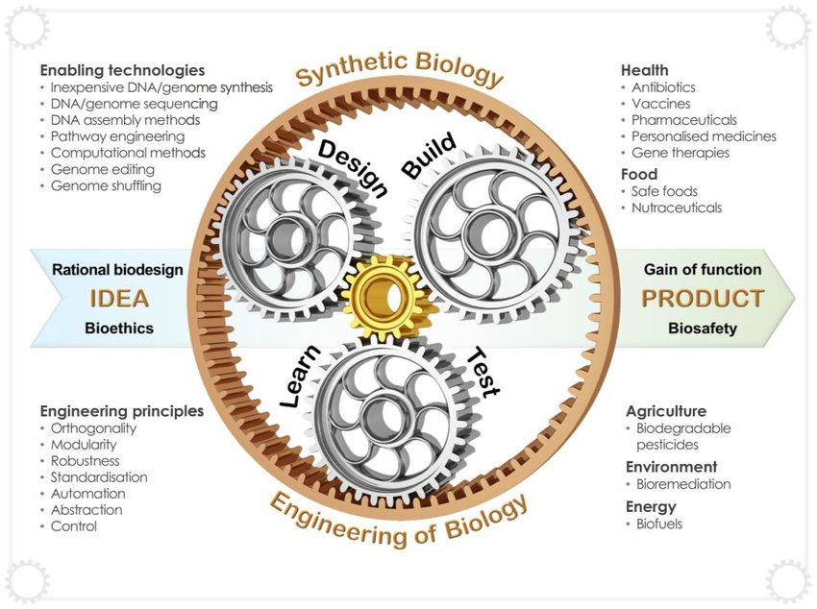

Figure1: Synthetic biology entails the engineering of biology, incorporating enabling technologies and enabling
approaches framed around rational engineering principles.
(Source: Cameron, D., Bashor, C. & Collins, J. A brief history of synthetic biology. Nat Rev Microbiol 12, 381–390 (2014).
.
- Medicine: Synthetic DNA can be used to develop new therapeutics or diagnostics for various diseases or conditions. For example, synthetic DNA can be used to create vaccines that can elicit immune responses against pathogens, such as hepatitis B virus or malaria parasite. Synthetic DNA can also be used to create gene therapies that can deliver functional genes or correct defective genes in target cells, such as cancer cells or blood cells. Synthetic DNA can also be used to create molecular probes that can detect specific biomarkers or pathogens in biological samples, such as blood or saliva.
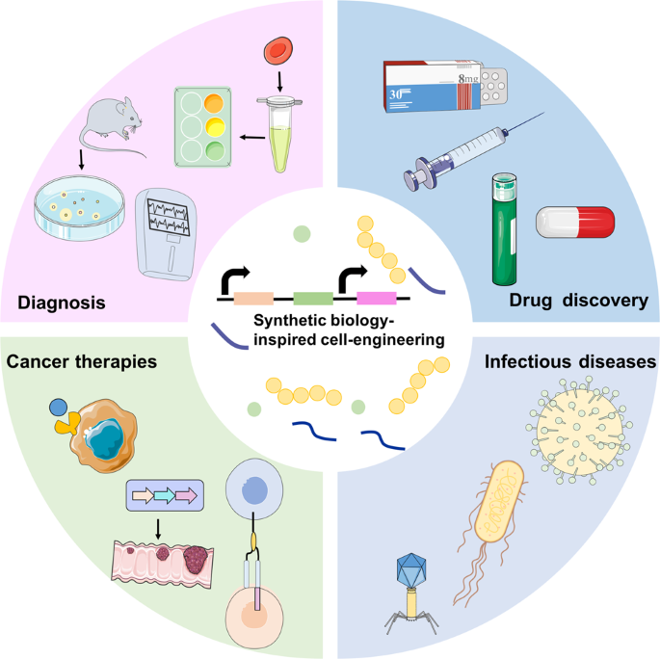
Figure 2: Synthetic biology-inspired cell engineering can be employed for various medical applications.
(Source: Zhao, N., Song, Y., Xie, X. et al. Synthetic biology-inspired cell engineering in diagnosis, treatment, and drug development. Sig Transduct Target Ther 8, 112 (2023).
- Data storage: Synthetic DNA can be used to store large amounts of digital information in a compact and durable format. For example, synthetic DNA can be used to encode binary data into nucleotide sequences and store them in synthetic DNA molecules that can be preserved for long periods of time. Synthetic DNA can also be used to retrieve the stored data by sequencing the synthetic DNA molecules and decoding the nucleotide sequences back into binary data. Synthetic DNA can offer advantages over conventional data storage media, such as high density, low energy consumption, and long-term stability.
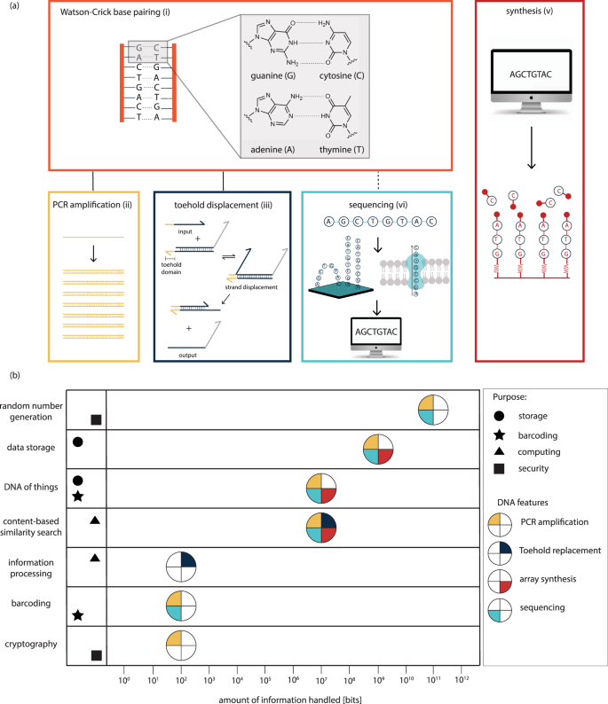
Figure 3: Synthetic DNA applications in information technology
(Source: Meiser, L.C., Nguyen, B.H., Chen, YJ. et al. Synthetic DNA applications in information technology. Nat Commun 13, 352 (2022).
- Security: Synthetic DNA can be used to enhance the security of various products or systems by providing unique and verifiable identifiers or codes. For example, synthetic DNA can be used to create barcodes that can label products or documents with specific information, such as origin, date, or authenticity. Synthetic DNA can also be used to create encryption keys that can protect data or communication from unauthorized access or tampering. Synthetic DNA can offer advantages over conventional security methods, such as high diversity, low visibility, and high resistance to counterfeiting.
- Bioengineering: Synthetic DNA can be used to manipulate the properties or functions of various biological materials or systems by introducing specific modifications or features. For example, synthetic DNA can be used to create nanomaterials that can self-assemble into desired shapes or structures, such as wires, tubes, or cages. Synthetic DNA can also be used to create biosensors that can detect and measure various physical or chemical stimuli, such as pH, temperature, or glucose. Synthetic DNA can also be used to create biocomputers that can perform logical operations or computations using biochemical reactions.
It's important to note that while synthetic DNA holds immense potential, there are also ethical considerations surrounding its use, such as ensuring responsible and safe practices, addressing potential environmental impacts, and considering the potential misuse of synthetic DNA for harmful purposes. Ongoing research and discussions are aimed at developing guidelines and regulations to govern the use of synthetic DNA technologies.
Please keep in mind that the field of synthetic DNA is rapidly evolving, and new applications and uses may continue to emerge as research progresses.
- Conclusion
Synthetic DNA is the artificial creation of DNA molecules with defined sequences, which can be used for various purposes in molecular biology and biotechnology. Synthetic DNA can be synthesized and manipulated by various methods, such as phosphoramidite method, gene synthesis method, genome synthesis method, and DNA manipulation method. Synthetic DNA has various applications and potential uses in different fields, such as biotechnology, medicine, data storage, security, and bioengineering. Synthetic DNA offers advantages over natural DNA or conventional methods, such as customization, speed, scalability, diversity, and stability. However, synthetic DNA also has some disadvantages and challenges, such as errors, complexity, cost, safety, and ethics. Synthetic DNA is a rapidly developing and expanding field that has great potential to revolutionize science and technology. Some directions for further research include:
- Improving the efficiency and accuracy of synthetic DNA synthesis and manipulation methods
- Exploring the feasibility and functionality of novel synthetic DNA sequences and modifications
- Developing new applications and products based on synthetic DNA for various sectors and domains
- Evaluating the environmental and social impacts and implications of synthetic DNA use and production
- Establishing the ethical and legal frameworks and guidelines for synthetic DNA research and innovation.
- References:
- Meiser, L.C., Nguyen, B.H., Chen, YJ. et al. Synthetic DNA applications in information technology. Nat Commun 13, 352 (2022).
- Zhao, N., Song, Y., Xie, X. et al. Synthetic biology-inspired cell engineering in diagnosis, treatment, and drug development. Sig Transduct Target Ther 8, 112 (2023).
- Cameron, D., Bashor, C. & Collins, J. A brief history of synthetic biology. Nat Rev Microbiol 12, 381–390 (2014).
- Nxumalo, Z., Thimiri Govinda Raj, D.B. (2020). Application and Challenges of Synthetic Biology. In: Singh, V. (eds) Advances in Synthetic Biology. Springer, Singapore.
- Benner, S. A. Synthetic biology: act natural. Nature 421, 118 (2003).
- Shapira, P., Kwon, S. & Youtie, J. Tracking the emergence of synthetic biology. Scientometrics 112, 1439–1469 (2017).
- Singh, V. Recent advancements in synthetic biology: current status and challenges. Gene 535, 1–11 (2014).
- Westerhoff, H. V. & Palsson, B. O. The evolution of molecular biology into systems biology. Nature Biotech. 22, 1249–1252 (2004).

