Dual source and Dual energy computed tomography

Sanjay Yadav
M.Sc. Radio-Imaging Technology
SGT University, Gurugram
Ydvsanjay880@gmail.com

Nakul Tyagi
M.Sc. Radio-Imaging Technology
SGT University, Gurugram
Tyaginakul876@gmail.com

Hitesh Sharma
M.Sc. Radio-Imaging Technology
SGT University, Gurugram
Hiteshsharma2201@gmail.com

Navreet Boora
Assistant Professor
Department of Paramedical
SGT University, Gurugram
Navreet999@gmail.com

Mohit Deswal
Assistant Professor
Department of Paramedical
SGT University, Gurugram
Mohitdeswal.md.md@gmail.com

Bhrigu Kumar Das
Assistant Professor
NEPNI Group of Institution
Singimari, Assam
Bhrigudas1999@gmail.com

In computed tomographic (CT) imaging, materials having different elemental compositions can be represented by the same, or very similar, CT numbers, making the differentiation and classification of different types of tissues extremely challenging. A classic example is the difficulty in differentiating between calcified plaques and iodine-containing blood. Although these materials differ considerably in atomic number, depending on the respective mass density or iodine concentration, calcified plaque or adjacent bone may appear identical to iodinated blood on a CT scan. In addition to the difficulty in differentiating and classifying tissue types, the accuracy with which material concentration can be measured is degraded by the presence of multiple tissue types. For example, when measuring the amount of iodine enhancement of a soft-tissue lesion, the measured mean CT number over the lesion reflects not only the enhancement due to iodine, but also the CT number of the underlying tissue.
In dual-energy CT, attenuation measurements obtained at a second energy allow the decomposition of a mixture of two or three materials into its constituent materials. A number of technical approaches exist for acquiring dual energy data, including sequential acquisition of two different scans, rapid tube potential switching, multilayer detectors, and dual x-ray sources. Energy-resolving, photon-counting detectors represent an emerging approach to acquiring more than two energy measurements; this may provide new applications such as K-edge energy subtraction techniques. A range of current and emerging clinical applications of dual energy CT exist, including virtual monoenergetic imaging, automated bone removal in CT angiography, perfused blood volume imaging, virtual noncontrast material–enhanced imaging, plaque removal, virtual non-calcium imaging, urinary stone characterization, imaging of crystalline arthropathies, and detection of silicone from breast implants.
Technical Approaches to Dual-Energy CT
Dual-energy methods for CT were subsequently investigated by Alvarez and Macovski in 1976. They demonstrated that even with polyenergetic x-ray spectra, one could still separate the measured attenuation coefficients into their contributions from the photoelectric effect and Compton scattering processes. Since this early work, a number of technical approaches have been developed for acquiring the dual-energy data set.

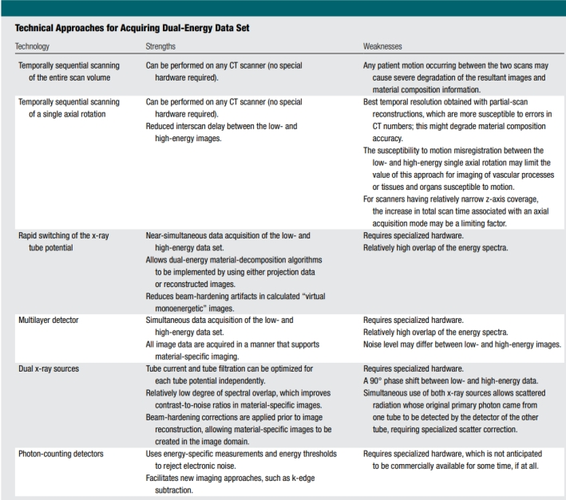

1) Two Temporally Sequential
Scans Initial applications focused primarily on the characterization of lung, liver, and soft-tissue composition (2,3). Two temporally sequential scans were performed to acquire the data at each of the two tube potentials. Because the data were not acquired simultaneously, patient motion occurring between the two scans caused severe degradation of the resultant images and material composition information. To minimize the time delay inherent in two consecutive scans of the entire anatomic volume of interest, a modified approach has been suggested, where one axial scan (ie, one tube rotation) is performed at each tube potential prior to table incrementation. This reduces the interscan delay between the low- and high-energy images. The best temporal resolution can be obtained for this scenario with use of partial scan reconstruction techniques.
In this approach, 180° plus the fan angle of projection data are acquired at each tube potential, with a small delay between acquisitions to allow for switching of the tube potential and table incrementation. This approach may be appropriate for relatively static organs or tissues. However, because the time delay between the two scans is still relatively long, the susceptibility to motion misregistration between the low- and high-energy data sets may limit the value of this approach for dual-energy imaging of vascular processes, or tissues and organs susceptible to motion. For scanners having relatively narrow z-axis coverage, the increase in total scan time may also be a limiting factor.
2) Rapid Switching of X-Ray Tube Potential
Clinical application of this technique focused primarily on bone densitometry measurements. However, the tube current could not be increased quickly enough for the low tube potential measurements to achieve comparable noise levels in both the low and high tube potential data sets. This difference in noise limited extension of the technique beyond bone densitometry applications. Switching the tube potential between consecutive views requires that the transition time from low to high tube potential be less than a millisecond. In addition, the transition must be as abrupt as possible to maximize the energy separation of the measured data, although difficulty in rapidly modulating the x-ray tube current may cause high noise levels in the low energy data or excessive dose from the high-energy projections. This problem can be addressed, however, by using asymmetric sampling for the low- and high-energy projections. In this manner, without rapidly changing the tube current, the needed increase in tube current-time product for the low-energy projections is obtained by using a longer sampling interval for the low-energy data However, because the same x-ray tube is used for both the low- and high-energy data set, it is technically difficult to optimize the spectral filtration for both the low- and high-energy images. Finally, very fast data sampling is needed to avoid decreasing the in-plane spatial resolution subsequent to allocating a fraction of the acquired samples to each energy’s data set. The very short time interval between the low- and high-energy views (less than 1 msec) provides near-simultaneous data acquisition of the low- and high energy data set. The one-view misregistration requires a correction to be applied to avoid streak artifacts; however, this allows dual-energy material decomposition algorithms to be implemented by using either projection data or reconstructed images. The ability to use projection data assists in reducing beam-hardening artifacts in calculated “virtual monoenergetic” images
3) Multilayer Detector
A third mechanism for acquiring dual-energy CT projection data uses a single high tube potential beam and layered or “sandwich” scintillation detectors. The low-energy data are collected from the front or innermost detector layer and the high-energy data are collected from the back or outermost detector layer. This is analogous to the use of multilayer detectors for dual-energy radiography. To achieve comparable noise in the low- and high-energy images, different detector thicknesses are used. An advantage to this approach is that the low- and high-energy data sets are acquired simultaneously, and the data from the inner and outer detector layers are recorded at all times. This allows dual-energy analysis to be performed on every data set acquired. That is, the system is always operating in a “dual-energy mode.”
Approaches to Multi-Energy CT on a Technical Level
Photon-counting Detectors
Energy-resolving photon counting detectors may provide the most robust option for dual-energy, or multi-energy, data gathering. Such detectors, which can count discrete photon interactions, are still under development and are not commercially available in CT systems, however they are utilised in nuclear medicine and spectral mammography. Counts are assigned to certain energy threshold data sets based on the energy thresholds chosen and the associated energy of each photon. By removing distinct energy threshold data, data linked with specific energy windows are generated. Photon-counting detectors can be utilised for dual-energy imaging in the particular situation with n = 2 energy windows.
The transmitted x-ray spectrum is separated into a number of distinct energy bins using pulse-height discrimination, the number of which relies on the design of the application-specific integrated circuit that is bonded to the energy-resolving detector. Cadmium telluride (CdTe) and cadmium zinc telluride are thought to be the most likely options for the material utilised to convert the energy of an absorbed x-ray into an electrical signal whose amplitude is proportionate to the energy of the incoming photon. Although similar detectors are now accessible and employed in other fields, coping with the exposure rates required in CT imaging presents hurdles. At the high peak x-ray radiation utilised in CT imaging (about 109 counts/sec/mm2), current detectors lose counts owing to pulse pile-up effects and can finally become entirely paralysed. The dispersion of a photon's energy across many detector pixels (known as charge sharing) or the reemission of a characteristic x-ray (known as K-escape) might reduce the accuracy of the recorded energy.
A charge-summing mode has been proposed to lessen the impacts of charge sharing, in which communication between close detector pixels is formed using hardware circuits.
Charges from adjacent pixels of coincident occurrences are added together, and the total charge is awarded to the pixel that gathers the greatest charge.
Using this strategy, significant improvements in spectral performance have been reported. A variety of potential benefits, including as enhanced spectrum separation and dosage efficiency, are driving major research and development in this sector. Photon-counting detectors, in particular, have a better geometric efficiency than energy-integrating detectors (by roughly 30%), and the use of an energy threshold allows the rejection of counts attributable exclusively to measurable electronic noise.
Above the threshold, electronic noise affects just the measured energy of each photon; it has no effect on photon counts. This detector technology is also capable of doing K-edge imaging.
Material Decomposition Algorithms
Dual- or multi-energy CT's capacity to deconstruct a material into its constituent elements is based on the energy- and element-dependent nature of x-ray attenuation. The photoelectric effect and Compton scattering mechanisms are the primary causes of x-ray attenuation by matter in the diagnostic energy range (E, 150 keV).
This is a monotonic and smoothly changing function for elements with no K- or L-edges that are beneficial for diagnostic x-ray imaging. In the absence of a K- or L-edge, a given material's attenuation coefficient may be modelled as a linear mixture of photoelectric and Compton interactions.
A rZ map may be constructed and material-specific information gained by modelling the dependency of the photoelectric and Compton interaction processes on material mass density (r) and atomic number (Z).
Because x-ray attenuation is predominantly determined by these two interaction processes, the attenuation coefficient of any material may be represented as a linear combination of the attenuation coefficients of two underlying basic materials. Early research on dual energy CT material decomposition concentrated on methods employed in pre-reconstruction (projection) space to generate either rZ image pairs or basis material image pairs.
The use of projection data has the theoretical benefit of removing beam-hardening artefacts from the reconstructed pictures. However, due to inadequate system calibrations, beam-hardening artefacts may not be totally eradicated in practice.
This illustrates the need of reliable system calibrations, which establish the link between projection measurements and known densities of basis materials, or CT numbers and known thicknesses of basis materials, independent of the algorithm domain (projection or image space).

REFFERENCE
- Johnson, T. R. C. (2012). Dual-energy CT: General principles. AJR. American Journal of Roentgenology, 199(5_supplement), S3–S8. https://doi.org/10.2214/ajr.12.9116
- Kambadakone, A., Andrabi, Y., Patino, M., Das, C., Eisner, B., & Sahani, D. (2015). Advances in CT imaging for urolithiasis. Indian Journal of Urology: IJU: Journal of the Urological Society of India, 31(3), 185. (Hsu, 2014)https://doi.org/10.4103/0970-1591.156924
- Parakh, A., Lennartz, S., An, C., Rajiah, P., Yeh, B. M., Simeone, F. J., Sahani, D. V., & Kambadakone, A. R. (2021). Dual-energy CT images: Pearls and pitfalls. Radiographics: A Review Publication of the Radiological Society of North America, Inc, 41(1), 98–119. https://doi.org/10.1148/rg.2021200102
- Hsu C, Sharma R, Murphy A, et al. Dual energy CT. Reference article, Radiopaedia.org (Accessed on 25 Aug 2023) https://doi.org/10.53347/rID-31353
- Hacking, C., & Hsu, C. (2014). Dual energy CT. In Radiopaedia.org. Radiopaedia.org. https://doi.org/10.53347/rID-31353
- McCollough, C. H., Leng, S., Yu, L., & Fletcher, J. G. (2015). Dual- and multi-energy CT: Principles, technical approaches, and clinical applications. Radiology, 276(3), 637–653. https://doi.org/10.1148/radiol.2015142631
- Sanghavi, P. S., & Jankharia, B. G. (2019). Applications of dual energy CT in clinical practice: A pictorial essay. The Indian Journal of Radiology & Imaging, 29(03), 289–298. https://doi.org/10.4103/ijri.ijri_241_19

