REVIEW FOR VERTICAL AXIS MAGLEV WIND TURBINE HAVING VARIOUS DESIGNS

Dr.Harshit Bhavsar¹

- Assistant Professor, Department of Mechanical Engineering, SAL College of Engineering, Ahmedabad, Gujarat, India.

Abstract:-
In recent years, with increasing concerns about environmental pollution, renewable energy sources such as turbines have become more important. Several developments are underway to harness the energy of the stars and the wind. Wind is a boon everywhere, even for short periods of time, but few places have wind turbines installed to generate electricity. Efforts are underway to harness wind power even from small areas with the development of vertical axis wind turbines that exploit railway suspensions to harness electrical power. In this work, a new approach to magnet placement (two-level placement) was tested. The goal is to use direct materials as turbine blades and generate electricity through a magnetic levitation system. During this work, a completely new device for placing the ND magnets and coils on the wind turbine plate was developed and tested. As the wind turbine rotates, the magnetic array passes over the copper coil array creating an axial magnetic flux.

Key words:- Turbine, Rotation, Magnets, Wind Energy, maglev,

Introduction:-
Presently a day, we will eventually have to look for inexhaustible or basically limitless fuel hotspots for the human turn of events to proceed. The majority of environmentally friendly energy comes from sources like wind power, sunlight-based energy, geothermal energy, hydropower, and others. Because of the tedium of traditional power generation methods, demand for environmentally friendly energy has increased over the past several years. The utilization of environmentally friendly power is the as it were thing that diminishes the reliance of human on petroleum products. Among the wide range of various environmentally friendly power sources Wind Energy is one of the quickest developing fuel sources which is developing at the pace of 30% yearly diagram.[2]

The breeze speeds in Asian nations is extremely low, particularly in the urban areas, and this much measure of wind speed isn't sufficient to begin the breeze factory. This undertaking presents structure and guideline of the proposed attractive levitation wind turbine for better use of wind energy. In the Maglev Wind turbine there is no grating, and subsequently, it can deal with low speed. The Maglev wind turbine configuration is a massive take off from customary propeller plans. Its fundamental choices are that it makes use of frictionless orientation and an appealing levitation plan and it doesn't have to brilliant spaces wished by means of greater regular breeze generators. It additionally requires nearly nothing if any support. The Maglev wind turbine was first unveiled at the Wind Power Asia Display in Beijing 2007. The extraordinary working standard behind this scheme is through attractive levitation. As long as anyone knows an amazingly masterful structure for wind power, there is fascinating levitation. The vertically situated edges of the breeze turbine are adjourned visible all around supplanting any necessity for metal rollers.( T G Sriganesh, G J Naveen, Vishnu P)

Wind power terminology:

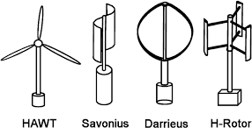

Fig. 1:-Maglev Vertical Axis Wind Turbine

Sujata R. Ingle, Ambikaprasad O. Chaubeyhave shown the effectiveness of the breeze turbine is subject to wind availability, in the event that the measure of wind is adequate breeze turbine sharp edges are turning unceasingly.

The wind knockouts the cutting edges of the turbine, the force age by the cutting edges can be determined as, Dynamic energy (K.E) = ½ mv2 Measure of Air cruising is given by,
m = ρ AV (1)
Subbing this estimation of the mass in the articulation of K.E,
K.E = ρAv3 Watts (2)
To change control over to kilo watt a non-dimensional proportionality steady k is presented where k = 2.14 X 10-3
Along these lines, Force in KW (P) = 2.14 ρAv3 x10 (3) Where,
m = Mass of air navigating A = Area
Air Density (ρ) = 1.2 kg/m3
Cleared by the sharp edges of the turbine
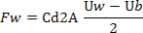
Speed (V) = wind speed with condition over, the force being created can be determined, anyway one should take note of that it is preposterous to expect to change over all the intensity of the breeze into power. The turbine assimilates the breeze energy with their individual edge will move more slow that the breeze speed. The distinctive speed creates a drag power to drive the sharp edges. The drag power for following up on one sharp edge is determined as
Where,
A = Swept territory of the cutting edge
ρ = Air thickness (about 1.225 kg/m3 adrift level) Uw = Wind speed
Cd =The drag coefficient (1.9 for rectangular structure) Ub =The speed on the edge surface.

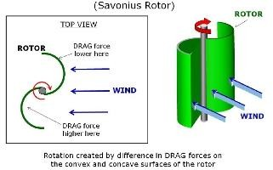

Fig.1:-Drag- Based Wind Turbine Concept

Principle and types of magnetic suspension:
research on Magnetic suspension way that an item is suspended through magnetic enchantment and/or repulsion forces to reap non-touch guide and low-friction in motion.

Due to no mechanical contact in the attractive bearing, it has numerous points of interest, including no wear, no defilement, reasonable for long haul use in vacuum and destructive climate, no mechanical grinding, low commotion, low force misfortune and no need of grease or fixing. In this manner, attractive suspension innovation can be utilized for fast applications to kill mechanical issues identified with oil and force misfortune.
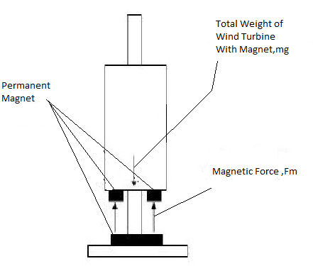

Fig. 2:-Free body diagram of magnetically levitated object

Attractive levitation is a technique wherein an article is deferred with no help other than attractive fields. The attractive power created is utilized to neutralize the impacts of gravitational power and lift up the item. By putting two magnets on top of one another with like splits confronting one another, the attractive shock will be solid enough to get both magnets a good way off far from one another. There are numerous preferences for using attractive levitation which is to limit contact, make power estimation, plan, and engage gadgets. As of late, this

development invention is applied into conveyance outline in which non-leading vehicle travel securely at extremely rapid while suspended, guided, and moved over a guide path by attractive fields. The concept of an elegantly suspended vehicle sparked developments with practical applications in other industries, such as the power age.

Working Principle:
The force is generated using Faraday's first law of acceptance, which states that "Anywhere a conductor is put in a fluctuating attractive field, emf are instigated, which is called incited emf, and if the conductor circuit are shut, current are likewise actuated, which is called initiated current." This is the overall schematic diagram of an attractive levitation vertical hub wind turbine. The magnets on the blades of the breeze turbine are connected to a circle, and the magnets' appealing motion connects with the loop that is placed on the base of the maglev wind factory to turn the blades of the turbine.[3]
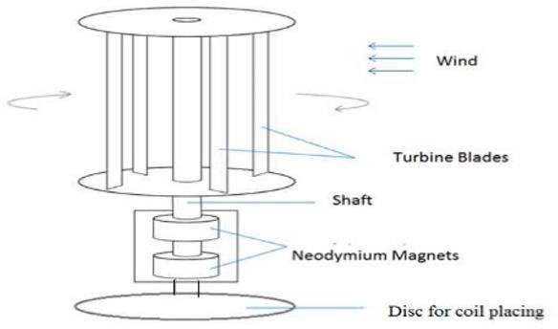
Fig. 4:-Sketch and components of maglev wind turbine

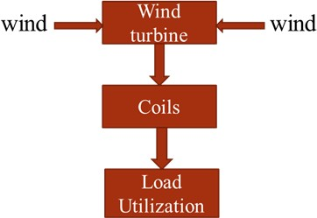

Fig. 5:-Block diagram of maglev wind turbine

Advantages:
- A monstrous pinnacle structure isn't needed, as VAWT's are mounted nearer to the ground.

- These are found nearer to the ground and subsequently simpler to keep up.
- No such oil requirements.
- Skilled of creating power from wind speeds as low as 1.5 m/s and answered to work in breezes arriving at 40 m/s.
- Making 20% more energy than a regular turbine, at once shrinking operational expenses by half over the customary draft turbine.
- Better response to quickly evolving winds.
- Lighter weight towers

Future Scope:
Future work could involve an examination of the impact of the following points of view talked about beneath on the presentation of the current rotor.
- By utilizing modernized cutting edges for the Savonius propeller, the force of the propeller can be expanded to deliver more force at even low speeds.
- Design identified with self-flexible End Plates can be created to draw in more air to go through the cutting edges via programmed formation of weight differential across the gulf and source.
- In this plan we can put Solar Plate and can get multiplied power with a similar spot being used

Conclusion:-
The vertical wind hub mill idea worked effectively using attractive flotation. Unlike conventional monotonous wind turbines, single maglev wind turbines produce more power with larger constraints. Turbine efficiency is increased through the use of magnets, which help rotate at high speeds with minimal grinding to offset the weight on the turbine shaft. A set of 1,000 standard windmills can power 5 lakh homes, whereas a single maglev wind turbine can power up to 7.5 lakh homes. A field of 1,000 windmills needs more than 64000 sections of land, however a single maglev windmill only needs fewer than 100 pieces of land. This viewpoint leads us to the conclusion that a single maglev wind turbine is more environmentally friendly than a traditional wind turbine.

When it comes to large-scale power generation, it is not clear whether vertical hub wind turbines are suitable for these applications. A mortgage bearer would have the choice of opting for free clean energy, which would reduce their utility costs and also contribute to the "Environmental power Energy" awareness that is steadily becoming more widespread.

References:-
- Santoshkumar Jiledar Chaturvedi, „Maglev Wind Generator‟, 3rd The International Conference on Renewable Energy Technology, eISSN: 2319-1163 | pISSN: 2321-7308,(2014).
- Nitin A. Dhumne, surbhi Shrivastava, “A Novel Method Design of Vertical Axis WindTurbine by using Magnetic Levitation, –International Journal for Innovative Research in Science & Technology| Volume 4 | Issue 1 | June 2017
- Manoj L, Nithesh J, Manjunath T, Gowreesh S “ Power Generation using Magnetic Levitation Vertical Axis Wind Turbine, International Journal of Engineering and Advanced Technology (IJEAT), Volume-9 Issue-2, December, 2019
- Vishal D Dhareppgoal and Maheshwari M Kona-gutti, „Regenedyne Maglev Wind Power Generation‟, SARC- IRAJ International Conference, ISBN: 978-81-92747-8-3. 16th June 2013
- Dinesh N Nagarkarand, Dr. Z. J. Khan, „Wind Power Plant Using Magnetic Levitation Wind Turbine‟, International-Journal of Engineering and Innovative Technology (IJEIT) Volume 3, Issue1, July 2013.
- Baker J R., Features to aid or enable self-starting of fixed pitch low solidity vertical axis wind turbines, (2003) Journal of Wind Engineering and Industrial Aerodynamics; 15:369–80.
- Ponta F L, Seminara J J, Otero A D., on the aerodynamics of Variable-geometry oval-trajectory Darrieus wind turbines. Renewable Energy; 32(2007) 35–56.
- Chaichana T, Chaitep S., Wind power potential and characteristic analysis of Chiang Mai, Thailand, Mechanical Science and Technology; 24(2010) 1475–9.
- Nayana Said, Maya Yeole, PriyankaPatil, P.N.Salunkhe, “Magnetic levitation is used as merit over conventional wind mill” International Journal for Scientific Research and Development (IJSRD), in 2017

- C.M.Vivek, P.Gopalakrishan, R.Murugesh, R.Raja Mohamed, “Increasing the efficiency of wind turbine using wind energy by producing electricity” International Research journal of engineering and Technology(IRJET), in April-2017
- Harshal Vaidya, PoojaChandadkar, Bobby Khobragade, R.K.Kharat, “The implementation of different types of wind turbine for power generation” International Journal of Research in Engineering and Technology (IJRET), in 2016
- ParthRathod, KapilKhalik, Ketul Shah, Het Desai, Jay Shah, “The study of combined vertical axis wind turbine and optimizing combined rotor blades” International Journal of Innovation Research in Science Engineering Technology(IJIRSET), in April-2016
- Ajay L.Parate, Pawan M Kumbhare, Rahul C Patekar, Pravingupta, “The implementation of an alternative configuration of a wind turbine for power generation” International Journal for Scientific Research and Development (IJSRD), in 2015
- D.A.Nikam, S.M.Kherde, “Various stages of design and development of optimizing vertical wind turbine” International Journal of Engineering Research and Application (IJERA), in Nov-2015
- Er.Rahul Jangam, Avinash Barve, Bhagyesh Talekar, Pratik Hajare “Frictionless Wind Turbine Using Magnetic Levitation” Journal of Emerging Technologies and Innovative Research, JETIR18IC051, 2018
- Dr. Dinesh N Nagarkar, Dr. Z. J. Khan,“Wind Power Plant Using Magnetic Levitation Wind Turbine”, International Journal of Engineering and Innovative Technology (IJEIT),Vol. 3, Issue 1, July 2013.
- Dr. Aravind CV, Dr. Rajparthiban, Prof. Rajprasad R,"A Novel Magnetic Levitation Assisted Vertical AxisWind Turbine–Design Procedure and Analysis", 8th International Colloquium on Signal Processing and its Applications, (IEEE) in 2014.
- Nitin Sawarkar, Sumedh Dongre, PG.T.Dhanuskar,Deepak Hajare “ Design and Fabrication of Windmill Using Magnetic Levitation” International Journal of Innovations in Engineering and Science, Vol. 1, No.1, 2016
- Ashwin P. Joseph, Suraj P. Chavhan, Pravesh K. Sahare, Abdul Arif, Tanveer A. Hussain,” Review Paper on Wind Turbine using Magnetic Levitation”, IJRMET Vol. 6, Issue 1, Nov 2015-Apri l 2016
- Huachun Wu Ziyan Wang Yefa Hu,” Study on Magnetic Levitation Wind Turbine forVertical Type and Low Wind Speed”, 2010 IEEE.

