Dangers of Plastic Pollution and its Remedies

Abstract

Plastic pollution has emerged as a grave environmental concern, posing significant dangers to ecosystems worldwide. This abstract provides an overview of the dangers associated with plastic pollution and its adverse impacts on biodiversity, marine life, human health, and the overall balance of natural systems. The abstract emphasizes the urgent need for comprehensive measures to address this issue, including reducing plastic production, improving waste management systems, and promoting sustainable alternatives. By understanding the dangers of plastic pollution, we can strive for effective solutions that protect our ecosystems and ensure a healthier future for both the planet and its inhabitants.

Keywords: plastic pollution, environmental concern, dangers, ecosystems, biodiversity, marine life, human health, natural systems, comprehensive measures, reducing plastic production, waste management systems, sustainable alternatives, effective solutions.

Author

KHALAK ABARAR A.
Assistant Professor Department of Civil Engineering
Grow More faculty of Engineering
Himmatnagar

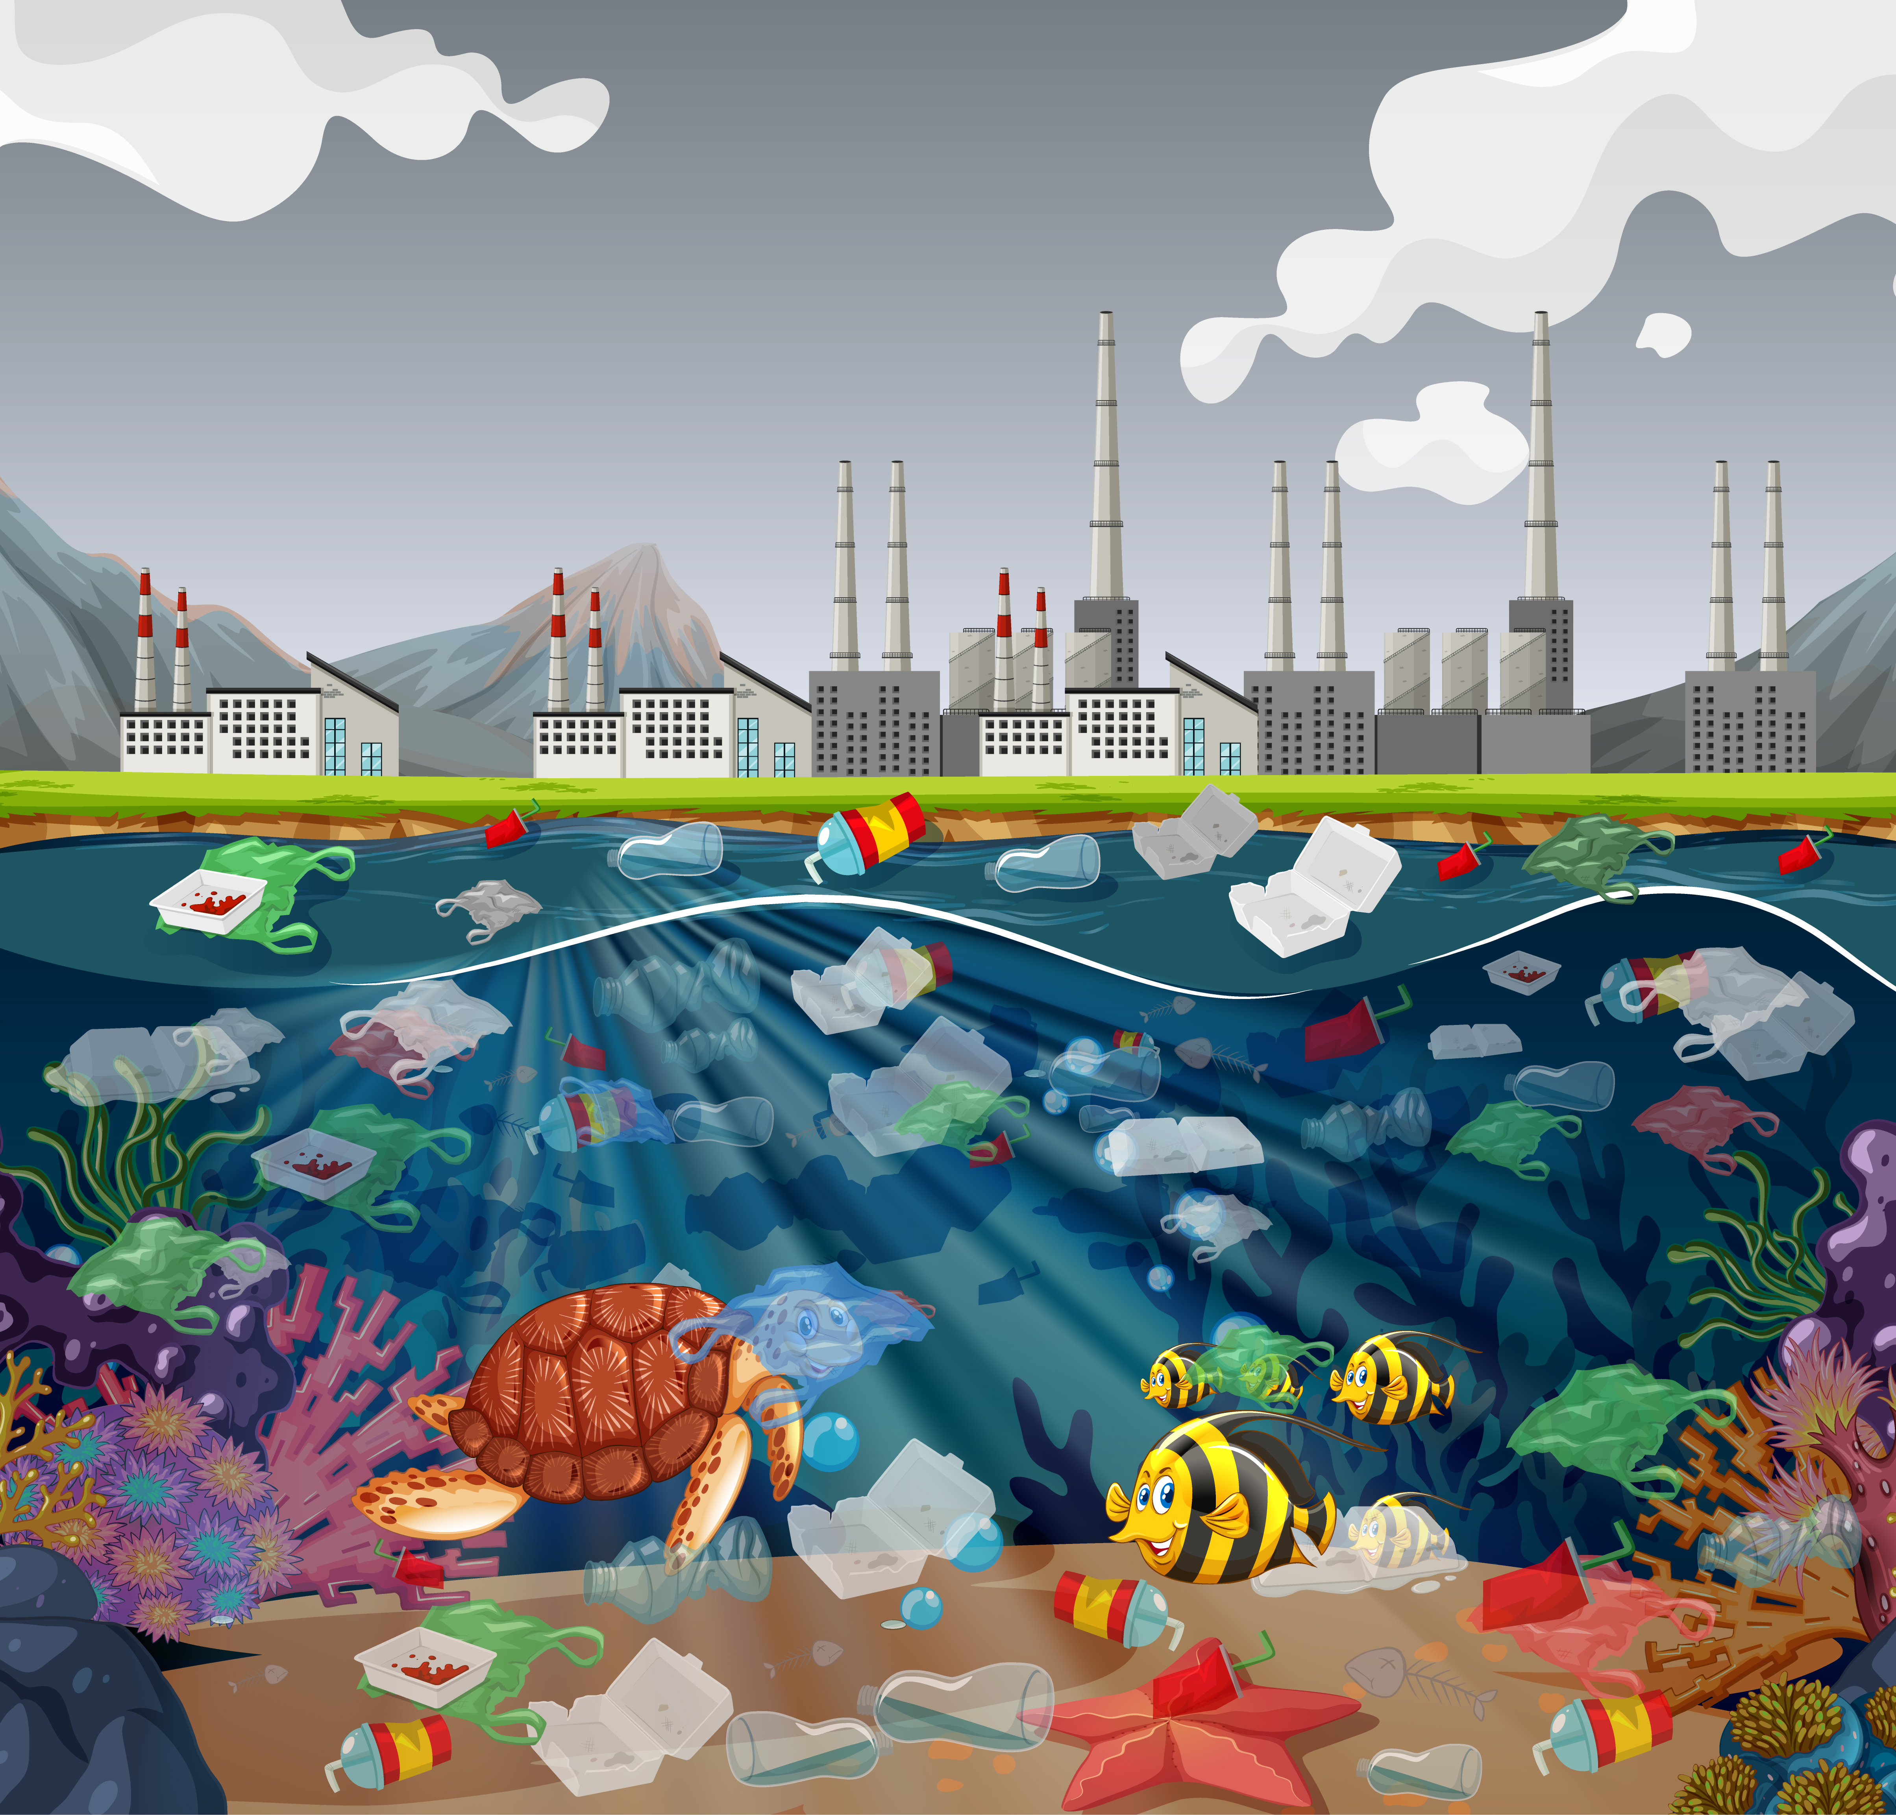

Plastic pollution originates from multiple sources, with single-use plastics, micro plastics, and plastic waste from industries and households being major contributors.

Single-use plastics:
These are disposable plastic items designed for one-time use before being discarded. Examples include plastic bags, food packaging, straws, bottles, and coffee cups. Due to their widespread use and improper disposal, single-use plastics have become a significant source of pollution, particularly in marine and coastal environments.

Microplastics:
Micro plastics are tiny plastic particles that measure less than 5mm in size. They can be either primary micro plastics, which are intentionally manufactured for specific purposes like microbeads in personal care products, or secondary micro plastics, which result from the breakdown of larger plastic items through weathering, degradation, and fragmentation. Micro plastics are found in various ecosystems, including oceans, rivers, soils, and even the air.

Plastic waste from industries:
Industries contribute to plastic pollution through manufacturing processes, packaging materials, and waste disposal. Plastic waste generated by industries, such as plastic pellets, packaging films, and discarded products, can enter ecosystems through improper waste management practices, leading to environmental contamination.

Plastic waste from households:
Household plastic waste is another significant source of pollution. It includes items such as plastic packaging, bottles, containers, and everyday items like utensils and toys. Inadequate recycling and improper disposal methods, such as littering or improper waste management, can result in these plastics entering ecosystems and causing environmental harm.

Understanding the various sources of plastic pollution is crucial for developing effective strategies to reduce plastic waste and mitigate its negative impacts on the environment. By addressing these sources through targeted interventions and promoting sustainable alternatives, we can work towards a cleaner and healthier planet.

Plastic pollution has profound ecological impacts on various ecosystems, including marine environments, terrestrial habitats, and freshwater systems. Here are some of the detrimental effects:

Marine environments:

- Entanglement and suffocation: Marine animals like seals, dolphins, sea turtles, and seabirds can become entangled in plastic debris, leading to injury, suffocation, or death.
- Ingestion and digestive issues: Marine organisms often mistake plastic items for food and ingest them. This can lead to blockages in their digestive systems, malnutrition, and starvation.
- Disruption of food chains: Plastic pollution can impact the entire marine food chain. Microplastics can be ingested by zooplankton, which are then consumed by small fish, ultimately affecting larger predators, including marine mammals and humans.
- Habitat degradation: Plastic debris can damage or destroy marine habitats such as coral reefs, seagrass beds, and mangroves, which are essential for biodiversity and coastal protection.

Terrestrial habitats:

- Soil contamination: Plastic waste that is improperly disposed of or littered can contaminate soils, affecting nutrient cycling and the health of plants and organisms.
- Wildlife hazards: Animals on land can also be harmed by plastic pollution. They can ingest or get entangled in plastic items, leading to injury, suffocation, or reduced mobility.
- Disruption of ecosystems: Plastic pollution in terrestrial habitats can disrupt the delicate balance of ecosystems, impacting populations of plants, insects, birds, and mammals.

Freshwater systems:

- Water pollution: Plastic waste in rivers, lakes, and other freshwater bodies can contaminate the water, affecting aquatic life and biodiversity.
- Blockage of waterways: Large plastic debris can obstruct waterways, causing flooding and altering natural flow patterns.
- Invasive species transportation: Floating plastic items can act as rafts, transporting invasive species to new areas and causing disruptions to native ecosystems.

Plastic pollution poses a significant threat to the health and functioning of ecosystems. It disrupts natural processes, contributes to species decline, and compromises the overall balance and resilience of these environments. Mitigating plastic pollution requires collective efforts, including reducing plastic consumption, improving waste management systems, promoting recycling, and adopting sustainable alternatives.

Plastic pollution has severe ecological impacts, including the disruption of food chains, habitat degradation, and the introduction of toxic chemicals into the environment. These impacts can have far-reaching consequences on ecosystem health and stability. Let's explore each of these effects in detail:

Disruption of food chains:

Plastic pollution can disrupt food chains in various ways:

Ingestion of plastics:
Marine organisms, such as fish, seabirds, and marine mammals, often mistake plastic debris for food. When they ingest plastic, it can lead to internal injuries, blockages, and even death. This disrupts the natural flow of energy and nutrients within the food chain.

Transfer of toxins:
Plastics can adsorb and accumulate harmful pollutants from the surrounding environment. When predators consume plastic-contaminated prey, they may be exposed to concentrated levels of toxins, leading to bioaccumulation and biomagnification throughout the food chain.

Habitat degradation:
Plastic pollution contributes to habitat degradation in various ecosystems:

Marine habitats: Coral reefs, seagrass beds, and mangroves, which are critical habitats for a wide range of species, can be damaged or destroyed by plastic debris. This leads to the loss of important breeding and feeding grounds, reducing biodiversity and ecosystem resilience.
Terrestrial habitats: Plastic waste can litter and degrade terrestrial habitats, including forests, grasslands, and wetlands. This can disrupt natural processes, such as nutrient cycling and seed dispersal, and negatively impact the diversity and abundance of plants and animals.

Introduction of toxic chemicals:
Plastics contain additives and can absorb and release toxic chemicals, posing risks to organisms and ecosystems:

Chemical leaching: Plastics can release harmful chemicals such as phthalates, bisphenol A (BPA), and persistent organic pollutants (POPs) into the environment. These chemicals can leach into soils, water bodies, and sediments, affecting the health of plants, animals, and microorganisms.

Bioaccumulation and biomagnification: Toxic chemicals present in plastics can accumulate in the tissues of organisms over time. As predators consume contaminated prey, these chemicals can biomagnify, reaching higher concentrations in top predators, posing risks to their health and reproductive success.
These ecological impacts highlight the urgent need to address plastic pollution through sustainable practices, improved waste management, and the development of alternatives to single-use plastics. By mitigating these impacts, we can protect the integrity of food chains, preserve habitats, and prevent the introduction of toxic chemicals into ecosystems, ultimately safeguarding the health and well-being of both wildlife and humans.

Plastic pollution poses significant risks to biodiversity, leading to the loss of species and disruptions in ecological balance. The impacts of plastic pollution on biodiversity include:

Species decline and extinction: Plastic pollution directly threatens various species, particularly those inhabiting marine and coastal environments. Marine animals such as sea turtles, seabirds, marine mammals, and fish can become entangled in plastic debris or mistake it for food, leading to injury, suffocation, reduced reproductive success, and ultimately population decline. The loss of these species can disrupt entire ecosystems and contribute to reduced biodiversity.

Habitat destruction: Plastic pollution can cause habitat degradation and destruction, affecting the survival and abundance of numerous species. Marine habitats like coral reefs, seagrass meadows, and mangroves are particularly vulnerable to plastic debris, which can smother and damage these critical ecosystems. Terrestrial habitats, such as forests and grasslands, can also be impacted when plastic waste contaminates the soil or obstructs natural processes like seed dispersal.

Disruption of ecological interactions: Plastic pollution can disrupt key ecological interactions, including pollination, seed dispersal, and predator-prey relationships. For example, insects may mistake plastic fragments for flowers or prey, affecting pollination and disrupting food chains. Additionally, plastic debris can entangle or suffocate organisms that play crucial roles in maintaining ecosystem balance, such as pollinators or soil decomposers.

Genetic and physiological effects: Some studies suggest that exposure to plastic pollution, particularly microplastics, can have genetic and physiological impacts on organisms. These effects may include changes in gene expression, altered reproductive patterns, and compromised immune systems. Such disruptions can have cascading effects on population dynamics and biodiversity.

Ecosystem resilience and functioning: Plastic pollution can reduce the resilience and functioning of ecosystems. When key species are lost or populations decline, it can disrupt the natural balance and functioning of ecosystems. This can lead to cascading effects on other species, nutrient cycling, and overall ecosystem health.

The preservation of biodiversity is essential for maintaining ecosystem stability, resilience, and the provision of vital ecosystem services. Addressing plastic pollution through measures such as reducing plastic consumption, improving waste management, and promoting sustainable alternatives is crucial for mitigating the risks posed to biodiversity. By protecting biodiversity, we safeguard the interconnectedness of ecosystems and ensure the long-term survival of countless species and the health of our planet.

Plastic waste has detrimental effects on a wide range of organisms, including marine animals, birds, and terrestrial wildlife. Here's a closer look at how plastic pollution affects these groups:

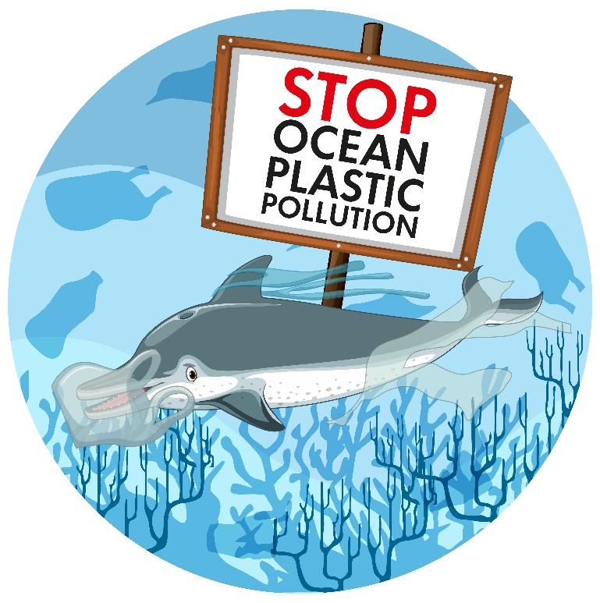

Marine animals:

Sea turtles: Plastic bags resemble jellyfish, a common food source for sea turtles. Ingesting plastic bags can cause blockages in their digestive systems, leading to starvation and death. Entanglement in plastic debris can also cause injuries and limit their mobility.
Seabirds: Birds often mistake small plastic fragments for food and feed them to their chicks, leading to malnutrition, digestive issues, and reduced reproductive success. Entanglement in fishing lines or other plastic items can cause injuries or restrict their ability to forage.
Marine mammals: Dolphins, seals, and whales may become entangled in discarded fishing gear or other plastic debris, resulting in severe injuries, suffocation, or drowning. Ingestion of plastic can lead to digestive blockages, malnutrition, and impaired health.

Birds:

Waterbirds: Many waterbirds feed on small organisms at the water's surface and mistake floating plastic for food. Ingesting plastic can cause blockages, organ damage, and ultimately, death.
Land birds: Birds that scavenge for food in human-populated areas can ingest plastic fragments or packaging materials, leading to internal injuries or toxic effects from ingested chemicals. Nesting birds may also incorporate plastic debris into their nests, which can harm their offspring or cause entanglement.

Terrestrial wildlife:

Mammals: Land mammals may encounter plastic waste in their habitats, leading to entanglement, ingestion, or injuries. Small mammals and rodents can become trapped in discarded plastic containers or packaging.
Insects and invertebrates: Insects and invertebrates, such as bees, butterflies, and earthworms, can be affected by plastic pollution. Plastic debris can disrupt pollination and hinder their movements, affecting ecosystem functions and biodiversity.
Large herbivores: Animals like deer, elk, or cattle can accidentally ingest plastic fragments while foraging, potentially causing internal injuries or blockages.
The ingestion and entanglement of plastic waste can cause physical harm, impair reproduction, and lead to population declines among various species. Plastic pollution also introduces toxic chemicals into ecosystems, further compromising the health and survival of organisms. The widespread impact of plastic waste on marine animals, birds, and terrestrial wildlife underscores the urgent need for effective waste management, recycling, and the reduction of single-use plastics to protect these vulnerable species and maintain biodiversity.

Plastic pollution has the potential to drive species to extinction and disrupt ecological balances, posing significant risks to biodiversity. Here are the key points emphasizing these dangers:

Species extinction:

Endangered species: Plastic pollution exacerbates the threats faced by already endangered species. The additional stress caused by entanglement, ingestion of plastic, or habitat degradation can push these species closer to extinction.
Vulnerable ecosystems: Plastic pollution negatively impacts sensitive ecosystems such as coral reefs, mangroves, and rainforests. The loss of key species within these ecosystems can lead to a cascading effect, potentially resulting in the collapse of entire ecosystems and the extinction of numerous species dependent on them.
Disproportionate impacts: Certain species are particularly vulnerable to plastic pollution. For example, marine turtles mistake plastic bags for jellyfish, a crucial food source, leading to high mortality rates. The extinction of these keystone species can have far-reaching consequences for ecosystem functioning.

Ecological imbalances:

Disrupted food chains: Plastic pollution disrupts the natural flow of energy and nutrients within ecosystems. When species decline due to entanglement or ingestion of plastic waste, it can disrupt predator-prey relationships and alter the structure of food chains. This can lead to imbalances and potential collapse of entire ecological networks.
Altered community dynamics: Plastic pollution can favor certain species that are more tolerant of or attracted to plastic debris, leading to shifts in community dynamics. These changes can have cascading effects on other species, disrupting the balance of populations and altering ecological interactions.
Decline of ecosystem services: Biodiversity loss resulting from plastic pollution can impair the delivery of essential ecosystem services. Services such as pollination, nutrient cycling, water filtration, and climate regulation can be compromised, impacting human well-being and the functioning of ecosystems.
The potential for species extinction and ecological imbalances emphasizes the urgency to address plastic pollution. Implementing effective measures, including reducing plastic consumption, improving waste management practices, and promoting sustainable alternatives, is crucial for mitigating these risks. By preserving biodiversity and maintaining ecological balances, we can safeguard the stability and resilience of ecosystems and ensure a sustainable future for both wildlife and humans.

Plastic pollution poses specific dangers to marine life, including entanglement, ingestion, and the spread of diseases. The impact on key marine species and ecosystems, such as coral reefs, sea turtles, marine mammals, and seabirds, is particularly concerning. Let's explore these impacts in more detail:

Entanglement:

Marine mammals: Discarded fishing nets, lines, and other plastic debris can entangle marine mammals like seals, sea lions, and whales. This can lead to injuries, amputations, or suffocation, impairing their ability to swim, hunt, and reproduce.
Sea turtles: Plastic bags, fishing lines, and six-pack rings pose a significant entanglement risk for sea turtles. Entangled turtles may suffer from injuries, infections, or restricted movement, hindering their foraging and swimming capabilities.
Seabirds: Birds, such as albatrosses and seagulls, can become entangled in fishing lines or plastic debris, preventing their flight or causing injuries. This can disrupt their feeding and breeding behaviors, leading to reduced reproductive success.
Ingestion:

Sea turtles: Sea turtles often mistake plastic bags, balloons, and other floating debris for jellyfish, their natural prey. Ingesting plastic can cause internal injuries, blockages in the digestive system, malnutrition, and even death.
Seabirds: Birds may ingest small plastic fragments, mistaking them for food items. The ingested plastic can fill their stomachs, leading to malnutrition, reduced energy levels, and compromised overall health.
Marine mammals: Dolphins, whales, and seals can accidentally consume plastic while feeding on fish or squid. Ingested plastic can cause internal injuries, blockages, digestive disorders, and nutritional deficiencies.
Spread of diseases:

Coral reefs: Plastic pollution can introduce and facilitate the spread of diseases in coral reefs. Plastic debris can provide surfaces for pathogens and harmful bacteria to attach and multiply, leading to coral diseases and subsequent reef degradation.
Marine mammals: Plastic pollution can serve as a vector for the transport of pathogens and contaminants. Marine mammals coming into contact with plastic debris may suffer from increased vulnerability to infections and diseases, impacting their overall health and survival.
The impact of plastic pollution on these marine species and ecosystems is profound. Coral reefs, sea turtles, marine mammals, and seabirds play critical roles in maintaining ecosystem balance and biodiversity. Mitigating plastic pollution through effective waste management, reducing single-use plastics, and promoting sustainable practices is essential for protecting these species and preserving the health of marine ecosystems. By taking action, we can ensure the long-term survival of marine life and safeguard the integrity of our oceans.

Plastic pollution poses significant health risks to humans, primarily through the ingestion of microplastics and the release of harmful chemicals from plastic products. The long-term consequences for human health include potential endocrine disruption and carcinogenic effects. Let's delve into these implications in more detail:

Ingestion of microplastics:

Food chain contamination: Microplastics, tiny particles of plastic, have been found in various marine and freshwater organisms, including fish, shellfish, and even drinking water. When humans consume these contaminated organisms, they can inadvertently ingest microplastics.
Health concerns: While the full extent of health risks from ingested microplastics is still being studied, there are concerns about potential adverse effects. Microplastics can accumulate in the gastrointestinal tract, potentially leading to inflammation, organ damage, and impaired nutrient absorption. Moreover, the presence of microplastics in food raises concerns about their potential to transport toxic chemicals into the human body.
Release of harmful chemicals:

Plastic additives: Many plastic products contain additives such as phthalates, bisphenol A (BPA), and flame retardants. These additives can leach out of plastic items and enter the environment. When humans come into contact with or consume these contaminated products, they can be exposed to these harmful chemicals.
Endocrine disruption: Certain plastic additives, such as phthalates and BPA, are known endocrine disruptors. They can interfere with hormonal systems in the body, potentially leading to reproductive problems, developmental issues in children, and hormonal imbalances.
Carcinogenic effects: Some plastic additives and breakdown products have been identified as potentially carcinogenic. Prolonged exposure to these substances through plastic pollution may increase the risk of cancer and other chronic diseases.
Other health concerns:

Respiratory issues: Burning plastic waste or living near incineration facilities can release toxic fumes and particulate matter into the air, which can contribute to respiratory problems and other respiratory illnesses.
Allergic reactions: Certain individuals may develop allergic reactions when exposed to plastic materials, such as latex or certain types of plastic packaging.
The long-term consequences of plastic pollution on human health are still being studied, and the full extent of the risks remains uncertain. However, there is growing evidence suggesting potential harm. Minimizing plastic waste, adopting sustainable alternatives, and advocating for stricter regulations can help mitigate these health risks and protect human well-being. It is essential to address plastic pollution as part of a comprehensive approach to safeguarding both the environment and human health.

Plastic pollution is a global issue that transcends national borders and affects ecosystems on a global scale. The interconnectedness of ecosystems highlights the need for international cooperation to effectively address this problem. Here are the key points to consider:

Transboundary movement of plastic waste:

Global distribution: Plastic waste generated in one country can easily travel through waterways, rivers, and ocean currents, crossing national boundaries. It can be carried over long distances, reaching remote areas and impacting ecosystems far from the original source.
Ocean currents: Plastic debris can be transported by ocean currents, resulting in the accumulation of waste in specific regions, such as the Great Pacific Garbage Patch. This movement further emphasizes the global nature of the problem and the shared responsibility to address it.
Ecological interconnectedness:

Ecosystem connectivity: Ecosystems are interconnected, and disruptions in one area can have cascading effects on distant ecosystems. Plastic pollution affects marine environments, which are intricately linked to terrestrial and freshwater ecosystems through migratory species, nutrient flows, and climate regulation.
Biodiversity and ecosystem services: Biodiversity loss and degradation of ecosystems due to plastic pollution can compromise the provision of essential ecosystem services on a global scale. This includes fisheries, carbon sequestration, water filtration, and tourism, impacting economies and livelihoods worldwide.
International cooperation and collaboration:

Shared responsibility: Plastic pollution requires collective action and cooperation among nations, as no single country can address the problem in isolation. Collaborative efforts are needed to reduce plastic production, improve waste management systems, and promote sustainable practices globally.
Policy and regulation: International agreements and frameworks, such as the Basel Convention, aim to regulate the transboundary movement of hazardous wastes, including plastic waste. Strengthening and enforcing these agreements, along with developing new ones, is essential to tackle plastic pollution effectively.
Knowledge sharing and research: Collaboration in scientific research, data sharing, and technology development can enhance our understanding of the impacts of plastic pollution and facilitate the development of innovative solutions.
Addressing plastic pollution requires a comprehensive and coordinated approach that involves governments, industries, communities, and individuals worldwide. By recognizing the global implications of plastic pollution and fostering international cooperation, we can work towards effective solutions, reduce plastic waste generation, and protect ecosystems and biodiversity for current and future generations.

Environmental justice is a crucial aspect of addressing plastic pollution, as marginalized communities and developing nations often bear a disproportionate burden of its impacts. Understanding the social and economic implications of plastic pollution is vital, as is recognizing the need for equitable solutions.

Disproportionate impact on marginalized communities and developing nations:

Waste disposal sites: Marginalized communities are more likely to be located near waste disposal sites, including landfills and incinerators, where plastic waste accumulates. This proximity exposes them to the associated health risks, such as air and water pollution, respiratory illnesses, and other adverse health effects.
Lack of waste management infrastructure: Developing nations may have inadequate waste management systems, leading to uncontrolled plastic waste disposal. This further exacerbates the environmental and health impacts on local communities.
Limited resources and capacity: Marginalized communities and developing nations often have limited resources, technology, and capacity to manage and mitigate plastic pollution effectively.
Social and economic implications:

Livelihoods and income disparities: Plastic pollution can affect local economies and livelihoods, particularly in areas reliant on fishing, tourism, or agriculture. Contaminated ecosystems, reduced fish stocks, and negative perceptions of plastic pollution can lead to economic losses and exacerbate income disparities.
Health disparities: Marginalized communities, already facing socioeconomic challenges, may experience a higher burden of plastic pollution-related health issues due to limited access to healthcare and environmental resources.
Cultural and social impacts: Plastic pollution can impact cultural practices, traditional knowledge, and community cohesion, as well as cause aesthetic degradation of natural environments.
Importance of equitable solutions:

Inclusive decision-making: Efforts to address plastic pollution should involve the active participation of affected communities, marginalized groups, and developing nations. Their voices and perspectives are essential for developing inclusive policies and solutions that consider their unique challenges and aspirations.
Resource allocation and support: Equitable solutions require allocating resources and providing support to marginalized communities and developing nations to improve waste management infrastructure, promote sustainable practices, and develop alternative packaging materials.
Education and awareness: Building awareness and promoting education about plastic pollution, waste reduction, and recycling within marginalized communities can empower individuals to make informed choices and contribute to the solution.
Collaboration and partnerships: Collaboration between governments, non-governmental organizations, businesses, and communities is crucial to sharing knowledge, resources, and expertise to implement effective and equitable solutions.
Addressing plastic pollution with an environmental justice lens ensures that solutions prioritize the needs and well-being of marginalized communities and developing nations. By striving for equity and inclusivity, we can work towards a more sustainable and just future, where the impacts of plastic pollution are minimized, and the benefits are shared equitably by all.

To tackle plastic pollution effectively, a range of solutions and mitigation strategies need to be implemented. These include:

Reducing plastic consumption:

Single-use plastic reduction: Encouraging individuals, businesses, and governments to reduce the use of single-use plastics such as plastic bags, straws, cutlery, and beverage bottles.
Plastic-free alternatives: Promoting the use of reusable and sustainable alternatives like cloth bags, stainless steel water bottles, and biodegradable or compostable packaging materials.

Promoting recycling and waste management:

Improved recycling infrastructure: Investing in recycling facilities and infrastructure to enhance collection, sorting, and recycling capabilities.
Public awareness and education: Educating communities about the importance of recycling and providing clear guidelines for proper waste sorting and disposal.
Extended producer responsibility (EPR): Implementing EPR policies to hold manufacturers responsible for the end-of-life management of their plastic products, incentivizing them to design products with recyclability in mind.

Plastic waste policies and regulations:

Bans and restrictions: Implementing bans or restrictions on certain types of single-use plastics or high-risk plastic products to reduce their production and use.
Deposit return systems: Introducing deposit schemes for plastic bottles and containers, encouraging consumers to return them for recycling and promoting a circular economy approach.
International agreements: Strengthening international agreements and frameworks to regulate the transboundary movement of plastic waste and promote global cooperation.

Promoting sustainable alternatives:

Biodegradable and compostable materials: Supporting the development and use of biodegradable or compostable materials as alternatives to conventional plastics.
Innovative packaging solutions: Encouraging the adoption of innovative packaging designs and materials that are eco-friendly, reusable, and recyclable.
Research and development: Investing in research and development to explore and advance sustainable alternatives to plastic, such as plant-based polymers and bioplastics.

Community engagement and participation:

Citizen-led initiatives: Encouraging community-led initiatives, grassroots movements, and beach or river clean-up campaigns to raise awareness and actively participate in combating plastic pollution.
Collaboration with businesses: Partnering with businesses to develop and implement sustainable practices, reduce plastic packaging, and explore innovative solutions.
plastic pollution requires a multi-faceted approach that combines individual actions, government policies, industry cooperation, and international collaboration. By implementing these solutions and mitigation strategies, we can reduce plastic waste, protect ecosystems and biodiversity, and ensure a cleaner and more sustainable future for generations to come.

Individual and collective actions play a crucial role in combating plastic pollution. By taking personal responsibility and supporting initiatives aimed at reducing plastic waste, individuals can make a significant impact. Here's how readers can contribute to the cause:

Reduce plastic consumption:

Use reusable alternatives: Carry a reusable water bottle, coffee cup, and shopping bags to avoid single-use plastics.
Say no to straws: Refuse plastic straws when dining out or opt for reusable or biodegradable alternatives.
Choose plastic-free options: Purchase products with minimal packaging or choose items packaged in eco-friendly materials.
Avoid plastic utensils: Carry your own cutlery or choose biodegradable or compostable utensils when necessary.

Practice proper waste management:

Recycle responsibly: Learn about local recycling guidelines and ensure proper sorting of recyclable materials.
Reduce, reuse, and repair: Prioritize reducing waste by reusing items and repairing instead of replacing them whenever possible.
Compost organic waste: Composting food scraps and organic materials reduces the amount of waste sent to landfills.

Support initiatives and organizations:

Donate to environmental organizations: Contribute to organizations working towards plastic pollution prevention and promoting sustainable practices.
Volunteer in clean-up efforts: Participate in local beach clean-ups, river cleaning drives, or community-led initiatives to remove plastic waste from the environment.
Support eco-friendly businesses: Choose to support businesses that prioritize sustainable practices, use minimal packaging, and offer plastic-free alternatives.

Advocate for policy changes:

Stay informed: Educate yourself about plastic pollution and its impacts. Stay updated on local and national policies related to plastic waste management.
Engage with policymakers: Write to elected officials, sign petitions, or attend public meetings to voice your concerns and advocate for stronger regulations and policies addressing plastic pollution.
Support plastic-free initiatives: Encourage local businesses and institutions to adopt plastic-free practices and advocate for plastic bag bans or restrictions in your community.

Spread awareness and educate others:

Share knowledge: Inform friends, family, and colleagues about the detrimental effects of plastic pollution and the importance of reducing plastic waste.
Engage on social media: Use social media platforms to raise awareness, share informative content, and promote eco-friendly alternatives.
Educate children and students: Teach younger generations about the importance of responsible plastic use and environmental conservation.
Remember, collective action is key to creating lasting change. By taking personal responsibility and inspiring others to join the movement, individuals can contribute to a world with less plastic pollution. Together, we can advocate for policy changes, support organizations dedicated to plastic pollution prevention, and foster a global shift towards sustainable practices.

Future perspectives on addressing plastic pollution encompass ongoing research, innovative technologies, policy developments, the potential for a circular economy, and the role of education and awareness. Here's an overview:

Ongoing research:

Microplastic detection and impact assessment: Continued research is essential to better understand the sources, pathways, and ecological impacts of microplastics in various ecosystems.
Environmental fate and transport: Research on the behavior and fate of plastic waste in different environments, including oceans, rivers, and soils, helps inform mitigation strategies and identify effective clean-up methods.
Health effects: Investigating the long-term health effects of plastic pollution, including the impact of microplastic ingestion on human health, contributes to a better understanding of the risks and informs regulatory measures.

Innovative technologies:

Plastic waste management and recycling: Advancements in waste management technologies, such as improved recycling techniques, mechanical and chemical recycling, and innovative sorting methods, can help increase plastic recycling rates and reduce waste.
Alternative materials: Research and development of sustainable and biodegradable materials as alternatives to conventional plastics offer promising solutions for reducing plastic pollution.
Ocean cleanup technologies: Continued development of innovative technologies for the removal of plastic waste from oceans, such as floating barriers, autonomous robots, and passive collection systems, can help mitigate the accumulation of plastic debris.

Policy developments:

Plastic bans and restrictions: Many countries and municipalities are implementing bans or restrictions on single-use plastics and high-risk plastic products, aiming to reduce plastic waste generation at the source.
Extended producer responsibility (EPR): Strengthening EPR policies encourages manufacturers to take responsibility for the entire lifecycle of their products, including proper disposal and recycling.
International cooperation: Governments and organizations are collaborating to establish global frameworks and agreements, such as the Plastic Pollution Protocol under the Basel Convention, to regulate the movement and management of plastic waste internationally.

Circular economy approach:

Transition to a circular economy: Moving away from a linear "take-make-dispose" model to a circular economy aims to minimize waste generation, promote recycling and reuse, and design products for durability and easy recyclability.
Plastic waste as a resource: Viewing plastic waste as a valuable resource that can be repurposed, recycled, or converted into energy encourages innovative solutions and reduces reliance on virgin plastics.

Education and awareness:

Environmental education: Integrating environmental education into school curricula and community programs fosters awareness and understanding of plastic pollution, sustainable practices, and the importance of conservation.
Consumer awareness campaigns: Public awareness initiatives, including media campaigns, online platforms, and social media engagement, play a crucial role in informing individuals about the impacts of plastic pollution and empowering them to make sustainable choices.
Behavioral change: Education and awareness campaigns encourage individuals to adopt eco-friendly habits, reduce plastic consumption, and participate in community initiatives.
By combining ongoing research, innovative technologies, policy advancements, a circular economy approach, and education and awareness efforts, we can pave the way for a future with reduced plastic pollution. Embracing sustainable practices, promoting technological advancements, and fostering global collaboration will be instrumental in bringing about long-term change and ensuring a cleaner and healthier environment for future generations.

Plastic pollution poses significant threats to ecosystems, biodiversity, human health, and global sustainability. From the sources and types of plastic pollution to its ecological impacts, biodiversity loss, and effects on marine life and human health, the dangers are evident. However, there is hope for a better future through collective action and comprehensive solutions. By reducing plastic consumption, promoting recycling and waste management, implementing policies and regulations, and supporting sustainable alternatives, we can mitigate plastic pollution's adverse effects. The importance of individual and collective actions cannot be overstated. Encouraging readers to adopt eco-friendly habits, support initiatives, advocate for policy changes, and spread awareness empowers them to make a positive impact. Future perspectives hold promise with ongoing research, innovative technologies, and policy developments. Advancements in waste management, alternative materials, and ocean cleanup technologies contribute to tackling plastic pollution. Transitioning to a circular economy and emphasizing education and awareness are key drivers for long-term change. However, addressing plastic pollution requires a global approach. Recognizing the interconnectedness of ecosystems and the disproportionate impact on marginalized communities and developing nations, environmental justice must be prioritized. Equitable solutions, inclusive decision-making, resource allocation, and collaboration are crucial in ensuring a just and sustainable future for all.

In conclusion, by understanding the dangers of plastic pollution and embracing solutions, we can work together to reduce plastic waste, protect ecosystems and biodiversity, safeguard human health, and create a cleaner and more sustainable planet. The journey towards a plastic-free future requires collective responsibility, innovation, policy changes, education, and the commitment of individuals, communities, businesses, and governments worldwide. Together, we can make a significant and lasting difference in combatting plastic pollution and preserving the beauty and integrity of our planet for generations to come.
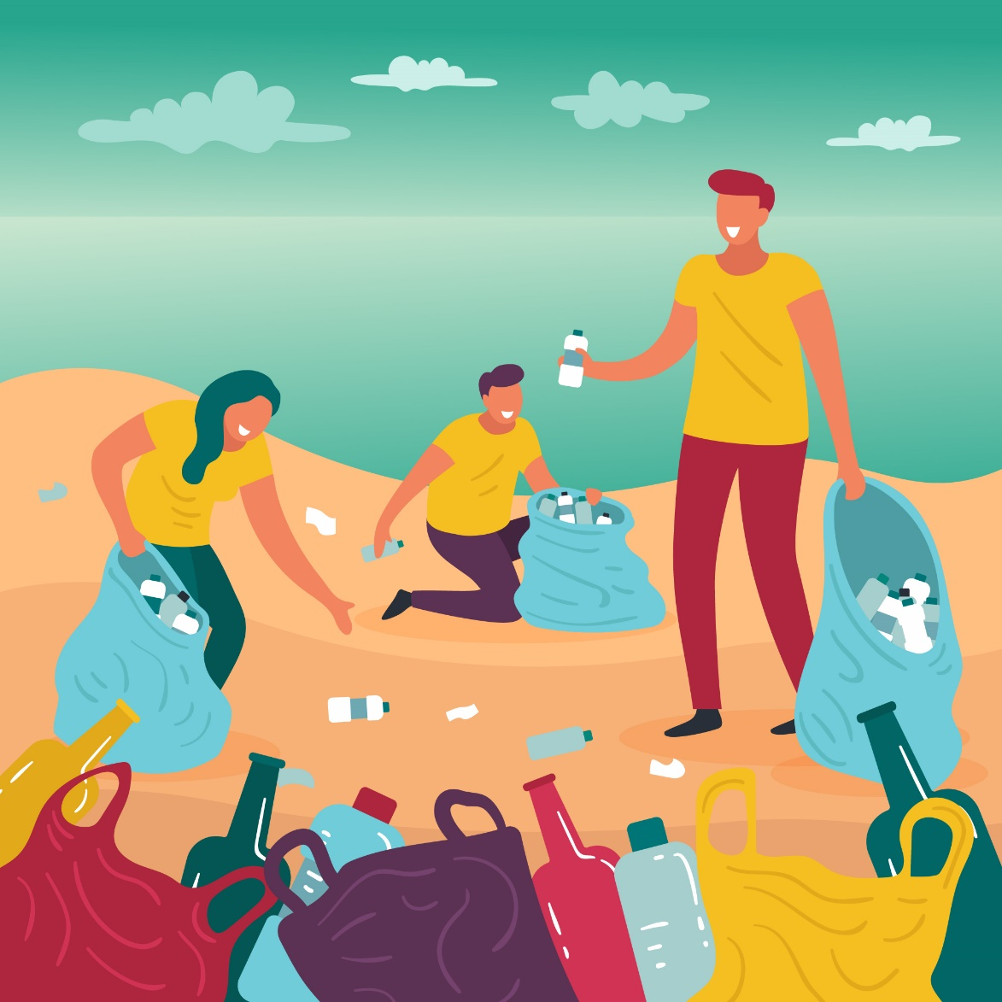

REFRENCES:

- Andrady, A. L. (2017). Microplastics in the marine environment. Marine Pollution Bulletin, 119(1), 12-22.
- Cózar, A., Echevarría, F., González-Gordillo, J. I., Irigoien, X., Úbeda, B., Hernández-León, S., ... & Duarte, C. M. (2014). Plastic debris in the open ocean. Proceedings of the National Academy of Sciences, 111(28), 10239-10244.
- Wright, S. L., Thompson, R. C., & Galloway, T. S. (2013). The physical impacts of microplastics on marine organisms: a review. Environmental Pollution, 178, 483-492.
- Rochman, C. M., Browne, M. A., Halpern, B. S., Hentschel, B. T., Hoh, E., Karapanagioti, H. K., ... & Thompson, R. C. (2013). Policy: Classify plastic waste as hazardous. Nature, 494(7436), 169-171.
- Law, K. L. (2017). Plastics in the marine environment. Annual Review of Marine Science, 9, 205-229.
- Geyer, R., Jambeck, J. R., & Law, K. L. (2017). Production, use, and fate of all plastics ever made. Science Advances, 3(7), e1700782.
- Horton, A. A., Walton, A., Spurgeon, D. J., Lahive, E., & Svendsen, C. (2017). Microplastics in freshwater and terrestrial environments: Evaluating the current understanding to identify the knowledge gaps and future research priorities. Science of The Total Environment, 586, 127-141.
- Hidalgo-Ruz, V., Gutow, L., & Thompson, R. C. (2012). Microplastics in the marine environment: a review of the methods used for identification and quantification. Environmental Science & Technology, 46(6), 3060-3075.
- von Moos, N., Burkhardt-Holm, P., & Köhler, A. (2012). Uptake and effects of microplastics on cells and tissue of the blue mussel Mytilus edulis L. after an experimental exposure. Environmental Science & Technology, 46(20), 11327-11335.
- Bergmann, M., Gutow, L., & Klages, M. (2015). Marine anthropogenic litter. Springer.
- Andrady, A. L. (2017). The plastic in microplastics: A review. Marine Pollution Bulletin, 119(1), 12-22.
- Eriksen, M., Lebreton, L. C., Carson, H. S., Thiel, M., Moore, C. J., Borerro, J. C., ... & Reisser, J. (2014). Plastic pollution in the world's oceans: More than 5 trillion plastic pieces weighing over 250,000 tons afloat at sea. PloS One, 9(12), e111913.
- Rochman, C. M. (2015). The complex mixture, fate and toxicity of chemicals associated with plastic debris in the marine environment. In Marine Anthropogenic Litter (pp. 117-140). Springer.
- Wright, S. L., & Kelly, F. J. (2017). Plastic and human health: A micro issue? Environmental Science & Technology, 51(12), 6634-6647.
- Gall, S. C., & Thompson, R. C. (2015). The impact of debris on marine life. Marine Pollution Bulletin, 92(1-2), 170-179.
- Geyer, R., Jambeck, J. R., & Law, K. L. (2018). Production, use, and fate of all plastics ever made. Science Advances, 4(7), eaat0131.
- Derraik, J. G. (2002). The pollution of the marine environment by plastic debris: a review. Marine Pollution Bulletin, 44(9), 842-852.
- Dauvergne, P. (2018). The politics of the plastic pollution crisis. Global Environmental Politics, 18(3), 1-11.
- Lusher, A. L., Hollman, P. C., & Mendoza-Hill, J. J. (2017). Microplastics in fisheries and aquaculture: status of knowledge on their occurrence and implications for aquatic organisms and food safety. FAO Fisheries and Aquaculture Technical Paper, 615.
- Wright, S. L., & Kelly, F. J. (2017). Plastic and human health: A micro issue? Environmental Science & Technology, 51(12), 6634-6647.

