IOT BASED PATIENT MONITORING SYSTEM

Dr Radhika Rani
Assistant Professor & HOD
Computer Science & Internet of Things Department
Loyola Academy, Secunderabad
radhikarani79@gmail.com
Sk Abdul Khadar
Assistant Professor
Computer Science & Internet of Things Department
Loyola Academy, Secunderabad
abdulkhadar.shaik08@gmail.com

Abstract

Employing the internet of things to monitor the patient's numerous metrics. Real-time patient health parameters are delivered to the cloud via Internet connectivity in a patient monitoring system built on the Internet of Things. The user can access these parameters from anywhere in the world by sending them to a remote Internet location. Between an IOT-based patient monitoring system and an SMS-based patient monitoring system, there are significant differences. Many individuals can view patient health information in an IOT-based system. This is necessary because the data must be checked by going to a website or URL. One of the most recent electronic project ideas with a medical application is this one. Another advantage of employing IOT is that this data may be viewed on a tablet, laptop, Android smartphone, desktop computer, and more. To view this data, all a person needs is a functional Internet connection. To view this data online, one can use a variety of cloud service providers.

Keywords – Internet of Things, Patient Monitoring, Data, Health

- INTRODUCTION

The Internet of Things (IOT) is a network of different physical quantities, including electronics. The ability to gather data from the environment around us and share it via the internet is shared by software and sensors that are embedded together. In many industries, including smart cities, the environment, health care, and others, the internet of things is useful. In our system, we are dealing with a health care system that offers a growing collection of modules that can make it easier for a doctor to diagnose a patient via telemonitoring. We Used A Set Of Medical Sensors To Gather Data From The Patient. These Sensors Gather Data And Relate This Data To Raspberry Pi For The Diagnosis Of Patient Anywhere In The World Using Internet.
For easy access, we can save data on the cloud of medical history. The architecture is intended for monitoring patients both in hospitals and privately at home. The System May Be Appropriate for a Village Health Centre As a result of technological advancement and an industry transformation, the Internet of Things (IoT) has gained significant attention. 4.0. IoT applications have been widely used in every area, including security systems, business, agriculture, and health. Several studies have been conducted to construct an IoT-based smart house, such as a home security system. An earlier study recommended using an Arduino Uno, an ESP wifi module, and a reed sensor, but it only used the sensor when it was positioned in front of the door as a security system and users in smartphone after the door opened.
There is still a greater chance of criminalization under this approach. Another study made use of an Internet of Things (IoT)-based smart security and home automation system with a PIR sensor located at the building's entry. If there is human movement, the sensor will trigger a microcontroller input, and the owner will be notified by voice calls. These systems are capable of taking immediate action for the owner, turning on the light and alarm as a warning system when the owner presses the previously programmed keypad button.
The Blynk Framework-based IoT-based smart home system consists of three distinct, isolated sub-systems, including temperature, GPS, and relay module systems. It also includes PIR and ultrasonic sensors to measure the water level in the connected tank using Nodemcu via Wi-Fi.
As opposed to this, ethernet-based smart home designs may safeguard houses and keep an eye on variables like temperature, humidity, gas leaks, and fire utilising sensors that are combined with the Arduino Mega microcontroller and Ethernet shield. A message notification system was put up to alert the owner if there is any strange or out-of-the-ordinary action. Ethernet systems, however, are limited to local networks. While combining the AT89C52 microprocessor, RFID, and MMS technologies in an integrated manner to develop an embedded wireless monitoring and access control system.
Anyone with access must present a legitimate RFID tag. If the phone number is located, the microcontroller sends an interrupt signal to the microcontroller in the MMS section, which then sends AT commands to the Quested M33 cellular device to take pictures of individuals and send them through MMS via the GSM network. The owner then responds, granting or denying access. In order to make judgements, owners can also ask the website for further photographs. The stepper motor is moved by the microcontroller using AT-command to read messages from cellular and open the gate or activate the alarm.
Design and installation of GSM-based security systems for smart homes that employ web cameras to detect motion and email users when it happens. When sensing fires or rising temperatures, GSM-based systems can send SMS, although the amount of time it takes to send an SMS depends on the specified cellular network coverage. Within 25 to 30 seconds, the SMS will be sent if the phone is connected to coverage networking.
Using a variety of sensors and layered security systems, the current study set out to establish integrated home safety and monitoring systems based on earlier research. So, it is possible to identify intruders early, detect rain, monitor temperature and humidity, and receive alerts on a smart phone every few minutes when the stove is on. Additionally, users can control the output remotely.

- BLOCK DIAGRAM
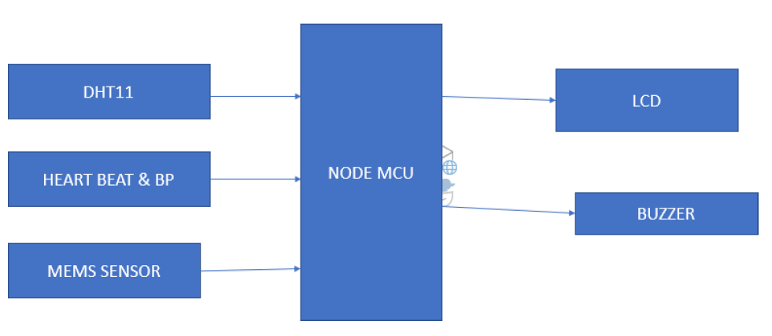
Figure 1: Block Diagram

- EMBEDDED IOT SYSTEMS

A computer system that performs a specific, targeted task is referred to as an embedded system. Examples of embedded systems include the air conditioner, VCD player, DVD player, printer, fax machine, mobile phone, and others. Each of these appliances will include a processor, specialized hardware, embedded software, and hardware that is run by the processor to satisfy the application's specific requirements. The term "firm ware" also refers to the embedded software. The desktop or laptop computer is a multifunctional device. It can be used for a wide range of tasks, including word processing, accountancy, software creation, and playing games. In contrast, the embedded systems' software is constantly fixed.
Embedded systems are incapable of being programmed to perform other tasks; they perform a very specialized task only. Particularly the memory, embedded systems' resources are extremely constrained. They typically lack secondary storage options like CDROMs and floppy discs. Systems that are embedded must meet certain deadlines. A certain task must be finished in a certain amount of time. Deadlines are strict in some embedded systems known as real-time systems. Missing a deadline could result in a catastrophe, such as a death or property damage. Power consumption is restricted for embedded systems. The power consumption needs to be extremely low because many embedded systems are powered by batteries.
Extreme environmental conditions, such as extremely high temperatures and humidity, are required for the operation of some embedded systems.
The circuit diagram based on embedded systems is shown in figure 2 which includes power supply, sensors for different health parameters monitoring and LED / LCD display to display these values.
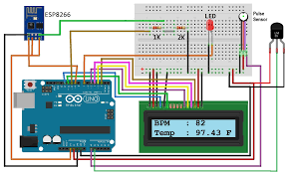
Figure 2: Circuit Diagram

- Result

The figure 3 and figure 4 shows the circuit hardware with pulse rate monitoring sensor, temperature sensor, heart rate monitoring sensor and display to display these values.

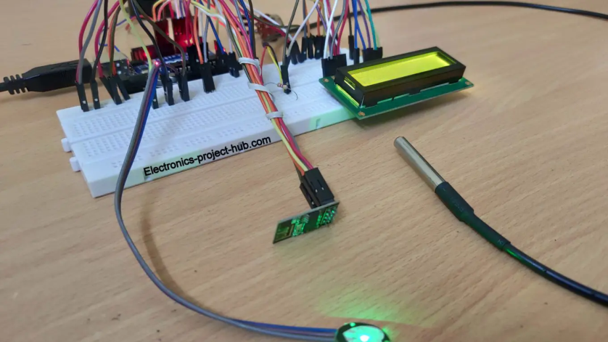

Figure 3: Sensors in the Circuit

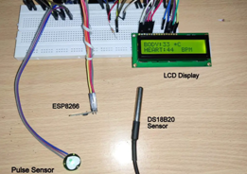

Figure 4: Parts of Design

Figure 4 shows display of health parameters on LED Display .

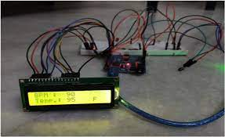

Figure 5: Display of health parameters

- CONCLUSION

We determine that the IOT and cloud computing are the only two foundations for our system. We employed cloud computing to store the data, which can be viewed from anywhere and kept permanently. Keeping patients updated is another benefit of cloud computing. In an emergency, doctors and other carers can interact with patients right away, take significant action, and administer medication based on the patient's health criteria. Doctors and other carers can communicate with patients without being physically present since the technology can automatically create a graph showing how the patient's body has changed as a result of an emergency SMS.
Our technology is ideal for village health care centres and rural regions with limited access to medical facilities since it makes it simple for doctors to diagnose problems and saves time during examinations if a patient has a high body temperature. Additionally, this approach protects patients' privacy outside of the hospital, at home. The effectiveness of this patient health monitoring system has been demonstrated.

REFERENCES

[1] "Low Cost And Portable Patient Monitoring System For E-Health Services In Bangladesh" Mithun Chandra Paul,Suman Sarkar,Md. Mahfujur Rahman,Sayed Mohsin Reza Iit Jahangirnagar University1342
[2] "Patient Health Management System Using E-Health Monitoring Architecture" Srijani Mukherjee, Koustabh Dolui.2014
[3] M. V. M. Figueredo, J. S. Dias, "Mobile Telemedicine System For Home Care And Patient Monitoring". Proceedings Of The 26th Annual International Conference Of The Ieee Embs San Francisco, Ca, Usa,September 1-5,2004.
[4] Pei-Cheng Hii, Wan-Young Chung, "A Comprehensive Ubiquitous Healthcare Solution On an Android Mobile Device", Sensors 2011,
[5] "Apnea Medassist: Real-Time Sleep Apnea Monitor Using Single-Lead Ecg" Majdi Bsoul, Member, Ieee, Hlaing Minn, Senior Member, Ieee,
[6] "Android Based Body Area Network For The Evaluation Of Medical Parame- Ters",Ieee,2012
[7] "Communication And Security In Health Monitoring Systems" - A Review Hos- Sein Fotouhi, Aida C Ausevic, Kristina Lundqvist, Mats Bjorkman
[8] Health Gare : "A Real-Time Wearable System For Monitoring And Analysing Physiological Signal" .Nuria Oliver 1 Fernando.2008

