A method for achieving 99% autoverification in a tertiary care cancer center's primary clinical chemistry laboratory using a step-by-step procedure

Debdatta Das 1, Subhosmito Chakraborty 2
Discipline of Quality Assurance, Tata Trusts, Mumbai, India
Discipline of Laboratory Medicine, Tata Medical Center, Kolkata, India

ABSTRACT
Autoverification may be a prepare whereby clinical research facility comes about are discharged without manual intercession. To control the dissemination of results, it makes use of pre-programmed computer rules like instrument error flags, interference indices, reference ranges, analytical measurement range (AMR), critical values, and delta checks. Middleware is utilized to perform autoverification. At our hospital, we present the implementation procedure and TAT improvement information. The TAT of a routine clinical chemistry metabolic panel from 2016 to 2017 is the subject of this study. Following the creation of the verification rules, the process was put into place by a team made up of quality managers, IT specialists, biochemists, and technologists.
R software was used to collect and analyze the TAT data. In the study, a TAT reduction of about 50% was found to be significant, and >75% of the tests underwent autoverification. Other platforms and tests will eventually be included; they are currently in the works.
Key words: algorithms; TAT; AMR; automated data processing; software; patient safety
- Introduction
Clinical laboratory results are made public through the autoverification process without the need for manual human intervention. To control the dissemination of results, autoverification employs predefined computer rules. The clinical laboratory is a component of healthcare systems that is coming under increasing pressure from users and administrators to increase productivity in order to handle the increased patient volume effectively while minimizing costs and utilizing staff time. Autoverification rules assist in making decisions based on instrument error flags (such as short samples, potential bubbles, or clots), interference indices (such as lipemia, hemolysis, and icterus), critical values, reference ranges, analytical measurement ranges (AMR), and delta checks (comparison of the current value to previous values, if available, from the same patient).
For some analytes, rules may also specify potentially absurd (physiologically improbable) values. They may also regulate automated dilutions and the circumstances under which samples are analyzed again. The laboratory information system (LIS) and/or middleware software, which sits in between the laboratory instruments and the LIS, are frequently used to perform autoverification.
In order to limit staff screen fatigue brought on by reviewing and verifying hundreds to thousands of results per shift, autoverification can significantly reduce the time and effort required for manual review by laboratory staff. In an ideal scenario, autoverification enables laboratory personnel to concentrate manual review on a small subset of potentially problematic specimens and test results. However, poorly planned autoverification may result in the release of results that ought to have been suppressed, which might have a negative effect on patient management.

The Clinical and Laboratory Standards Institute (CLSI) has produced a guideline document on the autoverification of clinical laboratory test results that focuses on the procedure for validating and putting autoverification protocols into practice. Data on autoverification employed in a clinical chemistry core laboratory at a tertiary care cancer center are presented in this study.

2. Objective
The purpose of this study was to assess the effectiveness of the routine biochemistry test autoverification process and how it affected patient safety..

3. Experimental design, materials and methods
Clinical chemistry testing is offered for both outpatient and inpatient services by a core laboratory within the Department of Laboratory Science. From 1/1/2016 to 30/11/2017, the clinical chemistry division is the subject of this study. Table 1 provides a summary of the DMAIC (Design, Measure, Analyze, Improve, Control) methodology-based Quality process improvement schedule. Thirteen people made up the project team, including managers, clinical biochemists, front-line employees, and others. The "Design and Measurement" phases led to the establishment of the process metrics and benchmarks/targets. According to the guidelines of the Clinical and Laboratory, a number of process maps, including Fig. 1, which describes the patient verification rules, were created in the connectivity software using manual validation criteria for laboratory professionals..
Following steps involved for implementation of AV process
Master algorithm template development-All analyzer-specific (or test-specific) AV algorithms must be descended from a master algorithm, which in turn must be descended from an algorithm specific to an analyzer. The master algorithm provides the high-level description that serves as the overall AV system's architectural blueprint.
Tool selection and implementation-It's typical for laboratories to invest in IT infrastructure before creating the specifications for their purpose. The laboratory's requirements, as stated in the algorithms, must be met by the AV tool. A single system for the entire laboratory lowers the overall cost of service and lowers the cost of implementation, interfacing, and training.
creating rules from algorithms. One of the most challenging aspects of AV implementation is turning the algorithms into code that the tool can use.
Exceptions review process- It is impossible to achieve 100% autoverification, and managing AV exceptions (results that fail AV) can take a lot of time. So take the time to comprehend and improve the exceptions review process. An ideal review procedure with the right information system can significantly reduce error rates, TAT, etc. even when a lab isn't performing AV. During the installation of AV, there is a perfect opportunity to put in place a new exceptions review procedure.
Substantiation- It can take a lot of time to test and validate rules, but doing so is essential whenever an algorithm is updated. Document each test case after performing quick tests on all rules to ensure functionality. Store the documentation electronically. Each test case ought to have a patient report, audit trail (from AV tools), and analyzer printout. Regular AV revalidation is required, with the frequency depending on the regulatory body overseeing the laboratory.
Scale-Any amount of autoverification will lead to a significant improvement in the process. Continuous improvement procedures in the laboratory must include routine reevaluations of AV. The laboratory will be able to allocate resources to AV thanks to the improvements in the process that resulted from implementing AV. But higher levels of autoverification become harder to achieve as the rates asymptotically approach 100%, so a balance must be kept.
In 2016 and 2017, a total of 15154 test results were gathered to define the turnaround time data. These data were taken from HMS, tabulated, and further computed.
Non-conforming product (NCP) percentages were estimated before and after the procedure, and the autoverification percentage was established. Additionally, pilot tests were run on various days to fine-tune the procedure.
Table-1: A list of the project's activities broken down by stage
Phase | Description | Activities | Relative start time (Duration)
Define | Most components of venture arranging were carried out amid this stage of the work | - Create top-level process maps,  - Top-level SIPOC diagrams,  - Draft project charters,  - Draft and finalize schedules,  - Choose and prepare project teams,  - And complete project charters. | 3 weeks
Measure | The system for measuring the AV process had to be defined, assessed, and put into place during this phase. | - Create process maps for AV;  - Choose metrics;  - Create/implement monitoring system;  - Start data collection;  - And assess measurement system | 8 weeks
Analyze | In order to make decisions about improvements, this phase involved creating AV benchmarks and targets as well as analyzing and interpreting data. | - Determine the AV benchmark,  - Perform the AV variance analysis,  - The root cause analysis,  - And analyze the requirements and process drivers to summarize the analyses. | 3 weeks
Improve | The creation and implementation of a new AV process were part of this phase. | - Examine early data from new processes,  - Process and optimize parameters,  - Design new AV process, conduct FMEA for new processes,  - Implement new AV processes,  - And prioritize improvement opportunities.  - Meetings with technical staff to discuss feedback | 7 weeks
Control | The development of a control plan to maintain the new AV process was done during this phase, along with the verification of improvements. | - Assign a monitor, confirm/validate the new AV process,  - Create and implement SOPs,  - Approve deliverables,  - Close out the project,  - And conduct a review. | - weeks
- SIPOC (Suppliers, Inputs, Process, Outputs, Customers).
- FMEA (Failure Modes and Effects Analysis).
- SOP (Standard Operating Procedures).

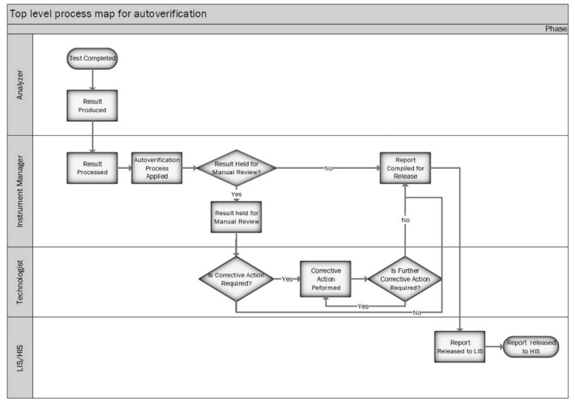

Fig. 1. AV work flow is described in a high level process map. The automated analyzer, the middleware software (Instrument Manager), the technologist, and the laboratory/hospital information system (LIS/HIS) are all identified in this flowchart as performing specific tasks. Data in Brief 18 (2018) 1740–1749 [E.W. Randell et al.]

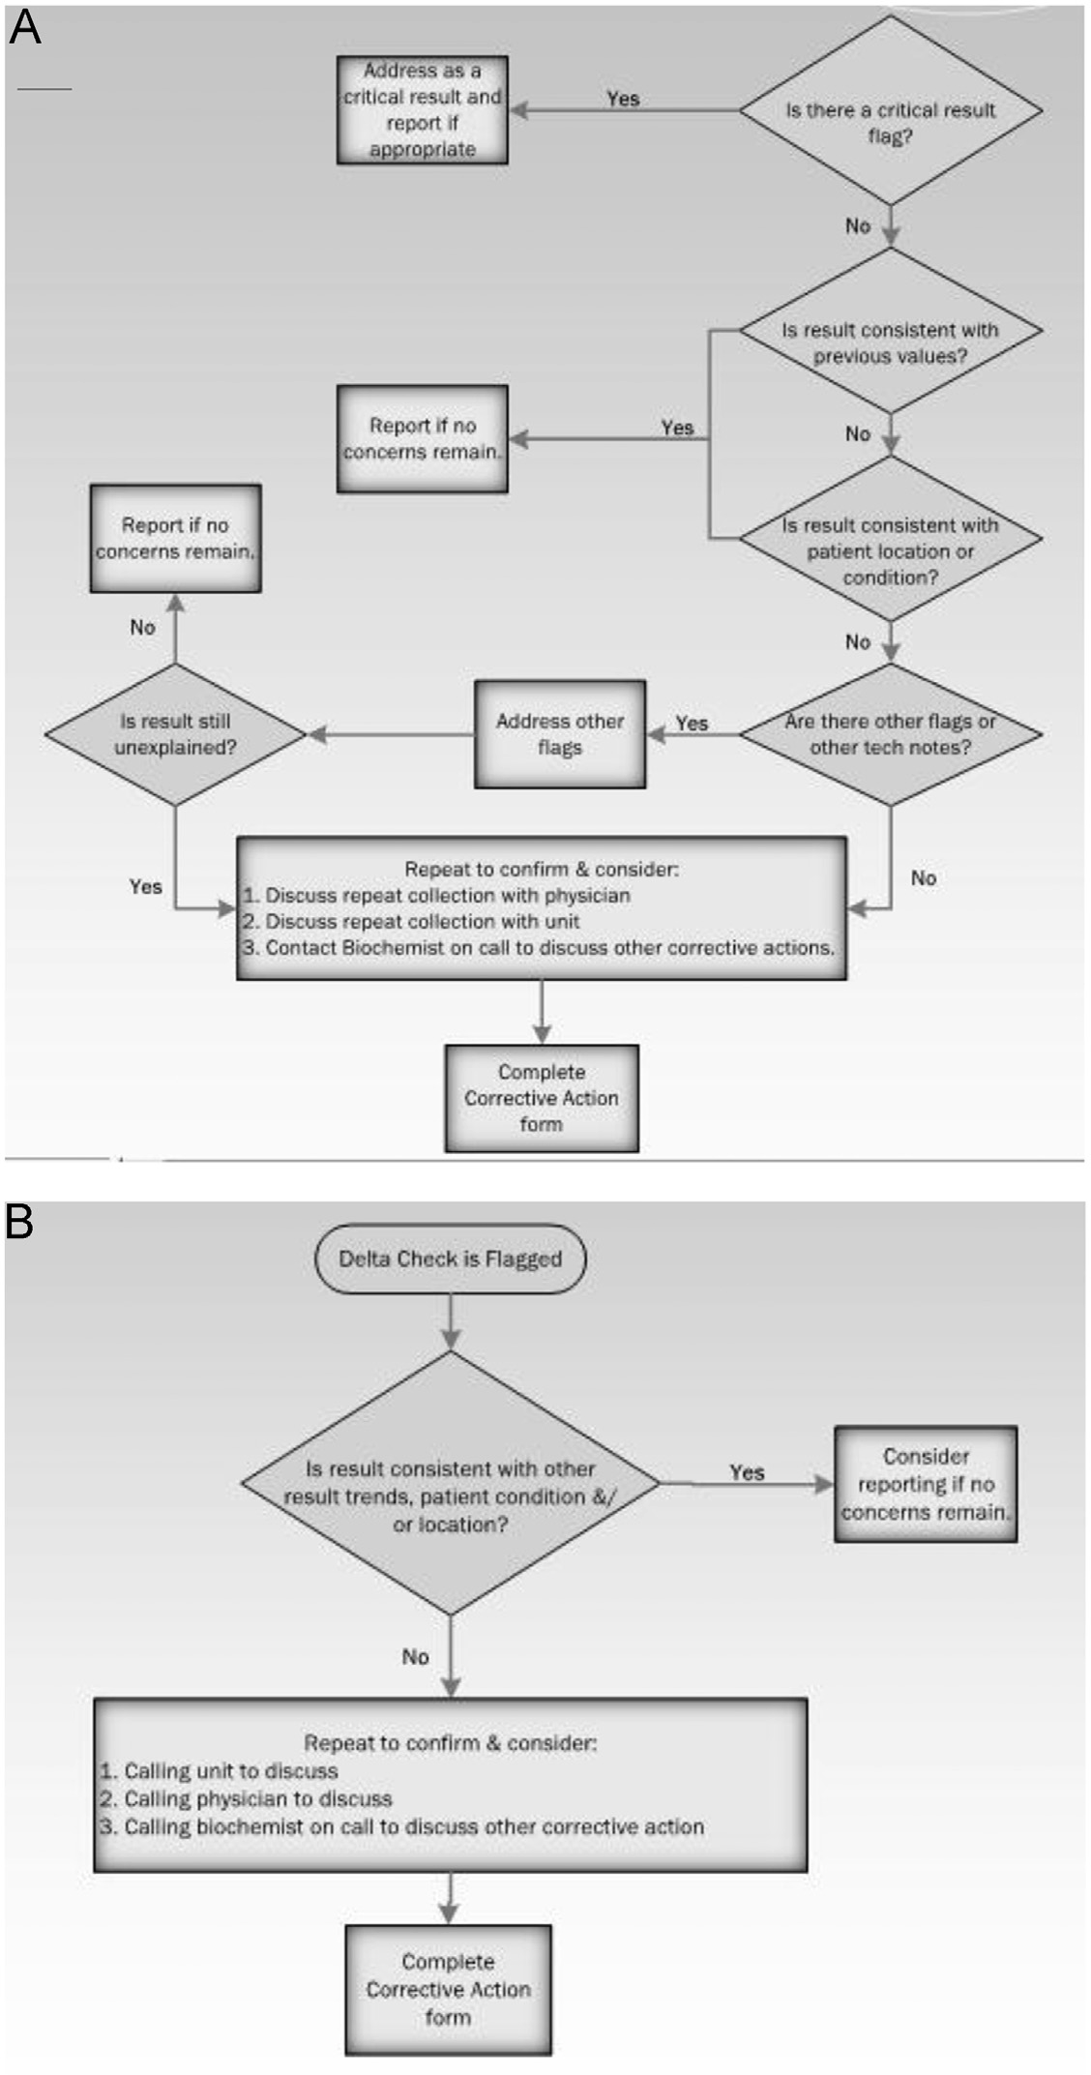
Fig. 2. Extreme result testing on the decision tree (A) and delta checks (B). "Data in Brief 18 (2018) 1740-1749," by E.W. Randell et al.
4. Results
Understanding return on investment and keeping track of progress require measuring key metrics both before and after implementation. Three metrics that need to be understood and monitored are turnaround time, technologist utilization, and error rates. Although many laboratories don't frequently have access to all of these statistics, getting them is crucial. TAT is a metric that can be easily obtained from lab information systems, but technologist utilization—the amount of time that a technologist spends carrying out their duties—is rarely known. The number of corrected reports (due to releasing or data-entry error) per number of patients that are run on the analyzers where AV will be performed can be used to calculate error rates.
99% of routine biochemistry parameters could be verified automatically,

Fig 3: Break down of various aspects of TAT prior to autoverification

Fig 4: Break down of various aspects of TAT after autoverification

After the introduction of autoverification rules, the overall TAT was significantly reduced by 1 hour, and authorization took less than 30 minutes, as is evident from both of the figures. If no other rules are broken, our workflows allow for critical value autoverification.
5. Discussion
The autoverification of laboratory test results is a crucial part of improving clinical laboratories' efficiency. Despite the significance of autoverification, over the years there has been a dearth of literature published on its actual application in clinical laboratories. In this report, we discuss our autoverification experiences in a tertiary care cancer center's busy automated core chemistry lab. The autoverification rules developed over time, and the rate of autoverification steadily increased to reach its current level of 99.5%. The highest volume tests or test panels (such as routine chemistry), which all have autoverification rates exceeding 90%, are a major contributor to the high rate of autoverification. Although a small portion of the tests in our study currently have autoverification rates below 90%.
We are aware of very little published information regarding the autoverification of critical values. If no other rules are broken, our workflows allow for critical value autoverification. The provider frequently sees the autoverified value before the call, which helps laboratory staff communicate these results. Critical values still necessitate provider notification and subsequent documentation. For instance, our medical center's emergency treatment center and intensive care units employ electronic dashboards or displays that continuously show patient data in off-limits staff areas. When the laboratory test result has already been seen, the phone calls to document the critical value move more quickly.
Even though autoverification has benefits, it also has potential drawbacks. The autoverification validation process takes time, and accuracy is crucial. Even the most thorough validation plan may overlook uncommon events or unexpected instrument error flags. Additionally, testing every conceivable set of rules is not possible. For autoverification to be successfully implemented and maintained, informatics support is essential. Network, LIS, AV software, and/or the interfaces between these systems interruptions are the most frequent issues preventing autoverification. Information systems' inability to perform complex rules and results reviews, as well as a lack of autoverification experience and a well-established AV implementation process, were listed as additional major reasons.
Our organization uses separate test servers for the initial testing of middleware rules without compromising the production system, as well as keeping both production and shadow middleware servers in various geographical locations. The amount of time the systems are down has decreased as a result. The other risk associated with autoverification, and in fact with increased automation in general, is the reduction of staff (both in terms of the number of staff and in terms of the mix of level of training and experience), to the point where the staff is unable to handle downtimes or other challenges without seriously impairing turnaround time.
The ability to detect rare events that might escape manual verification is one advantage of computer rules.Our research indicates that investing in personnel and training over a long period of time is necessary for the successful and ongoing use of autoverification. High levels of attention to detail are needed when validating autoverification rules. Rules ought to be based on evaluations of assays and published evidence. Additionally, using autoverification does not eliminate the requirement for meticulous quality control. Last but not least, ongoing success depends on close cooperation between the clinical laboratory and computing services.

6. Conclusion
The autoverification rules and instrument interfaces to the LIS and AV software that these rules rely on, which are presented in this manuscript, were created over a period of years and would not have been possible without the dedication of staff. The autoverification process made it possible to reduce the variability brought on by human intervention, allowing the professional to concentrate on the analysis of the pathological report, lowering the risk of errors, enhancing TAT, and promoting a greater emphasis on patient safety.

REFERENCES

- Building and Validating an Autoverification System in the Clinical Chemistry Laboratory: Laboratory Medicine, Volume 42, Issue 11, November 2011, Mu-Chin Shih, MT, Huey-Mei Chang, MS, Ni Tien, MS, Chiung-Tzu Hsiao, MS, Ching-Tien Peng
- Autoverification in Clinical Laboratory: Pitfalls and Challenges: Dr. Mohd Jamsani Mat Salleh: 24 Jun 2022
- Autoverification in a core clinical chemistry laboratory at an academic medical center: Matthew D. Krasowski1 , Scott R. Davis1 , Denny Drees1 , Cory Morris1 , Jeff Kulhavy1 , Cheri Crone1 , Tami Bebber1 , Iwa Clark1 , David L. Nelson1 , Sharon Teul1 , Dena Voss1 , Dean Aman2 , Julie Fahnle2 , John L. Blau1: Received: 17 December 2013 Accepted: 13 February 2014 Published: 28 March 14.
- A model to establish autoverification in the clinical laboratory: Deniz Ilhan Topcu 1, Ozlem Gulbahar 2, PMID: 33831387:DOI: 10.1016/j.clinbiochem.2021.03.018
- Autoverification: lessons drawn from a core lab in 2022 Issues, ARTICLES, August 2022
- Design and evaluation of a LIS-based autoverification system for coagulation assays in a core clinical laboratory: Zhongqing Wang1,2, Cheng Peng3, Hui Kang4, Xia Fan4, Runqing Mu4, Liping Zhou4, Miao He2 and Bo Qu: Wang et al. BMC Medical Informatics and Decision Making (2019) 19:123 https://doi.org/10.1186/s12911-019-0848-2
- A step-by-step process to 95% autoverification in 2015: Bill Marquardt, C(ASCP), MBA, CSSBB Issues, ARTICLES, December 2015
- Strategy for 90% autoverification of clinical chemistry and immunoassay test results using six sigma process improvement: Edward W. Randell a b, Garry Short c, Natasha Lee a, Allison Beresford a, Margaret Spencer c, Marina Kennell a, Zoë Moores a, David Parry a b: https://doi.org/10.1016/j.dib.2018.04.080
- S.H. Park, S.Y. Kim, W. Lee, S. Chun, W.K. Min, New decision criteria for selecting delta check methods based on the ratio of the delta difference to the width of the reference range can be generally applicable for each clinical chemistry test item, Ann. Lab. Med. 32 (5) (2012) 345–354.
- J. Lee, S.Y. Kim, H.J. Kwon, H.K. Lee, Y. Kim, Y. Kim, Usefulness of biological variation in the establishment of delta check limits, Clin. Chim. Acta 463 (2016) 18–21.

