**IoT based Evapotranspiration Irrigation System for Enhancing Water Conservation**

Simrat Walia1 and Jyotsna Sengupta 2

1 Department of CSE, Baba Banda Singh Bahadur Engineering College, Fatehgarh Sahib

2 Department of Computer Science, Punjabi University, Patiala

**Abstract:** In developing countries, water conservation has immense significance where economies rely on for livelihood and food security. The irrigation and other farming activities involve consuming a large amount of water. Smart farming uses IoT (Internet of Things) and WSN (Wireless Sensor Network) to handle fundamental farming activities like irrigation scheduling, weed control, pest control and disease management involving sensor data acquisition, data storage, and data processing. The sensor inputs and their comparison against prescribed values for decision making utilized in these systems. This chapter proposed an automated irrigation system capable of monitoring field conditions and controlling the irrigation process. The proposed system aims at saving water, manpower saving, risk management and other resources. The system integrates various information from sensors, evapotranspiration and online weather forecasts. NodeMCU microcontroller, 5v DC submersible water pump, motor driver module (L293D), Capacitive soil moisture sensor, water flow sensor (FS300A), and solderless breadboard are the main hardware components of system. The sensor analyses soil moisture and delivers data to the microcontroller at predetermined intervals. When the soil moisture level drops below the threshold, a submersible water pump, which is linked to a microcontroller through a motor driver module, is activated to supply water. Based on the ETo of the region and infield sensor feedback, the system generates irrigation schedules.

**Keywords:** IoT (Internet of Things), Automated, Irrigation Scheduling, Evapotranspiration, Wi-Fi, ZigBee.

1. **Introduction**

### Water is an elementary resource across many sectors of human life such as health and sanitation, farming, energy production, industry, recreation, domestic and urban development. Groundwater, rain, and surface water are the primary sources of usable water. However, Seventy percent of useable water is consumed in agricultural pursuits [16]. The useable water resources are inadequate to meet escalating future demands driven by expansion in population. The expansion of the population necessitates increased crop production to meet increasing food needs. Due to limited resources, climate change, and groundwater depletion, optimal water utilisation in agriculture is a prerequisite. The emphasis on water conservation is prominent in developed and underdeveloped countries where agriculture is a cornerstone of economic growth and sustenance. Indian irrigation is predominantly rely on groundwater, facing multifaceted challenges like over-exploitation, inadequate water supply infrastructure and diminishing of groundwater tables. In India, groundwater sustains irrigation across 39 million hectares, surpassing usage figures of 19 million hectares in China and 17 million hectares in the United States. To fulfill urban, industrial, and agricultural needs of current and future generations emphasize a requirement to conserve current water resources [16].

In the agrarian economy of India farmers play a crucial role in society with 50% of the workforce is employed in agriculture. There are several challenges in this sector such as inadequate rainfall, traditional farming techniques, pest and diseases that affect various activities from routine to harvest. Information Technology (IT) defines the modern era, and a wide range of technologies, including sensors, autonomous vehicles, automated devices, web services, mobile devices, and the Internet of Things (IoT), offer solutions to these challenges. The automation of agricultural processes through incorporation of sensors and machine learning constitutes significant domain of research aiming sustainable growth, automation and intelligent decision making. It has the potential to assist farmers in Using sustainable farming methods, preserving natural resources, and enhancing lifestyle.

* 1. **Problem Statement**

The IoT and WSN are two prominent technologies that connect physical objects to the internet through wireless and wired technologies for automation. The objects are capable of interacting and exchanging data to improve service, reduce costs, and save labor. The use of computers and internet brought significant advancements to farming including automating various operations, tracking crop progress, and optimising yields. IoT is a dynamic field that is influenced by ongoing developments in sensor technology, communication systems, data processing techniques, storage and microcontroller. It is a rapidly expanding field of study among researchers. There are numerous automated irrigation systems that consider evapotranspiration, sensor readings, crop and regional topography.

Punjab has agriculture as primary mean of livelihood and state has significant contribution towards national food production. The state primarily has a monoculture of wheat and paddy responsible for water overexploitation. Therefore, water resources such as surface water and groundwater are insufficient. This paper proposes automated irrigation system using IoT techniques to conserve groundwater according to state climate, crop and topography. The chapter is not only providing a system that effectively use irrigation water but also focus on cost effectiveness, user friendliness and ease of use solution.

* 1. **Objectives**

The literature presents various studies on irrigation automation, such as IoT based systems, Fuzzy-DSS, ET based irrigation and machine learning based irrigation systems. The chapter has following objectives:

* To explore different irrigation scheduling approaches like IoT and Evapotranspiration based.
* To propose an IoT based system for scheduling irrigation and optimizing water usage by using sensor, evapotranspiration and weather forecast from the internet.

The paper consists of five sections with subsequent section provides a comprehensive background by using a literature review. The third section provides a design of the proposed system. The fourth phase encompasses of results, while the fifth section focuses into the potential areas for future research. Lastly, the sixth section provides a conclusion.

1. **Literature Review**

According to the United Nations, water conservation is an important issue. The United Nations has a goal of providing equitable access to clean and inexpensive potable water for everyone. Enhance the efficiency of water utilisation across all sectors and ensure sustainable freshwater withdrawals and supply to overcome water scarcity. Sustainable water use requires the immediate development of scientific and technological techniques [29]. The fact that irrigation uses 85 percent of all usable water makes water conservation an unarguable issue[15]. Distribution of water to crops via channels, canals, or ditches has been the standard method of irrigation for centuries. While these methods have shown some success, their effectiveness and viability are compromised in the context of water conservation issues. The amount of water available influences plant growth and productivity because excess water affects crops by making roots inefficient in collecting nutrients from the soil, whilst a lack of water causes slow seed germination [12]. Irrigation scheduling seeks to provide plants with the optimal quantity of water at the optimal time in order to enhance plant growth and achieve a high yield and quality. There are four kinds of irrigation scheduling: (1)Evapotranspiration and water balance, (2) soil moisture, (3) plant water requirement according to stage of crop, and (4) models based [31]. In this chapter two types of irrigation scheduling is used such as soil moisture based and Evapotranspiration based.

* 1. **IoT based Irrigation Systems**

Farmers across the globe are increasingly adopting Internet of Things (IoT) technologies to transform their agricultural methods, with a special emphasis on developed nations. The utilisation of IoT technology in automated irrigation systems has been found to significantly improve the efficiency of water management and optimise the growing of crops. These systems are comprised of several components, including sensors, microcontrollers, receiver units, and software programs. Feedforward systems employ a crop evapotranspiration, whereas feedback-controlled systems make decisions based on sensor data.

Gutierrez et al. (2014) presented system to automate drip irrigation, which 90 percent more efficiently conserved water than traditional irrigation. The system consists of two essential components Wireless Information Unit (WIU) to transmit sensors data and Wireless Sensor Units (WSU) having sensors to collect the data. The system has wireless network of soil moisture and temperature sensors incorporated into root zone of plants. The WIU was equipped with a GPRS module, which use the public mobile network to transmit the sensor data to a designated web server. A fuzzy decision support system based on forecasts of soil water was proposed by Giusti and Libelli (2014). To make decisions about the system, agricultural data (soil composition, crop characteristics, and site) and climate data (rain, temperature, and solar radiation) were combined.

Hu and Shao (2017) offered a cloud-based, remotely operated irrigation system based on several factors such as soil temperature, humidity, and carbon dioxide content, are taken into account while deciding whether or not to water plants. For Sri Lanka's green roof vegetation, Bandara et al. (2017) presented a sprinkler irrigation system that uses evapotranspiration forecasts to estimate irrigation requirements for crops.

Sivagami et al. (2018) presented an automatic greenhouse drip and sprinkler irrigation system which would determine watering needs in response to soil moisture and environmental factors.Kwok and Sun (2018) created an irrigation system that takes into account things like water needs according to plant and sensor inputs. An Arduino-based irrigation controller and a deep learning based plant-recognizing mobile app work together to identify plants from photographs. Aydin et al. (2019) proposed a system that manages operations such as starting, maintaining and stopping the irrigation based on deep learning algorithms.. The information gathered by sensors and other IoT devices, transmitted over various channels, and saved in MongoDB. An Irrigation Control that used data from an nearby weather station and runoff from the soil's surface to calculate how long each sprinkler zone may operate[3]. An et al. (2021) demonstrated an automated irrigation system based on sensors to track the temperature of the substrate, Number of leaves, leaf area, chlorophyll concentration, and root length are all indicators of system performance. Munir (2021) presented intelligent strategy wherein ontology is to make half of the decisions, with the remaining half depending on sensor data values and Combining ontology with sensor data is with KNN. The various factors involve in decision making are crop type, soil type, climate type, temperature, humidity, and soil moisture.

Table 1: Main Findings from Literature Corresponding to Automated Irrigation

|  |  |  |
| --- | --- | --- |
| **Name of Study** | **Type** | **Main Findings** |
| Gutierrez et al. (2014) | Automated drip irrigation system | WSU (Wireless Sensor Units) connected to sensors and a WIU (Wireless Information Unit), Water Savings are 90% more than traditional system |
| Giusti and Libelli (2014) | Fuzzy-DSS | Estimate Soil water content based on climate and soil data |
| Hu and Shao (2017) | Cloud based Automated Irrigation | Soil temperature, humidity, and carbon dioxide parameters considered to take decisions |
| Bandara et al. (2017) | Automated sprinkler irrigation system | Estimation of irrigation from evapotranspiration and sensor data |
| Sivagami et al. (2018) | Automatic greenhouse drip and sprinkler irrigation system | Determine watering needs from soil moisture and environmental factors |
| Aydin et al. (2019) | Deep Learning based Irrigation Scheduling | Irrigation decisions are taken by DNN algorithms, Sensor data is saved on MongoDB |
| An et al. (2021) | Sensor based Automated Irrigation | Sensor input used for irrigation decisions, Performance of system evaluated in terms of temperature of the substrate, Number of leaves, leaf area, chlorophyll concentration, and root length |
| Silalahi et al. (2022) | Fuzzy inference system for irrigation scheduling. | Fuzzy logic for irrigation scheduling |

Silalahi et al. (2022) proposed a fuzzy inference system using Raspberry Pi for irrigation scheduling. The main findings from the literature are presented in Table 1.

* 1. **Common Framework for IoT based Irrigation System**

This section describes main activities and components of automated irrigation system which generalized as common framework on the basis of past studies. The main activities of system are sensor data collection, data transfer, data storage and analysis. Figure 1 shows main components such as sensor nodes, a base station, an irrigation controller and a server. The base station collects data from sensor nodes and transmits to the server. A user or web application takes decisions based on analysis of sensor data on server side like irrigation schedule, amount and duration of water supply. The analysis of data is done according to sensor feedbacks and with machine learning techniques.

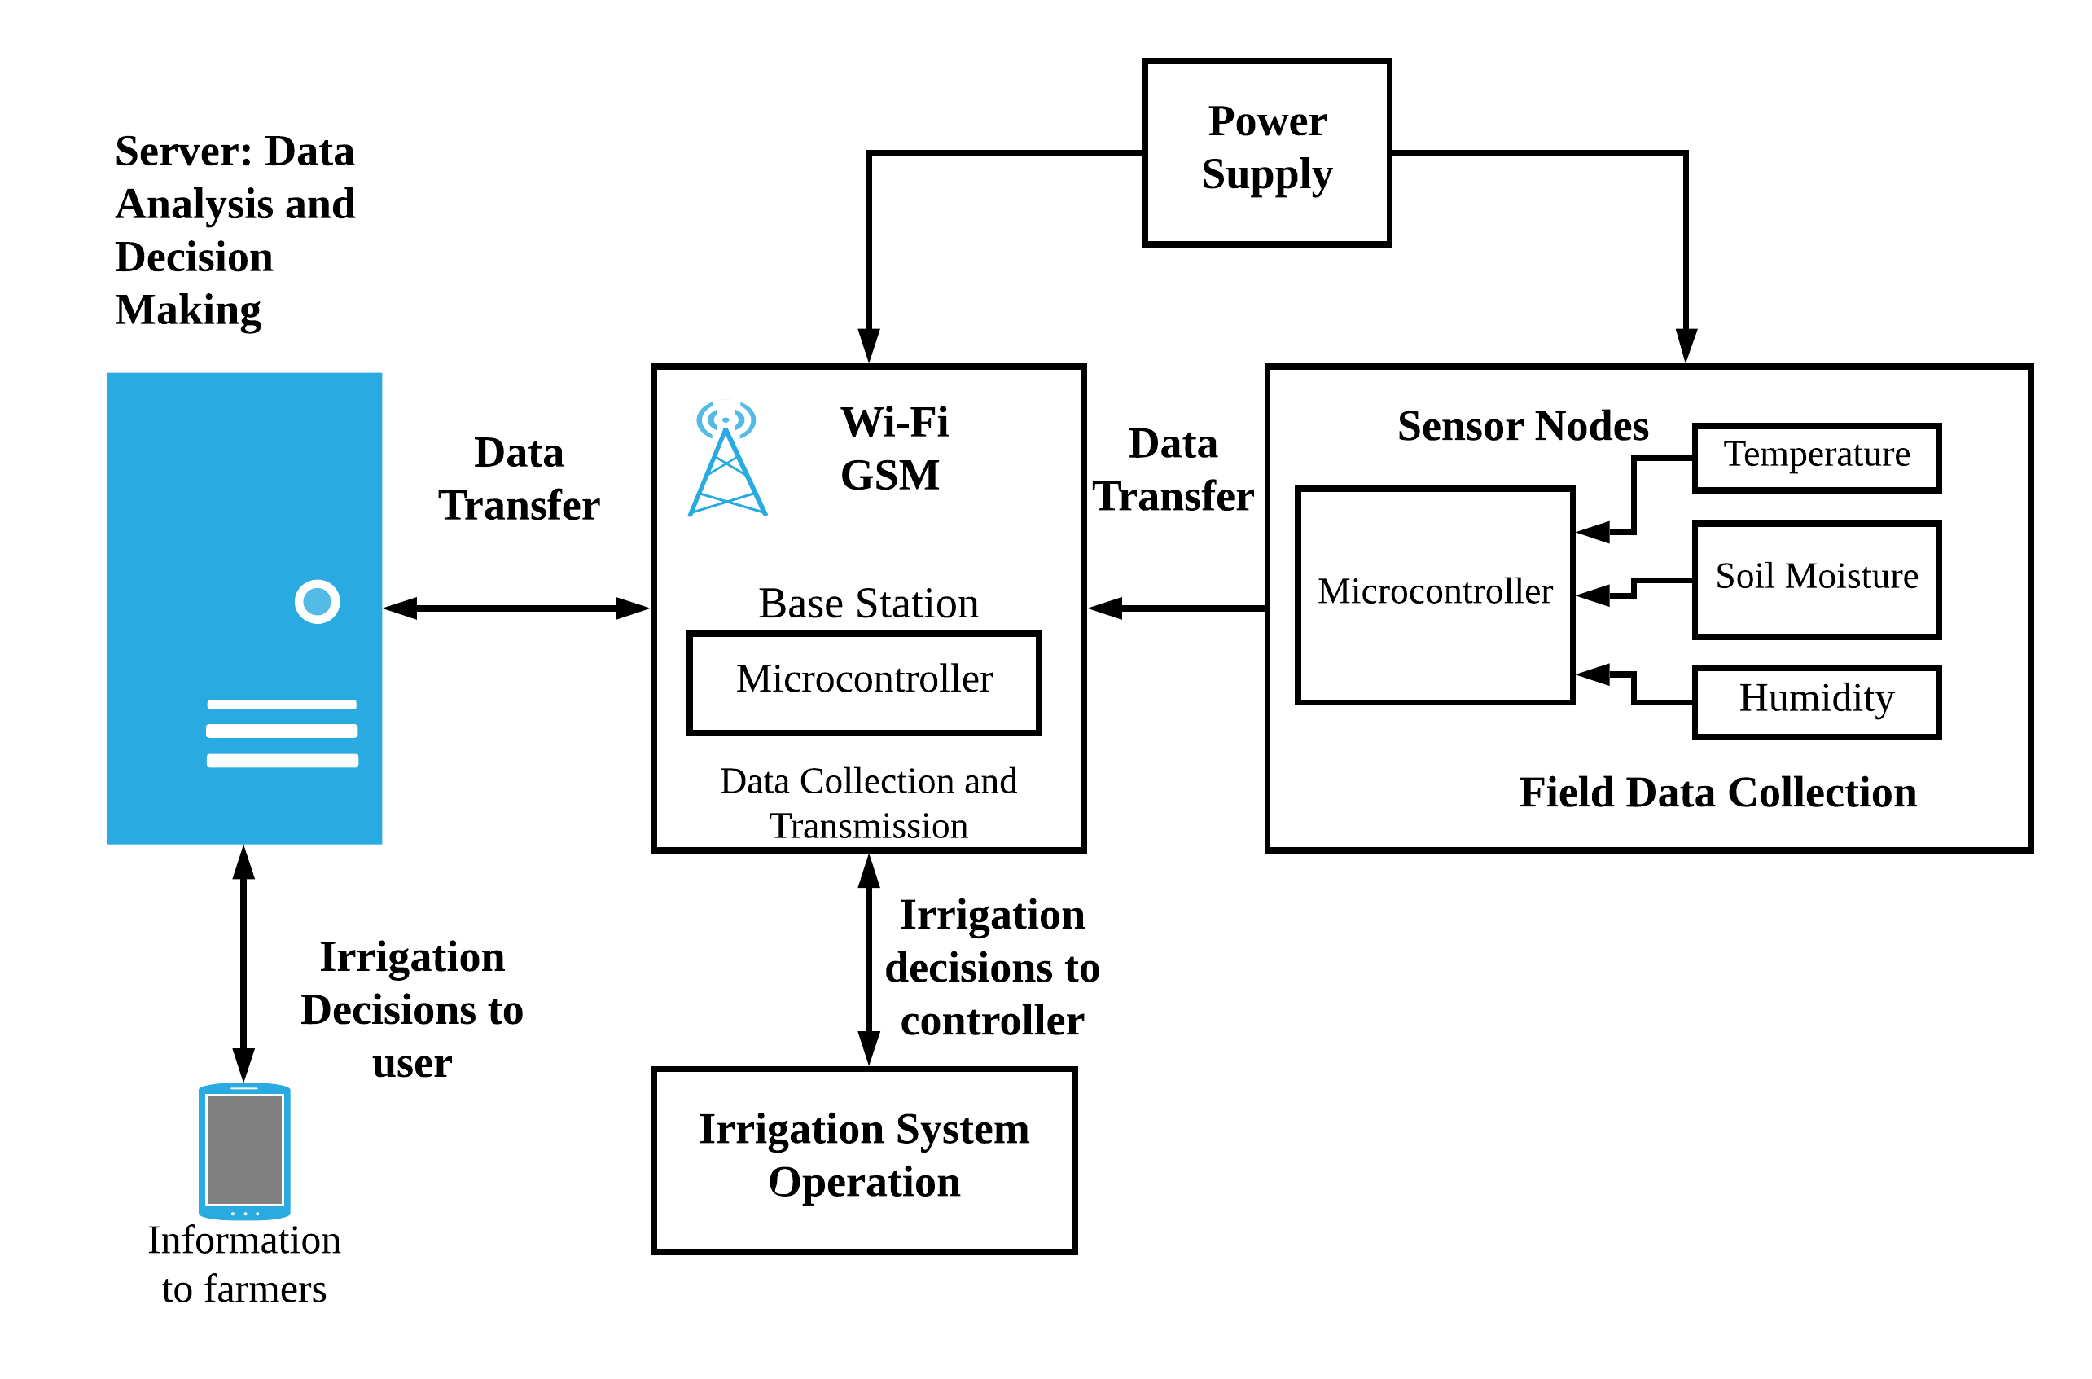

Figure 1: Common Framework and Hardware Components of Automated Irrigation System

### The design of automated system differs corresponding to various factors such as type of sensors employed, number of sensor nodes, communication methods, data storage, and power supply sources. The main activities and hardware components are as follows:

1. **Data Acquisition from sensor nodes:** The data for numerous real-time metrics, including soil moisture, humidity, and temperature, are gathered from sensor nodes in the field and sent to the base station, which then processes the data. It enabled with Wi-Fi or other internet technologies gathers information from various sensor nodes and transfers it to a cloud or web server. The two types of data communication used long range from base station to cloud and short range from sensor nodes to base station. The Internet Protocol Version 6 (IPv6), Firewire, ZigBee, EspNow and Near Field Communication (NFC) facilitate short range communication through private area networks (PAN) limited to few meters. Communication over the internet can be accomplished through the use of technologies such as GPRS and Wi-Fi. Murthy et al. (2020) employed the MQTT protocol to transmit sensor data categorised by zones. This data was transferred to a web server that was constructed on the AWS cloud.
2. **Data Storage and Processing:** The information is stored on a cloud platform or a server for the purposes of doing analysis and making decisions. The researchers are now a days interested to use cloud instead of web server because of ease of access, scalability in terms of sensor nodes, fault tolerance and cost effectiveness. The collected data from sensors nodes is analyzed against some threshold values with traditional or machine learning algorithm for decisions making. Gutierrez et al. (2014) utilised a web application to facilitate the collecting and processing of data. In another study, Ghosh et al. (2016) put forward the suggestion of using a cloud platform for the purpose of data storage and analysis. The hybrid system designed specifically for the irrigation of individual crops, as developed by Lenka and Mohapatra (2016), incorporates a feedforward neural network and a fuzzy logic based decision support system (DSS. The DSS utilizes fuzzy logic to forecast moisture levels of soil which are subsequently communicated to the farmer through mobile notifications.

### **Sensors Used:** The sensor node includes a microcontroller and a number of sensors for measuring things like soil temperature, soil moisture, water level, pH, and humidity. The number and type of parameters collected through sensor nodes are determined by the crop type and irrigation technique. The different crops as well as techniques consider different parameters for scheduling irrigation. Dhanalakshmi et al.(2022) used soil moisture and DH11 sensor.

### **Microcontroller:** The choice of microcontrollers for sensor nodes and base station is important as it affects performance, cost-effectiveness, complexity and fault tolerance. It is a centralised component of an automated irrigation system that is responsible for collecting data from sensor nodes that have been installed in the fields, converting that data into digital form, and then transmitting that data for analysis. The various aspects, such as low cost, versatility to connect with sensor nodes and low power consumption taken into account while selecting a microcontroller. Gutierrez et al. (2014) used single chip (PIC24FJ64GB004) 16-bit microcontroller to transfer data.

### **Power Sources:** Solar panels, rechargeable batteries, and dry cell batteries all contribute to the power supply of the base station and the individual sensor nodes. The reduced power consumption is preferred to design a power efficient system felicitous for real life situations. The solor powered nodes are preferred due to power sufficiency, portability and sustainable power source. The researchers are interested to design power saving irrigation system by simplifying sensor nodes, use of low power components and timing based predicted irrigation scheduling through machine learning. In the study, Gutierrez et al. (2014) employed a solar panel to provide energy to a WSU, while a power storage battery was utilised to offer power to a WIU.

* 1. **Evapotranspiration and its Significance in Agriculture**

Evapotranspiration (ET) comprises two distinct hydrological cycle processes: evaporation and transpiration. Evaporation refers to the vaporization of water from surfaces such as water sources, soils, and vegetative cover, whereas transpiration refers to water drawn from the soil to the roots and other parts of plants through the vascular system of plants [21]. As a key factor in agricultural water management, irrigation scheduling, and water budgeting, evapotranspiration is an essential part of the water cycle.

ETo is calculated using a reference surface which is assumed to be completely irrigated having a 0.12 m tall hypothetical grass crop. Penman-Monteith method is often used to calculate reference evapotranspiration by using important weather and altitude parameters like solar radiation, air pressure, air temperature, humidity, and wind speed. The meteorological variables required for the use of the PM technique, on the other hand, are not always available. As a result, the approaches for estimating ETo with air temperature are advantageous for regions where climate data is unavailable. Hargreaves-Samani is a well-known approach that uses air temperature [1].

Zanetti et al. (2007) suggested an ANN for estimating reference evapotranspiration ETo by considering its relationship to maximum and minimum air temperatures. The multilayer perceptron (MLP) was employed in which inputs propagate forward through layer by layer and backpropagates to correct synaptic weight errors.

Antonopoulos and Antonopoulos (2017) compare the use of Artificial Neural Networks (ANN) and the empirical methods like Priestley-Taylor, Makkink, and Hargreaves to estimate reference evapotranspiration using four years of daily meteorological data. The algorithm utilised for optimisation is a multilayer feedforward artificial neural network with backpropagation.

Üneş et al. (2018) offered a comparison of the ETo estimation techniques such as  Hargreaves-Samani, Turc equations, and Artificial Neural Network (ANN). For daily average evapotranspiration estimation average daily air temperature (T), highest (Tmax) and lowest daily air temperatures (Tmin), wind speed (U), solar radiation (SR), and relative humidity (RH) were employed. The architecture of the ANN model was feedforward-back propagation. The effectiveness of ANN models was accessed using models based on different combinations of meteorological variables like mean temperature, wind speed, solar radiation, and relative humidity.

Saggi and Jain(2019) introduced a DNN model to predict the daily ETo for two districts of Punjab utilizing H2O AI Cloud Platform framework. The system employs four supervised learning algorithms for evapotranspiration prediction including the Generalised Linear Model (GLM), the Random Forest (RF), and the Gradient-Boosting Machine (GBM).

Walls (2020) showed seven distinct artificial neural network (ANN) models to predict daytime actual Evapotranspiration (ET). The key components included the sigmoid and ReLU(rectified linear unit) activation functions, as well as the stochastic gradient descent (SGD) and root-mean-square-propagation (RMSprop) learning methods. The input variables consists of net radiation, air temperature, soil heat flow, and wind speed.

Ogunrinde et al. (2021) proposed ETo prediction model for  determining  standardised precipitation and evapotranspiration index (SPEI). The ANN model(9-8-1) having input, hidden, and output neurons trained using the Levenberg-Marquardt training algorithm, with activation and hidden transfer functions of Tansig. Table 2 summarised main studies for ETo prediction.

Table 2:Main Findings from Literature Corresponding to ETo Prediction

|  |  |  |
| --- | --- | --- |
| **Name of Study** | **Type** | **Main Findings** |
| Zanetti et al. (2007) | Multi-Layer Perceptron (MLP)for ETo | 1) Air temperatures (Max and Min) as input parameters |
| Antonopoulos and Antonopoulos (2017) | Multilayer feedforward artificial neural network with backpropagation for Eto | 1)Performance of ANN model compared with empirical models |
| Üneş et al. (2018) | Feedforward ANN model with back propagation for ETo | 1)Inut parameters are air temperature (T), Tmax,Tmin, wind speed (U), solar radiation (SR), and RH 2)Performance of ANN model compared with empirical models |
| Saggi and Jain(2019) | Deep Neural Network | 1)Supervised ML model were used using H2O framework |
| Walls (2020) | ANN Model for actual ET | 1)Input parameters are Net Radiation, Air Temperature, Soil Heat Flow, Wind Speed |
| Ogunrinde et al. (2021) | ANN Model to find out ETo for determining   evapotranspiration index (SPEI) | 1) Levenberg-Marquardt training algorithm and Tansig Activation model was used |

Traditional methods for estimating evapotranspiration, such as the Penman-Monteith equation, are extensively used but they rely on complex climate data. The usage of computing and machine learning techniques for evapotranspiration estimate is cost effective and revolutionize agricultural water management.

1. **Proposed System** **Design and Architecture**

In this section, a hybrid approach of IoT based automated irrigation system and smart irrigation scheduling app was proposed by considering the influencing factors such as weather conditions, soil and crop specifications. The system incorporates the strengths of two control mechanisms: feedforward and feedback. The feedforward control calculate crop evapotranspiration to determine crop water requirements as predictive control, while the feedback control uses sensor readings for decision making . Fig. 2 illustrates a block diagram of the proposed system showcasing evapotranspiration and sensor readings are input parameters whereas irrigation schedules generation is output.

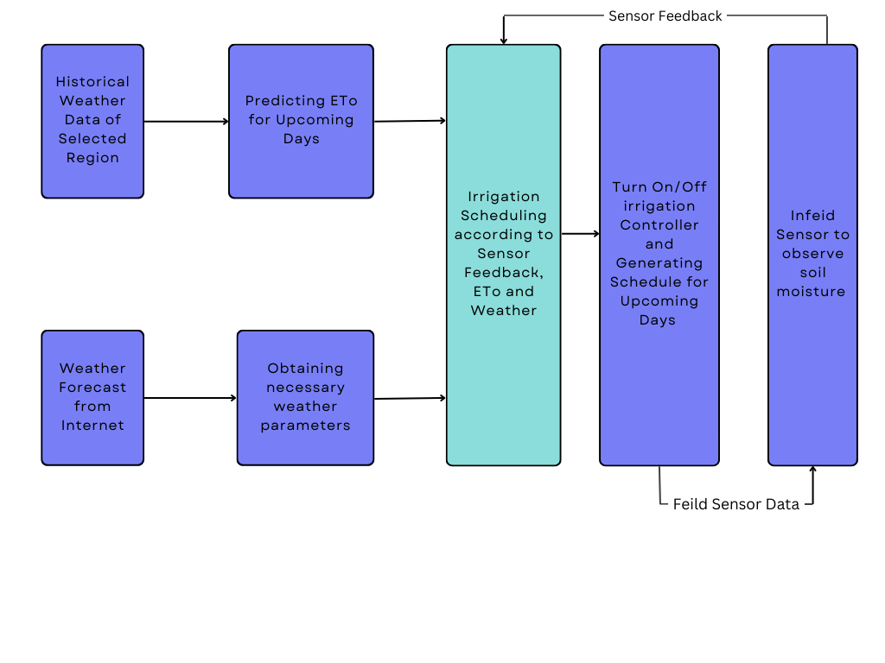

Figure 2: Block Diagram of Proposed System

* 1. **Hardware Components of IoT based System**

The irrigation scheduling module employed with hardware consist of two main units such as the sensing and irrigation controller. The main hardware components of proposed system consist of NodeMCU Microcontroller, 5v Water Pump, L293D Motor Driver Module, Capacitive Soil Moisture Sensor, and GL-12 Solderless Breadboard. The NodeMCU has 32-bit microprocessor can function at 160 or 240 MHz along with an integrated Wi-Fi module for seamless data transfer. It has 128kB of memory and Analog (A0) and Digital (D0-D8) interfaces. The 5V water pump used to deliver water from its source to an irrigation field. The microcontroller can on and off it based on the irrigation schedule or soil moisture levels. The motor driver module is a operates in a bidirectional manner to control the speed and direction of DC motors. In the irrigation system, it can be used to control the water pump by enabling the microcontroller to on and off the pump as sensor input. The capacitive sensor made up of corrosion resistant material and measures the moisture content of the soil by detecting changes in capacitance. The sensor is placed at opposite side of water inlet to monitor the soil moisture of substrate layer of entire irrigation area. The soil moisture capacitive sensors generate analog readings which can be converted to a percentage of moisture. Maximum and minimum voltages are calibrated between 0 and 100 percent of soil moisture.

The soil moisture sensor consistently observes the soil moisture content and sends inputs to the microcontroller for cloud storage and decision making. The microcontroller is connected to the DC submersible motor through the motor driver module. When the moisture level falls below the threshold the motor activates to pumps water. Punjab is characterized by a semiarid climate and deep water tables.

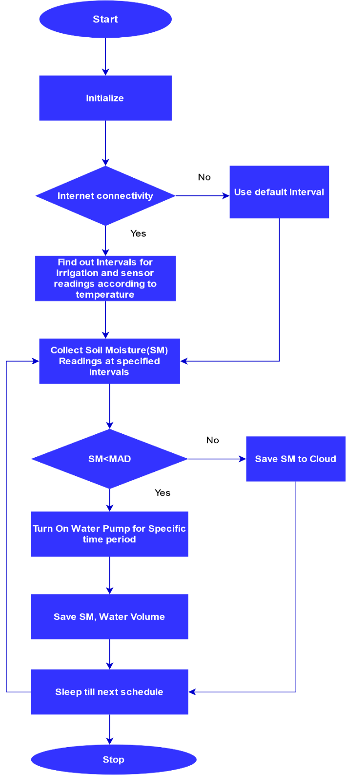

Figure 3:Irrigation Controller with IoT

To reduce the effects of percolation and evaporation the fields needs to be frequently irrigated with short duration. The timing, number of cycles and duration between successive irrigations are all controlled by this component. The critical activities, such as sensor data collection and irrigation sessions, are scheduled at regular intervals based on the temperature of the day, with the frequency of irrigation increasing with temperature increase and decreasing with a decrease in temperature, and the system remaining in sleep mode when no processing is done. The flowchart illustrating irrigation controller is visualised in Fig. 3.

The system was tested On a testbed having single node. The sensor data is transmitted to cloud platform with Wi-Fi module where analysis and decision making takes place.

* 1. **Decision Support System for Irrigation**

1. **Evapotranspiration Prediction*****:*** Reference crop evapotranspiration (ETo) is used to derive crop evapotranspiration (ETc), which is used to assess the amount of water required by the crop. The ETo is the estimate of water losses in evaporation and transpiration occurring on a hypothetical grass crop of height 0.3 feet. It is reliant upon a number of variables, including humidity, temperature, air pressure, solar radiation, and wind velocity. The current method for predicting ETo for forthcoming days based on historical weather data for the region employs a feedforward neural network. The historical weather data is collected from the OpenWeatherMap website as a dataset in JSON format. For training of dataset, the reference evapotranspiration(ETo) is computed with the empirical Hargreaves-Samani method with air temperature as the primary factor. The ETo is calculated according to equation 1.

ETo = α * (Tmean + 17.8) (Tmax-Tmin)1/2 Ra  (1)

Where ETo represents the reference evapotranspiration [mm day−1] , Tmean denotes the mean daily temperature [°C] computed as Tmean = (Tmax + Tmin )/ 2. α is empirical constant corresponds to value 0.0023 and Ra is extra-terrestrial solar radiation [4]. ETo is predicted using a multilayer FNN with one input layer, two ReLU-activated hidden layers, and one output layer containing a neuron representing ETo. The various parameters from weather data are taken for FNN are Tmean, Tmin, Tmax, Humidity, Wind Speed, and Cloudiness .

Features of Dataset for Eto Prediction: The dataset mentioned in section 3 utilized for prediction of ETo has the following features:

* 1. The dataset encompasses Historical Weather data of the region.
  2. The parameters like city_name, temp_minimum, temp_maximum, pressure, humidity, cloudiness, weather_description (Rainy, Clear, Foggy etc.), and rain_fall are integrated to dataset.
  3. The dataset comprises hourly data encompassing the temporal span from 2016 to September 2020.
  4. The value of ETo in dataset is manually computed with Hargreaves-Samani formula.
  5. The dataset is partitioned into testing and training data facilitating model development.

The reference evapotranspiration (ETo) is utilised to calculate crop evapotranspiration (ETc). The evapotranspiration of a crop is calculated using equation 2.

ETc = Kc*ETo  (2)

ETc is crop specific evapotranspiration, and Kc is the crop coefficient that varies with crop type [4]. The system predicts the ETo of forthcoming days using a FNN trained and evaluated on historical weather data.

3.2 Data Analysis and Irrigation Scheduling: It entails system design having capability to generate crop specific irrigation schedules relying on several parameters such as ETo, weather forecasts, and crop inputs. The irrigations for the crop will be suggested by the system as weather according to following steps:

1. Collect and store historical weather data of selected region in a dataset

2. Calculate the reference evapotranspiration of each day in the dataset utilizing Hargreaves Samani empirical method[4].

3. Train-Test the model for ETo prediction using FNN and determine the necessary weather parameters for ETo prediction using the FNN model.

4. Predict ETo for the next days and then transform ETo to ETc using crop coefficients.

5. Find out the irrigation schedule from using weather forecast, crop

6. Supply water according to irrigation schedule

1. **Results**

This section presents main findings of various modules such as evapotranspiration prediction, sensor calibration, soil moisture monitoring and cloud data storage. The hardware unit for irrigation system is proposed in the preceding section.

**Soil Moisture Sensor readings and calibration:** The soil moisture readings obtained through a serial connection is visually represented in Figure 4, while Figures 4 and 5 present graphical illustrations of the same data. The data obtained from the soil moisture sensor for testing purposes is presented in Figures 5 and 6, with a sampling period of three minutes and three seconds, respectively. The sensor measurements were acquired under varying levels of soil moisture, including high, moderate, and low circumstances. The soil moisture content per minute interval ranges from a minimum of 16.62 percent to a maximum of 41.06 percent. During the second interval, the soil moisture exhibits a range of values, with the maximum recorded at 68.9 percent and the minimum at 0.29 percent. The findings suggest that the sensor was subjected to variations in soil moisture. The values clearly demonstrate the sensor's ability to detect changes in soil moisture levels.



Figure 4: Data from soil moisture sensor captured using a serial port

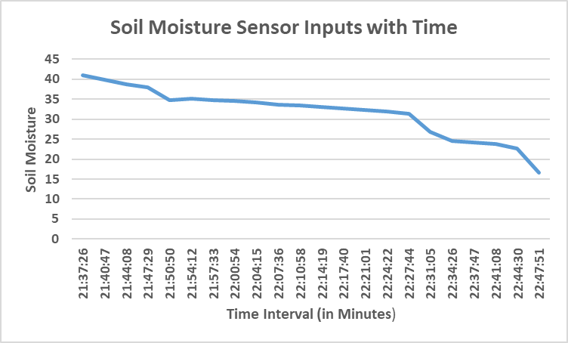

Figure 5: Information retrieved from the soil moisture sensor with a time interval of minutes

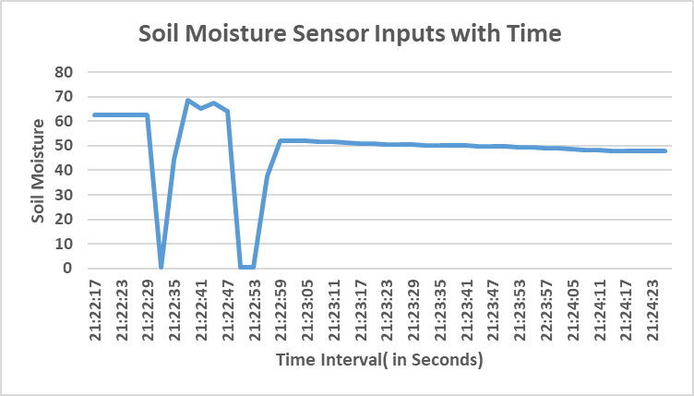

Figure 6: Information retrieved from the soil moisture sensor with a time interval of seconds

**To calibrate the sensor the two reference points are considered such as the soil is considered to have 0% moisture when the sensor is in the air and 100% moisture when it is completely dipped water. Fig. 7 represent voltages change due to variation in moisture. At 0% moisture, the voltage variations from 705 to 625 and readings stop at 625 volts, which corresponds to 0% soil moisture. With 100 percent moisture, the voltage variations are from 282 to 292 and readings stop at 292 volts, so this is considered 100 percent soil moisture.**

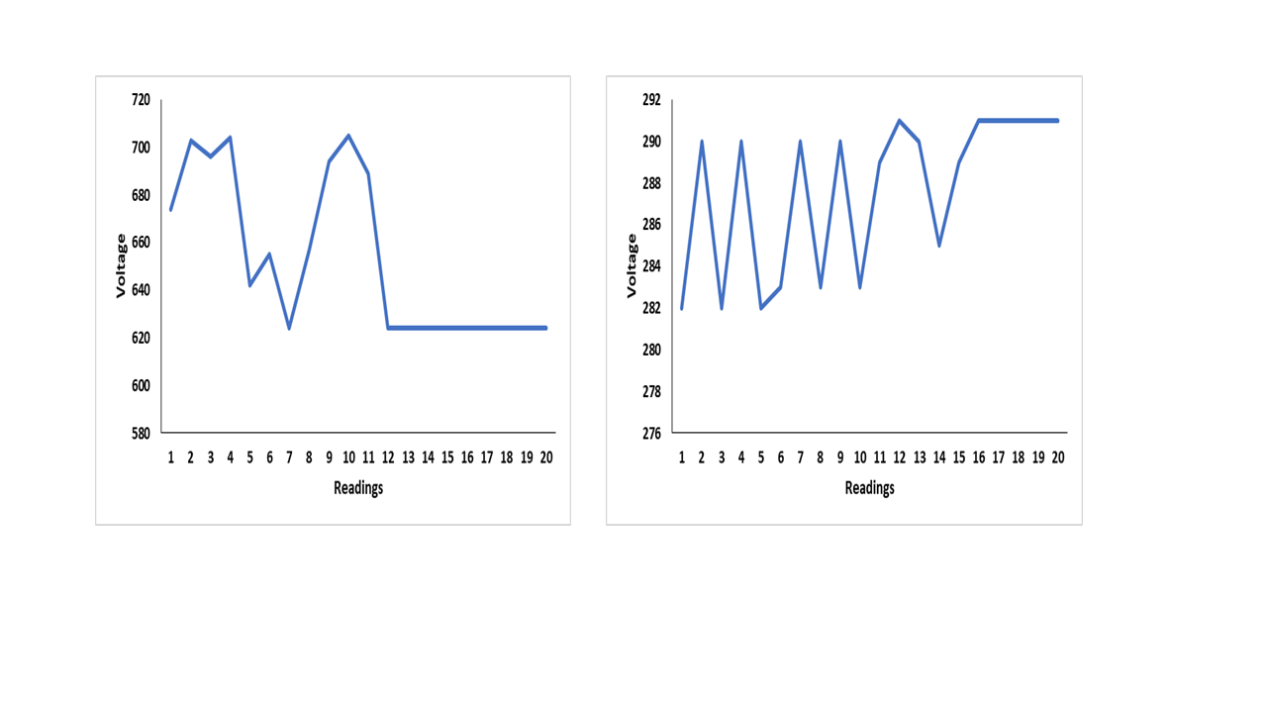

Figure 7: Variation in voltages when 0% moisture and 100% moisture

**Accessing soil samples and analysing their soil moisture at various periods of the day constitutes the second method. The soil is allowed to dry at the room temperature. The soil is prepared for a variety of conditions, including total dry, semi-humidity, and saturation. As depicted in Figure 8, the capacitive soil moisture sensor readings are synchronised with the moisture metre.**

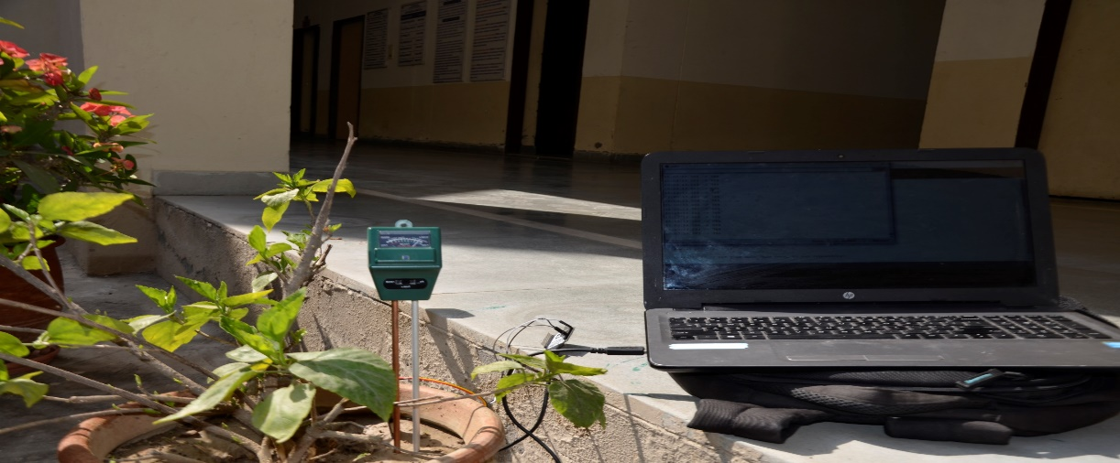

Figure 8: Sample Moisture Meter reading

The various trials are performed to compare soil moisture given by moisture meter(standard device) and sensor. The calculation of absolute and relative errors is helpful to find out errors. The mean percent error is - 4.226112 which is acceptable. The following equations give Absolute Error (AE), Relative Error (RE) and Mean Percent Error (MPE). Fig. 9 shows observed and expected (moisture meter reading) soil moisture values.



Figure 9: Observed and Expected (Moisture Meter Reading) Soil Moisture Sensor Values

Data Collection: Figures 10 and 11 depict the graphical illustration of soil moisture sensor and temperature sensor information collected on the Thingspeak cloud. A user-friendly online interface facilitates the visualization of sensor data in graphical form. Cloud data storage ensures data accessibility and availability from anywhere, facilitating remote monitoring and control of the irrigation system.

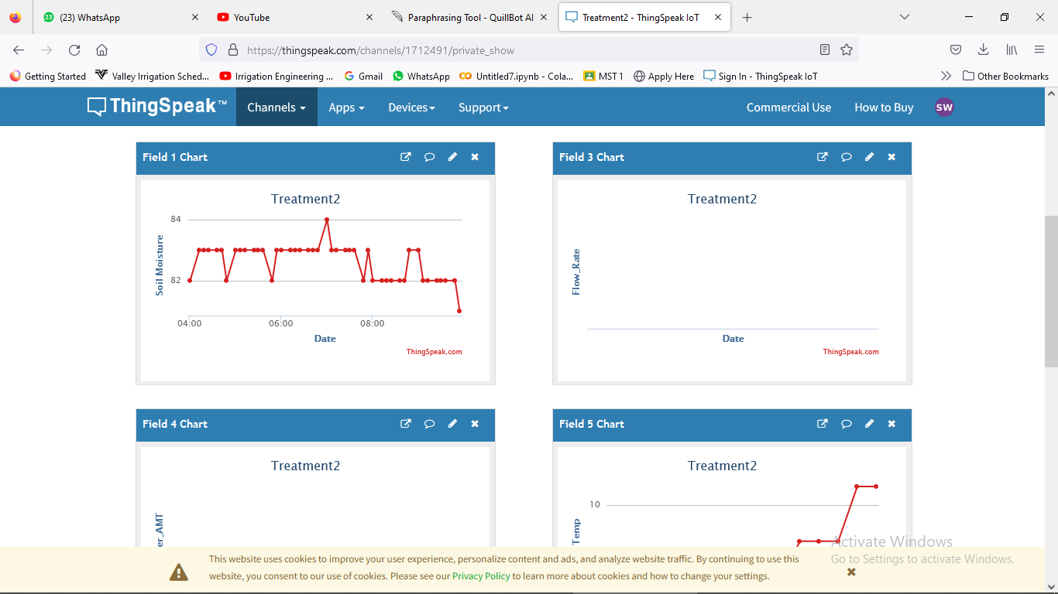

Figure 10: Soil moisture sensor information collected on the Thingspeak cloud

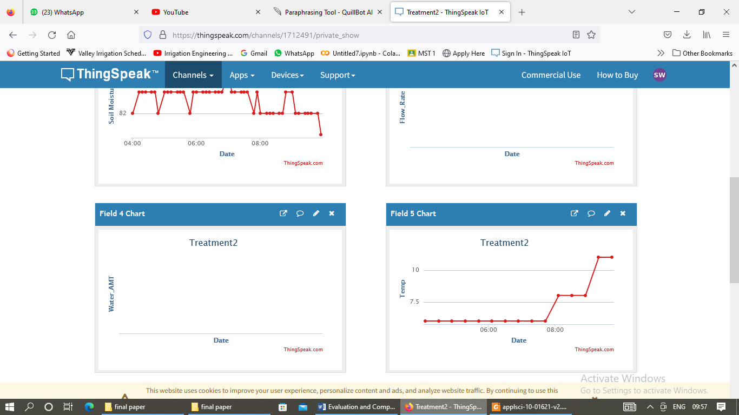

Figure 11: Graphical illustration of temperature sensor information collected on the Thingspeak cloud

**Weather forecast Data:** The weather forecast component uses an application programming interface (API) to take  forecast information from the web. City names, latitudes, longitudes, minimum and maximum temperatures, wind speeds, wind directions, cloudiness, and precipitation are all included in the dataset. Fig. 12 depicts daily maximum and minimum temperatures in Celsius corelated with respective the date and time obtained from online weather forecast. Fig. 13 shows the percentage of cloudiness against the date and hour based on an online weather forecast.

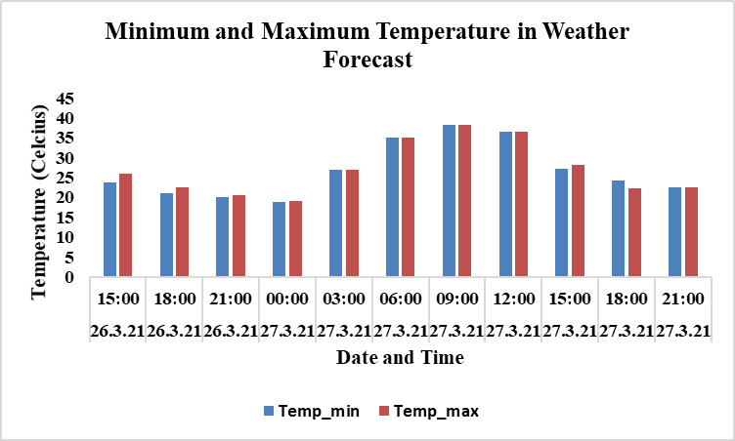

Figure 12:Daily Minimum and Maximum Temperature Data Extracted from Online Weather Forecast

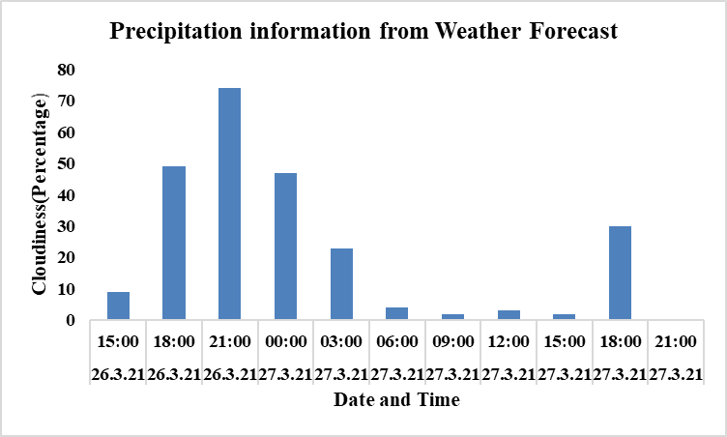

Figure 13: Daily Cloudiness (Percentage) in Online Weather Forecast

1. **Challenges and Future Directions**

The IoT and Evapotranspiration based irrigation Systems provide solutions for water conservation and improve agriculture. The implementation of that system has challenges are given as follows:

1. The Evapotranspiration prediction module requires complicated weather data parameters like altitude, sunshine, wind speed and atmospheric pressure.  The selection of a method that calculates ET accurately with the fewest parameters is a challenge.
2. The cost effectiveness of a solution is determined by the price of hardware components, sensors, and the deployment of an automated irrigation system.
3. The Punjab region has unreliable power supply especially in paddy season so consistent power supply for IoT devices can be a challenge.
4. IoT-based systems create huge amounts of data from sensors, and handling this data via cloud and webserver.
5. The lack of readily available crop data and meteorological data datasets poses a challenge to research.
6. Due to the high cost of installation, farmers have resisted to use the system. To obtain user acceptance and convincing them of the benefits such as increased crop yields and water savings.

Several potential solutions and enhancements are considered for overcoming the previously mentioned challenges in implementing automated systems:

1. The temperature based Hargrevas Samani method is used to calculate ET of training and testing data. The FNN based ETo prediction module was degined based on weather forecast.
2. The proposed system use open source technologies and low cast past to ensure cost effectiveness.
3. The various operations are scheduled according to temperature of the day so it ensure power saving system.
4. In proposed system data is saved on cloud that is easy to use, access and maintain.
5. The datasets are maintained for the research.
   1. **Future Directions**

The future of IoT-based Evapotranspiration Systems in agriculture highlights the following areas :

1. Machine learning and artificial intelligence algorithms are used to optimise irrigation schedules based on historical data.
2. Include a weather station in the system to improve irrigation decision accuracy and to provide real-time weather patterns.
3. The utilization of drones and remote sensing technology for large-scale data collecting for precise irrigation across vast agricultural areas.
4. Develop the strategies for expanding the systems to cover vast agricultural areas.
5. **Conclusion**

The proposed automated irrigation systems provide a sustainable solution for conserving resources like water, energy and manpower. The literature review have been carried out to uncover hardware deployment, sensors selection, smart algorithms and scholarly foundation in terms of research background. In the subsequent section, fundamental activities and common framework was illustrated. A robust and efficient automated irrigation system was suggested based on IoT and Evapotranspiration for irrigation scheduling. The system utilizes online weather forecast, predicted evapotranspiration and sensor inputs to optimize water usage in precision irrigation. By minimizing resource wastage through automated irrigation enhances crop productivity is particularly significant in regions facing water scarcity. This is especially important in regions with a water shortage, high deployment costs, less power sources, and the influence of vagaries and disturbances such as climate variations, weather fluctuations, soil type, and salinity pose the greatest obstacle for automated irrigation systems. To minimise these factors and enhance the system's response are future research priorities. Governments, researchers, and farmers must collaborate for the implementation and adoption of such systems to be lucrative.

References

1. S. S. Zanetti, E. F. Sousa, V. P. Oliveira, F. T. Almeida, and S. Bernardo, “Estimating Evapotranspiration Using Artificial Neural Network and Minimum Climatological Data,” Journal of Irrigation Drainage Engineering, vol. 133, no. 2, pp. 83–89, 2007.
2. J. Kwok and Y. Sun, “A smart IoT-based irrigation system with automated plant recognition using deep learning,” ACM International Conference Proceeding Ser., pp. 87–91, 2018.
3. A. Murthy, C. Green, R. Stoleru, S. Bhunia, C. Swanson, and T. Chaspari, “Machine learning-based irrigation control optimization,” BuildSys 2019 - Proceedings ACM International Conference Syst. Energy-Efficient Buildings, Cities, Transport, pp. 213–222, 2020.
4. M. Cruz-Blanco, I. J. Lorite, and C. Santos, “An innovative remote sensing based reference evapotranspiration method to support irrigation water management under semi-arid conditions,” Agricultural Water Management, vol. 131, pp. 135–145, 2014.
5. S. Ghosh, S. Sayyed, K. Wani, M. Mhatre, and H. A. Hingoliwala, “Smart irrigation: A smart drip irrigation system using cloud, android and data mining,” in Proceedings of IEEE International Conference on Advances in Electronics, Communication and Computer Technology, ICAECCT, pp. 236–239, 2017.
6. F. Hu and L. Shao, “Design of remote irrigation system in farmland based on the cloud platform,” Proc. 29th Chinese Control Decis. Conf. CCDC 2017, pp. 1125–1129, 2017.
7. A.G. N. Bandara, B. M. A. N. Balasooriya, H. G. I. W. Bandara, K. S. Buddhasiri, M. A. V. J. Muthugala, A. G. B. P. Jayasekara, and D. P. Chandima, “Smart irrigation controlling system for green roofs based on predicted evapotranspiration,” Proceedings of Electrical Engineering Conference (EECon), pp. 31–36, 2017.
8. N. Kaewmard and S. Saiyod, “Sensor data collection and irrigation control on vegetable crop using smart phone and wireless sensor networks for smart farm,” ICWiSe 2014 - IEEE Conference Wireless Sensors, pp. 106–112, 2014.
9. O. Adeyemi, I. Grove, S. Peets, Y. Domun, and T. Norton, “Dynamic neural network modelling of soil moisture content for predictive irrigation scheduling,” Sensors (Switzerland), vol. 18, no. 10, 2018, doi: 10.3390/s18103408.
10. A. Sivagami, U. Hareeshvare, S. Maheshwar, and V. S. K. Venkatachalapathy, “Automated irrigation system for greenhouse monitoring,” Journal of The Institution of Engineers (India), vol. 99, no. 2, pp. 183–191, June 2018.
11. S. K. Lenka and A. G. Mohapatra, “Neuro-fuzzy-based smart DSS for crop specific irrigation control and SMS notification generation for precision agriculture,” International Journal of Convergence Computing, vol. 2, no. 1, pp. 3–22, 2016.
12. E. Giusti and S. Marsili-Libelli, “A fuzzy decision support system for irrigation and water conservation in agriculture,” Environmental Modelling & Software, vol. 63, pp. 73–86, 2014.
13. J. Gutierrez, J. F. Villa-Medina, A. Nieto-Garibay, and M. A. Porta-Gandara, “Automated irrigation system using a wireless sensor network and GPRS Module," IEEE Transactions on Instrumentation and Measurement, vol. 63, pp. 166–176, 2014.
14. G. Kavianand, V. M. Nivas, R. Kiruthika, and S. Lalitha, “Smart drip irrigation system for sustainable agriculture,” in Proceedings of IEEE Technological Innovations in ICT for Agriculture and Rural Development (TIAR), pp. 19–22, 2016.
15. F. Touati, M. Al-Hitmi, K. Benhmed, and R. Tabish, “A fuzzy logic based irrigation system enhanced with wireless data logging applied to the state of Qatar,” Computers and Electronics in Agriculture, vol. 98, pp. 233–241, 2013.
16. Water Ethics and the World Commission on the Ethics of Scientific Knowledge and Technology, & Appelgren, B. (2004). Water in agriculture (5).
17. Obota, M. E., & Inyama, H. C.,” Soil moisture based irrigation control system for rice cropping using wireless sensor network. The International Journal of Engineering and Science (IJES), 2(3), pp. 37–43, 2013.
18. S. K. An, H. B. Lee, J. Kim, and K. S. Kim, “Efficient Water Management for Cymbidium Grown in Coir Dust Using a Soil Moisture Sensor-Based Automated Irrigation System,” Agronomy 2021, 11(41), 2021.
19. O. Aydin, C. A. Kandemir and U. Kirat, "An artificial intelligence and Internet of things based automated irrigation," in International Conference on Computer Applications in Food and Agriculture, Konya, 2019.
20. M. S. Munir, I. S. Bajwa, A. Ashraf, W. Anwar and R. Rashid, “Intelligent and Smart Irrigation System Using Edge Computing and IoT,” Wiley Complexity, 2021, doi: 10.1155/2021/6691571.
21. S. Walls, A. D. Binns, J. Levison, and S. MacRitchie, “Prediction of actual evapotranspiration by artificial neural network models using data from a Bowen ratio energy balance station,” Neural Computing and Applications, vol. 32, no. 17, pp. 14001–14018, Mar. 2020, doi: 10.1007/s00521-020-04800-2.
22. V. Z. Antonopoulos and A. V. Antonopoulos, “Daily reference evapotranspiration estimates by artificial neural networks technique and empirical equations using limited input climate variables,” Computers and Electronics in Agriculture, vol. 132, pp. 86–96, Jan. 2017, doi: 10.1016/j.compag.2016.11.011.
23. F. Üneş, S. Doğan, B. Taşar, and Y. Kaya, “The Evaluation and Comparison of Daily Reference Evapotranspiration with ANN and Empirical Methods,” Natural and Engineering Sciences, pp. 55–63, 2018.
24. M. K. Saggi and S. Jain, “Reference evapotranspiration estimation and modeling of the Punjab Northern India using deep learning,” Computers and Electronics in Agriculture, vol. 156, pp. 387–398, Jan. 2019, doi: 10.1016/j.compag.2018.11.031.
25. A. T. Ogunrinde, I. Emmanuel, M. A. Enaboifo, T. A. Ajayi, and Q. B. Pham, “Spatio-temporal calibration of Hargreaves–Samani model in the Northern Region of Nigeria - Theoretical and Applied Climatology,” SpringerLink, Dec. 28, 2021. https://link.springer.com/article/10.1007/s00704-021-03897-2
26. M. E. Karar, F. Alotaibi, A. A. Rasheed, and O. Reyad , “A Pilot Study of Smart Agricultural Irrigation using Unmanned Aerial Vehicles and IoT-Based Cloud System,” International Journal of Information Sciences Letters, 2021, [Online]. Available: https://arxiv.org/ftp/arxiv/papers/2101/2101.01851.pdf
27. L. M. Silalahi, D. Jatikusumo, S. Budiyanto, F. A. Silaban, I. U. V. Simanjuntak, and A. D. Rochendi, “Internet of things implementation and analysis of fuzzy Tsukamoto in prototype irrigation of rice,” International Journal of Electrical and Computer Engineering (IJECE), vol. 12, no. 6, p. 6022, Dec. 2022, doi: 10.11591/ijece.v12i6.pp6022-6033.
28. R. Dhanalakshmi, L. Kavisankar, and S. Balasubramani, “A Novel Technique using IoT Based Automated Irrigation System for Smart Farming,” Journal of Applied Science and Engineering, vol. 25, no. 4, 2022, [Online]. Available: http://jase.tku.edu.tw/articles/jase-202208-25-4-0009
29. United Nations, “Water and Sanitation,” United Nations Sustainable Development, 2020. https://www.un.org/sustainabledevelopment/water-and-sanitation/
30. Z. Gu, T. Zhu, X. Jiao, J. Xu, and Z. Qi, “Neural network soil moisture model for irrigation scheduling,” Computers and Electronics in Agriculture, vol. 180, p. 105801, Jan. 2021, doi: https://doi.org/10.1016/j.compag.2020.105801.