Plasmonic Nanoparticles: Synthesis, Processing, Characterization, and Applications
Dasari Ayodhya
Chemical Group, Intellectual property India, Patent Office, Chennai-600032, Tamil Nadu, India
E-mail: ayodhyadasari@gmail.com

ABSTRACT
This book chapter presents the main characteristics of plasmonic nanoparticles (PNPs), especially consisting of noble metal such as silver (Ag), gold (Au), and palladium (Pd), and brief information on their synthesis methods. The physical and chemical properties of the metal NPs are described, with a particular focus on the optically variable properties (surface plasmon resonance based properties) and surface-enhanced Raman scattering of plasmonic materials. Plasmonic NPs have attracted particular attention due to strong optical, electrical, biological, and catalytic effects they are accompanied with Surface plasmon resonance characteristics of plasmonic NPs and their assemblies enable fine-tuning of these effects with unprecedented dynamic range. In turn, the uniquely high polarizability of plasmonic nanostructures and related optical effects exemplified by surface-enhanced Raman scattering and red–blue color changes give rise to their application to bio-sensing. In addition, this chapter covers ways to achieve advances by utilizing their properties in the catalytic, sensing, and biological studies. These descriptions will help researchers new to nanomaterials for catalytic and biomedical diagnosis to understand easily the related knowledge and also will help researchers involved in the biomedical field to learn about the latest research trends.
Keywords - Plasmonic nanoparticles; Noble metals; SPR; Properties; Catalysis; Biological activity.
I. INTRODUCTION
Plasmonic nanoparticles are particles whose electron density can couple with electromagnetic radiation of wavelengths that are far larger than the particle due to the nature of the dielectric-metal interface between the medium and the particles: unlike in a pure metal where there is a maximum limit on what size wavelength can be effectively coupled based on the material size [1]. Metal nanoparticles (MNPs) containing only a few atoms up to a few hundred are versatile materials with broad applications in area such as optics, electronics, biosensors, biomedicines, and catalysis [1–5]. To produce MNPs, molecular templates and organic ligands have been utilized. When molecular templates other than organic ligands are used, the protected MNPs may lose their catalytic capability due to the almost complete blockage of surface active atoms [3–5]. Therefore, developing an easy, flexible, and effective method to produce ultra-small (< 5 nm), highly-dispersed, functionalized, and ultra-stable MNPs is highly desirable. Plasmonic nanoparticles including noble-MNPs, such as those made of Au, Ag, and Pt, are considered ingenious forms of nanomaterials due to their unique physicochemical properties [6]. Among them, noble NPs are highly stable nanostructures that possess tunable optical properties and can be prepared in a variety of shapes, making them an attractive subject of scientific and technological research in recent years [4–5]. MNPs have a long history of application in catalytic, sensing, bio-imaging, drug-delivery vehicles, and other fields [7]. Additionally, recent studies have been reported on the catalytic degradation of dyes and other pollutants, as well as the detection of various metal ions using MNPs [8].
Over the last two decades, the potential of plasmonic nanoparticles (PNP) as green and performing hydrogenation photocatalysts has been the subject of intense research. The photoinitiated localized surface plasmon resonance (LSPR) of these PNPs has demonstrated its ability to enhance catalytic reductive transformations across a range of substrates, toward more selectivity, higher yields, and milder reaction conditions. Plasmonic metals, like silver and gold, exhibit photothermal effects arising from their LSPR. For instance, triangular silver nanoplates have been widely explored for their photothermal effects under NIR laser irradiation [9]. As for gold, a typical absorption band of gold nanospheres is presented in the 500 to 550 nm region due to their LSPR. When the particle size increases, there is some LSPR red shift due to electromagnetic retardation in larger particles. Metal nanoparticles have a plethora of uses, notably antimicrobial activity, radical scavenging activity, anti-inflammatory activity, oxidation, hydrogenation reactions, reduction reactions of nitro-arenes, -C–C- coupling reactions [9] and also in environmental remediation process to degrade many organic pollutants which are lethal and interfering with human and aquatic life as catalysts. The enhanced physicochemical properties that are attributed to nanoparticles are possibly due to miniaturization [10]. Earlier, the conventional studies reported on the preparation of transition metal nanoparticles like platinum, silver, gold, copper, and palladium, etc., involved the usage of toxic, expensive, multistep procedures like chemical reduction, electrochemical reduction, sol–gel methods that are either eco-friendly or economical procedures. Among noble MNPs, PdNPs are considered as one of the most precious transition metal nanoparticles, used in many organic transformations like oxidation, reduction of nitroarenes, -C–C- coupling reactions [9], and so on. Moreover, PdNPs are distinctive due to high stability and catalytic activity [9]. As a result, the current study describes the green chemistry based production of effective PdNPs.
The major source of organic pollutants in the water today is through industry, and these man-made chemicals are extremely harmful to the ecosystem and have an impact on human health issues [8]. The products from nitro aromatic compounds are used in the synthesis of pesticides, dyes, drugs, and explosives. The nitrophenols are known to pose a number of menaces to human health, including the irritability of skin and eyes, causing harm to kidneys, liver, organ damage, and central nervous system dysfunction [11]. Several types of nanoparticles used as catalysts, including Ni, Au, Co, Fe, Ag, Pd, and Cu, were effectively prepared and utilized in superior catalytic reduction of 4-NP in the presence of reducing agents [12]. Among them, PdNPs have outstanding catalytic activity in 4-NP reduction and -C–C- coupling reactions due to their higher electron-accepting ability [11]. In addition, Figure 1 shows the different application categories of plasmonic nanoparticles/nanostructures. In photocatalytic progressions, the energy of the photons could be used to initiate several beneficial chemical reactions together with solar energy production in future fuel and water treatment applications. The photodegradation developments are potentially quite advantageous. Alterations from solar energy to chemical energy also have numerous advantages over conversions from solar energy to electric energy conversion using plasmonic nanostructures.
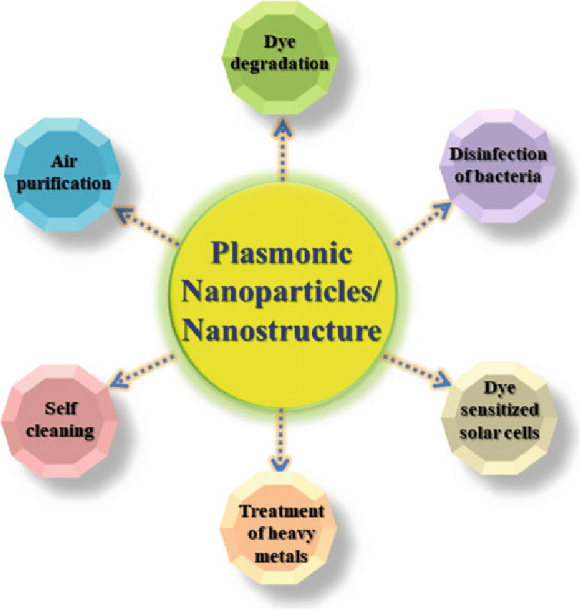
Fig. 1 Several possible fields of application using plasmonic nanoparticles/nanostructures [13]
II. DESIGN
A. Plasmonic materials by leaf extracts
Previously, a variety of physical and chemical methods of preparation were used, such as thermal breakdown, laser irradiation, and electrolysis, which need sophisticated technology and a lot of energy [14]. Chemical synthesis, like chemical reduction, has limitations due to the usage of dangerous chemicals, high temperatures, and/or pressures required for it to function [14]. It may also produce poisonous byproducts. Although biological approaches that synthesize nanoparticles using bacteria, fungus, yeast, viruses, and plant biomass/extract are popular as they are environmentally beneficial [15]. Plant-mediated biosynthesis of metallic nanoparticles occurs through biomolecules (such as proteins, vitamins, enzymes, polysaccharides, amino acids and organic acids such as citrates) present in the plant biomass which has been used in waste management and dye reduction [16]. The synthesis of nanoparticles using plant extracts can provide an inexpensive, green, and facile alternative to chemical synthesis [17]. Different forms of metal salts of Ag, Au, Pt, and Pd can be converted to nanomaterials by reducing them using various methods, such as hard templates, plants, bacteria, and fungi. Sugars, ﬂavonoids, phenolic acids, terpenoids, polyphenols, and other metabolites were present in plant parts act as reductants for transforming metallic atoms and ions into nanoscale materials [18]. The use of plant-mediated biosynthesis to synthesize metal nanoparticles has gained tremendous popularity in recent years due to its fast and safe nature, environmental friendliness, and nonpathogenic. Contrary to traditional chemical or physical techniques, green synthesis typically involves a few simple steps requiring minimal energy, pressure, or temperature [19]. Because of this, the process is energy-efficient and, in addition to being a large scale production method, it is also extremely cost-effective. Here, biologically active elements serve as both a reductant and a cap. Recent studies have investigated the use of metal nanoparticles especially Au, Ag, and PdNPs as therapeutic agents for treating a variety of diseases. An efficient, economical, and environmentally safe method for synthesizing these nanomaterials is therefore one of the most important research directions in biomedical nanotechnology [20].
B. Plasmonic materials by natural gums
Green synthesis of MNPs has recently gained popularity in the field of nano-biotechnology due to their unique biological, catalytic, electrical, and optical properties [21]. With an estimated production of 500 tons/year of nanosilver globally, AgNPs are highly commercialized and are commonly used in the textile industry for their antibacterial properties, which have been recognized since ancient Greek times [22]. Moreover, this encouraged the textile industry to use AgNPs in different textile fabrics [22]. Traditional methods for AgNPs preparation require strong reducing agents or radiation, but green synthesis methods, utilizing plant materials, microorganisms, and various bio-wastes, have emerged as a promising area of research for creating nanomaterials that are environmentally friendly, cost-effective, and stable [23]. Xanthan gum is a type of extracellular polysaccharide that is secreted through the fermentation process of the bacterium Xanthomonas campestris [23]. Its structure consists of a linear D-glucose backbone linked to a trisaccharide side chain containing D-mannose with an acetyl group, D-glucuronic acid, and a terminal D-mannose unit linked to a pyruvate group, D-glucose, D-mannose, and D-glucoronic acid in a ratio of 2:2:1 [24]. Xanthan gum is highly stable over a wide range of pH and temperature and is resistant to enzymatic degradation. Due to its non-toxic and biocompatible properties, it has been extensively used in the food and pharmaceutical industries [25]. In this study, xanthan gum was utilized as both a reducing and stabilizing agent for the synthesis of AgNPs. The synthesis was performed using the Monowave method, which is a synthetic route that produces sterile AgNPs that are entirely free from bacteria, viruses, and spores, thus having biological implications [26]. The synthesis was carried out in an aqueous medium without adding any reducing agents.
C. Plasmonic materials by Schiff bases
The Schiff base ligands with N,O-donors are employed in the metal ion-directed assemblies of coordination architectures [27]. These Schiff bases have been used in a multitude of different applications areas such as medical, biological, sensing, and catalytic applications [28]; in addition to its broad spectrum of biological activities such as antiviral, antifungal, antiparasitic, antibacterial, anti-inﬂammatory, antitumor, anti-HIV, and anticancer [29-30]. The well-defined Schiff base ligands containing nitrogen donor atoms are considered as ‘privileged ligands’ because of their capability to stabilize different metals in various oxidation states, and their complexes are extensively studied due to their synthetic flexibility, selectivity and sensitivity toward a variety of metal ions [30]. Schiff bases have been successfully used in several studies as highly efficient and selective sensing materials for diverse ion sensors such as optical, electrochemical and membrane sensors [31]. Depending upon the type of Schiff base, these structures displayed selectivity towards specific metal ions over the others due to the unique size of the ion, the electron configuration of both the ligand and the metal, the charge on the metal ion, the hard-soft acid base nature of both the metal and donor atom from the Schiff base, and size of the cavity of the Schiff base. Schiff bases are versatile organic ligands that form numerous stable complexes when co-ordinate with different transition metal ions, making them important chemical compounds in various fields such as inorganic, analytical, and medicinal chemistry [32]. Due to their strong affinity and actual confinement provided by their open, well-isolated, and abundant structure, using MNPs as a platform for the confined growth of MNPs with ultra-small size, high-disposability, and high-stability is a promising approach [33]. Thus, encapsulating MNPs within Schiff bases may provide an unusual synergy for developing a new generation of heterogeneous catalysts [34]. So far, many researchers have been reported AuNPs by using various biological systems like plants and its parts (flowers, fruits, leaf, seeds, stem, and root), proteins, carbohydrates, algae, and microbes (bacteria, fungi, yeast) can transform inorganic metal ions into metal nanoparticles via the reductive capacities of the proteins and metabolites present in these organisms for various applications [35]. In addition, a few reports are discussed about the properties and applications of MNPs by using Schiff bases [36]. To the best of our knowledge, the synthesis of AuNPs by different processes have been extensively explored, including a chemical process that gives particles the desired characteristics. The two phases of chemical synthesis are reduction by a reducing agent and stabilization of the generated nanoparticles using an appropriate stabilizing agent, which is preventing particle aggregation and stable.
III. SYNTHESIS
A. Synthesis of plasmonic NPs using plant extracts
In the preparation of PdNPs, 10 ml of the stock solution of leaf extract was dissolved in 90 ml double distilled water slowly by stirring to make 1% w/v solution of PG leaf extract. The solution was then filtered using Whatmann Filter Paper No. 41 to get pure leaf extract. Approximately 5 ml of 1 mM PdCl₂ solution was dissolved in 10 ml of 1% w/v PG leaf extract solution in a beaker. The microwave radiation of 450 W was applied to the reaction mixture for 30 s. The procedure involved changing the light yellow colour solution to a dark brown colour solution to authenticate the creation of PdNPs as depicted in Fig. 2. To generate a 1% w/v BM ﬂoral extract solution for the synthesis of PdNPs, 5 mL of the stock solution of flower extract was gently dissolved in 5 mL of double distilled water while stirring. The solution was then fltered using Whatman flter paper no. 41 to get the pure aqueous extract. A beaker containing 10 mL of 1% w/v BM ﬂower extract solution and 1 mM PdCl₂ solution was used. The reaction mixture was autoclaved for 10 min at 15 lbs of pressure and 120 ◦C temperature. The transformation of the yellow reaction mixture solution to a dark brown colour during the synthesis verifed the development of PdNPs. Once, the formation of PdNPs, the solution was centrifuged at 11,000 rpm for 30 min to remove the insoluble materials and the supernatant was used for all the experiments. In this process of autoclaving makes the PdNPs intrinsically safe and sterile, in environmentally benign solvent water [37]. Moreover, generation of BM ﬂower extract-PdNPs by autoclaving is a prerequisite for biological applications as shown in Fig. 2.
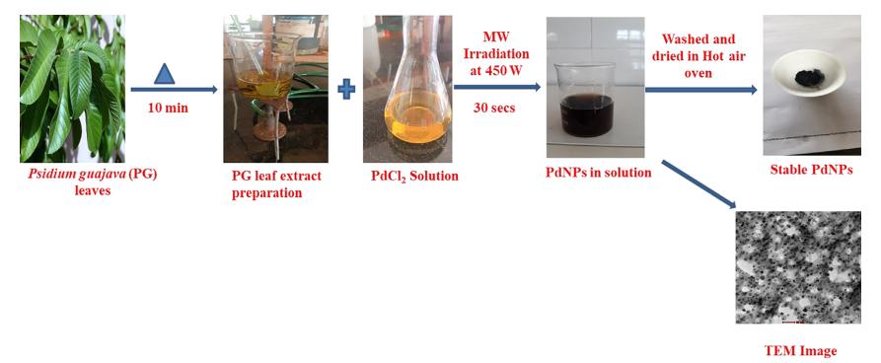
Fig. 2 The green synthesis of PdNPs utilizing aqueous decoction of Psidium guajava leaf extract [37]
B. Synthesis of plasmonic NPs using natural gums
To synthesize Xanthan gum stabilized AgNPs, a test tube was filled with 5 mL of aqueous silver nitrate (0.5%) solution and 5 mL of aqueous xanthan gum (0.5%) solution. The reaction was performed at 150 ◦C for various time intervals, namely 5, 10, 15, 20, 25, and 30 min, using a Monowave method. Subsequently, the test tube was removed from the Monowave and used for further characterization and investigation without any additional treatment. The cashew gum was obtained from the anacardium occidentale tree and purified using the slight modification process as mentioned in the previous reports [38]. The modified gum was carboxymethylated using monochloroacetic acid as an esterification agent to obtain the carboxymethylated gum as described in our previous study [39]. 1 g of CG was distributed in 80 mL of ice cold NaOH solution (45% w/w), supplemented by 10 mL of monochloroacetic acid solution (75% w/v). The reaction mixture was then heated for 2 h at 75 °C with continuous stirring. After that, the reaction mixture was cooled to room temperature and suspended in methanol with 80% (v/v) concentration. The resulting precipitate was purified and neutralized with glacial acetic acid. Finally, the product was again washed with methanol and dried in hot air oven at 40 °C for 6 h. To obtain the CMCG extract, 100 mg of CMCG fine powder was dispersed in 10 mL of double distilled water for 30 min to obtain a 1% stock solution. Then, 2.5 mL of 10 mM HAuCl₄ solution was added to the CMCG solution and treated with microwave irradiation at 450 W for 2 min in a domestic microwave oven. The Au⁺³ ions were reduced under these conditions from the reaction mixture and the colour of the solution was changed from pale yellow to wine red. After completion of the reaction, the final solution was centrifuged for 15 min at 15,000 rpm to form the pellet. Then the pellet was dispersed in double distilled water and final concentration was 1 mg/mL. The similar procedure was applied to prepare CG-AuNPs under identical conditions. The specific properties of CMCG allow for the rapid biosynthesis of narrow-sized AuNPs and that can be used in heavy metal detection and dye removal applications (Fig. 3) [40].
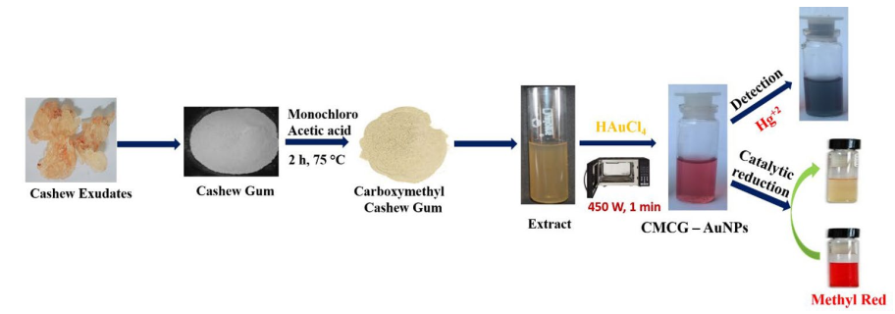
Fig. 3 Schematic representation for preparation of CMCG-AuNPs and its application for catalytic reduction of methyl red and detection of Hg²⁺ ions [40]
C. Synthesis of plasmonic NPs using Schiff bases
The AuNPs was synthesized using Schiff base as a stabilizing agent, which gold (III)chloride trihydrate (HAuCl₄⋅3H₂O) salt is reduced to AuNPs using Schiff base. In order to synthesize Schiff base stabilized AuNPs, 100 mL of boiling water was added 10 mL of preheated Schiff base solution (1 %, w/w) and 8.5 mg of HAuCl₄ salt; and the mixture solution was kept for about 6 h under magnetic stirring, until the solution color turns to ruby red which is the characteristic indication for the formation of AuNPs. Due to the presence of –OH and –C– –N groups in the Schiff base, the Au⁺³ ions reduced to Au(0) results AuNPs, further confirmed by obtaining the characteristic ruby red color to the solution. An equal molar ratio of HAuCl₄.3H₂O and NaBH₄ was dissolved in a mixture of ethanol and DD water in a 100 mL container at pH 7.0. After that, the synthesized TMPM4CP (2-(4-(trifluoromethoxy) phenylimino) methyl)-4-chlorophenol) was dissolved in acetone and added to the aqueous solution. The resulting mixture was vigorously stirred for 5 h at 27ºC. The completion of the reaction was indicated by a change in the organic layer color from yellow to light-pink indicated the formation of Schiff base stabilized AuNPs. Schiff base (TMPM5MΟP) was fabricated through adding 10 mM, 25 mL of 4-(trifluoromethoxy)benzenamine to10 mM, 25 mL of 2-hydroxy-4-methoxy benzaldehyde in equal ratio with unremitting stirring and refluxing at 65 ºC for 3 h. The obtained precipitate was isolated, filtered, and recrystalised in CH₃OH. In the fabrication of AgNPs, equal ratio of AgNO₃ and NaBH₄ were added slowly to TMPM5MOP solution and unremitting stirring for 5 h. The changing in color from light yellow to dark brown is evidence for the formation of AgNPs. AgNPs were synthesized by Brust-Schiffrin technique, which is a two-step phase transfer synthesis as reported in the previous work [36]. During the process, equal molar ratio of AgNO₃ and sodium borohydride (NaBH₄) was dissolved separately in ethanol and triple distilled water respectively. Both solutions were purged with nitrogen for 30 min and then the NaBH₄ solution was slowly added drop-wise to the ethanolic solutions of AgNO₃ with vigorous stirring and the temperature was maintained above 60 °C in nitrogen atmosphere. After the addition, synthesized Schiff base ligand was dissolved in acetone and introduced to the aqueous solutions and vigorously stirred for five hours. The colour change of organic layer from yellow to dark brown and black indicates the formation of Schiff base capped AgNPs. The organic layer was carefully separated and washed with triple distilled water four times and reduced to 20% in rota evaporator. This reduced organic phase solution was stored overnight and diethyl ether was added and dark solid precipitate obtained was isolated and washed with petroleum ether for several times and recrystallized by ethanol. The schematic representation for the synthesis of Schiff base capped AgNPs is shown in Fig. 4 [41].
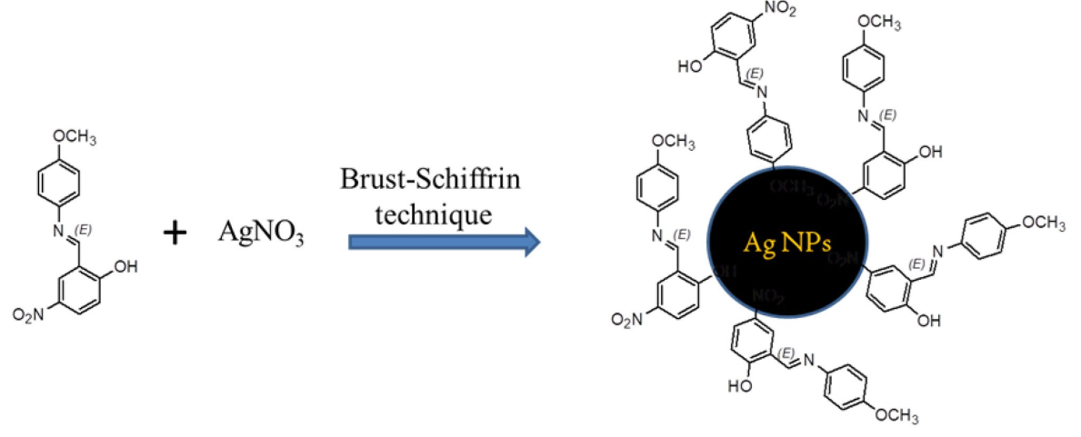
Fig. 4 The schematic representation for the synthesis of Schif base capped AgNPs [41]
IV. CHARACTERIZATION
The UV–Visible absorption spectra of Plasmonic NPs is recorded using UV-1800 (Shimadzu) in the range of 200–800 nm. The FT-IR spectral analysis of the synthesized PNPs was done by a spectrum-100 FT-IR spectrophotometer from Bruker (ALPHA, USA) within a fixed spectral range, i.e., 4000–400 cm⁻¹. Powder diffraction (XRD) was done using Rigaku Miniﬂex 600 X-Ray powder diffractometer in a 2-theta range of 10–80◦. The Dynamic Light Scattering (DLS) (Horiba Nano particle analyzer Sz-100) was used to determine Zeta potential values and size distribution of formed nanoparticles. For the study of surface morphology, diameter, and shape of PdNPs, FP5018/41, TecnaiG2 spirit Biotwin–TEM was used.
A. Optical analysis of plasmonic NPs
The electronic bands of UV–vis absorption spectra of Schiff base and AgNPs were recorded in the range of 200–800 nm. The exhibited absorption bands were assigned to intra-ligand charge transition (ILCT) bands and shown in Fig. 5. For Schiff base, the maximum absorption band at 356 nm was assigned to π→ π* transition of N = N linkage and aromatic rings. Also, the n→ π* electronic transition was observed at 422 nm, it is attributed to the azo aromatic chromophore and intra-molecular charge transfer interaction. In the UV–vis absorption spectra of AgNPs, the maximum absorption band was observed at 438 nm (Fig. 5). In this case, the blue shift was found and absorption bands shifted to a lower wavelength, probably due to the effect of the size quantization. The decrease in particle size creates a blue shift. The appearance of surface plasma resonance (SPR) band at 438 nm for AgNPs specifies the formation of nanoparticles [41]. The shift of UV–vis peaks of free Schiff base ligand at 264, 356, and 422 nm to maximum wavelength of 438 nm (AgNPs) also confirms that the Schiff base strongly interacted with the AgNPs.
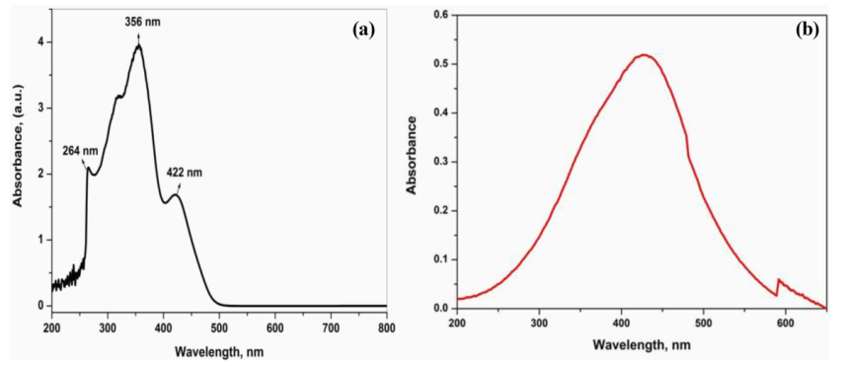
Fig. 5 UV–visible absorption spectra of a Schiff base and b Schiff base ligand capped AgNPs [41]
Formation of PdNPs was primarily monitored by UV–Vis absorption spectroscopy. Fig. 6 shows the UV–Visible absorption spectrum of as prepared PdNPs and it showed a high intense peak in the 400–420 nm wavelength range [20]. The colour change may be attributed to SPR phenomenon. During the reaction the colour of the solution changes gradually from yellow to black configuring the PdNPs formation. The color change is due to SPR phenomenon (which is the excitations of surface electron on the conduction band) as shown in Fig. 6 [42].
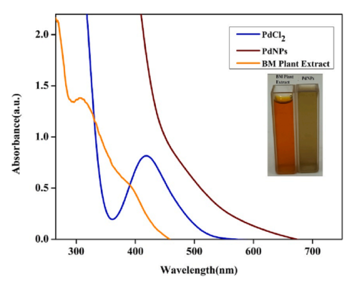
Fig. 6 The optical spectral data of the prepared PdCl₂, PG leaf extract, and PdNPs [42]
UV–vis spectroscopy was used to monitor the synthesis of CMCG-AuNPs at preliminary stage. The absorption maximum and absorption strength of the AuNPs had a major impact on the particle size. Inside the wavelength range of 510–530 nm, a higher intensity absorption peak was found, which could be due to the SPR of AuNPs. We optimize formulation conditions such as CMCG concentration, HAuCl₄ concentration and microwave irradiation time based on SPR peak strength [40].
Effect of CMCG Concentration: The UV–vis spectra of the prepared CMCG-AuNPs by different concentration of CMCG (0.1 to 1.2%), a constant concentration of HAuCl₄ and microwave irradiation time (120 s) are displayed in Fig. 7a [40]. The observed SPR peak at 528 nm was increased with the concentration of CMCG, reaching a limit with a CMCG concentration of 0.8%. It may be due to the Au³⁺ ions are reduced to AuNPs and the size of these particles can be regulated by effectively capping CMCG. The absorbance amplitude declined as the CMCG concentration was increased from 0.8 to 1.2% and the peak changed to a longer wavelength with decreased intensity, reflecting an increase in particle size. It may be attributed to the development of larger particles at higher CMCG concentrations, which acted as a reductant and dominated AuNPs nucleation and formation, similar results were observed in previous reports [43]. As a result, 0.8% CMCG was sufficient to fully reduce Au⁺³ ions to CMCG-AuNPs.
Effect of HAuCl₄ Concentration: The UV–vis spectra of CMCG-AuNPs with effect of various concentrations of HAuCl₄ (0.1 to 3 mM) were shown in Fig. 1b. It can be seen as a steady concentration of CMCG (0.8%) and at 120 s of microwave irradiation time. The SPR peak of AuNPs occurred at 528 nm, which is steadily with the rise in precursor concentration (Fig. 7b) [40], indicating the development of formation of CMCG-AuNPs. Finally, as the HAuCl₄ concentration was extended 2 mM to 3 mM, the SPR peak was moved to a higher wavelength with lower intensities, indicating that the AuNPs size was increased due to the aggregation of NPs according to the previous reports [43]. Therefore, it can be shown as the concentration of HAuCl₄ is 2 mM was optimized for the formation of AuNPs.
Effect of Microwave Irradiation Time: As shown in Fig. 7c [40], the development of CMCG-AuNPs was also tracked using a variable microwave irradiation time (30 to 150 s) and a constant concentration of HAuCl₄ (2 mM) and CMCG (0.8%). The following are some of the most important observations from the spectra, the absorption peak was wider and slower within the first 30 s of the reaction, indicating the production of larger particles, because at 30 s slow conversion of Au⁺³ to AuNPs. When the microwave irradiation time was raised to 120 s the SPR peak achieved nearly its full intensity. This indicated that a greater volume of Au⁺³ was reduced to AuNPs and the particle size was reduced. There was no difference in peak position when the time was raised to 150 s, although there was a small decrease in peak intensity, the longer time not effecting the NPs size and formation [43].
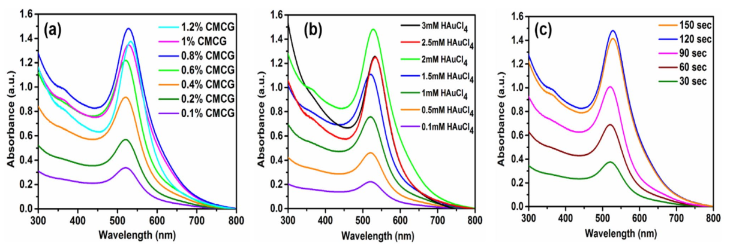
Fig. 7 The time dependent UV–vis absorption spectra of CMCG-AuNPs at a different concentrations of CMCG, b different concentrations of HAuCl₄ and c varying microwave radiation time from 30 to 150 s [40]
B. Structural analysis of plasmonic NPs
The crystallite size and lattice strain of manufactured PdNPs are well determined by Powder X-ray diffraction (XRD) pattern. The reflections from the (111), (200) and (220) planes of the face centered cubic crystal structure of produced metallic palladium are well-defined distinctive diffraction peaks observed at 2θ = 40.28◦, 45.90◦, and 66.8◦, respectively as shown in Fig. 8 [42]. The peak broadening was observed due to the result of SPR effect of PdNPs [44]. Thus, the XRD pattern confirms the extremely crystalline structure of PdNPs. The crystallite size of prepared PdNPs was calculated by using the peak broadening profile of (111) peak at 40.28◦ by Scherrer’s formula, which is 3.806 nm and well matched with the results of TEM analysis.
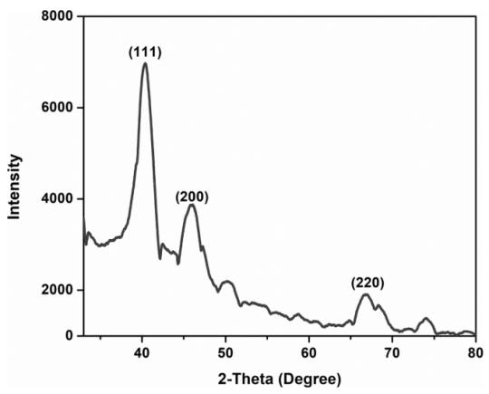
Fig. 8 The powder XRD pattern of the prepared BM ﬂower extract stabilized PdNPs [42]
X-ray diffraction (XRD) studies were performed to acquire information about the crystalline nature and average crystallite size of the synthesized AuNPs. Fig. 9 shows the XRD patterns of the synthesized Schiff base and AuNPs. The obtained XRD pattern of AuNPs was exhibited four peaks at the diffraction angles of 38.1◦, 44.51◦, 64.61◦, and 77.82◦, which are assigned to (111), (200), (220), and (311) crystal planes with face centered cubic lattice structure and agreement with the previous report [44]. The existence of diffraction peaks were matched to the standard data files (JCPDS card No. 04–0784) for all reflections [44]. These results (Fig. 4) [45] indicated that AuNPs synthesized from Schiff base are crystalline in nature. The crystalline sizes of the AuNPs were estimated using Debye-Scherrer’s equation. The average size was found 12 ± 1.5 nm corresponding to the planes (111) and (200), and 14 ± 1.8 nm according to the planes (220) and (311). The observations from the XRD analysis can very well be correlated with the values obtained from TEM images.
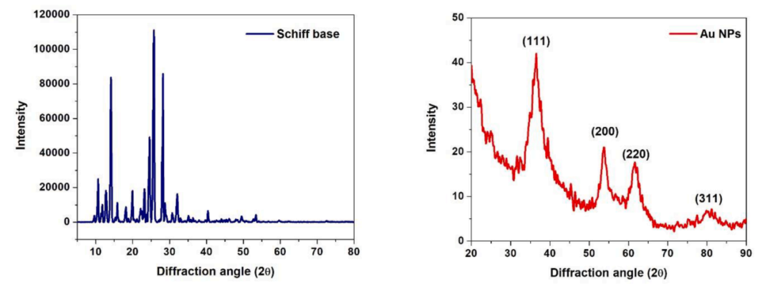
Fig. 9 Powder XRD spectra of Schiff base and AuNPs [45]
The determination of crystalline nature and structure of the synthesized AgNPs was done by using XRD crystallography technique. The XRD pattern of the synthesized Schiff base and its stabilized AgNPs showed the Bragg’s refection plane in the 2θ range between 20–70°. In the XRD pattern of AgNPs, the difraction peaks at 2θ = 38.21°, 44.39°, and 64.49° correspond to (1 1 1), (2 0 0), and (2 2 0) Miller indices of AgNPs as shown in Fig. 10, which can be interpreted as the face-centred cubic structure for the synthesized AgNPs [41]. The broad peaks observed in the XRD pattern suggest the small crystalline size of AgNPs.
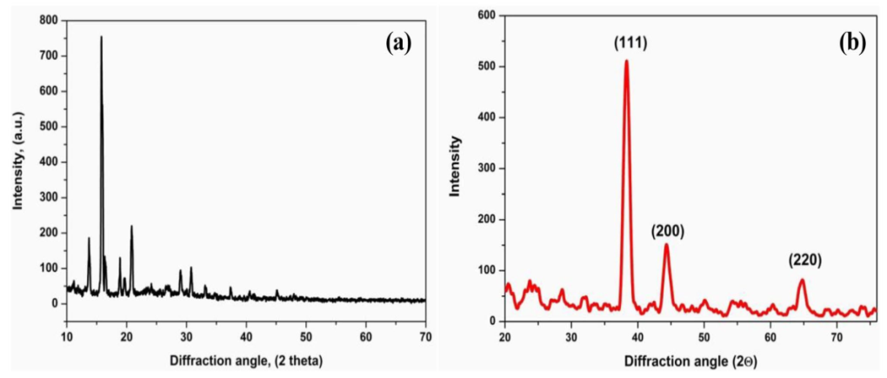
Fig. 10 Powder XRD spectra of a Schif base and b Schif base ligand capped AgNPs [41]
C. Morphological analysis of plasmonic NPs
TEM analysis may be utilized to examine the morphology, shape, & size of the PdNPs. Fig. 11(a) showed TEM image of prepared PdNPs and histogram are presented in Fig. 11(b) [37]. It displays nanoparticle sizes ranging from 3 nm to 17 nm, and an average diameter is 10 ± 2 nm. The existence of different phytochemicals in the PG leaf extract enabled the average grain size of PdNPs to be well disseminated & spherical in shape without any agglomeration. In the TEM image, almost plenty of the nanoparticles had a miniscule spherical crystal shape.

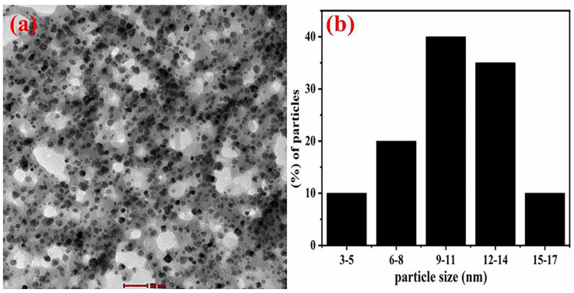
Fig. 11 TEM image (a) & histogram (b) of the PG leaf extract stabilized PdNPs [37]
The size, shape, and surface of the obtained BM extract stabilized PdNPs were examined by TEM analysis (Fig. 12(a)). The average crystallite size was found to be 8 ± 3 nm. The TEM image of PdNPs showed superior crystallinity, which seemed to reveal the characteristic of the (111) spherical crystal plane of FCC structure and indicated that the PdNPs are extremely crystalline. The average crystallite size and particles distribution are shown in the histogram (Fig. 12(b)), which also indicates that the PdNPs are extremely crystalline [42].
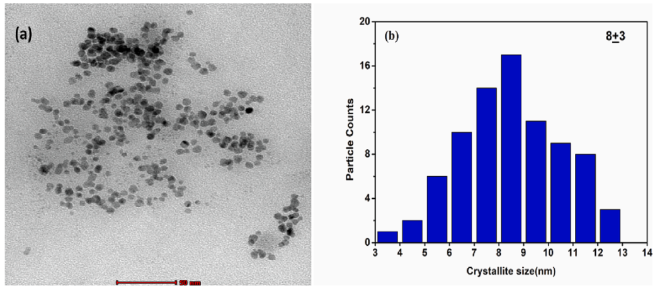
Fig. 12 (a) TEM image and (b) histogram of the BM ﬂower extract stabilized PdNPs [42]
The AgNPs are shown in the TEM images as spherical with irregular shape and size is 5–15 nm (Fig. 13(a-b) [46]. It exhibits the distribution of AgNPs with TMPM5MΟP, that might be attributed to complexion between Schiff base and Ag+. In addition, the crystalline character of synthesized AgNPs could be observed clearly in TEM image.

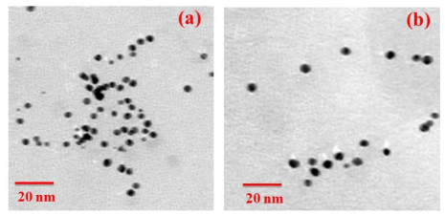
Fig. 13 (a-b) TEM images of Schiff base capped AgNPs [46]
TEM analysis was explored to in detail morphology and size of the particles. The TEM images of CMCG-AuNPs were displayed in Fig. 14, it can be seen as the pure CG synthesized AuNPs have various sizes with few aggregations. But after modifcation of CG with carboxymethyl the formed CMCGAuNPs are in spherical shape, well dispersed and range of the particle size between 9 to 15 nm as shown in Fig. 14(c-d). The HRTEM image of CMCG-AuNPs had more crystallinity with 0.23 nm space of atomic lattice fringes, which appears to show the property of the (1 1 1) plane of fcc structured AuNPs (Fig. 14e). Figure 14(b,d) shows the histogram of the synthesized CMCG-AuNPs, which reveals that the average particle size is about 12 ± 3 nm. A selected area electron difraction (SAED) pattern was showed the polycrystalline difraction rings, indicating that CMCG-AuNPs has pure crystalline natureas shown in Fig. 14(f). Therefore, the synthesized CMCG-AuNPs are more efcient for various applications due to the small size and high surface area [40].
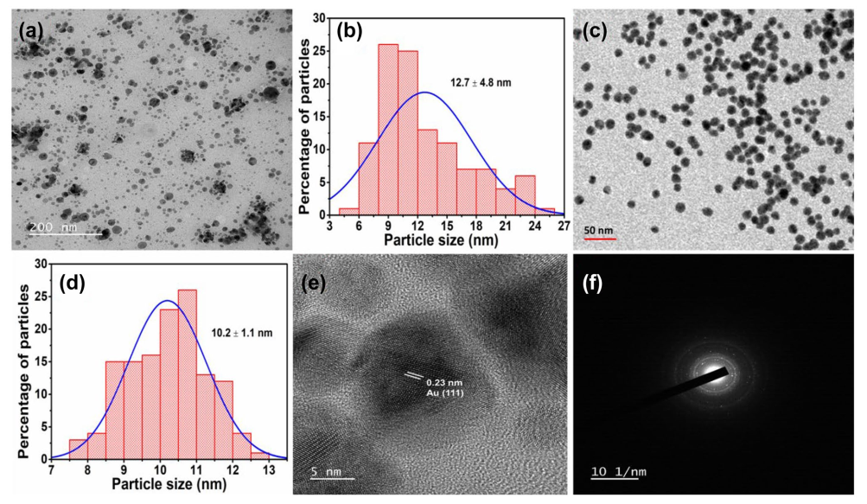
Fig. 14 TEM image of CG-AuNPs and its particle size distribution histogram (a-b), TEM image of CMCG-AuNPs and its particle size distribution histogram (c-d), HRTEM image of CMCG-AuNPs (e), and SAED pattern of CMCG-AuNPs (f) [40]
Surface plasmon resonance depends on many parameters of the nanoparticle, such as: its size and shape, dielectric properties of the metal from which the nanoparticle is created, and the dielectric permittivity of the environment (Fig. 15) [47]. Nanoparticles may have different plasmon modes. For small spherical nanoparticles only dipole plasmons are excited whereas for anisotropic nanoparticles also higher order plasmon modes can be excited. For example, UV-vis absorption spectrum of silver nanoprisms obtained by the plasmon-driven transformation revealed three peaks: at 340 nm (out of plane quadrupole resonance), 470 nm (in-plane quadrupole resonance), and 640 nm (in-plane dipole resonance). In the case of nanorods there are usually two separated absorption bands, one from the longitudinal excitation, and the second from the transverse excitation. Let us assume that the width of obtained nanorods is constant, and the length is changing. In this case the wavelength of the transverse mode is constant (for example 400 nm) and the wavelength of the longitudinal excitation is blue shifted when the length of the nanorod is decreasing. When both dimensions are the same (nanoparticles are spherical) only one peak in spectrum is present. In general nanorods may reveal many multipole modes: dipoles, tripoles, quadrupoles, pentapoles, hexapoles, and even heptapoles, the position of these modes strongly depends on the size and the aspect ratios (length/width) of the nanorod and is usually red shifted when the size of the nanorod is increasing.
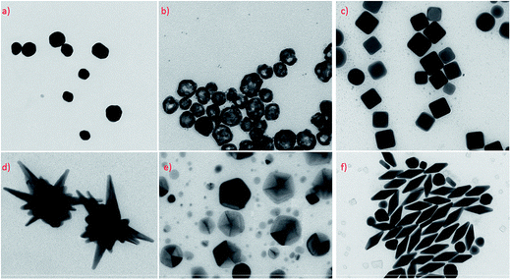
Fig. 15 TEM micrographs presenting Ag and Au nanoparticles with different geometry and shapes practically used as electromagnetic nanoresonators for SERS measurements: (a) quasi-spherical silver nanoparticles, (b) hollow spherical silver nanoparticles, (c) cubic silver nanoparticles, (d) gold–silver nanostars, (e) silver decahedral nanoparticles, (f) gold bipyramid [47]
V. APPLICATIONS
A. Catalytic applications of plasmonic NPs
The catalytic activity of the synthesized AgNPs using XG have been studied with regard to the reduction of hexacyanoferrate (III) by sodium borohydride in aqueous solution, which has been considered as a model reaction (Fig. 16) [48]. The details of the catalysis experiment were provided in the experimental Section. The reduction of hexacyanoferrate (III) by borohydride ions in aqueous solution can be written as:
BH₄ – + 8[FeCN₆]^{3–} + 3H₂O → H₂BO₃– + 8[FeCN₆]^{4–} + 8H⁺
The efficient electron transfer from BH₄⁻ ion to ferricyanide ion through the AgNPs is believed to be the reason for their catalytic activity. This is due to the large Fermi level shift of AgNPs in the presence of highly electron-injecting species like borohydride ions. The reaction proceeds in two steps: first, borohydride ions inject electrons on the particles, which act as an electron reservoir and become cathodically polarized; and second, ferricyanide ions diffuse toward the nanoparticle surface and are reduced by excess surface electrons, although this is a slower process. The non-catalyzed reaction pathway can be ignored, as it is much slower than the catalyzed reaction. It is important to maintain a basic pH in all experiments to prevent the decomposition of borohydride.
BH₄ – + Metal ↔ Q– (fast)
Q– + [FeCN₆]^{3–} → [FeCN₆]^{4–} + Q (slow)
In the experimental observation, the concentration of NaBH₄ was maintained in excess as compared to hexacyanoferrate (III) ions. Thus, the kinetics of the reduction process can be regarded as a pseudo-first order reaction. The progression of the reaction was monitored through the UV–Vis spectrum of hexacyanoferrate (III). UV–Vis spectra of a mixture of hexacyanoferrate (III) and sodium borohydride upon the addition of AgNPs is shown in Fig. 16. The characteristic absorption peak of hexacyanoferrate (III) is located at 420 nm, and its intensity was continuously decreased immediately after the addition of AgNPs, revealing the occurrence of catalyzed reduction. The absorption peaks of hexacyanoferrate (III) decreased quickly and completely disappeared within 14 min of reaction time.
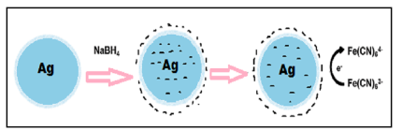
Fig. 16 The catalytic activity of the AgNPs, with regard to the reduction of hexacyanoferrate (III) by sodium borohydride in aqueous solution [48]
An economical analytical approach is used to convert 4-NP to 4-AP in the presence of NaBH₄ as a reducing agent and the produced PdNPs as a catalyst in a green way. The 4-AP serves as a significant precursor in the manufacturing of analgesics and antipyretic medications, rubber products, polymers, corrosion inhibitors, hair dyes, etc., As a result, 4-NP, a well-known precursor ingredient for 4-AP is in high demand since decades. The reduction process caused the absorption peak at 317 nm to shift to 400 nm as a result of the production of the 4-nitrophenolate ion in the presence of excessive NaBH4 (Fig. 17a). Since that the peak at 400 nm remained constant for an extended period of time, it is likely that a catalyst was required for the reduction of 4-NP. This is because the 4-NP reduction reaction is kinetically hampered but thermodynamically favoured. To circumvent this, the as-prepared PdNPs are added to the reaction mixture, which lowers the activation energy between NaBH4 and 4-nitrophenolate ion. The reaction began when the requisite dosage of as-prepared PdNPs was introduced. The peak intensity at 400 nm is subsequently seen to gradually fall, and then a new broad band with greater intensity emerges at the wavelength of 297 nm is demonstrating the successful formation of 4-AP (Fig. 17b). As the reaction goes on, a new peak that is associated with the synthesis of 4-AP develops, and the amplitude of the 400 nm 4-nitrophenolate ion peak at 400 nm gradually decreases. About 7 min, the reaction was finished, and the solution’s colour disappeared, leaving it colourless. It is possible to measure the whole reduction reaction process using UV–Vis spectroscopy. As illustrated in Fig. 17(c), the rate constant was estimated using the kinetic equation and was determined as 0.45 min-1. During the catalytic transformation of 4-NP, biosynthesized PdNPs of PG leaf extract serve as a carrier of electrons, assisting NaBH4 molecules in the conversion of the –NO₂ functional group to –NH₂ group [37].
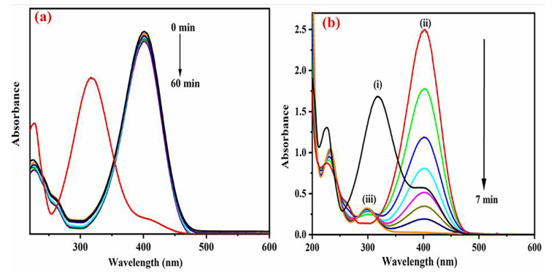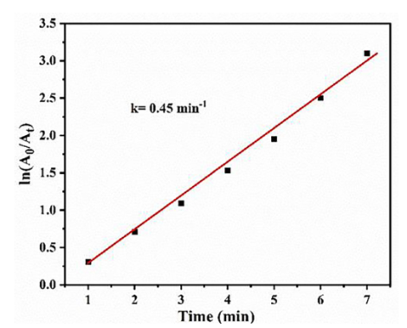
Fig. 17 The successive UV–Vis absorption spectra for the reduction of 4-NP with (a) NaBH₄ and (b) NaBH₄ with synthesized PdNPs consisting of (i) 4-NP (ii) 4-nitrophenolate ion (iii) 4-AP, (c) Kinetic rate constant determination plot for the reduction of 4-NP in the presence of NaBH₄ by using the synthesized PdNPs [37]
The produced PdNPs displayed exceptional nano-scale capabilities in addition to being stable, effective, and having a signifcant surface area. The decrease in the magnitude of MB (663 nm) and CV (588 nm) dyes may be determined at room temperature by monitoring the shift in their absorbance individually. The control experiments were performed in the presence of reducing agent (SBH) and absence of catalyst. Without the catalyst, even the freshly prepared reducing agent (SBH) added to dye solutions, did not show noticeable colour change for approximately an hour as shown in Figs. 18(a). The maximum absorption peaks of respective dyes however, remained constant throughout time, showing that no decrease of optical absorption took place in the absence of a catalyst. Thus, it is necessary to use a catalyst when reducing MB and CV dye because it requires the presence of a catalyst. As the reaction duration grows, the intensity of the MB and CV absorption peaks gradually decreases after adding a small amount of PdNPs (50 µL) to the reaction system utilizing SBH, as shown in Fig. 18(b). After about 6 min of reaction time, the blue colour (MB) changed to colourless (leuco MB) solution, and for CV takes 8 min for changing violet colour to colourless solution, signifying that MB and CV has almost completely degraded and been eliminated from an aqueous solution. This change is attributed to the addition of catalyst which might have decreased the kinetic energy barrier of the reactant dye molecules to form degradation products [37]. Cationic dyes and PdNPs might have established powerful electrostatic connections throughout the reduction process, aiding in dye reduction. Moreover, to further access the rate of reaction, we determined apparent kinetic data and it showed that the reaction follows pseudo first order kinetics with slope as equal to apparent rate constants as 0.56 min⁻¹ (MB) and 0.40 min⁻¹ (CV) (Fig. 18(c)).
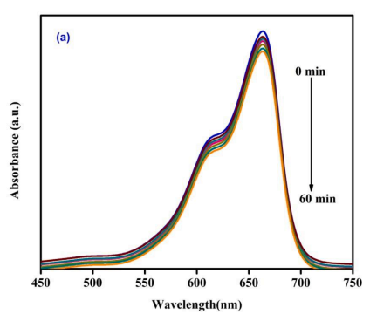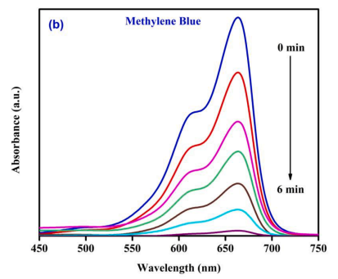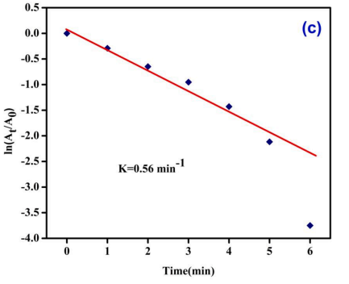
Fig. 18 (a) UV–Vis absorption spectra of SBH induced MB degradation and absence of PdNPs, (b) UV–Vis absorption spectra of MB degradation in the presence of SBH and PdNPs [37]
Fig. 19(a) and Fig. 19(b) shows the degradation of TC and Cipro using AgNPs after 30 min of the reaction in the presence of NaBH₄. According to the obtained results, the contribution of Tc and cipro degradation in on the whole degradation using AgNPs was outstanding than without catalyst, hence AgNPs was mostly required to degradation of antibiotics. After 30 min of the reaction, AgNPs adsorbed < 12% of the initial Tc and cipro in presence of AgNPs under identical reaction conditions. Hence, it can be conclude that the AgNPs was responsible for the adsorption of the antibiotic on the surface of catalyst. The degradation efficiency of AgNPs was enormously increased as 88.12% and 90.08% of TC and cipro in 30 min reaction (Fig. 19(c)). The result showed that the prepared AgNPs posseesed excellent catalytic activity in the degradation of TC and Cipro. The rate constants were 0.315 and 0.342 min⁻¹ were observed for the degradation of TC and Cipro using AgNPs, respectively (Fig. 19(d)). The recycling test results are indicating that the almost similar amount of Tc and cipro degraded up to the 3rd cycle, and only 5% decrement was observed in the 5th cycle as shown in Fig. 19(e) [46].
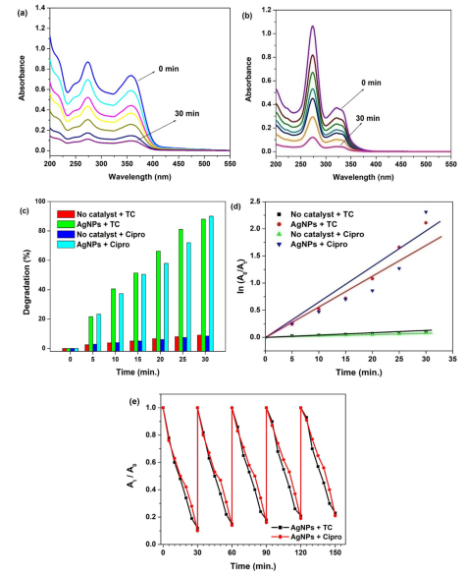
Fig. 19 Catalytic degradation of antibiotics (Tc and cipro) using AgNPs: UV–vis degradation profiles of (a) Tc and (b) cipro; (c) bar diagram,; (d) kinetic plot; and (e) recyclability [46]
B. Sensing applications of plasmonic NPs
In the PL spectra of the detection of Cr⁶⁺ ions, the addition of 10 µL of an aqueous solution of Zn²⁺,Co²⁺, Ni²⁺, Al³⁺, Mn²⁺, Pb²⁺, Ca²⁺, Cu²⁺, and Fe²⁺ ions to the AuNPs, did not produce any significant fluorescence intensity changes (Fig. 20(a)). However, upon addition of Cr⁶⁺ ions to the solution containing AuNPs and other metal ions, an immediate decrease in PL emission was observed in Fig. 20(b). The results demonstrated that the absorbance of SPR band follows a superior exponential response to Cr6+ concentrations (10–100 nM) with a regression constant (R2) of 0.98 as shown in Fig. 20(c) [49].
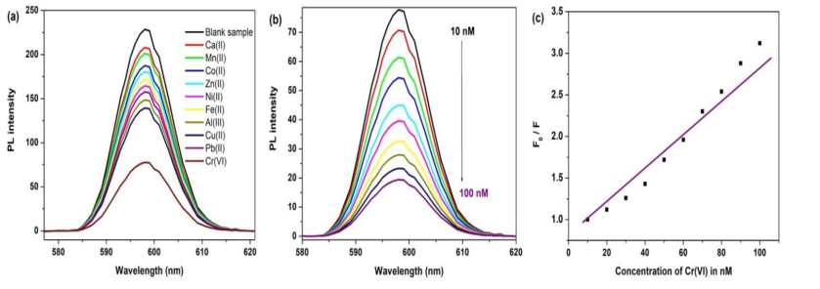
Fig. 20 (a) Fluorescence selective sensing of Cr⁶⁺, (b) sensitive sensing of Cr⁶⁺ in the concentration range of 10–100 nM, and (c) its Stern-Volmer plot using AuNPs [49]
In another case, the preset additions (0.5 mL, 10-3 mol/L) of individual metal ion solutions were added to 3 mL of AgNPs. Fig. 21(a) depicts the PL emission spectra during detection of Hg²⁺ at 27º C. Then the strength of the SPR-peak changed slightly when the addition of other metal ions to the AgNPs in aqueous medium. The preserved PL results showed that the addition of a nontrivial addition of the upper metal ions had no effect on the SPR-peak and colour of AgNPs (Fig. 21(b)). In contrast, the SPR characteristic peak vanishes and the colour of the solution changes from yellow to colourless when Hg²⁺ is added to the solution containing AgNPs [46].
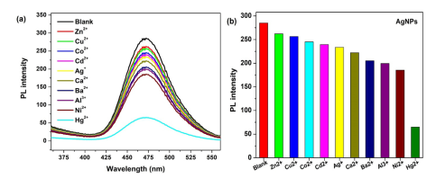
Fig. 21 PL spectra of a) Schiff base capped AgNPs with different metal ions and (b) bar diagram indicating emission intensity at 470 nm [46]
The selectivity of developed calorimetric sensor was checked, which was determined in the presence of major inorganic interfering ions such as metal ions with same molar concentration do not interfere under the same conditions, due to the absence of oxidative activity of these ions, which guarantees the high selectivity of the proposed optical sensor towards Hg²⁺ (Fig. 22(a–b)). It can be seen as, no other metal cations caused a significant decrease in the absorbance and shifting the absorbance position of the CMCG-AuNPs, but in the presence of Hg²⁺ ions the absorption band intensity drastically decreased and shifted to higher wavelength at 630 nm, which is implying that the prepared CMCG-AuNPs has a highly selective for sensing of Hg²⁺ ions only. As a result, CMCG-AuNPs seemed to function as a selective colorimetric sensing probe for Hg²⁺ in aqueous media. In Fig. 22(b), the colour of the solution becomes blue only after the addition of Hg²⁺ ions but in the case of other metal ions, there is no change in the colour of CMCG-AuNPs due to mercuric has a higher reduction potential than Au⁺, thus spontaneous redox reaction of 2Au + 2Hg²⁺ → 2Ag + Hg₂²⁺ occurs. This redox reaction is the principle of mercury colorimetric detection by AuNPs. Due to lower reduction potentials than Au(I), most of the transition metals, alkali, and alkaline earth metals cannot oxidize Au0 of AuNPs to Au(I), thus permitting highly selective Hg²⁺ analysis. Above study describes that no interference was found with the detection of Hg²⁺, it is evident that there is no significant change during the analysis of Hg²⁺, which indicates the suitability of developed sensor. It suggests that sensor was used to monitoring the Hg²⁺ in real water samples [40].
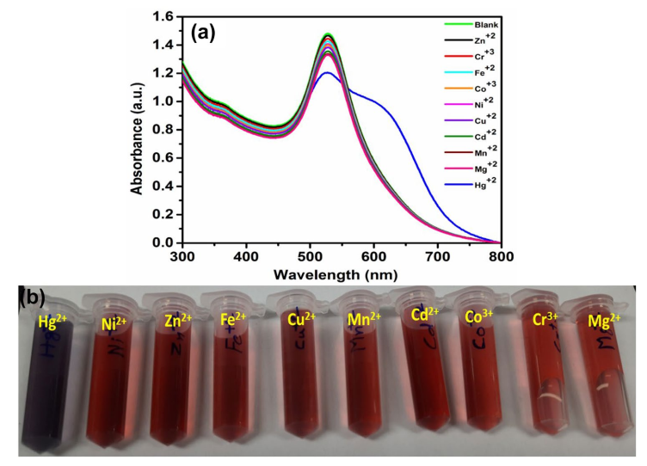
Fig. 22 (a) UV–vis absorption spectra of CMCG-AuNPs with diferent metal ions and (b) a digital photograph of CMCGAuNPs in the presence of various metal ions [40]
In addition to above studies, competitive experiments also investigated in the presence of other metal ions as analytes with Hg²⁺ using the developed CMCG-AuNPs as sensor. As shown in Fig. 23(a), CMCG-AuNPs have maximum absorption at λ = 528 nm, but Hg²⁺ added to CMCG-AuNPs, it showed the maximum absorption at λ = 630 nm, as well as Hg2+ with other metal ions also shown absorption at 630 nm. Furthermore, the bar diagram also shows that the prepared CMCG-AuNPs are highly selective for Hg²⁺ detection in the presence of other metal ions as shown in Fig. 23(b). However, the calorimetric response of combinations of Hg²⁺ and another metal ion are comparable to that of Hg²⁺ ions alone, but the blank has wine red colour as shown in Fig. 23(c). These findings were suggested as this approach has excellent selectivity for Hg²⁺ ions over other metal ions [40].
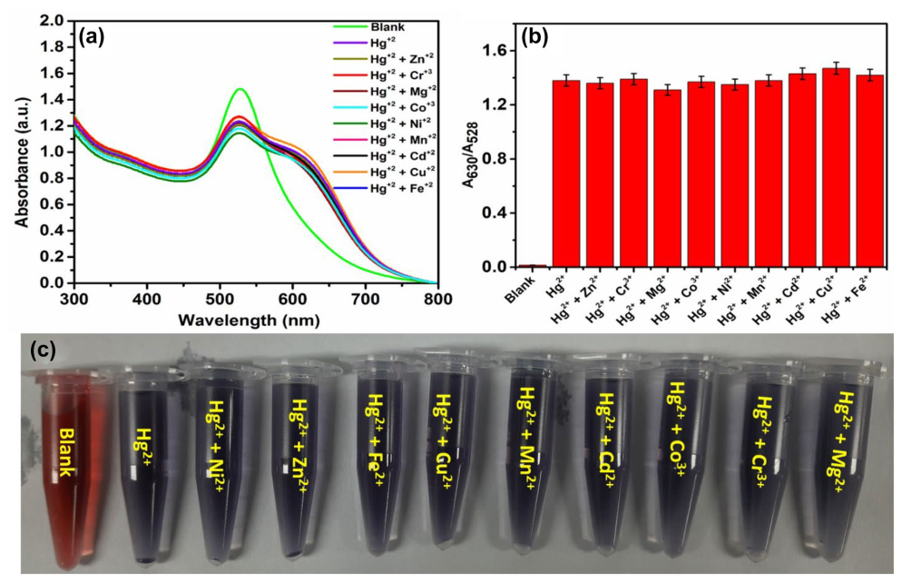
Fig. 23 (a) UV–vis absorption spectra of CMCG-AuNPs with Hg²⁺ and mixed with diferent metal ions, (b) corresponding bar diagram, and (c) a digital photograph of CMCG-AuNPs in the presence of Hg²⁺ with various metal ions [40]
C. Biological applications of plasmonic NPs
The MTT assay was used to investigate the anticancer potential of AgNPs synthesized via green methods on MCF-7 cells in vitro. Previous studies have examined the effects of green synthesized AgNPs using xanthan gum on breast cancer cell lines [50], and there have been a few reports on MTT assay studies on MCF-7 breast cell lines showing anticancer activity of AgNPs [50]. In this study, we synthesized AgNPs using XG at various concentrations (12.5, 25, 50, and 100 μg/mL), applied them to MCF-7 cells for 24 h, and measured % cell development inhibition using MTT assay. The results showed that cell viability decreased with an increase in dosage concentration (12.5, 25, 50, and 100 μg/mL), and a significant reduction in cell viability was observed at 100 µg/mL concentration (Fig. 24(a-e)) [48]. The treated cells were observed to be shrunken, spherical, attached, and aggregated when compared to XG (Fig. 24(f)) taken as reference Doxorubicin drug. The viability of tumor cells was confirmed using the neutral red assay, and the results showed that the IC50 concentration was 49.29 μg/mL, indicating that the green synthesized AgNPs were responsible for tumor cell death. The results indicated that the synthesized AgNPs exhibit excellent anticancer activity against MCF-7 cells, as evidenced by the variation in cell viability with an increase in concentration (Fig. 24).
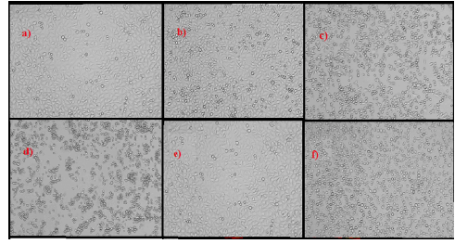
Fig. 24 Anticancer activity of AgNPs using (a) 12.5 μg/mL (b) 25 μg/mL (c) 50 μg/mL (d) 100 μg/mL (e) XG, and (f) DOX [48]
Silver has been widely used in the medical field due to its antibacterial properties. However, the exact mechanism by which AgNPs exert their antimicrobial effect is still not fully understood and is a matter of debate. Several theories exist regarding the action of AgNPs on microbes to cause their death [51]. AgNPs can bind to the bacterial cell wall and penetrate it, leading to structural changes in the cell membrane, such as increased permeability, eventually causing cell death. The bacterial cell membranes contain phosphorus and sulfur, which are soft bases. The interaction of AgNPs with the phosphorus and sulfur in DNA can interfere with bacterial DNA replication and ultimately terminate the microbes. To investigate the antibacterial activity of the AgNPs stabilized in XG, the nanoparticles were tested against the gram-positive pathogen (S. aureus) and the gram-negative pathogen (E. coli). The zone of inhibition caused by the AgNPs at various concentrations and XG alone are presented in Fig. 25 [48]. The details of the antimicrobial experiment are provided in the experimental section. Sterile discs were placed on inoculated plates using sterile forceps. Solutions of AgNPs at different concentrations, XG alone, and ampicillin were placed on these discs and incubated for 24 h at 37 ◦C in a bacterial incubator. Ampicillin was used as a positive control. The zone of inhibition decreased with decreasing concentrations of AgNPs. The pure xanthan gum sample showed no inhibitory properties. It should be noted that since xanthan gum has no antimicrobial activity, as evidenced by the lack of a zone of inhibition, the bactericidal activity observed is likely due to the synergistic activity of XG stabilized AgNPs.
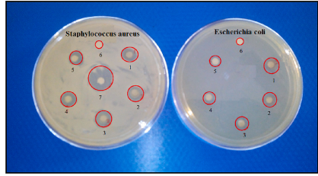
Fig. 25 Antibacterial test results of S. aureus and E. coli after 24 h of incubation using (1) 5 mg/mL AgNPs /XG, (2) 4 mg/mL AgNPs / XG, (3) 3 mg/mL AgNPs / XG, (4) 2 mg/mL AgNPs / XG, (5) 1 mg/mL AgNPs / XG, (6) pure XG, (7) Ampicillin (1 mg/mL) used as positive control [48]
The antimicrobial activity of Schiff base and ultra-small AuNPs was investigated against various Gram-positive and Gram-negative bacteria as well as fungi; and the obtained results are summarized in Fig. 26. The Schiff base and AuNPs were screened for their antimicrobial activity against in-vitro the both Gram-positive and Gram-negative bacteria using disc diffusion method. In this study, an attempt is being made to establish the antimicrobial activity of synthesized AuNPs as well as the combined effect of the metal and the Schiff base. The antibacterial and antifungal activity of the synthesized samples are represented in the Fig. 26. It is clear that the Schiff base has only slight inhibition effect on all the bacteria and fungi, while the extent of inhibition zones appeared more when Schiff base stabilized AuNPs was used. This is due to the greater lipophilic nature of the AuNPs. The higher antimicrobial activity of the AuNPs compared to Schiff base may be due to the change in structure or coordination and chelating tends to make Schiff base stabilized AuNPs act more powerful and potent bacteriostatic agents, thus inhibiting the growth of the bacteria. This increase in the activity of the AuNPs can be explained on the basis of chelation theory [52]. The chelation considerably reduces the polarity of the metal ion because of partial sharing of its positive charge with donor groups and possible electron delocalization over the whole chelate ring. Such a chelation could enhance the lipophilic character of the central metal atoms. Further, the Schiff base showed low activity and AuNPs moderate to higher activities as compared to standard drug towards the all organism tested due to the presence of –NH group present in Schiff base moiety plays an important role in the biological activity.
Generally, the antimicrobial activity mechanism of metal nanoparticles including AuNPs have shown higher activity against Grampositive bacteria than Gram-negative pathogens. In the present study indicated that the Gram-positive bacteria were inhibited more strongly than Gram-negative bacteria and explained on the basis of complex structure of cell wall. The gram-negative bacteria possessing an extra outer layer on top of the peptidoglycan and found to be highly impermeable. In the case of Gram-positive bacteria, the polysaccharides in their cell wall called teichoic acid (negatively charged) and facilitated the passage of the positive metal ions [52]. The polysaccharides and lipids are prime important constituents of cell wall and membranes and favorable for metal ion interaction. This cell wall also constitutes carbonyl, phosphate and cystenyl groups, which help in maintaining the integrity of the membrane by performing as a diffusion barrier and also provide suitable sites for binding interaction. Moreover, the reduction in polarity enhances the lipophilic character of the Au chelates and interaction between the lipid and Au ion is favored. This may lead to the breakdown of the permeability barrier of the cell resulting in intervention with the normal cell processes and blocking of the metal binding sites in the enzymes of the microorganisms. These complexes may also disturb the respiration process of the cell and therefore block the protein synthesis, which confines further growth of the organism.
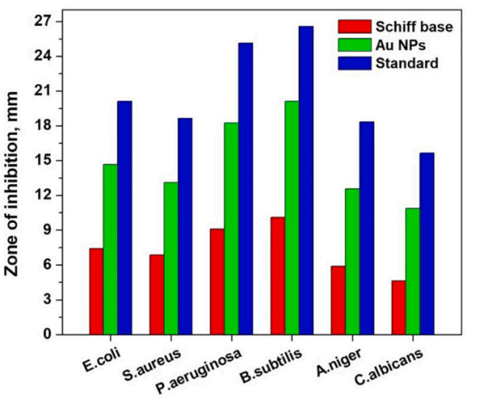
Fig. 26 The bar image of zone of inhibition of bacteria and fungi using the synthesized Schiff base and Schiff base stabilized AuNPs along with standard drugs (ampicillin and ketoconazole) [45]
The antioxidant potential of green synthesized AgNPs using XG was investigated in vitro by testing different concentrations of AgNPs. The results showed that AgNPs have a significant antioxidant effect as demonstrated by their DPPH scavenging activity at varying concentrations (10, 20, 30, 40, and 50 µg/mL), with a IC50 value of 51.11 µg/mL (Fig. 27). However, the scavenging activity of AgNPs was not higher than that of the control ascorbic acid. The reductive capabilities of AgNPs were also tested, and the results (Fig. 27) showed that the reducing power of AgNPs increased with increasing sample concentration [48].
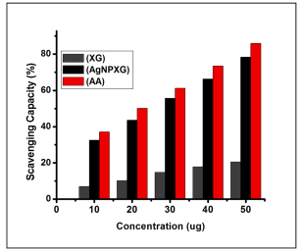
Fig. 27 Antioxidant activity of XG, XG stabilized AgNPs and ascorbic acid (AA) [48]
In vitro antioxidant activity of the Schiff base and AuNPs were ascertained by DPPH free radical scavenging assay method using ascorbic acid as a reference. DPPH is more stable radical, which reacts with any compound that supply an electron or hydrogen atom, resulting in a colour change from purple to yellow. The antioxidant activity of the Schiff base and AuNPs tested at various concentrations (0–5 µg/mL) under identical reaction conditions. An IC50 value was obtained from the plots of percentage of inhibition with an increase in concentration of the AuNPs (Fig. 28), and observed IC₅₀ value is 3.08 µg/mL [45]. As seen from the obtained results, the AuNPs show higher activities than Schiff base, and comparable to standard such as ascorbic acid, which may be due to the presence of the metal ions in the AuNPs and the significant contribution of the hydroxyl units in Schiff base [45]. From the observed IC50 value, Schiff base stabilized AuNPs can be considered as potential drugs to eliminate the hydroxyl radical (•OH) and utilized for the treatment of various diseases.
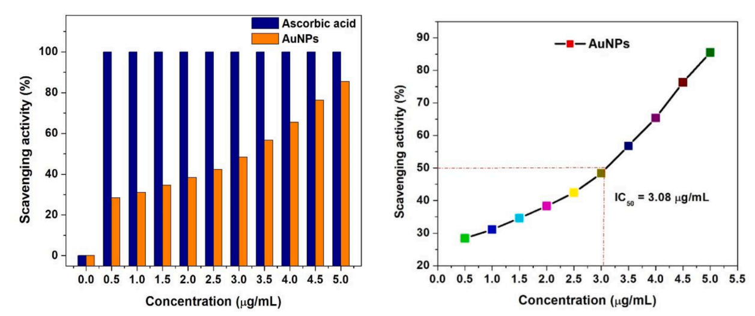
Fig. 28 Hydroxyl radical scavenging activity (%) and IC₅₀ values of the synthesized Schiff base stabilized AuNPs and ascorbic acid as standard using DPPH radical scavenging method [45]
VI. CONCLUSIONS
This book chapter provides a succinct review of the different classes of plasmonic nanoparticles such as Ag, Au, and Pd NPs, which have been broadly explored as highly promising candidates for a variety of applications including catalytic, sensing, and biological applications. The physical and chemical properties of the metal NPs are described, with a particular focus on the optically variable properties (surface plasmon resonance based properties) and surface-enhanced Raman scattering of plasmonic materials. Plasmonic NPs have attracted particular attention due to strong optical, electrical, biological, and catalytic effects they are accompanied with Surface plasmon resonance characteristics of plasmonic NPs and their assemblies enable fine-tuning of these effects with unprecedented dynamic range. In turn, the uniquely high polarizability of plasmonic nanostructures and related optical effects exemplified by surface-enhanced Raman scattering and red–blue color changes give rise to their application to biosensing. The different plasmonic nanoparticles along with their properties such as plasmonic localized heating of metals, as well as HOMO–LUMO excitation and lattice vibration of molecules are summarized. For the plasmonic light absorbing materials, the light absorption can be greatly improved through controlling the size, shape, and composition which in turn tune the LSPR peaks to the NIR region. On the other hand, enhancement of light absorption in a semiconductor can be obtained through element doping or introducing oxygen vacancies in the lattice. Additionally, to facilitate practical applications of solar-driven water evaporation in different water quality (e.g. seawater and industrial wastewater), the properties of the plasmonic nanoparticles, including photothermal stability, corrosion resistance, anti-biofouling ability, as well as cost effectiveness, long-term stability, and durability should be taken into consideration. We anticipate that, in the coming years, more plasmonic nanoparticles and structural engineering strategies will be developed to effectively enhance the light absorption and light-to-heat conversion or even emerging new properties for a wider range of applications.
REFERENCES
[1] S. Eustis, M.A. El-Sayed, Why gold nanoparticles are more precious than pretty gold: Noble metal surface plasmon resonance and its enhancement of the radiative and nonradiative properties of nanocrystals of different shapes, Chemical Society Reviews, vol. 35, 209-217, 2006.
[2] X. Yang, L. Chen, H. Liu, T. Kurihara, S. Horike, Q. Xu, Encapsulating ultrastable metal nanoparticles within reticular Schiff base nanospaces for enhanced catalytic performance, Cell Rep. Phys. Sci., vol. 2, pp. 1-10, 2021.
[3] K. Krishna, K.S. Harisha, R. Neelakandan, Y. Sangappa, Fabrication and conductivity study of silver nanoparticles loaded polyvinyl alcohol (PVAAgNPs) nanofibers, Mater. Today: Proc., vol. 42, pp. 515–520, 2021.
[4] D. Ayodhya, Recent progress on detection of bivalent, trivalent, and hexavalent toxic heavy metal ions in water using metallic nanoparticles: A review, Res. Chem., vol. 5, pp. 100874, 2023.
[5] D. Ayodhya, Ag-SPR and semiconductor interface effect on a ternary CuO@Ag@Bi₂S₃ Z-scheme catalyst for enhanced removal of HIV drugs and (photo) catalytic activity, New J. Chem., vol. 46, pp. 15838–15850, 2022.
[6] S. Swami, N. Sharma, A. Agarwala, V. Shrivastava, R. Shrivastava, Schiff base anchored silver nanomaterial: An efficient and selective nano probe for fluoride detection in an aqueous medium, Mater. Today: Proc., vol. 43, pp. 2926–2932, 2021.
[7] S.R. Barman, A. Nain, S. jain, N. Punjabi, S. Mukherji, j. Satija,, Dendrimer as a multifunctional capping agent for metal nanoparticles for use in bioimaging, drug delivery and sensor applications, J. Mater. Chem. B, vol. 6, pp. 2368–2384, 2018.
[8] K.S. Harisha, N. Parushuram, S. Asha, S.B. Suma, B. Narayana, Y. Sangappa, Ecosynthesis of gold nanoparticles by Sericin derived from Bombyx mori silk and catalytic study on degradation of methylene blue, Part. Sci. Technol., vol. 39, pp. 131–140, 2021.
[9] T. Baran, Biosynthesis of highly retrievable magnetic Palladium nanoparticles stabilized on bio-composite for production of various biaryl compounds and catalytic reduction of 4- nitrophenol, Catal. Lett., vol. 149, pp. 1721–1729, 2019.
[10] M. Venkatesham, D. Ayodhya, A. Madhusudhan, N. Veera Babu, G.Veerabhadram, A novel green one-step synthesis of silver nanoparticles using chitosan: catalytic activity andantimicrobial studies, Appl. Nanosci., vol. 4, pp. 113–119, 2014.
[11] G. Shimoga, R.R. Palem, S.H. Lee, S.Y. Kim, Catalytic degradability of pNitrophenol using ecofriendly silver nanoparticles, Metals (Basel) 10 (2020) 1–20.
[12] A. Iben Ayad, D. Luart, A. Ould Dris, E. Guénin, Kinetic analysis of 4-nitrophenol reduction by ‘‘water-soluble” Palladium nanoparticles, Nanomaterials 10 (2020) 1169
[13] Khan ME, Khan MM, Cho MH (2018) Recent progress of metal-graphene nanostructures in photocatalysis. Nanoscale 10:9427–9440.
[14] B.R. Gangapuram, R. Bandi, M. Alle, R. Dadigala, G.M. Kotu, V. Guttena, Microwave assisted rapid green synthesis of gold nanoparticles using Annona squamosa L peel extract for the effcient catalytic reduction of organic pollutants, J. Mol. Struct. 1167 (2018) 305–315.
[15] K. Seku, G. Bhagavanth Reddy, S.S. Hussaini, B. Pejjai, M. Hussain, D.M. Reddy, M.A.K. Khazaleh, G. Mangatayaru, An effcient biosynthesis of palladium nanoparticles using Bael gum and evaluation of their catalytic and antibacterial activity, Int. J. Biol. Macro. 209 (2022) 912–922.
[16] B. Jaleh, S. Karami, M. Sajjadi, B.F. Mohazzab, S. Azizian, M. Nasrollahzadeh, R. S. Varma, Laser-assisted preparation of Pd nanoparticles on carbon cloth for the degradation of environmental pollutants in aqueous medium, Chemosphere 246 (2020), 125755.
[17] A. Arya, K. Gupta, T.S. Chundawat, In vitro antimicrobial and antioxidant activity of biogenically synthesized palladium and platinum nanoparticles using Botryococcus braunii, Turkish J. Pharm. Sci. 17 (2020) 299–306.
[18] R. Banu, G.B. Reddy, D. Ayodhya, D. Ramakrishna, G.M. Kotu, Biogenic Pdnanoparticles from Lantana trifolia seeds extract: Synthesis, characterization, and catalytic reduction of textile dyes, Res. Chem. 5 (2023), 100737.
[19] S.R. Gupta, B. Ravindranath, T.R. Seshadri, The glucosides of Butea monosperma, Phytochemistry 9 (10) (1970) 2231–2235.
[20] R. Selvaraj, S. Pai, G. Murugesan, S. Pandey, R. Bhole, D. Gonsalves, T. Varadavenkatesan, R. Vinayagam, Green synthesis of magnetic α–Fe2O3 nanospheres using Bridelia retusa leaf extract for Fenton-like degradation of crystal violet dye, Appl. Nanosci. 11 (8) (2021) 2227–2234.
[21] Y. Li, Z. Lin, M. Zhao, Silver nanoparticle based codelivery of Oseltamivir to inhibit the activity of the H1N1 inﬂuenza virus through ROS-mediated signaling pathways, ACS Appl. Mater. Interfaces 8 (2016) 24385–24393.
[22] Y. Liu, S. Chen, L. Zhong, G. Wu, Preparation of high-stable silver nanoparticle dispersion by using sodium alginate as a stabilizer under gamma radiation, Radiat. Phys. Chem. 78 (2009) 251–255.
[23] G.C. Barrere, C.E. Barber, M.J. Daniels, Molecular cloning of genes involved in the production of the extracellular polysaccharide xanthan by Xanthomonas campestris pv. campestris, Int. J. Biol. Macromol. 8 (1986) 372–374.
[24] F. Garcia-Ochoa, V.E. Santos, J.A. Casas, Xanthan gum: production, recovery, and properties, Biotech Adv. 8 (2000) 549–579.
[25] D.F.S. Petri, Xanthan gum: A versatile biopolymer for biomedical and technological applications, J. Appl. Polym. Sci. 132 (2015) 42035.
[26] M. Venkatesham, D. Ayodhya, A. Madhusudhan, G. Veerabhadram, A novel green synthesis of silver nanoparticles using gum karaya: characterization, antimicrobial and catalytic activity studies, J. Clust. Sci. 25 (2014) 409–422.
[27] P.A. Vigato, S. Tamburini, Advances in acyclic compartmental ligands and related complexes, Coord. Chem. Rev. 252 (2008) 1871–1995.
[28] K.S. Kumar, Design, one-pot synthesis, cytotoxic, in vivo anticancer, antioxidant and antimicrobial evaluation of a novel mixed Schiff base ligand and its metal complexes, Results Chem. 4 (2022), 100463.
[29] K.C. Gupta, A.K. Sutar, Catalytic activities of Schiff base transition metal complexes, Coord. Chem. Rev. 252 (12-14) (2008) 1420–1450.
[30] M. Sonmez, ¨ M. Celebi, Y. Yardim, Z. Sentürk, Palladium(II) and platinum(II) complexes of a symmetric Schiff base derived from 2,6, diformyl-4-methylphenol with N-aminopyrimidine: synthesis, characterization and detection of DNA interaction by voltammetry, Eur. J. Med. Chem. 45 (2010) 4215–4220.
[31] A.G. Ertürk, V. Sekeroglu, E. Yildirim, G. Dindaroglu, Z.A. Sekeroglu, Antipyrine derived-Schiff base copper complex: Synthesis, characterization, and in vitro evaluation, Inorg. Chim. Acta 543 (2022) 121146.
[32] S. Sathiyaraj, K. Sampath, R.J. Butcher, R. Pallepogu, C. Jayabalakrishnan, Designing, structural elucidation, comparison of DNA binding, cleavage, radical scavenging activity and anticancer activity of copper(I) complex with5-dimethyl-2-phenyl-4-[(pyridin-2-ylmethylene)-amino]-1,2-dihydro-pyrazol-3-oneSchiff base ligand, Eur. J. Med. Chem. 64 (2013) 81–89.
[33] L.P. Singh, J.M. Bhatnagar, Copper (II) selective electrochemical sensor based on Schiff Base complexes, Talanta 64 (2) (2004) 313–319.
[34] V.K. Gupta, A.K. Singh, B. Gupta, A cerium (III) selective polyvinyl chloride membrane sensor based on a Schiff base complex of N, N′-bis [2-(salicylideneamino) ethyl] ethane-1, 2-diamine, Anal. Chim. Acta 575 (2) (2006) 198–204.
[35] M. Dudev, J. Wang, T. Dudev, C. Lim, Factors governing the metal coordination number in metal complexes from Cambridge Structural Database analyses, J. Phys. Chem. B 110 (4) (2006) 1889–1895.
[36] J. Balachandramohan, T. Sivasankar, Sonication-assisted synthesis of a new heterostructured schiff base ligand Silver-Guar gum encapsulated nanocomposite as a visible light photocatalyst, J. Microencapsul. 37 (1) (2020) 29–40.
[37] K. Sandhya, G. Bhagavanth Reddy, Dasari Ayodhya, M. Noorjahan, K. Girija Mangatayaru, Microwave-assisted green synthesis of Palladium nanoparticles using aqueous decoction of Psidium guajava leaf extract and kinetic analysis in the reduction of 4-Nitrophenol, Mater. Today. Proceed.. 2023, https://doi.org/10.1016/j.matpr.2023.04.295
[38] Nicolau L, Batista-Lima F, Santana A, Sales T, Carmo-Neto J, Freitas G et al (2019) Cashew gum, a biopolymer, topically protects oesophageal mucosa in non erosive refux disease: A promising translational study. Carbohydr Polym 226:115205
[39] Ganapuram BR, Alle M, Dadigala R, Dasari A, Maragoni V, Guttena V (2015) Catalytic reduction of methylene blue and congo red dyes using green synthesized gold nanoparticles capped by salmalia malabarica gum. Int Nano Lett 5:215–222
[40] Ruqya Banu, Bhagavanthreddy Gangapuram, Dasari Ayodhya, Ramakrishna Dadigala, Guttena Veerabhadram, Girija Mangatayaru Kotu, Biogenic Synthesis of Carboxymethyl Cashew Gum Modified Gold Nanoparticles and its Sensitive and Selective Calorimetric Detection of Hg2+ Ions and Catalytic Reduction of Methyl Red, Journal of Fluorescence (2023) 33:209–221.
[41] G. Suneetha, D. Ayodhya, S.M. Padma, Design, Synthesis, Characterization, Catalytic, Fluorometric Sensing, Antimicrobial and Antioxidant Activities of Schiff Base Ligand Capped AgNPs, Journal of Fluorescence (2022) 32:2363–2378.
[42] K. Sandhya, G. Bhagavanth Reddy, Dasari Ayodhya, M. Noorjahan, K. Girija Mangatayaru, Phytoconstituents mediated fabrication of palladium nanoparticles using Butea Monosperma ﬂower extract by autoclaving treatment towards the degradation of noxious organic dyes, Res. Chem. 5 (2023) 100969.
[43] Gangapuram BR, Bandi R, Alle M, Dadigala R, Kotu GM, Guttena, V (2018) Microwave assisted rapid green synthesis of gold nanoparticles using Annona squamosa L peel extract for the efficient catalytic reduction of organic pollutants. J Mol Struct 1167:305–315.
[44] A. Miri, M. Darroudi, R. Entezari, M. Sarani, Biosynthesis of gold nanoparticles using Prosopisfarcta extract and its in vitrotoxicity on colon cancer cells, Res.Chem. Intermed. 44 (5) (2018) 3169–3177
[45] G. Suneetha, D. Ayodhya, P.S. Manjari, Schiff base stabilized gold nanoparticles: Synthesis, characterization, catalytic reduction of nitroaromatic compounds, ﬂuorometric sensing, and biological activities, Res. Chem. 5 (2023) 100688.
[46] V. Sumalatha, D. Ayodhya, Synthesis of Schiff base stabilized AgNPs for enhanced catalytic degradation of antibiotics, Hg(II) detection, antioxidant, and antimicrobial activities, Mater. Today Proceed., 2023, https://doi.org/10.1016/j.matpr.2023.05.346
[47] Jan Krajczewski, Karol Kołątaj, Andrzej Kudelski, Plasmonic nanoparticles in chemical analysis, RSC Adv., vol. 7, pp. 17559-17576, 2017.
[48] A.S. Kumari, D. Ayodhya, D.P. Kumar, V. Maragoni, Xanthan gum mediated monowave synthesis of silver nanoparticles: Characterization, anticancer, antimicrobial, antioxidant and catalytic studies, Res. Chem. 5 (2023) 100930.
[49] S. Vislavath, M.P. Kumar, G. Balraj et al., Synthesis of Schiff base stabilized AuNPs for enhanced catalytic degradation of pesticides, Cr(VI) detection, antioxidant, and antimicrobial activities, Materials Today: Proceedings, 2023, https://doi.org/10.1016/j.matpr.2023.05.348
[50] W. Li, J. Zhou, Y. Xu, Study of the in vitro cytotoxicity testing of medical devices, Biomed. Rep. 3 (2015) 617–620
[51] V.K. Sharma, R.A. Yngard, Y. Lin, Silver nanoparticles: Green synthesis and their antimicrobial activities, Adv. Coll. Interf. Sci. 145 (2009) 83–96.
[52] C.W. Lou, A.P. Chen, T.T. Lic, J.H. Lin, Antimicrobial activity of UV-induced chitosan capped silver nanoparticles, Mater. Lett. 128 (2014) 248–252

