Influence of Essential Oil as Honey Bees Attractant on Seed Yield of Onion (Allium cepa)

N. Gayen, S.H. Ansary, B. Sarkar, S. Tamang, S. Saha, B. Biswas and S. Raha
Hooghly Krishi Vigyan Kendra
Bidhan Chandra Krishi Viswavidyalaya
Chinsurah, Hooghly, W.B.

Abstract:

Low productivity of onion seed due to lesser visit of honey bees is a prominent problem for onion growers in Hooghly district of West Bengal. A field trial was carried out at Instructional Farm of Hooghly Krishi Vigyan Kendra, Chinsurah, Hooghly during 2021-22 to study the influence of some essential oils performing as honey bees attractant on seed yield of onion. The experiment was laid out in randomized block design with three replications and five treatments. The treatments consisted of spraying of four different essential oils twice at 5-10% flowering and 50 % flowering stage viz. T-1) 0.1% Lemon grass oil, T2) 0.1% Lavender oil T3) 0.5% Fennel seed oil and T4) 0.5% Coriander seed oil along with control treatment i.e. T-5) No spray of essential oil. It has been observed that application of 0.5% Coriander seed oil was able to attract significantly highest honey bees per plants per min (3.6) and produced significantly highest seeds per umbel (673.8) and seed yield (6.63q/ha) as compared to other treatments.

Introduction:
Onion is one of the important vegetable crops grown all over the country and Indian agricultural economy greatly depends on its production and marketing. Belonging under the family Liliaceae onion (Allium cepa L.) is generally grown commercially as an annual crop for bulb production but it is actually a biennial crop which requires two growing season (From seed to seed) for seed production. In Hooghly district a locally reputed variety ‘Sukhsagar’ is widely cultivated and is very important because of its maximum area coverage and cultivation year after year by the farmers. Seed production venture is more profitable than bulb production of Onion and it requires some scientific know-how and proper management. Being a protandrous in nature the pollination of the crop is highly depended on visit of insects in the field. Pollinating agents i.e. insects including bees are basically responsible for effective pollination as onion is highly cross-pollinated crop. According to Crane, 1990, immature stages of bees are depended on pollen and nectar and that’s why they act as the most important pollinators. It is highly reported that for onion seed production honey bees are most important pollinating agent. 90.47 % seed set and 77.8 % germination was recorded in onion under bee pollination as found by Kumar et al. (1989). Indiscriminate use of pesticides and herbicides results lower population of natural bees which greatly affects pollination of the crops. Plant based attractants may take important role to increase the visit of honey bees and thereby seed yield. But in this regard scanty information is available for onion seed crop.
Objective of the Experiment:
- To identify suitable essential oil that can be acted as honey bees attractant
- To study the efficacy of essential oil as honey bee attractants
- To increase the yield of onion seed
Materials & Methods:
The experiment was carried out during 2021-22 at Instructional Farm of Hooghly Krishi Vigyan Kendra, Chinsurah, Hooghly during winter season. The variety ‘Sukhsagar’ was taken which is a good locally adopted variety having huge market demand. The treatments consisted of spraying of four different essential oils viz. T-1) Spraying of 0.1% Lemon grass oil T-2) Spraying of 0.1% Lavender oil T-3) Spraying of 0.5% Fennel seed oil T-4) Spraying of 0.5% Coriander seed oil along with control treatment i.e. T-5) No spray of essential oil. All essential oils were applied twice at 5-10% flowering and 50 % flowering stage of the crop. Randomized block design was followed for data analysis of the experiment. Three replications per treatment were taken. All standard management practices were followed including application of recommended dose of fertilizers. Planting was done during 3rd week of December and harvesting of seed was done during 3rd week of April.
Findings of the experiment:
Among the four treatments, spraying of 0.5% Coriander seed oil at 5-10% flowering and 50 % flowering stages resulted significantly highest visit of honey bees per plants in a minute (3.6) and produced significantly highest seed number per umbel (673.8) as compared to other treatments and control (Table 1). Seed yield was also recorded highest in Coriander seed oil application (6.63 q/ha). From the analysis it was also found that the best treatment is more economical than others (Table-2).

Table-1: Effect of essential oil on visit of honey bees and seed yield of onion seed
Treatments | No. of bees / plants /min | No. of seed per umbel | Test weight (g) | Seed Yield (q/ha)
T-1 | 3.2 | 631.5 | 3.36 | 6.42
T-2 | 2.5 | 563.6 | 3.39 | 6.18
T-3 | 2.8 | 595.3 | 3.34 | 6.37
T-4 | 3.6 | 673.8 | 3.30 | 6.63
T-5 | 1.9 | 492.4 | 3.46 | 5.51
SEm+ | 0.052 | 3.62 | 0.056 | 0.064
CD(P=0.05) | 0.15 | 10.80 | NA | 0.19

The present findings clearly shows that, increasing the number of seeds/umbel was due to positive influence of application of bees attractant which was actually due to higher visit of bees to the flowers resulting enhancing cross pollination thereby to increase seed setting. Smell from essential oils attracts the bees in the crop field which increase the chances of pollination. Smell of coriander seed oil is more effective to attract the bees as compared to other oils. Singh and Hameed (1995) reported that maintenance of large population of pollinating insects in the field leads to higher seed yield of the crops. Honey bee pollination increased in seed yield 10-11 times as recorded by Munawar and Muzaffar (1999). 2.5 times increase in seed yield was found due to induced bee pollination (971 seeds per umbel as compared to 406 in the control) as per report of Chandel et al. (2004). Chandrashekar (2009) reported increased the seed yield in radish due to attraction of maximum number of pollinators with application of cacambe and jaggery solution. According to Naik et al. (2019) 10% jaggery solution can be considered as one of the most effective and economical attractant for enhancing seed yield and quality of onion crop. Hosamani et. al. (2020) reported that the spraying of cacambe (10%) of water in open pollinated onion plot was found significantly superior which recorded highest number of seeds/umbel (930.44 seeds/umbel) and resulted in 65.92% and 126.40% increase over open pollination without spray and caged plot without bees, respectively.

Table-2: Economics of seed production of onion under different treatments
Treatments | Cost of cultivation  (Rs/ha) | Gross Return  (Rs/ha) | Net Return  (Rs/ha) | BC Ratio
T-1 | 500850 | 1926000 | 1425150 | 3.85
T-2 | 501850 | 1854000 | 1352150 | 3.69
T-3 | 495850 | 1911000 | 1415150 | 3.85
T-4 | 490880 | 1989000 | 1498120 | 4.05
T-5 | 468750 | 1653000 | 1184250 | 3.53

Conclusion:
From the experimental results, it could be concluded that visit of honey bees plays very important role for pollination of onion. Onion seed yield can be increased by increasing the visit frequency of honey bees during flowering. Plant based essential oils plays vital role to attract the bees to effect more pollination. It was found that application of 0.5% Coriander seed oil spray at 5-10% flowering and 50 % flowering stage resulted significantly highest visit of bees per plants and produced highest seed number and seed yield which was also economical as compared to other essential oil application. Whereas, control treatment i.e. no application of essential oil recorded lower visit of honey bees and seed yield. Therefore, 0.5% Coriander seed oil may be applied twice during flowering to increase the pollination and seed yield of onion for more profit of the farmers.
References:
Chandel, R.S., Thakur, R.K., Bhardwaj, N.R., and Pathania, N. (2004). Onion seed crop pollination: a missing dimension in mountain horticulture. Acta Hortic.,631: 79-86.
Chandrashekar GS (2009). Influence of bee attractants on bee pollination on seed yield and yield in radish. Karnataka J Agri. Sci., 22(4):777-780.
Crane, E. (1990). Bees and Beekeeping. Bath Press Ltd., Avon., 68-69pp. Deodikar, G.B. and Suryanaryana, M.C. (1972).Crop yields and bee pollination. Indian Bee J., 4: 53-64.
Hosamani, V., Venkateshalu, Jagadeesha, N., Reddy, M.S., Gangadarappa, P.M. and Ravikumar, B. (2020). Effect of Bee Pollination and Attractants on Quantitative and Qualitative Parameters of Onion (Alliun cepa) Seed Yield and Quality, Int. J. Curr. Microbiol. App. Sci , 9(2): 1885-1892.
Kumar, J., Mishra, R. C. and Gupta, J. K., (1989). Effect of honey bee pollination on onion (Allium cepa L.) seed production. Indian Bee Journal, 51 : 3-5.
Munawar, M.S. and Muzaffar, N. (1999). Role of honeybee (Apis mellifera L.) pollination on onion (Allium cepa) seed production. In: 36th limondia Congress September, 12-18, Vancouver-Canada, 276pp.
Naik, J.M., Gopali, J.B., Ganiger, V.M., Patil, S.R., Kumar, V and Patil, B. (2019). Influence of honey bee attractants in enhancing the seed productivity and quality of onion seed crop, International Journal of Chemical Studies; 7(4): 2958-2662.
Singh, B. and Hameed, S.F. (1995). Physical factors and foraging activity of insects visiting rye bloosoms. In: Pollination Biology: Environment Factors and pollination (ed. Sihag, R.C.), Rajendra Scientific Publishers, Hisar. 111-116pp.
Photograph of experimental field:
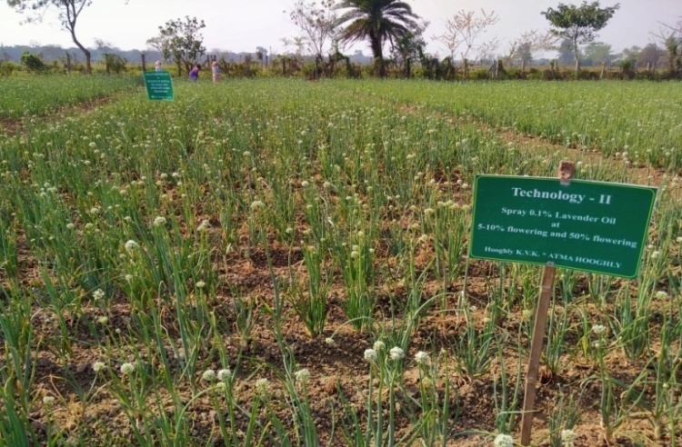 | 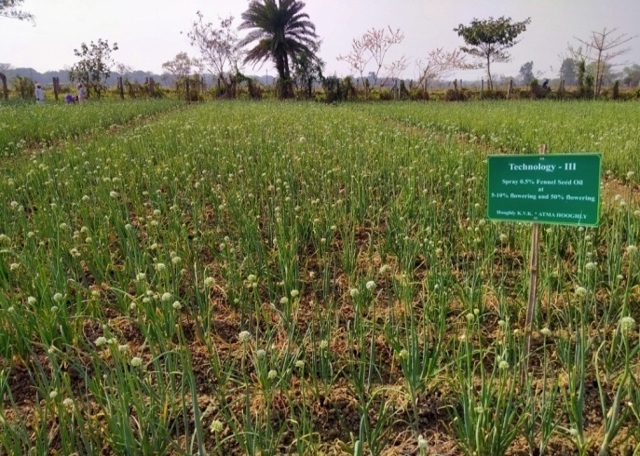
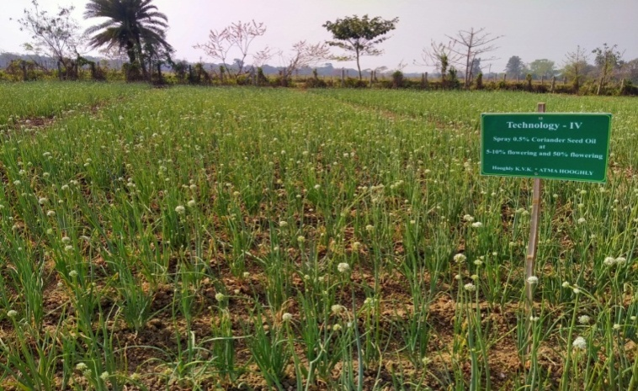 | 