Charge Transport Mechanism in Nanotube-Soaked Nanocomposite Polymer Electrolyte Membranes for Electrochemical devices

Lovely Ranjta and Chandra Prakash Singh

Department of Physics, AKS University, Panna Road, Sherganj, Satna (M.P.) 485001 India
E-mail: lovelyranjta@gmail.com

The present work is intended to study the impact of MWCNT on the performance of a PVA based nanocomposite polymer electrolytes (NCPEs) gel membranes namely, [(PVA-NH₄CH₃COO):MWCNT] system. The gel membranes are prepared by solution cast method and characterized by structural, electrical and electrochemical measurements. SEM pictures confirm diminution in porosity of the system on increasing MWCNT contents. FTIR spectral studies show the role of MWCNT as passive filler only causing structural changes and minor shifting occurs in the system. Optimum conductivity is achieved at 5.49 x10⁻⁴Scm⁻¹ for 1wt% MWCNT embedded NCPEs gel membranes. The temperature dependence conductivity of (NCPEs) membrane follows an Arrhenius and Vogel-Tammam-Fulcher (VTF) behaviour which shows hopping of ions in polymer matrix. The a.c. conductivity response seems to follow universal power law. LSV investigations on gel membranes have better electrochemical stability viz. ±4.29 Volt. All these results indicate this system an alternative to electrolyte materials for applications in electrochemical devices.
Keywords: Nanocomposite electrolyte, SEM, FTIR, conductivity and cyclic voltammetry

- Introduction
In the past few decades, polymer electrolytes have emerged as potential candidate for various electrochemical devices (such as high performance batteries, fuel cell, super capacitor, sensors, smart window etc.) on account of possibility of achieving high ionic conductivity, better mechanical and thermal stability as well as the ability to form appropriate electrode-electrolyte contacts.^{[1-4]} Within this class of polymer gel electrolytes are known to suffer from mechanical degradation and solvent exudation despite their high ionic conductivity. Researchers in recent times have dispersed non-interacting filler particles like SiO₂, Al₂O₃, TiO₂, Ba ferrite etc. to over-come these drawbacks thereby creating a new class of polymer electrolytes, termed as, nanocomposite polymer electrolytes (NCPEs).^{[5-8]}Among the favourable polymer host for synthesis of nanocomposite gel electrolyte, PVA is a semi crystalline, water soluble polymer with 1, 3, glycol structure where in anion / cation mobility occurs in the amorphous phase and its diffusion occurs through a complex mechanism involving PVA segmental mobility. Moreover, this polymer contains hydroxyl groups attached to methane carbons which are active sites for complexation with different salts and acids. Owing to possibility of achieving maximal ionic conduction with protons/NH₄⁺ ions as transporting specie in gel electrolyte systems, it has been used as a host for development of proton conducting electrolytes in recent times.^{[9]}Further, it possesses relatively low glass transition temperature and high melting temperature and has an exceptional property to dissolve high concentration of a wide variety of dopants. Prompted by these considerations, attempts have been made in the present work to develop a proton/ammonium ion conducting nanocomposite polymer gel electrolyte based on host polymer PVA.^{[10]} Among the different dopants materials, NH₄CH₃COO salt has been considered as a favourable solute owing to small cationic/bigger anionic size which allows greater mobility for transporting ion. Among the different nanofillers used in development of nanocomposite system, multi walled carbon nanotube (MWCNT) which possess unique mechanical properties and usually characterized by high thermal stability, have off late been suggested as effective active dispersoid material for development of NCPEs.^{[11]}Looking into such above discussed favourable properties of CNT, an attempt has been made in the present work to improve the performance of PVA based electrolyte membranes through dispersal of MWCNT filler. Based on these considerations, efforts have been carried out in the present work to develop a free-standing proton conducting nanocomposite gel membrane dispersed with multiwall carbon nanotubes (MWCNTs) followed by its characterizations like SEM, FTIR, CV, LSV and complex impedance spectroscopic measurements were conducted.
- Materials and Methods
PVA (average molecular weight 124000–186000, Aldrich make), ammonium acetate (NH₄CH₃COO), AR grade, and aprotic solvent dimethyl sulphoxide (DMSO) were used for synthesis of composite gel membranes. MWCNT used in the study were obtained from Aldrich, possessing average diameter 60-90nm and length 3-5μm. PVA was dispersed in solution of NH₄CH₃COO in DMSO to form pristine gel electrolyte (PVA-NH₄CH₃COO system). Subsequently, Composite polymer gel electrolyte viscous solutions were prepared by admixing MWCNT in pristine gel electrolyte solution in different weight proportions followed by thorough mixing at slightly elevated temperature on a magnetic stirrer for 7-12 hours. To obtain free standing NCPE membranes one portion of so formed solutions were poured in PC petridishes and covered with Al-foils to avoid contamination. After syneresis, gels in the form of thin stable membranes were taken out.
Synthesized NCPE gel membranes were characterized using different experimental probes as below:
Scanning Electron Microscopy (SEM) - The surface morphology of nanocomposite polymer electrolytes was seen using a JEOL scanning electron microscope (Model JSM-6390A). A very thin coating of gold was applied to the NCPE membranes in a sputtering unit before using the samples for examination of surface morphology.
FTIR spectroscopy–The Infrared (IR) spectrums were traced on Bruker Alpha platinum ATR Spectrophotometer in a range 4,000-600 cm⁻¹ at room temperature to completely understand the interaction among ingredients. The complex-impedance measurements and Cyclic Voltammetry analysis were carried using an Electrochemical Analyzer (CH Instruments, USA model no. CHI608D) in the voltage sweep range ±3V keeping the scan rate at 0.1Vs⁻¹ to assess electrochemical stability of samples and electrochemical window. Electrical conductivity measurements were performed in the frequency range varying from 1Hz–10⁶Hz at various temperatures ranging between 25˚C and 90˚C.
3. Results and Discussion
3.1Scanning Electron Microscopy Studies
Figure 1(a-d) illustrates the surface morphology of pure MWCNTs and NCPEs containing 0, 0.4, 1wt% concentration of MWCNT contents. Image ‘a’ confirms the SEM picture of pure MWCNT swhich ascertains nanometric dimensions of filler particles. PVA:NH₄CH₃COO electrolyte membrane reveals a closed pore structure made up of PVA chains (image b).
Figure 1: SEM Images of: (a) pure MWCNT (b) DMSO casted PVA:NH₄CH₃COO electrolyte membrane and its composite containing (c) 0.6 wt% (d) 1 wt% MWCNT filler contents.

Addition of 0.4wt% MWCNTs contents, diminishes the porosity of PVA:NH₄CH₃COO electrolyte because MWCNTs are entrapped between chains in the pores (image c), to indicate the attachment/adhesion of MWCNTs on the surface of matrix electrolyte.^{[12]} On increase of MWCNT content to 1wt% in matrix of polymer electrolyte (image d), filler contents are still fully covered by PVA chains which indicates complete dispersion of MWCNTs in electrolyte membrane.
3.2 Infrared (IR) Spectroscopy Studies
Figure 2 shows the FTIR spectra of pure PVA, NH₄CH₃COO and NCPE membranes of (PVA-NH₄CH₃COO) containing 0, 0.2, 0.4 & 1wt% concentration of MWCNTs. This figure confirms, the characteristic broad peaks of pure NH₄CH₃COO with occurrence of stretching vibration of C-O bond near 1046& 1244cm⁻¹and the stretching vibration of C=O bond near 1734 cm⁻¹(see table 1). These results confirmed well with earlier findings of Agrawal et al.^{[13]}
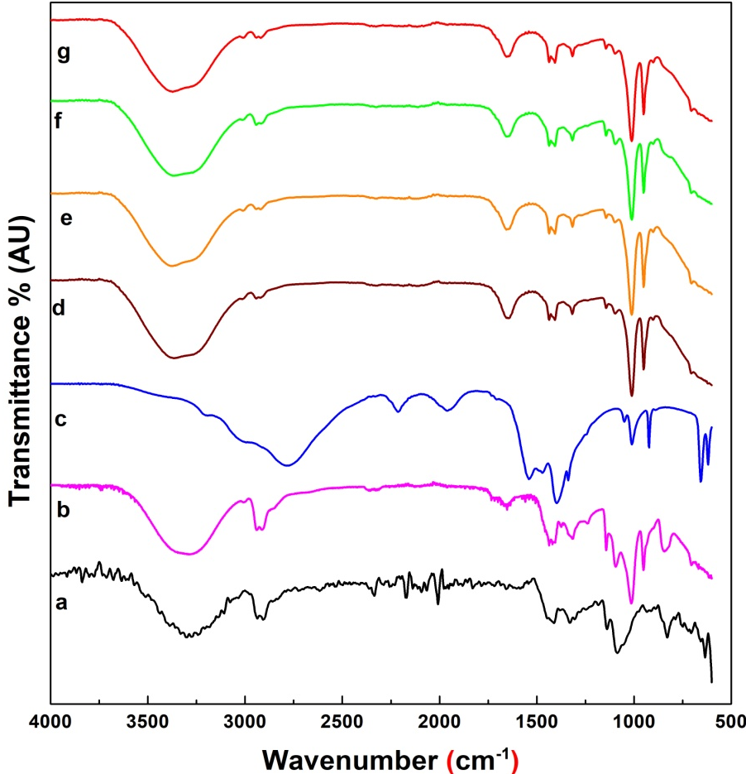
Figure 2. Infrared spectra of Pure PVA and NCPE membranes of PVA:DMSO:NH₄CH₃COO containing different wt% concentrations of MWCNT.

Triplet peaks 1406 cm⁻¹, 1418 cm⁻¹ and 1436 cm⁻¹ are observed in PVA-DMSO spectrogram and these peaks merged into double peaks at 1408 cm⁻¹ and 1441 cm⁻¹ in spectra of DMSO-PVA-NH₄CH₃COO and few shifting is also seen in spectra (e-g)on addition of MWCNT contents (see table 1). This is due to strong interaction of salt with polymer in the presence of the MWCNT.C-H deformation related and C-O stretching related peaks at 1006 cm⁻¹ and1326 cm⁻¹(pure PVA related CH-OH bending and CH₃ in plane deformation) are seen to shift towards lower wave number on increase of MWCNT contents in composite electrolyte membrane while peaks at 1244 cm⁻¹ (C-O stretching mode) and NH deformation vibration related peak of NH₄CH₃COO (1401 cm⁻¹) shows in decreasing intensity. These modulations in IR spectra result from improved salt-polymer interaction in the presence of MWCNT dispersoid.
Table 1.IR transmittance bands (in wave numbers) of NCPE gel membranes
Descriptions of Vibrations Mode | Pure PVA | Pure  NH₄CH₃COO | [(PVA-NH₄CH₃COO) containing MWCNT (wt %)
 |  |  | 0.0 | 0.2 | 0.4 |  | 1.0
C- H out of plane deformation | 714 | 618  657 | 619  706 | 615  711 | 618  702 | 614  703
O-H bending mode | 923 |  | 951 | 952 | 954 | 947
C-H wagging mode |  | 1014 | 1006 | 1010 | 1009 | 1014
C-O stretching mode | 1083 | 1046 | 1095 | 1093 | 1096 | 1097
C-C and C-O stretching mode | 1135 |  | 1139 | 1142 | 1140 | 1147
C-O stretching mode | 1236 | 1244
CH-OH bending mode CH₃ in plane deformation & C-H wagging | 1326 |  | 1317 | 1317 | 1315 | 1313
N-H deform. & asymmetric CH₃ bending mode |  | 1401
C-H deformation mode | 1410  1445 |  | 1406  1439 | 1408  1441 | 1403  1436 | 1412  1437
C-H stretching | 1643 |  | 1650 | 1649 | 1655 | 1653
-CONH- bending mode | 1661
C=O stretching mode |  | 1734
C-H symmetric stretching mode of CH₂ group | 2845  2906  2937  3059 | 2790  3006 | 2920  2942  3014 | 2911  2944  3010 | 2914  2947 | 2915  2948  3006
O-H stretch | 3295 | 3210 | 3372 | 3307 | 3352 | 3380

Broadening and decrease in intensity of these peaks are also possibly on account of presence of shoulder of MWCNT to indicate role of MWCNT as of passive nature and only modifying the morphology of the system with stretching in PVA chains. Diminishing nature of transmittance peaks at 1650 cm⁻¹ in pristine electrolyte which is related to C-H stretching respectively results due to stretching in PVA chain in the presence of MWCNT filler. This is based on the fact that MWNT provides reinforcement for polymers. Further, peaks at 3372, 3014, 2942, 2920, 1139, 619cm⁻¹ which are related to C-H stretch (asym and submethyl), sym C-H stretch, C-H stretch and OH stretch, sym υ (SH) and acetal overtone, C≡N stretch, C-C and C-O stretch, O-H twisting respectively shifted to 3380, 3006, 2948, 2915, 1147, 614 cm⁻¹ respectively with increase in broadness. These shifting of peaks may be correlated to physical attachment of nanomatrix galleries of MWCNT with NH₄CH₃COO salt in composite polymer electrolyte. All these features reveal important role of MWCNT in improving morphology of the polymer electrolyte system through polymer-salt interaction.
3.3 Cyclic Voltametry Studies
Figure 3 (a-d) shows the cyclic voltagrams for MWCNT embedded PVA-NH₄CH₃COO composite electrolytes system. On addition of 0.2wt% MWCNT filler (scan b), stability is seen to improve. A small oxidation peak appear at 0.5V in cyclic voltagram ‘a’ which corresponds to NH₄⁺/H⁺ ion thereby indicating protonic conduction in NCPEs.^{[14]}Further, on increasing MWCNT contents, the oxidation peak (related to NH₄⁺/H⁺) tends to diminish and finally disappears in cyclic voltagrams c&d. This feature ascertains change in system morphology subsequent to MWCNT insertion in pristine electrolyte matrix. Besides voltagram ‘b’ shows a small peak around 1.6V. This is possibly due to oxidation of MWCNT –a feature reported earlier by Crooks and co-workers for Ag│AgCl (3M NaCl) in an aqueous 0.1 M KCl electrolyte solution.^{[15-16]} Interestingly, this oxidation peak tends to reduce with increasing MWCNT filler contents in polymer gel electrolyte (voltagrams b & c). This is might be due to unoxidized MWCNT. In comparison to (PVA-NH₄SCN):Al₂O₃ NCPE, the improved cyclic stabilities of the [(PVA-NH₄CH₃COO):MWCNT] NCPE gel membrane was noticed.^{[17]}These anodic and cathodic peaks diminish in intensity and become broaden along with shifting of anodic peak towards higher potential and cathodic peak towards lower potential in each of the voltagram of NCPEs (scan b-d). This is essentially due to interaction of polymer with the NH₄CH₃COO salt in the presence of MWCNT.
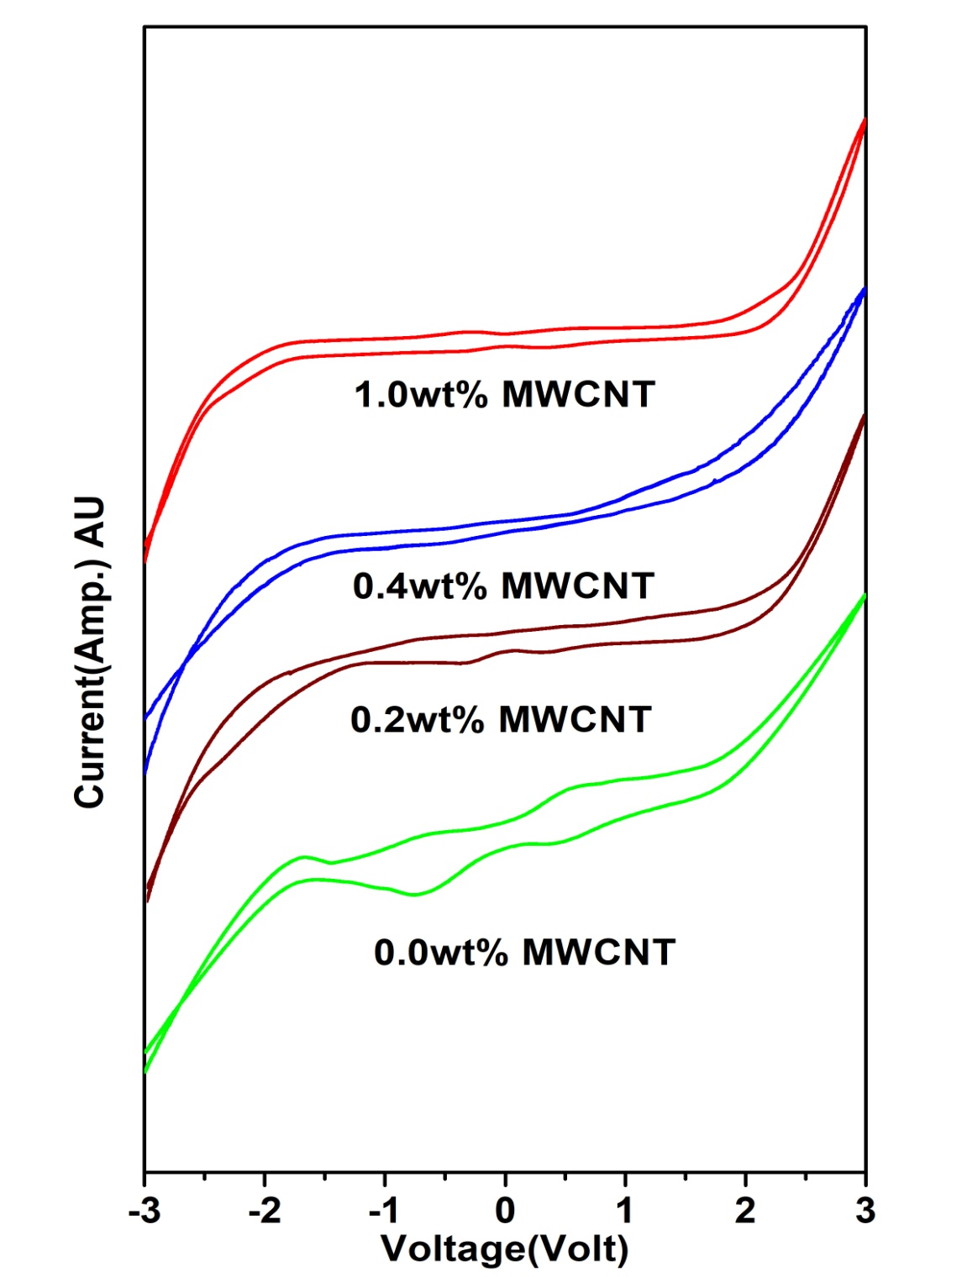
Figure 3. Cyclic Voltagrams of DMSO casted PVA:NH₄CH₃COO gel membrane and its composite containing 0.2 wt%, 0.4 wt% and 1 wt% MWCNT filler content.
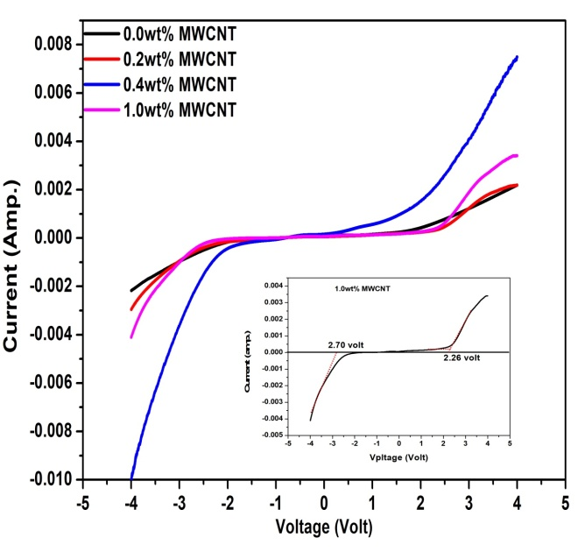
Figure 4. Shows the Linear Sweep Voltammetry (LSV) measurement with addition of MWCNT in PVA-NH₄CH₃COO system containing 0.2,0.4 & 1wt%MWCNT filler content.

Similarly, the optimum operational potential energy for MWCNT doped NCPEs system examined by carrying out Linear Sweep Voltammetry (LSV) measurement (see figure 4). Upon addition of MWCNT in PVA-NH₄CH₃COO system, the electrochemical window stability is expanded upto ±4.96V at 1.0wt% MWCNT doped system (see figure 4inset image).The cathodic and anodic potentials are detected at -2.70V and +2.26V respectively. It can be concluded that infused of MWCNT can improve the electrochemical stability of the system.
3.4Impedance Spectroscopy
Figure 5 shows the role of MWCNT nanotubes concentration on ion conduction behaviour of polymer gel electrolytes. Closer examination of conductivity behaviour shows two maximas one around 0.5wt% and another around 1wt% filler concentration - a feature typical of polymer nanocomposite gel electrolytes^{.[18]}A flattening in conductivity response is noticed beyond 1 wt% MWNT contents. This can be associated to the fact that all the salt has been dissociated and so charge carrier concentration is limited. It is only the change in system morphology that tends to affect the conductivity and thus again an enhancement of small magnitude is visible. Another explanation to the rise in conductivity can be provided in terms of the breathing chain model^{[19]} and Tsagaropolous modelwhich were reported earlier.^{[20]}According to this model ion dissociation results from folding and unfolding of the polymeric chains which creates free volume due to local pressure fluctuations for the ions to migrate easily. This overcomes the decreasing trend of transporting ions to again help in escalating ionic conductivity as seen in figure 5. Thus, an optimum in conductivity was found 5.49 x10⁻⁴Scm⁻¹for 1wt% of MWCNT. The temperature dependence of the electrical conductivity of the polymer gel electrolyte and its composite membranes is presented in figure 6. The increase in conductivity with temperature is attributed to hopping mechanism between coordinated sites, local structural relaxation and segmental motion of the polymer. As the amorphous region progressively increases, the polymer chain acquires faster internal motion and bond rotations (segmental motions).
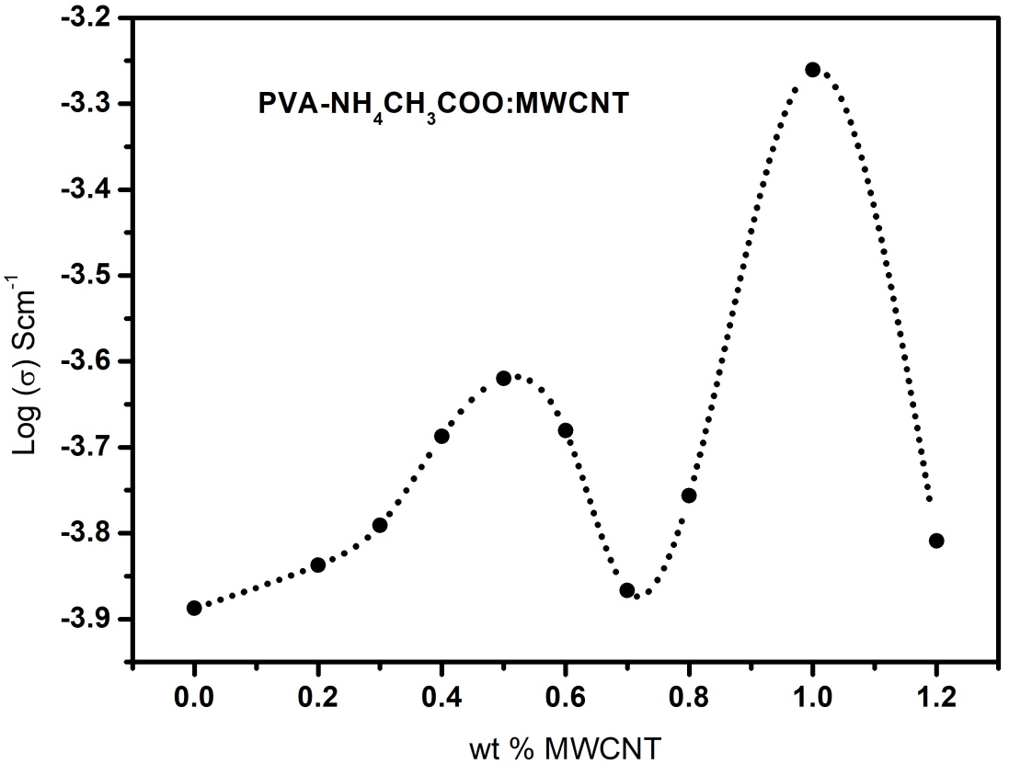
Figure 5. Variation of conductivity of nanocomposite polymer electrolyte gel membranes with MWCNT filler concentration at room temperature.
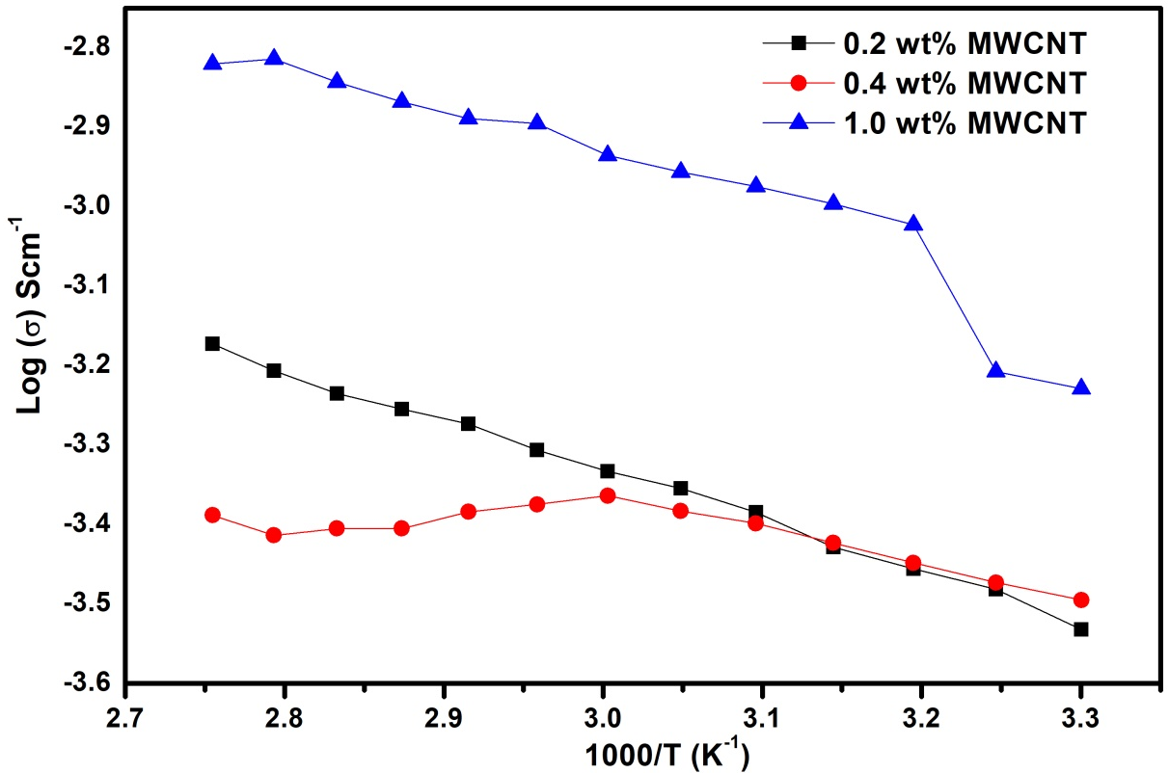
Figure 6. Shows the temperature dependence of the electrical conductivity of the nanocomposite polymer electrolyte gel membranes on addition of 0.2, 0.4 & 1wt% concentrations of MWCNT.

This in turn favours the hopping of inter-chain and intra-chain movement and ionic conductivity of polymer electrolyte becomes high. It is apparent from conductivity behaviour (figure 6) that all the curves show two linear regions separated by a nonlinear behaviour. The linear region in the low temperature zone (25°C to 40°C), conductivity obeys Arrhenius nature as described earlier.^{[20]} This is possibly due to presence of liquid electrolyte encapsulated by the polymer matrix i.e. effect of temperature of conductivity of liquid electrolytes. The mid temperature regime (40°C to 85°C) conductivity response can be well described by VTF relationship. When the temperature approaches to the glass transition of the complex/pure PVA the matrix becomes flexible giving rise to a VTF type behaviour. Similar observations have been recorded by Srivastava et al.^{[22]} and correlated to two regions separated by a region corresponding to crystalline to amorphous phase transition regime. It has been observed that reorganizations at the interfaces are more pronounced at temperatures around the Tg of the composites. Owing to a modification of the polymer dynamics when it is confined and strongly interacting with the CNTs.^{[23,24]}Further it has been shown in the polymer nanocomposite electrolytes^{[25]}that nanoparticles can increase the glass transition temperature of the polymer at the polymer-nanoparticles interface. As a consequence, with different MWCNT loadings in the composite electrolyte system the nonlinear regime shall change and also observed in present case. On the whole as the temperature of system is raised beyond 40°C, segmental motion of polymer in polymer composite comes into play and which starts affecting the conductivity. Therefore, all the curves display similar behaviour i.e., a combination of Arrhenius and VTF character.
The variation of a.c. conductivity for different concentration of MWCNTs doped NCPEs with frequency is shown in figure 7. It is apparent from figure 7 that a.c. conductivity increases with frequency in the low frequency regime followed by a nearly frequency independent behaviour in the high frequency regime. The increasing conductivity behaviour is connected to the electrode-electrolyte phenomena i.e. it results from electrode polarization effects.^{[26]} This kind of behaviour has been reported for wide range of polymer nanocomposite electrolytes^{[27]} and also for [(PVA-NH₄CH₃COO:MWCNT]electrolytes. It is observed that the increase in filler content enhances a.c. conductivity. The calculated value of power law exponent (p), generally for ionic conductor can be in between 1.0 and 0.5, indicating the ideal long-range pathway diffusion limited hopping.
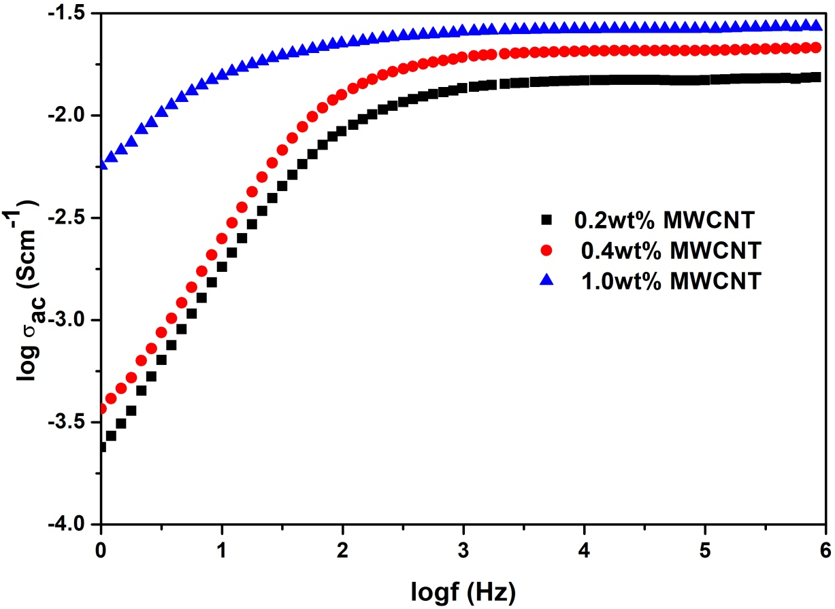
Figure 7. Variation of a.c. conductivity with frequency for nanocomposite polymer electrolyte gel membranes containing (■) 0.2 wt.%, (●) 0.4 wt.% and (▲) 1 wt.% MWCNT contents.

The observed frequency dispersion for different composite can be rationalized with the help of jump relaxation model ^{[24-25]} since the dynamical effect of polymer host caused by segmental renewal rates, is less significant below microwave frequencies. According to this model, an ion can hop from a site to neighbouring vacant site successfully to contribute to conductivity. At high frequencies the probability for ion to hop back increases due to short time periods. This forward-backward hopping at high frequencies together with relaxation of dynamic cage potential seems to be responsible for high frequency plateau.
Conclusion
The SEM images show heterogeneous distribution of fillers in nanocomposite electrolyte system and chains of PVA fully covered by MWCNT. FTIR spectral studies have established the MWCNT serves as the role of passive filler only causing structural changes in the system. Cyclic Voltammetric investigations on different NCPEs membranes have shown that MWCNT based NCPE membranes have good window stability upto 1wt% MWCNT.dc ionic conductivity has been found to increase and obey two conductivity maximas with increasing MWCNT content and reached optimum at 1wt% MWCNT filled nanocomposite electrolyte. Temperature dependent study of dc conductivity response is described by the combination of Arrhenius and VTF behaviours. The a.c. conductivity responses in all the cases are well described by jump relaxation model and Jonscher power law. Highest ac conductivity values possibly due to creation of extra hopping sites assisting to ion hop. Present investigations recommends the nanotubes embedded NCPE gel membranes as a suitable system of achieving thermally, electrochemically and thermally stable electrolytes with appropriate ionic conductivity properties approaching that of liquid electrolyte. Such properties are expected to open up application areas particularly in supercapacitors and batteries.
Acknowledgements
Authorsare grateful to Prof. S.L. Agrawal, Solid State Ionics Laboratory, Department of Physics, APS University for providing Electrochemical Analyzer for experimental analysis for CV, LSV and impedance spectroscopy.
Authors are also thankful to Dr. Kamlesh Pandey, Sr. Scientist, National Centre of Mineralogy& Petrology, University of Allahabad for performing FTIR anlaysis.
References
[1] M. M. E. Jacob, E. Hackett, E. P. Giannelis, J. Mater. Chem.2003, 13, 1-5.
[2] Y. Ma, L. B. Li, G. X. Gao, X. Y. Yang, J. You, Elsevier 2016, 502,130-138.
[3] X. Fan. J. Liu, Z. Song, X. Han, Y. Deng, C. Zhong, W. Hu, Elsevier, Nano energy, 2019, 56, 454-462.
[4] S. K. Tripathi, A. Gupta, A. Jain, M. Kumari, Indian Journal of Pure & Applied Physics,2013, 51, 358-361.
[5] M. Tripathi, S. M. Bobade, A. Kumar, Journal of Physics & Chemistry of solids, 2021, 152, 109944.
[6] S. Choudhary, R.J. Sengwa, Effects of different inorganic nanoparticles on the structural, dielectric and ion transportation properties of polymers blend based nanocomposite solid polymer electrolytes, Electrochim. Acta, 2011, 247, 924–941.
[7] D. Stojanovic, J. S. Hanol, Fluids, 2010, 52, 276–284.
[8] T. V. Rajendran and V. Jaisankar, Materialstoday: Proceedings, 2015, 2, 4421-4428.
[9]G. R. Baymuratova, A. V. Chernyak, A. A. Slesarenko, G. Z. Tulibaeva, V. I. Volkov, O. V. Yarmolenko, Russian Journal of Electrochemistry, 2019, 55(6),529-536.
[10] A. P. Khandale, S. S. Bhoga, S. K. Gedam, Ionics, 2013, 19 (11).
[11] S. Manzetti & J.C.P. Gabriel, International Nano letters,2019, 9, 31-49.
[12] J. M. Chun, M. S. Akhtar, K. J. Kim, O. B. Yang, Theories and Applications of Chem. Eng., 2007, 13, 2038.
[13] C. P. Singh, P. K. Shukla, S. L. Agrawal, Advanced Science News, 2020, 32, 1-8.
[14] S. Sharma, N. Dhiman, D. Pathak and R. Kumar, i-Manager’s Journal on Material Science, 2016, 3(4), 28-34.
[15] T. Ito, L. Sun, R. M. Crooks, Electrochem.Solid-State Lett. 6, 2003, C4.
[16] B. J. Hinds, N. Chopra, T. Rantell, R. Andrews, V. Gavalas and L.G. Bachas, Science, 2004, 62, 303.
[17] M. A. Haque, A. B. Sulong, L. K. Shyuan, E. H. Majlan, T. Husaini, R. E. Rosli, International Journal of Hydrogen Energy, 2021, 46, 4339-4353.
[18] R. Kumar, S. Sharma, D. Pathak, N. Dhiman, N. Arora, Solid State Ionics, 2017, 305, 57-62.
[19] S. Chandra, S. S. Sekhon, N. Arora, Ionics,2000, 5(1), 112-118.
[20] V. Arrighi, I. J. Mcewen, H. Qian, M. B. S. Prieto, Polymer, 2003,44, 6259–6266. [21] B. A. Shujahadeen, J. W. Thompson, M. A. Hameed, Journal of Science: Adv. Materials and Devices, 2018, 3(1), 1-17.
[22] N. Srivastava, A. Chandra, S. Chandra, Physics Review, 1995,B 52, 225.
[23] C. Bartholome, P. Miaudet, A. Derre, M. Maugey, O. Roubeau, C. Zakri, P. Poulin, Composites Sc. and Tech., 2008, 68, 2568.
[24] N. Chand, N. Rai, S. L. Agrawal, S. K. Patel, Bull. Mate. Sci., 2011, 34,1297.
[25] K. Pandey, M. M. Dwivedi, M. Tripathi, M. Singh, S. L. Agrawal, Ionics, 2008, 14, 515.
[26] S. L. Agrawal, M. Singh, M. Tripathi, M. M. Dwivedi, K. Pandey, J. Mater. Sci., 2009, 44, 6060.
[27] M. Abdullah, W. Lenggoro, K. Okuyama, Nalwa, Encyclopedia of Nanoscience and Nanotech.,2004,8, 731.

