Comparison of Mechanical Performance on Cranial Implant from Computer Tomographic Data using Finite Element Simulation
ª Karthik Narayanan A, ^{b*} Mugendiran V
ª Department of Rubber and Plastics Technology, MIT Campus, Anna University, Chennai – 600044, Tamilnadu, India
^{b} Department of Production Technology, MIT Campus, Anna University, Chennai – 600044, Tamilnadu, India
*Corresponding author: mugendiran.v@mitindia.edu
Orchid Id: 0000-0002-2436-1236

ABSTRACT
Design and fabrication of patient’s specific cranial implant plays a vital role in cranioplasty for better surgical planning, to restore intracranial structure and appearance of the patient. In the last few years, even though many research have discussed in developing bio implant materials for cranioplasty, surgeons are still facing challenges in developing optimal design for safe and more accurate reconstruction of cranial implant. In this work, the voxel data based DICOM images of the patient skull is converted into triangle data based STL file. The damaged temporal portion of the skull is reconstructed into a 3D patient specific cranial implant using available commercial software. Finite element study has been carried out on the reconstructed CAD file to analyze the mechanical performance of cranial implant with different bio - implant materials (Poly Ether Ether Ketone (PEEK), Poly Methyl Metha Acrylate (PMMA) and Titanium alloy (Ti6Al4V)) and external deformity by two fixture conditions (8 and 10 fixation points). The results show that Ti6Al4V has less deformation and PEEK exhibit lesser equivalent stress under 15 mm Hg of intracranial pressure when compared to other selected bio - materials. This study may help the surgeon with a better evaluation of pre-surgical implant materials and fixation points depending on the situation.
Keywords: Cranial implant, Biomaterials, Image Segmentation, Finite Element Analysis.
1.0 INTRODUCTION
Traumatic skull injury caused by accident, bone destruction or brain tumor results in functional and appearance deficiency. Cranioplasty is reconstructive surgical process by which defect part on the skull is repaired by specific cranial implant [1-3]. Cranial implant is medical device that aims to restore the damaged and missing part on the skull [4]. In the seventeenth century, the first true and successful bone graft, which was performed with bone from a dead dog cranium [1]. Allograft bone transplantation is the best way of cranioplasty but it has some complications, availability of donor, infections and layer complex defect [1-2, 5]. Last few decades many of researchers have been working on developing optimal materials with osteo integration and implant model creation [3].
Development in medical image processing like CT or MRI assists in 3D development of human anatomical structure. Patient’s specific cranial implant are designed and manufactured from the patient CT or MRI data [5-6]. CT data where series of X-ray images captured at various angles and combined, called as DICOM file consists of different tissues, skin and bone and it is required to transfer into 3D model of specific part [7-8]. Isolation the objects from other images in DICOM file, image segmentation plays a vital role [7, 9-11]. Thresholding method is one of the easy method used for image segmentation, in which binary image is created from a gray scale or full colour image which contain all essential information about position and shape of the implant, by selecting the appropriate threshold range [7, 9-10].
The CAD model generated from slicer software is saved as stereo lithographic type (STL) which is of meshed structure of different face sizes. It is found that implant with pore structure is more efficient than pore less structure. Pores in the implant helps in interfacial adhesion with bone, bio mineralization with better fitting and shorter healing time [12-13]. The ideal size of pore ingrowth lies from 500-1500µm for better cell adhesion and transplantation of fluids [13-17]. Even though pores in the implant have many advantages, there is a limitation in withstanding intracranial pressure. Mathematical analysis of implant exhibit biological situations and provide results compatible with the real function of the model. In recent days FEA in medical area to analysis human musco-skeleton system, remodeling biomechanics, evolution anthropology and functional morphology is in increasing trend [9, 13, 17-19]. The investigation of structural changes and failure behavior of cranial implant on various load conditions, fixation points and intracranial pressure for reproducing optimal cranial implant is a crucial one [2,9,13-15,20].
Although Autogenous bone transplantation is preferred as first choice for cranioplasty, due to its complication implants made out of biomaterials are chosen. For fabricating patient specific cranial implant common materials used are Poly Ether Ether Ketone (PEEK), Hydroxyapatite (HA), Poly Methyl Metha Acrylate (PMMA), and Titanium alloy (Ti6Al4V) [1,3]. PMMA is low cost readily available biocompatible material that can be either molded or 3D printed. In terms of mold, PMMA is pressed into a mold and gets cured. After cooling it can be avertedly be transferred to the skull defect with some minor adjustments. When compared to cortical bone, PMMA is weaker in mechanical properties because of its low elastic modulus and secretion of air bubbles which leads to the rise in infections. Compared to PMMA and PEEK, Ti6Al4v has high elastic modulus [21]. Due to his higher stress shielding effect, absorption of bone tissue around the implant occurs, which leads to loosening and failure of implant. When compared to other materials, PEEK an excellent polymer, has good mechanical, biological and chemical properties [22]. Due to this, it can reduce the risk of bone resorption and osteolysis caused by stress shielding effect of implant [23]. Its toughness, fatigue resistance, creep resistance, nontoxic and sterilization properties improves its success rate in cranioplasty upto 93.7% [1, 14, 24-26]. Considering traditional methods, Additive Manufacturing (AM) has vastly adoption in manufacturing patient’s customized cranial implant with help of reverse engineering technique and computer aided design [27].
Based on the literature, fixation condition and material properties like Young’s Modulus plays vital role in designing the cranial implant. Three different biomaterials are analyzed on different load and fixation conditions. The objective of the present study is to integrate design and analysis of customized cranial implant using CAD tools and reverse engineering technique to reconstruct patient specific 3D CAD model of cranial from DICOM images using finite element simulation.
2.0 MATERIALS AND METHODOLOGY
2.1 Materials
In this study, bio – implant materials like (Poly Ether Ether Ketone (PEEK), Poly Methyl Metha Acrylate (PMMA) and Titanium alloy (Ti6Al4V)) are considered and their physical and mechanical properties has been listed in Table.1 and Table.2. The material properties are assumed be linear elastic, homogenous and isotropic.
Table 1 Material Properties of PMMA, PEEK and TI6Al4V
Properties | PEEK | PMMA | Ti6Al4V
Density (gm/cc) | 1.31 | 1.18 | 4.429
Thermal Conductivity (W/mK) | 0.252 | 0.167 – 0.25 | 6.7
Table 2 Mechanical Properties of PMMA, PEEK and TI6Al4V
Properties | PEEK | PMMA | Ti6Al4V
Yield Strength (MPa) | 100MPa | 72 MPa | 800 MPa
Young’s Modulus (MPa) | 4000MPa | 300 MPa | 110000MPa
Poisson’s ratio | 0.4 | 0.38 | 0.3
Flexural strength GPa | 4.14 | 2.9 | 0.123
2.2 Methodology
The CAD model of the implant is generated by scanning the cranial defect of the patient using CT scanning. Figure 1 shows proposed methodology that has been adopted in this study. The first phase starts with Data acquisition in which CT scan data of patient with cranial defect are obtained in DICOM file format, which contains the metadata such as slice thickness, spacing between slices, depth, dimensions, etc., is considered to reconstruct the CT model.
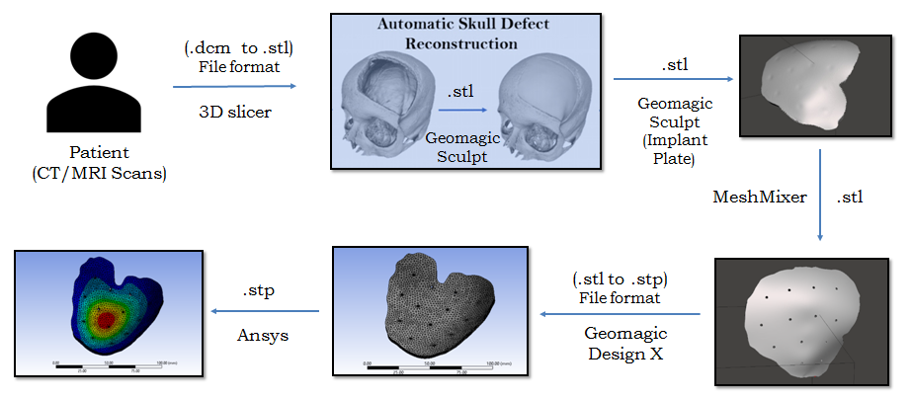
Fig. 1 Reconstruction procedure form DICOM images to 3D CAD model
Image segmentation and geometric reconstruction technique in slicer software helps in surface representation of skull with defect. By selecting adequate threshold range (1000-1500HU) skull part is extracted and saved in Stereo Lithographic (STL) file format. From this geometric model, patients specific cranial implant dimension and contour can be easily extracted. Figure 2 shows the skull part generated from DICOM file in Slicer software.
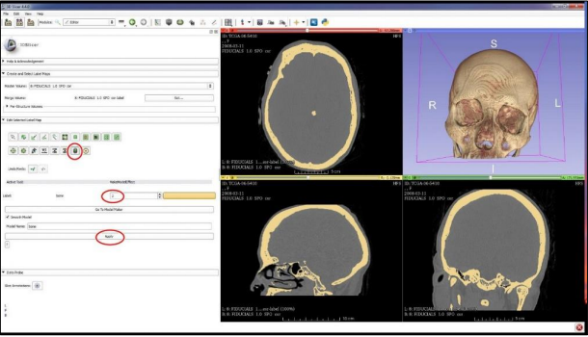
Fig. 2 Conversion of skull part using slicer software
Once the geometry of the defect is available, with help of Geomagic sculpt software, implant to be inserted is generated by clay modeling method. A curve line is drawn around the defect and datum plane is introduced approximately 5 mm from the defect perpendicular to z-axis. The 3Curve is projected on this datum plane and extruded as solid clay. From this SubD surface which covers the defect is created. The surface is extruded for 4 mm as per the design consideration and it leads to a three dimensional patients specific cranial implant model in STL file format. The generated implant is re-fixed with the missing portion of the skull for its accuracy and its dimensions are slightly adjusted for better fit. The implant is smoothened by laser smoothening tool. Figure 3 shows the skull part with defect in GeoMagic Sculpt software.
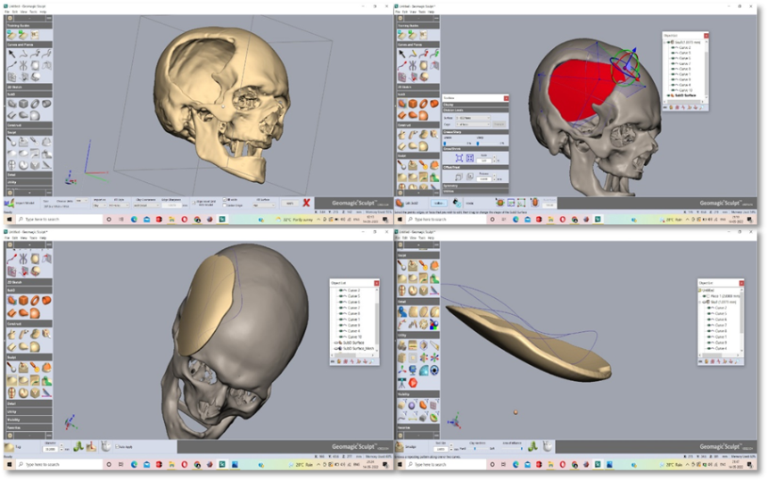
Fig. 3 Defective portion of skull part
In between the inner dermis of underlying head scalp skin bio-mineralization takes place during which blood vessels and minerals circulation takes place. Considering this into account, pores of diameter 2 mm are made in the implant with specific interval of 20 mm for better exchange of minerals and bone regrowth at good time period. Figure 4 show the obtained 3D model of cranial implant from Autodesk Meshmixer software.
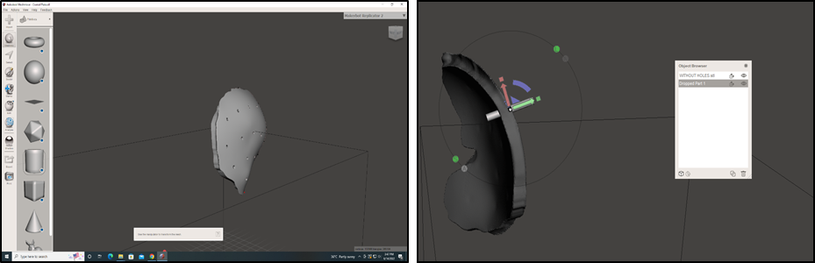
Fig. 4 Pore generation on Cranial Implant
Fig. 5 Generated Cranial Implant with pores
Figure 5 shows the 3D model of specific cranial implant obtained using described methodology. It consists of faceted model made of triangular facets of different mesh sizes throughout the design. To overcome this, STL file is converted into STEP file by using GeoMagic Design X software. With help of surface primitive and Meshfit, a region is generated on both top and bottom layer of the model. A line is drawn on the impression made over the top and bottom layer respectively. The edges of the sketch made on the two regions are made to solidify by using extrusion command. Now the step file of cranial implant is arrived for analysis. Figure 6 indicates the 3D model of cranial implant in Geomagic Design X software.
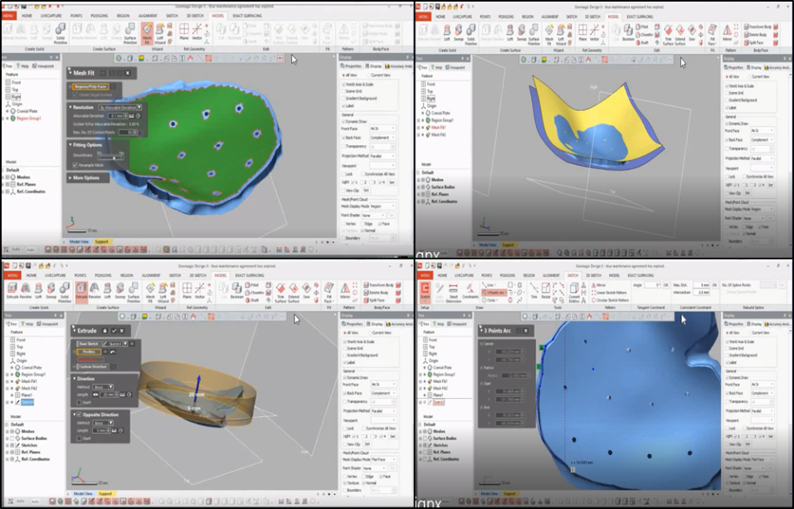
Fig. 6 Conversion of STL to STEP file
The STEP file of the cranial implant is discretized into tetrahedral meshed elements. The total elements in the file are of same edge length 2mm.The accuracy and file size increase with decrease in edge length. The volumetric difference between the meshed part and unmeshed part is observed to be within 2 % limit and is shown in Figure 7.
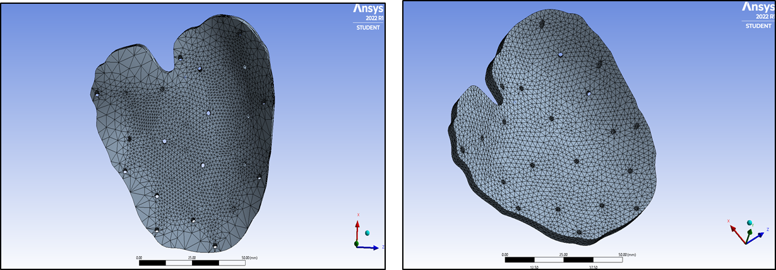
Fig. 7 Part with irregular mesh and refined mesh
Comparison of mesh elements and nodes for cranial implant of two different cases is represent in Table 3.

Table. 3 Comparison of meshed components for 8 fixation and 10 fixation points
 | Case 1:  8 Fixation points | Case 2:  10 Fixation point
Element size | Edge length 2 mm | Edge length 2 mm
Number of nodes | 48863 | 55878
Number of elements | 28345 | 32855

3.0 RESULT AND DISCUSSION
Three different implant materials with two fixture point conditions has been considered to determine the optimal implant material and fixture point design. Finite Element Analysis of Cranial Implant under static loading condition was carried out. As the implant is to be fixed on the skull, the defect edges are fixed under two different conditions 8 and 10 fixation points. The implant fixation points allow implant to react according to the developed intracranial pressure, within the craniospinal compartment, a closed system which comprises a fixed volume of neural tissue, blood, and cerebrospinal fluid. Few literature survey have concluded that for an normal adult the nominal intracranial pressure ranges between 8-15 mm Hg. Static pressure of 15mm of Hg is considered based on intracranial pressure condition and applied on the inner surface, evenly distributed over an area of implant. The solid part of both the cases (8 point fixation & 10 point fixation) undergoes total deformation and equivalent Stress (von Mises stress).
The application of intracranial pressure deforms the implant and the developed deformation and equivalent von Mises stresses from the simulation is shown in Figure 7 and Figure 8 for 8 fixation and 10 fixation points respectively.

Case 1: 8 fixation points
Material | PEEK | PMMA | Ti6Al4V
Equivalent Stress | 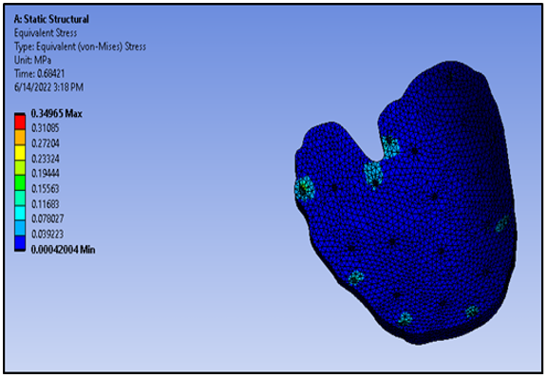 | 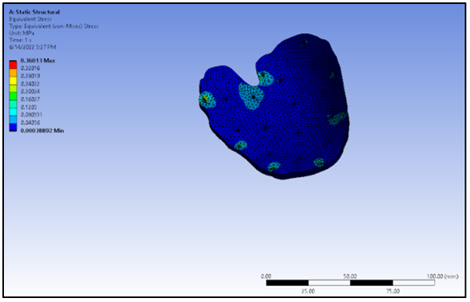 | 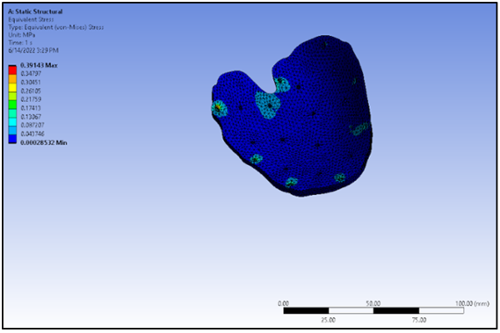
Deformation | 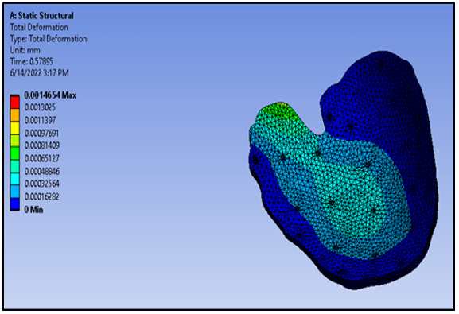 | 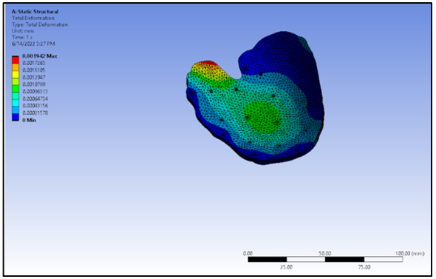 | 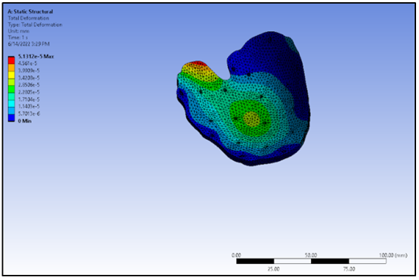
Fig. 7 Equivalent stress and Maximum deformation for 8 fixation points
Case 2: 10 fixation points
Material | PEEK | PMMA | Ti6Al4V
Equivalent Stress | 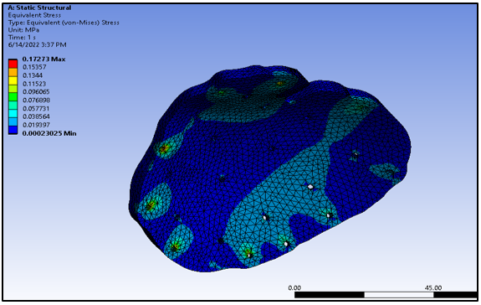 | 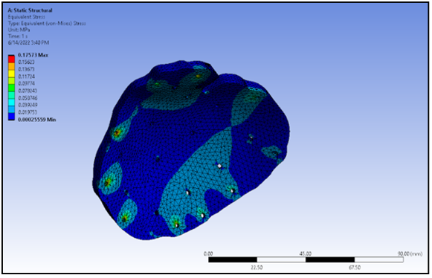 | 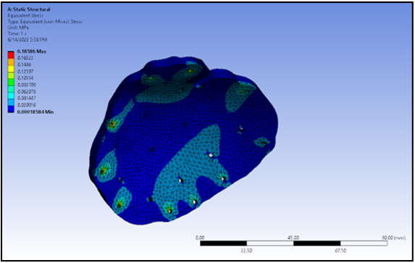
Deformation | 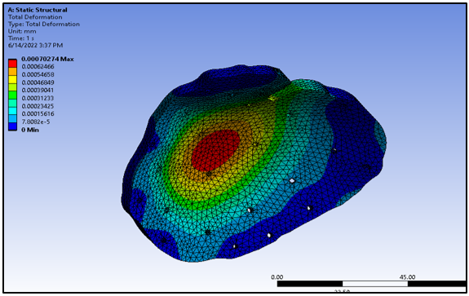 | 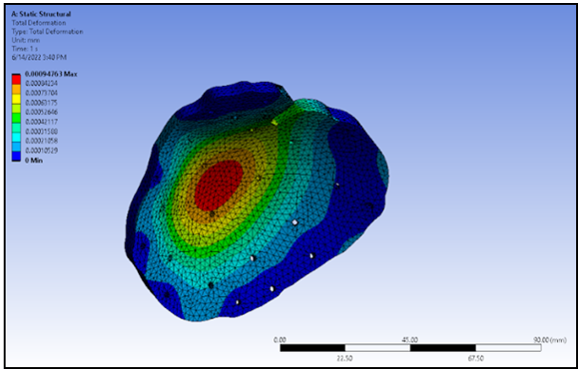 | 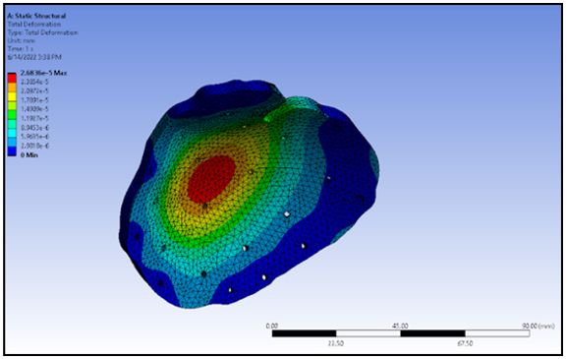
Fig. 8 Equivalent stress and Maximum deformation for 10 fixation points
Table 4 and Table 5 shows the simulated result of cranial implant under 15 mm Hg of intracranial pressure for 8 fixation points and 10 fixation points respectively.

Table. 4 Total Deformation and Equivalent Stress for 8 fixation Points
Case1: 8 fixation points structural analysis
 | PEEK | PMMA | Ti6Al4V
Deformation(mm) | 0.0014654 | 0.001942 | 0.000051312
Equivalent Stress (MPa) | 0.34965 | 0.36013 | 0.39143
Table. 5 Total Deformation and Equivalent Stress for 10 fixation Points
Case2: 10 fixation points structural analysis
 | PEEK | PMMA | Ti6Al4V
Deformation(mm) | 0.00070274 | 0.00094763 | 0.000026836
Equivalent Stress (MPa) | 0.172731 | 0.17573 | 0.18586
Figure 9 and Figure 10 shows the comparison of maximum deformation and equivalent stress developed due to the application of intra cranial pressure on the cranial implant.
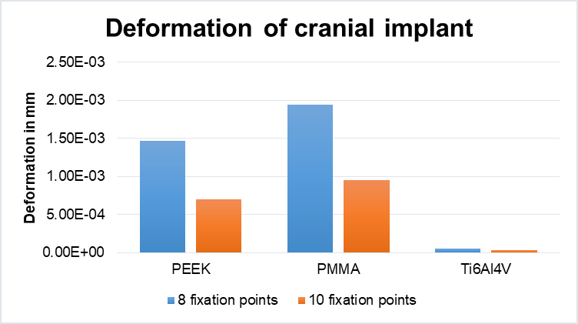
Fig. 9 Comparison of deformation in 8 fixation and 10 fixation points
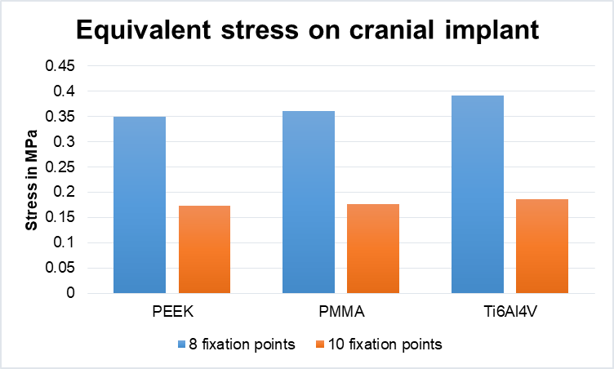
Fig. 10 Comparison of equivalent stress in 8 fixation and 10 fixation points
4.0 CONCLUSION
The implant for cranioplasty is designed and developed considering three different materials PMMA, PEEK and Titanium alloy. Cranial implant has been modelled from DICOM image to STL file and converting it into solid part from STEP file. For mineralization pores were created on the solid cranial implant. Fixation points 8 and 10 were selected and an intra cranial pressure of 15 mm Hg is applied on the surface of the implant. FEA Simulation of the cranial implant with boundary conditions was carried out to determine the developed deformation and equivalent stress. With 8 fixation point condition, Ti6Al4V shows lower deformation and equivalent stress, but in case of 10 fixation points the deformation in Ti6Al4V is lower and the PEEK has lower equivalent stress when compared to PMMA and Ti6Al4V. The implant deformation and the developed equivalent stress are directly proportional to intracranial pressure, whereas it is inversely proportional to fixation points in both cases. The results presented in this work provide information about the biomechanical behavior of cranial implants and can thus be used for design purposes to further improve the clinical outcomes of cranioplasty with these materials.
Acknowledgement: The authors are grateful to the Department of Production
Technology and Department of Rubber and Plastics Technology, MIT campus, Anna University, Chennai, India.
Funding: No funds, grants, or other support was received.
Conflicts of interest: The authors declare that they have no conflicts of interest.
REFERENCES
- Alkhaibary, A., Alharbi, A., Alnefaie, N., Almubarak, A. O., Aloraidi, A., & Khairy, S. (2020). Cranioplasty: A comprehensive review of the history, materials, surgical aspects, and complications. World neurosurgery, 139, 445-452. https://doi.org/10.1016/j.wneu.2020.04.211
- Jindal, P., Chaitanya, Bharadwaja, S. S. S., Rattra, S., Pareek, D., Gupta, V., & Juneja, M. (2022). Optimizing cranial implant and fixture design using different materials in cranioplasty. Proceedings of the Institution of Mechanical Engineers, Part L: Journal of Materials: Design and Applications, 14644207221104875. https://doi.org/10.1177/146442072211048
- Zanotti, B., Zingaretti, N., Verlicchi, A., Robiony, M., Alfieri, A., & Parodi, P. C. (2016). Cranioplasty: review of materials. Journal of Craniofacial Surgery, 27(8), 2061-2072. 10.1097/SCS.0000000000003025
- Savaser, B. O., & Erogul, O. E. O. (2017). Patient specific implant design and production for closure of skull defects. The Eurasia Proceedings of Science Technology Engineering and Mathematics, (1), 22-29. https://d5128909-8eb2-4d67-866a-06e3e3771af4.filesusr.com/ugd/da3e78_ad2d0d16115d49b7b92a023c2f319d0d.pdf
- Bonda, D. J., Manjila, S., Selman, W. R., & Dean, D. (2015). The recent revolution in the design and manufacture of cranial implants: modern advancements and future directions. Neurosurgery, 77(5), 814-824. 10.1227/NEU.0000000000000899
- Bhavsar, T., & Prakash, S. (2020). 3D-printing of skull bone from CT scan data. Materials Today: Proceedings, 28, 2447-2451. 10.1016/j.matpr.2020.04.789
- Modi, Y. K., & Sanadhya, S. (2018). Design and additive manufacturing of patient-specific cranial and pelvic bone implants from computed tomography data. Journal of the Brazilian Society of Mechanical Sciences and Engineering, 40(10), 1-11. https://doi.org/10.1007/s40430-018-1425-9
- Gill, D. K., Walia, K., Rawat, A., Bajaj, D., Gupta, V. K., Gupta, A., ... & Jindal, P. (2018). 3D modelling and printing of craniofacial implant template. Rapid Prototyping Journal, 25 (3). 10.1108/RPJ-12-2017-0257
- Ameen, W., A. Al-Ahmari, M. K. Mohammed, O. Abdulhameed, U. Umer, and K. Moiduddin. "Design, finite element analysis (FEA), and fabrication of custom titanium alloy cranial implant using electron beam melting additive manufacturing." Advances in Production Engineering & Management 13, no. 3 (2018): 267-278. 10.14743/apem2018.3.289
- Bogu, V. P., Ravi Kumar, Y., & Asit Kumar, K. (2018). 3D Printed, Customized Cranial Implant for Surgical Planning. Journal of The Institution of Engineers (India): Series C, 99(3), 255-259. https://doi.org/10.1007/s40032-016-0292-3
- Mian, S. H., Moiduddin, K., Elseufy, S. M., & Alkhalefah, H. (2022). Adaptive mechanism for designing a personalized cranial implant and its 3D printing using PEEK. Polymers, 14(6), 1266. 10.3390/polym14061266
- Berretta, S., K. Evans, and O. Ghita. "Additive manufacture of PEEK cranial implants: Manufacturing considerations versus accuracy and mechanical performance." Materials & Design 139 (2018): 141-152. https://doi.org/10.1016/j.matdes.2017.10.078
- Mian, S. H., Moiduddin, K., Abdo, B., Sayeed, A., & Alkhalefah, H. (2022). Modelling and evaluation of meshed implant for cranial reconstruction. The International Journal of Advanced Manufacturing Technology, 118(5), 1967-1985. https://doi.org/10.1007/s00170-021-08161-5
- Huys, S. E., Van Gysel, A., Mommaerts, M. Y., & Vander Sloten, J. (2021). Evaluation of patient-specific cranial implant design using finite element analysis. World Neurosurgery, 148, 198-204. 10.1016/j.wneu.2021.01.102
- Santos, P. O., Carmo, G. P., Sousa, R. J. A. D., Fernandes, F. A., & Ptak, M. (2022). Mechanical strength study of a cranial implant using computational tools. Applied Sciences, 12(2), 878. https://doi.org/10.3390/app12020878
- Dagang, W. N. F. S. W., Marwan, S. H., Mahmud, J., Manan, N. F. A., & Abdullah, A. H. (2021). The Influence of Pore Size and Material Properties on Biomechanical Analysis of Parietal-Temporal Implant, 8(4), 750-758.
https://doi.org/10.5109/4742118
- Bogu, V. Phanindra, Y. Ravi Kumar, and Asit Kumar Khanara. "Modelling and structural analysis of skull/cranial implant: beyond mid-line deformities." Acta of Bioengineering and Biomechanics 19.1 (2017): 125-131. https://pubmed.ncbi.nlm.nih.gov/28552926/
- Sharma, N., Ostas, D., Rotar, H., Brantner, P., & Thieringer, F. M. (2021). Design and additive manufacturing of a biomimetic customized cranial implant based on voronoi diagram. Frontiers in Physiology, 12, 647923. 10.3389/fphys.2021.647923
- Shweta, P., and M. Anburajan. "Finite element analysis of the skull implant using ansys software." In 2011 3rd International Conference on Electronics Computer Technology, vol. 3, pp. 420-425. IEEE, 2011. 10.1109/ICECTECH.2011.5941784
- Moiduddin, K., Darwish, S., Al-Ahmari, A., ElWatidy, S., Mohammad, A., & Ameen, W. (2017). Structural and mechanical characterization of custom design cranial implant created using additive manufacturing. Electronic Journal of Biotechnology, 29, 22-31. https://doi.org/10.1016/j.ejbt.2017.06.005
- Moiduddin, K., Mian, S. H., Umer, U., & Alkhalefah, H. (2019). Fabrication and analysis of a Ti6Al4V implant for cranial restoration. Applied Sciences, 9(12), 2513. https://doi.org/10.3390/app9122513
- Ng, Zhi Yang, and Irfan Nawaz. "Computer-designed PEEK implants: a peek into the future of cranioplasty?" Journal of Craniofacial Surgery 25 (1) (2014): 55-58. 10.1097/SCS.0b013e3182a2f7b6
- El-Ghani, Abd, and M. A. Wael. "Cranioplasty with polymethyl methacrylate implant: solutions of pitfalls." Egyptian Journal of Neurosurgery 33.1 (2018): 1-4. https://doi.org/10.1186/s41984-018-0002-y
- Marcián, P., Narra, N., Borák, L., Chamrad, J., & Wolff, J. (2019). Biomechanical performance of cranial implants with different thicknesses and material properties: A finite element study. Computers in Biology and Medicine, vol.109, pp.43-52. https://doi.org/10.1016/j.compbiomed.2019.04.016
- Huotilainen, E., Jaanimets, R., Valášek, J., Marcián, P., Salmi, M., Tuomi, J., ... & Wolff, J. (2014). Inaccuracies in additive manufactured medical skull models caused by the DICOM to STL conversion process. Journal of cranio-maxillofacial surgery, 42(5), 259-265. https://doi.org/10.1016/j.compbiomed.2019.04.016
- Moiduddin, K. (2018). Implementation of computer-assisted design, analysis, and additive manufactured customized mandibular implants. Journal of Medical and Biological Engineering, 38(5), 744-756. 10.1007/s40846-018-0370-5
- Mazzoli, A., Germani, M., & Raffaeli, R. (2009). Direct fabrication through electron beam melting technology of custom cranial implants designed in a PHANToM-based haptic environment. Materials & Design, 30(8), 3186-3192. https://doi.org/10.1016/j.matdes.2008.11.013

