**Abstract**

Nearly 50% of noncommunicable diseases (NCDs) currently can be attributed to cardiovascular disease (CVD). While infectious diseases continue to be the world's biggest cause of mortality, accounting for 17.3 million deaths annually, the burden of noncommunicable diseases (NCDs) has surpassed them and is anticipated to reach 23.6 million by 2030. Prevention is an integral strategy for managing CVDs, promoting a healthy lifestyle that includes regular exercise, a well-balanced diet, and smoking cessation. However, challenges persist in promoting adherence to these measures, owing mostly to socioeconomic factors and lifestyle habits. Medications play a crucial role in the treatment of CVDs, regulating risk factors, and enhancing heart function. Medication adherence, meanwhile, can be challenging, and certain patients might experience adverse effects or have contraindications to specific medications. Interventional procedures such as percutaneous coronary intervention (PCI) and coronary artery bypass grafting (CABG) are employed to restore blood flow in blocked arteries, however their inherent risks and limited availability and affordability in certain regions pose challenges. Surgical interventions, including valve replacement, cardiac transplantation, and ventricular assist devices, improve heart function but needs specialized facilities and skilled surgeons. However, the scarcity of donor organs remains a substantial limitation to cardiac transplantation. Therefore, the development of novel drug delivery methods and novel drug carriers remains crucial to address the drawbacks of existing treatment approaches. This chapter explores the recent advancements in the field of novel drug delivery and drug carrier systems for the treatment of CVD, and how these advancements contribute to enhancing therapeutic outcomes. This investigation sheds light on recent advancements in novel drug delivery and drug carrier systems, their underlying mechanisms, clinical outcomes and efficacy, various challenges and limitations associated with their implementation. Furthermore, it identifies emerging trends and future directions in the development of novel drug delivery and drug carrier systems for CVD’s.

**Keywords**: *Cardiovascular disease, novel drug delivery, drug carriers, advancements, emerging trends, future directions.*

**Introduction**

In 2017, cardiovascular diseases emerged as a prominent contributor to disability-adjusted life-years (DALYs), a comprehensive metric that encompasses both premature mortality and the extent of illness and its impact on quality of life (1). Based on the 2019 global burden of disease (GBD), CVD is responsible for 18.5 million casualties globally, corresponding to nearly 31% of all disease-associated casualties (2). According to the World Health Organisation, India accounts for one-fifth of these casualties globally, particularly among the young. According to the findings of the Global Burden of Disease research, India has an age-standardized CVD mortality rate of 272 per 100,000 people, which is much higher than the global average of 235. CVDs affect Indians about ten years before the rest of the world (3). According to the National NCD Monitoring Survey (NNMS), more than or equal to 30% of 10-year cardiovascular risk prediction for study participants aged 40-69 years was assessed to be 12.8% employing WHO-ISH CVD risk prediction charts (4). Furthermore, NNMS identified that 41.4% of men and 39.0% of women exhibited clustering of more than or equal to three risk variables, compared to 17.7% for males and 24.7% for women in the Ahmed et al research (5).

**Existing Strategies and Limitations for Cardiovascular Diseases**

Cardiovascular diseases (CVDs) encompass a range of conditions that affect the heart and blood vessels, including coronary artery disease, heart failure, stroke, and hypertension. While significant progress has been made in the field, challenges remain in effectively combating these diseases. The current strategies employed for managing CVDs include prevention, medications, and interventional procedures. Prevention strategies include promoting a healthy lifestyle, including regular exercise, balanced diet, smoking cessation, and weight management. Additionally, managing risk factors such as high blood pressure, diabetes, and high cholesterol is essential. Despite awareness campaigns and educational efforts, adherence to preventive measures can be challenging. Socioeconomic factors, lack of access to healthcare, and lifestyle habits can hinder successful implementation (6). Medications play a pivotal role in treating CVDs. Drugs like statins, anticoagulants, beta-blockers, and ACE inhibitors are commonly prescribed to control blood pressure, cholesterol levels, and heart function. Some patients may experience side effects or have contraindications to certain medications. Moreover, adherence to long-term drug regimens can be difficult, leading to suboptimal disease management (7).

Interventional procedures such as percutaneous coronary intervention (PCI), coronary artery bypass grafting (CABG), and stenting are employed to treat specific CVDs by opening blocked arteries and improving blood flow. These procedures carry inherent risks including bleeding, infection, and procedural complications. Availability and affordability of such procedures may also be limited in certain regions (8). Surgical interventions such as valve replacement or repair, cardiac transplantation, and ventricular assist devices are performed in advanced cases to improve heart function and overall prognosis. However, surgical procedures are invasive, requiring skilled surgeons, specialized facilities, and extensive postoperative care. The scarcity of donor organs poses a significant limitation to cardiac transplantation (9). Ongoing research and technological advancements have led to the development of novel treatments such as gene therapies, stem cell therapies, and minimally invasive procedures aimed at improving outcomes for CVD patients. While promising, these innovative approaches are still in the early stages of development and may not be widely available or extensively studied. Regulatory approval and long-term efficacy and safety data are necessary (10).

It is crucial to recognize that the strategies and limitations discussed here represent a broad overview and may vary depending on the specific CVD condition and individual circumstances. The multidimensional nature of CVDs necessitates a comprehensive approach involving healthcare professionals, policymakers, researchers, and individuals at risk. Collaborative efforts, continued research, and equitable access to healthcare are key to addressing the limitations and improving outcomes for those affected by cardiovascular diseases.

**Importance of Developing Novel Drug Delivery and Drug Carrier Systems in Cardiovascular Disease**

This chapter highlights the importance of developing novel approaches in drug delivery to enhance treatment efficacy, improve patient compliance, and minimize side effects in cardiovascular disease management.

***Addressing Therapeutic Challenges:***

The intricate nature of cardiovascular diseases necessitates the development of novel drug delivery systems that can effectively administer therapeutic doses while overcoming limitations. Targeted delivery of drugs to specific cardiovascular tissues can be achieved by employing advanced drug carriers and delivery methods. With such strategies, off-target effects are diminished, drug absorption is enhanced, and the target site receives optimal therapeutic doses (11).

***Controlled Release and Sustained Effects:***

The development of drug delivery systems with controlled and sustained release properties has transformative implications in the management of cardiovascular disease. Sustained-release systems improve efficacy and potentially reduce drug administration frequency by maintaining therapeutic levels for extended periods of time. This method strengthens patient compliance while minimizing drug concentration fluctuations, contributing to improved disease management (12).

***Enhanced Drug Stability and Bioavailability:***

The intrinsic instability of certain cardiovascular drugs can limit their efficacy. Novel drug delivery systems present protective measures to enhance drug stability and improve bioavailability (13). Encapsulation within carrier systems, such as nanoparticles or liposomes, shields drugs from degradation, enzymatic breakdown, and rapid clearance. As a result, drug stability is enhanced, and bioavailability is maximized, ensuring optimal therapeutic outcomes (14).

***Targeted Drug Delivery:***

Precision targeting of cardiovascular tissues is a fundamental objective in improving therapeutic efficacy. Novel drug delivery systems can be designed to accumulate specifically in diseased sites, such as atherosclerotic plaques or ischemic regions. This targeting reduces systemic exposure, minimizes potential side effects, and increases drug concentration at the desired site of action. Targeted drug delivery systems holds great promise for personalized medicine approaches in the treatment of cardiovascular disease (15).

The development of novel drug delivery and drug carrier systems for cardiovascular diseases remains crucial. Adopting these novel approaches addresses therapeutic challenges, enables controlled release, improves drug stability and bioavailability, and enables targeted drug delivery. These breakthroughs have the potential to transform cardiovascular disease management, improving treatment outcomes, and ultimately improving the lives of millions of patients affected by these conditions. Continued research and collaboration in this field are critical for developing novel drug delivery systems and changing the face of cardiovascular disease management.

**Purpose and objectives of the chapter**

The purpose of this book chapter is to explore and assess the recent advancements in novel drug delivery and drug carrier systems employed in the management of cardiovascular diseases. Specifically, the chapter aims to investigate the mechanisms of action underlying the effectiveness of these approaches, evaluate their clinical outcomes and efficacy in managing specific cardiovascular disorders, analyse the challenges and limitations in their implementation, and explore the potential of targeted drug delivery for improving treatment outcomes. Additionally, the chapter will assess safety and regulatory considerations related to the utilization of these novel systems and identify emerging trends and future directions in the development and translation of drug delivery technologies for cardiovascular disorders.

**Recent Advancements in Novel Drug Delivery and Drug Carrier Systems**

Recent advancements in novel drug delivery and drug carrier systems have revolutionized the field of medicine, presenting promising solutions to address therapeutic challenges and improve patient outcomes. These novel approaches have been at the forefront of research and development, exploring various delivery systems such as nanoparticles, liposomes, hydrogels, and targeted drug carriers (11,14,15).

***Biomimetic nano drug delivery carriers***

Nanotechnology is a rather compelling tool for addressing unmet clinical drug delivery requirements by presenting a diverse variety of synthetic nanoparticles (NPs) like micelles, liposomes, and polymeric spheres fabricated for targeting specific diseased tissues (16). Despite the advancements there presently exists no clinically viable NP for the treatment of CVD (17). This is primarily due to the recognition that when these NPs are administered systemically, they encounter several biological barriers that restrict them from performing their therapeutic role adequately. Kupffer cell clearance in the liver is a significant biological barrier for NPs (18). The blood mononuclear phagocyte system (MPS) is another biological barrier for NP. By speeding NP clearance from the circulation, this defence mechanism disrupts the transportation of NP to the intended target site (19). The incorporation of polyethylene glycol (PEG) into NP formulations was one of the most successful approaches to cross the MPS barrier. However, PEG administration on a regular basis may cause the host immune system to react undesirably (20). Biomimetic NPs (BNPs) are another possible solution to overcome biological barriers. By modifying the NP surface, mimicking the intricate structure of native cells, or biomimicry of native cells, BNPs try to overcome these obstacles (21). Generally BNPs intended for CVD management are designed to target activated endothelial cells (ECs) that emerge accompanying inflammation. This kind of endotheliopathy manifests at various stages of CVD pathogenesis. Other strategies utilize the morphology of circulating cells to enhance oxygen binding and accessibility to the microvasculature, which may be advantageous for the management of CVD (22). Surface bioengineering of nanoparticles (NPs) is vital for surpassing biological barriers, targeting tissues effectively, and extending NP circulation. According to the therapeutic material being administered, a suitable NP backbone is chosen (such as a solid core, liposomes, or micelles), and functional moieties are added to help the drug evade biological barriers and reach its intended destination (22).

*Biomimetic erythrocytes*

Taking inspiration from the prolonged circulation of erythrocytes, spherical nanoparticles (NPs) composed of poly lactic-co-glycolic acid (PLGA) were coated with erythrocyte membranes **(Figure 1.)**. This surface modification extended the circulation time of the NPs by approximately 2.5 times compared to the uncoated control NPs (PEGylated PLGA) (23). Specifically, the coated NPs demonstrated 29% retention in the systemic circulation at 24 hours and 16% at 48 hours, while the control NPs exhibited only 11% retention at 24 hours and 2% at 48 hours. A study utilized the extended circulation time to transport the immunosuppressive drug, rapamycin (Rapa), to arteriosclerotic plaques (24). Rapa suppresses the proliferation of smooth muscle cells, which is considered a contributor to cardiovascular disease (CVD). It lessens myointimal hyperplasia in transplanted hearts and prevents arterial re-narrowing following the intervention. Researchers loaded Rapa with erythrocyte membrane-coated BNP to extend circulation and boost accumulation at atherosclerotic plaques. The progression of atherosclerosis was slowed by this targeted therapy, and the toxicity profiles were improved (24).

*Biomimetic leukocytes*

Leuko-like vectors, inspired by leukocytes' ability to evade MPS sequestration and target activated endothelium, were created **(Figure 1.)** These hybrid nonporous silica NPs, coated with leukocyte membranes, served as the initial proof-of-concept of this strategy. In their first application, these BNPs demonstrated their capability to bypass MPS, target ECs using Lymphocyte function-associated antigen 1 (LFA-1), and deliver therapeutic doses effectively (25).

*Biomimetic thrombocytes*

Thrombocyte-membrane-coated L-arginine and γ-Fe2O3 magnetic BNPs, inspired by thrombocytes' ability to target injured blood vessels during thrombus formation, hold promise for early stroke diagnosis and treatment **(Figure 1.)**. When a magnetic field was applied, these 200-nm BNPs demonstrated 2-fold higher targeting at the stroke site 12 hours after administration. The released L-arginine triggered ECs to produce nitric oxide, promoting vasodilatation and enhanced reperfusion. Similarly Fe3O4 magnetic BNPs coated with platelet-derived membrane proteins, leading to prolonged blood retention times over 48 hours compared to non-coated magnetic NPs (26).

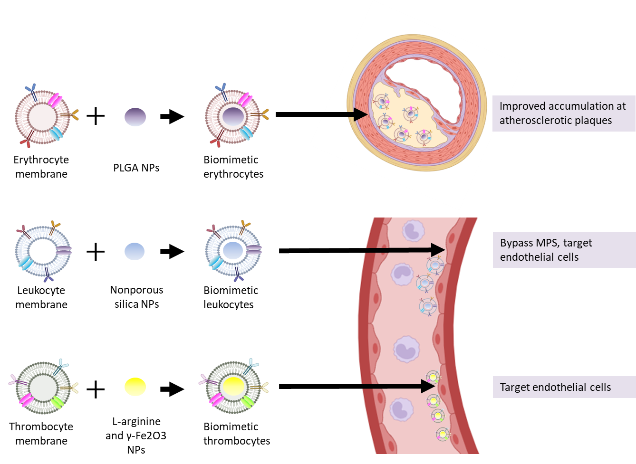

**Figure 1. A representation of biomimetic nanoparticles and their proposed mechanism of action.**

***Extracellular vesicles drug carriers***

Extracellular vesicles (EVs) are vesicles enclosed in a phospholipid bilayer that are secreted by a wide variety of cells and are detectable in biological fluids such as saliva, breast milk, cerebrospinal fluids, blood, and malignant ascites, as well as tissue culture supernatants (27). EVs serve as a transporter for a variety of biomolecules, including proteins, lipids, DNA, and a multitude of RNA types. EVs are a diverse group of particles, categorized into three main types: exosomes, microvesicles, and apoptotic bodies. Exosomes are created through inward budding of endosomal membranes, forming multivesicular bodies (MVBs), which later fuse with the cell's plasma membrane to release exosomes into the extracellular space. Exosomes may influence nearby cells within the microenvironment once they are released by interacting with the extracellular matrix. On the other hand, microvesicles arise from the plasma membrane directly budding outward, releasing EVs of a variety of sizes. Although exclusively released by dying cells during cell fragmentation, apoptosis bodies are also produced from the cell surface. Microvesicles have a size between 50 and 1000 nm, but exosomes generally range in size from 40 to 120 nm (27,28). EVs demonstrate characteristics that make them a prospective therapeutic avenue and drug delivery technique. EVs carry and protect a diverse range of nucleic acids and appear to be inherently capable of effectively delivering them to target cells (29). Another of these promising characteristics is their inherent stability in circulation owing to their negatively charged surface, as well as their capacity to escape the MPS by expressing the surface protein CD47. Furthermore, recent research indicates that EVs have identical clearance kinetics comparable to liposomes (30). Additionally, EVs might possess the ability to traverse biological barriers (31), take advantage of existing intracellular trafficking processes, and elicit a reaction once absorbed by desired cells. Additionally, they may possess innate targeting properties determined by their lipid and protein composition (32). The capability of endogenous cellular machinery to be trafficked to produce and sort the necessary cargo inside EVs, as opposed to synthetic carriers, is one potential advantage of using EVs for the delivery of biotherapeutics, as opposed to synthetic carriers, given that manufacturing, storing, and loading of such biotherapeutics can be challenging. This is especially important for protein-driven therapeutics because temperature, solvent, and pH variations frequently have an impact on their stability (27).

Existing conventional synthetic delivery strategies endure considerable limitations in efficiently traversing biological barriers such as tissue, cellular, and intracellular barriers (31). EVs have demonstrated an exceptional ability to pass one of the most challenging drug delivery barriers, the blood-brain barrier (BBB). The BBB is a major hurdle to delivering therapeutic drugs to treat central nervous system disorders, preventing the great majority of small-molecule drugs from passing through. EVs, on the contrary, have shown promise in intercellular communication between neuronal cells, facilitating neuronal integrity, synaptic plasticity, and maintaining cerebral microenvironment. Additionally, increasing evidence suggests that EVs, particularly in inflammatory conditions, can traverse the BBB to deliver functional cargo from hematopoietic cells to the brain (33). Likewise, it has been demonstrated that EVs can enter the brain parenchyma through the choroid plexus and pass across the blood-cerebrospinal fluid barrier (34). EVs can communicate with the plasma membrane at the cellular level through a variety of ligand/receptor interactions. Consequently, EVs appear to be more successfully incorporated than synthetic nanocarriers (35). Considering their biological origin, EVs are projected only to trigger a weak immunological response. A large number of EVs being transported to patients with no evident adverse effects. EVs are also relatively harmless in comparison to virus-derived vehicles or cell therapies since they are entirely non-replicative and non-mutagenic, which eliminates regulatory concerns about adverse effects or neoplastic growth. The minimal toxicity reported has corroborated the aforementioned advantages (27).

*Cardioprotective exosomes*

In recent years, there has been extensive research into the applications of exosomes for the treatment of cardiovascular diseases (CD). Exosomes produced by several types of cells, such as mesenchymal stem cell (MSC), embryonic stem cell (ESC), induced pluripotent stem cells (iPSCs), and cardiosphere-derived cells **(Figure 2.)**, are capable of functioning as CD therapeutic agents owing to the therapeutic RNAs they possess (36,37). Human MSC-secreted exosomes play a crucial role in myocardial rehabilitation considering they decrease ischemia, minimize reperfusion injury, and promote angiogenesis (36,37). Exosomes released by the ESC have been demonstrated to enhance cardiac functions through enhancing intrinsic rehabilitation in myocardial infarction. Similarly, both ESC-derived and iPSC-derived cardiomyocytes release cardioprotective exosomes containing miRNA and incRNA. Exosomes from cardiosphere-derived cells also had beneficial influences on acute and chronic myocardial infarction, resulting in better cardiac function while reducing negative cardiac remodelling (38). Exosomes generated from cardiac progenitor cells have been observed to contain miRNA-21, which limits cardiomyocyte apoptosis. Moreover, administering cardiac stem cells with MSC-secreted exosomes promotes myocardial rehabilitation indirectly (36,37,38).

In certain contexts, the production and activity of exosomes can be modulated to promote the rehabilitation of CDs. Exosome secretion, for example, can be augmented in MSCs overexpressing hypoxia-inducible factor-1α, resulting in exosomes with improved angiogenic capability, owing partially to an increase in Jagged1 packing. Exosomes released by anti-miRNA-375-transfected bone marrow-derived endothelial progenitor cells may recover from exosome malfunction under inflammatory stimulation, resulting in reduced cardiac neovascularization and enhanced ischemia damage (39). CD34+ stem cells can improve their angiogenic activity by secreting proangiogenic miRNA containing exosomes (37).

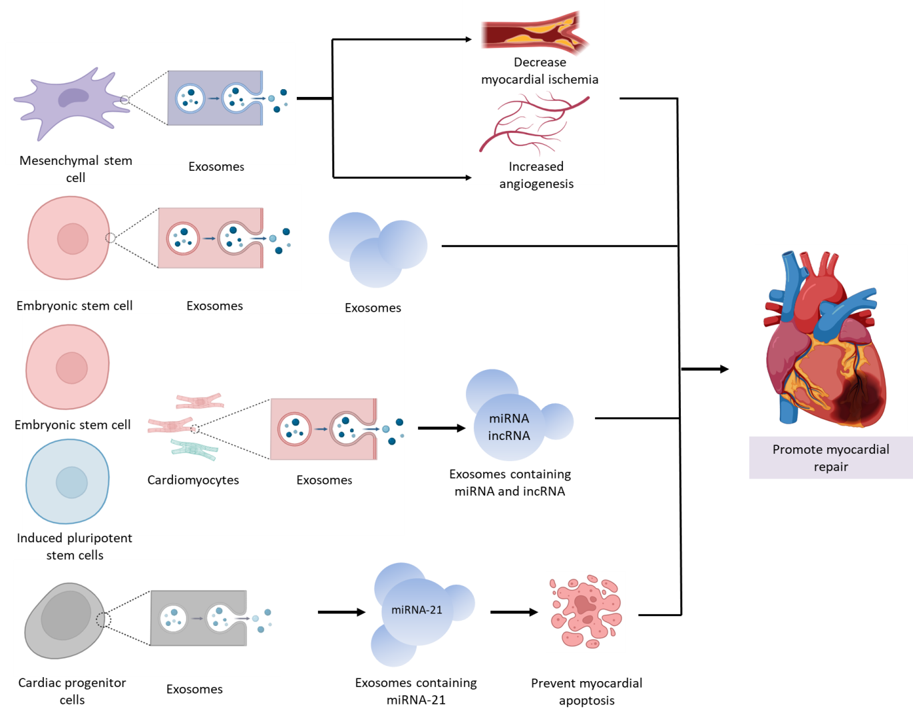

**Figure 2. A representation of different types of exosomes used in CVD and their underlying mechanism for promoting myocardial repair**

***Drug carriers for vascular drug delivery***

The vascular system in humans offers distinct physiological characteristics that can be harnessed to improved targeted drug delivery for greater effectiveness. The interior of blood vessels are lined a thin layer of ECs forming a barrier between the circulating blood in the vessel lumen and the surrounding tissue, these ECs can also operate as targets for delivery of drugs in different vascular areas. Under numerous pathological conditions, such as tumour neovasculature, oxidative stress, thrombosis and inflammation, ECs may overexpress certain cell-surface molecules that are either non-existent or hardly measureable in conventional standard blood vessels. Taking advantage of these one of a kind endothelial surface markers, drug carriers can be coupled with antibodies, certain peptides, or growth factors to create effective active vascular-targeted drug delivery systems. This approach allows drugs to be delivered specifically to ECs in the desired vascular locations, increasing the therapeutic precision and reducing side effects associated with non-specific drug distribution (40).

Numerous vascular system processes, including vascular smooth muscle tone, host defense responses, angiogenesis, and tissue fluid balance are regulated by the intima. ECs assist in these functions by releasing specific compounds. Nitric oxide (NO), prostacyclin, and other substances, for instance, are accountable for modulating vascular tone and may serve as antithrombotic agents by reducing platelet aggregation (40). ECs also secrete urokinase and tissue-type plasminogen activators, which produce the fibrin-degrading protease plasmin and breakdown blood clots. ECs release a number of compounds during physiological processes like as inflammation or thrombosis, consisting of cytokines, reactive oxygen species (ROS), growth factors, and different chemokine. Adhesion molecules are additionally exposed on the cell surface. This release and stimulation of adhesion molecules results in leukocyte attraction, adhesion, and transmigration, all of which promote the inflammatory response (41). These released compounds and surface-exposed chemicals identified on ECs are potential drug delivery targets. Drugs can be targeted to specific sites within the circulatory system to effectively address various diseases by selectively targeting these molecules.

*Vascular gene delivery*

Gene transfer into the vascular wall possesses tremendous potential for a multitude of applications, including investigating the pathological mechanisms of atherosclerosis and offering the delivery of therapeutic genes for the management of CVDs. Particularly, considerable progress has been achieved in successfully transferring genes to the vasculature, which translated into clinical trials across numerous studies. (42). The most predominantly used vectors for transferring genes to both healthy and damaged vascular walls are adenoviruses **(Figure 3.)**. This was also accomplished by using many other vectors, such as lentiviruses and retroviruses. To be effective, gene delivery vectors must be very efficient in gene transduction while also being safe and simple to work with. Nonviral vectors have recently attracted attention as gene carriers, however their transduction effectiveness remains poor. Researchers are taking steps to enhance this characteristic using a multitude of approaches. For instance, cationic lipids and an integrin antagonist were developed to facilitate gene delivery to angiogenic blood vessels in tumour-bearing animals. Similarly, an RGD sequence-containing peptide was linked with phospholipids to deliver the β-galactosidase gene into tumour vasculature (43). When paired with the RGD peptide as an integrin recognition sequence, polyethylenimine was also shown to be an effective nonviral gene delivery approach for delivering the luciferase plasmid DNA into cancer cells (44). Integrin is a potential therapeutic target for drug- and gene-loaded carriers designed for specific targets due to its close association with a range of disorders and cellular processes. These advances in gene delivery have the potential to significantly increase the comprehension of vascular disorders and facilitate the discovery of viable therapeutics.

*Immunoliposomes*

Liposomes, artificial monolamellar or multilamellar phospholipid vesicles of various sizes and compositions, have emerged as versatile drug delivery carriers with significant pharmaceutical potential (45). These carriers have already obtained regulatory approval to transport a range of chemotherapeutics. Particularly, liposomes have presented evidence that they can passively aggregate in regions with higher vascular permeability, making them ideal candidates for targeting the vascular system in pathological conditions like atherosclerotic lesions, thrombosis, cancer and vascular inflammation **(Figure 3.)**. Numerous studies have explored the targeted delivery of agents to the vasculature using liposomes. For instance, early research investigated the thrombolytic efficacy of liposome-encapsulated streptokinase in a canine model of myocardial infarction, revealing a significant reduction in vessel patency restoration time and a smaller remnant of thrombi compared to free enzyme. Furthermore, entrapping antiplatelet peptides into liposomes displayed great potential in decreasing intravascular platelet aggregation and the repercussions of thrombosis. Additionally, liposomal delivery of antioxidant enzymes, such as SOD and catalase, showed promise in modulating tissue damage in a lung oxidative stress model of animals (46). To achieve targeted delivery, liposomes can be modified with specific targeting moieties, by including targeting peptides or antibodies with therapeutic affinity for the organ or tissue in consideration. Engineered liposomes with monoclonal antibodies directed against specific components of the cardiovascular and cancer vascular systems have become an increasingly popular notion. The vasculature has been successfully targeted employing immunoliposomes, in which antibodies are coupled to the liposomal surface or the distal end of the liposomal PEG. For example, myosin-specific antibody fragments were found to specifically localize in experimental myocardial infarction, and this antibody activity was preserved after covalent coupling to liposomes. Moreover, hypoxic cardiocyte death was suppressed by sealing membrane lesions with antimyosin-liposomes (47). The utilization of liposomes as targeted drug carriers continues to show great promise, and ongoing research in this area holds significant potential for advancing treatment options in various vascular-related conditions.

*Ultrasound-enhanced echogenic liposomes*

Immunoliposomes present a captivating avenue as a targeted acoustic enhancement platform. Their application as acoustically reflecting carriers that are precisely targeted for site-specific enhancement by ultrasonic stimulation is a fascinating application **(Figure 3.)**. An *ex vivo* mouse aorta model was employed to investigate the potential of ultrasound parameters in enhancing the delivery of therapeutic-loaded echogenic immunoliposomes into the arterial wall for treating atherosclerosis. The study incorporated anti-ICAM (Intercellular Adhesion Molecule-1) targeted echogenic liposomes and 1-MHz wave ultrasound. Encouragingly, the results revealed enhanced adherence of targeted liposomes to the vascular endothelium and improved passage across the vessel wall (48). These promising findings hint at the transformative role of immunoliposomes, complemented by specific ultrasound parameters, in revolutionizing atherosclerosis treatment, offering a more effective and precise therapeutic delivery system to affected arterial regions. Moreover, numerous *in vivo* studies have explored the potential of various peptides as targeting moieties for immunoliposomes, focusing on tumour vascular targetability. These peptides, including RGD motifs, NGR motifs, CREKA, GPLPLR, APRPG, and the synthetic angiostatic peptide anginex, possess specific binding capabilities to receptors or molecules present in the tumour microenvironment. Such peptide modifications have shown advantages over conventional antibodies, exhibiting slower clearance from circulation and improved targeting efficiency. For example, the RGD peptide demonstrated significant improvements in directing liposomes to activated platelets and vascular lesions (49). Furthermore, cationic liposomes have shown promise in delivering anticancer medicines to tumour ECs. Their positive charge fosters affinity for anionic molecules on the surface of targeted cells, prevalent in the tumour microvasculature. This targeted approach ensures effective delivery of therapeutic agents to tumour ECs, enhancing the overall efficacy of anticancer treatments and minimizing potential side effects on healthy tissues (50).

In conclusion, immunoliposomes, when integrated with ultrasound or peptide modifications, offer a promising frontier in targeted drug delivery systems. These innovative approaches hold immense potential in enhancing the treatment of various diseases, such as atherosclerosis and cancer, by optimizing drug delivery precision and efficiency, ultimately leading to improved therapeutic outcomes and patient care.

*Polymersomes*

Polymersomes exhibit a similar architecture to liposomes, but with a key distinction – they are composed of synthetic polymer amphiphiles, including poly (lactic acid) (PLA)-based copolymers **(Figure 3.)**. The functionalization of polymersomes with an anti-ICAM-1 antibody and the evaluation of the adhesion of the antibody-functionalized polymersomes were both documented in a study (51). Polymeric micelles are self-assembling monolayers composed of amphiphilic block copolymers. These micelles exhibit a number of beneficial attributes that make them effective drug transporters, including outstanding stability in vitro and in vivo and good biocompatibility. Additionally, micelles prove to be effective in solubilizing poorly soluble pharmaceuticals, making them valuable for targeted drug delivery. The recent discovery of a unique targeted polymeric micellar formulation of the antivascular drug Combretastatin A4 (CA4) was a fascinating breakthrough (52). The lipophilic CA4 agent was meticulously entrapped in polymeric micelles with RGD modifications. Due to the agent's considerable antivascular activity, this novel micellar formulation not only dramatically improved the encapsulated drug's absorption by angiogenic tumour ECs but also produced an elevated antiproliferative effect.

In summary, polymersomes and polymeric micelles are promising drug delivery systems that offer distinct advantages in targeted therapy. The functionalization of polymersomes with antibodies and the modification of polymeric micelles for efficient drug delivery to specific cells demonstrate their potential as versatile platforms in advancing vascular drug delivery and enhancing therapeutic outcomes.

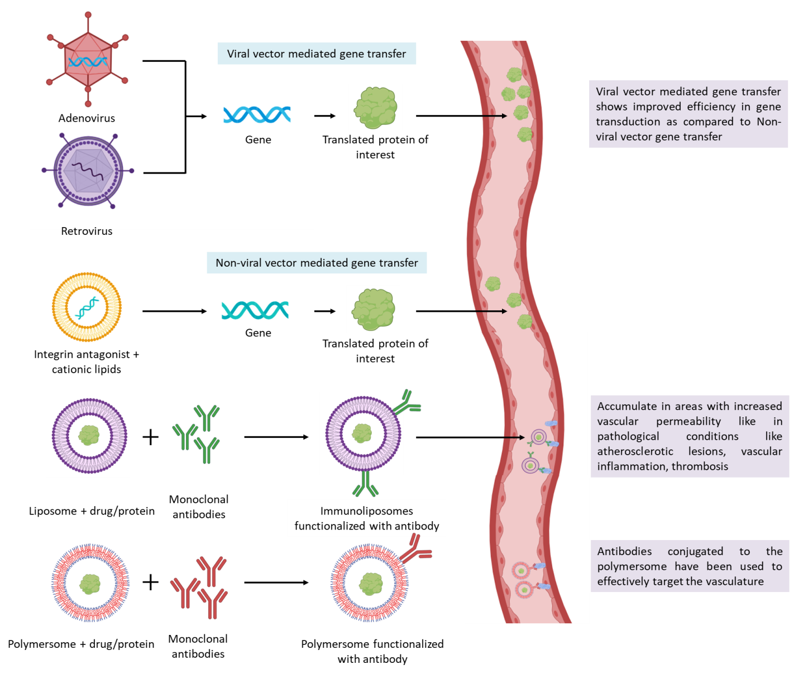

**Figure 3. A representation of different carriers for vascular drug delivery against CVD**

**Challenges and Limitations in Implementing Novel Drug Delivery and Drug Carrier Systems in Cardiovascular Therapies**

Despite its promise implementing novel drug delivery and drug carrier systems in cardiovascular therapies presents several challenges and limitations. The intricate anatomy and dynamic blood flow in the cardiovascular system make precise targeting a demanding task. The complex pathophysiology of cardiovascular diseases requires tailored drug carrier systems to address different therapeutic needs effectively. Developing such systems requires in-depth understanding and expertise in both drug delivery and cardiovascular medicine . Ensuring the long-term stability and biocompatibility of drug carriers in the bloodstream is crucial. The immune response and potential toxicity associated with some carriers must be carefully addressed to prevent adverse reactions in patients. The BNP technology, inspired by natural cells, encounters specific and general challenges that necessitate attention before its clinical application. Although RBC BNPs demonstrate traits that contribute to prolonged circulation and therapeutic advantages, the efficacy of their active targeting ability requires further verification (22). Furthermore, there are growing concerns surrounding the utilization of polymer-based carriers due to their inherent structural heterogeneity, leading to a lack of homogeneous size distribution (51,52). Cost-effectiveness and scalability are other limitations in implementing novel drug delivery systems. Developing and manufacturing these advanced technologies can be expensive, hindering their widespread adoption in healthcare settings. The surface bioengineering of leukocytes in BNP technology, the sole nucleated cells involved, poses difficulties. Additionally, the effectiveness of cell membrane proteins enclosing the NPs relies on their specific conformational state. Attaining the appropriate conformational state during BNP generation remains a technical obstacle that has not yet been completely resolved (22). Achieving mass production of exosomes with quality control and developing efficient methods for their purification are vital steps in expanding their practical utility. Moreover, it is essential to highlight that current research on exosomes has been limited to small animal models. To validate their potential for practical application, further investigation using larger animal models and clinical trials is imperative. Additionally, potential hazards arising from tumour cell-derived exosomes that may promote tumour development need careful consideration (27). Thorough evaluation of exosomes adverse effects and efficacy is crucial to ensure their safe and effective use in therapeutic settings. By addressing these challenges and conducting comprehensive research, exosomes can become a promising tool in various medical applications. In practical terms, the analytical applications of immunoliposomes are expected to find rapid implementation in medicine. However, for a comprehensive and fully developed immunoliposomal treatment of a disease, it will necessitate more time for thorough development, testing, and regulatory approval processes (37).

**Safety and Regulatory Considerations in Utilizing Novel Drug Delivery and Drug Carrier Systems**

Safety studies for nanopharmaceuticals are guided by the general guidelines specified in the Second Schedule of the New Drugs and Clinical Trials Rules, 2019. These guidelines provide a framework for assessing safety and potential risks associated with new drugs, including nanopharmaceuticals. In cases where specific studies for nanopharmaceuticals are not covered by the general requirements, alternative approaches can be taken, following principles outlined by reputable international organizations like US Food and Drug Administration (USFDA), International Council for Harmonisation of Technical Requirements for Pharmaceuticals for Human Use (ICH), and Organisation for Economic Co-operation and Development (OECD). It is essential to ensure that these guidelines align with the provisions of the Drugs and Cosmetics Act, 1940, and the New Drugs and Clinical Trials Rules, 2019, which specifically address certain aspects of quality, safety, and efficacy applicable to nanopharmaceuticals (53,54,55). Researchers and pharmaceutical companies can conduct comprehensive safety studies for nanopharmaceuticals by adhering to guidelines and incorporating specific aspects required by regulatory authorities. This ensures valuable data for the approval and clinical translation of nanomedicine, benefiting cardiovascular diseases and other medical fields. The evaluation of nano-pharmaceuticals, considering the Second Schedule within the context of Schedule Y of Drugs and Cosmetics Rules, 1945, and the New Drugs and Clinical Trials Rules, 2019, provides crucial guidance for stability testing, animal pharmacology, toxicology data, and clinical trial evaluation. The inherent complexity of nanotechnology-based products necessitates a 'case-by-case approach' for evaluating nanopharmaceutical quality, safety, and efficacy. Each nano-pharmaceutical should undergo individual evaluation, addressing potential risks associated with nanoscale formulations and ensuring safety measures. Understanding the nanotechnology-based formulation's behavior within the human body and its interactions with cells, tissues, and organs is critical during the assessment process. The specific requirements outlined in the guidelines for nanopharmaceuticals aim to address the unique challenges and complexities of these products, fostering innovation in nanomedicine while ensuring safety and efficacy. By adopting a case-by-case approach, regulators can thoroughly evaluate each nanopharmaceutical, obtaining essential safety and efficacy data before clinical approval. Overall, this regulatory framework strikes a balance between encouraging nanomedicine innovation and ensuring the safety and efficacy of advanced drug formulations. Such an approach is vital in promoting the successful translation of nanotechnology-based pharmaceutical products, including those developed for cardiovascular diseases, from research to practical clinical applications (56,57).

The administration of cell-based therapies for cardiovascular conditions often involves the use of delivery devices such as syringes or catheters. The USFDA has identified potential concerns related to these devices, including the biocompatibility of materials used in their construction. Ensuring that these materials interact safely with therapeutic cells and the patient's tissues is crucial to avoid adverse reactions. Another concern is the risk of catheter lumens clogging when delivering high concentrations of therapeutic cells, which can hinder effective therapy. Additionally, when using needle or balloon models for delivery, there is a risk of tissue perforations or over-inflation of balloons, leading to tissue damage and compromising safety (58). To address these concerns, rigorous testing, validation, and quality control of the delivery devices are essential. Biocompatibility studies must be conducted to ensure safe interactions with therapeutic cells and the patient's body. Optimization of cell concentration and delivery parameters can prevent catheter clogging, and proper training and technique are vital for healthcare professionals using needle or balloon models. Regarding cell-based therapy and delivery devices, the USFDA considers them combination products if they meet the definition. Regulation is based on their primary mode of action (PMOA), considering specific characteristics and intended use. If multiple delivery devices can be safely and effectively used with the same cell-based therapy, the approved labelling may reflect this, but additional data and analysis are necessary to support such claims. The outcome depends on various factors, and it is not always the case that a specific brand/model of delivery device will be mandated for a cell-based therapy with USFDA approval (59).

The regulatory scenario for EVs drug delivery is still evolving and uncertain, as EVs are a relatively new and complex type of biological product. EVs have been shown to have potential applications in drug delivery, disease diagnosis, and therapeutic intervention, but there are also many challenges and risks associated with EVs, such as their heterogeneity, stability, immunogenicity, biodistribution, and toxicity (60). The regulation of EVs drug delivery depends on the classification of EVs as either drugs, biological products, or combination products by the relevant authorities, such as the USFDA in the United States, the European Medicines Agency (EMA) in the European Union, or the National Medical Products Administration (NMPA) in China. Each authority may have different criteria and requirements for the approval and marketing of EVs products, depending on their intended use, mode of action, source of origin, and manufacturing process. The regulatory landscape for EVs drug delivery is still developing and may change over time as more scientific evidence and clinical data become available. Therefore, it is important for researchers and developers of EVs products to keep up with the latest regulatory guidance and standards, as well as to communicate and collaborate with the relevant authorities to ensure the safety and efficacy of their products (61).



**Table 1. Representation of different NDDS and their functional principles, target site, advantages and possible outcomes.**

**Conclusions**

In conclusion, cardiovascular diseases remain a significant global health concern, necessitating the continuous pursuit of innovative therapeutic approaches. Novel drug delivery and drug carrier systems have emerged as promising avenues to address the limitations of existing therapies and improve treatment outcomes. Advancements in biomimetic nano drug delivery carriers, extracellular vesicles drug carriers, and targeted drug delivery approaches have shown great potential in enhancing therapeutic efficacy. Clinical studies and trials have demonstrated the positive impact of these novel systems in managing specific cardiovascular disorders, showcasing improved clinical outcomes compared to traditional drug delivery methods **(Table 1.)**. However, challenges and limitations persist in implementing these technologies, such as regulatory uncertainties and safety concerns. It is crucial to address these hurdles through rigorous research, strategic collaborations, and adherence to regulatory guidelines. Ensuring the safety and compliance of novel drug delivery and drug carrier systems is of utmost importance to realize their full potential in clinical practice. Continued research and translation efforts are essential to bridge the gap between scientific discoveries and practical applications, ultimately enhancing patient care and therapeutic outcomes in cardiovascular diseases.

Moving forward, it is imperative to focus on future research and development in the field, exploring key areas for improvement and advancements in novel drug delivery. By doing so, we can pave the way for a transformative shift in cardiovascular therapeutics, offering hope for a healthier and more resilient future for individuals affected by cardiovascular disorders. Embracing these innovative approaches, together with a commitment to evidence-based medicine and patient-centered care, will undoubtedly shape a brighter landscape for cardiovascular treatments.

**Reference**

1. Kyu, H.H., Abate, D., Abate, K.H., Abay, S.M., Abbafati, C., Abbasi, N., Abbastabar, H., Abd-Allah, F., Abdela, J., Abdelalim, A. and Abdollahpour, I., 2018. Global, regional, and national disability-adjusted life-years (DALYs) for 359 diseases and injuries and healthy life expectancy (HALE) for 195 countries and territories, 1990–2017: a systematic analysis for the Global Burden of Disease Study 2017. *The Lancet*, *392*(10159), pp.1859-1922.
2. Roth, G.A., Mensah, G.A. and Fuster, V., 2020. The global burden of cardiovascular diseases and risks: a compass for global action. *Journal of the American College of Cardiology*, *76*(25), pp.2980-2981.
3. Kumar, A.S. and Sinha, N., 2020. Cardiovascular disease in India: a 360 degree overview. *medical journal armed forces india*, *76*(1), pp.1-3.
4. World Health Organization (WHO), 2012. WHO/ISH risk prediction charts for 14 WHO epidemiological sub-regions [internet]. WHO; 2007.
5. Ahmed, S.M., Hadi, A., Razzaque, A., Ashraf, A., Juvekar, S., Ng, N., Kanungsukkasem, U., Soonthornthada, K., Van Minh, H. and Huu Bich, T., 2009. Clustering of chronic non-communicable disease risk factors among selected Asian populations: levels and determinants. *Global health action*, *2*(1), p.1986.
6. Buttar, H.S., Li, T. and Ravi, N., 2005. Prevention of cardiovascular diseases: Role of exercise, dietary interventions, obesity and smoking cessation. *Experimental & clinical cardiology*, *10*(4), p.229.
7. Kumar, M.U.K.E.S.H., Dahiya, V.I.C.K.Y., MISHRA, S., SHARMA, D., MISHRA, N. and LAHKAR, M., 2016. Cardiovascular disease prevalence and drug utilization patterns at a tertiary care hospital in northeastern India. *Hypertension*, *8*, pp.116-9.
8. SoS Investigators, 2002. Coronary artery bypass surgery versus percutaneous coronary intervention with stent implantation in patients with multivessel coronary artery disease (the Stent or Surgery trial): a randomised controlled trial. *The Lancet*, *360*(9338), pp.965-970.
9. Ammirati, E., Oliva, F., Cannata, A., Contri, R., Colombo, T., Martinelli, L. and Frigerio, M., 2014. Current indications for heart transplantation and left ventricular assist device: a practical point of view. *European journal of internal medicine*, *25*(5), pp.422-429.
10. Ylä-Herttuala, S., Bridges, C., Katz, M.G. and Korpisalo, P., 2017. Angiogenic gene therapy in cardiovascular diseases: dream or vision?. *European heart journal*, *38*(18), pp.1365-1371.
11. Singh, B., Garg, T., Goyal, A.K. and Rath, G., 2016. Recent advancements in the cardiovascular drug carriers. *Artificial cells, nanomedicine, and biotechnology*, *44*(1), pp.216-225.
12. Plosker, G.L. and Clissold, S.P., 1992. Controlled release metoprolol formulations: a review of their pharmacodynamic and pharmacokinetic properties, and therapeutic use in hypertension and ischaemic heart disease. *Drugs*, *43*(3), pp.382-414.
13. Mladěnka, P., Applová, L., Patočka, J., Costa, V.M., Remiao, F., Pourová, J., Mladěnka, A., Karlíčková, J., Jahodář, L., Vopršalová, M. and Varner, K.J., 2018. Comprehensive review of cardiovascular toxicity of drugs and related agents. *Medicinal research reviews*, *38*(4), pp.1332-1403.
14. Pinto-Alphandary, H., Andremont, A. and Couvreur, P., 2000. Targeted delivery of antibiotics using liposomes and nanoparticles: research and applications. *International journal of antimicrobial agents*, *13*(3), pp.155-168.
15. Li, C., Naveed, M., Dar, K., Liu, Z., Baig, M.M.F.A., Lv, R., Saeed, M., Dingding, C., Feng, Y. and Xiaohui, Z., 2021. Therapeutic advances in cardiac targeted drug delivery: From theory to practice. *Journal of Drug Targeting*, *29*(3), pp.235-248.
16. Patra, J.K., Das, G., Fraceto, L.F., Campos, E.V.R., Rodriguez-Torres, M.D.P., Acosta-Torres, L.S., Diaz-Torres, L.A., Grillo, R., Swamy, M.K., Sharma, S. and Habtemariam, S., 2018. Nano based drug delivery systems: recent developments and future prospects. *Journal of nanobiotechnology*, *16*(1), pp.1-33.
17. Anselmo, A.C. and Mitragotri, S., 2019. Nanoparticles in the clinic: An update. *Bioengineering & translational medicine*, *4*(3), p.e10143.
18. Sadauskas, E., Wallin, H., Stoltenberg, M., Vogel, U., Doering, P., Larsen, A. and Danscher, G., 2007. Kupffer cells are central in the removal of nanoparticles from the organism. *Particle and fibre toxicology*, *4*(1), pp.1-7.
19. Gustafson, H.H., Holt-Casper, D., Grainger, D.W. and Ghandehari, H., 2015. Nanoparticle uptake: the phagocyte problem. *Nano today*, *10*(4), pp.487-510.
20. Yang, Q. and Lai, S.K., 2015. Anti‐PEG immunity: emergence, characteristics, and unaddressed questions. *Wiley Interdisciplinary Reviews: Nanomedicine and Nanobiotechnology*, *7*(5), pp.655-677.
21. Zinger, A., Brozovich, A., Pasto, A., Sushnitha, M., Martinez, J.O., Evangelopoulos, M., Boada, C., Tasciotti, E. and Taraballi, F., 2020. Bioinspired extracellular vesicles: lessons learned from nature for biomedicine and bioengineering. *Nanomaterials*, *10*(11), p.2172.
22. Zinger, A., Cooke, J.P. and Taraballi, F., 2021. Biomimetic nano drug delivery carriers for treating cardiovascular diseases. *Nanomedicine: Nanotechnology, Biology and Medicine*, *33*, p.102360.
23. Hu, C.M.J., Zhang, L., Aryal, S., Cheung, C., Fang, R.H. and Zhang, L., 2011. Erythrocyte membrane-camouflaged polymeric nanoparticles as a biomimetic delivery platform. *Proceedings of the National Academy of Sciences*, *108*(27), pp.10980-10985.
24. Wang, Y., Zhang, K., Qin, X., Li, T., Qiu, J., Yin, T., Huang, J., McGinty, S., Pontrelli, G., Ren, J. and Wang, Q., 2019. Biomimetic nanotherapies: red blood cell based core–shell structured nanocomplexes for atherosclerosis management. *Advanced science*, *6*(12), p.1900172.
25. Parodi, A., Quattrocchi, N., Van De Ven, A.L., Chiappini, C., Evangelopoulos, M., Martinez, J.O., Brown, B.S., Khaled, S.Z., Yazdi, I.K., Enzo, M.V. and Isenhart, L., 2013. Synthetic nanoparticles functionalized with biomimetic leukocyte membranes possess cell-like functions. *Nature nanotechnology*, *8*(1), pp.61-68.
26. Rao, L., Bu, L.L., Meng, Q.F., Cai, B., Deng, W.W., Li, A., Li, K., Guo, S.S., Zhang, W.F., Liu, W. and Sun, Z.J., 2017. Antitumor platelet‐mimicking magnetic nanoparticles. *Advanced Functional Materials*, *27*(9), p.1604774.
27. Elsharkasy, O.M., Nordin, J.Z., Hagey, D.W., de Jong, O.G., Schiffelers, R.M., Andaloussi, S.E. and Vader, P., 2020. Extracellular vesicles as drug delivery systems: Why and how?. *Advanced drug delivery reviews*, *159*, pp.332-343.
28. Chivero, E.T., Dagur, R.S., Peeples, E.S., Sil, S., Liao, K., Ma, R., Chen, L., Gurumurthy, C.B., Buch, S. and Hu, G., 2021. Biogenesis, physiological functions and potential applications of extracellular vesicles in substance use disorders. *Cellular and Molecular Life Sciences*, *78*, pp.4849-4865.
29. Valadi, H., Ekström, K., Bossios, A., Sjöstrand, M., Lee, J.J. and Lötvall, J.O., 2007. Exosome-mediated transfer of mRNAs and microRNAs is a novel mechanism of genetic exchange between cells. *Nature cell biology*, *9*(6), pp.654-659.
30. Smyth, T., Kullberg, M., Malik, N., Smith-Jones, P., Graner, M.W. and Anchordoquy, T.J., 2015. Biodistribution and delivery efficiency of unmodified tumor-derived exosomes. *Journal of Controlled Release*, *199*, pp.145-155.
31. Alvarez-Erviti, L., Seow, Y., Yin, H., Betts, C., Lakhal, S. and Wood, M.J., 2011. Delivery of siRNA to the mouse brain by systemic injection of targeted exosomes. *Nature biotechnology*, *29*(4), pp.341-345.
32. Murphy, D.E., de Jong, O.G., Brouwer, M., Wood, M.J., Lavieu, G., Schiffelers, R.M. and Vader, P., 2019. Extracellular vesicle-based therapeutics: natural versus engineered targeting and trafficking. *Experimental & molecular medicine*, *51*(3), pp.1-12.
33. Chen, C.C., Liu, L., Ma, F., Wong, C.W., Guo, X.E., Chacko, J.V., Farhoodi, H.P., Zhang, S.X., Zimak, J., Ségaliny, A. and Riazifar, M., 2016. Elucidation of exosome migration across the blood–brain barrier model in vitro. *Cellular and molecular bioengineering*, *9*, pp.509-529.
34. Grapp, M., Wrede, A., Schweizer, M., Hüwel, S., Galla, H.J., Snaidero, N., Simons, M., Bückers, J., Low, P.S., Urlaub, H. and Gärtner, J., 2013. Choroid plexus transcytosis and exosome shuttling deliver folate into brain parenchyma. *Nature communications*, *4*(1), p.2123.
35. Millard, M., Yakavets, I., Piffoux, M., Brun, A., Gazeau, F., Guigner, J.M., Jasniewski, J., Lassalle, H.P., Wilhelm, C. and Bezdetnaya, L., 2018. mTHPC-loaded extracellular vesicles outperform liposomal and free mTHPC formulations by an increased stability, drug delivery efficiency and cytotoxic effect in tridimensional model of tumors. *Drug Delivery*, *25*(1), pp.1790-1801.
36. Caplan, A.I., 2019. Mesenchymal stem cells in regenerative medicine. In *Principles of regenerative medicine* (pp. 219-227). Academic Press.
37. Liao, W., Du, Y., Zhang, C., Pan, F., Yao, Y., Zhang, T. and Peng, Q., 2019. Exosomes: the next generation of endogenous nanomaterials for advanced drug delivery and therapy. *Acta biomaterialia*, *86*, pp.1-14.
38. Gallet, R., Dawkins, J., Valle, J., Simsolo, E., De Couto, G., Middleton, R., Tseliou, E., Luthringer, D., Kreke, M., Smith, R.R. and Marbán, L., 2017. Exosomes secreted by cardiosphere-derived cells reduce scarring, attenuate adverse remodelling, and improve function in acute and chronic porcine myocardial infarction. *European heart journal*, *38*(3), pp.201-211.
39. Yue, Y., Garikipati, V.N.S., Verma, S.K., Goukassian, D.A. and Kishore, R., 2017. Interleukin-10 deficiency impairs reparative properties of bone marrow-derived endothelial progenitor cell exosomes. *Tissue Engineering Part A*, *23*(21-22), pp.1241-1250.
40. Koren, E. and Torchilin, V.P., 2011. Drug carriers for vascular drug delivery. *IUBMB life*, *63*(8), pp.586-595.
41. Cines, D.B., Pollak, E.S., Buck, C.A., Loscalzo, J., Zimmerman, G.A., McEver, R.P., Pober, J.S., Wick, T.M., Konkle, B.A., Schwartz, B.S. and Barnathan, E.S., 1998. Endothelial cells in physiology and in the pathophysiology of vascular disorders. *Blood, The Journal of the American Society of Hematology*, *91*(10), pp.3527-3561.
42. Baker, A.H., 2004. Designing gene delivery vectors for cardiovascular gene therapy. *Progress in biophysics and molecular biology*, *84*(2-3), pp.279-299.
43. Pramanik, D., Majeti, B.K., Mondal, G., Karmali, P.P., Sistla, R., Ramprasad, O.G., Srinivas, G., Pande, G. and Chaudhuri, A., 2008. Lipopeptide with a RGDK tetrapeptide sequence can selectively target genes to proangiogenic α5β1 integrin receptor and mouse tumor vasculature. *Journal of medicinal chemistry*, *51*(22), pp.7298-7302.
44. Erbacher, P., Remy, J.S. and Behr, J.P., 1999. Gene transfer with synthetic virus-like particles via the integrin-mediated endocytosis pathway. *Gene therapy*, *6*(1), pp.138-145.
45. Torchilin, V.P., 2005. Recent advances with liposomes as pharmaceutical carriers. *Nature reviews Drug discovery*, *4*(2), pp.145-160.
46. Nguyen, P.D., O'rear, E.A., Johnson, A.E., Patterson, E., Whitsett, T.L. and Bhakta, R., 1990. Accelerated thrombolysis and reperfusion in a canine model of myocardial infarction by liposomal encapsulation of streptokinase. *Circulation research*, *66*(3), pp.875-878.
47. Khaw, B.A., Torchilin, V.P., Vural, I. and Narula, J., 1995. Plug and seal: prevention of hypoxic cardiocyte death by sealing membrane lesions with antimyosin-liposomes. *Nature medicine*, *1*(11), pp.1195-1198.
48. Hitchcock, K.E., Caudell, D.N., Sutton, J.T., Klegerman, M.E., Vela, D., Pyne-Geithman, G.J., Abruzzo, T., Cyr, P.E., Geng, Y.J., McPherson, D.D. and Holland, C.K., 2010. Ultrasound-enhanced delivery of targeted echogenic liposomes in a novel ex vivo mouse aorta model. *Journal of controlled release*, *144*(3), pp.288-295.
49. Gupta, A.S., Huang, G., Lestini, B.J., Sagnella, S., Kottke-Marchant, K. and Marchant, R.E., 2005. RGD-modified liposomes targeted to activated platelets as a potential vascular drug delivery system. *Thrombosis and haemostasis*, *93*(01), pp.106-114.
50. Abu Lila, A.S., Ishida, T. and Kiwada, H., 2010. Targeting anticancer drugs to tumor vasculature using cationic liposomes. *Pharmaceutical research*, *27*, pp.1171-1183.
51. Lin, J.J., Ghoroghchian, P.P., Zhang, Y. and Hammer, D.A., 2006. Adhesion of antibody-functionalized polymersomes. *Langmuir*, *22*(9), pp.3975-3979.
52. Wang, Y., Yang, T., Wang, X., Wang, J., Zhang, X. and Zhang, Q., 2010. Targeted polymeric micelle system for delivery of combretastatin A4 to tumor vasculature in vitro. *Pharmaceutical research*, *27*, pp.1861-1868.
53. Research C for DE and. Drug Products, Including Biological Products, that Contain Nanomaterials - Guidance for Industry [Internet]. FDA; 2022 [cited 2023 Jul 25]. Available from: https://www.fda.gov/regulatory-information/search-fda-guidance-documents/drug-products-including-biological-products-contain-nanomaterials-guidance-industry
54. OECD Guidelines for the Testing of Chemicals, Section 1 : Physical-Chemical properties | OECD Guidelines for the Testing of Chemicals | OECD iLibrary [Internet]. [cited 2023 Jul 25]. Available from: https://www.oecd-ilibrary.org/environment/oecd-guidelines-for-the-testing-of-chemicals-section-1-physical-chemical-properties_20745753
55. ICH guideline Q11 on development and manufacture of drug substances (chemical entities and biotechnological/biological entities), Step 3.
56. NewDrugs_CTRules_2019.pdf [Internet]. [cited 2023 Jul 25]. Available from: https://cdsco.gov.in/opencms/export/sites/CDSCO_WEB/Pdf-documents/NewDrugs_CTRules_2019.pdf
57. Guidelines_For_Evaluation_of_Nanopharmaceuticals_in_India_24.10.19.pdf [Internet]. [cited 2023 Jul 25]. Available from: <https://dbtindia.gov.in/sites/default/files/uploadfiles/Guidelines_For_Evaluation_of_Nanopharmaceuticals_in_India_24.10.19.pdf>
58. US Food and Drug Administration, Guidance for industry: Cellular therapy for cardiac disease. FDA, MD, October 2010.
59. Weber, D.J., 2008. Regulatory considerations for manufacturing and delivery of cell-based therapies for cardiovascular indications. *Journal of Cardiovascular Translational Research*, *1*, pp.196-200.
60. Liu, Y.J. and Wang, C., 2023. A review of the regulatory mechanisms of extracellular vesicles-mediated intercellular communication. *Cell Communication and Signaling*, *21*(1), pp.1-12.
61. Palazzolo, S., Canzonieri, V. and Rizzolio, F., 2022. The history of small extracellular vesicles and their implication in cancer drug resistance. *Frontiers in Oncology*, *12*, p.948843.