Hornbills: Allies of Farmers
Ruchira Nigam¹, Asif Ahmad Siddiqui², Ruby Yadav³, *Chitra Singh⁴
^{1, 4} Department of Zoology, Isabella Thoburn College, University of Lucknow, Lucknow, Uttar Pradesh, India
² Department of Environmental Science, Integral University, Lucknow, Uttar Pradesh, India
³ Krishna Devi Balika P.G. College, Awas Vikas, Farukhabad, Uttar Pradesh, India
*Corresponding author: csingh19a@gmail.com
Introduction
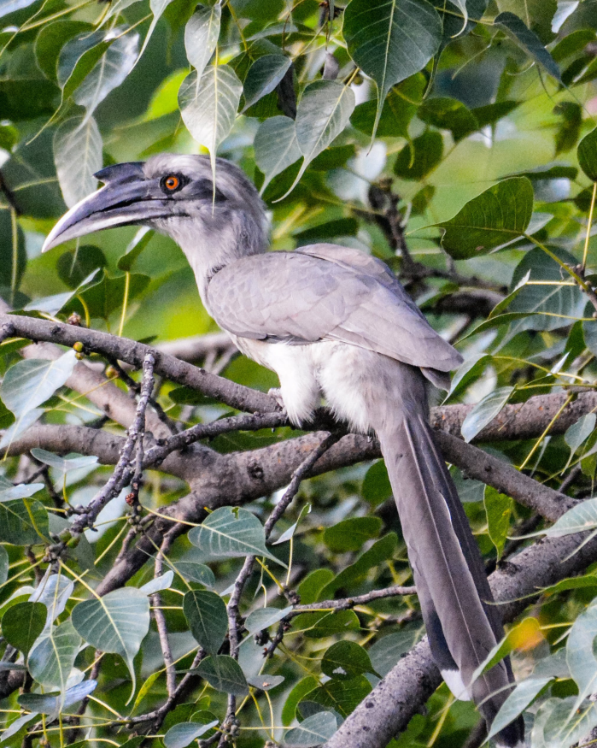
Relationships between species frequently cross boundaries in the intricate tapestry of the natural world. Hornbills and farmers have one of the most intriguing and advantageous relationships. The unusual partnership these iconic birds have formed with farmers has resulted in a delicate balance that supports both biodiversity and agricultural livelihoods. These birds are widely recognized for their striking appearance and remarkable behaviors. We delve into the enchanting world of these endearing birds in this chapter, highlighting how important it is for them to serve as farmers' friends and how they may assist in maintaining the delicate balance of nature.
©Asif Ahmad Siddiqui
Indian Grey Hornbill captured during Roosting

The Acreage Landscape
Long-term conservation planning must take into account the importance of agro ecosystems as habitat for wildlife because differents crop strata and landscape features can have an impact on bird communities, which are also influenced by seasonality. Aesthetic, cultural, and other societal values are all present in agricultural landscapes, which are the visible results of the interaction between agriculture, the environment, and natural resources. A key element of human civilization is agriculture. A major alteration in the terrain resulted from the expansion of agricultural activity alongside civilizations. Unluckily, these developments frequently encroach on natural ecosystems, resulting in confrontations between people and animals. Hornbills have managed to close this gap, nevertheless.

Ecological Context
A diversified group of birds in the Bucerotidae family, hornbills are predominantly found in tropical and subtropical areas of Africa and Asia. Large bills, colorful plumage, and unique nesting behavior are merely a few of these birds' distinguishing characteristics. But what really highlights their importance is how they interact with farmers. Incredibly, they also play an important role in preserving the diversity and viability of these habitats. Their distinctive traits extend beyond their outward appearances, including intricate nesting behaviors and foraging patterns.
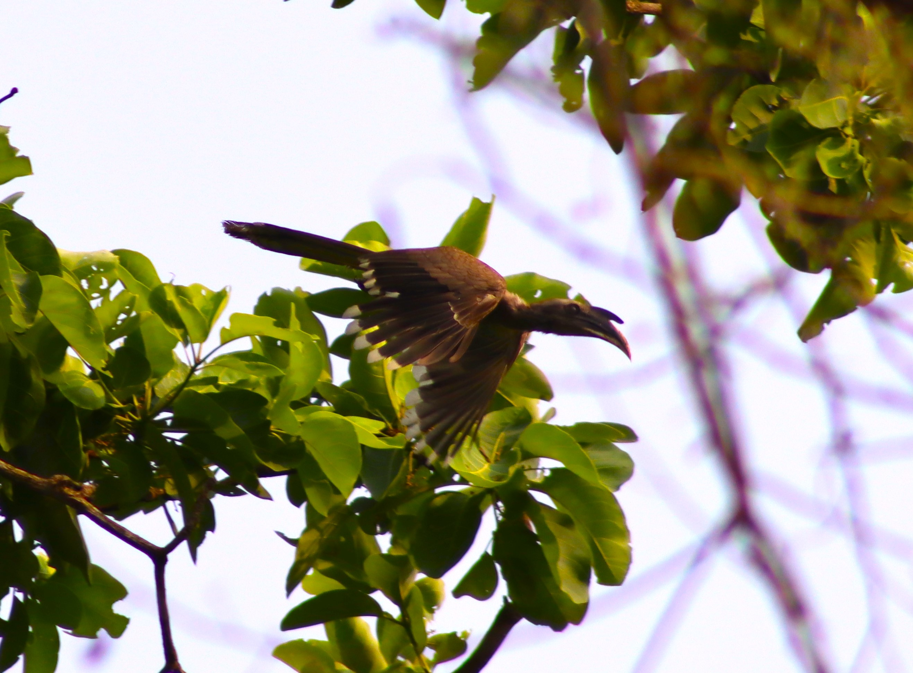

©Asif Ahmad Siddiqui

Indian Grey Hornbill captured during Feeding on Ficus Tree

The Unveiled Mutualism
A specific type of ecological interaction between two species is known as mutualism, in which both species benefit from the other's presence. The mutualistic relationship between hornbills and farmers is illustrated by the fact that the hornbills disperse seeds, which helps the farmers by promoting forest regeneration and delivering ecosystem services. Hornbills swallow the fruit and then regurgitate or urinate the seeds in various places as they migrate through the forest. Hornbills unintentionally spread seeds over vast areas when they consume a variety of foods. Some of these seeds wind up in fields of crops, where they can sprout and develop into fresh fruit-bearing plants.

Seed Dispersal: Fostering Biodiversity
Hornbills' function as seed dispersers is among their most important contributions to agricultural environments. Frugivorous, or eating predominantly fruits, describes the diet of many hornbill species. Hornbills are important in dispersing the seeds throughout their habitats after eating these fruits. After that, these seeds grow into new plants that help to regenerate forests and enhance plant genetic variety.
This behavior becomes particularly advantageous in the context of agriculture. Hornbills assist in the spread of native tree species, some of which might be beneficial to farmers directly or indirectly. For instance, hornbills frequently disseminate trees that provide fruits or nuts vital for communities nearby, ensuring a steady supply of these resources for farmers. Hornbill-aided forest regrowth can also lessen soil erosion, control water cycles, and create habitat for beneficial bugs.

Hornbills: Crop Defenders
With their striking appearance and loud calls, hornbills are not only recognizable creatures in the forests of Asia and Africa, but they are also valuable assets for farmers. Pest management is one of the most important contributions rendered by hornbills. They specialize in capturing pests that may damage crops, as their food consists of insects, small animals, and fruits. Hornbills consume insects that would otherwise destroy crops in agricultural areas, minimizing the need for synthetic pesticides and supporting organic farming methods. In addition to saving farmers money, this organic pest management method also contributes to the preservation of a healthy environment.

Diversity of Trees and Nesting Ecology
Hornbill nesting habits are essential to preserving the health of the forest ecosystem. Hornbills require large tree hollows for nesting for which they frequently choose older trees that naturally harbor decay and disease. Removing potential disease sources, this behavior enhances the health of the forest. Additionally, farmers' long-term interests are aligned with the preservation of such mature trees because they gain from healthy forests in terms of soil fertility and water retention.

Cultural Significance and Conservation
Beyond their ecological benefits, hornbills have important cultural roles in a variety of communities. They have been included in mythology and customs because of their remarkable appearance, distinctive behaviors, and vocalizations. Although hornbills are well-recognized, problems still exist. Their habitats are still being encroached upon by habitat destruction, habitat fragmentation, and rising agricultural activity. Furthermore, hornbills and the ecosystems they rely on are both impacted by new dangers brought on by climate change. Integrative strategies that incorporate habitat conservation, sustainable land-use methods, and community involvement are crucial for addressing these issues.
In recognition of the significance of these birds, and to ensure the continuity of this unique alliance, conservation initiatives have gained a greater spotlight. Conservation organizations, farmers, and local communities are working together to protect hornbill habitats and educate society about the vital roles that these birds play in ecosystems and agriculture. These initiatives aid in safeguarding the long-term survival of hornbills and the agricultural landscapes they live in by fostering a greater appreciation of the ecological and cultural worth of hornbills.
Conservation Strategies
- Habitat Protection: To ensure hornbills have sufficient nourishment supplies and nesting locations, conservation efforts must focus on preserving and restoring their ecosystems.
- Community Engagement: Informing nearby populations about the value hornbills possess for the environment assists in fostering a sense of responsibility and the long-term survival of these birds.
- Anti-Poaching Initiatives: Hornbills' existence depends on collaboration with law enforcement organizations in the fight against hunting and poaching.
Conclusion
The complex interactions between agriculture and nature are best exemplified by hornbills. They support farmers as allies by offering essential pest control services, maintain resilient landscapes and promoting biodiversity through the dissemination of seeds. Hornbills are important to cultural narratives and have the ability to spur conservation efforts in addition to their ecological significance. The value of protecting hornbill habitats and the delicate equilibrium they help preserve between agriculture and the natural world are highlighted by understanding the relevance of hornbills in these many functions.

References
- Ali S., Ripley S.D. 1987. Compact Handbook of the Birds of India and Pakistan together with those of Bangladesh, Nepal, Bhutan and Sri Lanka (2nd Edition, Vol. 1–10). Delhi: Oxford University Press. 890 p.
- Anggraini, K., Kinnaird, M. & O’Brien, T. 2000. The effects of fruit availability and habitat disturbance on an assemblage of Sumatran hornbills. Bird Conserv. Int. 10: 189–202.
- Bachan A.K.H. 2006. The Hornbill haven. Sanctuary Asia 25(6): 46–49.
- Balasubramanian P., Prasad S.N., Kandavel K. 1998. Role of birds in seed dispersal and natural regeneration of forest plants in Tamil Nadu. Technical Report No. 7. Coimbatore, India: Salim Ali Centre for Ornithology and Natural History. 33 p.
- Cody M.L. 1985. An introduction to habitat selection in birds. In: M.L. Cody (Ed.): Habitat Selection in Birds. Orlando, Florida: Academic Press. P. 3–56.
- Datta A. 1998. Hornbill abundance in unlogged forest, selectively logged forest and a forest plantation in Arunachal Pradesh, India. Oryx 32(4): 285–294. DOI: 10.1046/ j.1365-3008.1998.d01-58.
- Gadikar, A. 2017. Adaptations of the Indian Grey Hornbill Ocyceros birostris in an urban environment. Indian Birds 13: 167–168.
- Holbrook, K.M. & Smith, T.B. 2000. Seed dispersal and movement patterns in two species of Ceratogymna hornbills in a West African tropical lowland forest. Oecologia 125: 249–257.
- Ismail, S.A., Ghazoul, J., Ravikanth, G., Kushalappa, C.G., Uma Shaanker, R. & Kettle, C.J. 2017. Evaluating realized seed dispersal across fragmented tropical landscapes: a two-fold approach using parentage analysis and the neighbourhood model. New Phytol. 214: 1307–1316.
- Kalina J. 1988. Nest intruders, nest defense and foraging behavior in the Black-and-white Casqued Hornbill (Bycanistes subcylindricus). Ibis 131(4): 567–571. DOI: 10.1111/j.1474-919X.1989.tb04791.
- Kinnaird M.F. 1998. Evidence for effective seed dispersal by the Sulawesi Red-knobbed Hornbill Aceros cassidix. Biotropica 30(1): 50–55. DOI: 10.1111/j.1744-7429.1998.tb00368.
- Karanth, K.K., Sankararaman, V., Dalvi, S., Srivathsa, A., Parameshwaran, R., Sharma, S., Robbins, P. & Chhatre, A. 2016. Producing diversity: agroforests sustain avian richness and abundance in India’s Western Ghats. Front. Ecol. Evol. 4: 111.
- Leighton M., Leighton D.R. 1983. Vertebrate responses to fruiting seasonality within a Bornean rainforest. In: S.L. Sutton, T.C. Whitmore, A.C. Chadwick (Eds.): Tropical Rainforests: Ecology and Management. Oxford: Blackwell Scientific. P. 181–209.
- O’Brien T. G., Kinnaird M.F., Jepson P., Setiwan I. 1998. Effect of the forest size and structure on the distribution of Sumba Wreathed Hornbills Aceros everetti. In: P. Poonswad (Ed.): The Asian Hornbills: Ecology and Conservation (Thai studies in Biodiversity No.2). P. 209–218.
- Raman T.R.S. 2001. Effect of Slash-and-Burn shifting cultivation on rainforest birds in Mizoram, Northeast India. Conservation Biology 15(3): 685–698. DOI: 10.1046/j.1523-1739.2001.015003685.
- Raman T.R.S., Mudappa D. 2003. Correlates of hornbill distribution and abundance in rainforest fragments in the Southern Western Ghats, India. Bird Conservation International 13(3): 199–212. DOI: 10.1017/S0959270903003162.

