Photo-Rechargeable Supercapacitor: Mode of Integration, Application, Challenges, and Future Prospects

Shivang Beniwal¹, Akash Patel¹ and Meetesh Singh^{2*}

¹ Department of Physics, Indian Institute of Technology Roorkee, Uttarakhand, 247667, India
²National Institute for Materials Advancement, Pittsburg State University, 1701 S Broadway St, KS 66762, USA
*Corresponding author: Meetesh Singh (meeteshsingh007@gmail.com)

Abstract:
Due to the increasing energy needs and exacerbating levels of greenhouse gases and environmental pollution, developing clean and sustainable energy sources has drawn much attention in recent years. These renewable energy sources need suitable energy storage systems because of their sporadic nature. Among the various energy storage technologies, Photo-rechargeable-supercapacitors (P-SCs), a type of electrochemical energy storage device, have drawn attention from around the world due to their use in portable electronics, electric vehicles, power supplies, and a variety of other applications. However, the seamless integration of solar cells and supercapacitors presents challenges such as bulkiness, external connections, and manufacturing costs, thus limiting practicality. To address these issues and enhance system viability, the concept of self-rechargeable supercapacitors has gained significant traction. This innovative fusion aligns seamlessly with broader goals of sustainable energy transformation, offering a pragmatic and practical response to the energy needs of our interconnected world. This chapter emphasizes the photo-rechargeable supercapacitor and its mode of integration, application, challenges, and future prospects.

Keywords: Photo-rechargeable supercapacitor, Types, Principle, challenges, and Applications

- Introduction
In our energy-dependent world, the demand for uninterrupted power supply spans industries and daily life, particularly for portable electronics. This reliance depletes natural resources, drives emissions, and heightens pollution. Amidst this backdrop, the rapid surge of industrialization and the continuous growth of the global population have exacerbated the issue of excessive energy consumption. Projections indicate that the global energy demand will escalate by almost 60% in the forthcoming decade and double by 2050 ^{1–3}. Regrettably, much of this growth is driven by non-renewable fossil fuels, like coal, oil, and natural gas. This trajectory of energy dependence not only presents the threat of an impending energy crisis but also significantly contributes to environmental challenges. The combustion of these fuels releases toxic and greenhouse gases, exacerbating issues such as global warming and ecological degradation ^{4,5}. In response, urgent and proactive action is essential in green energy technology to develop innovative and sustainable solutions. While renewable sources like solar and wind hold substantial promise, they also confront inherent challenges that require strategic mitigation^{6–9}.
One of the pressing sectors is transportation, a significant contributor to CO₂ emissions. The multifaceted dimensions of energy storage requirements further highlight the imperative for innovation. These encompass vital aspects such as capacity, power output, longevity, cost-effectiveness, and weight efficiency. While batteries have long been a cornerstone of electrical technology, they face intrinsic limitations like cycle stability and power density¹⁰. Addressing these enduring obstacles necessitates exploring new paradigms and technologies. Challenges posed by internal resistance within batteries and temperature fluctuations call for a holistic approach to redefine energy storage possibilities^{11,12}. This approach aims to merge efficiency, sustainability, and adaptability, catering to the dynamic energy demands of our modern world.
In contrast, supercapacitors emerge as advanced energy storage solutions, boasting impressive capabilities and extended cycle lives, making them suitable for both stationary and mobile applications^{13,14}. Offering various charging mechanisms, including thermal^{15,16} and photo-rechargeable systems^{17–20}, supercapacitors outperform conventional electrolytic capacitors by storing significantly more energy, albeit with some limitations in AC compatibility. The pursuit of alternative options, exemplified by supercapacitors, promises to overcome these constraints and deliver superior energy storage efficiency.
Amid the quest for enhanced energy storage solutions, photovoltaic energy's abundant potential remains captivating. Nevertheless, its realization is often hampered by the unpredictable impact of climatic conditions on power generation. Acknowledging the intermittent nature of photovoltaic energy, integrating solar cells with supercapacitors offers a way to address the variability challenges. This integration enables solar cells to charge supercapacitors using harnessed solar energy, expanding the scope of renewable sources.
While the synergy between solar cells and supercapacitors holds promise, combining these components poses some challenges. The resulting configuration's bulkiness raises practicality and convenience concerns. Moreover, creating integrated devices requires external connections, introducing complexities, energy losses, and elevated manufacturing costs. To address these issues and enhance system viability, the concept of self-rechargeable supercapacitors has gained significant traction. This innovative fusion aligns seamlessly with broader goals of sustainable energy transformation, offering a pragmatic and practical response to the energy needs of our interconnected world ^{21,22}.
This chapter explores the burgeoning field of photo-powered supercapacitors, shedding light on their promising integration with solar cells. The seamless fusion of these technologies offers a compelling avenue for advancing energy storage, enabling solar energy harvesting and utilization for electrical conversion and storage. This integration promises compact, efficient, and versatile energy storage solutions, eliminating the need for external connections and mitigating conventional systems' limitations in size and bulk. We have delved into four primary integration modes, categorizing how solar cells and supercapacitors cooperate in photo-rechargeable energy storage systems. As we conclude, we acknowledge the challenges faced in material compatibility, electrolyte selection, lack of standardized testing protocols, and long-term feasibility. Addressing these issues will be pivotal in realizing the full potential of solar-charged bifunctional devices, paving the way for high-efficiency, long-lasting integrated energy solutions.
- Principle and Mode of Integration
The seamless integration between solar cells and supercapacitors holds immense promise for advancing energy storage technology, as it enables the simultaneous harvesting and utilization of solar energy for both electrical conversion and storage. Photo supercapacitors offer a compact and efficient solution for harnessing renewable energy sources by eliminating the need for external connections and streamlining the design. This integration also circumvents the limitations posed by the size and bulk of conventional integrated systems, providing a pathway towards portable, lightweight, and adaptable energy storage solutions suitable for diverse applications, including wearable electronics, miniaturized devices, and self-powered technologies. As the development of integrated devices continues to progress, the utilization of novel materials, improved design strategies, and enhanced performance characteristics are poised to reshape the landscape of renewable energy utilization and storage.
The various integration modes between photovoltaic cells and supercapacitors or batteries in the context of photo-rechargeable energy storage systems can be classified into four main categories:
Type I integration connects the solar cell and the supercapacitor through an external circuit (Figure 1A). In this configuration, both devices operate relatively independently. In hybrid devices employing this integration mode, solar energy conversion and storage processes occur as two separate steps. Initially, solar energy is harvested and converted into photocurrent (i.e., electric energy) by the solar cell. Subsequently, this electric energy is stored in the supercapacitor through charging.^{23–26}
Type II integration involves the integration of the solar cell and the supercapacitor into a single device through innovative configurations, such as shared electrodes (Figure 1B). In contrast, Type I and Type II integration facilitates a deeper amalgamation between solar light conversion and the supercapacitor. This results in the simultaneous conversion and storage of solar energy, eliminating the need for intermediary steps. While the Type I integration offers a straightforward connection method applicable to various types of solar cells and supercapacitors, it is associated with energy losses due to external circuit resistance. Additionally, the spatial separation between the solar cell and the supercapacitor often leads to bulky integrated devices, impacting their volume energy density and portability. To address these challenges, developing highly integrated hybrid devices has become imperative. Notably, the evolving Type II integration mode demonstrates significant potential for high-performance integrated devices. In this integration mode, the reduced distance between both devices enhances space efficiency and volume energy density. Moreover, such Type II integrated devices offer additional benefits, including lightweight construction, portability, and flexibility, rendering them suitable for a wide range of applications, such as miniaturized, flexible, wearable, implantable, and self-powered devices^{17,27–30}.
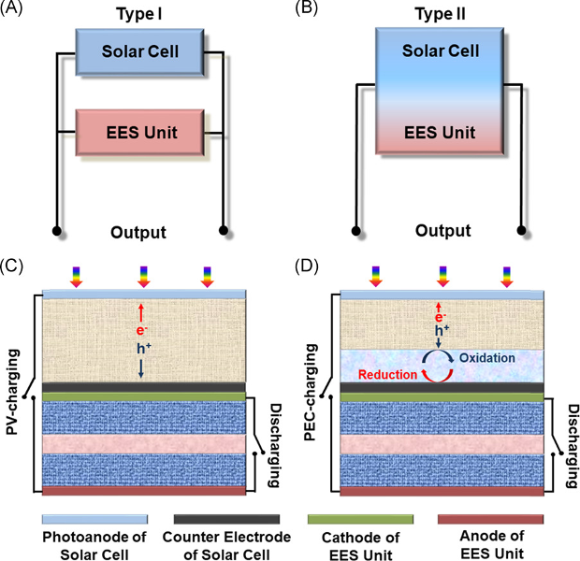

Figure 1: Schematic Diagram Illustrating Four Primary Integration Modes of Photo-Charging Hybrid Devices. (a) Type I Integration Mode, (b) Type II Integration Mode, (c) Photo Charging and Discharging Processes of Photovoltaic (PV) Integrated Devices, and (d) Photo Charging and Discharging Processes of Photoelectrochemical (PEC)-Rechargeable Integrated Devices.¹⁸

Within the context of integrated devices, solar cells play a pivotal role in converting solar radiation energy into electricity. Diverse types of solar cells have been successfully combined with supercapacitors to create advanced integrated systems, encompassing silicon-based solar cells³¹, organic solar cells (OSCs)³², perovskite solar cells (PSCs)³³, dye-sensitized solar cells (DSSCs)³⁴, and quantum dot (QD)/dye-sensitized solar cells³⁵. Solar cells can be categorized into two main types: Photovoltaic (PV) cells and Photoelectrochemical (PEC) cells. The distinction between these two types lies in the presence or absence of redox reactions during the solar energy conversion process. PV cells do not involve redox reactions, while PEC cells do³⁶. Silicon-based solar cells, OSCs, and PSCs belong to the category of PV cells, whereas DSSCs and QD/dye co-sensitized solar cells fall under the domain of PEC cells. Depending on the type of solar cells integrated into the devices, photo-rechargeable batteries, and supercapacitors can be classified into PV and PEC-rechargeable devices. Notably, the diverse types of solar cells employed result in distinct solar energy conversion and storage behaviors. PV-rechargeable devices rely on the photovoltaic effect of semiconductors within solar cells to generate photogenerated electrons and holes under incident light. These electrons and holes are subsequently directed to the respective anode and cathode of the supercapacitor, resulting in the storage of electrochemical energy.
Conversely, PEC-rechargeable devices involve photo-induced redox reactions. Excited photosensitive materials within the photoanode of PEC cells inject photogenerated electrons into the supercapacitor's anode. The subsequent reduction of the remaining holes by the redox pairs of the electrolyte allows the storage of solar energy in the supercapacitor. During discharge, the anode of the supercapacitor releases electrons, generating an electric current that flows back to the cathode.^{37–39}
Type III integration involves the creation of photoelectrochemical supercapacitors through the amalgamation of dye-sensitized, perovskite, and organic or silicon solar cell devices with supercapacitors, encompassing Electric Double-Layer Capacitors (EDLCs), pseudocapacitors, and hybrid capacitors, into a unified module (Figure 2). Nonetheless, the type II approach introduces spatial and weight constraints. A solution to these constraints lies in incorporating pioneering materials that exhibit bifunctional activity encompassing ion adsorption and solar irradiation on semiconductor electrode materials. Notably, semiconductor materials like TiO₂ and hybrid organic-inorganic perovskites showcase this dual capability, thereby holding significant promise for advancements in this domain. The operational mechanism of a photoelectrochemical supercapacitor unfolds as follows. Upon immersion in an aqueous electrolyte, a semiconductor electrode initiates the formation of a space charge layer. Subsequent exposure to light triggers the generation of electrons and holes in the electrode material. These photogenerated holes migrate toward the electrode surface, where they interact with the present anions within the electrolyte. Meanwhile, the photogenerated electrons traverse the semiconductor material under the influence of the electric field within the space charge layer. As a result of electron accumulation, the potential of the semiconductor electrode material diminishes, leading to a reduced affinity for attracting cations from the aqueous electrolyte onto its surface. This, in turn, prompts the sequestration of cations within the electric double layer situated at the upper surface of the bifunctional material. Upon connecting the electrode to a counter electrode through an external circuit, electrons flow through the circuit while cations desorb and migrate back into the electrolyte. This process effectively restores equilibrium within the system.
The bifunctional solar-charged energy storage devices can be realized in either planar or fiber designs. A significant milestone was achieved in 2004 when Miyasaka and co-workers developed the first photo-supercapacitor⁴⁰. This apparatus successfully accomplished the on-site transformation of radiant energy into electrical power, exhibiting an impressive efficiency in solar energy conversion. The functionality of this solar-charged capacitor relies on the utilization of visible light, which is absorbed by a dye-sensitized crystalline film. The architectural blueprint of these photo-supercapacitors encompasses a photoelectrode tasked with proficiently capturing sunlight, a redox-free liquid electrolyte, and a counter electrode. The electrode and counter electrode are both equipped with a heterojunction that incorporates a porous layer of activated carbon, thereby augmenting the capacity for charge accumulation.
A study by Kumar et al.¹⁷ in 2022 addresses a pivotal gap in off-grid power systems, where prevailing approaches segregate energy conversion and storage processes. This novel research undertakes the challenge of harmonizing electronic and ionic conductivity by capitalizing on a semiconductor endowed with light absorption capabilities spanning the solar spectrum, as illustrated in Figure 2. The resultant outcome, a halide perovskite-based photo-rechargeable supercapacitor, achieves exceptional charging performance, recording energy and power densities of 30.71 W h kg⁻¹ and 1875 W kg⁻¹, respectively. The strategic integration of hybrid halide perovskite materials, esteemed for their elevated absorption coefficient, considerable carrier diffusion length, and substantial ionic conductivity, engenders a paradigm shift in energy storage paradigms. The infusion of carbon black into porous perovskite electrodes amplifies energy and power density, showcasing an exemplary feat of innovation.
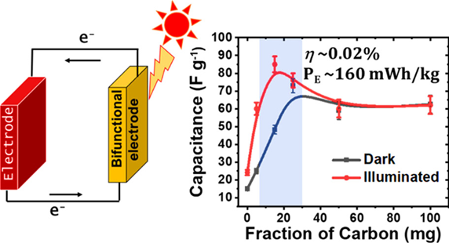
Empirical results underscore a noteworthy photo-charging conversion efficiency of approximately 0.02% and a photo-energy density approximating 160 mW h kg−1, thereby substantiating substantial progress in photo-rechargeable energy storage. Notably, meticulous optimization of electronic and ionic conductivity within the porous perovskite electrodes emerges as a pivotal determinant in enabling efficient energy storage capabilities. As delineated in this scholarly discourse, the exposition of the third variant of photo-rechargeable supercapacitors introduces an epoch-making fusion of energy conversion and storage domains. The compelling synergy between halide perovskite materials and carbon black within porous electrodes culminates in remarkable energy and power density achievements, thereby furnishing a tangible solution for coalescing solar energy capture with efficacious storage mechanisms.

Figure 2 (a) Hybrid perovskite-based bifunctional electrode for energy conversion and storage, and a graph depicting its variation in capacitance with a fraction of carbon used during electrode fabrication⁴¹

This process entails a series of precisely orchestrated steps, wherein light energy is harnessed to initiate reactions resulting in photoinduced electrons' generation and transfer. Moreover, photosensitization has been explored with alternative materials such as quantum dots, organic compounds, and perovskite, expanding the potential avenues for charge accumulation. These endeavors, however, are relatively less explored in the existing literature.
The effective harnessing of waste heat presents a crucial avenue for enhancing energy efficiency. Type IV of photo-rechargeable supercapacitors involves leveraging heat sources from industries and solar energy to elevate the performance of supercapacitors. While both sources hold significance, solar energy stands out due to its environmentally friendly nature. Nevertheless, challenges persist regarding the adequacy and optimization of solar energy utilization. The distinction between conventional supercapacitors and thermally charged supercapacitors lies in their energy storage mechanisms. Through faradaic, non-faradaic, or hybrid processes, the latter directly converts heat into electricity and stores it as surface charges. The efficacy of thermally charged supercapacitors is contingent upon various factors, encompassing electrolyte type, cation and anion size, and the electrode material's work function. Solar thermal-driven supercapacitors offer a promising avenue to enhance capacitance. Yet, their practical application faces hindrances, such as reduced photothermal conversion efficiency and challenges in broad solar spectrum absorption and thermal loss mitigation. Photothermal materials extend their research significance beyond environmental contexts, extending to energy harvesting and enhancement applications. The burgeoning field of photothermal capacitors encompasses emerging functional materials, including plasmonic metallic particles, metal oxides, conducting polymers, graphene oxide, and other carbonaceous substances. Notably, the working principle of photothermal supercapacitors is well-defined, with parameters such as temperature, electrode and electrolyte conductivity, electric double-layer capacitance, reaction rate constants, and diffusion coefficients pivotal to performance optimization.
Recent developments in photothermal supercapacitors hold promise for addressing performance limitations at low temperatures and augmenting energy storage capacity. For example, researchers have synthesized a reduced graphene oxide/poly(3,4-ethylenedioxythiophene): Poly (sodium styrene sulfonate) composite (rGO/PEDOT: PSS) via hydrothermal synthesis, which has been integrated into a symmetric supercapacitor (Figure 3) ⁴². This composite demonstrates a 50% increase in specific capacitance compared to pure rGO. Moreover, it exhibits remarkable photothermal properties, achieving a high photothermal conversion efficiency of 62.0% under near-infrared light at 1.05 W cm⁻².
Leveraging the photothermal effect, even under low illumination intensities of 0.18 W cm⁻², the supercapacitor shows 1.8 times increase in specific capacitance and 1.6 times increase in energy density compared to dark conditions. These findings indicate the potential of photothermal supercapacitors for enhancing energy storage performance, particularly in low-temperature environments, and suggest innovative applications in flexible and wearable devices while promoting efficient light energy utilization⁴².
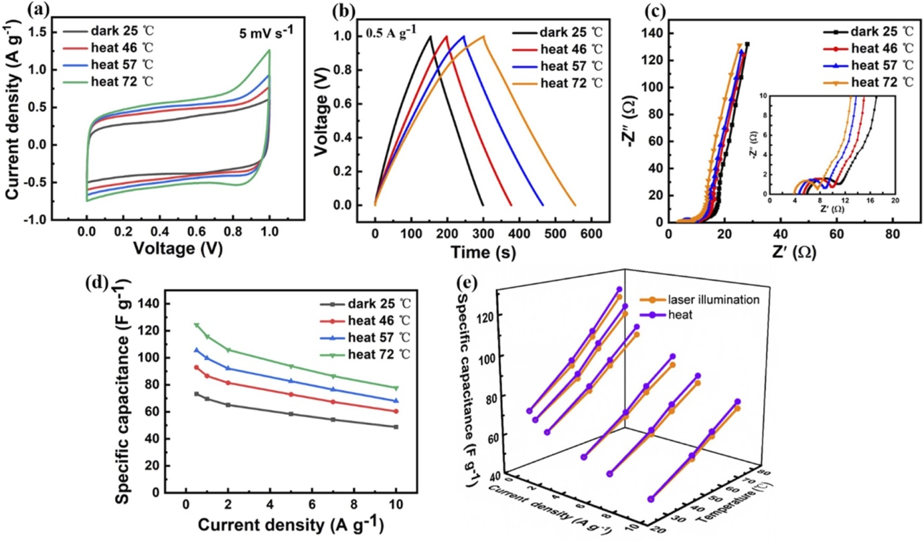
Figure 3: Investigation of Supercapacitor Electrochemical Performance under Varied Thermal Conditions, (a) CV curves recorded at a scan rate of 5 mV s⁻¹, (b) GCD profiles at a current density of 0.5 A g⁻¹, (c) Nyquist impedance curves, and (d) Specific capacitance plotted against current density for the photothermal-enhanced supercapacitor in a dark environment and at different heating temperatures. (e) Comparative analysis of specific capacitance between the supercapacitor subjected to laser irradiation and direct heating.⁴²

- Applications of Photorechargeable Supercapacitors
With the relentless pursuit of sustainable energy solutions, the convergence of cutting-edge technologies has yielded this new frontier of photo-rechargeable supercapacitor-integrated devices. This chapter explores the multifaceted applications of these integrated systems, where the synergy between supercapacitors and photovoltaic cells births a host of advancements that redefine the landscape of energy utilization.
In 2022, Jinrong Yin et al.⁴³ explored the application of electrochromism, an active discolouration process, in smart windows and various other domains such as anti-glare car rearview mirrors, military camouflage, flexible electronics, and electrochromic display screens. They addressed a significant issue faced by conventional electrochromic smart windows, which require external power sources for charging, leading to increased installation costs and energy consumption. The authors introduced electrochromic supercapacitors (ESC) that combine electrochromic technology and supercapacitors, offering an interactive mode for energy storage and dynamic display of energy levels through colour changes. By integrating photovoltaic conversion devices with ESC, they enabled energy storage through photoelectric conversion, providing sustainable power supplies. The authors simplified the device structure by integrating dye-sensitized solar cells (DSSC) and ESC on one current collector surface, achieving controlled and reversible colours with rapid optical modulation and coloured/bleached responses. This integration not only enhances the energy efficiency of ESC but also opens up opportunities for innovative applications in smart windows and dynamic light modulation for business intelligence windows.

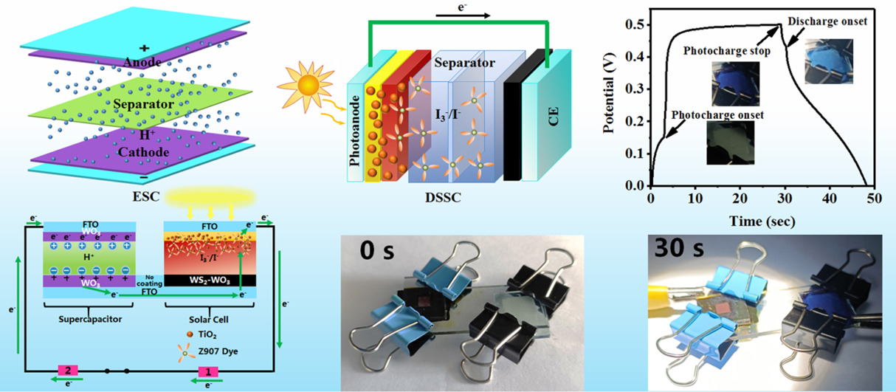
Figure 4. Application of Photo-rechargeable supercapacitor in electrochromic technology, offering an interactive mode for energy storage and dynamic display of energy levels through colour changes.⁴³

In summary, the authors successfully designed an integrated self-powered electrochromic system by integrating a solar and supercapacitor, with WS₂-WO₃ composite as the common electrode, yielding outstanding performance. This system functions as a self-powered energy storage electrochromic intelligent system, absorbing sunlight through DSSC to generate electrical energy and adjusting the ESC smart window's light transmittance via reversible colour changes. This multifunctional approach offers promising prospects for next-generation, thermally, electrochemically, and photochemically stable integrated self-powered electrochromic devices, positioning them as innovative and upgradeable smart windows for modern energy-efficient buildings.
Ireneusz Plebankiewicz et al.⁴⁴, systematically engineered a photo-rechargeable energy storage system based on silicon solar cells and supercapacitors. They designed a solar charger using commercially available components and simulated its operation under idealized conditions. Next, they developed electronic connections and control systems to facilitate the charging and discharging process of the energy storage system. This research led to constructing three different demonstrator systems, each employing distinct silicon solar cells and supercapacitor architectures. The results demonstrated the potential for high energy conversion efficiency, with one demonstrator achieving an impressive efficiency of 93%. This innovative approach held significant promise for addressing energy demand and supply mismatches, especially during night hours, by harnessing the combined benefits of supercapacitors and silicon solar cells as a reliable energy storage solution.
In addition to the applications mentioned earlier, photo-rechargeable supercapacitor-integrated devices offer various other possibilities. We have already discussed their use in wearable technology, portable energy systems, efficient lighting, wearable electronics, and smart textiles. However, it's essential to recognize that these devices have even more versatile applications. The following section delves into these additional uses, showing how these innovative devices are making a significant impact across various industries and contributing to a more sustainable energy future.^{45–48}
- Wearable and Portable Energy Sources: Integrating SCs with PV cells led to the creation of wearable and portable energy sources. Using lightweight materials and flexible designs, these integrated devices were embedded into clothing, accessories, or wearables, enabling self-powered and on-the-go charging for small electronic devices like LED lamps, smartwatches, and even mobile phones. This technology was particularly advantageous for individuals requiring reliable energy sources in remote or outdoor settings⁴⁵.
- Stretchable and Compact Hybrid Systems: The combination of SCs and PV cells in integrated devices allowed for more compact and lightweight energy systems. The use of advanced materials, such as graphene and carbon nanotubes, enhanced the energy storage capacity of SCs while maintaining their flexibility. This development offered new possibilities for applications in space-constrained environments or when weight limitations were critical, such as in portable medical devices or remote monitoring systems.¹⁸
- Energy-Efficient Lighting: Integrating SCs and PV cells facilitated efficient energy storage and release for lighting applications. These integrated devices could accumulate energy during daylight hours, and power LED lamps or other low-power lighting solutions at night. This application was precious in off-grid or emergency scenarios, providing illumination without relying on traditional power sources.⁴⁷
- Smart Textiles: Integrating SCs with PV cells contributed to developing smart textiles capable of energy generation and storage. These textiles could be used in various industries, such as fashion, sports, and healthcare, to create garments and fabrics that harness solar energy during the day and stored it for later use in powering embedded electronics or sensors.⁴⁶

- Challenges and future directions
This paper extensively explores photo-powered supercapacitor devices' integration mode, summarizing their principles, the factors influencing their performance, evaluation parameters, and recent developments in this rapidly evolving field. We have delved into various integration modes, types of solar cells, and emerging technologies that hold great promise for the future of energy storage. Despite the remarkable progress made in developing integrated devices, it is essential to acknowledge that the research in this domain is still in its infancy. Most efforts have focused on designing and demonstrating prototypes, with limited attention given to efficiency improvement and practicality enhancement, which are crucial for real-world purposes.
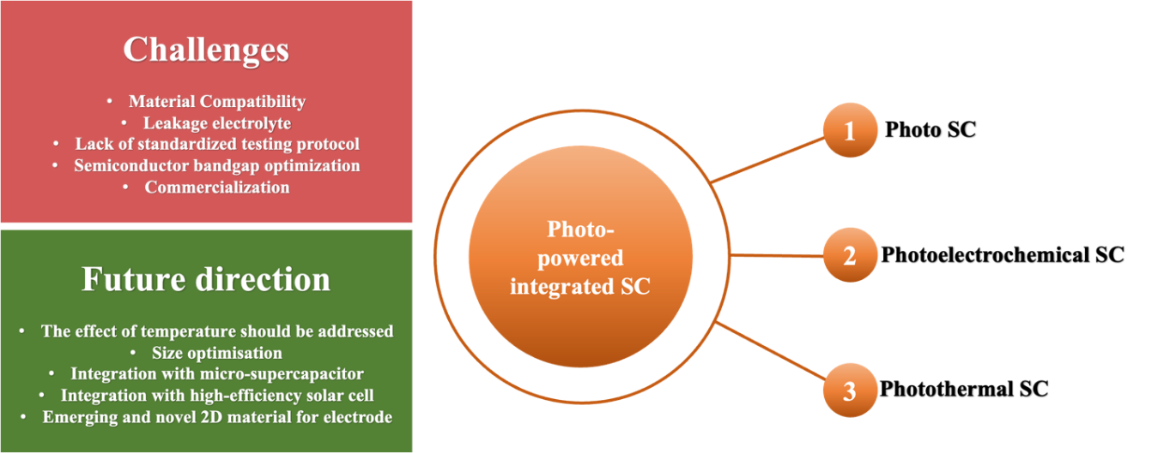
Figure 5. Challenges and Future directions of photo rechargeable devices

The challenges encountered while manufacturing solar-charged bifunctional devices, such as material compatibility, electrolyte selection, and the lack of standardized testing protocols, must be addressed comprehensively to achieve high-performance integrated devices. Transitioning from liquid electrolytes to solid-state electrolytes is a significant step in improving device safety and reliability.
Future Prospects:
The future of photo-powered integrated devices is filled with challenges and boundless opportunities. To pave the way for these devices to become the next-generation power source, several critical areas of focus are essential, including device coupling, Novel material, life cycle stability, multi-integration, scale-up techniques, and suitable application with the best possible new method.
- Efforts should be directed towards achieving optimal performance combinations between solar energy conversion parts and energy storage elements. This entails intelligent circuit design to match the outputs of solar cells or photoelectrodes with the electrochemical kinetics of energy storage units.
- Integrating novel materials like single-atom catalysts^{49,50}, phosphorene⁵¹, metal-organic frameworks (MOFs)^{52,53}, and various carbon nanomaterials^{54,55} can significantly enhance device efficiency and performance. These materials offer opportunities to optimize electrochemical reactions and improve overall device performance.
- Advanced fabrication methods, such as laser-scribing⁵⁶, atomic/molecular layer deposition⁵⁷, and ion implantation⁵⁸, can achieve higher device performance. These technologies warrant consideration during the preparation stages of integrated devices.
- Identifying appropriate application scenarios for different types of integrated gadgets is crucial. Tailoring integrated devices for specific use cases, such as portable and wearable devices, IoT applications, or grid-connected systems, will maximize their impact.
- Ensuring integrated devices' long-term stability and robustness is crucial for their commercialization. This involves enhancing the stability of individual components and developing reliable encapsulation technologies.
- Integrating multiple energy sources, such as mechanical energy conversion⁵⁹ and industrial waste heat utilization⁶⁰, will contribute to a profound energy revolution.
- Keep an eye on emerging technologies, including tandem solar cells, Zinc-ion capacitors⁶¹, and single photoelectrode-based integrated devices. These innovations may be essential to more proficient and stable solar energy harvesting, storage, and utilization.
- Develop scalable manufacturing processes for these devices to meet the growing demand. Consider automated assembly techniques and mass production methods to reduce production costs and make them accessible to a broader market.
- Emphasize sustainable manufacturing practices, including eco-friendly materials and recycling methods. Minimize the environmental impact of device production and disposal.
Though photo-rechargeable integrated devices hold immense potential for practical photovoltaic energy applications, significant challenges still persist. However, continued research and development efforts will pave the way for these advanced hybrid solar energy systems to usher in a new era of sustainable and efficient energy storage. Carbon, Metal-organic frameworks, and Perovskite-based functional materials will likely play a pivotal role in this journey, driving innovation and progress in photo-rechargeable integrated devices.
- Conclusion
In our modern, energy-dependent world, the increasing demand for continuous power supply, especially for portable electronics, has strained natural resources, increased emissions, and escalated pollution. The relentless march of industrialization and global population growth has intensified our energy consumption, primarily reliant on non-renewable fossil fuels. This trajectory threatens an impending energy crisis and exacerbates environmental challenges such as global warming and ecological degradation. Urgent action is imperative to develop innovative and sustainable solutions in green energy technology despite the inherent challenges faced by renewable sources.
Among these challenges, the intermittent nature of renewable energy sources necessitates suitable energy storage systems. P-SCs, a type of electrochemical energy storage device, have emerged as a solution with promising applications in portable electronics, electric vehicles, power supplies, and more. This book chapter has explored recent advancements in P-SCs, emphasizing the challenges and future prospects. We also demonstrated four different types of integration: Type I with external circuits, Type II with shared electrodes, Type III with bi-functional semiconductor electrode materials, and Type IV harnessing photothermal effects. Despite the promise of P-SCs, material compatibility, electrolyte selection, standardization of testing protocols, and long-term feasibility remain significant challenges. Overcoming these hurdles will be pivotal in unlocking the full potential of solar-charged bifunctional devices and advancing high-efficiency, long-lasting integrated energy solutions.
Looking ahead, the future of photo-powered integrated devices holds immense potential. The key focus areas are achieving optimal performance coupling between solar energy conversion components and energy storage units, using novel materials, advanced fabrication methods, tailored applications, and ensuring long-term stability. Additionally, exploring integrating multiple energy sources and keeping an eye on emerging technologies will contribute to a profound energy revolution. Photo-rechargeable integrated devices playing essential roles can transform solar energy utilization, contributing to a cleaner, sustainable future. These gadgets have the power to fundamentally alter how we gather, store, and use solar energy in a single unit, making a significant contribution to a cleaner and more sustainable future.

6. References
(1) Poompavai, T.; Kowsalya, M. Control and Energy Management Strategies Applied for Solar Photovoltaic and Wind Energy Fed Water Pumping System: A Review. Renewable and Sustainable Energy Reviews. Elsevier Ltd June 1, 2019, pp 108–122. https://doi.org/10.1016/j.rser.2019.02.023.
(2) Guo, L.; Sun, J.; Wei, J.; Liu, Y.; Hou, L.; Yuan, C. Conductive Metal-Organic Frameworks: Recent Advances in Electrochemical Energy-Related Applications and Perspectives. Carbon Energy. Blackwell Publishing Inc. June 1, 2020, pp 203–222. https://doi.org/10.1002/cey2.45.
(3) Li, K.; Hu, Z.; Ma, J.; Chen, S.; Mu, D.; Zhang, J. A 3D and Stable Lithium Anode for High-Performance Lithium–Iodine Batteries. Advanced Materials 2019, 31 (33). https://doi.org/10.1002/adma.201902399.
(4) Ong, W.-J.; Tan, L.-L.; Ng, Y. H.; Yong, S.-T.; Chai, S.-P. Graphitic Carbon Nitride (g-C ₃ N ₄ )-Based Photocatalysts for Artificial Photosynthesis and Environmental Remediation: Are We a Step Closer To Achieving Sustainability? Chem Rev 2016, 116 (12), 7159–7329. https://doi.org/10.1021/acs.chemrev.6b00075.
(5) Zhou, P.; Yu, J.; Jaroniec, M. All-Solid-State Z-Scheme Photocatalytic Systems. Advanced Materials. Wiley-VCH Verlag August 6, 2014, pp 4920–4935. https://doi.org/10.1002/adma.201400288.
(6) Carrillo, A. J.; González-Aguilar, J.; Romero, M.; Coronado, J. M. Solar Energy on Demand: A Review on High Temperature Thermochemical Heat Storage Systems and Materials. Chem Rev 2019, 119 (7), 4777–4816. https://doi.org/10.1021/acs.chemrev.8b00315.
(7) Wang, L.; Feng, J.; Tong, Y.; Liang, J. A Reduced Graphene Oxide Interface Layer for Improved Power Conversion Efficiency of Aqueous Quantum Dots Sensitized Solar Cells. Int J Hydrogen Energy 2019, 128–135. https://doi.org/10.1016/j.ijhydene.2018.01.155.
(8) Sun, H.; You, X.; Yang, Z.; Deng, J.; Peng, H. Winding Ultrathin, Transparent, and Electrically Conductive Carbon Nanotube Sheets into High-Performance Fiber-Shaped Dye-Sensitized Solar Cells. J Mater Chem A Mater 2013, 1 (40), 12422–12425. https://doi.org/10.1039/c3ta12663c.
(9) DeCarolis, J. F.; Keith, D. W. The Real Cost of Wind Energy. Science (1979) 2001, 294 (5544), 1000–1003. https://doi.org/10.1126/science.294.5544.1000.
(10) Wang, J.; Liu, P.; Hicks-Garner, J.; Sherman, E.; Soukiazian, S.; Verbrugge, M.; Tataria, H.; Musser, J.; Finamore, P. Cycle-Life Model for Graphite-LiFePO4 Cells. J Power Sources 2011, 196 (8), 3942–3948. https://doi.org/10.1016/j.jpowsour.2010.11.134.
(11) Simon, P.; Gogotsi, Y.; Dunn, B. Where Do Batteries End and Supercapacitors Begin? Science (1979) 2014, 343 (6176), 1210–1211. https://doi.org/10.1126/science.1249625.
(12) Gogotsi, Y.; Simon, P. True Performance Metrics in Electrochemical Energy Storage. Science (1979) 2011, 334 (6058), 917–918. https://doi.org/10.1126/science.1213003.
(13) Jiang, H.; Lee, P. S.; Li, C. 3D Carbon Based Nanostructures for Advanced Supercapacitors. Energy Environ. Sci. 2013, 6 (1), 41–53. https://doi.org/10.1039/C2EE23284G.
(14) Chaudhary, N.; Khanuja, M. High-Performance Supercapacitor Electrode Material Based on the Two-Dimensional/Three-Dimensional Architecture of MoS ₂ –PbS Hybrid Material. Energy & Fuels 2022, 36 (2), 1034–1042. https://doi.org/10.1021/acs.energyfuels.1c02685.
(15) Wang, J.; Feng, S.-P.; Yang, Y.; Hau, N. Y.; Munro, M.; Ferreira-Yang, E.; Chen, G. “Thermal Charging” Phenomenon in Electrical Double Layer Capacitors. Nano Lett 2015, 15 (9), 5784–5790. https://doi.org/10.1021/acs.nanolett.5b01761.
(16) Kim, S. L.; Lin, H. T.; Yu, C. Thermally Chargeable Solid-State Supercapacitor. Adv Energy Mater 2016, 6 (18), 1600546. https://doi.org/10.1002/aenm.201600546.
(17) Kumar, R.; Kumar, A.; Shukla, P. S.; Varma, G. Das; Venkataraman, D.; Bag, M. Photorechargeable Hybrid Halide Perovskite Supercapacitors. ACS Appl Mater Interfaces 2022, 14 (31), 35592–35599. https://doi.org/10.1021/acsami.2c07440.
(18) Wang, L.; Wen, L.; Tong, Y.; Wang, S.; Hou, X.; An, X.; Dou, S. X.; Liang, J. Photo-Rechargeable Batteries and Supercapacitors: Critical Roles of Carbon-Based Functional Materials. Carbon Energy. Blackwell Publishing Inc. June 1, 2021, pp 225–252. https://doi.org/10.1002/cey2.105.
(19) Renani, A. S.; Momeni, M. M.; Aydisheh, H. M.; Lee, B. K. New Photoelectrodes Based on Bismuth Vanadate-V2O5@TiNT for Photo-Rechargeable Supercapacitors. J Energy Storage 2023, 62. https://doi.org/10.1016/j.est.2023.106866.
(20) Hsu, C. Y.; Chen, H. W.; Lee, K. M.; Hu, C. W.; Ho, K. C. A Dye-Sensitized Photo-Supercapacitor Based on PProDOT-Et2 Thick Films. J Power Sources 2010, 195 (18), 6232–6238. https://doi.org/10.1016/j.jpowsour.2009.12.099.
(21) Renani, A. S.; Momeni, M. M.; Aydisheh, H. M.; Lee, B. K. New Photoelectrodes Based on Bismuth Vanadate-V2O5@TiNT for Photo-Rechargeable Supercapacitors. J Energy Storage 2023, 62. https://doi.org/10.1016/j.est.2023.106866.
(22) Momeni, M. M.; Navandian, S.; Aydisheh, H. M.; Lee, B. K. Photo-Assisted Rechargeable Supercapacitors Based on Nickel-Cobalt-Deposited Tungsten-Doped Titania Photoelectrodes: A Novel Self-Powered Supercapacitor. J Power Sources 2023, 557. https://doi.org/10.1016/j.jpowsour.2022.232588.
(23) Plebankiewicz, I.; Bogdanowicz, K. A.; Iwan, A. Photo-Rechargeable Electric Energy Storage Systems Based on Silicon Solar Cells and Supercapacitor-Engineering Concept. Energies (Basel) 2020, 13 (15), 3867. https://doi.org/10.3390/en13153867.
(24) Kelly, N. A.; Gibson, T. L. Solar Photovoltaic Charging of High Voltage Nickel Metal Hydride Batteries Using DC Power Conversion. J Power Sources 2011, 196 (23), 10430–10441. https://doi.org/10.1016/j.jpowsour.2011.07.043.
(25) Gibson, T. L.; Kelly, N. A. Solar Photovoltaic Charging of Lithium-Ion Batteries. In 2009 IEEE Vehicle Power and Propulsion Conference; IEEE, 2009; pp 310–316. https://doi.org/10.1109/VPPC.2009.5289834.
(26) Koksbang, R.; Barker, J. Solid-State Photovoltaic Power and Battery Unit. J Power Sources 1995, 55 (2), 259–262. https://doi.org/10.1016/0378-7753(95)02197-O.
(27) Boruah, B. D.; Mathieson, A.; Wen, B.; Jo, C.; Deschler, F.; De Volder, M. Photo-Rechargeable Zinc-Ion Capacitor Using 2D Graphitic Carbon Nitride. Nano Lett 2020, 20 (8), 5967–5974. https://doi.org/10.1021/acs.nanolett.0c01958.
(28) Boruah, B. D.; Wen, B.; De Volder, M. Light Rechargeable Lithium-Ion Batteries Using V ₂ O ₅ Cathodes. Nano Lett 2021, 21 (8), 3527–3532. https://doi.org/10.1021/acs.nanolett.1c00298.
(29) Ahmad, S.; George, C.; Beesley, D. J.; Baumberg, J. J.; De Volder, M. Photo-Rechargeable Organo-Halide Perovskite Batteries. Nano Lett 2018, 18 (3), 1856–1862. https://doi.org/10.1021/acs.nanolett.7b05153.
(30) Deka Boruah, B.; Mathieson, A.; Park, S. K.; Zhang, X.; Wen, B.; Tan, L.; Boies, A.; De Volder, M. Vanadium Dioxide Cathodes for High‐Rate Photo‐Rechargeable Zinc‐Ion Batteries. Adv Energy Mater 2021, 11 (13), 2100115. https://doi.org/10.1002/aenm.202100115.
(31) Agbo, S. N.; Merdzhanova, T.; Yu, S.; Tempel, H.; Kungl, H.; Eichel, R.-A.; Rau, U.; Astakhov, O. Photoelectrochemical Application of Thin-Film Silicon Triple-Junction Solar Cell in Batteries. physica status solidi (a) 2016, 213 (7), 1926–1931. https://doi.org/10.1002/pssa.201532918.
(32) Chien, C.-T.; Hiralal, P.; Wang, D.-Y.; Huang, I.-S.; Chen, C.-C.; Chen, C.-W.; Amaratunga, G. A. J. Graphene-Based Integrated Photovoltaic Energy Harvesting/Storage Device. Small 2015, 11 (24), 2929–2937. https://doi.org/10.1002/smll.201403383.
(33) Xu, J.; Ku, Z.; Zhang, Y.; Chao, D.; Fan, H. J. Integrated Photo-Supercapacitor Based on PEDOT Modified Printable Perovskite Solar Cell. Adv Mater Technol 2016, 1 (5), 1600074. https://doi.org/10.1002/admt.201600074.
(34) Poojari, V.; Devadiga, D.; Hegde, N.; Sangeetha, D. N.; Santosh, M. S.; Selvakumar, M. Conductivity and Electrochemical Behavior of Plasticized Polymer Electrolyte for Dye-Sensitized Solar Cell Integrated Supercapacitor. Journal of Electrochemical Energy Conversion and Storage 2020, 17 (3). https://doi.org/10.1115/1.4046107.
(35) Das, A.; Deshagani, S.; Kumar, R.; Deepa, M. Bifunctional Photo-Supercapacitor with a New Architecture Converts and Stores Solar Energy as Charge. ACS Appl Mater Interfaces 2018, 10 (42), 35932–35945. https://doi.org/10.1021/acsami.8b11399.
(36) Archer, M. D. Photovoltaics and Photoelectrochemistry: Similarities and Differences. Physica E Low Dimens Syst Nanostruct 2002, 14 (1–2), 61–64. https://doi.org/10.1016/S1386-9477(02)00450-2.
(37) Guo, W.; Xue, X.; Wang, S.; Lin, C.; Wang, Z. L. An Integrated Power Pack of Dye-Sensitized Solar Cell and Li Battery Based on Double-Sided TiO ₂ Nanotube Arrays. Nano Lett 2012, 12 (5), 2520–2523. https://doi.org/10.1021/nl3007159.
(38) Kim, B.-M.; Lee, M.-H.; Dilimon, V. S.; Kim, J. S.; Nam, J. S.; Cho, Y.-G.; Noh, H. K.; Roh, D.-H.; Kwon, T.-H.; Song, H.-K. Indoor-Light-Energy-Harvesting Dye-Sensitized Photo-Rechargeable Battery. Energy Environ Sci 2020, 13 (5), 1473–1480. https://doi.org/10.1039/C9EE03245B.
(39) Yang, Z.; Li, L.; Luo, Y.; He, R.; Qiu, L.; Lin, H.; Peng, H. An Integrated Device for Both Photoelectric Conversion and Energy Storage Based on Free-Standing and Aligned Carbon Nanotube Film. J. Mater. Chem. A 2013, 1 (3), 954–958. https://doi.org/10.1039/C2TA00113F.
(40) Miyasaka, T.; Murakami, T. N. The Photocapacitor: An Efficient Self-Charging Capacitor for Direct Storage of Solar Energy. Appl Phys Lett 2004, 85 (17), 3932–3934. https://doi.org/10.1063/1.1810630.
(41) Kumar, T.; Kumar, A.; Beniwal, S.; Kumar, R.; Bag, M. Photo-Generated Charge Trapping in Phase Segregated Halide Perovskites- A Comprehensive Approach towards Efficient Photo-Rechargeable Ion Capacitors. Batter Supercaps 2023. https://doi.org/10.1002/batt.202300213.
(42) Wu, J.; Deng, Y.; Wu, Y.; Yan, L. Preparation of RGO/PEDOT:PSS Composite with High Photothermal Conversion Efficiency for Light Enhanced Quasi-Solid-State Supercapacitor. J Alloys Compd 2023, 960. https://doi.org/10.1016/j.jallcom.2023.170463.
(43) Yin, J.; Li, J.; Wang, L.; Cai, B.; Yang, X.; Li, X.; Lü, W. Integrated Photoelectrochromic Supercapacitor for Applications in Energy Storage and Smart Windows. J Energy Storage 2022, 51. https://doi.org/10.1016/j.est.2022.104460.
(44) Plebankiewicz, I.; Bogdanowicz, K. A.; Iwan, A. Photo-Rechargeable Electric Energy Storage Systems Based on Silicon Solar Cells and Supercapacitor-Engineering Concept. Energies (Basel) 2020, 13 (15). https://doi.org/10.3390/en13153867.
(45) Shin, J.; Tran, V.-H.; Tien Nguyen, D. C.; Kim, S.-K.; Lee, S.-H. Integrated Photo-Rechargeable Supercapacitors Formed via Electrode Sharing. Org Electron 2021, 89, 106050. https://doi.org/10.1016/j.orgel.2020.106050.
(46) Lee, Y.-H.; Kim, J.-S.; Noh, J.; Lee, I.; Kim, H. J.; Choi, S.; Seo, J.; Jeon, S.; Kim, T.-S.; Lee, J.-Y.; Choi, J. W. Wearable Textile Battery Rechargeable by Solar Energy. Nano Lett 2013, 13 (11), 5753–5761. https://doi.org/10.1021/nl403860k.
(47) Fu, Y.; Wu, H.; Ye, S.; Cai, X.; Yu, X.; Hou, S.; Kafafy, H.; Zou, D. Integrated Power Fiber for Energy Conversion and Storage. Energy Environ Sci 2013, 6 (3), 805. https://doi.org/10.1039/c3ee23970e.
(48) Chae, J. S.; Park, S. K.; Roh, K. C.; Park, H. S. Electrode Materials for Biomedical Patchable and Implantable Energy Storage Devices. Energy Storage Mater 2020, 24, 113–128. https://doi.org/10.1016/j.ensm.2019.04.032.
(49) Ding, S.; Hülsey, M. J.; Pérez-Ramírez, J.; Yan, N. Transforming Energy with Single-Atom Catalysts. Joule. Cell Press December 18, 2019, pp 2897–2929. https://doi.org/10.1016/j.joule.2019.09.015.
(50) Yan, X.; Liu, D.; Cao, H.; Hou, F.; Liang, J.; Dou, S. X. Nitrogen Reduction to Ammonia on Atomic‐Scale Active Sites under Mild Conditions. Small Methods 2019, 3 (9), 1800501. https://doi.org/10.1002/smtd.201800501.
(51) Sang, D. K.; Wang, H.; Guo, Z.; Xie, N.; Zhang, H. Recent Developments in Stability and Passivation Techniques of Phosphorene toward Next‐Generation Device Applications. Adv Funct Mater 2019, 29 (45), 1903419. https://doi.org/10.1002/adfm.201903419.
(52) Ma, Y.; Du, J.; Fang, Y.; Wang, X. Encapsulation of Cobalt Oxide into Metal‐Organic Frameworks for an Improved Photocatalytic CO ₂ Reduction. ChemSusChem 2021, 14 (3), 946–951. https://doi.org/10.1002/cssc.202002656.
(53) Xu, H.; Zhao, L.; Liu, X.; Huang, Q.; Wang, Y.; Hou, C.; Hou, Y.; Wang, J.; Dang, F.; Zhang, J. Metal‐Organic‐Framework Derived Core‐Shell N‐Doped Carbon Nanocages Embedded with Cobalt Nanoparticles as High‐Performance Anode Materials for Lithium‐Ion Batteries. Adv Funct Mater 2020, 30 (50), 2006188. https://doi.org/10.1002/adfm.202006188.
(54) Wen, Y.; Zhu, G.; Shao, Y. Improving the Power Conversion Efficiency of Perovskite Solar Cells by Adding Carbon Quantum Dots. J Mater Sci 2020, 55 (7), 2937–2946. https://doi.org/10.1007/s10853-019-04145-9.
(55) Liu, S.; Cao, X.; Zhang, Y.; Wang, K.; Su, Q.; Chen, J.; He, Q.; Liang, S.; Cao, G.; Pan, A. Carbon Quantum Dot Modified Na ₃ V ₂ (PO ₄ ) ₂ F ₃ as a High-Performance Cathode Material for Sodium-Ion Batteries. J Mater Chem A Mater 2020, 8 (36), 18872–18879. https://doi.org/10.1039/D0TA04307A.
(56) Zhang, W.; Lei, Y.; Jiang, Q.; Ming, F.; Costa, P. M. F. J.; Alshareef, H. N. 3D Laser Scribed Graphene Derived from Carbon Nanospheres: An Ultrahigh‐Power Electrode for Supercapacitors. Small Methods 2019, 3 (5), 1900005. https://doi.org/10.1002/smtd.201900005.
(57) Zhao, Y.; Zheng, K.; Sun, X. Addressing Interfacial Issues in Liquid-Based and Solid-State Batteries by Atomic and Molecular Layer Deposition. Joule. Cell Press December 19, 2018, pp 2583–2604. https://doi.org/10.1016/j.joule.2018.11.012.
(58) Song, X.; Li, W.; He, D.; Wu, H.; Ke, Z.; Jiang, C.; Wang, G.; Xiao, X. The “Midas Touch” Transformation of TiO ₂ Nanowire Arrays during Visible Light Photoelectrochemical Performance by Carbon/Nitrogen Coimplantation. Adv Energy Mater 2018, 8 (20), 1800165. https://doi.org/10.1002/aenm.201800165.
(59) Pu, X.; Li, L.; Song, H.; Du, C.; Zhao, Z.; Jiang, C.; Cao, G.; Hu, W.; Wang, Z. L. A Self-Charging Power Unit by Integration of a Textile Triboelectric Nanogenerator and a Flexible Lithium-Ion Battery for Wearable Electronics. Advanced Materials 2015, 27 (15), 2472–2478. https://doi.org/10.1002/adma.201500311.
(60) Yi, Z.; Chen, G.; Hou, F.; Wang, L.; Liang, J. Strategies for the Stabilization of Zn Metal Anodes for Zn‐Ion Batteries. Adv Energy Mater 2021, 11 (1), 2003065. https://doi.org/10.1002/aenm.202003065.
(61) Boruah, B. D.; Mathieson, A.; Wen, B.; Jo, C.; Deschler, F.; De Volder, M. Photo-Rechargeable Zinc-Ion Capacitor Using 2D Graphitic Carbon Nitride. Nano Lett 2020, 20 (8), 5967–5974. https://doi.org/10.1021/acs.nanolett.0c01958.

