**Biogenic Synthesis of Zinc Oxide Nanoparticles Using the Aqueous Leaf Extract of *Murraya Koenigii***

**Prof.A.CERIL JEOFFREY* S.DINESHKUMAR**

Assistant Professor, II-M.Sc Chemistry,

PG & Research Department of Chemistry, PG & Research Department of Chemistry,

St.Joseph’s College (Autonomous), St.Joseph’s College (Autonomous),

Affiliated to Bharathidasan University, Affiliated to Bharathidasan University,

Tiruchirapalli-2, Tamilnadu, India Tiruchirapalli-2, Tamilnadu, India.

**S.VIGNESH**

II-M.Sc Chemistry,

PG & Research Department of Chemistry,

St.Joseph’s College (Autonomous),

Affiliated to Bharathidasan University,

Tiruchirapalli-2, Tamilnadu, India.

Email ID: [dineshkumar2582002@gmail.com](mailto:dineshkumar2582002@gmail.com)

**Abstract**

The nature acts like a large “bio-laboratory” comprising of plants, algae, fungi, yeast, etc. which are composed of biomolecules. These naturally occurring biomolecules have been identified to play an active role in the formation of [nanoparticles](https://www.sciencedirect.com/topics/chemistry/nanoparticle) with distinct shapes and sizes thereby acting as a driving force for the designing of greener, safe and environmentally benign protocols for the synthesis of nanoparticles.  This study aims to investigate the methanol and aqueous extracts of the leaves of *Murraya koenigii* for the presence of various phytochemicals and to synthesize zinc oxide nanoparticles using the aqueous extract of *Murraya koenigii* leaves. The presence of various phytochemicals viz. polyphenols, alkaloids, terpenoids, flavonoids, carbohydrates and steroids were investigated by following standard biochemical methods. Zinc oxide nanoparticles (ZnONPs) were synthesized by green method using *Murraya koenigii* leaf extract as natural solvent and reaction biomedia under environmentally benign reaction conditions. The synthesized copper nanoparticles (CuNPs) were characterized by using UV-Vis spectroscopy, FT-IR, EDAX and SEM. Results: The synthesized nanoparticles were found to be spherical in shape with average size of 28.65 nm. The results revealed that the aqueous extract of *Murraya koenigii* leaves is a very good bioreductant for the synthesis of zincoxide nanoparticles.

**Key words:** Zinc oxide nano particles, *Murraya koenigii***,** UV-Vis spectroscopy, FT-IR, XRD, EDAX and SEM

1. **Introduction:**

Nanoscience/nanotechnology has been applied extensively in pharmacological activities (drug delivery, biological applications) to develop and improve the therapeutic outcomes of several diseases. Nanostructured materials of semiconductor acquire much more attention in the recent years owing different properties and wide range of application in numerous fields such as sensors, catalyst, highly effective and functional devices and photoelectron device, etc., zinc oxide is the best semiconductor with the wide (energy gap) band gap of 3.37eV at room temperature. Specially, it is greatly applicable in catalytic reaction because of their high catalytic activity with the large surface area. The properties, behavior and applications of zinc oxide are depending on the size and surface morphology of the materials. [1-3] This size and morphology are directly controlled by the reducing and capping agents which was used in the synthesis. They are also widely used in the daily used commercial products, such as plastics, food packaging, soaps, pastes, food, and textiles, which has increased their market value to a great extent. Plenty of physical, chemical and biological methods were reported in the zinc oxide nanomaterial synthesis among all the biological method is the low cost, eco-friendly and most efficient compare to others.

Biosynthesis or green synthesis of zinc oxide nanoparticles is an alternative approach to the synthesis of nanoparticles using plant extracts, fungi, bacteria, yeast, algae, etc. Plant extracts mediated nanoparticles approach is most biocompatible, effective, safe and low-cost process than other methods. Furthermore, plant extract also acts as stabilizing and reducing agents in nanomaterials synthesis. Literature states that plant extract are successfully used to synthesize nanoparticles such as zinc, copper, silver, gold, cobalt, platinum, palladium, magnetite and etc., Plant extracts mediated zinc oxide nanomaterials have an effective remedy for cancer, hepatitis, malaria, and other acute diseases. Now-a-days nanoparticles were increasingly used as alternative antibiotics against the various bacteria and bacterial infectious diseases. [4-6] Zinc oxide nanoparticles utilized to prevent infection, control bacterial infections (as antibacterial vaccines), treat infectious disease (as antibiotic), promote wound healing and generate microbial diagnostics (in bacterial detection systems). Other than antibiotic effects ZnO have reported numerous therapeutic outcomes such that, antioxidant effects, immunomodulatory, sunscreen and anticancer. In plant extract mediated nanomaterials excess of phytocompounds were involved in the synthesis which can affect the shape, size, and property of the resulted zinc oxide nanomaterials.

The *Bergera koenigii* or *Murraya koenigii* tree commercially known as curry tree which is Asia native and are tropical to sub-tropical tree belongs to Rutaceae family i.e. rue family that includes citrus, rue and satinwood. It is also called as sweet neem even though *Murraya koenigii* is in a different family to neem which was related to *Meliaceae* family. Its leaves are called as curry leaves and it is used in various dishes in Indian subcontinent. The literature survey revealed that the *Murraya koenigii* whole tree has lot of pharmacological effects such as anti-bacterial activity, anti-fungal activity, anti-inflammatory activity and anti-oxidant activity. Even though it possess numerous medicinal values its seeds are could be toxic to humans. [7,8] Generally in leaves, bark, seeds and stems of *Murraya koenigii* contains various carbazole alkaloids such as mahanine, girinimbine, and mahanimbine. In additionally the leaves of *Murraya koenigii* has the terpenoids of beta-carotene, carotenoids and also contains micro nutrients like iron and calcium, etc.

From the literature studies in the plants it clearly showed that the pharmacological potential of the plant *Murraya koenigii* and this triggers us to study the usage whole plant extract as a reducing agent for zinc oxide nanomaterial preparations. Utilization of medicinal plant extracts may reduce the toxicity of the nanomaterials and thus enhance the medicinal applications in pharmacological fields. Main advantages of practicing plant is unnecessary usage of capping and stabilizing agents. The plant extracts act as all the three reagent’s role because of presence of many phytocompounds present in the single extract. Present study aimed to biosynthesis and characterize the *Murraya koenigii*leaf extract mediated ZnONPs and its validation.

**II. Experimental Methods**

**2.1. Collection and Extraction of *Murraya koenigii* :**

Plant material *Murraya koenigii* leaf were collected from palakarai, Trichy district. The taxonomy of the plant is identified by the Rapinat Herbarium, St. Joseph’s College (Autonomous) Trichy. About 500gms of disease free leaves of *Murraya koenigii* was chopped and grind. Then transfer into the 500 ml beaker to that, 500ml of double distilled water was added and mixed well. Maintain the solvent level in beaker at 2cm above than the plant material, kept for 5 to 8 hrs on heating mantle for the complete extraction of all the phyto constituents from the leaves. Final extract was first filtered by normal filter paper then followed by Whatman No-1 filter paper. Filtrate was stored in refrigerator for further qualitative screening and nanoparticle preparations.

**2.2. Qualitative Analysis of of Aqueous Extract of *Murraya koenigii*:**

The different qualitative chemical tests can be performed to establish or screen the phytochemical profile of extract of *Murraya koenigii*. It is an essential test for detecting bioactive compounds (plant products) present in the different extracts of plants. The standard screening tests and procedures were carried out which is performed on the extract to detect various phytocompounds present in them.

**2.3. Biogenic Synthesis of ZnO nanoparticles from the aqueous extract of *Murraya koenigii:***

50ml of 0.1 M Zinc acetate solution was taken in a 250ml beaker, and placed on the magnetic stirrer at 60⁰C. To this, 10ml of the filtered aqueous extract of *Murraya koenigii* was slowly added at every 30 minutes intervals. After completion of 50ml extract addition, the reaction mixture was kept overnight at room temperature. ZnO nanoparticles deposited in the beaker bottom and it was collected by centrifuging at 6,000 rpm. In order to achieve the maximum purity of ZnO nanoparticles, the collected ZnONPS were washed with D.D water, followed by ethanol. Solvent free ZnONPS was dried in an oven for complete conversion of Zn(OH)2 into ZnO. Synthesized ZnO nanoparticles were confirmed with the help of UV-Visible Spectroscopy, FT-IR Spectral analysis, X-Ray Diffraction (XRD), Scanning Electron Microscope (SEM) and Energy Dispersive X-Ray Analysis (EDAX) analysis. [9-13]

1. **Results and Discussion**

The phytochemical components present in the leaves extract of *Murraya koenigii* was investigated by standard phytochemical screening procedure. Results showed the presence of carbohydrates, glycosides, proteins, amino acids, phenolic compounds, flavonoids, terpenoids, phlobatannins in the plant extract (as reducing agents) which plays synergistic effect in the reduction of zinc in zinc acetate.

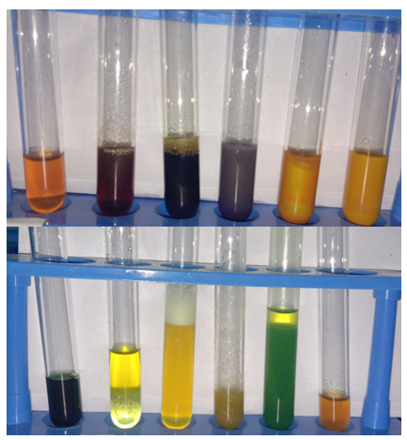

**Figure-1: Phytochemical Screening results of aqueous extract of *Murraya koenigii* leaves**

UV-visible spectra of *Murraya koenigii* extract shows the maximum absorbance at 219nm, 271nm, 329nm, and 338nm which is due to unsaturated groups or hetero atoms (C=C, S, N, O) in the extract and are mainly flavonoids, phenolics, alkaloids, etc., absorbance at 663nm is because of chlorophyll (organic chromophores) (fig-2). In ZnONPs UV spectrum, the maximum absorption peak observed at 234nm and 330nm which confirms the formation of ZnONPs (due to surface plasmon resonance effect) (fig-3). FT-IR spectra of plant extracts reveals the functionalities of OH, C=O, C=C, C-O which indicates the presence of phyto-molecules (fig-4). Usually, metal-oxygen (M-O) bond showed FT-IR frequencies at below 600 cm-1. The FT-IR spectrum of ZnO nanoparticles (fig-5) absorbed multi peaks between 433 cm-1 to 548 cm-1. [14-16]

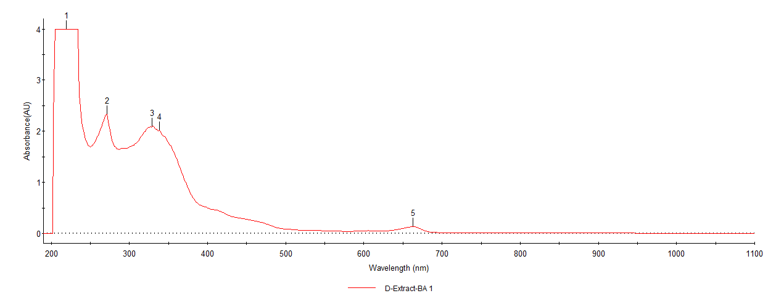

**Figure-2: UV-Visible of aqueous extract of *Murraya koenigii* leaves**

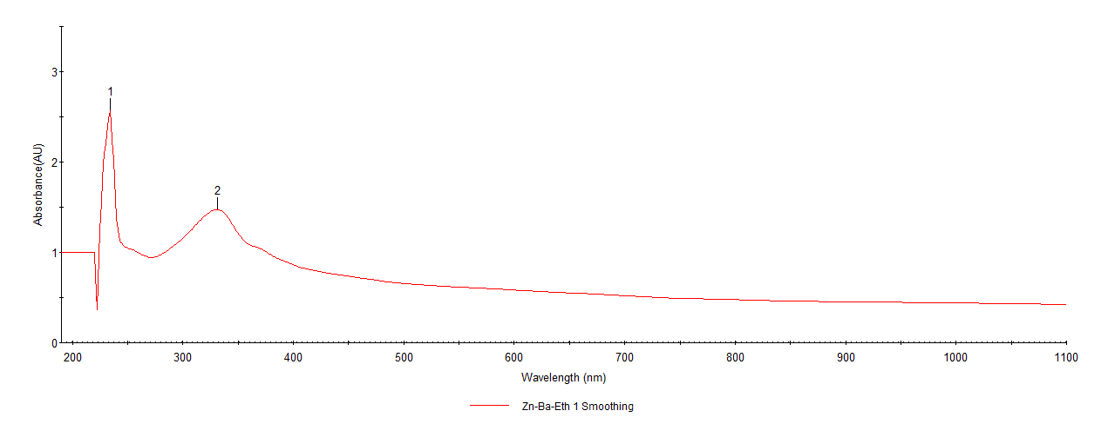

**Figure-3: UV-Visible Spectrum of *Murraya koenigii* mediated ZnONPs**



**Figure-5: FT-IR Spectrum of aqueous extract of *Murraya koenigii***



**Figure-5: FT-IR Spectrum of *Murraya koenigii* mediated ZnONPs**

XRD was used to determine the crystal structure of a material system. The 2ϴ values of synthesized zinc nanoparticles (fig.6) were found to be 31.840, 34.520, 36.380, 47.640, 56.700, 63.060 and 68.100. The peaks of the graph were in good agreement with the literature report (JCPDS File no: 36-1451). Using Debye Scherrer equation **[Dp = (0.94*λ) / (β*Cosϴ)]**, the average size of the nanoparticles was determined. The average crystalline size of the formed ZnONPs was found to be 28.65 nm. XRD patterns obtained in this study are similar to XRD patterns obtained in the other biologically synthesized ZnO nanoparticles.[17,18]

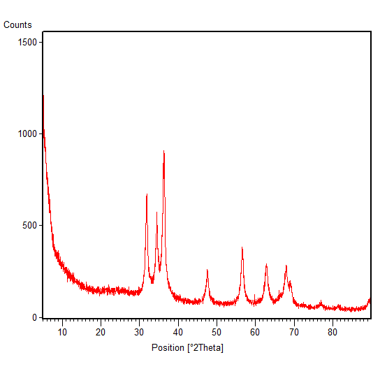

**Figure-6: XRD Pattern of *Murraya koenigii* mediated ZnONPs**

SEM analysis was used to identify the morphology, size and shape of the nanoparticles. The obtained SEM image showed the spherical shape of obtained ZnO nanoparticles (Fig. 7).As the synthesized nanoparticles are in spherical shape, they can easily penetrate into the cell wall of the pathogens which contributed to its effective anti-bacterial activity of the ZnO nanoparticles.

C:\Users\God\AppData\Local\Microsoft\Windows\INetCache\Content.Word\Zn-Nps-BA-07.tif 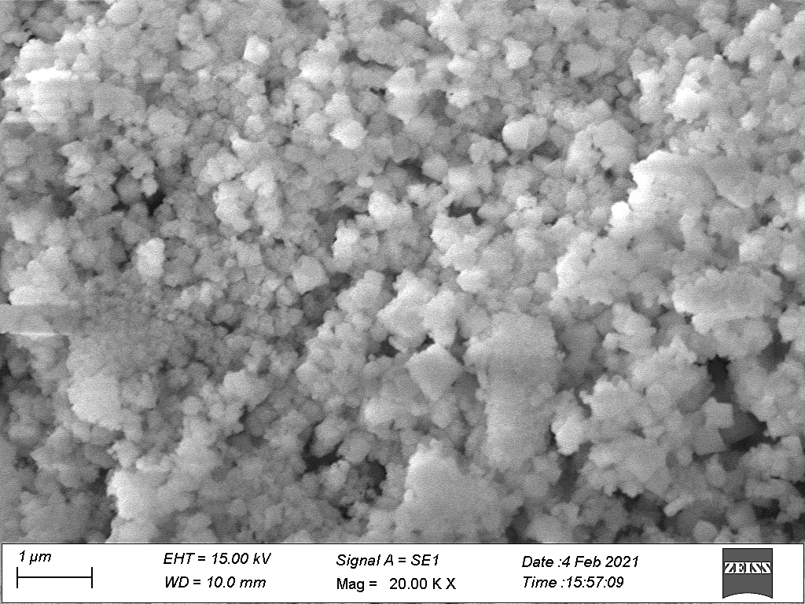

**Figure-7: SEM Images of *Murraya koenigii* mediated ZnONPs**



**Figure-7: EDAX Image of *Murraya koenigii* mediated ZnONPs**

The Energy-Dispersive X-ray (EDAX) investigation was done to check the elemental composition of synthesized zinc oxide nanoparticles.[19] The EDAX spectrum showed highest percentages of Zinc and oxygen with the elemental composition of 70.04% and 29.96%respectively (Fig. 7).

1. **CONCLUSION:**

Green synthesis of nanoparticles used in the research work was found to be eco-friendly, non-toxic and less usage of chemicals than the physical and chemical methods. The phytochemicals present in the leaf extract itself help in the synthesis of metal oxide nanoparticle. The presence of functional groups induce the nanoparticle synthesis were alcohols and phenols that are widely seen in secondary metabolite flavonoids. From the literature it is understood that, 70% ethanol extract possess flavonoid compounds (major phyto-molecule) which is also confirmed by qualitative and UV-Visible. Further the XRD analysis proved the spherical crystalline nature of the ZnO NPs with the average size of 28.65 nm. The existence of major elemental percentage of zinc and oxygen without any additional peaks confirmed the purity of the ZnONPs. The above research work reveals that, the aqueous extract of *Murraya koenigii* leaves is a very good bioreductant for the synthesis of zincoxide nanoparticles.

1. **References**
2. Matej Balaz, Michal Goga, Michal Hegedus, Nina Daneu, Maria Kovacova, Ludmila Tkacikova, Ludmila Balazona, Martin Backor (2020) Biomechanochemical Solid-state synthesis of Silver Nanoparticles with Antibacterial activity using Lichens, ACS Sustainable Chemistry & Engineering*,* 8(37), 13945-13955.
3. M. Jazmin Silveroc, Kiamela M. Rocea, Emilce Artur de la Villarmois, Kelsay Fourneir, Anabel, E. Lanterna, Mariela, F. Perz, M. Cecilia Becerra, Juan C. Scaiano (2018) Selective Photoinduced Antibacterial activity of Amoxicillin – coated Gold Nanoparticles: From one-step synthesis to in Vivo Cytocompatibility, ACS Omega*,* 3(1), 1220-1230.
4. Ameu Azam, Arham S. Ahmed, Mohammed Oves, Mohammad S. Khan, Sami S. Habib (2012) Antimicrobial activity of metal oxide nanoparticles against Gram-positive and Gram-negative bacteria – a Comparative Study, International Journal of Nanomedicine,7, 6003-6009.
5. D. Saravanakumar, Hicham Abou Oualid, Younes Brahmi, A. Ayeshamariam, M. Karunanaithy, A. Mohamed Saleem, K. Kaviyarasu, S. Sivaranjani, M. Jayachandran (2019) Synthesis and characterization of CuO/ ZnO/ CNTs thin film on Copper substrate and its photocatalytic applications, Open Nano*,* 4, 100025, 1-15.
6. Jianhui Zhang, Baodan Zhao, Zhongda Pan, Min Gu, Alex Punnoose (2015) Synthesis of ZnO Nanoparticles with controlled Shapes, Sizes, Aggregations and Surface Complex compounds for Tuning or Switching the Photoluminescence, Crystal Growth & Design,15(7), 3144-3149.
7. Xiaosheng Tang, Eugene Shi Guang Choo, Ling Li, Jun Ding, Junmin Xue (2010) Synthesis of ZnO Nanoparticles with Tunable Emission Colors and their Cell Labeling Applications, Chemistry of Materials*,* 22(11), 3383-3388.
8. K. Nithya, S. Kalyana Sundharam (2019) Effect of chemically synthesis compared to biosynthesized ZnO nanoparticles using aqueous extract of C. halicacabum and their antibacterial activity, Open Nano,4, 100024, 1-12.
9. Eric A. Meulenkamp (1998) Synthesis and Growth of ZnO Nanoparticles,The Journal of Physical Chemistry B, 102(29), 5566-5572.
10. Joghee Suresh, Ganeshan Pradheesh, Vincent Alexramani, Mahalingam Sundrarajan, Sun lg Hong (2018) Green synthesis and Characterisation of Zinc oxide nanoparticles using insulin plant *(Coctus pictus D. Don)* and investigation of its antimicrobial as well as anticancer activities, Advances in Natural Sciences: Nanoscience and Nanotechnology*,* 9, 015008, 1-8.
11. Deepali Sharma, Myalowenkosi I. Sabela, Suvardhan Kanchi, Krishna Bisetty, Adam A. Skelton, Bahareh Honarparvar (2018) Green synthesis, characterization and electrochemical sensing of silymarin by ZnO nanoparticles: Experimental and DFT studies, Journal of Electroanalytical Chemistry,808, 160-172.
12. Hamid Reza Ghaffarian, Mahboobeh Saiedi, Mohammad Ali Sayyadnejad, Ali Morad Rashidi (2011) Synthesis of ZnO Nanoparticles by Spray Pyrolysis Method, Iranian Journal of Chemistry and Chemical Engineering,30 (1), 57, 1-6.
13. Nehal A. Salahuddin, Maged El-Kemary, Ebtisam M. Ibrahim (2015) Synthesis and Characterisation of ZnO Nanoparticles via Precipitation method: Effect of Annealing Temperature on Particle size, Nanoscience and Nanotechnology*,* 5(4), 82-88.
14. J. Santhoshkumar, S. Venkat Kumar, S. Rajeshkumar (2017) Synthesis of zinc oxide nanoparticles using plant extract against urinary tract infection pathogen, Resource-Efficient Technologies, 3(4), 459-465.
15. M.S. Geetha, H. Nagabhushana, H.N. Shivananjaiah (2016) Green mediated synthesis and characterization of ZnO nanoparticles using Euphorbia Jatropa latex as reducing agent, Journal of Science: Advanced Materials and Devices, 1(3), 301-310.
16. W.Y. Ming, L.J. Hua, H.R. Yu (2012) Large scale synthesis of ZnO nanoparticles via homogeneous precipitation, Journal of Central South University, 19, 863–868.
17. Joghee Suresh, Ganeshan Pradheesh, Vincent Alexramani, Sun Ig Hong (2018) Phytochemical Screening, Characterization and Antimicrobial, Anticancer Activity of Biosynthesized Zinc Oxide Nanoparticles Using Cyathea nilgiriensis Holttum Plant Extract, Journal of Bionanoscience, 12(1), 37-48.
18. Hamid Reza Ghorbani, Ferdos Parsa Mehr, Hossein Pazoki, Behrad Mosavar Rahmani (2015) Synthesis of ZnO Nanoparticles by Precipitation Method, Oriental Journal of Chemistry, 31(2), 1219-1221.
19. A. Jafar Ahamed, P. Vijaya Kumar (2018) Synthesis and characterization of ZnO nanoparticles by co-precipitation method at room temperature,Journal of Chemical and Pharmaceutical Research, 8(5), 624-628.
20. Julian Medina, Harold Bolanos, Lyda Patricia Mosquera‑Sanchez, J.E Rodriguez‑Paez (2018) Controlled synthesis of ZnO nanoparticles and evaluation of their toxicity in *Mus musculus* mice, International Nano Letters, 8,165–179.