Chemistry aspect for the wastewater treatment of Buddah Nullah, Ludhiana and treatment of their wastes to value added products
Chamandeep Kaur, Manishi, and Suneel Singh Berhyan and N. Kaur
*Department of Chemistry, School of Basic and Applied Sciences
RIMT University, Mandi Gobindgarh, Punjab, 147301 (INDIA)
Abstract
In this report, we present chemistry aspect for the treatment of solid and liquid wastes of Buddah Nullah, Ludhiana, Punjab. This waste to value model not only sorts out the problem of solid and liquid wastes of Buddah Nullah but also generates values from them. This model work upon three major aspects i.e. Wastewater treatment, production of Bio-mass Briquette from sludge, and generating Biofuel from waste plastic materials. For the treatment of wastewater, we use natural coagulants like Moringa Olifera, Strychnos potatorum, and Arachis hypogea in 20% alum solution, rGO-TiO₂ nanocomposite as well as rGO-Zr₃(PO₄)₂ ion exchange resins. Natural coagulants act as Bio-Coagulants that are not only clarify wastewater but also have antimicrobial activity along with a tendency to remove about 20-25% heavy metals from wastewater. rGO-TiO₂ nanocomposite has the efficiency to remove organic dye from wastewater and the rGO-Zr₃(PO₄)₂ ion exchange resins have the ability to remove heavy metals that are present in soluble form in the wastewater. The Bio-mass Briquette is prepared from the sludge, and is the best alternative source of natural fuels like coal and that are used in thermal power plants. The pyrolysis oils are manufactured from the waste plastic materials that are obtained from Buddah Nullah and Bio-Ethanol is produced from the waste juggaries. The mixture of pyrolytic oils and Bio-Ethanol in appropriate proportion generates Bio-fuel. By adopting this proposed model, we are able to produce valuable eco-friendly products which have commercial applications also. This model gives a new vision and helps to lower the burden of industries as well as State Government also for the regeneration of Buddah Dariyan again.
Keywords: Waste to value model, nanocomposite, Ion exchange resin, Biomass Briquettes, Bio-fuel.
Introduction
Buddah Nullah or Budha Nallah earlier it was called Buddah Driyan, a small, narrow, seasonal water stream that runs through the Malwa region of Punjab, passes through highly populated Ludhiana and drains into Sutlej River, a tributary of the Indus. Due to the dumping of waste either domestic, industrial or from sewage plants, its name got changed to Buddha Nullah (drain) that run into a 14-km stretch within Ludhiana city municipal corporation limits beginning from Tajpur road. It has set off as a serious origin of pollution within the area of Sutlej river, because it gets polluted after entering the highly populated and industrialized Ludhiana city, turning it into an open drain. a number of the foremost important categories of industries in Ludhiana are textile and hosiery. These industries use a huge quantity of chemicals and various sorts of dyes. By using hazardous chemicals such as nickel, and cyanide, the processes of electroplating and warmth treatment were done. Another important issue which resulted in increase in pollution of Buddha Nullah is the discharge of untreated waste, occupancy of people of slum areas around river banks and ever increasing population. As such the status of Buddah Nullah has to ascertained by assessing the assessment of Physiochemical parameters of surface water and develop a model to not treat wastewater but also waste to value concept apply thereto. So that our government gets commercial value also. Only then this problem is often mapped out. Through this waste to value project, not only environmental problems are mapped out but health, economic also as commercial problems are sorted out.
Buddha Nullah was a good source of fishing many years ago and in 1944 it recorded 56 species of fish. When Ludhiana developed and industries started coming, its condition deteriorated due to the pollution of industry and city. Later, during the 1970s, only 18 species were found. In 1984, only 4 species of air-breathing were recorded. Due to the high level of toxicity in the water, the drain is no longer for any fish. According to the State Department of Fisheries, pollution in the Sutlej River has led to a sharp decline in fish production. After entering the city of Ludhiana, the river water is polluted. It is now an open gutter instead of a stream. Passing through the city of Ludhiana, it carries the city's sewage and industrial sludge and is an important drainage system that runs uncomfortably 25 km across the Sutlej River. Large quantities of domestic and industrial wastewater have been diverted to sewers in Nullah. Solid waste from industrial waste, sewage, diaries, leather, and power industries has polluted Ludhiana. PGIMER and the Punjab Pollution Control Board in a joint study in 2008 stated that the groundwater and tap water permitted limits (MPL) in villages with drains, calcium, magnesium, fluoride, mercury, beta-endosulfan, and heptachlor has been exceeded. Also, the amount of COD and BOD was high in the water. ammonia, phosphate, chloride, chromium, arsenic, and chlorpyrifos. The groundwater also contains nickel and selenium, while the tap water has a high concentration of lead, nickel, and cadmium. ammonia, phosphate, chloride, chromium, arsenic, and chlorpyrifos. The groundwater also contains nickel and selenium, while the tap water has a high concentration of lead, nickel, and cadmium, ammonia, phosphate, chloride, chromium, arsenic, and chlorpyrifos. The groundwater also contains nickel and selenium, while the tap water has a high concentration of lead, nickel, and cadmium.
According to PPCB, sewage water requires a wastewater treatment capacity of at least 680,000 m3 per day, while the current sewage treatment plants at Jamalpur, Naloke, and Bhattian have a capacity of 311 MLD. In 2010, the presence of high levels of heavy metals and uranium in sewer water samples was 1½ times the reference range. For example, chromium was 50 times higher than the reference range, aluminum and iron were 20 and 60 times higher, while the concentration of silver, manganese, nickel, and lead was the same. Pollution has increased in temperature, pH, hardness, and BOD and the total solids in that stream. Now only septic conditions prevail (Kaur, 1997). As the drain eventually flows into the Sutlej River, an important source of drinking water and fishing in Punjab, about 25 km from the city of Ludhiana, the Sutlej River is also being polluted now. Therefore it will be useful from an economic and health point of view to assess the effect of this pollution on the immune system of fish, which makes them prone to disease. Buddah Nullah is the most polluted tributary in Punjab and so far no solution has been found. This despite the efforts of the Central Government to initiate a project on "bioremediation techniques" to prevent pollution by sewage and industrial sewage in the Buddah drain. The cost of the project was Rs. 16 crores in the initial phase and should be borne by National River Conservation
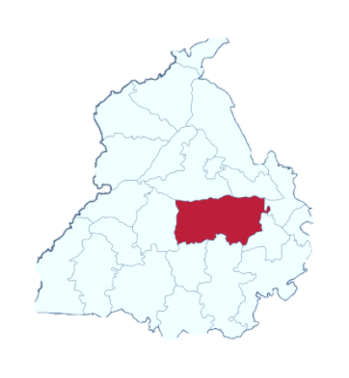Figure 1- shows Geographical location of Buddah Nullah, Ludhiana, Punjab, India

Figure 2- Shows the Action plan taken by the Government, NGT, and NGOs:

Dyeing and electroplating units’ area aforementioned to be major polluting industries. The geographic area Pollution control panel (PPCB) is entrusted by the geographic area Government to prevent pollution in the geographic area. PPCB tried to require action against twenty-six coloring units in Ludhiana for polluting Buddha vale stream with pollutants there have been specific inputs with the PPCB that coloring trade was discharging pollutants within the Buddha vale that enters watercourse Satluj. The effluent treatment plants at these units were found shut throughout a visit by the board recently against that the trade had protested. Board had conjointly conducted surprise raids at electroplating units and initiated action for waterproofing and disconnection of fifty-one major violators that were discharging untreated effluents into a sewer. However, true has not modified abundant despite the unenthusiastic efforts of geographic area pollution control panel as is clear from the visits of this investigator together with his team from Tajpur to Walipur Kalan. The water from Buddha vale into Satluj at Walipur Kalan is kind of black and it is a little portion that converts a large amount of brown Satluj water into the black also. The Satluj water of the watercourse is collected in Harike Lake and this water is employed for irrigation and water system functions within the southern part of the geographic area and the neighbouring state of Rajasthan. The State of Rajasthan has complained concerning the deteriorating quality of the water being received from Harike Lake. The result on crops and health of the folks in southern a part of the geographic area too is incredibly damaging.

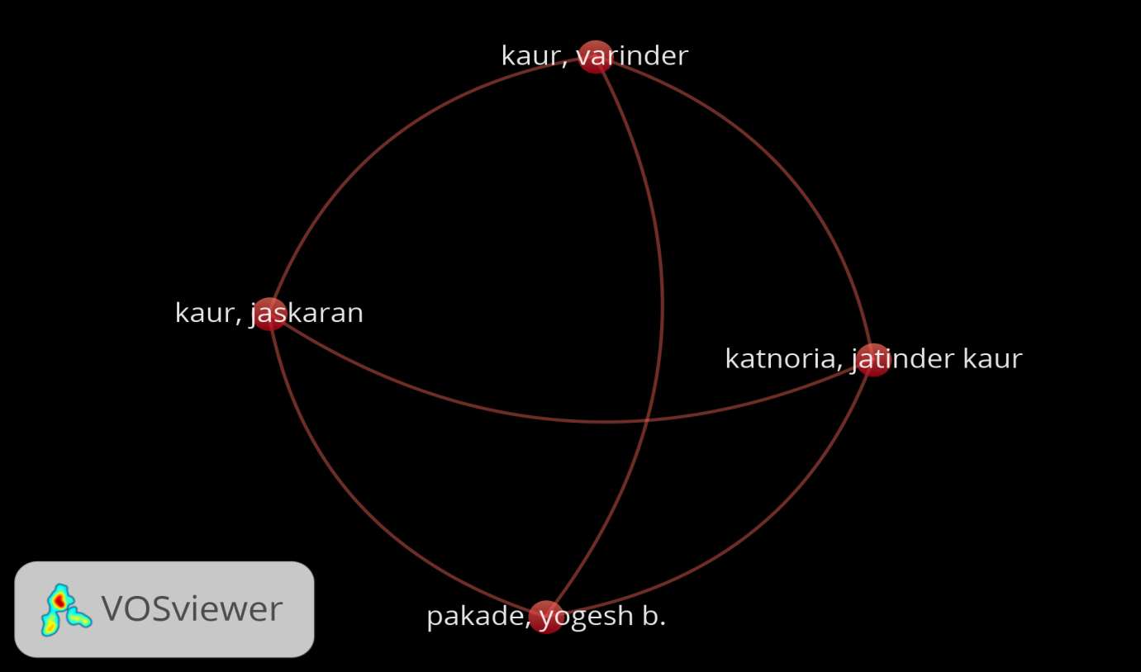Figure 3- Scholastic study on the assessment of the quality of Buddah Nullah:
Sources of waste: As per the Indian Express, the Buddha Nullah Untreated Sewage Treatment Plant (STP), 228 dyeing units, and 116 outlets are the three main sources of untreated industrial waste. It dumps sewage and industrial waste directly into rivers. Of these 16 sewers, 11 are MC disposal sites, where civil society organizations discharge untreated sewage waste directly into rivers. Untreated sewage from the Jamalpur and Balloke STPs in Ludhiana also enters. For the ability to handle 48 MLD, Jamalpur STP receives an average of 205 MLD per day. The Balloke STP gets 268 MLD for a 257 MLD capacity. Both STPs are mostly inactive. Unprocessed excess waste also flows into the stream.

Figure 4- Shows the source polluting Buddah Nullah

Figure 5- Shows the Scholastic study on Natural Coagulants*
Figure 6- Shows the Scholastic study on Graphene Oxide*

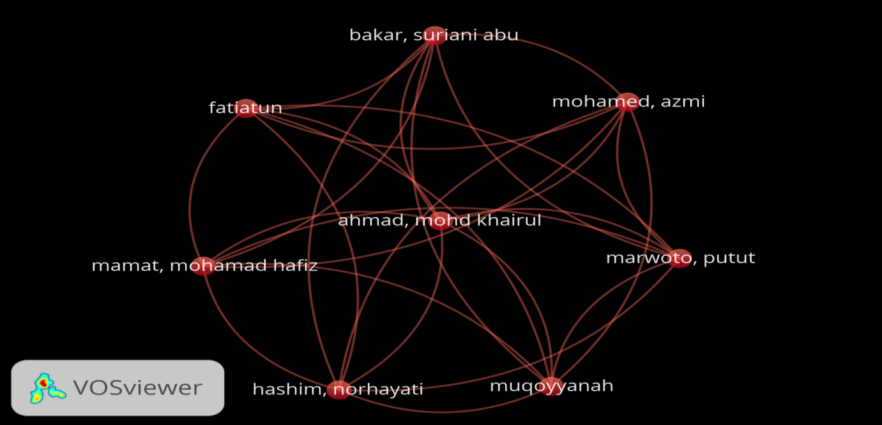Figure 7- Shows the Scholastic study on GO+TiO2*
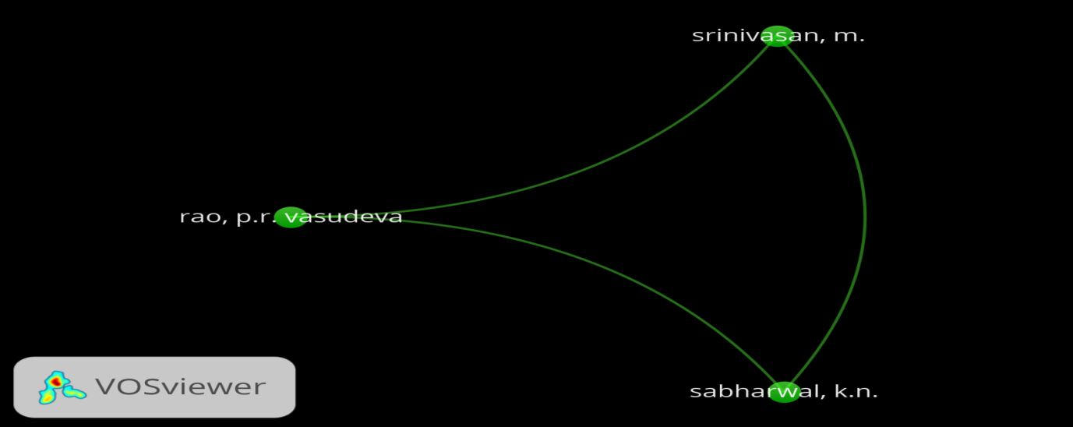Figure 8- Shows the Scholastic study on GO+ IER*

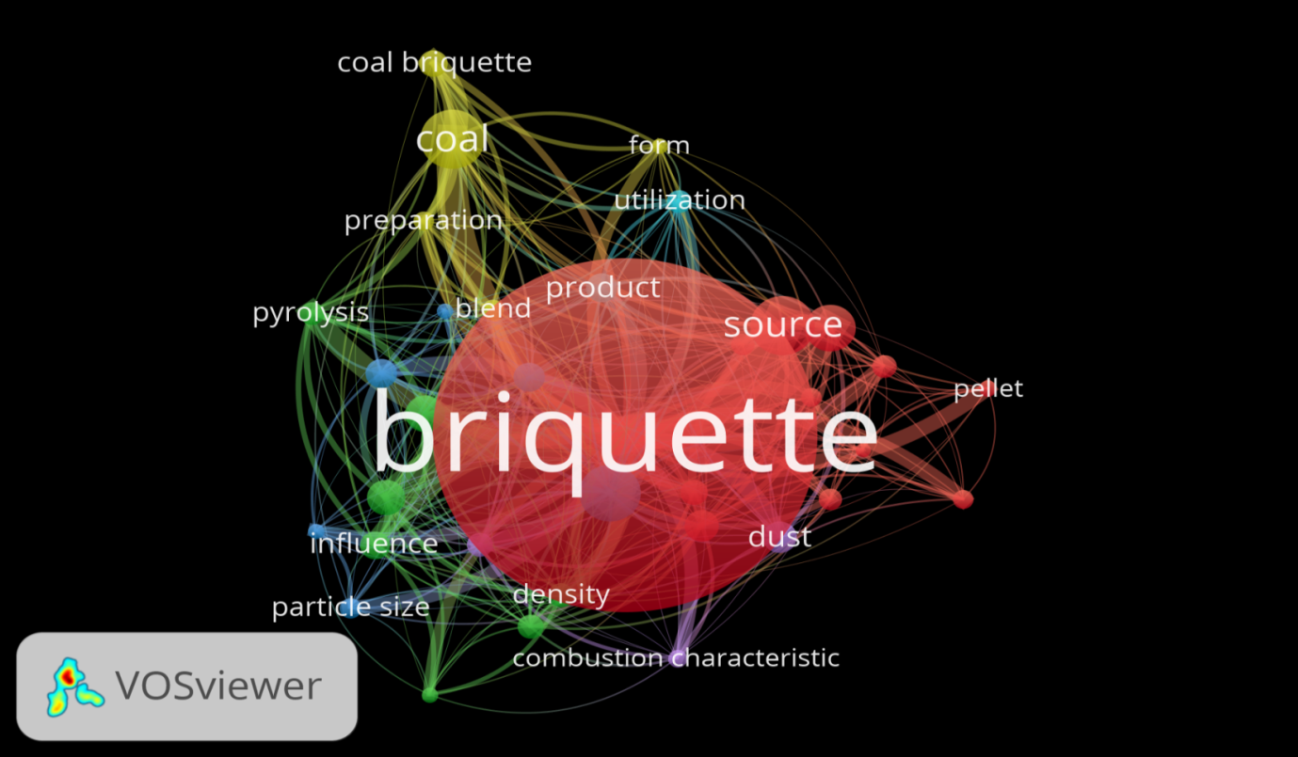Figure 9- Shows the Scholastic study on Briquettes*

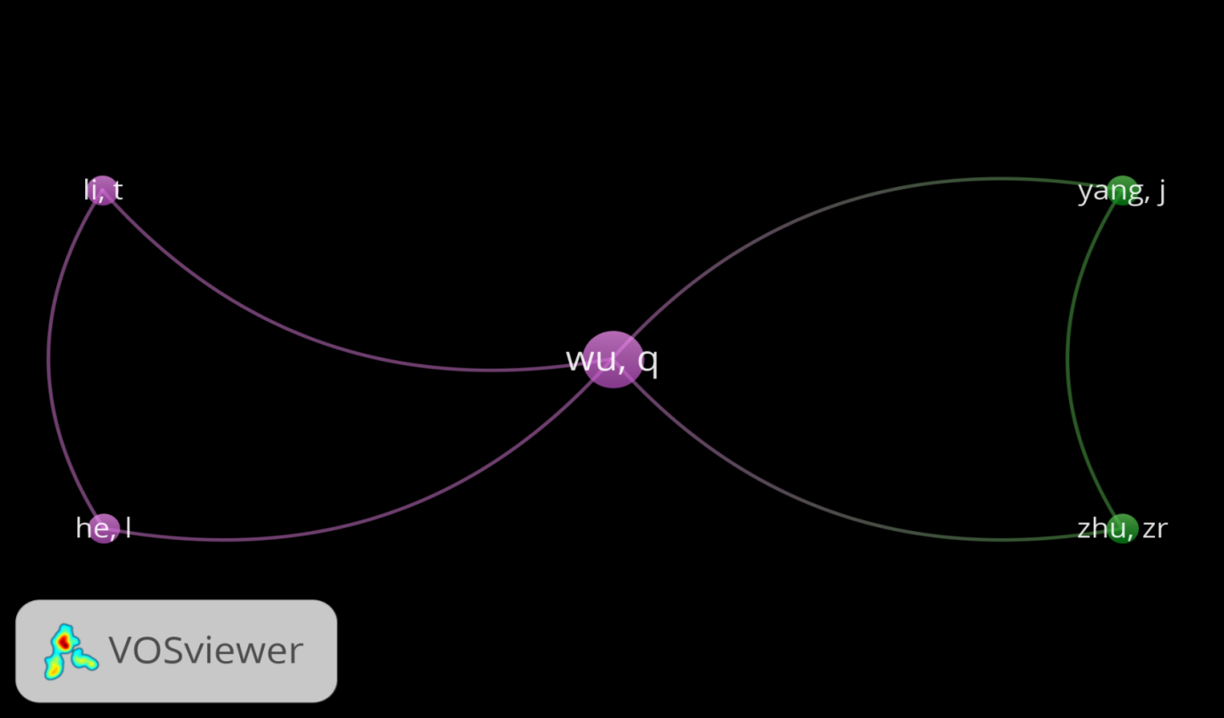Figure 10- Shows the Scholastic study on pyrolytic oil from waste plastic materials*
*All the above Bibliometric analysis of scholastic studies through VOSviewer software at the world level show that natural coagulants, TiO₂, GO, Ion exchange resins(IER) and their Nano composite materials have wide applications for the treatment wastewater.
Hypothesis: The Buddha Nullah is heavily polluted, affecting not only the surface water of the city of Ludhiana but also crops when it merges with the Sutlej River in southern Punjab and Rajasthan. It affects not only plants and animals but also the health and hygiene of millions of people. The beauty of the city is also sober. It is important to control Buddha Nullah contamination without further delay before it can cause an epidemic. Pollution agencies of state and central government cannot control this pollution. It requires a collective effort to control it.
Research Design:

Phenomenon: To make waste to value plan on Buddah Nullah by using a scientific approach.
Theory: Treat the Buddah Nullah by using scientific techniques, Research methods, doing work as per National and International standards like BIS, ASTM, APHA, EPA, etc., and generate a new theory by experimentation.
Model: Once, experimentation work can be done and data can be collected by using a scientific approach and then statistical tools and techniques can be applied so that theory can be proved and valid and fit into the model.
Scheme Design:

Figure 11- Shows the Waste to Value Model of Buddah Nullah, Ludhiana, Punjab

Research Methodology:

Figure 12- Research methods adopted for Buddah Nullah Waste Treatment

Figure 13- Schematic Model Process Design to treat wastewater Of Buddah Nullah
Natural Coagulants treatment: In wastewater treatment, the coagulation-flocculation process can be used as a preliminary or intermediary step between other treatment processes like filtration and sedimentation. This process is a straightforward method to clarify wastewater. Coagulation is a chemical process that involves the neutralization of charge. On the other hand, Flocculation is a physical process that does not involve the neutralization of charge. Natural coagulants have the efficiency to clarify turbid water. Natural Coagulants that are to be taken: Arachis hypogea seeds that used for ∼50% Pb removal,∼40% Cr removal,∼25% Zn removal. Moringa Olifera leaves/ seeds and Strychnos potatorum (Nirmali seeds) act as bio-coagulants which are used for reducing turbidity, organic matter, COD. Absorptive Coagulation techniques can be used to lower the pH, Turbidity, Organic matter, COD, Pb, Cr, Zn, As, etc. from the wastewater. Natural coagulants are cost-effective, abundantly available, the lesser dosage required, do not lead to the formation of dissolved particles, settled heavy metals, the lesser amount of sludge produced which is bio-degradable and also do not alter pH while being added.

Figure 14- Process of making Natural Coagulants
Synthesis of Graphene Oxide by Modified hummer Method:
Firstly, material was obtained from Graphite powder using an improved Hummer technique (li. et. al. 2017), add 2.5gm NaNO₃ to 5gm of graphite powder and mixed it. Now, transfer this into 140ml of 1.0M H₂SO₄ solution by slowly with continuous stirring in ice-cold bath condition. The agitation of the above obtained solution is done keeping the temperature below 278k. After this add 15gm KMnO₄ into it, by keeping the temperature less than 278K for 6h. Now, increasing the temperature to 393K, and further agitatating the solution for a duration of another 30 minutes. Subsequently, 50ml of H₂O₂ is transfer into the suspension. After centrifuging, the suspension is rinsed with 5% HCl solution and deionized water until the solution becomes neutralized (pH=7.0). The final product is collected and dried in an oven at 3378K overnight.
Figure 15 - Show the synthesis of Graphene Oxide by Modified Hummer Method
Conversion of dispersed graphene oxide (dGO) into Reduced graphene oxide (rGO):
To convert dGO into rGO, treat dGO in 1% hydrazine hydrate solution. So that grapheme oxide becomes highly conductive in nature.
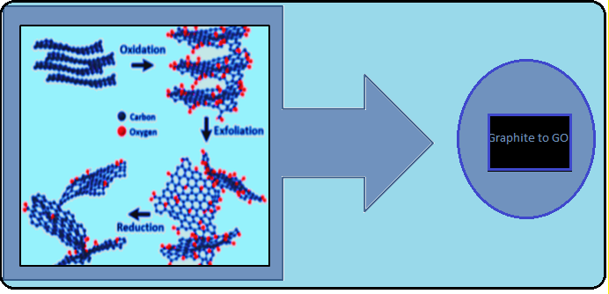Figure 16 – Show the conversion of Graphite to Reduced Graphene Oxide
Figure 17- Schematic Chemical structure of Graphite, Graphite Oxide, Dispersed Graphene Oxide, and Reduced Graphene Oxide.
Synthesis of TiO₂ by Sol-Gel Method: Following are the steps that are involved in the synthesis of TiO₂ nanoparticles by sol-gel method:

Figure 18- Systematic steps for synthesis of TiO₂ by sol gel method
Hydrolysis: This step can be started with a mixture of metal oxide and water in a solvent (usual alcohol) at the ambient temperature. Acid or base catalysts are added to speed up the reaction.
Polymerization: This step involves condensation of adjacent molecules wherein water and ROH can be eliminated and metal alkoxide linkages are formed. Polymeric networks grow to colloidal dimensions in the liquid (sol) state.
Gelation: This step involves the polymeric networks to link up and form a three-dimensional network throughout the liquid. They become somewhat rigid, characteristics of a gel. The solvent along with water and smaller polymeric units are added to the main network until the aging the gel continues.
Drying: In this step, water and alcohol are removed at a moderate temperature (i.e. <470K) and leaving a hydroxylated metal oxide with residual organic content. The main objective is to prepare a high surface area of aerogel powder with low bulk density, the solvent is removed supercritically.
Dehydration and Densification: The dehydration step is carried out between 670 and 1070K to drive off the organic residues and chemically bound water, yielding a glassy metal oxide with up to 20%-30% microporosity. On the other hand, in densification, the temperature over 1270K was used to form a dense oxide product.

Figure 19- Shows Dehydradation and densification process
Figure 20- Step by Step schematic process of synthesis of TiO₂ nanoparticles by Sol-Gel method
Synthesis of TiO₂-rGO composite: Each GO and TiO₂ composite can be made by mixing 2gm of the TiO₂ with a predetermined amount of the GO at a concentration of 7.24ppm solution. To this GO solution, add 200ml deionized water and now placed it in an ultrasonic dispenser for 1hr before adding 2gm of TiO₂ in each composite. After this, stir for 30min under ultrasonic dispersion and can be dry at 293K for 4hour. Finally, it can be centrifuged at 6000rpm for 20min. The suspension can be discarded and the solid can be dried in an oven at 323K overnight.
Mechanism of TiO₂-rGO composite for the removal of organic dye from wastewater of Buddah Nullah: Under UV-VIS irradiation-assisted TiO₂, .OH is produced instantly. The .OH which is produced has the ability to undergo oxidation thus aiding in breakdown of the pollutants into smaller by-products. This helps in decreasing the impact of water pollutants by producing harmless CO₂ and H₂O as end-products (Zhu. et. Al. 2020a). Because of the stability and low cost, TiO₂ is a preferable photocatalyst in water treatment (Kwniawan. et. al, 2018, Pipi.et.al, 2018). The mechanism of the TiO₂-based that its electron-hole pairs, excited by the UV, have a great than the band gap of the TiO₂ (Sillianpaa.et.al,2011), where the UV light promotes charge carriers for the oxidative reaction between target pollutants and the TiO₂. If the photocatalyst is irradiated under the UV-VIS at wavelengths lower than 385nm (Serpoue. et. al, 2020), electrons are excited from the valence band of the TiO₂ to its conduction band, leaving h_{vb}⁺(reaction 1). The hole reacts with OH⁻ or H₂O adsorbed on the surface of the TiO₂ to form .OH (Lin.et.al,2017). In rections 2-4, the hvb:
- Oxidizes target pollutants through an electrophilic attack.
- Oxidizes existing species after forming a hydroxylated TiO₂ surface species. The TiO₂ has a band gap energy (E°) of 31eV, enough to breakdown pollutants upon UV irradiation (Sharma.et.al2018, Zhu.et.al., 2020a,2020b).
$$TiO2 +hγ →TiO2 \left(e-,hγb+\right) \left(1\right)$$
$$hγb+OH- → ∙OH \left(2\right)$$
$$hγb- + H2Oabs → ∙OH +H \left(3\right)$$
$$e-cb + O2 → ∙O2 \left(4\right)$$
A preliminary study reported by Marsmanu. et. al., (2019) found that TiO₂ alone has limitations like a lack of visible –light utilization, a low quantum yield, fast recombination of photo-excited electron-hole pairs, and a wide band gap energy (3.1eV). This drawback limits the application of UV/TiO₂ in wastewater treatment applications. So, here TiO₂ needs to be functionalized with rGO as a loading material. The rGO not only has a stable thermal conductivity, mechanical strength, and a huge surface area but also possesses an efficient electro transfer, high conductivity, and adsorptive property (Bal.et.al., 2017). It is expected that the composite would have distinct advantages towards target pollutant concerning selectivity or capacity (Zhu.et.al.,2020)

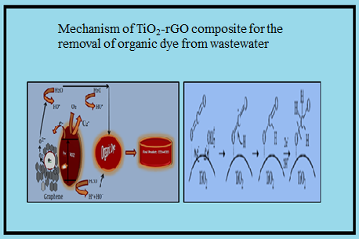
Figure 21- Show Mechanism of TiO₂-rGO composite for the removal of organic dye from wastewater
Chemical analysis of organic Dye removal: Changes in organic dye concentration after treatment would be determined by using a UV-VIS Spectrophotometer at 664nm of wavelength. The organic dye removal efficiency (ɳ %) after treatment would be determined based on the study conducted by Zhu.et.al (2019)
Characterization of rGO-TiO₂: It would be done by TEM, X-RD, FTIR analysis.
Synthesis of Ion Exchange Resin for the removal of heavy metals from the wastewater of Buddah Nullah:
Synthetic inorganic ion exchange resins can be prepared by modified pearl experimental techniques.

Synthesis of Zirconyl Phosphate inorganic Synthetic resins:

Figure 22- Illustrates the systematic steps taken for synthesis of Zirconyl Phosphate inorganic Synthetic resins
Preparation of 0.1M Potassium pyroantimonate: Dissolve 26.7gm of potassium pyroantimonate in 800ml hot water. After this add 26-30ml HF acid and 16ml of HCl into it with constant stirring. Heat this solution with continuous stirring for a few minutes so that solution becomes clear. After doing this, filter the solution if a little bit turbid and makeup volume upto 1000ml.
Preparation of 0.1M Zirconium oxychloride solution:
Dissolve 33.58 gm of ZrOCl₂.8H₂Oin 1000ml deionized water.
Preparation of 0.1M phosphoric acid solution:
Dissolve approximately 6.8ml of H₃PO₄ in 1000ml of deionized water.
Procedure for preparation of Zr₃(PO₄)₂ ion –exchange resin: Following are the schematic design for the synthesis of Zr₃(PO₄)₃ resin:

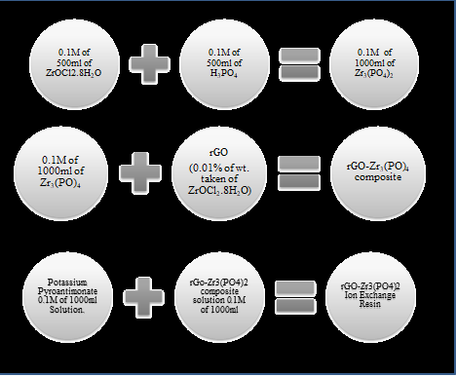
Figure 23-Show the process of synthesis of Zr₃(PO₄)₂ ion –exchange resin

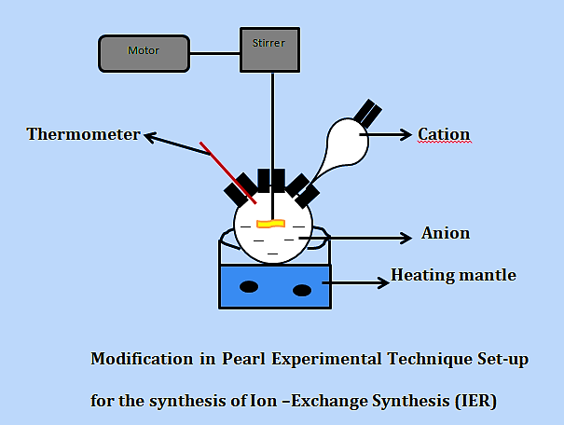
Figure 24- Modification of Pearl experiment technique set-up for the synthesis of Ion-exchange synthesis
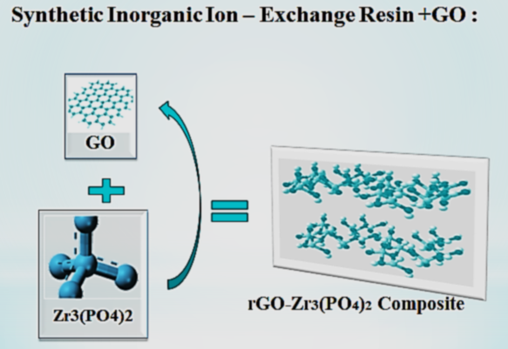Figure 25- Structural representation of rGO- Zr₃(PO₄)₂ Ion –Exchange Resin
Preparation of 0.1M Potassium pyroantimonate: Dissolve 26.7gm of 0.1M Potassium pyroantimonate in 800ml hot water by slowly added. After this add 26-30ml HF acid into it with constant stirring. Then add 16ml HCl into it with continuous stirring. Continuous heat this solution with continuous stirring for a few minutes so that solution becomes clear. After doing this, filter the solution if a little bit turbid and makeup volume 1000ml.
Preparation of 0.1M SnCl₂.2H₂O solution:
Dissolve 35.9640gm of SnCl₂.2H₂O in 1000ml of 0.1MHCl solution.
Preparation of 0.1M Sodium arsenate solution:
Dissolve 31.2535gm of Na₃AsO₄ in 1000ml of deionized water.
Procedure for preparation of Sn₃ (AsO₄)₄ ion –exchange resin: Following are the schematic design for the synthesis of Sn₃ (ASO₄)₄ resin:

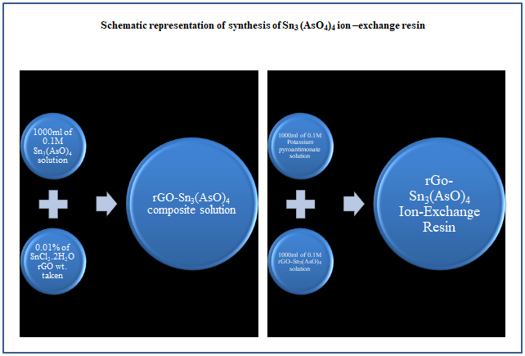
Figure 26-Show the process of synthesis of Sn₃(AsO₄)₄ ion –exchange resin
Synthesis of Titanium Phosphate Synthetic Inorganic Resin:
Preparation of 0.1M Potassium pyroantimonate: Dissolve 26.7gm in 800ml hot water by slowly added. After this add 26-30ml HF acid into it with constant stirring. Then add 16ml HCl into it with continuous stirring. Continuous heat this solution with continuous stirring for a few minutes so that solution becomes clear. After doing this, filter the solution if a little bit turbid and makeup volume 1000ml.
Preparation of 0.1M TiOCl₂ solution:
Dissolve 13.477gm of TiOCl₂ in 1000ml deionized water.
Preparation of 0.1M phosphoric acid solution:
Dissolve approximately 6.8ml of H₃PO₄ in 1000ml of deionized water.
Procedure for preparation of Ti₃ (PO₄)₂ ion –exchange resin: Following are the schematic design for the synthesis of Ti₃ (PO₄)₂ resin:

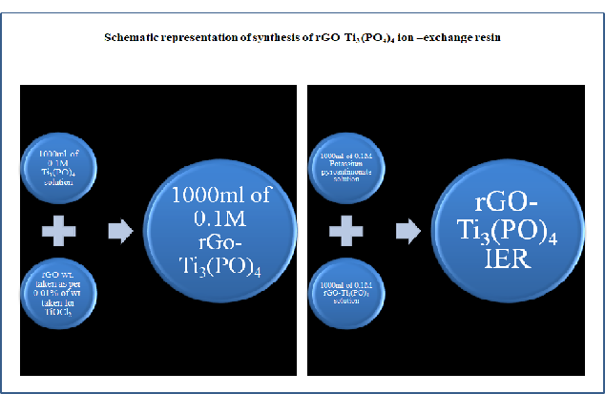
Figure 27- preparation of Ti₃ (PO₄)₂ ion –exchange resin
Solubility Test of IER: Solubility test will be performed in water HCl, HNO₃, H₂SO₄. After that concentration of dissolved Phosphorus (in mg/l) will be examined through UV-VIS Spectrophotometer followed by APHA method of Water and Waste Water Examination.
Thermal Stability Test: The test was performed by heating the IER in Muffle's Furnace at temperature 30°C, 50°C, 100°C, 200°C, 400°C, 600°C for 1hour. So that we will able to get %age retention of IER Classical and %age retention with rGO.
Kinetic Study of IER: Kinetic study of IER was done by adding 0.2gm of IER in each 20ml of 0.1M solution of Cu²⁺, Ni²⁺, Mn²⁺, Co²⁺ either of NO₃⁻ or Cl2 salt form for 0, 10, 20, 30, 40, 50, 60 minutes. After this filter it and dilute it as per requirement (10t, 100t, 1000t, and 2500t) and run each sample in AAS/MP-AES/ICP-OES for the measurement of concentration/absorbance difference.
Ion- Exchange Capacity: First of all prepare a column. To this column, add 0.2gm IER. Then pass 0.5 M NaNO3 solutions into it by setting drop fall rate i.e. one drop per second. After that titrate it with 0.1M HCL by using methyl orange and phenolphthalein indicator. After noting the burette reading, calculate the %age IEC.
Potentiometric Study of IER: Potentiometric study will be done by adding 0.2gm of IER in 20ml deionized and placed it for 24hour alone without any disturbance. After 24hour, perform a potentiometric titration experiment by adding 0.1M NaOH in the proportion of 1ml. Noted the mV Change. After this plot a potentiometric curve.
Procedure to treat wastewater of Buddah Nullah and turn it into Commercial purpose:
- Collection of Waste Water through the sampling point by using suitable sampling techniques.
- Perform Physio-chemical analysis of collected wastewater so that to make a record /data before treatment and also check the present status of Buddah Nullah (Methods to be adopted APHA methods, EPA methods, IS 3025 of different parts)
- Coagulation - flocculation Process by using 60ppm of natural coagulant and 20% Alum, so that we can separate the Sludge and use it for other purposes.
- Filter the wastewater after coagulation through vacuum filtration technique.
- Now, apply Nano-filter TiO₂-Graphene Oxide, IER-GO approach to treat wastewater and turn it into commercial purpose (like drinking water/Construction water/Agriculture water).
- Now, perform the Physio-Chemical analysis of treated water again and keep a data/ record.
- Results obtain can compare with before and after treatment and also with drinking water specification/construction water specification/ Agriculture water specification as per Bureau Indian Standards.
- Conclusion of research.
*Physio-Chemical analysis include pH, color, odour, taste, Turbidity, conductivity,TSS,TDS,F⁻,Cl⁻,NO₂⁻,NO₃⁻,CN⁻,Na⁺,K⁺,P,Al,Fe, Cr³⁺,Cr⁶⁺,T.Cr,Pb, Hg, As, Se, Bio-Assay etc. in mg/l.
2. Schematic Design to treat Sludge obtained from wastewater and converts it into Briquettes which is used in Thermal Power Plant and is the alternative of Natural Solid fuels
- Obtained sludge from wastewater can be oven-dried at 100°±5°C.
- Collect the other raw material like plastic waste (polythenes etc.), biodegradables waste like flowers, coconut shells, rice husk, Paddy waste, mustard seed waste, sugar cane pulp, etc.
- Collected raw material can be dried at 100°±5°C (if they are wet) and convert into small pieces and fine powder by grinding machines.
- Now to make a refractory material of collected raw materials add a cow dung waste into it and make a fine paste and make a briquette (which is used in Thermal Power Plants as an alternative to Natural Solid Fuels).
- Dry the prepared briquette first at laboratory temperature for 72hrs. and then dry at 100°±5°C.
- Now, perform the proximate and ultimate analysis along with GCV and NCV. Also compare keep the data/record of analysis and compare it with their specification.
- Conclusion of the research.
About Biomass Briquette:
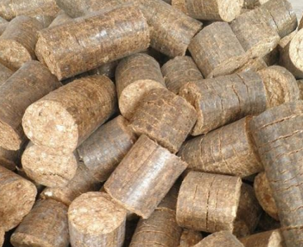
Figure 28- Show Biomass Briquettes
Bio-mass briquette used in Boilers, Furnace, Hot air Generators, Water, or oil heaters. Bio-Coal is a lump of renewable coal which is made from the natural pure husk, so is also called Husk briquette. They form an environment-friendly replacement for coal or wood.
Specification:
Impurity: Nil
Bio-Coal Diameter: 90mm
Bio-Coal Length: 100mm-2000mm
Chemical details: VM%60.30,FC%20.00,
Ultimate analysis: C%6.10,H%4.80N%0.29S%<0.02,O%5.90,Cl%0.16
Low Moisture<5%
Ash Content:7.5%
GCV: 3500-4500Kcal/Kg
Shape: Cylindrical
Features: high density, Eco-friendly, Excellent thermal capability.
3. Design to treat waste plastic material obtained from Buddah Nullah or any other source and converts it into Bio-fuels:
Figure- 18: Schematic Model Process Design to treat waste plastic materials Of Buddah Nullah
Now, performing a Physio-Chemical analysis of plastic fuels obtained and record the data.
After doing this process, now we have to take the 2nd step i.e. take waste juggary. To this add deionized water and yeast. Cover it properly and keep it for 24hours so that fermentation takes place. After this, we have to extract ethanol from it by the distillation process. Add this ethanol in the following proportion to the plastic fuels obtained so that to increase the %age yield of plastic fuels and make the bio-diesel.
Table -1 Difference between the percentages of plastic fuel and Ethanol taken (in ml)
%age of plastic fuel taken(in ml) | %age of Ethanol taken(in ml)
20 | 80
40 | 60
60 | 40
80 | 20

Now, after this performing the physio-chemical analysis again and keep the record of the data obtained. After doing all these things, the next step is to compare the results obtained with standard bio-fuels specification and then conclude it.
Table -2 Physio-Chemical assessment of Pyrolytic Oil & Pyrolytic Oil+Ethanol:
Parameters | Theoretical Values
GCV | 10,200 Kcal /Kg
Kinematic viscosity | 2.4-15.7 CST @ 40°C
Flashpoint | 50°C
Pour Point | 12-18°C
Cloud Point | 35-42°C
Sulfur Content | 1-1.8% max.
Ash Content | 0.02%
Moisture content | 1.0 max.
Acid Value | 0.01 or Nil mg KOH/gm
Specific gravity | 0.82-0.845
*Methods adopt during analysis is IS:1350:P(i,ii,iii,iv), ASTM methods.etc.
Conclusion:
It is concluded that massive efforts are required to control the pollution problem of Buddah Nullah before it becomes an epidemic. The waste to value model gives a new vision to control the pollution related problem and also helps our state government to earn from the waste by using a scientific approach. This will strengthen the economy as well as financial problems also. Chemical synthesis of materials like TiO₂-rGO composite and rGO-Zr₃(PO₄)₂ has been prepared frequently by novel methods and has wide application in the treatment of wastewater. This will also help to underscore the major role of Chemistry in the synthesis of materials, making Bio-mass briquettes, producing Biofuel from the waste plastic materials.

References:
(1) Abdolhosseinzadeh, S.; Asgharzadeh, H.; Kim, H. Fast and Fully-Scalable Synthesis of Reduced Graphene Oxide. Sci. Rep. 2015, No. 324 cites: https://scholar.google.com/scholar?cites=6799190321551104445 & as_sdt=2005 & sciodt=0,5 & hl=en.
(2) Abraham, J.; Vasu, K. S.; Williams, C. D.; Gopinadhan, K.; Su, Y.; Cherian, C. T.; Dix, J.; Prestat, E.; Haigh, S. J.; Grigorieva, I. V. Tunable Sieving of Ions Using Graphene Oxide Membranes. Nat. Nanotechnol. 2017, 12 (6), 546.
(3) Ahmad, H.; Fan, M.; Hui, D. Graphene Oxide Incorporated Functional Materials: A Review. Compos. Part B Eng. 2018, No. 83 cites: https://scholar.google.com/scholar?cites=8233997086270200273 & as_sdt=2005 & sciodt=0,5 & hl=en.
(4) Aunkor, M.; Mahbubul, I.; Saidur, R.; Metselaar, H. The Green Reduction of Graphene Oxide. Rsc Adv. 2016, No. 120 cites: https://scholar.google.com/scholar?cites=5662527879524737850 & as_sdt=2005 & sciodt=0,5 & hl=en.
(1) Voiry, D.; Yang, J.; Kupferberg, J.; Fullon, R.; Lee, C.; Jeong, H. Y.; Shin, H. S.; Chhowalla, M. High-Quality Graphene via Microwave Reduction of Solution-Exfoliated Graphene Oxide. Science 2016, 353 (6306), 1413–1416.
(2) Dimiev, A. M.; Eigler, S. Graphene Oxide: Fundamentals and Applications; John Wiley & Sons, 2016.
(3) Morelos-Gomez, A.; Cruz-Silva, R.; Muramatsu, H.; Ortiz-Medina, J.; Araki, T.; Fukuyo, T.; Tejima, S.; Takeuchi, K.; Hayashi, T.; Terrones, M. Effective NaCl and Dye Rejection of Hybrid Graphene Oxide/Graphene Layered Membranes. Nat. Nanotechnol. 2017, 12 (11), 1083.
(4) De Silva, K. K. H.; Huang, H.-H.; Joshi, R. K.; Yoshimura, M. Chemical Reduction of Graphene Oxide Using Green Reductants. Carbon 2017, 119, 190–199.
(5) Chen, L.; Shi, G.; Shen, J.; Peng, B.; Zhang, B.; Wang, Y.; Bian, F.; Wang, J.; Li, D.; Qian, Z. Ion Sieving in Graphene Oxide Membranes via Cationic Control of Interlayer Spacing. Nature 2017, 550 (7676), 380–383.
(6) Abraham, J.; Vasu, K. S.; Williams, C. D.; Gopinadhan, K.; Su, Y.; Cherian, C. T.; Dix, J.; Prestat, E.; Haigh, S. J.; Grigorieva, I. V. Tunable Sieving of Ions Using Graphene Oxide Membranes. Nat. Nanotechnol. 2017, 12 (6), 546.
(7) Clancy, A. J.; Bayazit, M. K.; Hodge, S. A.; Skipper, N. T.; Howard, C. A.; Shaffer, M. S. P. Charged Carbon Nanomaterials: Redox Chemistries of Fullerenes, Carbon Nanotubes, and Graphenes. Chem. Rev. 2018, 118 (16), 7363–7408. https://doi.org/10.1021/acs.chemrev.8b00128.
(8) Han, B.; Zhang, Y.-L.; Zhu, L.; Li, Y.; Ma, Z.-C.; Liu, Y.-Q.; Zhang, X.-L.; Cao, X.-W.; Chen, Q.-D.; Qiu, C.-W. Plasmonic-Assisted Graphene Oxide Artificial Muscles. Adv. Mater. 2019, 31 (5), 1806386.
(9) Tian, J.; Wu, S.; Yin, X.; Wu, W. Novel Preparation of Hydrophilic Graphene/Graphene Oxide Nanosheets for Supercapacitor Electrode. Appl. Surf. Sci. 2019, 496, 143696.
(10) Zhang, J.; Zhang, Z.; Jiao, Y.; Yang, H.; Li, Y.; Zhang, J.; Gao, P. The Graphene/Lanthanum Oxide Nanocomposites as Electrode Materials of Supercapacitors. J. Power Sources 2019, 419, 99–105.
(11) Uzoejinwa, B. B.; He, X.; Wang, S.; Abomohra, A. E.-F.; Hu, Y.; Wang, Q. Co-Pyrolysis of Biomass and Waste Plastics as a Thermochemical Conversion Technology for High-Grade Biofuel Production: Recent Progress and Future Directions Elsewhere Worldwide. Energy Convers. Manag. 2018, 163, 468–492.
(12) Kaur, M.; Babbar, B. K.; Kaur, H. Study of Snail and Slug Population Dynamics concerning Edaphic Factors in Plant Nurseries near Buddha Nullah, Ludhiana (Punjab), India. Arch. Agric. Environ. Sci. 2017, 2 (1), 25–28.
(13) Kaur, J.; Kaur, V.; Pakade, Y. B.; Katnoria, J. K. A Study on Water Quality Monitoring of Buddha Nullah, Ludhiana, Punjab (India). Environ. Geochem. Health 2020, 1–24.
(14) Amritjot, K.; Aulakh, R. K.; Hundal, S. S. Assessment of Water Quality Parameters of Buddha Nullah in Ludhiana District of Punjab. Agric. Res. J. 2017, 54 (4), 534–538.
(15) Jaidka, A.; Hundal, S. S. Histological Changes in Gills and Liver of Fishes in River Sutlej as an Effect of Buddha Nullah Pollution at Ludhiana. Int. J Life Sci. 2016, 5 (1), 87–92.
(16) Dua, K.; Joshi, N. Isolation, Screening and Characterization of Potential Chlorpyrifos Utilizing Bacteria from Buddha Nullah as Well as Agricultural Soils of Rural Ludhiana, Kapurthala, Punjab. Progress. Agric. 2020, 20 (1and2), 6–14.
(17) Chetan, S.; Satpute, S. T.; Sunil, G. Determination of Heavy Metal Pollution Index of Ground Water of Village Wallipur in Ludhiana District. J. Appl. Nat. Sci. 2017, 9 (2), 1139–1145.
(18) Kaur, A.; Hundal, S. S.; Aulakh, R. K. Seasonal Study of Zooplankton Diversity in the Polluted Water Stretch of Buddha Nullah, Ludhiana. 2018.
(19) Kaur, H.; Kainth, G. S. Physiochemical Assessment of Ludhiana Textile Industry Effluent near Buddha Nullah.
(20) Jaidka, A. Impact of Buddha Nullah Pollution on Reproductive Health of Fish in River Sutlej. Ph.D. Thesis, Punjab Agricultural University, Ludhiana, 2017.
(21) Padhi, S.; Rangarajan, R.; Rajeshwar, K.; Sonkamble, S.; Venkatesam, V. Assessment of Hydro-Geochemical Evolution Mechanism and Suitability of Groundwater for Domestic and Irrigation Use in and around Ludhiana City, Punjab, India. J. Indian Geophys. Union 2017, 21, 4.
(22) Smith, A. T.; LaChance, A. M.; Zeng, S.; Liu, B.; Sun, L. Synthesis, Properties, and Applications of Graphene Oxide/Reduced Graphene Oxide and Their Nanocomposites. Nano Mater. Sci. 2019, 1 (1), 31–47.
(23) Sharma, S.; Yadav, A.; Ahmad, W. The Classification, Characterization, and Application of Ion Exchange Resins: A General Survey. In International Conference on New Horizons in Green Chemistry & Technology (ICGCT); 2018.
(24) Hamed, M. M.; Holiel, M.; El-Aryan, Y. F. Removal of Selenium and Iodine Radionuclides from Waste Solutions Using Synthetic Inorganic Ion Exchanger. J. Mol. Liq. 2017, 242, 722–731.
(25) Ahmad, W.; Sharma, S. Synthesis, Characterisation and Ion-Exchange Properties of Hybrid Organic-Inorganic Composite Material: Polyacrylamide Zirconium (IV) Iodosulphosalicylate. Int. J. Environ. Anal. Chem. 2019, 99 (15), 1604–1614.
(26) Cechinel, M. A. P.; Mayer, D. A.; Mazur, L. P.; Silva, L. G.; Girardi, A.; Vilar, V. J.; de Souza, A. A. U.; de Souza, S. M. G. U. Application of Eco-friendly Cation Exchangers (Gracilaria Caudata and Gracilaria Cervicornis) for Metal Ions Separation and Recovery from a Synthetic Petrochemical Wastewater: Batch and Fixed Bed Studies. J. Clean. Prod. 2018, 172, 1928–1945.
(27) Gebrewold, F. Advances in Inorganic Ion Exchangers And Their Applications A Review Article.
(28) Rathna, R.; Varjani, S.; Nakkeeran, E. Sequestration of Heavy Metals from Industrial Wastewater Using Composite Ion Exchangers. In Applications of Ion Exchange Materials in the Environment; Springer, 2019; pp 187–204.
(29) Al-Sheikh, F.; Moralejo, C.; Pritzker, M.; Anderson, W. A.; Elkamel, A. Batch Adsorption Study of Ammonia Removal from Synthetic/Real Wastewater Using Ion Exchange Resins and Zeolites. Sep. Sci. Technol. 2020, 1–12.
(30) Seenivasan, R. K.; Maheshkumar, V.; Selvapandian, P. Synthesis and Characterization of Low-Cost Ion-Exchange Resins Used for the Removal of Metal Ions. J. Appl. Res. Water Wastewater 2016, 3 (1), 209–216.
(31) Peng, H.; Guo, J. Removal of Chromium from Wastewater by Membrane Filtration, Chemical Precipitation, Ion Exchange, Adsorption Electrocoagulation, Electrochemical Reduction, Electrodialysis, Electrodeionization, Photocatalysis, and Nanotechnology: A Review. Environ. Chem. Lett. 2020, 1–14.
(32) Kaur, K.; Jindal, R.; Tanwar, R. Chitosan–Gelatin@ Tin (IV) Tungstatophosphate Nanocomposite Ion Exchanger: Synthesis, Characterization, and Applications in Environmental Remediation. J. Polym. Environ. 2019, 27 (1), 19–36.
(33) Ru, J.; Huo, Y.; Yang, Y. Microbial Degradation and Valorization of Plastic Wastes. Front. Microbiol. 2020, 11.
(34) Nanda, S.; Berruti, F. Thermochemical Conversion of Plastic Waste to Fuels: A Review. Environ. Chem. Lett. 2020, 1–26.
(35) Ilyas, M.; Ahmad, W.; Khan, H.; Yousaf, S.; Khan, K.; Nazir, S. Plastic Waste as a Significant Threat to Environment–a Systematic Literature Review. Rev. Environ. Health 2018, 33 (4), 383–406.
(36) Narancic, T.; O'Connor, K. E. Microbial Biotechnology Addressing the Plastic Waste Disaster. Microb. Biotechnol. 2017, 10 (5), 1232–1235.
(37) Wei, R.; Tiso, T.; Bertling, J.; O'Connor, K.; Blank, L. M.; Bornscheuer, U. T. Possibilities, and Limitations of Biotechnological Plastic Degradation and Recycling. Nat. Catal. 2020, 1–5.
(38) Mihreteab, M.; Stubblefield, B. A.; Gilbert, E. S. Microbial Bioconversion of Thermally Depolymerized Polypropylene by Yarrowia Lipolytica for Fatty Acid Production. Appl. Microbiol. Biotechnol. 2019, 103 (18), 7729–7740.
(39) Lee, A.; Liew, M. S. Tertiary Recycling of Plastics Waste: An Analysis of Feedstock, Chemical, and Biological Degradation Methods. J. Mater. Cycles Waste Manag. 2020, 1–12.
(40) Ghosh, S.; Das, S.; Chowdhury, R. Effect of Pre-Pyrolysis Biotreatment of Banana Pseudo-Stem (BPS) Using Synergistic Microbial Consortium: Role in Deoxygenation and Enhancement of Yield of Pyro-Oil. Energy Convers. Manag. 2019, 195, 114–124.
(41) Oh, J.-I.; Lee, J.; Lee, T.; Ok, Y. S.; Lee, S.-R.; Kwon, E. E. Strategic CO2 Utilization for Shifting Carbon Distribution from Pyrolytic Oil to Syngas in Pyrolysis of Food Waste. J. CO2 Util. 2017, 20, 150–155.

