ERGONOMICS: A HUMAN FACTOR APPROACH FOR THE DEVELOPMENT OF FARMERS IN AGRICLTURE
Research Scholar in Farm Machinery and Power Engineering,
Department of Farm Machinery and Power Engineering Punjab Agricultural University, Ludhiana, India.
Email-vinaykumarmangotra27@gmail.com
ABSTRACT
Agriculture is mostly documented as the country's most dangerous industry, and with high rates of musculoskeletal and whole-body disorders that include several risk factors agricultural workplaces have very little history of using ergonomic methods. Agriculture considers ergonomics a very important subject because it is an interdisciplinary science that tends to align between work and workers to safeguard the health and safety of an individual farmer. It can help to determine which methods are in place to carry out agricultural work that will not only stabilize but will improve working conditions for workers with a few small convenient steps. But more collaboration is needed among engineers, ergonomics experts, physicians, and manufacturers in terms of creating new ergonomic technologies and raising employee sanity about risk factors.
- INTRODUCTION
The agricultural industry plays a strong role in meeting basic human needs by providing food in rural areas and creating large amounts of jobs. In India, more than 70 percent of the rural sector relies on agriculture as the main source of income (Kumar V and Dogra R, 2023). It provides raw materials and various types of employment opportunities for other industries. As a result, the safety and health of its employees is of great importance, given the key role that agriculture plays in the global economy. But the occupation of the profession involves many harmful diseases and illnesses. Agriculture is considered one of the unsafe sectors in both developing as well as developed countries (Babu, 2016). It is seen as one of the most susceptible to the drudgery of the worker hard in the informal sector because of the lack of improvement in agricultural machinery (Mehta, 2012). Poor health conditions such as musculoskeletal syndromes are directly related to agricultural activity. (Singh and Arora 2017). Many farmers complained of back pain as a health problem at work in agriculture Farmers have confronted many problems in agriculture due to lack of appropriate equipment and poor information about the working environment.
Conferring to the International Labour Organization, there are about 160 million work-associated diseases annually worldwide which play an important role in terms of work health and the economy (Niu, 2010). The World Health Organization also stated that there are many factors that cause or exacerbate work-related shortcomings such as work requirements, social factors, job environment characteristics, and cultural factors. In this regard, ergonomics has played an important role in the health of workers. In addition, the major concern is related to the problem being faced by the majority of female staff (Parimalam et al. 2005). Otherwise, most of the work in agriculture occurs due to the requirements of physical muscles, uncomfortable postures, long-standing and kneeling, sewing, bending, and frequent muscle activity. Unquestionably these things will lead to exhaustion, illness, disease, and accidents. In addition, the lack of sufficient knowledge of agricultural health and safety workers leads to life-threatening situations.
Currently, mechanization in agriculture encompasses most agricultural processes as a way to reduce rigorous manual labour, improve task time and increase productivity (Kumar V and Bector V, 2022). But in many cases, the introduction of machinery does not eliminate worker’s health problems such as full body vibration, dust during harvest, and engine fume exposure. Therefore, interest in the use of practical procedures in agricultural conditions is growing in order to help reduce work-related accidents, diseases, illnesses, and various other various problems related to the human body. Thus, among workers in the agricultural industry, ergonomics can play a problem-solving role and reduce musculoskeletal damage (Nunes, 2009).
Ergonomics is the process of determining the best match of comforts of types of equipment or machine with the worker in the working environment (Fig. 1). It is an interdisciplinary science that strives to make job and worker-matching environments better to make them safe. The purpose of ergonomics is to test a person for his range, strength, speed, and endurance of movement, so as to design the working environment and equipment ergonomically as per the best well-being requirements of the workers so that workers can use them without difficulty and safely. (Dombekova, 2016). The effectiveness and efficiency of the worker can be increased through the implementation of convenient interventions in the agricultural industries. With convenient assessment and appropriate measures, not only risk factors for workers are studied, but some practical ways of preventing uncomfortable situations are also included (Richardson et al. 2005).
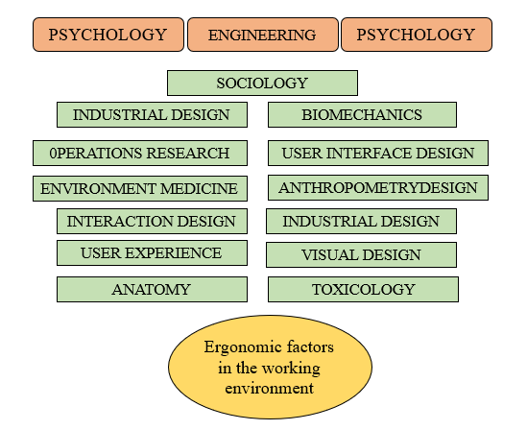
Fig. 1: Worker and Ergonomic factors in the working environment
2. BRANCHES OF ERGONOMICS BASED ON DISCIPLINES
2.1. Physical Ergonomics:
It applies to human anatomy that includes anthropometric, physiological parameters, and biomechanical properties of the worker that is related to physical movement. Among many problems associated with the working environment, the most important is the posture that workers adopt during physical working which causes problems related to physical fatigue, muscular, and skeletal load, and physical exertion. The principles of physical ergonomics are extensively used to design both user and industrial products to improve performance and prevent work-related shortcomings by reducing the mechanisms underlying severe and chronic mechanically induced musculoskeletal damages/disorders (Kumar V and Parihar NS, 2018). In a stable office environment, risk factors such as confined mechanical stress, strength, and posture result in injuries related to the working environment. The physical environment of work is more important (Fig. 2), especially for people diagnosed with diseases or physiological syndromes such as arthritis. Today many products are designed consulting the standards of physical ergonomics and indorsed to treat chronic stress-related pain and avoid such disorders.
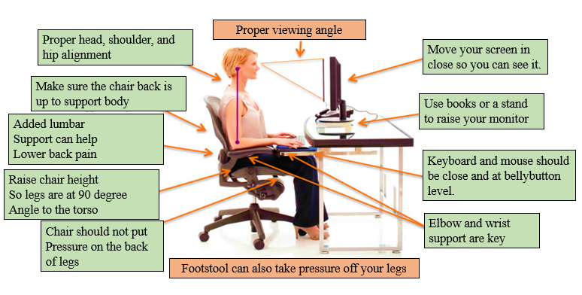
Fig. 2: Sitting posture in a working environment
2.2. Cognitive Ergonomics:
It is a part of the ergonomics discipline that includes study research, evaluation, design changes, functions, products, environments, systems, and their interaction with humans and their cognitive capabilities (Fig. 3). The International Societies of ergonomics association for the Work Environment quoted that it relates to mental processes such as cognition, memory, thinking, and motor reaction because they affect how people interact and other elements of the system. It is the quality of the work environment that studies cognitive developments in the workplace that lay stress on understanding the situation and supporting consistent, efficient, and acceptable performance. This approach solves problems such as decision-making, ease of use of human and computer systems, formation of learning skills, cognitive characteristics of the psychological load, mental trauma, and mistakes at work.
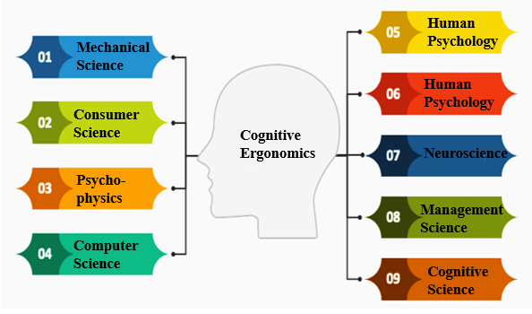
Fig. 3: Cognitive abilities flow chart
2.3. Neuro Ergonomics:
It is defined as the study of the human mind related to the performance of the workers at work and daily routine work. It combines the theories, neuroscience, standard procedures of ergonomics, and human intervention factors to offer valuable information about brain activity and behaviour as found in natural environments. For example, tilt angle during phone usage can exert different levels of pressure on the discs and joints of the cervix which immediately affects spinal cord pulling and muscle strain (Fig. 4). This can further lead to cognitive decline, poor concentration, brain tiredness, low energy levels, sleep problems, and lack of compassion. This is moderately a new development involving the use of deeper neurophysiological methods such as brain mimic methods. These progressive methodologies can be used to evaluate users’ liking for human-computer interface options for specific to a specific design or version of manufactured products (Ayaz et al. 2013).
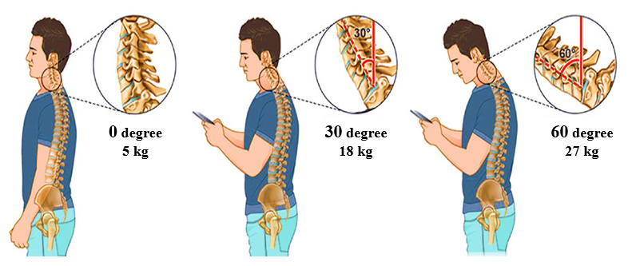

Fig. 4: Posture and Neuro-Ergonomics
2.4. Organizational Ergonomics:
It involves the improvement of social and technical work arrangements, together with organizational measures, as well as their structures and policies. Therefore, ergonomic specialists are often involved in the social design and development of communication systems, interactive procedures within working groups, company schedules and shifts during working hours, and other interrelated issues. Ergonomics by definition is an interdisciplinary ambition (Singh, 2012a). Multidisciplinary scientists and experts are interested in designing various characteristics of social and technical systems. So, they can all be termed "ergonomics" in logic, with additional specifications based on individual emphasis, from the physical and neurophysiological aspects to the mental, social, and organizational features based on the attention as per the requirement.
3. APPLICATION OF ERGONOMICS IN THREE MAJOR AREAS

3.1. Design of Human-Machine Systems:
It is a system in which one or more workers are related to one or more devices, machines, and apparatus. For example, a worker doing drilling at work, or a person with a hammer will drive a nail into a carpentry, a post office, a fire protection system, or a pharmacy can be an efficient/productive system or a facility system (FAO, 2011). The ergonomics are practically applied to acclimate these systems in order to provide system operators with maximum work satisfaction and comfort as well as minimal physical and mental load.

3.2. Design of Consumer Goods and Facility Systems:
Ergonomics applies to the design of consumer goods, starting with the design of toothbrushes and other elements such as Kitchen appliances, crockery sets, tables, sofa sets, home accessories, shoes, etc. In the same way, protective equipment such as gloves, goggles, collision helmets, severe weather and spacesuits, firefighting, etc., must be designed economically and well soundly (Singh, 2012b).

3.3 Design of Working Environment:
When designing a suitable work environment for the workers at working place, various factors related to the working environment such as the durability of body lighting, temperature, pollution, noise, and ventilation should be considered. This aspect must be taken into account at each stage, from the correct design, down to actual use or actual service (Singh, 2008). Its scope of application is unlimited and all factors involved in workplace design, public transportation, road systems, urban and rural planning, employees, communities, and the environment such as airports must be comfortably analysed on the basis of ergonomics. Users of convenient information for civilians or engineers such as electrical or mechanical, industrialist, or biomedical must make use of anthropology, psychology, and sociology study as relevant sources of information.
4. ERGONOMIC ASPECT OF AGRICULTURAL TOOLS AND IMPLEMENTS
In addition to performing the intended function of agricultural equipment, the points taken into account when designing agricultural equipment and the bending of equipment, not of the worker, to take into account the dynamism of people, to give workers a minimum muscle effort, taking into account 30 percent of the power of the 5th percentile worker (women). Taking into account the 95th percentile of the relevant anthropometric data of employees (users) for a place in an establishment with certain allowances, for push or pull types agricultural equipment, the fifth percentage required for manual transportation, taking into account the weight of employees (users) does not exceed 30 percent or taking into account safety aspects, etc. Anthropometry (dimensions), aerobic muscle strength capacity, position, load capacity, safety issues, physiological of working environment and other many factors are important on the basis of ergonomics in the design and development of agricultural instruments and manual equipment (Gite et al. 2009).
4.1 Anthropometry
In most developing and underdeveloped countries, small holder farmers use hand-operated or animal-powered tools to carry out land-making and tilling tasks, which are usually developed by village craftsmen and due to lack of their anthropological knowledge while building manual implements. Measurements of diverse body sizes are required according to the needs of the specific designs of agricultural equipment. In different body sizes, differences in weight and physique of male and female employees are compared, since these two parameters provide the most of the solutions to many problems. All women on farms in India weigh 21% less in the fifth percentile than male workers compared to male employees from anthropometry data of various states such as J&K, Mizoram MP, Tamil Nadu, Maharashtra, Punjab, Meghalaya, Odisha, Arunachal, Gujrat, and West Bengal. (Table 1).
The fifth percentile weight of West Bengal workers was the lowest amongst other states. It was also found that the fifth percentile values of the agricultural status of women are 8 percent lower compared to male employees (Gite et al. 2009). These data clearly indicate the ergonomic characteristics of agricultural employees including men and women. It is also proposed to carefully use anthropometric data according to the participation of agricultural employees in the process for which agricultural tools will be designed. Typically, percentile from 5 to 95 are taken for design to meet 90% of users. Data is taken for the 5th percentile where access is required, while the 95th percentile data is taken for space purposes.
Table 1. Anthropometric data of male and female workers in Indian
Dimension of Body | Men |  | Women |  | 5th percentile difference
Percentile | 5th | 95th | 5th | 95th
Eye height (mm) | 1409 | 1636 | 1302 | 1504 | 8.22
Maximum grip length (mm) | 94 | 151 | 81 | 138 | 16.05
Vertical reach (mm) | 1923 | 2237 | 1778 | 2063 | 8.16
Shoulder grip length (mm) | 628 | 818 | 579 | 749 | 8.46
Weight (kg) | 40.4 | 68.9 | 33.5 | 59.1 | 20.60
Stature (mm) | 1521 | 1746 | 1414 | 1615 | 7.57
Span (mm) | 1562 | 1832 | 1422 | 1680 | 9.85
Vertical grip reach (mm) | 1829 | 2141 | 1689 | 1973 | 8.29
Grip inside diameter (mm) | 39 | 57 | 35 | 55 | 11.43
Acromial height (mm) | 1256 | 1468 | 1168 | 1353 | 7.53
Sitting heigh (mm) | 744 | 916 | 702 | 847 | 5.98

4.2 Muscular strength
Most professional activities are carried out through worker intervention. In these cases, a person's ability to accomplish mechanical work is calculated based on his ability to use his/her muscle strength. For example, strong people may lift heavier weights than their weaker peers. Despite the increase in automation, the requirements for human strength for physical activity are still strong. The nature of several work tasks and job situations involves employing muscle strength. For example, when processing materials in limited spaces, transporting patients from form their beds to other place or carrying out maintenance activities. Muscle strength is also necessary to use the implements and controls or to exert the necessary forces and mesh to protect the external load pressure without causing personal damage (Fig. 5).
Lack of strength can cause an increased load on the joint system of Tendon muscular bones and thus cause injury. The relationship between lack of strength and wound is widely recognized for handling hand materials and work that requires the use of manual equipments. Thus, the knowledge of muscle’s strength or power is very important to develop such products for the prevention of musculoskeletal related problems and injuries (Pavlich, 2016).
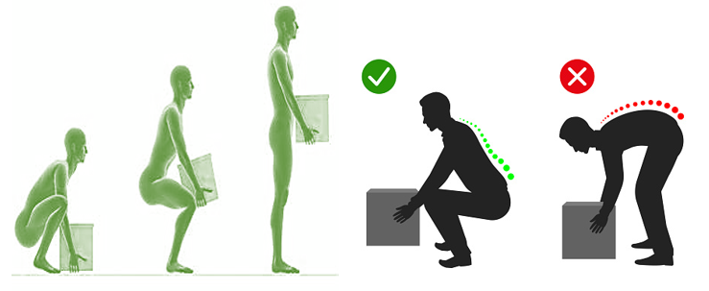
Fig. 5: Lifting posture ergonomically to avoid muscular stress
4.3 Aerobic Capacity
The maximum rate of oxygen consumption that determines a person's maximum physical working power is also called aerobic capacity. When performing any type of aerobic workout, the body uses oxygen to fuel metabolism process (converting the food into useful energy), which provides energy to the body for any type of motion. For women, this rate is largely 75 per cent of the value of men. According to the data available, this value for male and female employees of India is about 2.0 l/min and 1.5 l/min, respectively.
Some devices such as Samsung or Apple Watch may be used to estimate maximum VO2 based on heart rate, age, mass, and gender during exercise. These instruments can only offer approximate evaluations and cannot provide accurate measurements. In order to accurately assess aerobic capacity, you will need to perform an indirect calorimeter test (Fig. 6). One need to undergo an indirect thermometry test as alternative test to get an accurate assessment of your aerobic abilities. Depending on where you live, it can be difficult to find this test. Check if there are proper labs, or hospitals that can offer these tests. Indirect calorimetry tests involve wearing a mask over the face for measuring the breathing rate while doing intense exercise on a treadmill or lab bikes and normally take less than 10 minutes to accomplish this breathing test (Mani, 2014).
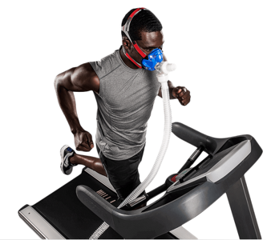
Fig. 6: A view of calorimeter test
4.4 Posture
Good working condition requires minimal static muscle strength to improve performance and reduce discomfort in the body. Any process in the curve or curve of posture involves a scourge, and is also reflected in terms of the distress experienced by employees. Therefore, it is necessary to avoid this situation as much as possible during working hours. It is also possible that a long-term sitting position is better than a standing position (Caffaro, 2018). Discomfort is physical pain of body caused by excessive muscle strain. While work is good within physiological limits in many situations, discomfort in the body may limit the length of work depending on the component of the static load involved, as is much agricultural activity.
4.5 Load carrying capabilities
Shipping and transportation are the most important events in agriculture. The manual tools and other commodities like seeds, manure, lifting and transport of the harvested products and grains, etc., the burden that the worker must bear should not exceed 40 percent of body weight of any individual. The loading mode should be such that one must avoid static loading of hands or arms (Fig. 7). But this restriction applies only to plains or mountainous terrain, and the restriction will depend less on slope or terrain
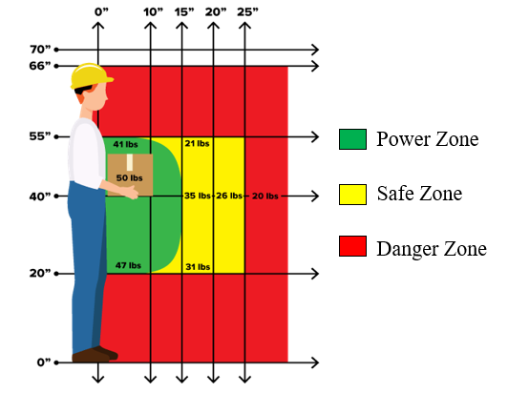
Fig. 7: Recommended load carrying limit at vertical and horizontal posture
5. WORK DONE ON ERGONOMICS IN INDIA AND ABROAD
5.1 Geographical Distribution of Research Studies Contribution to Ergonomics
The concern for ergonomics in agricultural machinery and processes seems to be of keen interest to developing as well as developed countries. Notably, no input from Africa was found, perhaps because most rural tasks there are still done manually, with fewer existing research institutions compared to developed countries. A considerable research study contribution was observed from Italy, New Zealand, Sweden, Serbia, India, Malaysia, the USA, and Canada. Greece, Poland, and Iran, whereas less contribution was observed from Brazil, Spain, the United Kingdom, Norway, Austria, Japan, Korea, and Thailand (Fig. 8). In total, the biggest source of the literature on ergonomic research surveys was Europe whose research institutes were more involved in ergonomics research. However, similar research studies on ergonomics in the design and development of agricultural machinery systems were carried out on a large scale in South Asia, Oceania, and North America (Benos et al. 2020).
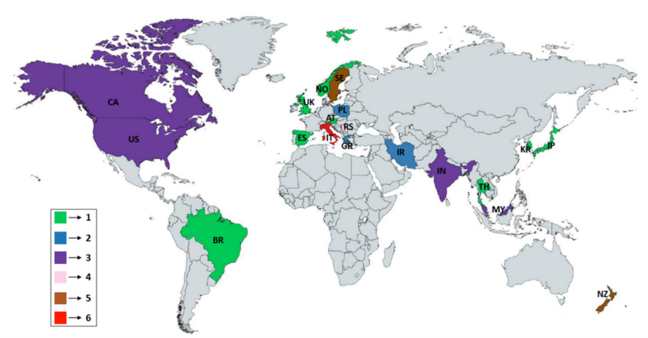
Fig. 8: Geographical contribution of organizations in Ergonomics studies
The geographical distribution covers a number of scientific disciplines, including musculoskeletal and whole-body disorders, work-related health risks and protection issues, industrial product design, ergonomics studies, and manual tool design. A number of research studies focus mainly on designing manual hand equipment and educational programs to improve the farming environment. The studies done in various countries percent-wise and on particular crops are shown in Fig. 9 and Fig. 10. Most studies are located in the United States, so there is a surging demand that studies should be conducted in developing countries and some Asian countries.

Fig. 9: Countries-wise share of studies related to ergonomics

Fig. 10: Crop-wise share of studies related to ergonomics
6. ERGONOMICS FUTURE NEEDS IN DEVELOPING COUNTRIES
The work environment and its applications strive to reconcile the work and work environment to promote individual wellbeing by improving productivity and work efficiency and improving the condition of the employee and user. In order to increase productivity in developing countries, the study of the working environment, research must be concentrated in the industrial segment. It is also observed that very less work is done in ergonomics especially in agriculture where most of the work is done manually but it has the great potential to improve and provide quality of life.
7. CONCLUSION
Ergonomists can develop and offer solutions to agricultural challenges that are attractive in terms of economic concepts, particularly for low-income communities. In addition, appropriate government agencies, large-scale agricultural companies and employers will be able to solve the favourable costs. The active participation and cooperation of the work environment is very important in this regard. In fact, some activities should be done simultaneously to develop a new practical method of ergonomics intervention and analysis of tasks through design. Convenient intervention allows workers to increase their productivity by reducing drudgery. Most importantly, the present researchers need to think to understand the issues related to the agricultural workers.

REFFERNCES
Ayaz, H., Onaral, B., Izzetoglu, K., Shewokis, PA., McKendrick, R and Parasuraman, R (2013). Continuous monitoring of brain dynamics with functional near infrared spectroscopy as a tool for neuro ergonomic research: empirical examples and a technological development. Front. Hum. Neuro
Babu, TR (2016). Productivity Improvement of Agro Based Farm Workers using Ergonomic Approach. Productivity. 57(2): 123.
Benos, L., Tsaopoulos, D and Bochtis, D (2020). A Review on Ergonomics in Agriculture. Part I: Manual Operations. Applied Science. 10: 1905.
Caffaro, F., Lundqvist, P., Cremasco, M., Nilsson, K., Pinzke, S and Cavallo, E (2018) Machinery-related perceived risks and safety attitudes in senior Swedish farmers. J. Agro medicine. 23: 78–91.
Dombeková, B (2016). Increasing Corporate and Government Spending: Can Ergonomics Help? . International Advances in Economic Research. 22(4), 469-470.
FAO (2011). The state of food and agriculture- Women in agriculture: Closing the gender gap for development. Pp. 5. Rome, Italy.
Gite, LP., Majumder J., Mehta CR and Khadatkar A (2009). Anthropometric and Strength Data of Indian Agricultural Workers for Farm Equipment Design. Book. No. CIAE/2009/ 14. ICAR-CIAE, Bhopal.
Kumar V and Bector V (2022). Recent Trends in Measurement of Soil Penetration Resistance and Electrical Conductivity of Agricultural Soil and Its Management under Precision Agriculture. AMA-Agric Mech Asia Africa & Latin America. 53:12-20. doi: 10.13140/RG.2.2.15977.57447.
Kumar V and Dogra R (2023). Artificial intelligence robotics technologies for harvesting horticultural crops: An alternative management approach. The Pharma Innovation Journal. 12(7): 1643-1651.
Kumar V and Parihar NS (2018). Ergonomic evaluation of manually operated single row manual vegetable transplanter. Journal of Pharmacognosy and Phytochemistry. 7(3): 683-685.
Mani, R., Milosavljevic, S., Ribeiro, DC and Sullivan, SJ (2014). Effects of agricultural quad bike driving on postural control during static, dynamic and functional tasks-A field study. Int. J. Ind. Erg. 50: 158-169.
Mehta, MG (2012). Intervention of drudgery reducing technologies in agriculture and impact evaluation. Work. 41: 5003-5008.
Niu, S (2010). Ergonomics and occupational safety and health: An ILO perspective. Applied Ergonomics. 41(6): 744-753.
Nunes, IL (2009). FAST ERGOX-a tool for ergonomic auditing and work-related musculoskeletal disorders prevention. Work. 34(2): 133-148.
Parimalam, P., Kamalamma, N., and Ganguli, AK (2005). Musculoskeletal problems of smallscale industrial workers in Madurai-A situational analysis, Proceedings of HWWE, 904-911.
Pavlich, G (2016) “The subjects of criminal identification”. Punishment and Society. 11(2): 171–190.
Richardson, EG., Jenkins, P., Fulmer, S., Mason, C., Burdick, P and May, J (2005). An ergonomic intervention to reduce back strain among apple harvest workers in New York State. Applied Ergonomics. 36: 327–334.
sci. 7:871.
Singh, S and Arora, R (2017). Ergonomic intervention for preventing musculoskeletal disorders among farm women. Journal of Agricultural Sciences. 1(2): 61-71.
Singh, SP., Gite LP, Majumeda, J and Agarwal N (2008). Aerobic capacity of Indian farm women using sub-maximal exercise technique on tread mill. Ag Engg Int: the CIGR Ejournal. Manuscript MES 08 001. Vol. X..
Singh, SP., Singh, S and Singh P (2012a). Bio-mechanical parameters while operating hand operated maize dehusker sheller. Ag Eng Today. 36(3): 27-32.
Singh, SP., Singh, S and Singh P (2012b). Ergonomics in developing hand operated maize dehusker-sheller for farm women. Applied Ergonomics. 43: 792-798.

