BIOFUELS: A SUSTAINABLE PATH TOWARDS ENERGY INDEPENDENCE
Athena Joseph ¹ Neha D Ullal¹, S. Abhinaya ¹, Suparna K ²
¹Department of Zoology, Jyoti Nivas College Autonomous, Bengaluru, Karnataka, India
²Department of Chemistry, NMKRV College for Women, Jayanagar, Benagaluru, Karnataka, India
Corresponding author: suparnak89@gmail.com

INTRODUCTION
Biofuels are strength-fortified chemical substances generated by means of organic procedures or deduced from the biomass of dwelling organisms, inclusive of microalgae, foliage, and microorganism. The adding transnational population requests lesser power rudiments for perfecting the high- quality of cultures. Biofuels can be considered one of the sources to satisfy the worldwide energy call for energy demand. Reactionary energies are getting used as a major force of power for decades; but, their use of them is unsustainable and reasons environmental problems associated with reactionary gas combustion. Biofuels have turned out to be a popular manner to use renewable biomass electricity and point surfaced as a doubtlessly major volition to energy and diesel transportation energies deduced from petroleum. Interest has been developing within the big- scale mileage of biofuels to address the binary worldwide challenges of worldwide climate exchange, and transferring far down from decreasingly scarce and environmentally and politically unpredictable petroleum substances [1].The four most important energies may be products of biomass ethanol, methanol, biodiesel, and hydrogen — despite the fact that different energies(e.g., biobutanol and dimethyl ether) also can be made from biomass [1].
The existing methods for producing microbial biofuels are thoroughly examined and respected, and a chance for microalgal civilization methods for energy directly converted to supply biofuels has been encouraged. For case, biofilm civilization of microalgae or cyanobacteria may be the brand-new place of biomass product pathways that in the long run explored for biofuel processing pathways. The fashion of biofilm civilization is promising for biofuel product with the aid of microalgae or cyanobacteria. For the once several a long time, the nice- conceded force of biofuels is factory biomass. Presently, the growing pieces of substantiation verified that algal biomass is a positive force for biofuel. A high characteristic identifying factory life and algae from other coffers is their capability to photosynthesize [5]. The operation of photosynthetic organisms as a force of biofuel is nicely- priced and doable, i.e., atmospheric CO2 serves as a force of carbon and sun serves as a strength force. The process of Photosynthesis takes place in two stages mild- structured and mild-impartial. For the duration of the light-dependent position, mild electricity is absorbed, converted right into a charge separation, and in the long run converted into the conflation of ATP and NADPH. Predominant photosynthetic colors bothered inside the immersion of mild are chlorophyll in foliage and bacterial chlorophyll in bacteria. In the course of the light unprejudiced degree, the power and electrons from ATP and NADPH, independently, are used to supply sugars [5].
The process of biomass accumulation through photosynthesis is one aspect of it. For the blending of bio alcohol, biodiesel, and turmoil-derived biohydrogen, factory biomass serves as the raw material. Once more, under extreme conditions, photosynthetic equipment provides biohydrogen. Despite the fact that algae and plants both have a similar photosynthetic organization, there are a number of advantages that algae have over modern factory life in terms of producing biofuels. As we realize, the most vital biofuels- ethanol, triglycerides, cellulose, adipose acids, alcohol, lipids, carbohydrates, cellulose, or the biomass of organisms can be produced by way of several species of algae, microorganisms, or incentive [5].
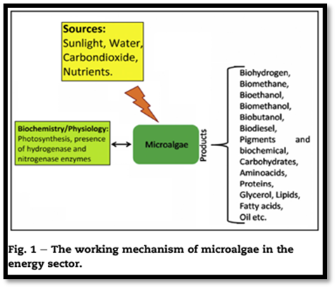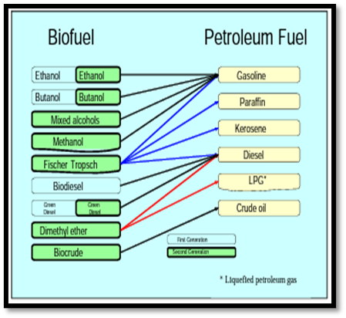
Figure 1: The working mechanism of microalgae Figure 2: Sustainability of biofuels with
Common petroleum
Based on contemporary-day expertise, the use of microalgae is being studied as an appealing feedstock for biofuels manufacturing. Relying on species and cultivation methods, microalgae can produce biohydrogen, bio methanol, bioethanol, carbohydrates, proteins, biodiesel , or different compounds that are being utilized in pharmaceutical businesses. The algal-derived biofuel production requires the best daytime, CO2, and water and generates a couple of renewable strength products primarily based definitely biofuels manufacturing are about a hundred instances better than that of higher plants. The algal biomass can be further processed to provide biofuels in the course of fermentation by microorganisms. Presently several microorganisms were determined to supply biofuels efficiently with the aid of the use of [5]:
- Engineering in the gene of cyanobacteria to intensify the production of hydrogen.
- Improvement of production of hydrogen and engineering of metabolism for manufacturing of biofuels in bacteria.
- Darkish fermentation by way of bacteria for conversion of carbohydrates to biohydrogen and other bio fuels.
- Photobiological strategies to supply biohydrogen through microalgae.
- Genetic engineering of the yeast to increase ethanol manufacturing through tolerating excessive alcohol recognition.
- Engineering in the gene of microorganisms which could ferment carbohydrates to produce bioethanol and biobutanol manufacturing.
- Screening the microalgae which could produce more oil for biodiesel production.
- Fermentation of cell wall carbohydrates of plants with the resource of yeast or different microorganisms to provide biofuels.[5]
TYPES OF BIOFUELS
In 1973, fossil fuels accounted for more than 86% of the sector's total primary energy delivery. The share of fossil fuels remains high even though the electrical supply has increased as a result. However, in 2007, more than 81% came from fossil fuels. The EU region imports crude oil from the internet and is heavily reliant on fossil fuels for transportation. Numerous experts predict that oil output will peak by the year 2020, even though demand will continue to rise, driven by China and India. To meet this need, petroleum products must be found as alternatives. [3].
Biofuels, often known as "agrofuels," are renewable fuels made from biological feedstock. In contrast to fossil fuels, their production no longer involves the release of hazardous substances. Biofuels can be created by converting biomass utilizing chemical, biological, and thermal conversion techniques. They can take the form of three of the four basic states of matter, including strong (firewood), liquid, and gasoline (methane, biogas, and bio-hydrogen). There are currently a variety of technological, monetary, and policy-related problems with biofuels and their sustainability that need to be resolved. [2]. The evidence currently available indicates that, if land-use trade (LUC) is not taken into consideration, first-generation biofuels can typically emit fewer greenhouse gases (GHGs) than fossil fuels. However, the discounts for maximum feedstocks are insufficient to achieve the GHG savings required by the EU Renewable Strength Directive (purple). However, second-generation biofuels have a better potential to reduce emissions overall, assuming there is no LUC. 0.33-generation biofuels do not currently represent a workable option because their GHG emissions are lower than those of fossil fuels.[6]
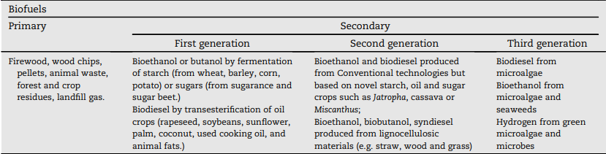
Figure 3: Classification of biofuels
Some of the key characteristics, such as the kind of feedstock, conversion process, specialized gas specification, and application, can be used to identify biofuels continuously. 'First and second Technology' and 'Traditional and Superior' biofuels are two commonly utilized typologies. First-generation biofuels are those made from waste products or animal feed mills. Since first-generation biofuels are created using properly installed technology and methods, such as turbulence, distillation, and transesterification, they may also be referred to as "conventional biofuels The ability to be produced from non-meal feedstocks, such as specialized electricity plants (such as Miscanthus, switchgrass, short gyration covert (SRC), and other lignocellulosic foliage), agrarian waste, wood waste, and other waste products (such as UCO and external stable waste), is a key feature of alternative-technology biofuels. Third-technology biofuel refers to biodiesel produced from microalgae using traditional transesterification or hydro-remedy of algal oil painting. Since the production methods or pathways for second- and third-generation biofuels are still under investigation and improvement, airman, or demonstration member status, they are frequently referred to as "superior biofuels"[6].
First generation bioethanol, biodiesel, and other biofuels
First- generation biofuels like bioethanol and biodiesel, must now not be regarded as technological niches presently; they're a part of the socio-specialized governance and their prolixity is sizable and consolidated all through the world. [2]
1. Bioethanol
Given that it can be used in vehicles that require gasoline, bioethanol is a biofuel that is genuinely well-known all over the world. Chemically, it is also known as ethylic alcohol (ethanol CH3eCH2eOH, the same organic emulsion used in alcoholic beverages), and it is made up of a jumble of vibrant foliage, including sugarcane, sludge, and other plants with excessive sugar or bounce. Bioethanol is distilled, dehydrated, and ultimately denatured after being subjected to microbial upheaval. It can be blended with energy and rated from E5 (ethanol and 95 gas) to E100 (100 ethanol), entirely based on the amount of ethanol present [2]. The abecedarian molecular substrate of bioethanol and memorandum methanol is sugar[5]. Although it might potentially be used in tractors, airplanes, and boats, bioethanol is mostly used in the machinery that powers automobiles. It is utilized as a drop-in biofuel in flexible-gas or flex-energy vehicles; in this example, the energies for the machine's propulsion are interchangeable. Since the freezing factor is so low, it cannot be used as spurt energy [2].
To date, bio alcohol is regarded as a non-fossil occasion transport. However, focus has recently switched to imperishable meadows, which include switchgrass and Miscanthus. Factory material with substantial bounce and sugars, such as grain foliage and sugarcanes, make up the majority of the force in memoir alcohols. Although those leafages don't deal with food application, the turbulence and distillation methods need that the cellulosic biomass be first converted into sugars. The most prevalent historical alcoholic beverage is ethanol, but biopropanol and biobutanol are significantly less prevalent. These alcohols are produced through the microbial turbulence of carbohydrate-modified feedstock [5]. The United States is currently the largest producer of bioethanol, followed by Brazil, the European Union (headed by Germany), and China. Brazil has been at the forefront of biofuel technology since the 1980s, and it is now self-sufficient, with bioethanol accounting for more than half of the domestic market for transportation fuels. Brazil's large supply of bioethanol is primarily derived from sugarcane, compared to nine in the USA. It is mostly made from sludge, and plutocrat is responsible for around one-third of the sludge product and six percent of the gas [2].

2. Biodiesel
The alternate most well known biofuel is biodiesel, which is produced from animal or vegetable fat that contains long-chain esters. Biodiesel's chemical structure is distinct from regular diesel's because it contains oxygen, hydrogen, and carbon, whereas petroleum-based diesel is made exclusively of hydrocarbons, which exclude oxygen. Any blend of natural or blended biodiesel may be used in standard diesel engines. The most popular composites are B2, B5, B20, and B100 (pure biodiesel). It is now possible to use it not just for traction vehicles but also for road locomotives and heating oil painting[2]. Currently, ethanol and biodiesel are closely tied to the product of biofuels. They contain an agricultural bio-resource akin to sugar club, sludge, or rapeseed, together with a sizable amount of water, pathogens, and fungicides [3]. Additionally, oil paintings that have accumulated and been recovered from usage in gastronomy or other artificial reasons can be used to make biodiesel. Other than virgin vegetable oil paintings, which are made in specialized stores, waste food oil paintings are a byproduct that would be thrown away otherwise if not recovered. In this aspect, used cooking oil is a cheap source of feedstock for making biodiesel, and its low cost can boost the product's overall competitiveness [2]. During the period 2008 to 2018, biodiesel product increased further than threefold, from 12 to 41 billion liters. presently, biofuels regard for about3.4 of total transportation energies worldwide [6].

3. Other biofuels
Biogas, various bio alcohols (such as biomethanol, biobutanol, and so forth.), wood, memoir ethers, dried ordure, and agricultural waste are among the diverse biofuels with significantly lesser large effect and prolixity (Guo et al., 2015). Like ethanol, methanol is a popular alcohol (CH3OH) that can be utilized as a source of energy. Methanol is currently produced as a reactionary gas from plant-based fuel, but it can also be produced from the gasification of biomass (memoir methanol), a process whose economic and commercial potential is still being assessed. From a specialized perspective, memoir methanol has a wide range of uses, including;
1.In internal combustion machines as an volition to gas and indeed if with the stylish half of the energy viscosity of the ultimate.
2.Rather than diesel, while dehydration ether to dimethyl ether, or for the product of biodiesel through the transesterification of vegetable oil painting.
3.In motive- constructed memoir methanol- powered buses, or in draw- heft and mongrel motorcars.
4. For energy manufacturing in gas manufactories or energy cells; and
5. As a home gas. [2]
Making butanol (C4H9OH), a kind of alcohol, from starch is known as "ABE fermentation" (i.e., employing acetone, butanol, and ethanol). It can be used unaltered in energy machines. With the help of several byproducts (such as nitrogen, carbon dioxide, methane, and hydrogen), biogas is produced by rupturing or anaerobic digestion of organic materials without the presence of oxygen. Similar to reactionary herbal gasoline, biogas can be compressed and used in a variety of different locations. Syngas is produced in a different way than biogas, through the partial burning of organic compounds in the presence of oxygen [2].
The stock of Biofuels era, economics, and content is dried or goes through pyrolysis before the combustion process. The prior biomasses are primarily composed of hydrogen, carbon monoxide, and other hydrocarbons after undergoing incomplete combustion. Additionally, syngas can be utilized to generate heat in addition to electricity in the transportation sector. The same raw materials used to make biodiesel, particularly animal or vegetable fats, are used to make green diesel, but the final product behaves very differently. While hydrogenation (including hydrogen motes) or biodiesel (13) [2].

Second - generation biofuels
These biofuels are deduced from non-fit-for-human consumption factory accoutrements, farming leftovers, and committed energy foliage together with switchgrass, miscanthus, and jatropha. They give a further sustainable volition with the aid of using waste products and non-food foliage, lowering the opposition to food product.
From a scientific and commercial standpoint, the first-generation biofuels—particularly those composed of sugars, and vegetable oil—have certain serious shortcomings. Comparing them to fossil fuels, this puts them in a bad offensive position. These issues will be resolved since, in addition to the advancement of primary-technology bones, there were significant investments made in the past to improve technology for the production of current biofuels. Since that time, the main goal has been to improve conversion performance in order to lessen feedstock musts [2].
experimenting with the potential for commercially viable production of biofuels, and primarily bioethanol, from non-food crops, primarily lignocellulose biomasses. Examples of this include lignocellulose's feedstock, which consists of bright agricultural waste products such cereal straw, sugarcane bagasse, forestland remnants, and garbage (organic components of external stable trash) [2].
Researchers are now doing numerous studies to find new methods for producing biofuels, including pyrolysis, gasification, anaerobic digestion, enzymatic hydrolysis, and improved incineration. Nevertheless, it is difficult to get ethanol from cellulose because the circulating sugars are locked inside a complex chemical framework. experimenting with the potential for commercially viable production of biofuels, and primarily bioethanol, from non-food crops, primarily lignocellulose biomasses. Examples of this include lignocellulose's feedstock, which consists of bright agricultural waste products such cereal straw, sugarcane bagasse, forestland remnants, and garbage (organic components of external stable trash) [2]. Researchers are now doing numerous studies to find new methods for producing biofuels, including pyrolysis, gasification, anaerobic digestion, enzymatic hydrolysis, and improved incineration. Nevertheless, it is difficult to get ethanol from cellulose because the circulating sugars are locked inside a complex chemical framework.
There are several different new- period biofuel technologies that can be explored, including biohydrogen, and the so- appertained to as fourth- generation biofuels, which can do without the burning of the feedstock. Indeed though veritably promising, those technological niches are at a completely original position and are nonetheless far from being commercially possible
The distribution of alternative-generation biofuels can also take the form of the biochemical or thermochemical processes needed to convert biomass to gasoline. It is common to refer to second-generation biochemically generated alcohol energy as "cellulosic ethanol" and "cellulosic biobutanol". Pre-treatment, saccharification, turbulence, and distillation are all steps in the process of making those. In order for the complex carbohydrate motes that make up cellulose and hemicellulose to be broken down by enzyme-catalyzed hydrolysis (water addition) into their constituent simple sugars, cellulose, hemicellulose, and lignin must first be separated from one another. A crystalline framework of long chains of glucose (6-carbon) sugar molecules makes up cellulose. It is difficult to separate into simple sugars because to its crystallinity, but once separated, sugar motes are easily converted to ethanol by the action of well-known microorganisms. Some microorganisms for butanol disruption are also taken into consideration. Hemicellulose is made up of polymers of five-carbon sugars and is easily broken down into its individual sugar components, such as xylose and pentose. However, 5-carbon carbohydrates are more turbulent than 6-carbon sugars. Numerous extraordinarily modern bacteria are capable of converting 5-carbon carbohydrates to ethanol. Phenols, which are present in lignin, are not technically fermentable. But lignin can be recovered and applied as energy to offer system lukewarmness and energy at an alcohol product installation [4].

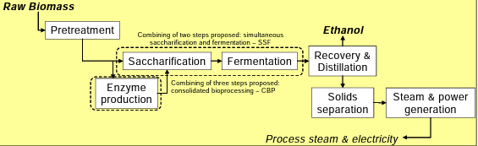

Figure 4-Process of production of second-generation fuel ethanol
Strategies for thermochemical biomass conversion use a variety of high temperatures. Better pressures are
typically found outside of biochemical conversion systems. The inflexibility of feedstocks that may be supported with thermochemical processing and the variety of final energies that may be produced are significant natural traits separating biochemical from thermochemical biofuels. The gasification or pyrolysis processes are the first steps in the thermochemical evolution of biofuels. The former typically requires more cash and requires a big scale for excellent economics, but the end result is a clean finished energy that can be used freely in machines. During the gasification process, biomass (which has a moisture content of 10 to 20 percent) is heated (often by burning some of the biomass in oxygen) to cause it to be transformed into a total of ignitable and non-combustible fuels. The removal of contaminants from the energy is followed, in some situations, by modifications to the composition of the gasoline (also known as conflation gasoline or syngas) to prepare it for further processing (the operation of the "water- gasoline shift" response). Since carbon dioxide(CO2) is a diluent in syngas, it is also eliminated to lubricate downstream posterior responses. The now-focused and smooth syngas' main complements are hydrogen (H2) and carbon monoxide (CO), usually with a tiny amount of methane (CH4). When the CO and H2 are surpassed over a catalyst (the CH4 are inert), liquid gas is produced. The type of biofuel produced depends on the catalyst's design. Not all of the syngas that passes over the catalyst can be converted to liquid energy in most industrial configurations. In most situations, the unconverted syngas would be burned to produce the majority or all of the electricity required to run the power plant and, in many cases, to export power to the grid. an other choice for converting syngas to liquid gasoline. This choice causes specially crafted microorganisms to convert syngas into ethanol or butamnol.

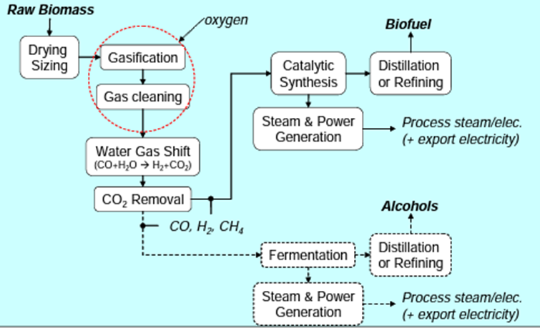
Figure 5-Process of production of thermochemical biofuels
Three thermochemically- produced energies are getting considerable attention in different parts of the world are FTL, DME, and alcohol.
1.Fischer-Tropsch liquid (FTL) is a mix of substantial instantly-chain hydrocarbon composites (olefins and paraffin) that act as semi-sensitive crude oil painting. The overall can be packed into a traditional petroleum refinery for processing or greater factor into “pure diesel, ” spurt fuel, naphtha, and different fragments. By means of the use of FTL catalytically it could be synthesized. Hence, any feedstock converted into CO and H2 may be used to supply FTL. Specifically, coal, natural electricity, or biomass may be used as a feedstock for FTL products.
2. Dimethyl ether (DME) is a title energy having ordinary temperatures and pressures, with a moderate Airy odor. It liquefies underneath moderate strain, analogous to propane. It's especially non-corrosive, inert, nearly non-toxic, non-corrosive, and doesn't form peroxides by way of prolonged hype to Air. These parcels make it an applicable relief (or as an agent for blending) for liquified Petroleum gasoline (LPG, an admixture of propane and butane). still, fusions of DME and LPG may be used with a combustion contrivance designed for LPG without changes to the device, If the DME blending position is confined to 15 – 25 Percent via extent. DME is likewise a fantastic diesel machine gas due to its High volume of cetane and absence of soot manufacturing all through combustion. It is not possible to admixture DME with traditional diesel energy in machines, because DME ought to be stored under moderate Pressure to keep a liquid state.
3.Alcohol that can be produced through syngas processing is gaining attention in the United States at present. One similar energy is ethanol (or butanol); an alternate is an admixture of alcohols that includes a significant bit of ethanol plus lower fragments of several advanced alcohols. Butanol and also the “mixed-alcohol” energy have the eventuality to be used much the way ethanol is used moment for blending with gasoline. These are characterized by advanced volumetric energy consistency and lower vapor pressures than ethanol, still, making them more appreciative as energy or blending agent. Syngas can be converted into an admixture of alcohol by catalytic conflation. The process steps act those for making FT liquids. Clean syngas is passed over a catalyst, forming an admixture of alcohol motes. Different catalysts for alcohol mixed products from syngas were patented in the late 1970s and early 1980s, but utmost development sweats were abandoned after oil painting prices decreased in the mid-1980s [4].
CHALLENGES AND IMPLICATIONS
Microalgae and its challenges
The worldwide energy crisis and increasing greenhouse gas emissions are the main factors driving the quest for alternative, ecologically friendly renewable energy sources. A significant source of energy from renewable sources for a sustainable future, microalgae biofuel has the possibility to substitute for fossil fuels, as determined by life cycle analysis. The severe drawbacks associated with oil crops and lignocellulose-based biofuels were absent from microalgae fuel. Green growth-based biofuels are actually commercially viable, cheap, and need little to no additional land or water consumption. They also reduce atmospheric CO2 levels. By designing advanced photobioreactors and developing low-cost innovations for biomass harvesting, drying, and oil extraction, microalgae biodiesel production can be made affordable. [7] Additionally, by establishing metabolic pathways for high lipid synthesis and furthering hereditary designing procedures to regulate ecological pressure situations, businesses can be created. In addition, researchers are looking into recently developed innovations such algal-bacterial interactions for improving the development of microalgae and lipid production. Despite the fact that microalgae are generally potential sources of bioenergy and biopharmaceuticals, a few obstacles and problems need to be overcome in order to adapt the innovation from the pilot stage to the present level. Upgrading the microalgae growth rate and item combination, dewatering green growth cultures for biomass production, pre-treating biomass, and optimizing the maturation cycle in the case of algal bioethanol production are the most challenging and important concerns. The current survey portrays the benefits of microalgae to deliver biofuels and different bioactive mixtures and also, talks about refined boundaries. [8]

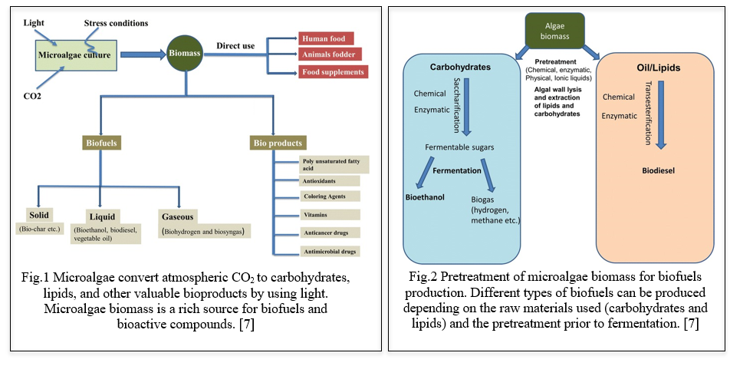

LAND USE AND FOOD SECURITY
The key test in the production of biofuels is to control productive land usage and reduce GHG emissions to ensure that it doesn't lead to a conflict between food and energy, environmental change, or other forms of natural extinction. However, whether the harvests are created for food or technology and fuel applications, using varied soil types to develop crops raises similar ecological difficulties. In forestry or field agricultural production, monoculture farming can put biodiversity, pests, and pathogens at danger. In addition, land utilization for growing mixed crops and woody species, such as perennial grasses or trees, could be used to increase biodiversity without reducing productivity. The use of biofuels is being advanced by legislatures worldwide to reduce the environmental impact of using energizers. Despite the complexity of the ecological and mechanical systems that affect environmental change, land usage, and water consumption, as well as the challenges of creating reliable data, it is possible to make a few subjective overall judgments. All things considered, compared to gasoline, biofuels produced from crops grown using conventional agricultural methods would aggravate pressures on water supplies, water quality, and land use. They will also fail to mitigate the effects of environmental change. The development of reasonable biofuel programs that use land with essentially no financial or environmental value for optional purposes and that depend on precipitation or abundant groundwater should be a priority. These programs should have very low contributions of petroleum products and synthetic substances. Regardless of this, existing evidence suggests that original biofuels can typically have lower GHG (Ozone depleting substances) outflows than non-renewable energy sources if there is no land-use change (LUC). However, the decreases for the majority of feedstocks are insufficient to meet the GHG investment funds anticipated by the EU Sustainable power Order (RED). Second-generation biofuels, however, typically have a better potential for carbon reduction if there is no LUC. Due to their higher GHG emissions than fossil fuels, third-generation biofuels do not present a viable alternative in the current climate. [9]

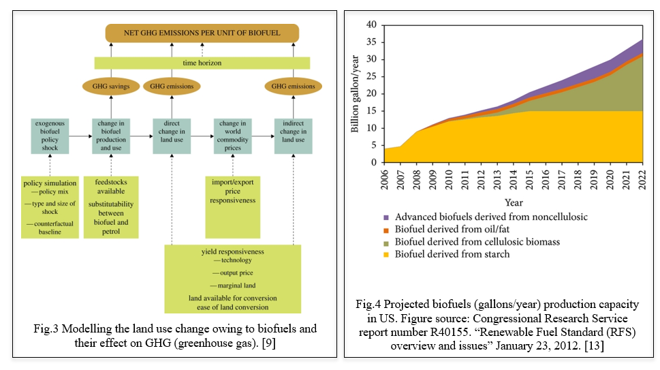
FEEDSTOCK AVAILABILITY AND SUSTAINABILITY
The challenge of the twenty first century will be managing energy. If biofuels are to be a part of the solution, they must submit to a level of vetting never seen in the birth of a new business. The life cycle assessment (LCA) paradigm has traditionally been used to analyze the sustainability of biofuels. These analyses demonstrate that compared to oil fuel, corn ethanol has a marginally reduced impact on fossil energy and ozone damaging substances. The carbon profiles of certain biodiesel and sugarcane ethanol are much lower. The impressions of new biofuels could be poor. As policymakers take into account the direct and indirect effects of biofuels on global water and soil assets, the quality of the air, general well-being, as well as civil rights, the science of LCA is being advanced as much as feasible. The production of ethanol in the United States using cornstarch, sugarcane in Brazil, and rapeseed oil, as well as biodiesel in Europe, are currently overtaking the biofuel markets. The accessibility of appropriate feedstock for biofuel creation is another test. Corn and sugarcane, two of the crops used in the production of biofuel, require climatic conditions and may not be cultivable in all regions. Additionally, depending on a set number of feedstock choices can make production network weaknesses and increment the gamble of cost changes. [10] 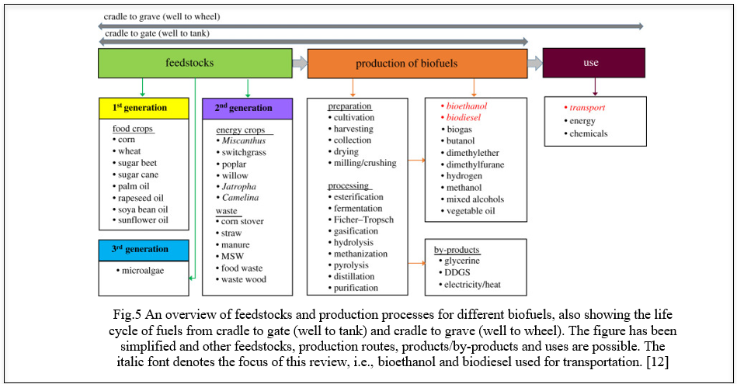

LIFE CYCLE ASSESSMENT
A technique known as life cycle assessment (LCA) is used to evaluate an item's or interaction's environmental impact over the course of its entire life cycle, from the extraction of raw materials to the end of its useful life. LCA is usually applied to biofuels to evaluate their by and large ecological execution and contrast them and ordinary non-renewable energy sources. One of the essential inspirations for utilizing biofuels is the possibility to diminish ozone depleting substance (GHG) emanations contrasted with fossil fills. LCA measures the outflows related with each phase of the biofuel life cycle, including feedstock creation, transportation, handling, and burning. It thinks about direct outflows (e.g., fuel burning) as well as circuitous outflows (e.g., land use change, manure creation). The net GHG discharges of biofuels rely upon variables, for example, feedstock type, development rehearses, transformation advances, and land-use change impacts. Biologists and established researchers are able to improve the precision of LCA for frameworks used in the production of biofuels by providing fresh information on biogeochemistry including plant metabolism [14].
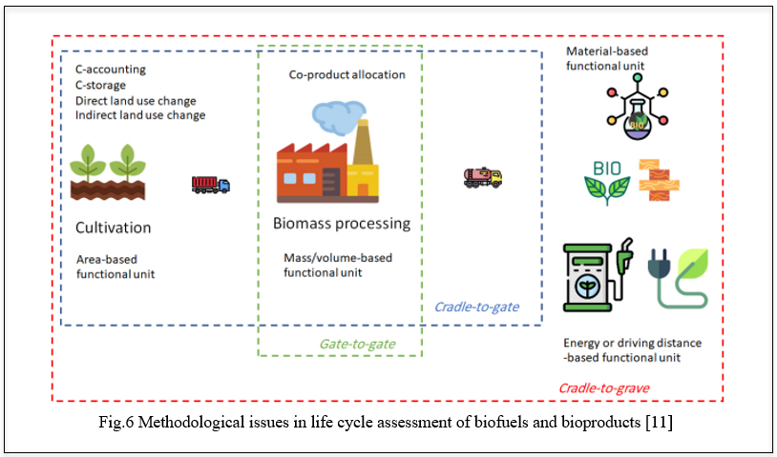

TECHNOLOGICAL AND INFRASTRUCTURAL CHALLENGES
There are several technological and infrastructural obstacles to overcome before biofuels are widely used as an alternative to fossil fuels. Numerous biofuel creation advancements are still in the beginning phases of improvement and are not yet increased for enormous scope business creation. The development of biofuels from various bioresources utilizing different arising advancements and organic cycles is expanding worldwide. It is probable that the generation of biofuels from biomass waste and agricultural crop residues will have a positive impact on the environment and resolve a number of societal challenges, such as the disposal of waste. Maintaining a consistent supply of feedstock, maximizing process efficiency, and ensuring economic viability are among the difficulties associated with scaling up biofuel production. It requires significant interest in exploration, improvement, and framework to progress from pilot-scale offices to full-scale creation. Biofuels are not always compatible with the existing infrastructure for storing, transporting, and distributing conventional fossil fuels. Biofuels have various properties and may require separate capacity tanks, transportation pipelines, and dissemination frameworks. Adjusting the foundation to oblige biofuels, incorporating mixing them with regular fills or laying out committed dissemination organizations, can be a critical test, particularly in districts with restricted biofuel request or accessibility. The expense of biofuels is significant considering their reception. Biofuel creation processes frequently include various advances, which can be capital-escalated and require continuous functional expenses. When considering the availability of subsidies or incentives to support their production and market penetration as well as fluctuating feedstock prices, economies of scale, and cost competitiveness with fossil fuels, biofuels face a significant challenge. Tending to these mechanical and infrastructural challenges requires supported innovative work endeavours, public and confidential ventures, steady strategies, also, joint effort between industry partners, specialists, and government substances. Beating these difficulties is fundamental for understanding the maximum capacity of biofuels as a economical and low-carbon energy source. This need will increase to almost 37% in 2040 since the world's economic, social, and political developments are dependent on fuel. Petrol and allied industries provide more than 80% of the globe's energy needs. Due to limited natural resources, scientists have been forced to investigate more efficient, alternative, and sustainable renewable energy sources, such as biofuels, to meet the world's energy needs. The main technological barriers to the production of biofuels are the use of unpalatable feedstock like lignin-based biomass and other vegetative feedstock, manufacture logistics, energy-effective pretreatment procedures, hydrolysis of enzyme, along with fermenting methods, successful co-product consumption, developing biofuel norms, delivery administration, recognition of its benefits for society and the economy, and the reduction of its environmental impact. [15] 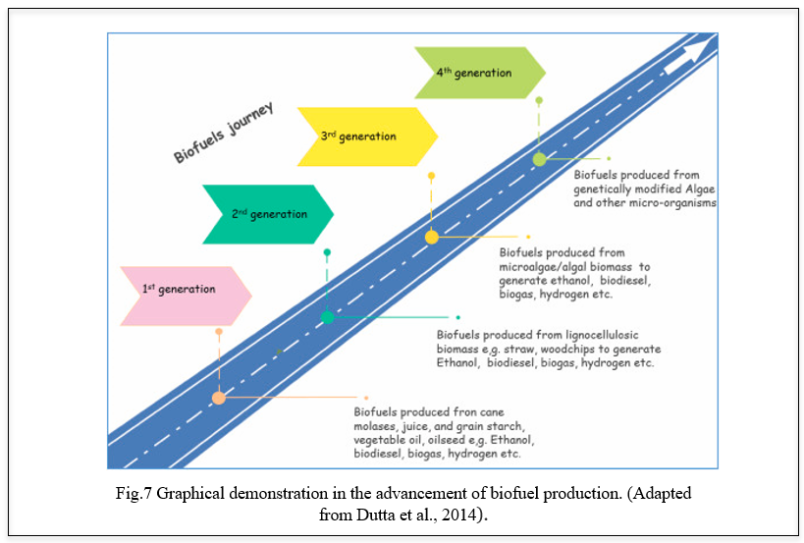
BENEFITS OF BIOFUELS
The direct transformation of biomass into liquid energy is known as biofuels. The two biofuels that are currently most often utilized are ethanol and biodiesel. Ethanol is one of the renewable energies that can be made from colorful factory sources which is inclusively called biomass. A blend of ethanol along with gasoline would increase the octane resulting in decrease of carbon monoxide and other agents caused by gauze. Flexible energy vehicles are designed to run on E85 which is an alternate energy with much advanced ethanol than gasoline. Biodiesel is produced from renewable sources like vegetable canvases, and beast fats which are important cleaner than petroleum- grounded diesel. Biodiesel is biodegradable and non-toxic and it's produced by mixing alcohol with vegetable oil painting or beast fats. Gas, spurt energy, and diesel are burned to produce energy. Biofuels are much preferred than any other as it can be grown indefinitely and it produces almost no damage to our environment. numerous of the world's major oil painting companies are now investing millions of bones in advanced biofuel exploration. Indeed, though there are numerous graces of using biofuels, there have to be technological advancements and scientific improvements which will help in biomass optimization and processing of biomass into feasible energies. Some companies are counting on the water- grounded result in the form of algae product. Compared to other sources algae might produce less biofuel per acre. Alga has another significant benefit over other bio sources. in that it may be used to make biofuels that are similar to current transportation energy. By accomplishing this, the conventional reactive energies of gasoline and diesel would be significantly replaced[19]. Consequently, employing biofuels to mitigate global climate change by reducing carbon emigrations is effective. Recent developments in biotechnology have increased the viability of renewable coffers. Environmental businesses are drawing attention to bioethanol as a cover. Energy is vital to the advancement of mortal society. The globe is currently experiencing global warming, and the use of fossil fuels is continuously declining. This is a crucial recommendation that all nations should take into account in order to begin the growth of renewable energy [18].Biofuel is one of the most significant sources of renewable energy. It is predicted to gradually outnumber the present-day energy coffers and has a wide range of development potential. Saving energy and emigration reduction are made possible by the development and use of biomass. This is a crucial step toward achieving low-carbon frugality..Biofuels can reduce hothouse gas emigrations compared to fossil energies. There’s eventuality for pastoral development with the pro Biofuels have gained important attention in recent times due to their capability to alleviate climate change and global warming, reduce dependence on fossil energies, and promote a further sustainable living. Liquid biofuels are vital as they replace petroleum energies. The cost of biofuels varies grounded on their dependence on feedstock, cost of product, the conversion process, and region. In terms of sulfur concentration, flash point, and sweetness, biodiesel is superior to diesel. Biofuels are attained from organic accoutrements similar as algae and shops which can be replenished through civilization or natural processes. Biofuels produce a renewable and sustainable source of energy, unlike finite reactionary energies. duct of biofuels as it involves exercising crops which can be a fresh request for growers. By using biofuels we're also indulging in bettered air quality as biofuels have the eventuality to reduce air pollution. They produce lower dangerous air pollution compared to fossil energies. Using biofuels in transportation also contributes to better air quality and reduces respiratory and environmental health pitfalls. When biofuels are used, they can stimulate profitable growth and also produce new job openings, especially in pastoral areas. Biofuels reduce dependence on imported reactionary energies which enhances the energy security for countries. The development of biofuel production techniques has received a lot of attention over the past 20 years, with a particular focus on those that are employed in the transportation industry. Every bone has a particular set of energy conditions and yield, and there are numerous biomasses and conversion pathways available for producing them. Although specialized feasibility has been proven, achieving profitable competitiveness is still difficult. The use of process intensification strategies is a promissory intention in order to achieve the commercial feasibility of biofuels [15]. The future belongs to renewable energy. A key concern in the global struggle to reduce greenhouse gas (GHG) emigration and the effects of climate change is sustainable bioenergy production.[16]. . By doing this it would go a long way in replacing the conventional reactionary energies of gasoline and diesel. The performance of biodiesel in cold rainfall depends on the mix of biodiesel, the feedstock, and the petroleum diesel characteristics. Biodiesel is also called B100[21]. There are biofuels in Spain that produce biofuels from recycled raw accoutrements and have a periodic product capacity of 250,000 tons of hydro biodiesel, memoir spurt, and propane to be used in exchanges, aircraft, and exchanges. Co2 doesn't increase when biofuels are used, which refers to the conception of carbon impartiality. Thus, using biofuels is an effective way of combating global climate by reducing carbon emigrations [23]. Rice straw, sludge stover, and timber thinning remainders are non-food-based biomass that are some of the promising offers for biofuel product. Dragged exercise of cooking oil painting for preparing food, especially in deep frying is an implicit health hazard and can lead to numerous health conditions. habituated cuisine oil painting is an implicit feedstock for biodiesel and its use for making biodiesel will help the diversion of used cuisine oil painting in the food acidity. Seaweed civilization in the coastal regions is very suitable for biofuel- making styles like anaerobic digestion to make biogas and fermentation to make ethanol. India has a high potential of biomass about 500 metric tons per time vacuity. Approximately 17,500MW of power may be produced by this accessible biomass, according to the MNRE (Ministry of New and Renewable Energy). Other states like Uttar Pradesh, Haryana, Gujrat, and Madhya Pradesh, which produce half of India's yearly agricultural waste worth rupees 50,000 crores, are underperforming because of low prices. Historically, Punjab and Maharashtra have led the way in setting up biomass stores. By 2026, India is expected to overtake China to become the third-largest ethanol consumer in the world. Biofuels offer a variety of benefits but all of them come with a cost. They're relatively expensive to produce in the current request. Biofuels are more expensive to produce than fossil fuels and this is because biofuels are derived from renewable resources like crop and waste materials and the process of inferring energy from them is more expensive. And as time passes, the demand for this will increase and the supply becomes a long- term operation that will be very precious. The practice of consistently growing the same crops is known as monoculture rather than producing colorful crops through a planter's field over time. Economically it's desirable to growers but growing a single crop over large tracts of land can beget a lot of problems.Crops that require illnesses to grow better are used to make biofuels. Diseases result in extensive environmental harm and water pollution. Biofuels are removed from businesses and crops with high sugar content. One of the main worries that people have is that rising food prices could result from increased usage of biofuels. When burned, biofuels have a lower carbon footprint than other forms of energy, but their production process makes up for it. Much water and oil painting are used to create this product. It is well recognized that the diligence used to produce biofuels causes significant emigrations and contributes to water contamination.The technology that's presently being used to produce biofuels isn't as effective as it has to be. The cost of exploration and installations means that biofuels will see a significant shaft in the price of biofuels. In the northwest, A readily available biomass for biofuels is wood from rent and energy treatments. Some case studies have shown that transporting biomass to a installation is more provident than converting energies into biofuels. Pyrolysis is a system of converting wood into heat and energy. Internationalization cooperation to increase and encourage exploration into biofuel products and use, thus benefits all countries because it helps to reduce the emigration of hothouse feasts, even though Europe and the USA are still the main consumers of fossil energies. These developments are also set to benefit the rapidly growing husbandry of Asia as more people, particularly in China and India, are suitable to go a car.The Chinese National Reform and Development Commission (Beijing, China) is creating programs "for a country that can consume like an advanced country, but still needs to nearly foster the requirements of the 800 million or so peasants living in China [22]," according to Jorge Sanchez, The Agricultural Attaché at the American Embassy in Beijing, China. China is the world's second-largest buyer of oil paintings after the United States, and it is the world's third-largest buyer of first-generation biofuels after the United States and Brazil. Over the times, fire repression has changed the northwest's structure and composition of timbers. In fire-prone timbers, fires burn both lower and larger trees when there's too important energy in the timber, performing in too important energy in the timbers high- inflexibility fires can beget severe environmental issues which impact mortal health, damage wildlife niche, destroy homes and communities, crippling natural coffers- grounded husbandry, and destroy a natural carbon store. Tree branches, covers, and imperfect logs which are left after timber crop is another implicit biofuel source. According to the 2016billion ton report from the US Department of Energy if all the timber residue were made into ethanol it could make roughly1.3 billion gallons of energy [21] If the rent is left unburnt it can lead to increased fire hazards. Reducing our demand for petroleum could also lower its price and which can induce profitable benefits for guests. Demand for biofuels can also increase ranch income. Domestically produced biofuels lead to lower reaction energy imports. However, It's important to note that biofuel product and consumption in itself won't reduce GHG or accessible adulterants emigration, lessen petroleum significances, If biofuel product and use reduce our consumption of imported reactionary energies.[24]

REFERENCES

[1]. Barry D Solomon – BIOFUELS AND SUSTAINABILITY
[2]. Handbook of Biofuels production edited by Rafael Luque, Carol Sze Ki Lin, Karen Wilson and James Clark
[3].Biofuels - Markus Schmidt , Manuel Porcar , Vincent Schachter , Antoine Danchin , and Ismail Mahmutoglu
[4].Biofuel production technologies: status, prospects and implications for trade and development by Dr. Eric D. Larson
[5].Rodionova MV, et al., Biofuel production: Challenges and opportunities, International Journal of Hydrogen Energy (2016), http://dx.doi.org/10.1016/j.ijhydene.2016.11.125
[6].Environmental sustainability of biofuels: A review by Harish K. Jeswani Andrew Chilvers and Adisa Azapagic https://doi.org/10.1098/rspa.2020.0351
Figure 2,4,5 - Biofuel production technologies: status, prospects and implications for trade and development by Dr. Eric D. Larson
Figure 3- Rodionova MV, et al., Biofuel production: Challenges and opportunities, International Journal of Hydrogen Energy (2016), http://dx.doi.org/10.1016/j.ijhydene.2016.11.125
Figure 1- : Rodionova MV, et al., Biofuel production: Challenges and opportunities, International Journal of Hydrogen Energy (2016), http://dx.doi.org/10.1016/j.ijhydene.2016.11.125
REFERENCES:
[7] Khan MI, Shin JH, Kim JD. The promising future of microalgae: current status, challenges, and optimization of a sustainable and renewable industry for biofuels,
feed, and other products. Microb Cell Fact. 2018 Mar
[8] Medipally SR, Yusoff FM, Banerjee S, Shariff M. Microalgae as sustainable renewable energy feedstock for biofuel production. Biomed Res Int.
2015;2015:519513. doi: 10.1155/2015/519513. Epub 2015 Mar 22.
[9] Delucchi MA. Impacts of biofuels on climate change, water use, and land use. Ann N Y Acad Sci. 2010 May;1195:28-45.
[10] Sheehan JJ. Biofuels and the conundrum of sustainability. Curr Opin Biotechnol. 2009 Jun;20(3):318-24
[11] Jeswani HK, Chilvers A, Azapagic A. Environmental sustainability of biofuels: a review. Proc Math Phys Eng Sci. 2020 Nov;476(2243):20200351. doi:
10.1098/rspa.2020.0351. Epub 2020 Nov 25. PMID: 33363439; PMCID: PMC7735313.
[12] Gnansounou, E., Dauriat, A., Villegas, J., &amp; Panichelli, L. (2009). Life cycle assessment of biofuels: Energy and greenhouse gas balances. Bioresource
Technology, 100(21), 4919-4930
[13] Current Challenges in Commercially Producing Biofuels from Lignocellulosic Biomass by Venkatesh Balan
[14] Davis SC, Anderson-Teixeira KJ, Delucia EH. Life-cycle analysis and the ecology of biofuels. Trends Plant Sci. 2009 Mar;14(3):140-6
[15] Singhania RR, Patel AK, Singh A, Haldar D, Soam S, Chen CW, Tsai ML, Dong CD. Consolidated bioprocessing of lignocellulosic biomass: Technological
advances and challenges. Bioresour Technol. 2022 Jun;354:127153.
[ 16] Fokaides, P., & Christoforou, E. (2016). Life cycle sustainability assessment of biofuels. Handbook of Biofuels Production (Second Edition), 41-60. https://doi.org/10.1016/B978-0-08-100455-5.00003-5

[17] Hernández, S. (2022). Process intensification in biofuels production. Biofuels and Biorefining, 1-40. https://doi.org/10.1016/B978-0-12-824117-2.00001-6
Anderson, R.B. 1984. The Fischer–Tropsch synthesis, Academic Press, New York.

[18] Shan, Y., & Lü, X. (2021). Ending fossil fuels addiction: Prospects for biofuels. Advances in 2nd Generation of Bioethanol Production, 229-242. https://doi.org/10.1016/B978-0-12-818862-0.00008-X

[19] https://www.conserve-energy-future.com/advantages-and-disadvantages-of-biofuels.php

[20] Bukur, D.B., Nowicki, L., Manne, R.V., Lang, X. 1995. Activation studies with a precipitated iron catalysts for the Fischer–Tropsch synthesis. J Catalysis 155:366–375.

[21] S. Paulson, Ph.D. (2013). Biodiesel Fuel [Online]. Avaliable: http://www.environment.ucla.edu/reportcard/article7320.html
[22] EMBO Reports. (2008). Bio Or Bust? The Economic and Ecological Cost of Biofuels [Online]. Avaliable: http://www.ncbi.nlm.nih.gov/pmc/articles/PMC2246417/
[23] epsol.com/en/sustainability/circular-economy/our-projects/renewable-fuels-from-waste/index.cshtml
[24] https://www.epa.gov/environmental-economics/economics-biofuels

